**AIM**

To model a simple HTML file describing your hometown (demonstrate the use of different

tags).

**PROGRAM CODE**

<html>

<head>

<title>myhometown</title>

</head>

<body>

<h1 align=“center”><b><u>MY HOMETOWN</u></b></h1>

<font color=“blue”>

<h2><i><u>NORTH PARAVUR</u></i></h2>

</font>

<img src=“paravur.jpeg”></img>

<p>My hometown is <b>North Paravur</b>.Formerly known as <strong><i>Paravur</i> or

<i>parur</i></strong>, is a municipality in <i>Ernakulam</i> district in the Indian state of

Kerala.<br>It is a northern suburb of the city of Kochi and is situated around 20 km from

the city centre. It is also the first place in India to use electronic <br>voting machine during

the by-elections in 1982.Paravur was once famous in the district for its traditional

industries like coir, handlooms and <br>agriculture. Now it is changing to a major

residential suburb of Cochin where people looking jobs in city. The Eloor-Edayar industrial

belt is <br>in Paravur Taluk.</p>

<p>Paravur is located at 10.14° N 76.7° . It has an average elevation of 10 metres (32

feet). The town is situated at north end of Ernakulam district<br> and bordering with

Thrissur district. The towns in Thrissur district like Kodungallore, Mala, Chalakudy and the

towns Kalamassery, Aluva,<br> Angamaly, Vypin island are located near to this town. The

Paravur Taluk lies in the flat delta region of the Periyar river and cut by several canals,<br>

which have resulted in the formation of many islands. The Kodungalloor

Kayal(backwaters) and Varappuzha Kayal (backwaters) are in this taluk.<br> The town

and neighboring areas were deeply affected by floods in 2018 due to heavy rain.

</p>

</body>

</html>

**OUTPUT**

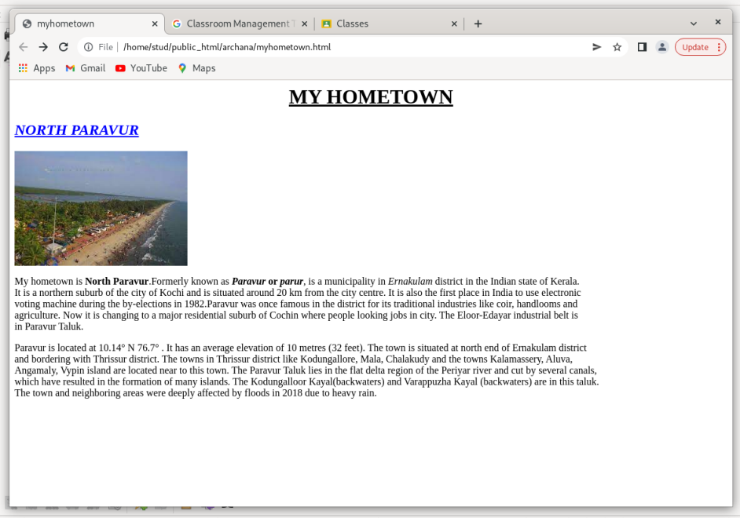

**AIM**

Create a webpage for displaying your biodata which contains images, tables, and also link within a page.

**PROGRAM CODE**

biodata.html

<html>

<head>

<title>biodata</title>

<body>

<h1><b><u>BIODATA</u></b></h1>

<p> <a href=“personal.html”>link for personal details</a></p>

<p> <a href=“academic.html”>link for academic details</a></p>

</body>

</head>

</html>

personal.html

<html>

<head>

<title>personal details</title>

</head>

<body>

<h2><b><u>PERSONAL DETAILS</u></b></h2>

<table border ="1" align="right" >

<tr>

<th><img src="bio.html.webp" width="100" height="100"></img></th>

</tr>

</table>

<p><br></p>

<p>NAME : ARCHANA PRASAD</p>

<p>ADDRESS : MUZHAGANTHARA(H), POOYAPPILLY, N.PARAVUR</p>

<P>NATIONALITY : INDIAN</P>

<P>FATHER&#39;S NAME : PRASAD M R</P>

<P>MOTHER&#39;S NAME : LATHA A R</P>

<p>GENDER : FEMALE</p>

<p>DATE OF BIRTH : 07/07/2002</p>

<P>MARITAL STATAUS : SINGLE</P>

<P>MOBILE NUMBER : 9074130475</P>

<P>EMAIL ID : archanam07prasad@gmail.com</P>

</body>

</html>

academic.html

<html>

<head>

<title>academic details</title>

</head>

<body>

<h2><b><u>ACADEMIC DETAILS</u></b></h2>

<table border ="1">

<tr>

<th></th>

<th>INSTITUTE NAME</th>

<th>YEAR OF PASSING</th>

<th>MARK PERCENTAGE</th>

</tr>

<tr>

<th>SSLC</th>

<th>ST ALOYSIUS ,N.PARAVUR</th>

<th>2017</th>

<th>90%</th>

</tr>

<tr>

<th>PLUS TWO</th>

<th>SNHSS ,N.PARAVUR</th>

<th>2019</th>

<th>89%</th>

</tr>

<tr>

<th>DEGREE</th>

<th>SNM COLLEGE ,MALIANKARA</th>

<th>2022</th>

<th>65%</th>

</tr>

</table>

</body>

</html>

**OUTPUT**

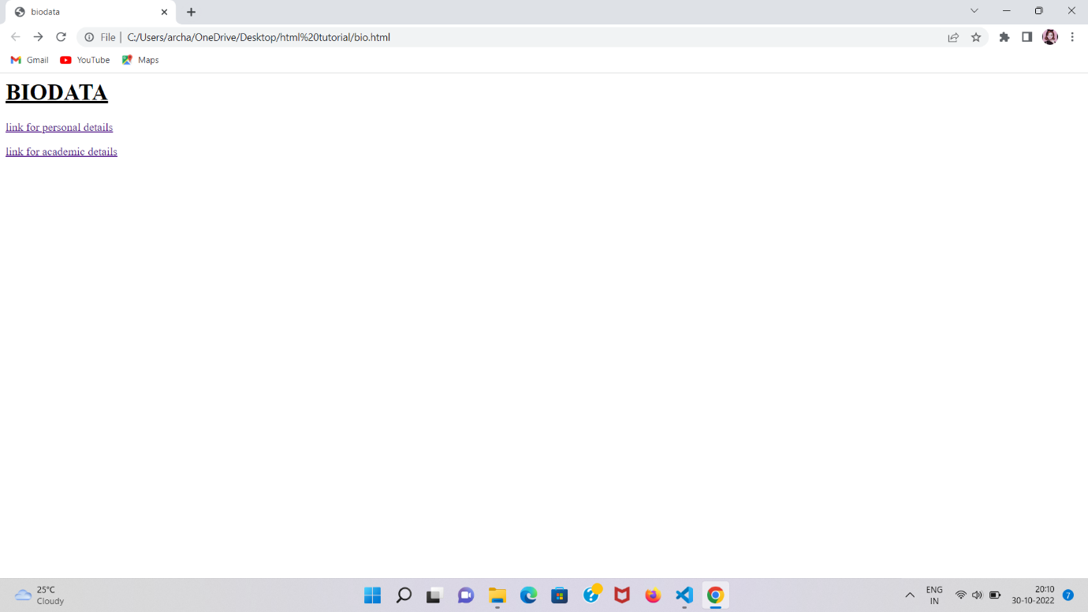

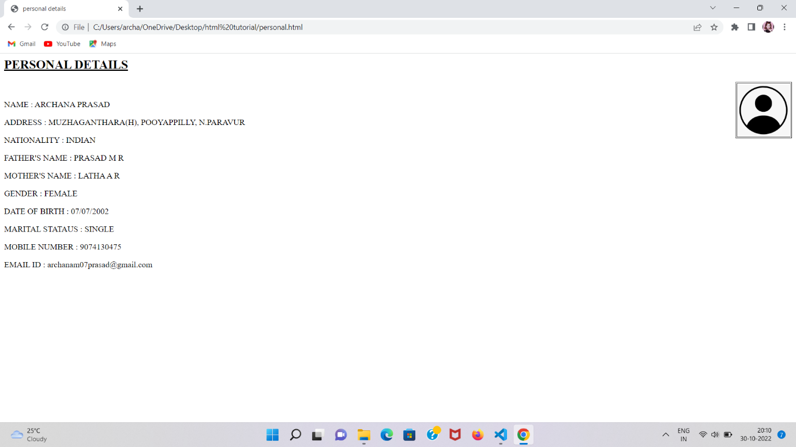

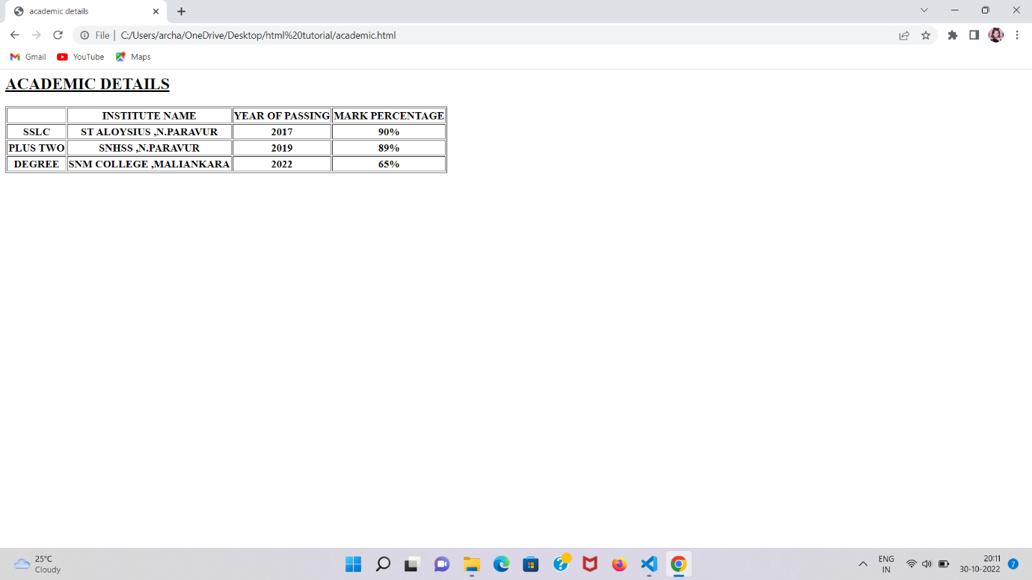

**AIM**

Design an application form for MCA course in FISAT using HTML.

**PROGRAM CODE**

<html>

<head>

<title>registration form</title>

</head>

<body>

<h1 align=“center”><b><u>REGISTRATION FORM</u></b></h2>

<form>

First Name : <input name=“name” type=“text” size=“20” value=“first name”>

Last Name : <input name=“name” type=“text” size=“20” value=“last name”><br><br>

Address : <textarea name=“name” row=“5” column=“30”>your

address</textarea><br><br>

Email ID : <input name=“name” type=“text” value=“your email id”><br><br>

Mobile : <input name=“name” type=“text” value=“mobile number”><br><br>

Gender : <input type=“radio” name=“name” value=“male”>Male<input type=“radio”

name=“name” value=“female”>Female<br><br>

Did you attend the entrance exam :

<input type=“button” name=“yes” value=“yes”> <input type=“button” name=“no”

value=“no”><br><br>

Programming languages known :

<input type=“checkbox” name=“name” value=“c”>C Programming <input type=“checkbox”

name=“name” value=“python”> Python <input type=“checkbox” name=“name”

value=“c++”>C++<br><br>

Graduation : <select name=“name”><option>BCA<option>BSc<option>BBA</select>

<br><br>

<p>Thank you </p>

<br>

<input type=“submit” name=“send” value=“send”>

<input type=“reset” name=“clear” value=“clear”><br>

</form>

</body>

</html>

**OUTPUT**

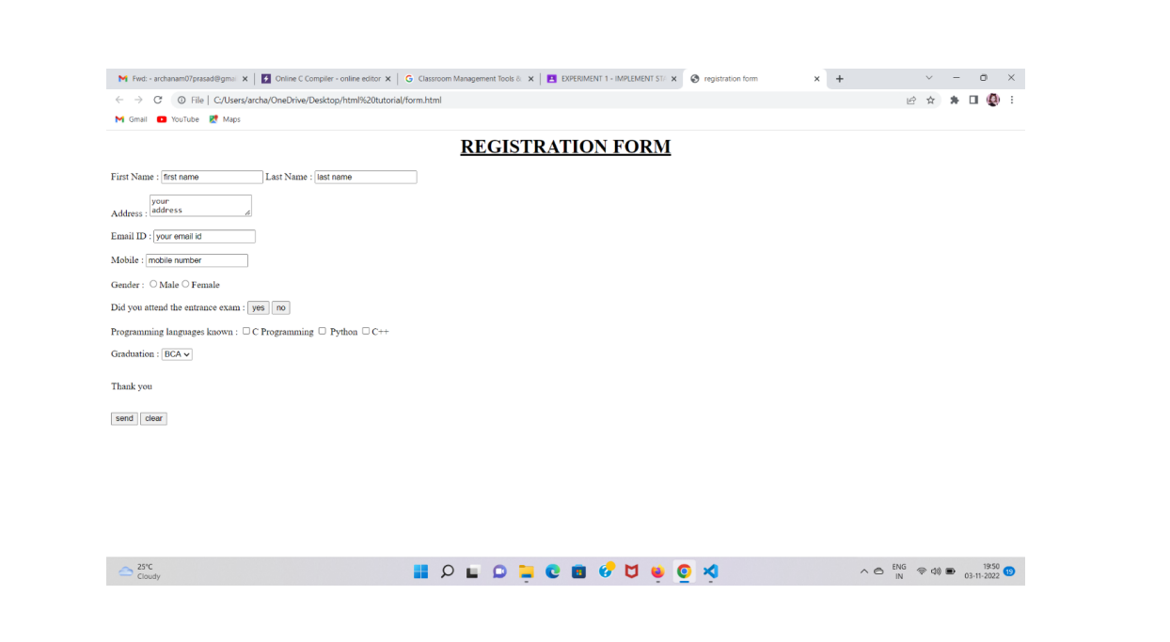

**AIM**

Create a HTML page with different types of frames such as floating frame, navigation

frame & mixed frame.

**PROGRAM CODE**

Main .html

<html><head><title>main page</title></head>

<body bgcolor=“ cyan”>

<h1><center>Differnt frames in html</h1>

<h2>

<a href=“frame.html” target=“mainF”>navigation</a><br><br>

<a href=“ifr.html” target=“mainF”>floating frame</a><br>

<a href=“mixed.html” target=“mainF”>mixed frame</a><br></h2>

</center></body>

</html>

Navigation.html

<html>

<head><title>Navigation Bar</title></head>

<body bgcolor=“DodgerBlue”><center>

<a href=“course.html” target=“mainF”>HTML Course</a><br><br>

<a href=“paragraph.html” target=“mainF”>Paragraphs</a><br>

<a href=“headings.html” target=“mainF”>Headings</a><br>

<a href=“intro.html” target=“mainF”>Home</a><br>

</center></body>

</html>

Ifr.html

<html>

<head>

<title>iframe</title>

</head>

<body bgcolor=“Aquamarine”>

<h1 align=“center”> Departments</h1>

<h3>

FISAT College Departments

<ul>

<li>Civil Engineering</li>

<li>Computer Science and Engineering</li>

<li>Electrical and Electronics Engineering</li>

<li>Electronics and Communication Engineering</li>

<li>Electronics and Instrumentation Engineering</li>

<li>Mechanical Engineering</li>

<li>Business Administration</li>

<li>Computer Applications</li>

<li>Science and Humanities</li>

</ul>

<iframe src=“course.html”></iframe>

<p>Federal Institute of Science and Technology (FISAT) is a self-financing engineering

institute established in the year 2002 by the Federal Bank Officers Association Education

Society (FBOAES).

It is approved by the All India Council for Technical Education (AICTE) and affiliated to

Kerala Technological University (KTU) and Mahatma Gandhi University, Kottayam</p>

<a href=“main.html”>back</a>

</body>

</html>

Mixed.html

<html>

<head><title>Frames 2</title></head>

<frameset cols=“140,*”>

<frame name=“navF” src=“navigation.html”>

<frameset rows=“30%,70%”>

<frame name=“upperF” src=“intro.html”>

<frame name=“lowerF” src=“course.html”>

</frameset>

</frameset>

</html>

**OUTPUT**

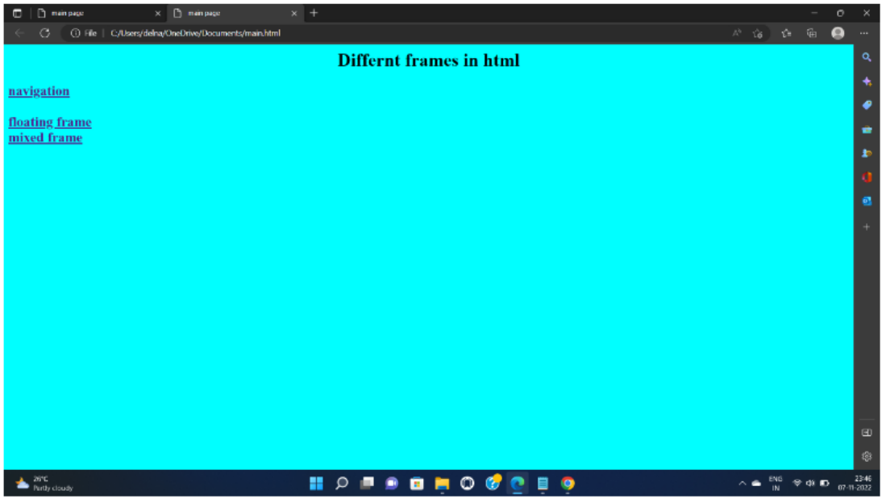

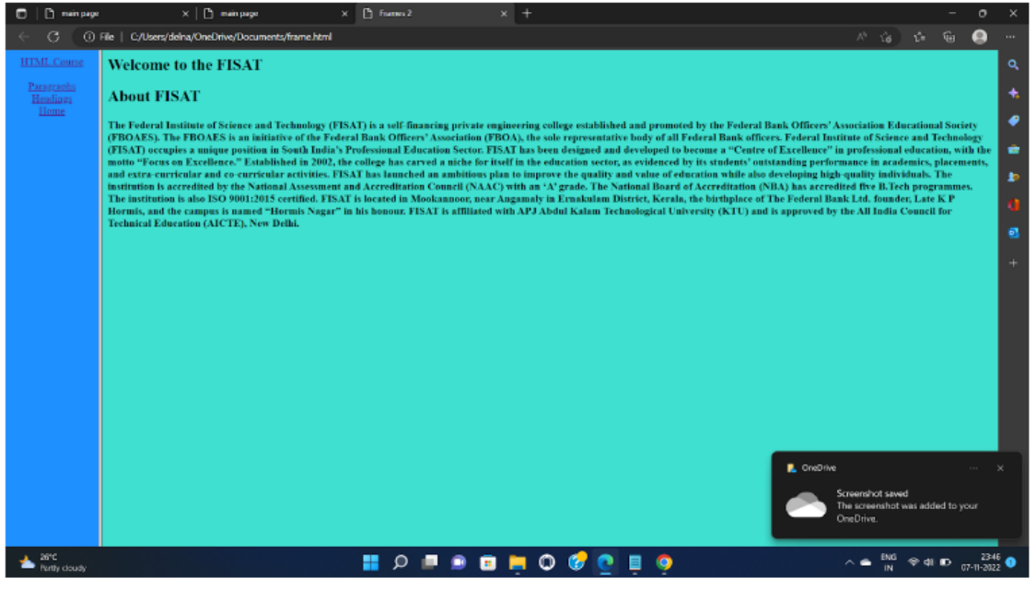

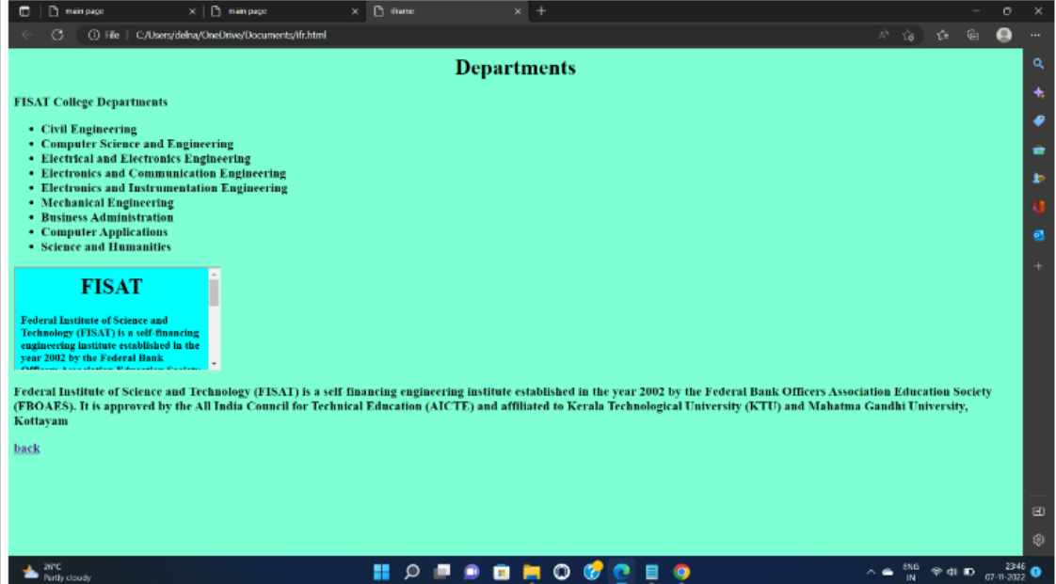

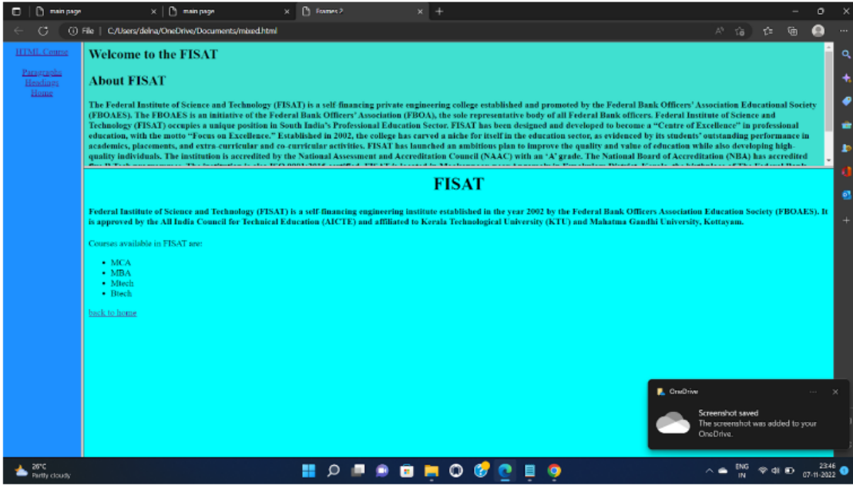

**AIM**

Analyze CSS by applying the different styles using inline, external &amp; internal style sheet in a HTML file.

**PROGRAM CODE**

<html>

<head>

<title>main</title>

</head>

<body bgcolor=“pink”>

<br>

<br>

<br>

<a href=“inline.html”>INLINE EXAMPLE</a><br>

<a href=“internal.html”>INTERNAL EXAMPLE</a><br>

<a href=“external.html”>EXTERNAL EXAMPLE</a><br>

</body>

</html>

<html>

<head>

<style>

body {background-color: powderblue;}

h1 {color: rgb(255, 89, 0);}

h3 {color: rgb(97, 50, 205)}

p {color: green;}

</style>

</head>

<body>

<h1 align=“center”>Internal example</h1><br>

<br><br>

<h2>course</h2>

<h3>

<ul>

<li>mca</li>

<li>mba</li>

<li>mtech</li>

<li>btech</li>

</ul>

</h3>

<h2><p>The institution offers post graduate programs in M Tech, Master of Computer Applications

and

Master of Business Administration, all affiliated to APJ Abdul Kalam Technological University.

The duration of the PG Programmes is 4 semesters.</p></h2>

</body>

</html>

<html>

<head>

<link rel=“stylesheet” href=“style.css”>

</head>

<body>

<h1 align=“center”>EXTERNAL EXAMPLE</h1><br><br>

<br>

<h2>fisat</h2><br><br>

<h3>the Department of Computer Science & Engineering was established in the year 2002.

<br>

Annual intake of students for B.Tech Computer Science & Engineering course is 180, B.Tech Computer Science and Design is 60, M.Tech (CSIS) is 12 and M.Tech (Artificial Intelligence and Data Science) is 12. </h3><br>

<p><h3>The institution offers post graduate programs in M Tech, Master of Computer Applications and Master of Business Administration, all affiliated to APJ Abdul Kalam Technological University.The duration of the PG Programmes is 4 semesters.</h3></p>

</body>

</html>

body {

    background-color: rgb(221, 160, 160);

    }

    h1 {

    color: rgb(112, 200, 216);

    }

    h3 {

    color: rgb(0, 130, 48);

    }

    p {

    color: rgb(74, 0, 211);

    }

<html>

<head>

<title>inline example</title>

</head>

<body bgcolor=“lavender”>

<h1 align=“center” style=“color:cyan;”><u>inline example</u></h1><br>

<br><br><p>

<h2 style=“color:blue;”>the Department of Computer Science & Engineering was established in the year 2002. <br>

Annual intake of students for B.Tech Computer Science Engineering course is 180, B.Tech Computer Science and Design is 60, M.Tech (CSIS) is 12 and M.Tech (Artificial Intelligence and Data Science) is 12. </h2><br>

<h3 style=“color:pink;” >Department is also recognized by APJ Abdul Kalam Technological University as a research center for Ph.D programmes. <br>

The department has competent and committed faculty which encourages students’ involvement in various

<h2 style=“color:green;”>co-curricular activities along with their academics.<br>

The institution offers post graduate programs in M Tech, Master of Computer Applications and Master of Business Administration, all affiliated to APJ Abdul Kalam Technological University.The duration of the PG Programmes is 4 semesters.</h2></p>

</p>

</body>

</html>

**OUTPUT**

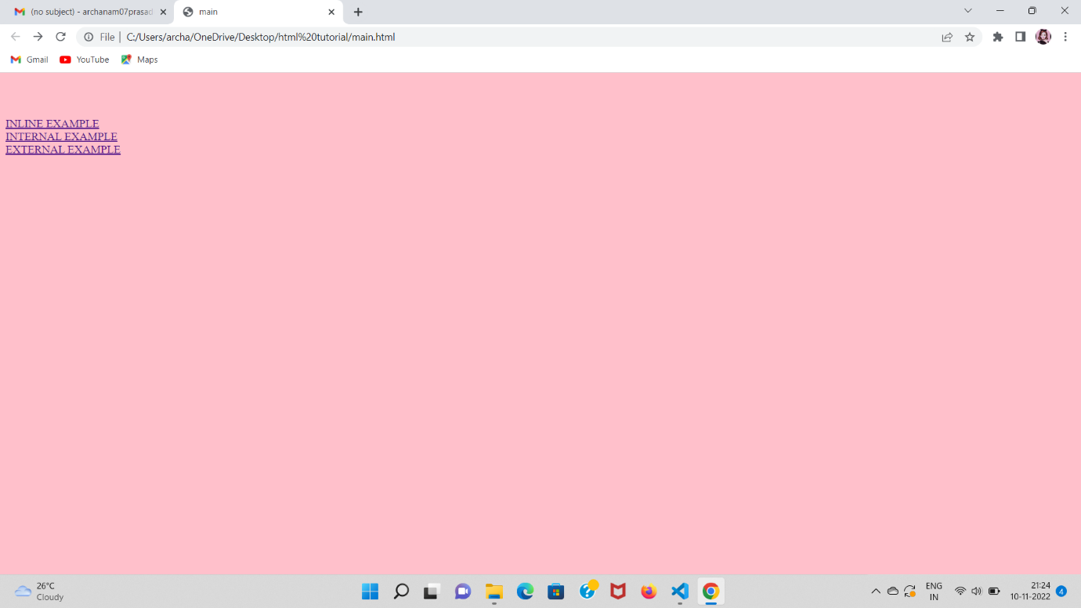

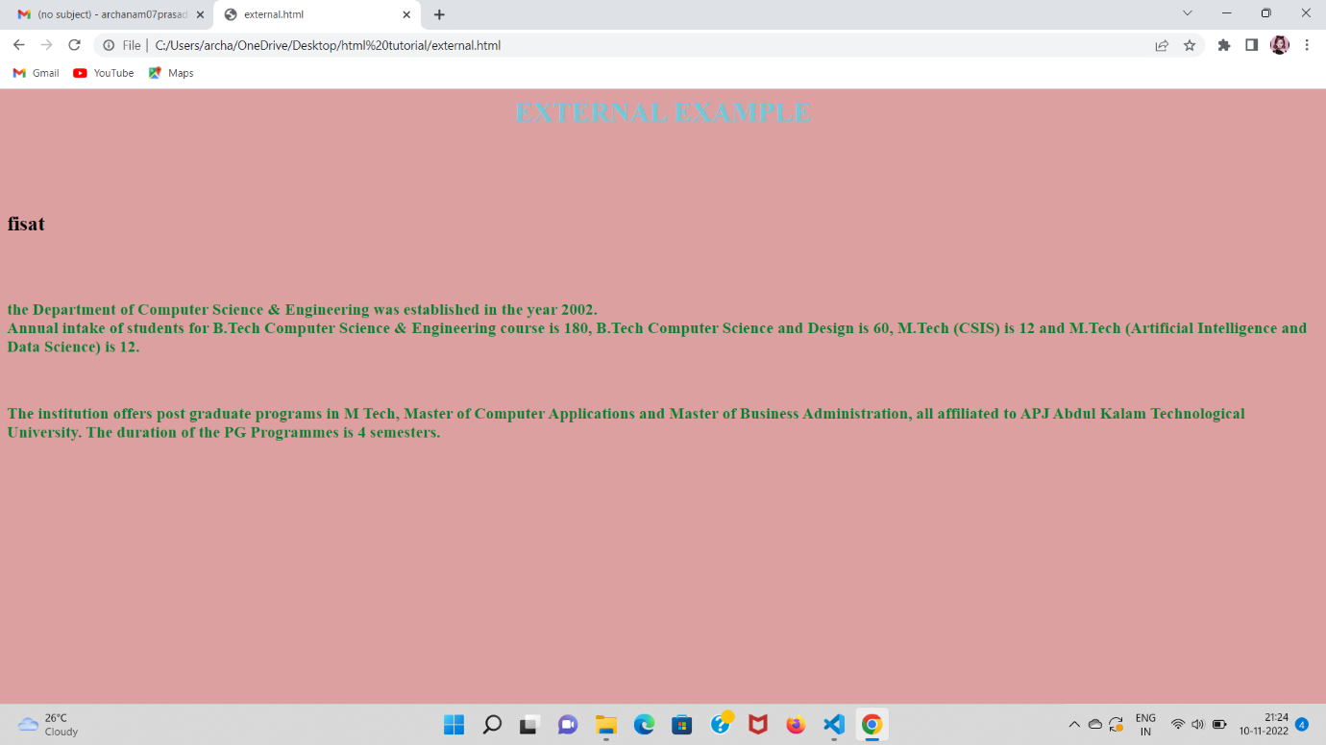



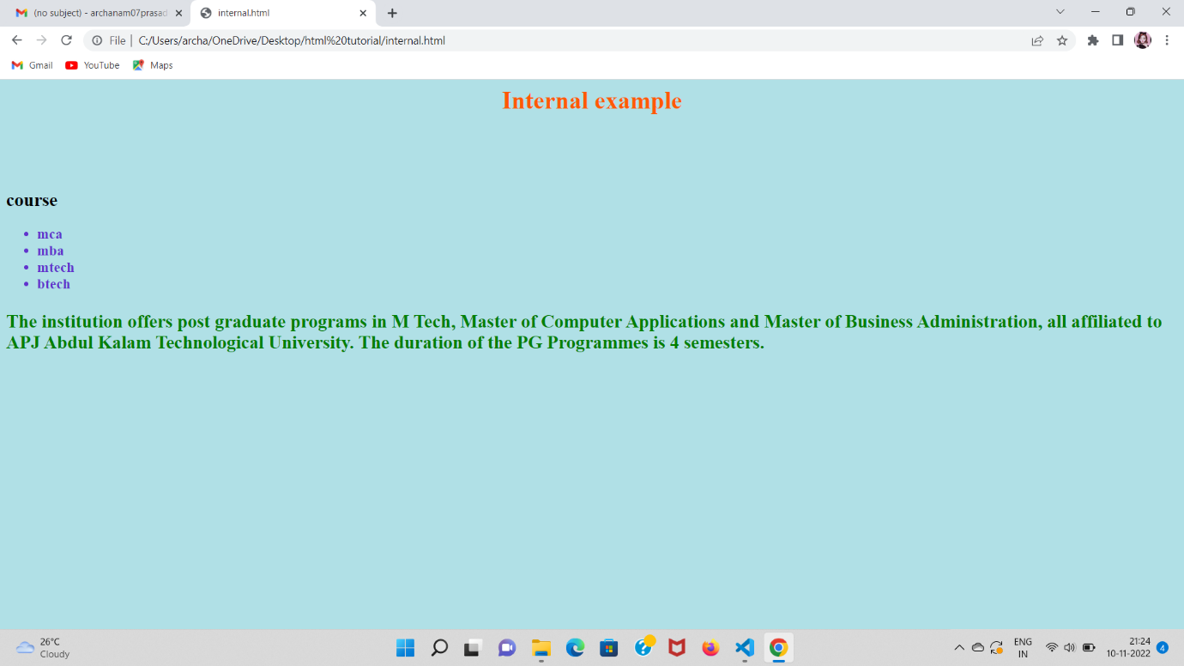

**AIM**

Create a HTML registration form and to validate the form using JavaScript code.

**PROGRAM CODE**

<html>

<head>

<script>

function validateform()

{

var x = document.forms[“myform”][“fname”].value;

var y = document.forms[“myform”][“fname1”].value;

if (x==““)

{

alert(“Name must be filled out”);

return false;

}

if (y==““)

{

alert(“Name must be filled out”);

return false;

}

var n = document.forms[“myform”][“fname2”].value;

if(isNaN(n))

alert(“mobile number must be digits”)

return false;

}

</script>

</head>

<body bgcolor=“cyan” align=“center”>

<h1 align=“center”><b>REGISTRATION FORM</b></h2>

<form name=“myform” onsubmit=“return validateform()” action=“main.html” method=“post”>

<table border=“3” align=“center”>

<tr>

<td>First Name:</td>

<td><input type=“text” name=“fname” placeholder=“enter first name”></td>

</tr>

<tr>

<td>Last Name:</td>

<td><input type=“text” name=“fname1” placeholder=“enter last name”></td>

</tr>

<tr>

<td>Mobile Number:</td>

<td><input type=“text” name=“fname2” placeholder=“mobile number”></td>

</tr>

<tr>

<td>Mail ID:</td>

<td><input type=“text” name=“fname3” placeholder=“mail is”></td>

</tr>

</table>

<input type=“submit” name=“send” value=“submit”><br>

</form>

</body>

</html>

**OUTPUT**

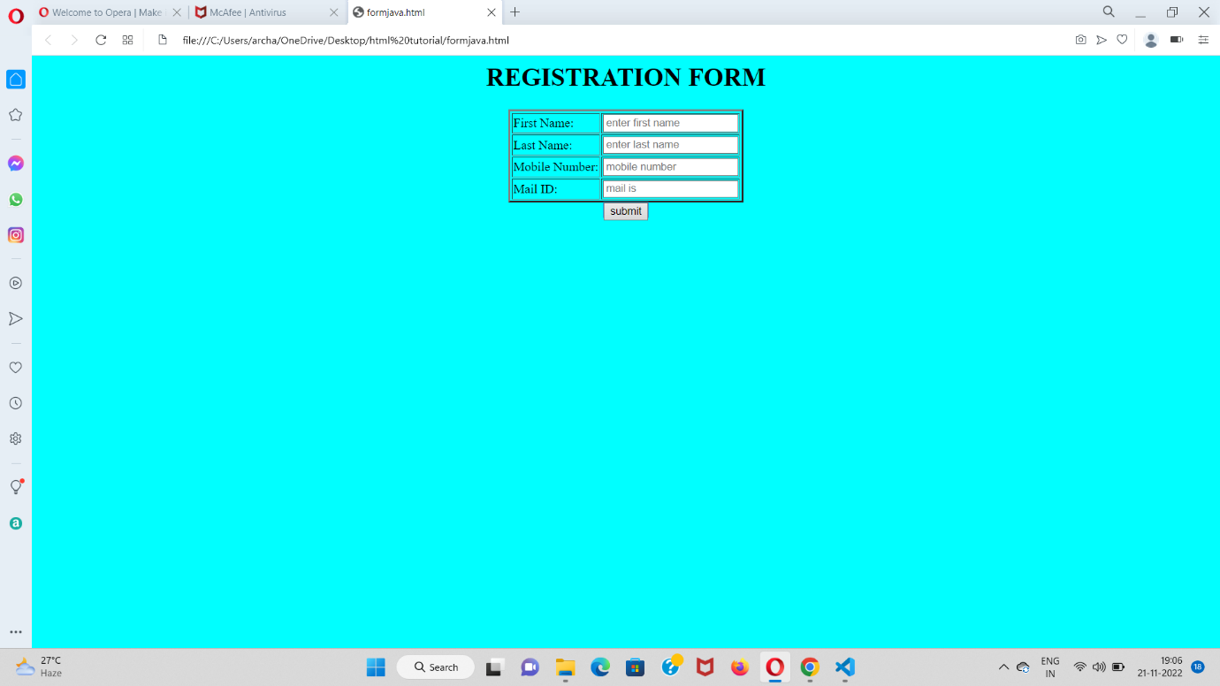

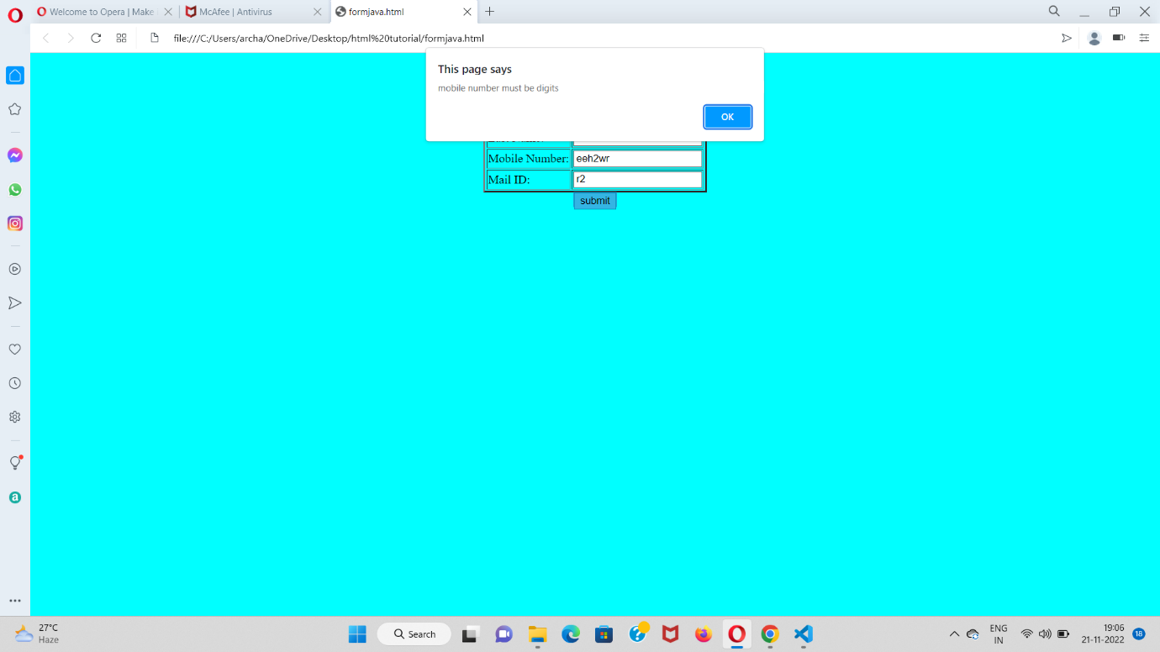

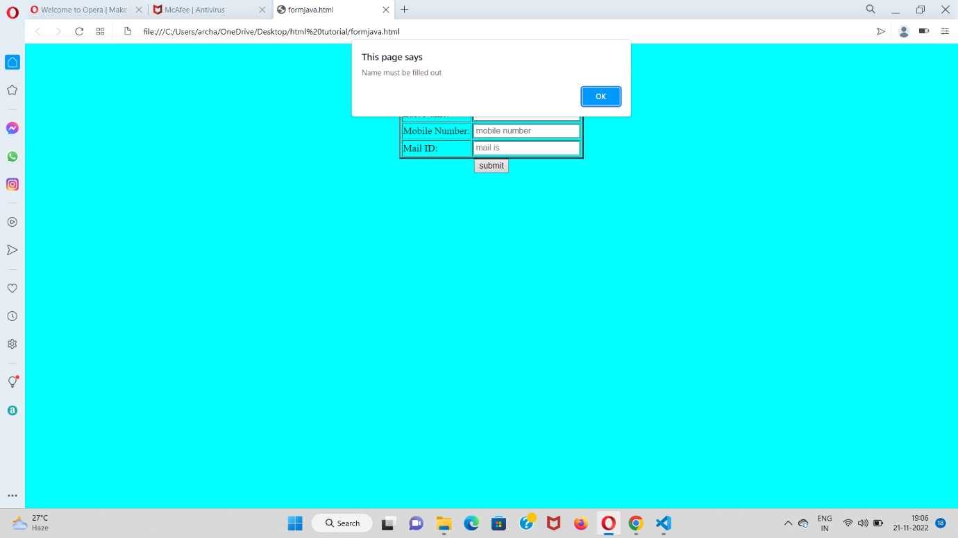

**AIM**

Create a HTML page to explain the use of various predefined functions in a string and math object in java script.

**PROGRAM CODE**

<html>

<head>

<title>

</title>

<style>

.myDiv {

   width: 500px;

   height: 700px;

   position: absolute;

   top: 5%;

   left: 15%;

   background-color: #fffbc9;

   text-align: center;

   border-style: groove;

   border-color: #92a8d1;

}

.myDiv1 {

   width: 500px;

   height: 1000px;

   position: absolute;

   top: 5%;

   left: 50%;

   background-color: #fffbc9;

   text-align: center;

   border-style: groove;

   border-color: #92a8d1;

}

</style>

</head>

<body>

<div class="myDiv">

<br><br><h2><u>STRING FUNCTIONS</u></h2><br>

Enter a string <br><br><input type="text" name="fname" id="text1">

<br><br>

<button type="submit" style="height:50px; width:100px" value="Submit" onclick="StringForm()">Submit</button>

<br><br>

<u>Output</u><br>

<p id="text2">

</p>

<p id="text3">

</p>

<p id="text4">

</p>

<p id="text5">

</p>

<p id="text6">

</p>

<p id="text7">

</p>

<p id="text8">

</p>

<p id="text9">

</p>

<p id="text10">

</p>

<p id="text11">

</p>

<p id="text12">

</p>

</div>

<div class="myDiv1">

<br><br><h2><u>MATH FUNCTIONS</u></h2><br>

Enter any digit<br><br><input type="number" id="qu" name="quantity">

<br><br>

<button type="submit" style="height:50px; width:100px" value="Submit" onclick="MathForm()">Submit</button>

<br><br>

<u>Output</u><br><br>

<u>Constants</u><br>

<p id="texta">

</p>

<br><br>

<p id="textb">

</p>

<p id="textc">

</p>

<p id="textd">

</p>

<p id="texte">

</p>

<p id="textf">

</p>

<p id="textg">

</p>

<p id="texth">

</p>

<p id="texti">

</p>

<p id="textj">

</p>

<p id="textk">

</p>

<p id="textl">

</p>

<p id="textm">

</p>

</div>

</body>

<script>

function StringForm() {

let text = document.getElementById("text1").value;

let length = text.length;

let part = text.slice(3,5);

let sub = text.substring(4,6);

let subs = text.substr(-1);

let re = text.replace("anex","pauly");

let rep = text.replaceAll("m","M");

let up = text.toUpperCase();

let lo = text.toLowerCase();

let co = text.concat("","pauly");

let tr = text.trim();

let ch = text.charAt(2);

document.getElementById("text2").innerHTML = "The String Length is : " + length;

document.getElementById("text3").innerHTML = "The Sliced String from 3rd to 5th position is : " + part;

document.getElementById("text4").innerHTML = "The Sub String from 4th to 6th position is : " + sub;

document.getElementById("text5").innerHTML = "The Subpart of the String is : " + subs;

document.getElementById("text6").innerHTML = "The replaced String is : " + re;

document.getElementById("text7").innerHTML = "The replaceAll String is : " + rep;

document.getElementById("text8").innerHTML = "The Uppercased String is : " + up;

document.getElementById("text9").innerHTML = "The Lowercased String is : " + lo;

document.getElementById("text10").innerHTML = "The concated String is : " + co;

document.getElementById("text11").innerHTML = "The Trimed String is : " + tr;

document.getElementById("text12").innerHTML = "The Character at 2nd position of the String is : " + ch;

return true;

}

function MathForm() {

let text = document.getElementById("qu").value;

let ro = Math.round(text);

let ce = Math.ceil(text);

let fl = Math.floor(text);

let tu = Math.trunc(text);

let si = Math.sign(text);

let po = Math.pow(text,2);

let sq = Math.sqrt(text);

let ab = Math.abs(text);

let sin = Math.sin(text * Math.PI / 180);

let cos = Math.cos(text * Math.PI / 180);

let min = Math.min(0, 150, 30, 20, -8, -200);

let max = Math.max(0, 150, 30, 20, -8, -200);

let ra = Math.random();

let l = Math.log(text);

document.getElementById("texta").innerHTML = "<p><b>Math.E:</b> " + Math.E + "</p>" +

"<p><b>Math.PI:</b> " + Math.PI + "</p>" +

"<p><b>Math.LN10:</b> " + Math.LN10 + "</p>" +

"<p><b>Math.LOG2E:</b> " + Math.LOG2E + "</p>"

document.getElementById("textb").innerHTML = "The Rounded value is " + ro;

document.getElementById("textc").innerHTML = "The Rounded value using ceil function is " + ce;

document.getElementById("textd").innerHTML = "The Rounded value using floor function is " + fl;

document.getElementById("texte").innerHTML = "The Rounded value using truncate function is " + tu;

document.getElementById("textf").innerHTML = "The sign of the value is " + si;

document.getElementById("textg").innerHTML = "The power of the value with 2 is " + po;

document.getElementById("texth").innerHTML = "The sin value for the angle given is " + sin;

document.getElementById("texti").innerHTML = "The cos value for the angle given is " + cos;

document.getElementById("textj").innerHTML = "The min value for the given values(0,150,30,20,-8,-200) is " + min;

document.getElementById("textk").innerHTML = "The max value for the given values(0,150,30,20,-8,-200) is " + max;

document.getElementById("textl").innerHTML = "The random value between 0 and 1 is " + ra;

document.getElementById("textm").innerHTML = "The log value for the given number is " + l;

return true;

}

</script>

</html>

**OUTPUT**

|  |  |
| --- | --- |
|  |  |

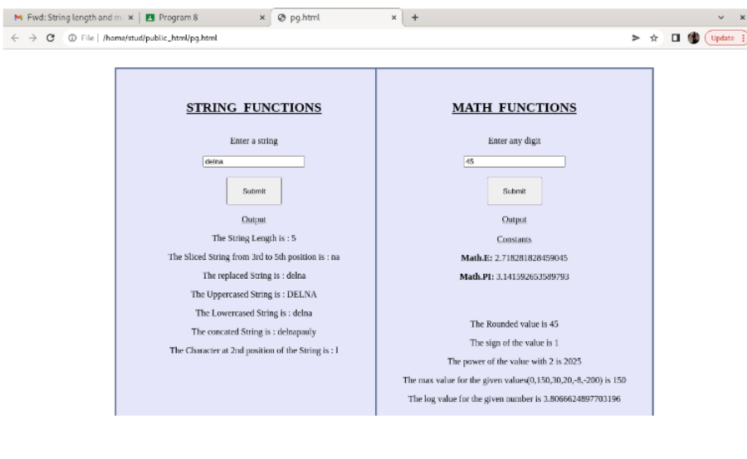

**AIM**

Create a HTML page to change the background color for every click of a button using JavaScript Event Handling.

**PROGRAM CODE**

<!DOCTYPE HTML>

<html>

<head>

<title>

changing the background color

</title>

</head>

<body style = "text-align:center;">

<h1 style = "color:blue;" >

Welcome

</h1>

<button type="button" id="color-button" onclick="changeBg()">Click Here

</button>

<br>

<script>

document.writeln( "Click on button to change the background color");

const pageBody = document.querySelector("body");

function changeBg()

{

let color = '#'+(Math.random()*0xFFFFFF<<0).toString(16);

pageBody.style.background = color;

}

</script>

</body>

</html>

**OUTPUT**

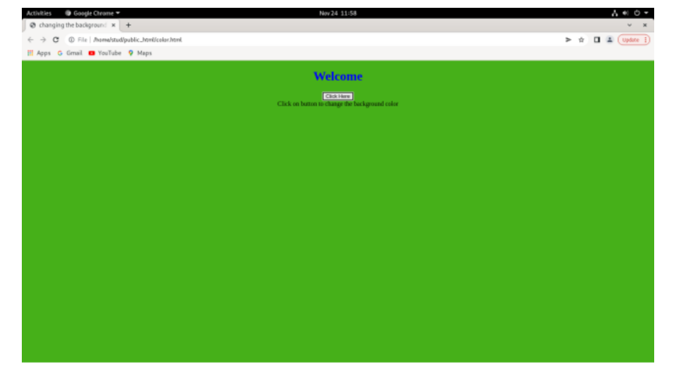

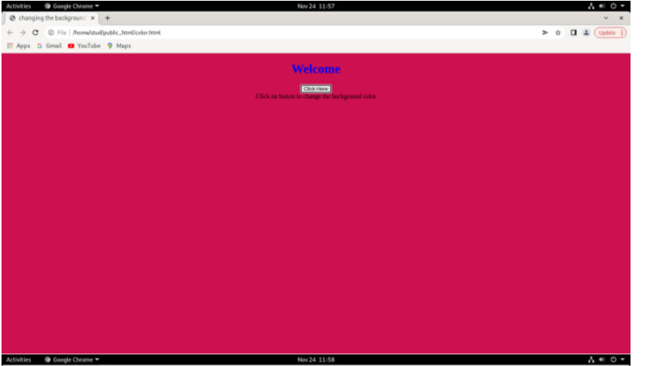

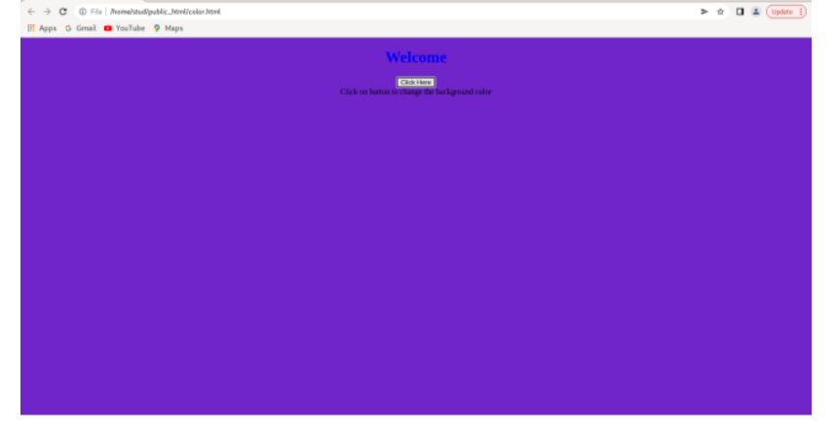

**AIM**

Compose Electricity bill from user input based on a given tariff using PHP.

**PROGRAM CODE**

<!DOCTYPE html>

<head>

<title>Calculate Electricity Bill</title>

</head>

<?php

$result_str = $result = '';

if (isset($_POST['unit-submit'])) {

    $units = $_POST['units'];

    if (!empty($units)) {

        $result = calculate_bill($units);

        $result_str = 'Total amount of ' . $units . ' - ' . $result;

    }

}

function calculate_bill($units) {

    $unit_cost_first = 4;

    $unit_cost_second = 5;

    $unit_cost_third = 6;

    if($units <= 100) {

        $bill = $units * $unit_cost_first;

    }

    else if($units > 100 && $units <= 200) {

        $temp = 100 * $unit_cost_first;

        $remaining_units = $units - 100;

        $bill = $temp + ($remaining_units * $unit_cost_second);

    }

    else {

        $temp = (100 * 4) + (100 * $unit_cost_second) + (100 * $unit_cost_third);

        $remaining_units = $units - 200;

        $bill = $temp + $remaining_units ;

    }

    return number_format((float)$bill, 2, '.', '');

}

?>

<body>

<div id="page-wrap">

<h1>Php - Calculate Electricity Bill</h1>

<form action="" method="post" id="quiz-form">

            <input type="number" name="units" id="units" placeholder="Please enter no. of Units" />

            <input type="submit" name="unit-submit" id="unit-submit" value="Submit" />

</form>

<div>

   <?php echo '<br />' . $result_str; ?>

</div>

</div>

</body>

</html>

**OUTPUT**

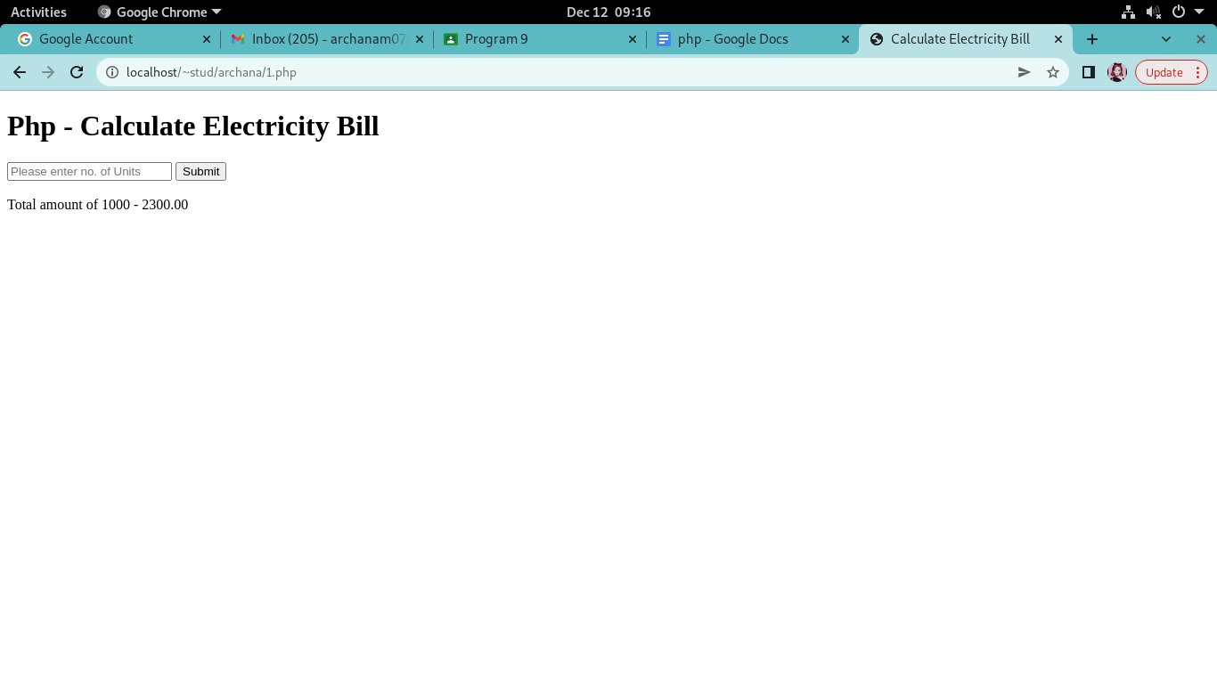

**AIM**

Build a PHP code to store name of students in an array and display it using print_r  
function. Sort and Display the same using asort & arsort functions.

**PROGRAM CODE**

10.html

<html>

<head><title>Stud</title></head>

<body bgcolor="pink">

<h1 align="center"><u>Enter the roll numbers and names of 5 students</u></h1><br><br>

<form action="10.php" method="post">

<table align="center" border="3">

<tr>

<th>Roll Number</th>

<td><input type="number" name="r1"></td>

<th>Name</th>

<td><input type="text" name="n1"></td>

</tr>

<tr>

<th>Roll Number</th>

<td><input type="number" name="r2"></td>

<th>Name</th>

<td><input type="text" name="n2"></td>

</tr>

<tr>

<th>Roll Number</th>

<td><input type="number" name="r3"></td>

<th>Name</th>

<td><input type="text" name="n3"></td>

</tr>

<tr>

<th>Roll Number</th>

<td><input type="number" name="r4"></td>

<th>Name</th>

<td><input type="text" name="n4"></td>

</tr>

<tr>

<th>Roll Number</th>

<td><input type="number" name="r5"></td>

<th>Name</th>

<td><input type="text" name="n5"></td>

</tr>

<tr>

<th> </th>

<td><input type="submit" name="Submit" id="submit"></td>

</tr>

</body>

</html>

10.php

<?php

echo"The student names represented in array are<br><br>";

$rl1=$_REQUEST["r1"];

$rl2=$_REQUEST["r2"];

$rl3=$_REQUEST["r3"];

$rl4=$_REQUEST["r4"];

$rl5=$_REQUEST["r5"];

$na1=$_REQUEST["n1"];

$na2=$_REQUEST["n2"];

$na3=$_REQUEST["n3"];

$na4=$_REQUEST["n4"];

$na5=$_REQUEST["n5"];

$arr=array("$rl1"=>"$na1","$rl2"=>"$na2","$rl3"=>"$na3","$rl4"=>"$na4","$rl5"=>"$na5");

print_r($arr);

echo"<br><br> The asorted array is:<br><br>";

asort($arr);

print_r($arr);

echo"<br><br> The arsorted array is:<br><br>";

arsort($arr);

print_r($arr);

?>

**OUTPUT**

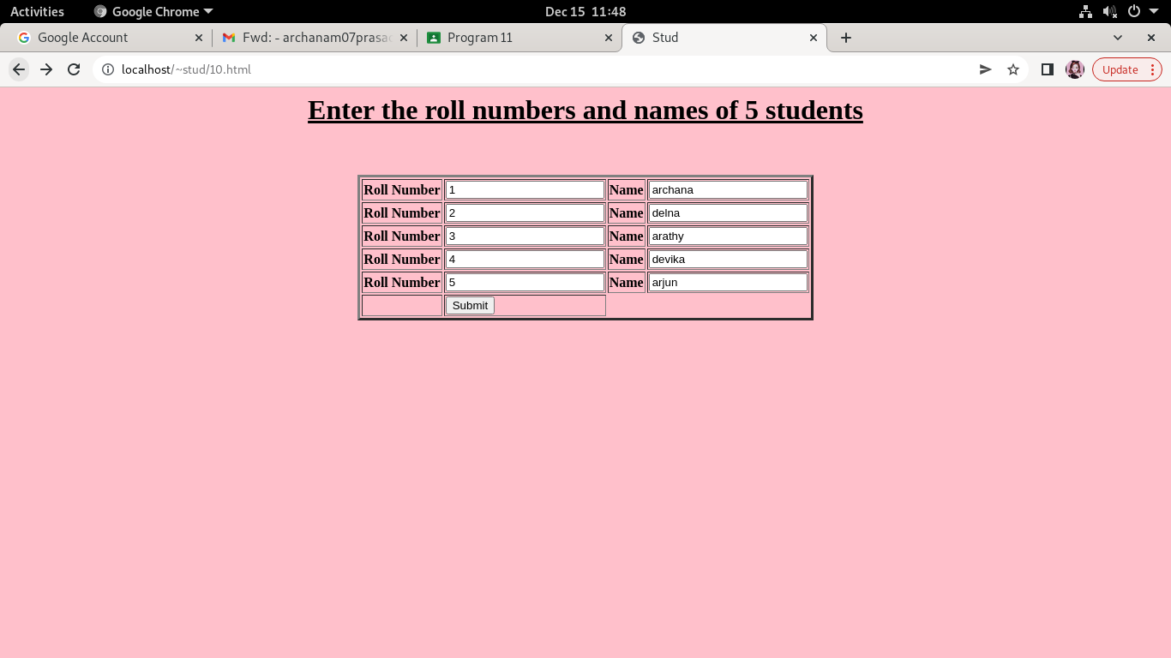

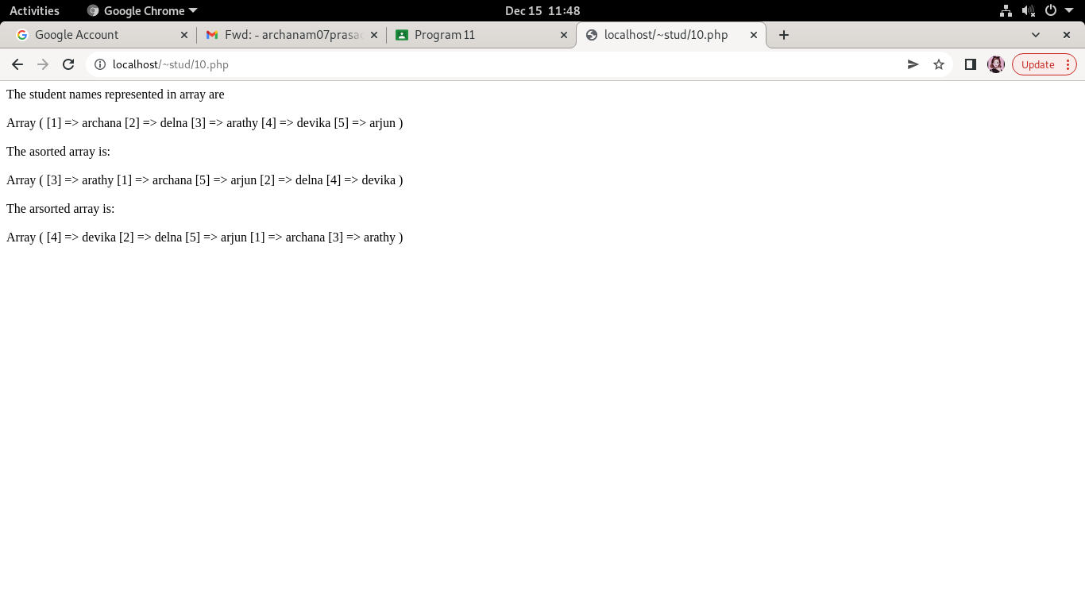

**AIM**

Build a PHP code to store name of Indian Cricket players in an array and display  
the same in HTML table.

**PROGRAM CODE**

11.html

<html>

<head>

  <title>Cricket players</title>

</head>

<body bgcolor="pink">

<h1 align="center"><font color="green"><u>5 INDIAN CRICKET PLAYERS</u></font></h1><br>

<form action="11.php" method="post">

<table align="center" border="2">

<tr>

<th>Player 1</th>

<td><input type="text" name="p1" id="p1"></td>

</tr>

<tr>

<th>Player 2</th>

<td><input type="text" name="p2" id="p2"></td>

</tr>

<tr>

<th>Player 3</th>

<td><input type="text" name="p3" id="p3"></td>

</tr>

<tr>

<th>Player 4</th>

<td><input type="text" name="p4" id="p4"></td>

</tr>

<tr>

<th>Player 5</th>

<td><input type="text" name="p5" id="p5"></td>

</tr>

<tr>

<th> </th>

<td><input type="submit" value="submit"></td>

</tr>

</table>

</form>

</html>

11.php

<?php

$pl1=$_REQUEST["p1"];

$pl2=$_REQUEST["p2"];

$pl3=$_REQUEST["p3"];

$pl4=$_REQUEST["p4"];

$pl5=$_REQUEST["p5"];

echo"<body style='background-color:lavender'>";

echo"THE NAMES OF 5 INDIAN CRICKET PLAYERS ARE <br><br>";

echo"<table border=20 cellspacing=5 cellpadding=10  bgcolor=pink>

<tr>

<th>Player 1</th>

<td>$pl1</td>

</tr>

<tr>

<th>Player 2</th>

<td>$pl2</td>

</tr>

<tr>

<th>Player 3</th>

<td>$pl3</td>

</tr>

<tr>

<th>Player 4</th>

<td>$pl4</td>

</tr>

<tr>

<th>Player 5</th>

<td>$pl5</td>

</tr>

</table>";

?>

**OUTPUT**

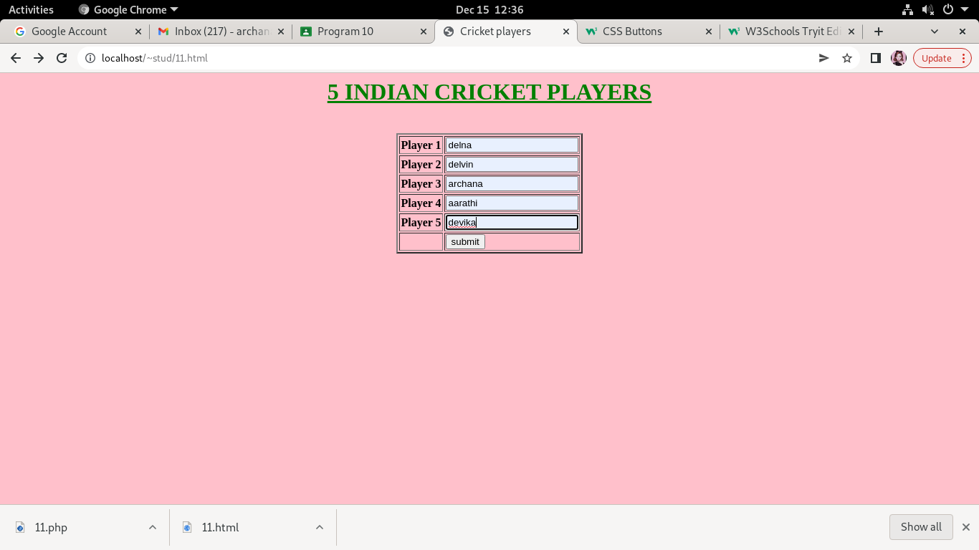

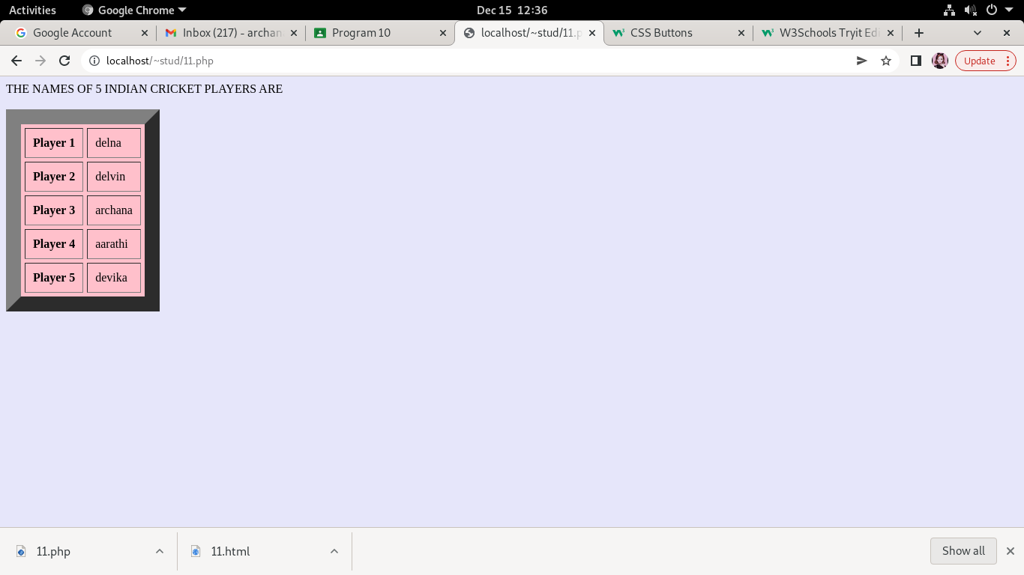

**AIM**

Outline a registration form using PHP and do necessary validations.

**PROGRAM CODE**

<?php

$name = $email= $gender = $address= $phone= $gender= "";

$name1= $email1= $gender1= $address1= $phone1= $gender1= "";

if (isset($_POST["submit"])){

if (empty($_POST["fname"])){

$name = "Name is required";}

else{

$name1 = $_POST["fname"];  }

if (empty($_POST["email"])){

$email= "Email is required";}

else{

 $email1= $_POST["email"];  }

if (empty($_POST["address"])){

$address = "Address is required";}

else{

$address1= $_POST["address"];  }

if (empty($_POST["gender"])){

$gender = "Gender is required";}

else{

$gender1 = $_POST["gender"]; }

if (empty($_POST["phone"])){

$phone= "phone is required";}

else{

 $phone1 = $_POST["phone"];  }

}

?>

<html>

<head>

<style>

.error {color: #FF0000;}

td{

padding:15px;}

</style>

</head>

<center>

<body bgcolor="pink">

<table >

<form method="post" action="#">

<h1><I>REGISTRATION FORM</I></h1><br>

<tr>

<td>NAME :<input type="text" name="fname"></td>

<td><span class="error"><?php echo $name;?></span></td>

</tr>

<tr>

<td>EMAIL :<input type="text" name="email"></td>

<td><span class="error"><?php echo $email;?></span></td>

</tr>

<td>GENDER : <input type="radio" name="gender" value="male">MALE

<input type="radio" name="gender" value="female">FEMALE</td>

<td><span class="error"><?php echo $gender;?></span></td>

</tr>

<tr>

<td>PHONE : <input type="text" name="phone"></td>

<td><span class="error"><?php echo $phone;?></span> </td>

</tr>

<tr>

<td>ADDRESS :<textarea rows="4" cols="20" name=address></textarea></td>

<td><span class="error"><?php echo $address;?></span></td>

</tr>

<td><center><input type="submit" name="submit" value="submit">

<input type="reset" name="reset" value="reset"></center></td></tr>

</table>

</form>

<?php

if(isset($_POST['submit'])) {

if($name == "" && $email== "" && $phone == "" && $gender== "" && $address == "")

{

echo "<h3 color = #FF0001> <b>You have sucessfully registered.</b> </h3>";

echo "<h2>Your Input:</h2>";

echo "Name: " .$name1;

echo "<br>";

echo "Email: " .$email1;

echo "<br>";

echo "Phone No: " .$phone1;

echo "<br>";

echo "Address: " .$address1;

echo "<br>";

echo "Gender: " .$gender1;

} else {

echo "<h3> <b>You didn't filled up the form correctly.</b> </h3>";

}

}

?>

</body>

</html>

**OUTPUT**

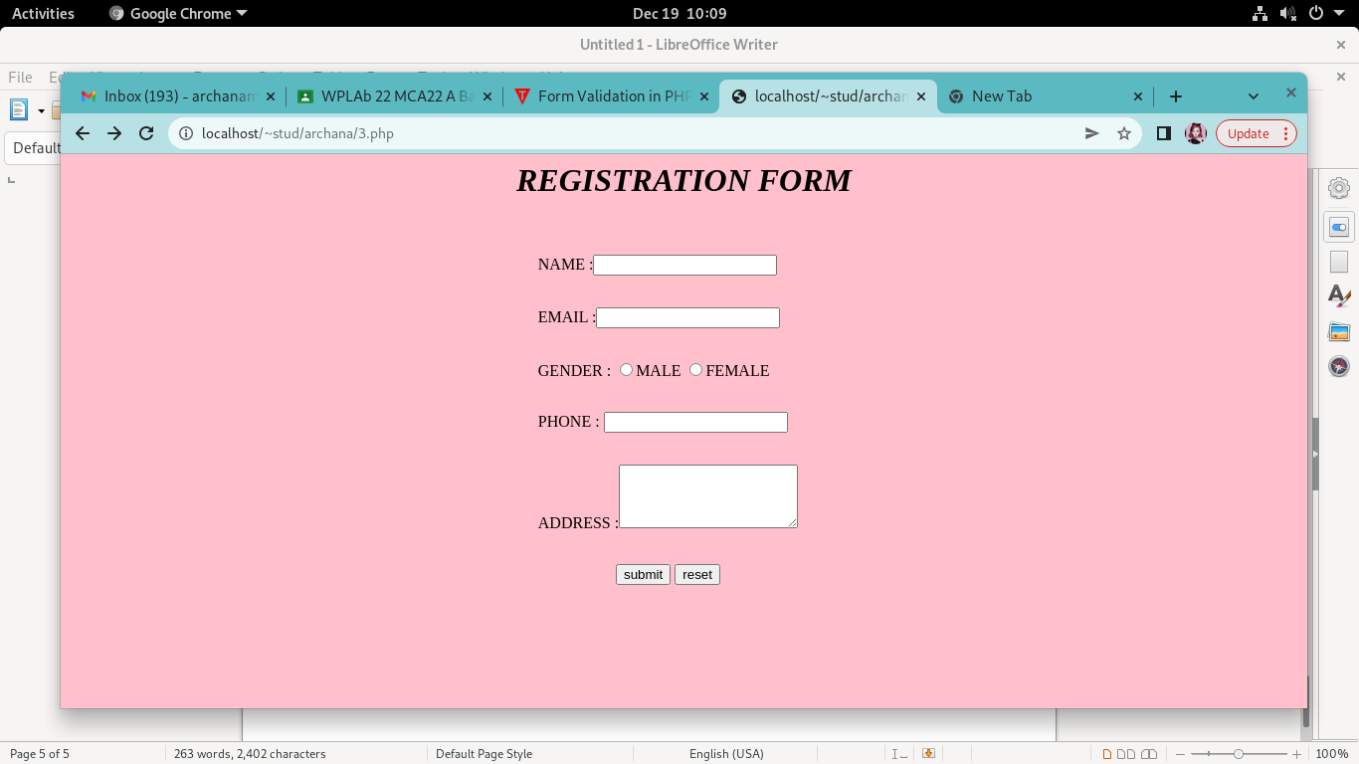

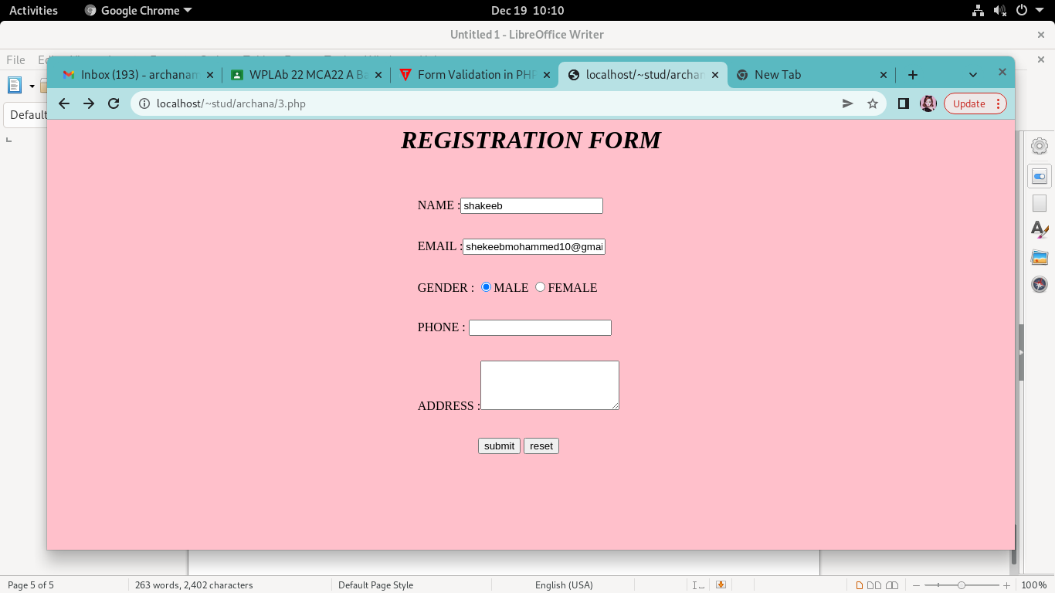

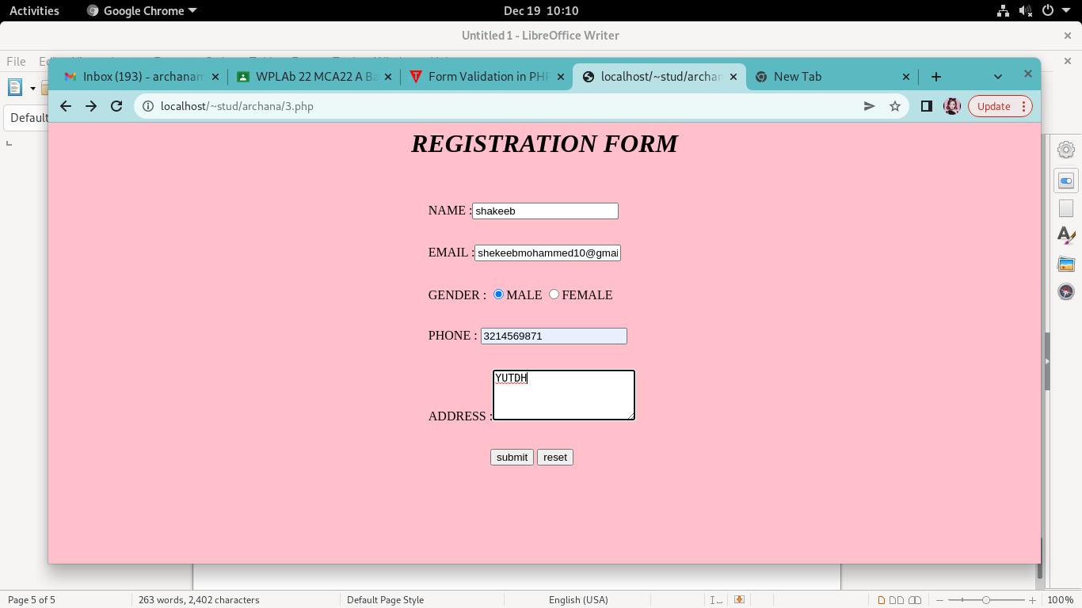



**AIM**

Develop a PHP program to connect to a database and add data to the employee table and retrieve data from the table andshow the retrieved details in a neat format.

**PROGRAM CODE**

Program1.php

<html>

<head>

<title>homepage</title>

</head>

<body align="center">

<h2>Employee Registration</h2>

<form name="registation" method="POST" action="program.php">

<button>REGISTER</button>

</form>

<form name="reg" method="POST" action="demo.php">

<button>VIEW</button>

</form>

</body>

</html>

demo.php

<?php

$con = new mysqli("localhost", "fisat", "fisat", "fisatdb");

if ($con=== false) {

die("ERROR: Could not connect. " . mysqli_connect_error());

}

$sql = "SELECT * FROM emp";

if ($result = $con->query($sql))

{ if ($result->num_rows > 0) {

 ?>

<html>

<body>

<table border=5>

<tr>

<th>Employee ID</th><th>Employee Name</th><th>Employee Department</th><th>Employee Age</th>

</tr>

<tr>

<?php while($row = $result->fetch_array()) { ?>

<td><?php echo $row[0]; ?> </td><td><?php echo $row[1];?></td><td><?php echo $row[2];?></td><td><?php echo $row[3];?></td>

</tr>

<?php

} ?>

</table>

<form name="reg" method="POST" action= "program1.php">

<button>HOME</button>

</form>

</html>

<?php

$result->close();

} else {

echo "No records matching your query were found.";

}

} else {

echo "ERROR: Could not execute $sql. " . $con->error;

} $con->close();

?>

program.php

<html>

<head>

<title>

</title>

</head>

<body bgcolor="lavender">

<center>

<h1> Add Employee</h>

<form name="myform" action="#" method="POST">

<table border="5" cellspacing="15" cellpadding="15">

<tr>

<td>ID:</td>

<td><input type="number" name="id"></td>

</tr>

<tr>

<td>Name:</td>

<td><input type="text" name="name"></td>

</tr>

<tr>

<td>Age:</td>

<td><input type="number" name="age"></td>

</tr>

<tr>

<td>Dept:</td>

<td><input type="text" name="dep"></td>

</tr>

</table>

<input type="submit" value="submit" name="submit">

</form>

<form name="reg" method="POST" action= "program1.php">

<button>HOME</button>

</form>

</center>

</body>

</html>

<?php error_reporting(0); ?>

<?php

$n1 = $_POST["id"];

$n2 = $_POST["name"];

$n3 = $_POST["age"];

$n4 = $_POST["dep"];

if (isset($_POST["submit"]))

{

$servername = "localhost";

$username = "fisat";

$password = "fisat";

$conn = new mysqli($servername, $username, $password,"fisatdb");

if ($conn->connect_error) {

die("Connection failed: " . $conn->connect_error);

}

echo "Connected successfully";

$sql = "INSERT INTO emp(emp_id,emp_name,emp_age,emp_dep) VALUES('$n1','$n2','$n3','$n4')";

if ($conn->query($sql) === true) {

echo "New row added";

}

else

{

echo "ERROR: Could not execute query:";

}

$conn->close();

}

?>

**OUTPUT**

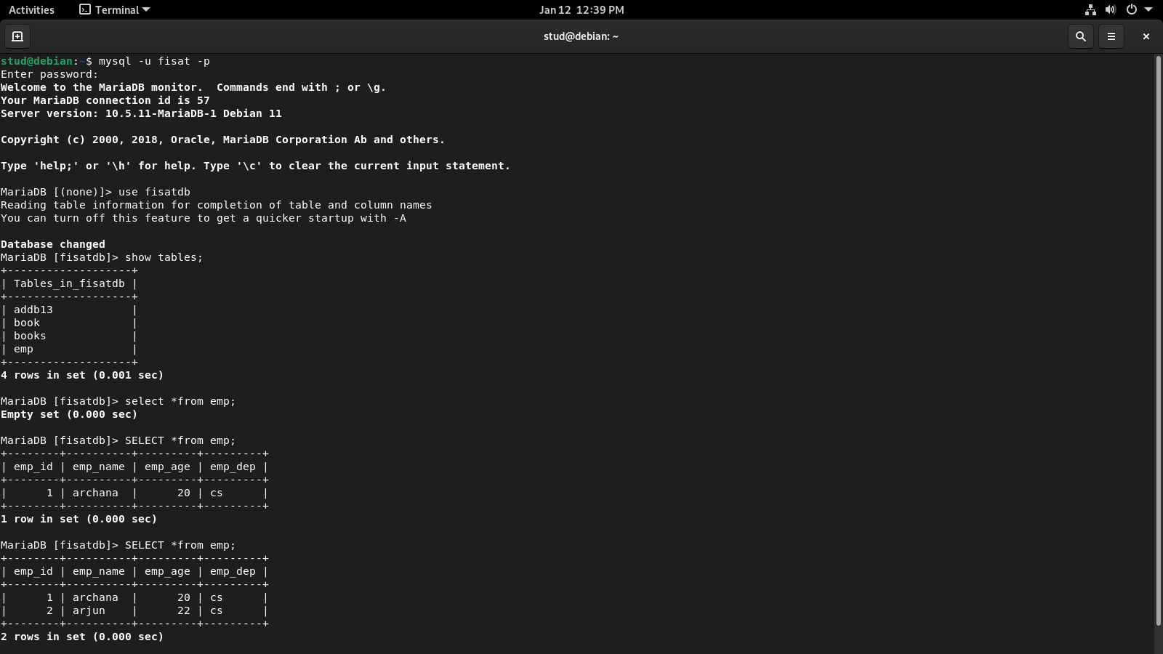

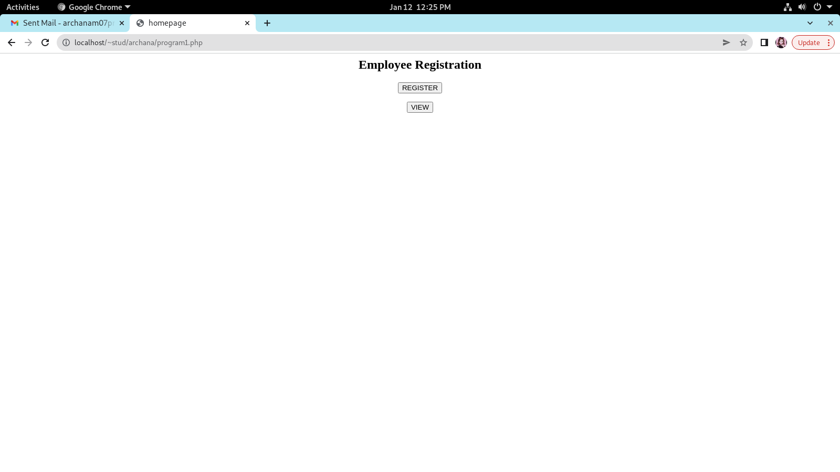

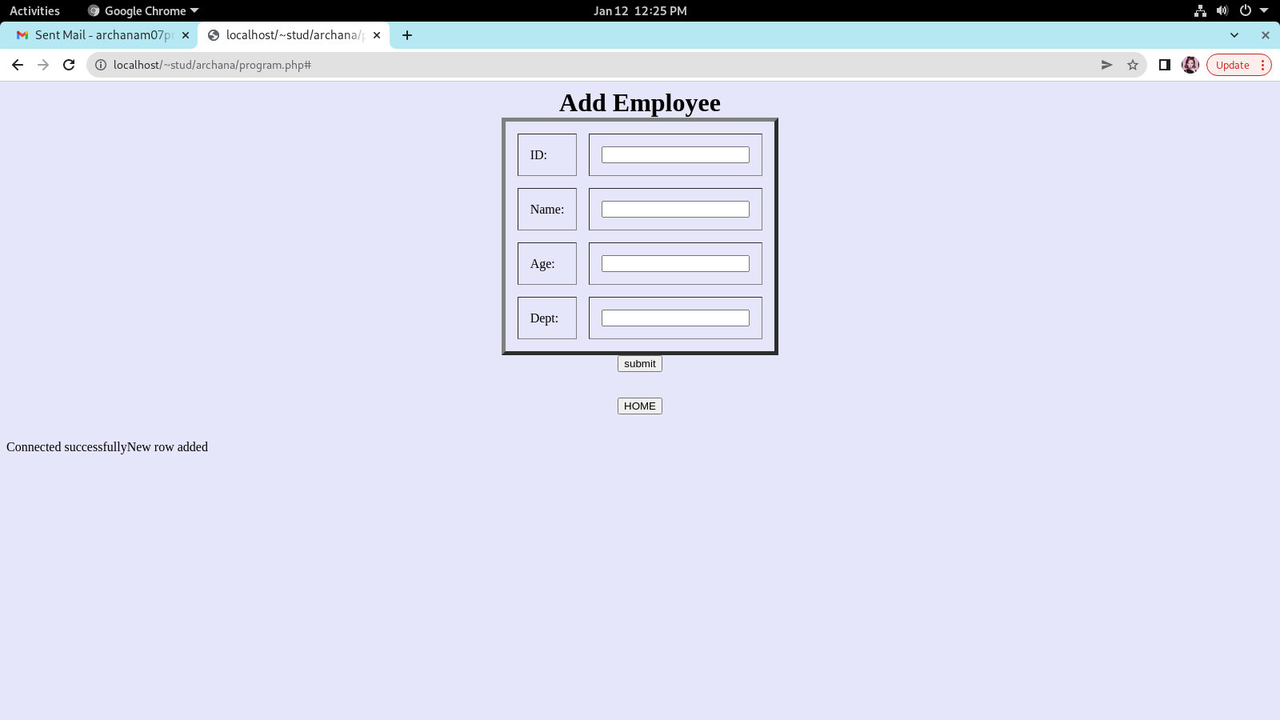

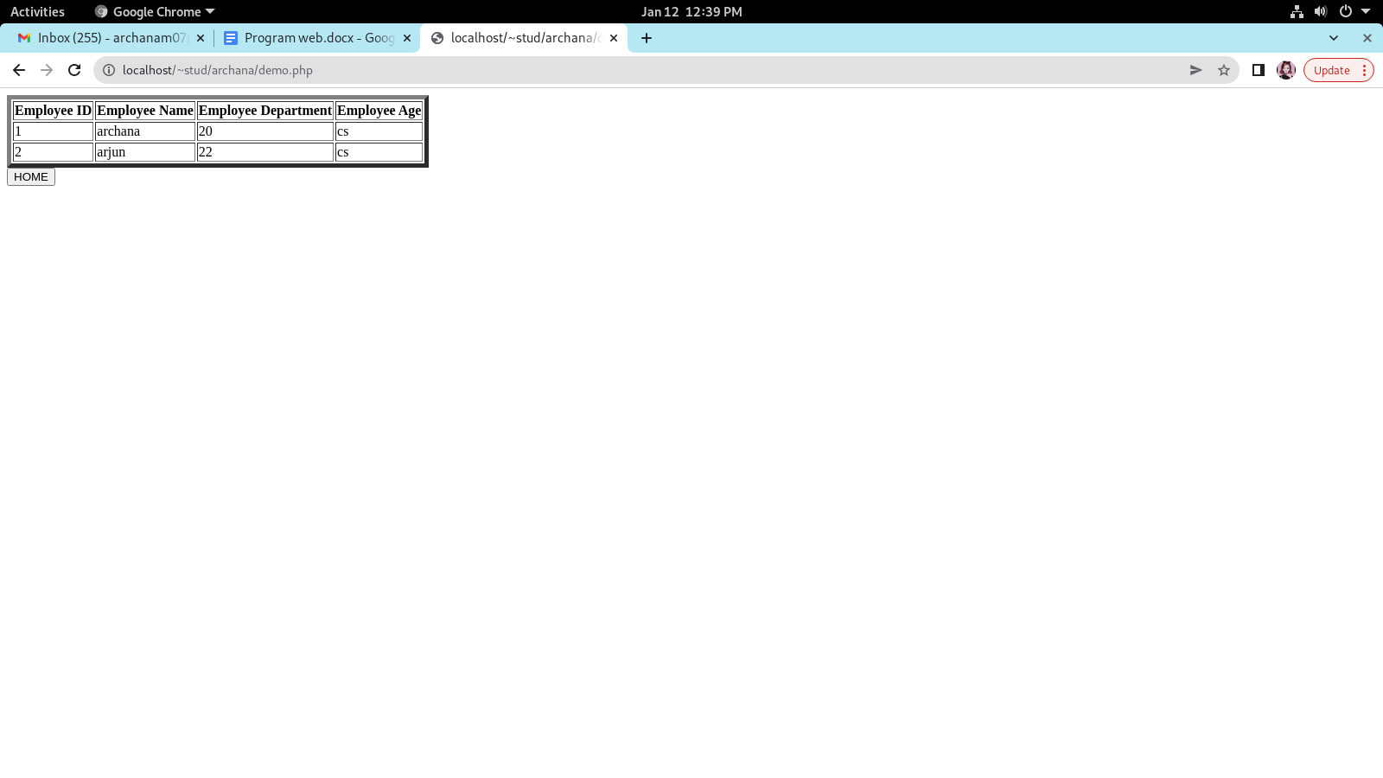

**AIM**

Using PHP and MySQL, develop a program to accept book information viz. Accession number, title, authors, edition and publisher from a web page and store the information in a database and to search for a book with the title specified by the user and to display the search results with proper headings.

**PROGRAM CODE**

search1.php

<?php  
$n3=$_REQUEST['author'];  
$con=new mysqli("localhost","fisat","fisat","fisatdb");  
if($con==false)  
{  
echo "Failed to connect";  
}  
?>  
<html><h1 align="center">BOOK DETAILS</h1></html>  
<?php  
$sql="SELECT * FROM booki where author='$n3'";  
if($result=$con->query($sql))  
{  
  
if($result->num_rows>0)  
{  
echo"<table border=1 align='center'>";  
echo " <tr> <th>Accession Number</th><th>Title</th> <th>Author</th> <th>Edition</th>  <th>Publisher</th>";  
  
while($row=$result->fetch_array())  
{  
echo"<tr>  
<td>$row[0]</td>  
<td>$row[1]</td>  
<td>$row[2]</td>  
<td>$row[3]</td>  
<td>$row[4]</td>  
  
</tr>";  
}  
$result->close();  
}  
}  
  
else  
{  
echo "\nCould not found ";  
  
}  
?>

search.php

<html>  
<head>  
<title>search</title>  
</head>  
<body>  
<form name="frm2" action="search1.php"method="POST">  
<center>  
<b><u>SEARCH BOOKS</u></b><br>  
Author name:<input type="text" name="author"><br>  
<input type="submit" name="Submit">  
</center>  
</form>  
</body>  
</html>

demo.php

<?php  
$con = new mysqli("localhost", "fisat", "fisat", "fisatdb");  
if ($con=== false) {  
die("ERROR: Could not connect. " . mysqli_connect_error());  
}  
$sql = "SELECT * FROM booki";  
if ($result = $con->query($sql))  
{ if ($result->num_rows > 0) {  
 ?>  
<html>  
<body>  
<table border=5>  
<tr>  
<th>access number</th><th>title</th><th>author</th><th>edition</th><th>publisher</th>  
</tr>  
<tr>  
<?php while($row = $result->fetch_array()) { ?>  
<td><?php echo $row[0]; ?> </td><td><?php echo $row[1];?></td><td><?php echo $row[2];?></td><td><?php echo $row[3];?></td><td><?php echo $row[4]; ?> </td>  
</tr>  
<?php  
} ?>  
</table>  
<form name=reg method=POST action= "program1.php">  
<button>HOME</button>  
</form>  
</html>  
<?php  
$result->close();  
} else {  
echo "No records matching your query were found.";  
}  
} else {  
echo "ERROR: Could not execute $sql. " . $con->error;  
} $con->close();  
?>

program1.php

<html>  
<head>  
<title>homepage</title>  
</head>  
<body align="center">  
<h2>BOOKS</h2>  
<form name=registation method="POST" action="program.php">  
<button>REGISTER</button>  
</form>  
<form name=reg method="POST" action="demo.php">  
<button>VIEW</button>  
</form>  
<form name=search method="POST" action="search1.html">  
<button>SEARCH</button>  
</form>  
</body>  
</html>

program.php

<html>  
<head>  
<title>  
</title>  
</head>  
<body bgcolor="lavender">  
<center>  
<h1> Book Information</h>  
<form name="myform" action="#" method="POST">  
<table border="5" cellspacing="15" cellpadding="15">  
<tr>  
<td>access number:</td>  
<td><input type="number" name="acc_no"></td>  
</tr>  
<tr>  
<td>Title:</td>  
<td><input type="text" name="title"></td>  
</tr>  
<tr>  
<td>Author:</td>  
<td><input type="text" name="author"></td>  
</tr>  
<tr>  
<td>Edition:</td>  
<td><input type="text" name="edition"></td>  
</tr>  
<tr>  
<td>Publisher:</td>  
<td><input type="text" name="publisher"></td>  
</tr>  
</table>  
<input type="submit" value="submit" name="submit">  
</form>  
<form name=reg method=POST action= "program1.php">  
<button>HOME</button>  
</form>  
</center>  
</body>  
</html>  
<?php error_reporting(0); ?>  
<?php  
$n1 = $_POST["acc_no"];  
$n2 = $_POST["title"];  
$n3 = $_POST["author"];  
$n4 = $_POST["edition"];  
$n5 = $_POST["publisher"];  
if (isset($_POST["submit"]))  
{  
$servername = "localhost";  
$username = "fisat";  
$password = "fisat";  
  
$conn = new mysqli($servername, $username, $password,"fisatdb");  
if ($conn->connect_error) {  
  die("Connection failed: " . $conn->connect_error);  
}  
echo "Connected successfully";  
$sql = "INSERT INTO booki(acc_no,title,author,edition,publisher ) VALUES($n1,'$n2','$n3','$n4','$n5')";  
if ($conn->query($sql) === true) {  
echo 'New row added.';  
} else {  
echo "ERROR: Could not execute query:";  
}  
$conn->close();  
}  
?>

**OUTPUT**



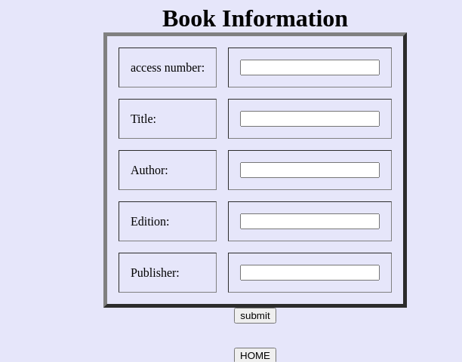

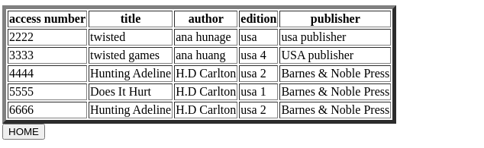



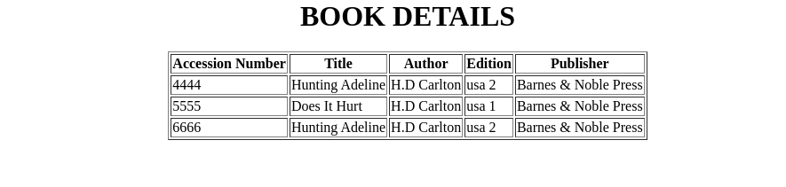

**AIM**

Using PHP and MySQL, develop a program to collect airline details and display all the airlines between a particular source and destination.

**PROGRAM CODE**

airlineinfo.html

<html>

<head>

<title>airline</title>

<style>

body{

background-color:Lavender;

text-align:center;

}

</style>

</head>

<body><u>AIRLINE INFORMATION SYSTEM</u><br><br>

<a href="add_airlineinfo.html">Add AIRLINE DETAILS</a><br><br>

<a href="search1.html">Search AIRLINE DETAILS</a><br>

</body>

</html>

add_airlineinfo.html

<html>

<head>

<style>

td{

padding:15px;

}

body{

background-color:Lavender;

text-align:center;

}

</style>

</head>

<form name="frm2" method="post" action="addair.php">

<h1>Enter Airline Details</h1>

<table border="1" align="center">

<tr>

<td>AIRLINE ID:</td>

<td><input type="number" name="id"></td>

</tr>

<tr>

<td>AIRLINE NAME:</td>

<td><input type="text" name="name"></td>

</tr>

<tr>

<td>DEPARTURE FROM:</td>

<td> <input type="text" name="depfrom"></td>

</tr>

<tr>

<td>DEPARTURE TIME:</td>

<td><input type="number" name="deptime"></td>

</tr>

<tr>

<td>AIRRIVAL TIME:</td>

<td><input type="number" name="aritime"></td>

</tr>

<tr>

<td>AIRRIVAL PLACE:</td>

<td><input type="text" name="ariplace"></td>

</tr>

<tr>

<td> <input type="submit" name="submit" value="submit"></td>

<td><input type="reset" name="reset" value="reset"></td></tr>

</table>

</form>

</body>

</html>

addair.php

<?php

$id=$_POST['id'];

$name=$_POST['name'];

$depfrom=$_POST['depfrom'];

$deptime=$_POST['deptime'];

$airtime=$_POST['aritime'];

$airplace=$_POST['ariplace'];

$con=new mysqli("localhost","fisat","fisat","fisatdb");

if($con==false)

{

echo "Failed to connect";

}

else

{

echo "connected";

}

$sql="INSERT INTO airline VALUES($id,'$name','$depfrom',$deptime,$airtime,'$airplace')";

if($con->query($sql))

{

echo "<BR>";

echo 'New row added';

}

else

{

echo "ERROR:could not execute query";

}

$con->close();

?>

search1.hml

<html>

<head>

<title>search</title>

<style>

td

{

padding:15px;

}

body

{

background-color:Lavender;

text-align:center;

}

</style>

</head>

<body>

<form name="frm2" action="searchl1.php"method="POST">

<center>

<table>

<b><u>SEARCH AIRLINE</u></b><br>

<tr>

<td>DEPARTURE FROM:</td><td><input type="text" name="txt"></td>

</tr>

<tr>

<td>ARIVAL PLACE:</td>

<td><input type="text" name="txt1"><br></td>

</tr>

<tr>

<td colspan="2"><center><input type="submit" name="Submit"></center></td>

</tr>

<table>

</form>

</body>

</html>

searchl1.php

<?php

$depfrom=$_POST['txt'];

$ariplace=$_POST['txt1'];

$con=new mysqli("localhost","fisat","fisat","fisatdb");

if($con==false)

{

echo "Failed to connect";

}

else

{

echo "connected\n";

}

$sql="select * from airline where dept_from='$depfrom' and air_place='$ariplace' ";

if($result=$con->query($sql))

{

if($result->num_rows>0)

{

?>

<h1> <center>Airline Details</center></h1>

<table align="center" border="1">

<tr>

<th>No.</th>

<th>Airline Name</th>

<th>Departure From</th>

<th>Departure Time</th>

<th>Arrival From</th>

<th>Arrival Time</th>

</tr>

<?php

while($row = $result->fetch_array())

{

?>

<tr>

<td><?php echo $row[0];?></td>

<td><?php echo $row[1]; ?></td>

<td><?php echo $row[2]; ?></td>

<td><?php echo $row[3];?></td>

<td><?php echo $row[5];?></td>

<td><?php echo $row[4]; ?></td>

</tr>

<?php

}

?>

</table>

<?php

$result->close();

}

else

{

echo "\nCould not found the airline";

}

}

else

{

echo "\nError:could not connect";

}

$con->close();

?>

**OUTPUT**



