# My picture one title

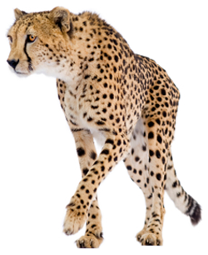

* Picture one bullet section