# My picture one title

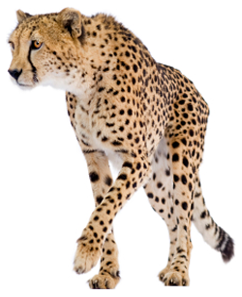

* Picture bullet section

# My picture two title



* Picture bullet section