# My picture one title

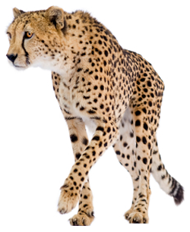

* Picture one bullet section

# My picture two title



* Picture two bullet section