**Problem Statement**: There were approximately 5000 coloured images of animals in 512 by 512 pixels. The problem was to display ‘n’ number of most similar photo of an image from this dataset.

**Solution**:

I made the use of a convolutional auto-encoder, to do the above task.

**Auto-encoder**: Auto encoder is used to reduce the dimensionality of a given input, the reduced dimensionality is called the **code,** the size of the input image provided to the auto-encoder was 160x160x3=76800, the dimensions of the code layer was **150**, this layer consists of all the relevant details of the input image.

**Cosine-Similarity**: I then used Cosine Similarity concept to find the cosine value of each image with every other image, and then arranged them in a descending order.

The higher the value of cosine the more the similarity.

**Clustering:** I used K-Means Clustering algorithm, by applying it on the image embedding, and then clustered the images.

COSINE SIMILARITY:

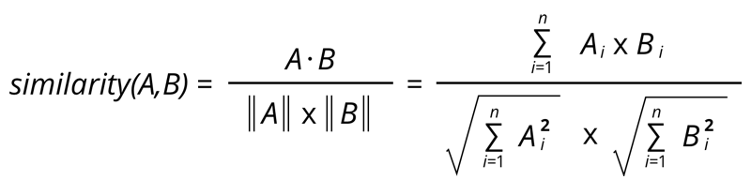

**ARCHITECHTURE OF THE AUTO-ENCODER:**

Model: "AE"

_________________________________________________________________

Layer (type) Output Shape Param #

=================================================================

input_1 (InputLayer) [(None, 160, 160, 3)] 0

_________________________________________________________________

conv2d (Conv2D) (None, 160, 160, 32) 896

_________________________________________________________________

max_pooling2d (MaxPooling2D) (None, 80, 80, 32) 0

_________________________________________________________________

conv2d_1 (Conv2D) (None, 80, 80, 16) 4624

_________________________________________________________________

max_pooling2d_1 (MaxPooling2 (None, 40, 40, 16) 0

_________________________________________________________________

conv2d_2 (Conv2D) (None, 40, 40, 8) 1160

_________________________________________________________________

max_pooling2d_2 (MaxPooling2 (None, 20, 20, 8) 0

_________________________________________________________________

flatten (Flatten) (None, 3200) 0

_________________________________________________________________

dense (Dense) (None, 150) 480150

_________________________________________________________________

batch_normalization (BatchNo (None, 150) 600

_________________________________________________________________

dense_1 (Dense) (None, 3200) 483200

_________________________________________________________________

batch_normalization_1 (Batch (None, 3200) 12800

_________________________________________________________________

reshape (Reshape) (None, 20, 20, 8) 0

_________________________________________________________________

conv2d_3 (Conv2D) (None, 20, 20, 8) 584

_________________________________________________________________

up_sampling2d (UpSampling2D) (None, 40, 40, 8) 0

_________________________________________________________________

conv2d_4 (Conv2D) (None, 40, 40, 16) 1168

_________________________________________________________________

up_sampling2d_1 (UpSampling2 (None, 80, 80, 16) 0

_________________________________________________________________

conv2d_5 (Conv2D) (None, 80, 80, 32) 4640

_________________________________________________________________

up_sampling2d_2 (UpSampling2 (None, 160, 160, 32) 0

_________________________________________________________________

conv2d_6 (Conv2D) (None, 160, 160, 3) 867

=================================================================

Total params: 990,689

Trainable params: 983,989

Non-trainable params: 6,700

Project by-

**Anuj Balodi**