
A SKIRMISH GAME OF THE KINGDOM OF WESTMARCH
Court of Blades
and Banners
Muster Warriors, Wizards and Healers under the named Knights and Paragons of Westmarch, and fight Amtgard's battlegames on the tabletop, down to the lost limb and the walk back from Nirvana.
Playtest rules · 2 players · 500 points · 6 rounds, about 2 hours

Contents

To refresh the page numbers in Word, right-click the contents and choose Update Field.

I Quick Start
Play your first battle in about an hour, using only troops, a single scenario and the core loop. Add Knights, magic and gear once the basics feel familiar.

What you need
- 9–12 miniatures per player on 25–32mm round bases, plus 40mm bases for characters later.
- A handful of six-sided dice (D6), a tape measure in inches, and a 48" × 48" table with a few pieces of terrain.
- A few tokens or a spare die per model to track lost limbs and lives.

Your first battle in four steps
- Take a starter warband. Each player uses one of the two starter musters below (about 140 points each). No characters, no spells, no gear yet.
- Set up a Field Battle. Place 4 pieces of terrain. Roll off; the winner picks a table edge. Take turns placing one model at a time within 8" of your own edge.
- Play 4 rounds. Each round: roll for priority, then take turns activating one model at a time in the Move, Shoot and Fight phases.
- Count kill points. Score 1 kill point every time you slay an enemy model, including models that come back from Nirvana and fall again. Most kill points wins.

Starter musters

The Wyvern's Spur Line
Models | Loadout | Pts
4 Warriors | Single Short + Shield, light armor (5+ save) | 64
3 Archers | Bow, light armor (6+ save) | 42
2 Barbarians | Great Weapon, light armor (6+ save) | 34
9 models |  | 140

The Siar Geata Raiders
Models | Loadout | Pts
3 Warriors | Two-Handed Long, heavy armor (5+ save) | 51
2 Barbarians | Dual Short, light armor (6+ save) | 32
2 Archers | Bow, light armor (6+ save) | 28
2 Scouts | Javelins, light armor (6+ save) | 28
9 models |  | 139

The core loop
Phase | What happens
1. Priority | Both roll a D6. High roll activates first this round.
2. Move | Take turns moving one model up to its M. Touching an enemy is a charge.
3. Shoot | Take turns shooting with models that aren't in combat and didn't charge.
4. Fight | Resolve each combat. Chargers strike first, then survivors strike back.
5. End | Slain models with lives left will return next Move phase.

Every attack in one breath
Roll a D6 for each Attack on the weapon and hit on its Hit value. Roll to wound by comparing weapon Strength to target Toughness. The target saves on its armor, worsened by the weapon's AP. Each wound that gets through takes a limb (a D6: 1–3 arm, 4–6 leg), unless the wound roll was a natural 6 or the weapon has Damage 2, in which case it is Lethal and the troop falls at once. Most troops have 2 W, so a second limb hit also fells them.

WHEN YOU'RE READY FOR MORE
Add one Paragon to each side (Chapter XIII), then magic (Chapter X), then Knights (Chapter XII) and the full 500-point muster (Chapter III). Roll on the scenario table (Chapter XIV) once you've played a Field Battle or two.

II The Basics
Models, profiles, dice and measuring: the conventions every other chapter relies on.

Models and warbands
Each player commands a warband. Its rank and file are troops, drawn from the twelve Amtgard classes. They are led by characters: Paragons, the masters of a single class, and Knights, the highest honors of the realm. Every character in this game is a named player from the Kingdom of Westmarch.
Mount troops on 25–32mm round bases and characters on 40mm bases. Distances are always measured between the closest points of two bases.

The profile
Every model has six characteristics. How many attacks it makes, what it needs to hit and how hard it strikes all come from its weapon, not from its profile.
Stat | Name | What it does
Pts | Points | What the model costs to muster
M | Movement | How far it moves each Move phase, in inches
T | Toughness | Compared against weapon Strength when rolling to wound
W | Wounds | How much punishment it takes before it is slain; each point is a limb or part of one
Ld | Leadership | Its nerve, used for morale checks and Leadership tests
Sv | Armor save | Bought as armor; the roll needed to shrug off a wound

Dice
- D6 is a six-sided die. D3 is a D6 halved, rounding up. 2D6 is two dice added together. Scenarios are chosen with a D8.
- A value written as 4+ means the roll must equal or beat 4.
- Re-rolls: a die can be re-rolled only once. Re-roll before applying modifiers.
- Natural rolls: a natural roll is what the die shows before modifiers. A natural 6 always hits and a natural 1 always misses.
- Roll-offs: both players roll a D6 and the higher roll wins. Re-roll ties.

Measuring
Players may measure any distance at any time. Moves, ranges and auras are all measured in inches from base edge to base edge. A model is within a distance if any part of its base is.

FROM THE FIELD
Everything in this book borrows from real Amtgard play: limbs before lives, the walk to Nirvana, class abilities, Knights of the five orders and the battlegames fought every week in the parks of Westmarch.

III Mustering a Warband
Before every battle, each player musters a warband and writes it on a roster. Then both players run the pre-battle sequence together.

The muster
- Agree the size. A standard game is 500 points per side. For a shorter game, play 300. Up to 30% of your points (150 in a standard game) may be spent on characters, including their upgrades.
- Choose your characters. Pick named Knights and Paragons from Chapters XII and XIII. You may take each Knight order only once, and each named person only once.
- Equip your characters. Choose each character's weapon and armor (free for characters), then spend their upgrade budget on field abilities and gear: up to 25 points for a Paragon, 50 for a Knight. Multi-belted Knights may buy abilities from their other orders here.
- Muster your troops. Spend the rest of your points on troops (Chapter IX). Pay for each troop's weapon and armor, and give any troop one Potion if you like.
- Fill the spellbooks. Every Healer, Druid and Wizard buys spells: 3 Spell Points for troops, 6 for Paragons. Spellbooks cost no army points.
- Name your General. Choose one model to lead. A troop General lasts longest (6 lives); a Knight General hits hardest (4 lives). Losing the General for good tests the whole warband's nerve.
- Write the roster. Record each model, its loadout, its points and its lives. Show your opponent the finished roster before the pre-battle sequence.

Muster limits
Limit | Standard (500) | Skirmish (300)
Characters, with upgrades | Up to 150 pts | Up to 90 pts
Knights of the same order | 1 | 1
Each named Knight or Paragon | 1 | 1
Each Relic | 1 | 1
Potions per troop | 1 | 1
Typical warband | About 20 troops and 2 characters | About 12 troops and 1 character

Example roster: The Aegir's Hall Muster (500 points)
Model | Loadout and upgrades | Pts
Characters | 138 of 150
Sir Zyax Blackraven (Knight of the Sword) | Dual Short, plate · Masterwork Weapon, Healing Potion | 83
Porkins, General (Paragon Healer) | Single Short + Shield, heavy armor · Deep Reserves | 55
Troops | 362
8 Warriors | Single Short + Shield, heavy armor | 136
3 Barbarians | Great Weapon, light armor | 51
4 Archers | Bow, light armor | 56
2 Scouts | Javelins, light armor | 28
2 Healers | Single Short + Shield, heavy armor | 38
1 Paladin | Two-Handed Long, heavy armor, Potion of Stoneskin | 24
1 Wizard | Single Short, no armor | 15
1 Monk | Spear (staff), no armor | 14
24 models |  | 500

The pre-battle sequence
- Choose a scenario. Roll a D8 on the scenario table (Chapter XIV), or agree on one.
- Set the field. Take turns placing 4–6 pieces of terrain, each more than 3" from the others, unless the scenario says otherwise.
- Pick edges. Roll off. The winner chooses a table edge; the other player takes the opposite edge.
- Deploy. Starting with the roll-off winner, take turns placing one model at a time within 8" of your own edge. Models held in reserve (such as Ambush) are set aside.
- Before the first round. Resolve pre-game abilities: Forward Scout moves, Masterwork upgrades and anything else marked "before the game". Then begin round 1.

IV The Battle Round
A game lasts 6 rounds. Players take turns activating one model at a time inside each phase, so neither army acts all at once.
Phase | Summary
1. Priority | Roll a D6 each. High roll has priority.
2. Move | Alternate moves, charges and fall-backs.
3. Shoot | Alternate shooting and spellcasting.
4. Fight | Alternate choosing combats to resolve.
5. End | Score, test morale, tidy effects.

Priority
Both players roll a D6. The higher roll has priority for the round and activates first in every phase. On a tie, priority passes to the player who did not have it last round. In round 1, roll off.

Activations
- In the Move, Shoot and Fight phases, players alternate, starting with the priority player. Each activation is one model taking its action for that phase.
- When one player has no models left to activate, the other activates the rest of theirs one after another.
- "Its next activation" means the model's next action in any phase.

Heroic Actions
At the start of the Move, Shoot or Fight phase, a character may declare a Heroic Action. That character and up to 3 friendly troops within 3" act first in that phase, before the priority player. Knights have 2 Heroic Actions per game and Paragons have 1. If both players declare one in the same phase, roll off to see whose heroes go first.

The Move phase
- Moving: a model may move up to its M in any direction. It can't move through other models or within 1" of an enemy unless it is charging.
- Charging: a model that can see an enemy within its M may move into base contact with it. It has charged this round. A model with a lost leg can't charge, and no model can charge across an obstacle.
- Engaged: a model in base contact with an enemy is engaged. Engaged models may only stay where they are or fall back.
- Falling back: an engaged model may move up to its M directly away from every enemy it touches. It can't shoot, cast or charge for the rest of the round.
- Returning models: models coming back from Nirvana are placed at the start of the phase, before the first activation (Chapter VI).

The Shoot phase
- Each model that is not engaged and did not charge or fall back may make one ranged attack or cast one spell.
- The target must be within the weapon's range and visible to the shooter (Chapter VII). Engaged enemies can't be targeted by ranged attacks.
- Casting follows the magic rules in Chapter X.

The Fight phase
- A combat is a group of engaged models touching one another. The priority player picks the first combat to resolve, then players alternate.
- Inside a combat, models that charged this round strike first. Then the surviving models of the other side strike back. If no one charged, the priority player's models strike first.
- Each model attacks with its melee weapon. Split its Attacks among enemies it touches, or among enemies within 2" if its weapon has Reach, before rolling.
- A model slain before it strikes does not strike.

The End phase
Score Victory Points as the scenario says, take any morale check caused this round (Chapter VI), and end effects that last "until the end of the round".

V Attacks and Wounds
Ranged and melee attacks use the same five steps. A wound takes a limb before it takes a life.

Making an attack
- Roll to hit. Roll one D6 per Attack on the weapon. Each roll that equals or beats the weapon's Hit value is a hit.
- Roll to wound. For each hit, compare the weapon's Strength with the target's Toughness on the wound chart. Set aside any natural 6s.
- Armor save. The target rolls its Sv for each wound, worsened by the weapon's AP. A roll of 1 always fails.
- Ward save. If the armor save fails, a model with a ward rolls it. AP never affects wards.
- Limb or Lethal. Each wound that gets through is a limb hit or a Lethal hit.

Wound chart
Weapon S vs target T | Wound on
S is double T or more | 2+
S higher than T | 3+
S equal to T | 4+
S lower than T | 5+
S half of T or less | 6+

Hit modifiers
A natural 6 always hits and a natural 1 always misses. All penalties to hit together (cover, a failed morale check, Cloak of Shadows, Suppression Arrow and so on) can never total worse than -2.

Limb and Lethal hits
As in Amtgard, most blows take an arm or a leg. Only a natural 6 to wound, or a heavy weapon, strikes the body.
Result | When | Effect
Limb hit | Any wound that is not Lethal | Lose 1 W, then roll a D6: 1–3 arm, 4–6 leg
Arm lost | Limb roll of 1–3 | No shield and no two-handed weapons (Two-Handed Long, Great Weapon, Spear, Bow). Other weapons get -1 A (minimum 1). With no usable weapon, fight as a Single Short with A1
Leg lost | Limb roll of 4–6 | M becomes 2" and the model can't charge
Lethal hit | Natural 6 to wound, or any wound from a D2+ weapon | A troop is slain outright. A character loses W equal to the weapon's D + 1

- A hit to a limb that is already lost costs the W but has no extra effect.
- Some rules make wound rolls of 5+ or 4+ Lethal. These never stack: use the best one.
- A model is slain when its W reaches 0 and goes to Nirvana (Chapter VI).
- Healing: each W restored also restores one lost limb, chosen by the healing player.
- Mortal wounds skip armor and ward saves and count as limb hits, unless the rule calls them Lethal.

EXAMPLE
A Barbarian with a Great Weapon (A2, Hit 4+, S5, AP -2, D2) strikes a Warrior in heavy armor with a shield (4+ save). It rolls a 4 and a 2: one hit. S5 against T3 wounds on 3+, and it rolls a 3. The Warrior's save becomes 6+ after AP -2 and it rolls a 5. The wound gets through, and because the Great Weapon has D2 it is Lethal. The Warrior goes to Nirvana.

VI Lives, Generals and Morale
Every model has several lives. The slain walk to Nirvana and return to the fight, until they run out.
Model | Revives | Lives in total
Knight | 3 | 4
Paragon | 4 | 5
Troop | 5 | 6

Nirvana and revives
- Nirvana: a slain model is removed from the table and set aside in its warband's Nirvana. Mark where it fell.
- Returning: at the start of the next Move phase, each model in Nirvana with revives left spends one and returns within 3" of its own table edge with full W and all limbs. It may move that round but can't shoot or cast.
- Out of lives: a model slain with no revives left is out of the game.
- Resurrection: Resurrect, the Resurrection Scroll, Rekindle and similar effects target a friendly model slain this round. It returns where it fell, or within 1" of the model using the effect, and does not spend a revive.
- No revives: summoned or converted models (Summon Beast, Undead Minion) have none.
- Models in Nirvana don't count for Presence, Leadership or auras.
- Tracking: keep a die beside each character, and tally troop lives on the roster.

The General
During the muster, each player names one model as their General. It may be a Knight, a Paragon or a troop. A General uses the normal revives for its rank.

Morale
- Army morale check: when the General is out of lives, the warband takes a morale check in that round's End phase. Roll 2D6 against the highest Leadership among your models still on the table. The check passes if the roll is equal to or under that Leadership.
- Failed check: every model in the warband gets -1 to hit for the rest of the game. This counts toward the -2 limit on hit penalties.
- Leadership tests: every other Leadership test works the same way: roll 2D6 and pass on a roll equal to or under the model's Ld.

VII Terrain and Cover
Shooting into cover is -1 to hit. Cover never affects melee.

Line of sight
Check from the model's own point of view. A shooter must be able to see at least part of the target. Impassable terrain blocks line of sight completely.

Cover
- In cover: a target is in cover if it is inside area terrain, within 1" behind an obstacle that lies between it and the shooter, or partly hidden by terrain or other models.
- Effect: ranged attacks against a target in cover get -1 to hit. Spellballs get -1 to the cast roll instead.
- High ground: a shooter on a hill ignores cover from obstacles, but not from area terrain.

Terrain types
Terrain | Examples | Cover | Movement
Open ground | Fields, hills | No | Normal
Area terrain | Woods, ruins, tall grass | For models inside it | Normal
Obstacles | Walls, hedges, fences, barricades | For models within 1" behind it | Crossing costs 2"; can't charge across
Difficult ground | Rubble, bog, shallow water | No | Half M
Impassable | Cliffs, deep water, solid buildings | Blocks line of sight | Can't enter

Hills: a model that charges onto a hill from lower ground does not strike first that round.

VIII The Armory
The weapon you carry decides how often you strike, what you need to hit and how hard you land. Armor is bought piece by piece, in the manner of The Old World.

Weapons
Each model carries one weapon loadout. Troops pay the listed cost; Knights and Paragons take any loadout free.
Weapon | A | Hit | S | AP | D | Special | Cost
Single Short | 3 | 3+ | 3 | 0 | 1 | — | Free
Single Short + Shield | 2 | 3+ | 3 | 0 | 1 | Shield: +1 armor save | +2
Dual Short (florentine) | 4 | 4+ | 3 | 0 | 1 | — | +2
Two-Handed Long | 2 | 4+ | 4 | -1 | 1 | Reach 2" | +2
Great Weapon | 2 | 4+ | 5 | -2 | 2 | Shieldbreaker | +3
Spear | 2 | 4+ | 4 | 0 | 1 | Reach 2"; +1 to hit in a round it charges or is charged | +2
Flail | 3 | 4+ | 4 | 0 | 1 | Wrap | +3
Bow | 2 | 3+ | 3 | -1 | 1 | Range 24" | Archers only
Javelins | 1 | 4+ | 4 | -1 | 1 | Range 8" | +2

Weapon rules
- Reach 2": the model may strike enemies up to 2" away as well as those in base contact.
- Shieldbreaker: the target gets no shield bonus to its save.
- Wrap: a flail's chain wraps around shields, so the target gets no shield bonus.
- Damage 2: every wound from this weapon is Lethal (Chapter V).

Armor
Armor | Save | Cost
None | — | Free
Light | 6+ | +2
Heavy | 5+ | +3
Plate (characters only) | 4+ | Included
Shield | +1 | With the weapon

- A shield improves body armor by 1, or gives a 6+ save on its own. Heavy armor and a shield make a 4+ save.
- AP worsens the save: AP -2 turns a 4+ into a 6+.
- No armor save can be better than 2+.

Armor Damage
When a model wearing body armor fails an armor save, its armor becomes Damaged: worsen its save by 1 for the rest of the game (heavy 5+ becomes 6+; light 6+ becomes no save). Shields are never Damaged. The Warrior's Restore Armor ability, the Mend spell and an Armorer's Kit restore Damaged armor.

IX Troops of the Realm
Twelve classes make up the rank and file. Each costs 10–15 points before gear and brings one class ability.
Base cost includes a Single Short and no armor. Add weapon and armor costs from Chapter VIII. Sv comes from the armor bought.
Troop | Pts | M | T | W | Ld | Weapons | Armor | Ability
Warrior | 12 | 5" | 3 | 2 | 6 | Any melee | Light, Heavy | Restore Armor
Barbarian | 12 | 6" | 3 | 3 | 6 | Any melee | Light | Cleave
Archer | 12 | 5" | 3 | 2 | 6 | Bow (included), Single Short | Light | Special Arrows
Scout | 10 | 7" | 3 | 2 | 6 | Short weapons, Javelins | Light | Forward Scout
Assassin | 13 | 6" | 3 | 2 | 6 | Single Short, Dual Short, Javelins | Light | Poisoned Blade
Monk | 12 | 6" | 3 | 2 | 7 | Single Short, Spear (staff) | None | Deflect Missiles
Bard | 13 | 5" | 3 | 2 | 7 | Single Short, Short + Shield | Light | Inspire
Healer | 14 | 5" | 3 | 2 | 7 | Single Short, Short + Shield | Light, Heavy | Heal · Spellcaster
Druid | 14 | 5" | 3 | 2 | 7 | Single Short, Spear | Light | Spellcaster
Wizard | 15 | 5" | 3 | 2 | 7 | Single Short | None | Spellcaster
Paladin | 15 | 5" | 3 | 2 | 8 | Any melee | Light, Heavy | Stalwart
Anti-Paladin | 15 | 5" | 3 | 2 | 7 | Any melee | Light, Heavy | Steal Life

Class abilities
- Restore Armor (Warrior): When this model slays an enemy, its Damaged armor is restored.
- Cleave (Barbarian): Melee wound rolls of 5+ are Lethal.
- Special Arrows (Archer): Once per round when shooting, choose one. Pinning Arrow: a model hit can't move in its next activation. Phase Arrow: the hit ignores armor saves (wards still apply).
- Forward Scout (Scout): After deployment, move up to 6", but not within 6" of an enemy.
- Poisoned Blade (Assassin): Melee wound rolls of 5+ are Lethal.
- Deflect Missiles (Monk): 4+ ward against ranged attacks and spellballs.
- Inspire (Bard): Friendly models within 6" get +1 Leadership and re-roll failed Leadership tests.
- Heal · Spellcaster (Healer): Heal: once per round, restore 1 W (and one lost limb) to a friendly model within 1". Spellcaster: casts from the Divine list.
- Spellcaster (Druid): Casts from the Nature list.
- Spellcaster (Wizard): Casts from the Arcane list.
- Stalwart (Paladin): 6+ ward.
- Steal Life (Anti-Paladin): When this model slays an enemy in melee, it regains 1 W (up to its starting W).

COSTING A TROOP
A Warrior with a Great Weapon and heavy armor costs 12 + 3 + 3 = 18 points.

X Magic
Every caster uses one system: buy a spellbook before the battle, then roll one die to cast.
Healers, Druids and Wizards, and their Paragons, are Spellcasters, each with its own list.
- Spellbook. During the muster, a troop caster spends 3 Spell Points (SP) and a Paragon caster spends 6. Each spell bought gives one use per game; buy a spell again for more uses.
- Casting. In its Shoot activation, instead of attacking, a caster may cast one spell at a target in range and line of sight. Touch means within 1".
- Cast roll. Roll a D6. Equal or beat the Cast value and the spell works, spending the use. Fail and nothing happens, but the use is kept. A natural 1 is a fizzle: nothing happens and the use is spent.
- Spellballs. A successful cast counts as a hit. Roll to wound and save as normal with the spell's profile.
- Engaged casters. An engaged caster may cast only Touch or Self spells, in its Fight activation instead of attacking.

Arcane (Wizard)
Spell | SP | Cast | Range | Effect
Lightning Bolt | 1 | 3+ | 18" | Spellball: S5, AP -2, D2
Iceball | 1 | 3+ | 12" | Target is Frozen until the end of the next round: it can't activate, attack, be attacked or be targeted
Fireball | 2 | 4+ | 12" | Spellball against the target and every other model within 2" of it: S4, AP -1, D1
Teleport | 2 | 4+ | Self | Place the caster anywhere within 12", not within 1" of an enemy

Nature (Druid)
Spell | SP | Cast | Range | Effect
Entangle | 1 | 3+ | 12" | Target can't move or fall back in its next activation
Heat Weapon | 1 | 3+ | 12" | Target's melee weapon has A1 until the end of the next round
Mend | 1 | 2+ | Touch | Restore the target's Damaged armor
Stoneskin | 2 | 4+ | Touch | Target ignores the next wound it would lose

Divine (Healer)
Spell | SP | Cast | Range | Effect
Greater Heal | 1 | 2+ | Touch | Restore D3 W
Protection from Magic | 1 | 3+ | Touch | Target gets a 3+ ward against spells for the rest of the game
Sanctuary | 1 | 3+ | Touch | Until the target next activates, it can't attack or be attacked in melee
Resurrect | 3 | 4+ | Touch | A friendly troop slain this round returns within 1" of the caster with 1 W, spending no revive

XI Gear
Weapons, Armor, Relics and Potions. Characters buy gear from their upgrade budget; any troop may carry one Potion.
- A model may take each piece of gear only once.
- Relics are unique: one of each per warband.
- Weapon gear upgrades the model's existing weapon. Armor gear stacks with the armor it already wears.
- Each Potion is used once, in the drinker's activation, on itself or a friendly model within 1".

Weapons
Weapon | Pts | Effect
Masterwork Weapon | 5 | Re-roll hit rolls of 1
Shieldsplitter | 5 | Melee weapon gains Shieldbreaker
Flameblade | 10 | Melee weapon gets +1 S; wound rolls of 6 are AP -3
Dragonbone Bow | 10 | Bow only: Range 30" and S4
Blade of the Realm | 15 | Melee weapon gets an extra -1 AP, and wound rolls of 5+ are Lethal

Armor
Armor | Pts | Effect
Armorer's Kit | 5 | Once per game, restore Damaged armor on this model or a friendly model within 1"
Reinforced Armor | 5 | The first failed save doesn't Damage this model's armor
Cloak of Shadows | 10 | -1 to hit this model with ranged attacks and spellballs
Enchanted Shield | 10 | Shield also gives a 6+ ward, or improves an existing ward by 1
Dragonscale Plate | 15 | Characters only: plate gives a 3+ save instead of 4+

Relics
Relic | Pts | Effect
Horn of Rally | 5 | Once per game, friendly models within 12" automatically pass Leadership tests this round
Amulet of Warding | 10 | The bearer gets a 4+ ward against spells
Warband Banner | 10 | Friendly models within 6" of the bearer re-roll failed Leadership tests. If the bearer is slain, the warband gets -1 Leadership. A troop may carry it
Resurrection Scroll | 15 | Once per game, a friendly troop slain this round returns within 1" with 1 W, spending no revive

Potions
Potion | Pts | Effect
Antidote | 2 | Remove one spell effect (Frozen, Entangled, Heat Weapon and so on)
Potion of Swiftness | 2 | +3" M this activation
Healing Potion | 3 | Restore D3 W
Potion of Strength | 3 | +1 S on melee weapons until the end of the round
Potion of Stoneskin | 4 | Ignore the next wound it would lose

XII Knights of Westmarch
Knights are the champions of the realm: 75 points each, with an upgrade budget of 50. Every Knight on the field is a named Knight of Westmarch.

Heroic
Knights and Paragons are Heroic: +1 Attack with any weapon, the weapon's Hit value improves by 1 (best 2+), and they take weapons and armor at no cost.

The five orders

Knight of the Sword
Duelist · Plate
Pts | M | T | W | Ld | Sv | Ward
75 | 6" | 4 | 6 | 9 | 4+ | 5+

- Bladesong: With a Single Short, Dual Short or Two-Handed Long weapon, gain an extra +1 Attack, and wound rolls of 5+ are Lethal.
- Master of the Blade: Each enemy melee hit roll that fails against this model deals 1 mortal wound to the attacker.
- Sworn Duel: At the start of combat, name one engaged enemy. The two may only attack each other this round, and the Knight re-rolls wound rolls against that model.

Battle Knight
Line anchor · Plate and shield
Pts | M | T | W | Ld | Sv | Ward
75 | 5" | 5 | 7 | 9 | 3+ | —

- Battle Aura (6"): At the start of each round, choose a stance. Shieldwall: friendly models within 6" get +1 Toughness. Warcry: friendly models within 6" get +1 Strength on melee weapons.
- Anvil of the Line: An enemy must pass a Leadership test to fall back from combat with this model.

Knight of the Crown
Commander · Plate
Pts | M | T | W | Ld | Sv | Ward
75 | 5" | 4 | 6 | 10 | 4+ | —

- Voice of the Realm: Friendly models within 9" use this Knight's Leadership.
- Royal Command: After this Knight activates, one friendly model within 9" may activate immediately.
- Decree: Once per game: for one round, all friendly models re-roll failed hit rolls.

Knight of the Flame
Protector · Plate
Pts | M | T | W | Ld | Sv | Ward
75 | 5" | 4 | 6 | 9 | 4+ | —

- Oath of Service: When a friendly model within 3" would lose a wound, roll a D6. On a 2+, this Knight takes it instead as a mortal wound.
- Eternal Flame (6"): Friendly models within 6" ignore a lost wound on a roll of 6.
- Rekindle: Once per game: return one friendly troop slain this round within 3" of this Knight, with 1 W. It spends no revive.

Knight of the Serpent
Artisan and trickster · Heavy armor
Pts | M | T | W | Ld | Sv | Ward
75 | 6" | 4 | 5 | 9 | 5+ | 5+

- Masterwork: Before the game, choose up to 3 friendly troops. Each upgrades its weapon with +1 AP or re-rolls wound rolls of 1.
- Serpent's Guile: Once per round, force one enemy within 12" to re-roll a successful hit roll or save.
- Tapestry of Glory: Friendly models within 6" get +1 Leadership.

Named Knights
- Fielded order: a named Knight uses the profile and abilities of the order they are listed under.
- Unique: each named Knight may appear once per warband, and the one-Knight-per-order limit still applies.
- Multi-belted: for +10 points per other order they hold, a Knight gains one ability from each of those orders. Sir Monkey, listed under Sword and belted in Crown, Flame and Serpent, could cost up to 105 points.
- Field abilities: a Knight buys field abilities from the list of any class they are a Paragon of. A Knight with no Paragonship picks one class list.
The roster holds 30 Knights: the most senior Knights of each order by belting date, the Knights who also hold Paragonships, Dame Wendy the Wench of the Serpent, and Sir Kismet, the Privateer Caballero Augustus Rodriguez, the Navigator, a guest Knight of the Flame from the Kingdom of the Nine Blades. Source: ORK Knights list, Kingdom of Westmarch.
Order | Knight | Park | Belted
Sword | Sir Zyax Blackraven | Aegir's Hall | 1985
Sword | Ashe Arala | Ethereal Hollow | 1999
Sword | Sir Monkey | Wavehaven | 2011
Sword | Deimos | Seven Sleeping Dragons | 2018
Battle | Aust Valanthe | Quixotic Valley | 2025
Crown | Castings Uhn Grimlock Von Cream Puff | Wyvern's Spur | 2001
Crown | Downfall | Siar Geata | 2001
Crown | Scoot | Siar Geata | 2021
Crown | Azus | Wyvern's Spur | 2022
Crown | thistledown notagnome | Wyvern's Spur | 2024
Flame | Baronet Sir Blackthorn | Crimson Wood | 1999
Flame | Sir Furball | Siar Geata | 2014
Flame | Leah (SSD) | Seven Sleeping Dragons | 2016
Flame | Fiks von Grunwald | Wavehaven | 2018
Flame | Sir Kismet, the Privateer Caballero Augustus Rodriguez, the Navigator | Felfrost, Kingdom of the Nine Blades (guest) | 2021
Flame | Mikezilla Darkwater | Wavehaven | 2022
Flame | Bacchus Springjaw | Clockwork Spires | 2024
Flame | Clenawe | Thor's Refuge | 2025
Flame | Evil Randy | Siar Geata | 2026
Flame | Milan of Amber | Dragonvale | 2026
Flame | Sir Rose Thorn 가시 장미 | Siar Geata | 2026
Flame | Lady Bridget | Wyvern's Spur | 2026
Serpent | Dame Elspeth Sharrisselva | Crimson Wood | 1996
Serpent | Ailanthus Finvarra | Wyvern's Spur | 2003
Serpent | Ohlanna De Mowbray, Lady | Thor's Refuge | 2021
Serpent | Ser Attano Sagax | Thor's Refuge | 2022
Serpent | Jacelendrahz | Crimson Wood | 2022
Serpent | Dame Wendy the Wench | Siar Geata | 2023
Serpent | Gravekeeper Sir Spade the Laborious | Ethereal Hollow | 2023
Serpent | Halavere Blackraven | Belial Peaks | 2023

Datasheets
Each Knight has a datasheet with a 3:4 frame for their player template graphic. In Word, right-click the placeholder and choose Change Picture to drop in the art at the same size.
 | KNIGHT OF THE SWORD  Sir Zyax Blackraven  Aegir's Hall · Belted 1985 · Duelist  - Bladesong: With a Single Short, Dual Short or Two-Handed Long weapon, gain an extra +1 Attack, and wound rolls of 5+ are Lethal.  - Master of the Blade: Each enemy melee hit roll that fails against this model deals 1 mortal wound to the attacker.  - Sworn Duel: At the start of combat, name one engaged enemy. The two may only attack each other this round, and the Knight re-rolls wound rolls against that model.  - Heroic: +1 Attack, Hit improves by 1, weapons and armor free. 2 Heroic Actions per game.  - Signature ability: to come, written with the Knight.  Paragon of: Anti-Paladin  Lives ☐ ☐ ☐ ☐
  Pts | M | T | W | Ld | Sv | Ward
  75 | 6" | 4 | 6 | 9 | 4+ | 5+

KNIGHT OF THE SWORD
Ashe Arala
Ethereal Hollow · Belted 1999 · Duelist
Pts | M | T | W | Ld | Sv | Ward
75 | 6" | 4 | 6 | 9 | 4+ | 5+

- Bladesong: With a Single Short, Dual Short or Two-Handed Long weapon, gain an extra +1 Attack, and wound rolls of 5+ are Lethal.
- Master of the Blade: Each enemy melee hit roll that fails against this model deals 1 mortal wound to the attacker.
- Sworn Duel: At the start of combat, name one engaged enemy. The two may only attack each other this round, and the Knight re-rolls wound rolls against that model.
- Heroic: +1 Attack, Hit improves by 1, weapons and armor free. 2 Heroic Actions per game.
- Signature ability: to come, written with the Knight.
Also belted: Crown · Paragon of: Assassin, Barbarian, Healer
Lives ☐ ☐ ☐ ☐

KNIGHT OF THE SWORD
Sir Monkey
Wavehaven · Belted 2011 · Duelist
Pts | M | T | W | Ld | Sv | Ward
75 | 6" | 4 | 6 | 9 | 4+ | 5+

- Bladesong: With a Single Short, Dual Short or Two-Handed Long weapon, gain an extra +1 Attack, and wound rolls of 5+ are Lethal.
- Master of the Blade: Each enemy melee hit roll that fails against this model deals 1 mortal wound to the attacker.
- Sworn Duel: At the start of combat, name one engaged enemy. The two may only attack each other this round, and the Knight re-rolls wound rolls against that model.
- Heroic: +1 Attack, Hit improves by 1, weapons and armor free. 2 Heroic Actions per game.
- Signature ability: to come, written with the Knight.
Also belted: Crown, Flame, Serpent · Paragon of: Archer, Bard
Lives ☐ ☐ ☐ ☐

KNIGHT OF THE SWORD
Deimos
Seven Sleeping Dragons · Belted 2018 · Duelist
Pts | M | T | W | Ld | Sv | Ward
75 | 6" | 4 | 6 | 9 | 4+ | 5+

- Bladesong: With a Single Short, Dual Short or Two-Handed Long weapon, gain an extra +1 Attack, and wound rolls of 5+ are Lethal.
- Master of the Blade: Each enemy melee hit roll that fails against this model deals 1 mortal wound to the attacker.
- Sworn Duel: At the start of combat, name one engaged enemy. The two may only attack each other this round, and the Knight re-rolls wound rolls against that model.
- Heroic: +1 Attack, Hit improves by 1, weapons and armor free. 2 Heroic Actions per game.
- Signature ability: to come, written with the Knight.
Also belted: Crown, Flame · Paragon of: Warrior
Lives ☐ ☐ ☐ ☐

 | BATTLE KNIGHT  Aust Valanthe  Quixotic Valley · Belted 2025 · Line anchor  - Battle Aura (6"): At the start of each round, choose a stance. Shieldwall: friendly models within 6" get +1 Toughness. Warcry: friendly models within 6" get +1 Strength on melee weapons.  - Anvil of the Line: An enemy must pass a Leadership test to fall back from combat with this model.  - Heroic: +1 Attack, Hit improves by 1, weapons and armor free. 2 Heroic Actions per game.  - Signature ability: to come, written with the Knight.  Paragon of: Bard, Healer, Monster  Lives ☐ ☐ ☐ ☐
  Pts | M | T | W | Ld | Sv | Ward
  75 | 5" | 5 | 7 | 9 | 3+ | —

 | KNIGHT OF THE CROWN  Castings Uhn Grimlock Von Cream Puff  Wyvern's Spur · Belted 2001 · Commander  - Voice of the Realm: Friendly models within 9" use this Knight's Leadership.  - Royal Command: After this Knight activates, one friendly model within 9" may activate immediately.  - Decree: Once per game: for one round, all friendly models re-roll failed hit rolls.  - Heroic: +1 Attack, Hit improves by 1, weapons and armor free. 2 Heroic Actions per game.  - Signature ability: to come, written with the Knight.  Also belted: Flame, Serpent · Field abilities: one chosen class list  Lives ☐ ☐ ☐ ☐
  Pts | M | T | W | Ld | Sv | Ward
  75 | 5" | 4 | 6 | 10 | 4+ | —

KNIGHT OF THE CROWN
Downfall
Siar Geata · Belted 2001 · Commander
Pts | M | T | W | Ld | Sv | Ward
75 | 5" | 4 | 6 | 10 | 4+ | —

- Voice of the Realm: Friendly models within 9" use this Knight's Leadership.
- Royal Command: After this Knight activates, one friendly model within 9" may activate immediately.
- Decree: Once per game: for one round, all friendly models re-roll failed hit rolls.
- Heroic: +1 Attack, Hit improves by 1, weapons and armor free. 2 Heroic Actions per game.
- Signature ability: to come, written with the Knight.
Paragon of: Anti-Paladin
Lives ☐ ☐ ☐ ☐

KNIGHT OF THE CROWN
Scoot
Siar Geata · Belted 2021 · Commander
Pts | M | T | W | Ld | Sv | Ward
75 | 5" | 4 | 6 | 10 | 4+ | —

- Voice of the Realm: Friendly models within 9" use this Knight's Leadership.
- Royal Command: After this Knight activates, one friendly model within 9" may activate immediately.
- Decree: Once per game: for one round, all friendly models re-roll failed hit rolls.
- Heroic: +1 Attack, Hit improves by 1, weapons and armor free. 2 Heroic Actions per game.
- Signature ability: to come, written with the Knight.
Paragon of: Druid, Scout, Wizard
Lives ☐ ☐ ☐ ☐

KNIGHT OF THE CROWN
Azus
Wyvern's Spur · Belted 2022 · Commander
Pts | M | T | W | Ld | Sv | Ward
75 | 5" | 4 | 6 | 10 | 4+ | —

- Voice of the Realm: Friendly models within 9" use this Knight's Leadership.
- Royal Command: After this Knight activates, one friendly model within 9" may activate immediately.
- Decree: Once per game: for one round, all friendly models re-roll failed hit rolls.
- Heroic: +1 Attack, Hit improves by 1, weapons and armor free. 2 Heroic Actions per game.
- Signature ability: to come, written with the Knight.
Also belted: Serpent · Field abilities: one chosen class list
Lives ☐ ☐ ☐ ☐

KNIGHT OF THE CROWN
thistledown notagnome
Wyvern's Spur · Belted 2024 · Commander
Pts | M | T | W | Ld | Sv | Ward
75 | 5" | 4 | 6 | 10 | 4+ | —

- Voice of the Realm: Friendly models within 9" use this Knight's Leadership.
- Royal Command: After this Knight activates, one friendly model within 9" may activate immediately.
- Decree: Once per game: for one round, all friendly models re-roll failed hit rolls.
- Heroic: +1 Attack, Hit improves by 1, weapons and armor free. 2 Heroic Actions per game.
- Signature ability: to come, written with the Knight.
Paragon of: Archer
Lives ☐ ☐ ☐ ☐

 | KNIGHT OF THE FLAME  Baronet Sir Blackthorn  Crimson Wood · Belted 1999 · Protector  - Oath of Service: When a friendly model within 3" would lose a wound, roll a D6. On a 2+, this Knight takes it instead as a mortal wound.  - Eternal Flame (6"): Friendly models within 6" ignore a lost wound on a roll of 6.  - Rekindle: Once per game: return one friendly troop slain this round within 3" of this Knight, with 1 W. It spends no revive.  - Heroic: +1 Attack, Hit improves by 1, weapons and armor free. 2 Heroic Actions per game.  - Signature ability: to come, written with the Knight.  Paragon of: Healer, Wizard  Lives ☐ ☐ ☐ ☐
  Pts | M | T | W | Ld | Sv | Ward
  75 | 5" | 4 | 6 | 9 | 4+ | —

KNIGHT OF THE FLAME
Sir Furball
Siar Geata · Belted 2014 · Protector
Pts | M | T | W | Ld | Sv | Ward
75 | 5" | 4 | 6 | 9 | 4+ | —

- Oath of Service: When a friendly model within 3" would lose a wound, roll a D6. On a 2+, this Knight takes it instead as a mortal wound.
- Eternal Flame (6"): Friendly models within 6" ignore a lost wound on a roll of 6.
- Rekindle: Once per game: return one friendly troop slain this round within 3" of this Knight, with 1 W. It spends no revive.
- Heroic: +1 Attack, Hit improves by 1, weapons and armor free. 2 Heroic Actions per game.
- Signature ability: to come, written with the Knight.
Field abilities: one chosen class list
Lives ☐ ☐ ☐ ☐

KNIGHT OF THE FLAME
Leah (SSD)
Seven Sleeping Dragons · Belted 2016 · Protector
Pts | M | T | W | Ld | Sv | Ward
75 | 5" | 4 | 6 | 9 | 4+ | —

- Oath of Service: When a friendly model within 3" would lose a wound, roll a D6. On a 2+, this Knight takes it instead as a mortal wound.
- Eternal Flame (6"): Friendly models within 6" ignore a lost wound on a roll of 6.
- Rekindle: Once per game: return one friendly troop slain this round within 3" of this Knight, with 1 W. It spends no revive.
- Heroic: +1 Attack, Hit improves by 1, weapons and armor free. 2 Heroic Actions per game.
- Signature ability: to come, written with the Knight.
Also belted: Serpent · Field abilities: one chosen class list
Lives ☐ ☐ ☐ ☐

KNIGHT OF THE FLAME
Fiks von Grunwald
Wavehaven · Belted 2018 · Protector
Pts | M | T | W | Ld | Sv | Ward
75 | 5" | 4 | 6 | 9 | 4+ | —

- Oath of Service: When a friendly model within 3" would lose a wound, roll a D6. On a 2+, this Knight takes it instead as a mortal wound.
- Eternal Flame (6"): Friendly models within 6" ignore a lost wound on a roll of 6.
- Rekindle: Once per game: return one friendly troop slain this round within 3" of this Knight, with 1 W. It spends no revive.
- Heroic: +1 Attack, Hit improves by 1, weapons and armor free. 2 Heroic Actions per game.
- Signature ability: to come, written with the Knight.
Field abilities: one chosen class list
Lives ☐ ☐ ☐ ☐

KNIGHT OF THE FLAME
Sir Kismet, the Privateer Caballero Augustus Rodriguez, the Navigator
Felfrost, Kingdom of the Nine Blades (guest) · Belted 2021 · Protector
Pts | M | T | W | Ld | Sv | Ward
75 | 5" | 4 | 6 | 9 | 4+ | —

- Oath of Service: When a friendly model within 3" would lose a wound, roll a D6. On a 2+, this Knight takes it instead as a mortal wound.
- Eternal Flame (6"): Friendly models within 6" ignore a lost wound on a roll of 6.
- Rekindle: Once per game: return one friendly troop slain this round within 3" of this Knight, with 1 W. It spends no revive.
- Heroic: +1 Attack, Hit improves by 1, weapons and armor free. 2 Heroic Actions per game.
- Signature ability: to come, written with the Knight.
Field abilities: one chosen class list
Lives ☐ ☐ ☐ ☐

KNIGHT OF THE FLAME
Mikezilla Darkwater
Wavehaven · Belted 2022 · Protector
Pts | M | T | W | Ld | Sv | Ward
75 | 5" | 4 | 6 | 9 | 4+ | —

- Oath of Service: When a friendly model within 3" would lose a wound, roll a D6. On a 2+, this Knight takes it instead as a mortal wound.
- Eternal Flame (6"): Friendly models within 6" ignore a lost wound on a roll of 6.
- Rekindle: Once per game: return one friendly troop slain this round within 3" of this Knight, with 1 W. It spends no revive.
- Heroic: +1 Attack, Hit improves by 1, weapons and armor free. 2 Heroic Actions per game.
- Signature ability: to come, written with the Knight.
Paragon of: Warrior
Lives ☐ ☐ ☐ ☐

KNIGHT OF THE FLAME
Bacchus Springjaw
Clockwork Spires · Belted 2024 · Protector
Pts | M | T | W | Ld | Sv | Ward
75 | 5" | 4 | 6 | 9 | 4+ | —

- Oath of Service: When a friendly model within 3" would lose a wound, roll a D6. On a 2+, this Knight takes it instead as a mortal wound.
- Eternal Flame (6"): Friendly models within 6" ignore a lost wound on a roll of 6.
- Rekindle: Once per game: return one friendly troop slain this round within 3" of this Knight, with 1 W. It spends no revive.
- Heroic: +1 Attack, Hit improves by 1, weapons and armor free. 2 Heroic Actions per game.
- Signature ability: to come, written with the Knight.
Paragon of: Healer
Lives ☐ ☐ ☐ ☐

KNIGHT OF THE FLAME
Clenawe
Thor's Refuge · Belted 2025 · Protector
Pts | M | T | W | Ld | Sv | Ward
75 | 5" | 4 | 6 | 9 | 4+ | —

- Oath of Service: When a friendly model within 3" would lose a wound, roll a D6. On a 2+, this Knight takes it instead as a mortal wound.
- Eternal Flame (6"): Friendly models within 6" ignore a lost wound on a roll of 6.
- Rekindle: Once per game: return one friendly troop slain this round within 3" of this Knight, with 1 W. It spends no revive.
- Heroic: +1 Attack, Hit improves by 1, weapons and armor free. 2 Heroic Actions per game.
- Signature ability: to come, written with the Knight.
Paragon of: Wizard
Lives ☐ ☐ ☐ ☐

KNIGHT OF THE FLAME
Evil Randy
Siar Geata · Belted 2026 · Protector
Pts | M | T | W | Ld | Sv | Ward
75 | 5" | 4 | 6 | 9 | 4+ | —

- Oath of Service: When a friendly model within 3" would lose a wound, roll a D6. On a 2+, this Knight takes it instead as a mortal wound.
- Eternal Flame (6"): Friendly models within 6" ignore a lost wound on a roll of 6.
- Rekindle: Once per game: return one friendly troop slain this round within 3" of this Knight, with 1 W. It spends no revive.
- Heroic: +1 Attack, Hit improves by 1, weapons and armor free. 2 Heroic Actions per game.
- Signature ability: to come, written with the Knight.
Paragon of: Healer
Lives ☐ ☐ ☐ ☐

KNIGHT OF THE FLAME
Milan of Amber
Dragonvale · Belted 2026 · Protector
Pts | M | T | W | Ld | Sv | Ward
75 | 5" | 4 | 6 | 9 | 4+ | —

- Oath of Service: When a friendly model within 3" would lose a wound, roll a D6. On a 2+, this Knight takes it instead as a mortal wound.
- Eternal Flame (6"): Friendly models within 6" ignore a lost wound on a roll of 6.
- Rekindle: Once per game: return one friendly troop slain this round within 3" of this Knight, with 1 W. It spends no revive.
- Heroic: +1 Attack, Hit improves by 1, weapons and armor free. 2 Heroic Actions per game.
- Signature ability: to come, written with the Knight.
Paragon of: Bard
Lives ☐ ☐ ☐ ☐

KNIGHT OF THE FLAME
Sir Rose Thorn 가시 장미
Siar Geata · Belted 2026 · Protector
Pts | M | T | W | Ld | Sv | Ward
75 | 5" | 4 | 6 | 9 | 4+ | —

- Oath of Service: When a friendly model within 3" would lose a wound, roll a D6. On a 2+, this Knight takes it instead as a mortal wound.
- Eternal Flame (6"): Friendly models within 6" ignore a lost wound on a roll of 6.
- Rekindle: Once per game: return one friendly troop slain this round within 3" of this Knight, with 1 W. It spends no revive.
- Heroic: +1 Attack, Hit improves by 1, weapons and armor free. 2 Heroic Actions per game.
- Signature ability: to come, written with the Knight.
Also belted: Crown · Paragon of: Archer, Bard
Lives ☐ ☐ ☐ ☐

KNIGHT OF THE FLAME
Lady Bridget
Wyvern's Spur · Belted 2026 · Protector
Pts | M | T | W | Ld | Sv | Ward
75 | 5" | 4 | 6 | 9 | 4+ | —

- Oath of Service: When a friendly model within 3" would lose a wound, roll a D6. On a 2+, this Knight takes it instead as a mortal wound.
- Eternal Flame (6"): Friendly models within 6" ignore a lost wound on a roll of 6.
- Rekindle: Once per game: return one friendly troop slain this round within 3" of this Knight, with 1 W. It spends no revive.
- Heroic: +1 Attack, Hit improves by 1, weapons and armor free. 2 Heroic Actions per game.
- Signature ability: to come, written with the Knight.
Paragon of: Color
Lives ☐ ☐ ☐ ☐

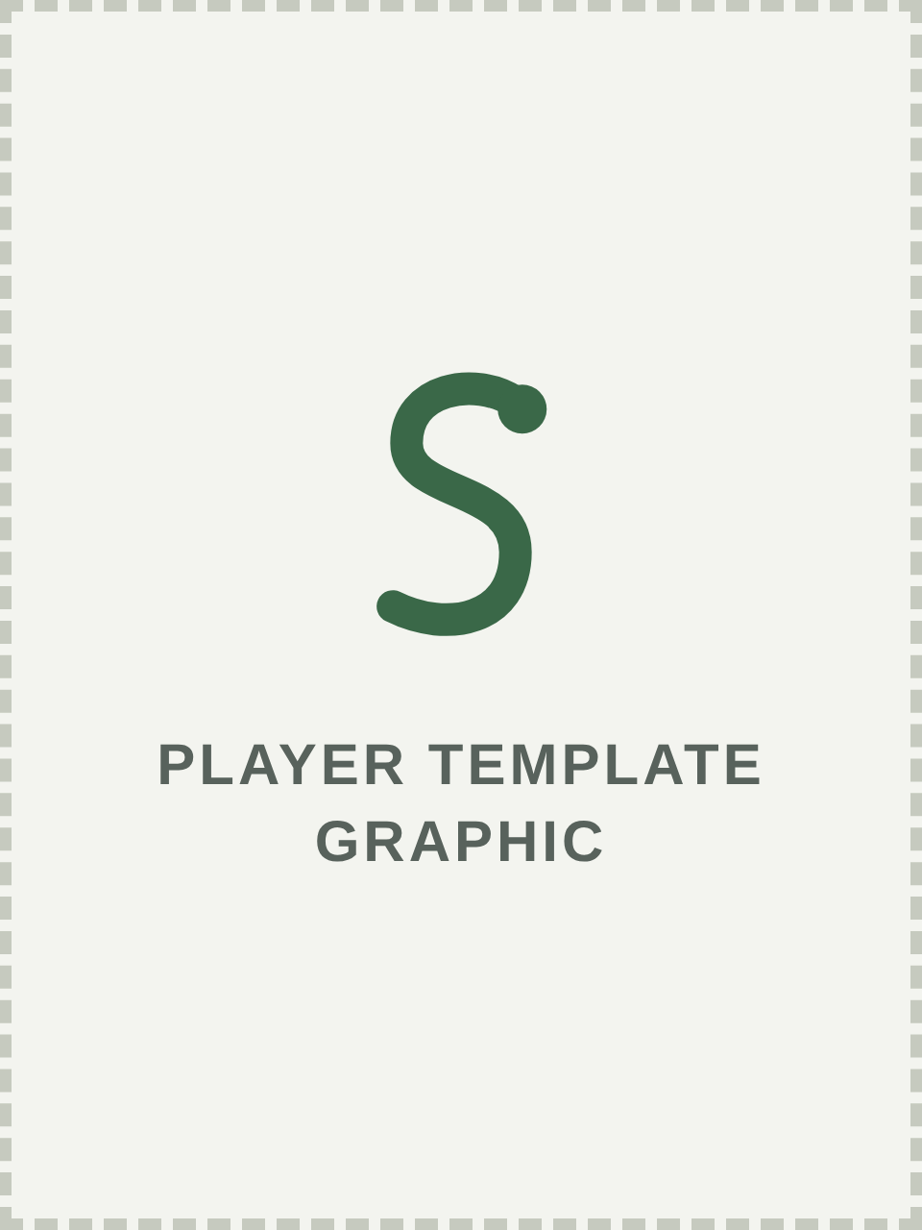 | KNIGHT OF THE SERPENT  Dame Elspeth Sharrisselva  Crimson Wood · Belted 1996 · Artisan and trickster  - Masterwork: Before the game, choose up to 3 friendly troops. Each upgrades its weapon with +1 AP or re-rolls wound rolls of 1.  - Serpent's Guile: Once per round, force one enemy within 12" to re-roll a successful hit roll or save.  - Tapestry of Glory: Friendly models within 6" get +1 Leadership.  - Heroic: +1 Attack, Hit improves by 1, weapons and armor free. 2 Heroic Actions per game.  - Signature ability: to come, written with the Knight.  Also belted: Flame · Field abilities: one chosen class list  Lives ☐ ☐ ☐ ☐
  Pts | M | T | W | Ld | Sv | Ward
  75 | 6" | 4 | 5 | 9 | 5+ | 5+

KNIGHT OF THE SERPENT
Ailanthus Finvarra
Wyvern's Spur · Belted 2003 · Artisan and trickster
Pts | M | T | W | Ld | Sv | Ward
75 | 6" | 4 | 5 | 9 | 5+ | 5+

- Masterwork: Before the game, choose up to 3 friendly troops. Each upgrades its weapon with +1 AP or re-rolls wound rolls of 1.
- Serpent's Guile: Once per round, force one enemy within 12" to re-roll a successful hit roll or save.
- Tapestry of Glory: Friendly models within 6" get +1 Leadership.
- Heroic: +1 Attack, Hit improves by 1, weapons and armor free. 2 Heroic Actions per game.
- Signature ability: to come, written with the Knight.
Also belted: Crown · Paragon of: Paladin, Warrior
Lives ☐ ☐ ☐ ☐

KNIGHT OF THE SERPENT
Ohlanna De Mowbray, Lady
Thor's Refuge · Belted 2021 · Artisan and trickster
Pts | M | T | W | Ld | Sv | Ward
75 | 6" | 4 | 5 | 9 | 5+ | 5+

- Masterwork: Before the game, choose up to 3 friendly troops. Each upgrades its weapon with +1 AP or re-rolls wound rolls of 1.
- Serpent's Guile: Once per round, force one enemy within 12" to re-roll a successful hit roll or save.
- Tapestry of Glory: Friendly models within 6" get +1 Leadership.
- Heroic: +1 Attack, Hit improves by 1, weapons and armor free. 2 Heroic Actions per game.
- Signature ability: to come, written with the Knight.
Also belted: Flame · Field abilities: one chosen class list
Lives ☐ ☐ ☐ ☐

KNIGHT OF THE SERPENT
Ser Attano Sagax
Thor's Refuge · Belted 2022 · Artisan and trickster
Pts | M | T | W | Ld | Sv | Ward
75 | 6" | 4 | 5 | 9 | 5+ | 5+

- Masterwork: Before the game, choose up to 3 friendly troops. Each upgrades its weapon with +1 AP or re-rolls wound rolls of 1.
- Serpent's Guile: Once per round, force one enemy within 12" to re-roll a successful hit roll or save.
- Tapestry of Glory: Friendly models within 6" get +1 Leadership.
- Heroic: +1 Attack, Hit improves by 1, weapons and armor free. 2 Heroic Actions per game.
- Signature ability: to come, written with the Knight.
Paragon of: Healer, Monster
Lives ☐ ☐ ☐ ☐

KNIGHT OF THE SERPENT
Jacelendrahz
Crimson Wood · Belted 2022 · Artisan and trickster
Pts | M | T | W | Ld | Sv | Ward
75 | 6" | 4 | 5 | 9 | 5+ | 5+

- Masterwork: Before the game, choose up to 3 friendly troops. Each upgrades its weapon with +1 AP or re-rolls wound rolls of 1.
- Serpent's Guile: Once per round, force one enemy within 12" to re-roll a successful hit roll or save.
- Tapestry of Glory: Friendly models within 6" get +1 Leadership.
- Heroic: +1 Attack, Hit improves by 1, weapons and armor free. 2 Heroic Actions per game.
- Signature ability: to come, written with the Knight.
Paragon of: Assassin
Lives ☐ ☐ ☐ ☐

KNIGHT OF THE SERPENT
Dame Wendy the Wench
Siar Geata · Belted 2023 · Artisan and trickster
Pts | M | T | W | Ld | Sv | Ward
75 | 6" | 4 | 5 | 9 | 5+ | 5+

- Masterwork: Before the game, choose up to 3 friendly troops. Each upgrades its weapon with +1 AP or re-rolls wound rolls of 1.
- Serpent's Guile: Once per round, force one enemy within 12" to re-roll a successful hit roll or save.
- Tapestry of Glory: Friendly models within 6" get +1 Leadership.
- Heroic: +1 Attack, Hit improves by 1, weapons and armor free. 2 Heroic Actions per game.
- Signature ability: to come, written with the Knight.
Field abilities: one chosen class list
Lives ☐ ☐ ☐ ☐

KNIGHT OF THE SERPENT
Gravekeeper Sir Spade the Laborious
Ethereal Hollow · Belted 2023 · Artisan and trickster
Pts | M | T | W | Ld | Sv | Ward
75 | 6" | 4 | 5 | 9 | 5+ | 5+

- Masterwork: Before the game, choose up to 3 friendly troops. Each upgrades its weapon with +1 AP or re-rolls wound rolls of 1.
- Serpent's Guile: Once per round, force one enemy within 12" to re-roll a successful hit roll or save.
- Tapestry of Glory: Friendly models within 6" get +1 Leadership.
- Heroic: +1 Attack, Hit improves by 1, weapons and armor free. 2 Heroic Actions per game.
- Signature ability: to come, written with the Knight.
Paragon of: Wizard
Lives ☐ ☐ ☐ ☐

KNIGHT OF THE SERPENT
Halavere Blackraven
Belial Peaks · Belted 2023 · Artisan and trickster
Pts | M | T | W | Ld | Sv | Ward
75 | 6" | 4 | 5 | 9 | 5+ | 5+

- Masterwork: Before the game, choose up to 3 friendly troops. Each upgrades its weapon with +1 AP or re-rolls wound rolls of 1.
- Serpent's Guile: Once per round, force one enemy within 12" to re-roll a successful hit roll or save.
- Tapestry of Glory: Friendly models within 6" get +1 Leadership.
- Heroic: +1 Attack, Hit improves by 1, weapons and armor free. 2 Heroic Actions per game.
- Signature ability: to come, written with the Knight.
Paragon of: Assassin
Lives ☐ ☐ ☐ ☐

XIII Paragons of Westmarch
Paragons are the masters of a single class: 50 points each, with an upgrade budget of 25.

The Paragon profile
A Paragon uses its class's troop profile with these changes: Pts 50 · T 4 · W 5 · Ld 8. M stays as its class; Sv comes from its armor.
- Heroic, plus its class ability from Chapter IX.
- Any weapon and armor its class may use, free. A Paragon whose class can wear heavy armor may take plate instead.
- Paragon casters spend 6 Spell Points on their spellbook.
- Up to 25 points of field abilities from its own class list, and gear.

Upgrade budgets
Character | Base | Budget | Most it can cost | Field abilities from
Paragon | 50 | 25 | 75 | Its own class list
Knight | 75 | 50 | 125 | Any class they are a Paragon of, or one chosen list

Each field ability may be taken once per model. Upgrades count toward the character limit.

Field abilities
Each class has four field abilities: two at 5 points, one at 10 and one at 15.

Warrior
Ability | Pts | Effect
Improve Weapon | 5 | +1 S on one weapon.
Improve Shield | 5 | The shield gives +2 to the save instead of +1.
Hardened | 10 | Armor is never Damaged.
Weapon Master | 15 | Once per round, re-roll all failed hit rolls for one weapon.

Paladin
Ability | Pts | Effect
Lay on Hands | 5 | Once per game, restore D3 W to a friendly model within 1".
Smite | 5 | Once per game, melee wound rolls of 5+ are Lethal for one round.
Aura of Protection | 10 | Friendly models within 3" get a 6+ ward.
Undying Faith | 15 | The first time this model would be slain, it stays with 1 W.

Barbarian
Ability | Pts | Effect
Berserk | 5 | +1 A in a round it charges.
Roar | 5 | Once per round, one enemy within 6" gets -2 Ld until the end of the round.
Fight After Death | 10 | When slain, make one melee attack before removal.
Rage | 15 | While below starting W, +1 S and +1 A.

Archer
Ability | Pts | Effect
Destroy Armor Arrow | 5 | Once per round, a hit Damages the target's armor even if it saves.
Poison Arrow | 5 | Once per game, a hit deals 2 mortal wounds instead of normal damage.
Suppression Arrow | 10 | Once per round, a model hit gets -1 to hit until the end of the next round.
Eagle Eye | 15 | Bow range 36"; ignores negative hit modifiers.

Scout
Ability | Pts | Effect
Tracking | 5 | Each round, name an enemy within 18". Friendly models re-roll hit rolls of 1 against it.
Shake It Off | 5 | Once per game, remove a Pinned, Entangled or Frozen effect from itself.
Pathfinder | 10 | +2" M and ignores terrain movement penalties.
Ambush | 15 | Start in reserve. At the start of any round, set up within 1" of a table edge and more than 6" from enemies, with +1 to hit that round.

Assassin
Ability | Pts | Effect
Poison | 5 | Poisoned Blade makes wound rolls of 4+ Lethal.
Shadowstep | 5 | Once per game, move 6", even out of combat, without penalty.
Hold Person | 10 | Once per game, an enemy within 6" can't act in its next activation.
Assassinate | 15 | Once per game, one melee attack against a character wounds on 2+ and every wound is Lethal.

Monk
Ability | Pts | Effect
Sanctuary | 5 | Once per game, cast Sanctuary on itself automatically.
Meditate | 5 | Once per game, regain D3 W.
Ancestral Armor | 10 | 5+ ward.
Flurry | 15 | +2 A with Single Short or Spear.

Bard
Ability | Pts | Effect
Legend | 5 | Once per game, one friendly model automatically passes a Leadership test.
Mimic | 5 | Once per game, copy a class ability of a friendly troop within 6" until the end of the round.
Awe | 10 | Once per round, one enemy within 6" can't attack this model in its next activation.
Song of Valor | 15 | Friendly models within 6" get +1 to hit in melee.

Healer
Ability | Pts | Effect
Deep Reserves | 5 | +2 Spell Points.
Cure | 5 | Once per round, remove one spell effect from a model within 1".
Protection from Death | 10 | Once per game, a friendly model within 6" that would be slain stays with 1 W.
Greater Resurrect | 15 | Resurrect may target Paragons and returns models with 2 W.

Druid
Ability | Pts | Effect
Deep Reserves | 5 | +2 Spell Points.
Barkskin | 5 | +1 T.
Call Lightning | 10 | Add one use of a spell: Cast 4+, 18", spellball S5 AP -2 D2, no line of sight needed.
Summon Beast | 15 | Add a Beast to the warband: M 8", T 4, W 3; A3, Hit 3+, S4, AP 0, D1. No revives.

Wizard
Ability | Pts | Effect
Deep Reserves | 5 | +2 Spell Points.
Arcane Focus | 5 | +1 to cast rolls for spellballs.
Cantrip | 10 | One 1-SP spell may be cast once per round without spending uses.
Sphere of Annihilation | 15 | Once per game, Cast 5+, 12": the target suffers D3+1 mortal wounds.

Anti-Paladin
Ability | Pts | Effect
Terror | 5 | Enemies within 3" get -1 to hit this model in melee.
Innate Poison | 5 | Melee wound rolls of 5+ are Lethal.
Undead Minion | 10 | Once per game, an enemy troop this model slays fights for you with 1 W until slain again, then goes to its owner's Nirvana.
Unholy Strength | 15 | +1 S and +1 A in melee.

EXAMPLE
Master Duro of the Vale takes Improve Weapon (5), Hardened (10) and a Healing Potion (3), spending 18 of his 25 points. He costs 68.

Named Paragons
Every Paragon is a named Westmarch player who is not also a Knight. Each class takes up to four, most senior first, with no one listed twice. E.O.N. The Eternal is added as a fifth Monk. Paladin has no Paragon, because the only Paladin Paragon, Ailanthus Finvarra, is a Knight.
Class | Paragon | Park | Since
Warrior | Lord General Tevas the Holy | Wavehaven | 2008
Warrior | Era | Wyvern's Spur | 2015
Warrior | Master Duro of the Vale | Stonehearth | 2017
Warrior | Jimmy Whitehammer | Wyvern's Spur | 2024
Barbarian | Baernoir | Crimson Wood | 2007
Barbarian | Collin MacAbee | Stonehearth | 2014
Barbarian | Fenra | Crimson Wood | 2023
Archer | Eldrin Dawnrider | Stonehearth | 2019
Archer | Nightshade | Clockwork Spires | 2020
Archer | Valen Blackthorn | Ashen Grove | 2023
Archer | Aries 'The Mad' Trucido | Belial Peaks | 2023
Scout | Lord Paragon Fayt Horizon | Clockwork Spires | 2015
Scout | TooDelz | Stonehearth | 2020
Scout | Sebastion | Wyvern's Spur | 2023
Scout | Super Ninja | Wyvern's Spur | 2026
Assassin | Thedro | Aegir's Hall | 1996
Assassin | Abbazabba | Anduril | 2000
Assassin | Aelelia Undine | Thor's Refuge | 2015
Assassin | Fun Size | Wavehaven | 2016
Monk | Nodule | Wavehaven | 1998
Monk | Lekvar | Wyvern's Spur | 2018
Monk | Ninja Raider | Stonehearth | 2019
Monk | Brujah | Fal Dare | 2021
Monk | E.O.N. The Eternal | Siar Geata | 2026
Bard | Endol Aethiem | Wyvern's Spur | 2016
Bard | Silent Judge | Thor's Refuge | 2019
Bard | Feste(s) | Wyvern's Spur | 2024
Healer | Porkins | Stonehearth | 2011
Healer | Aella | Crimson Wood | 2015
Healer | Delu Maethor | Wyvern's Spur | 2024
Healer | Fenroc Everscale | Fal Dare | 2025
Druid | Kalandra Mirdain | Aegir's Hall | 2013
Druid | Lothar Bloodeye | Dragonvale | 2020
Druid | Maul Sablehammer | Aegir's Hall | 2020
Druid | Dargon Ravenskull | Thor's Refuge | 2021
Wizard | Dandril Valekrel | Wavehaven | 2008
Wizard | Lord Paragon Caliban Acklie | Aegir's Hall | 2016
Wizard | Spark | Wyvern's Spur | 2019
Wizard | Lee | Wyvern's Spur | 2024
Anti-Paladin | Link Dragonrider | Clockwork Spires | 2026

Alternates (their class already has four): Limn Ology and Thomas Throatchop the Bold (Warrior; Limn tied Jimmy Whitehammer on date and the tie went alphabetically); Damia, Dash, Raokan and ToberDam Delargivic (Archer); Skalkeda Dragonslayer and Mask (Assassin); Dragoth Spineclever and Squire Walrus (Monk); Pigeon and Sky (Healer); Dagger (Wizard). Source: ORK Class Masters/Paragons, Kingdom of Westmarch.

XIV Scenarios
Eight battlegames, most of them fought in Amtgard parks every week. Roll a D8 or agree on one. The player with more Victory Points after round 6 wins.

Common rules
- Table: 48" × 48" with 4–6 pieces of terrain, unless the scenario says otherwise.
- Deployment: within 8" of your own table edge (shaded on each map).
- Objectives and Presence: 40mm markers. You control a marker if you have more Presence within 3" of it. Troops count as 1, Paragons 2, Knights 3. Frozen models and models in Nirvana count as 0.
- Kill points: 1 per enemy troop slain, 3 per Paragon and 5 per Knight, every time a model is slain. Kill points break ties in every scenario.
- Revives: standard in every scenario. In Unlimited scenarios, troops never run out; characters keep their normal count.
D8 | Scenario | Revives
1 | Field Battle | Standard
2 | Hold the Ground | Standard
3 | King of the Hill | Unlimited
4 | Capture the Flag | Unlimited
5 | Bridge Battle | Standard
6 | Escort the Monarch | Standard; Monarch none
7 | The Ditch | Unlimited
8 | Relic Hunt | Standard

1. Field Battle
An open-field clash, line against line. (Revives: Standard)
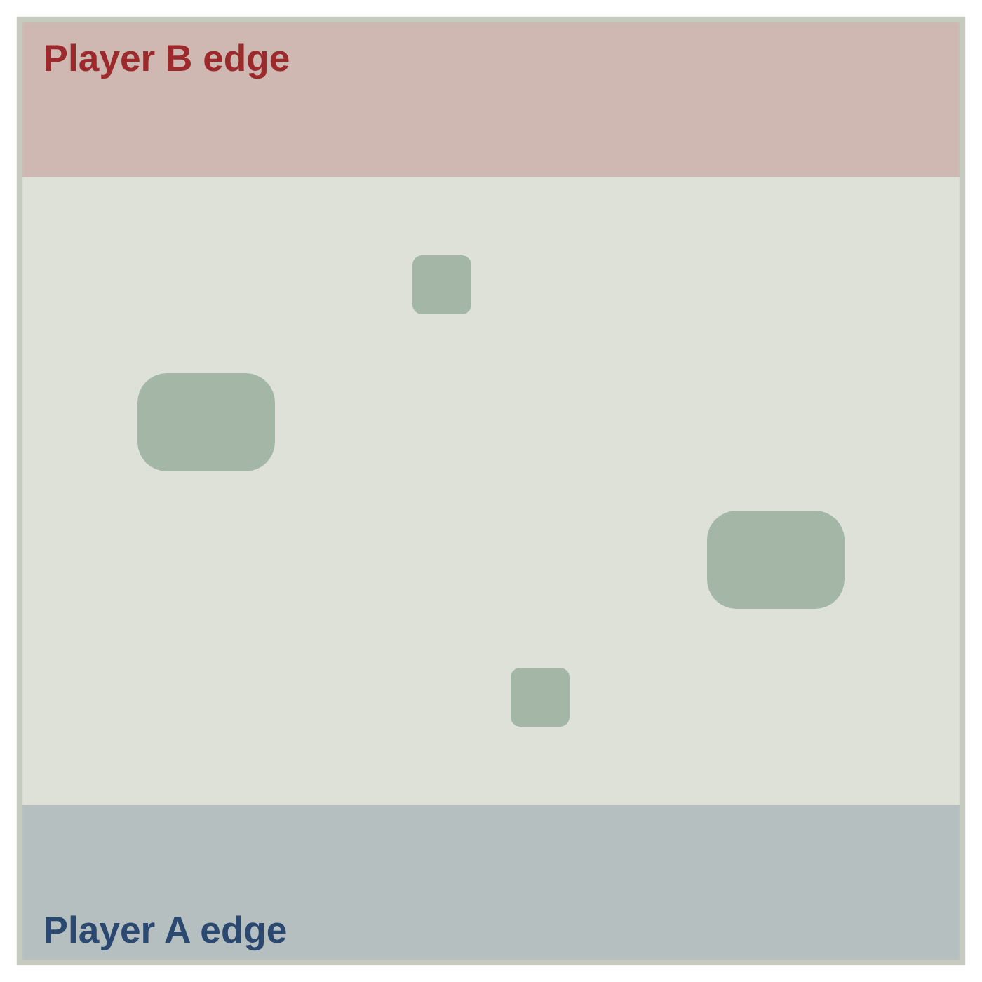
- Setup: Standard.
- Scoring: Kill points only.
- Special: A warband with no models left on the table or in Nirvana (all out of lives) loses immediately.

2. Hold the Ground
Banners are planted across the field, and both sides fight to hold them. (Revives: Standard)
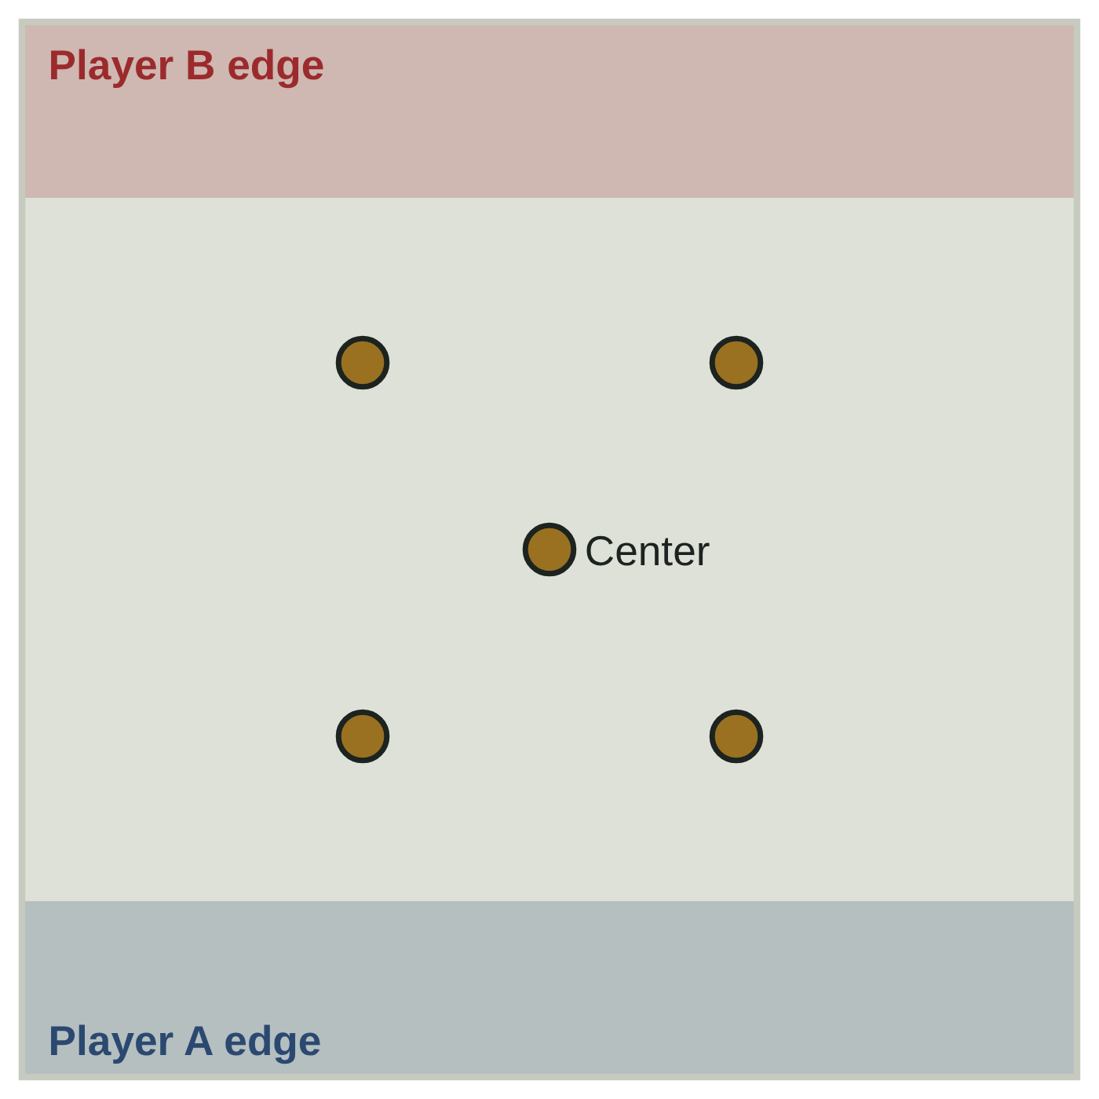
- Setup: Five objectives: one in the center and four placed 12" from the center toward each corner.
- Scoring: From round 2, in each End phase, score 1 VP per objective you control and 1 extra VP for the center.

3. King of the Hill
One hill, and whoever holds it rules the field. (Revives: Unlimited)
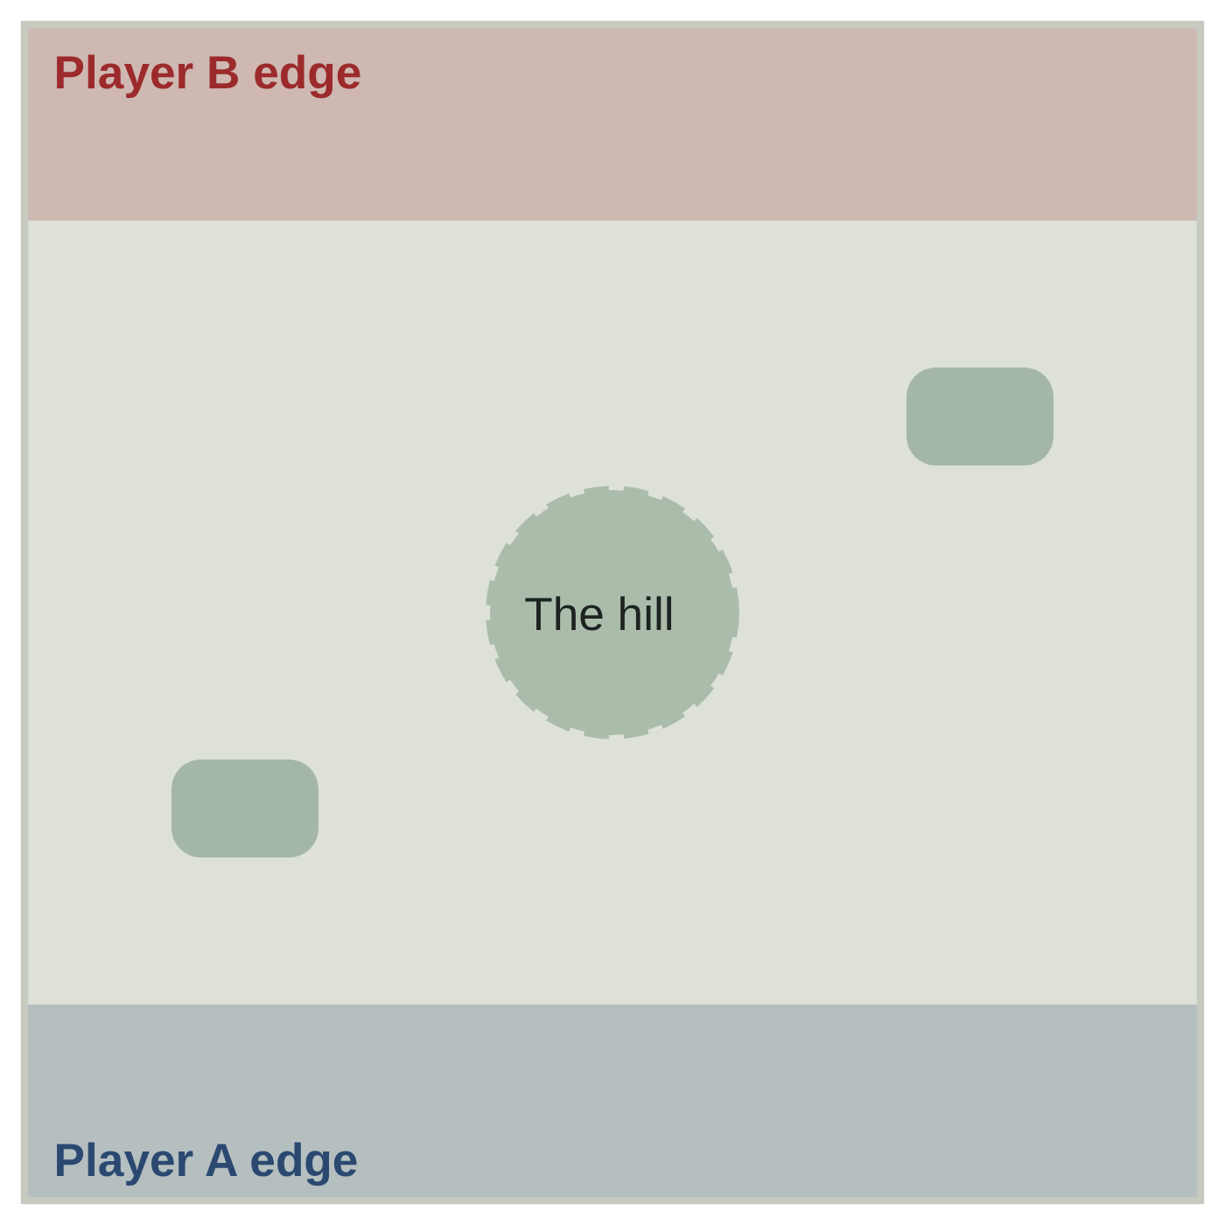
- Setup: A hill 10" across in the center of the table.
- Scoring: In each End phase, the player with more Presence on the hill scores 2 VP (4 VP in round 6). On a tie, no one scores.
- Special: Models charging up the hill don't strike first (the Hills rule).

4. Capture the Flag
The Amtgard classic. Steal their flag, protect yours. (Revives: Unlimited)
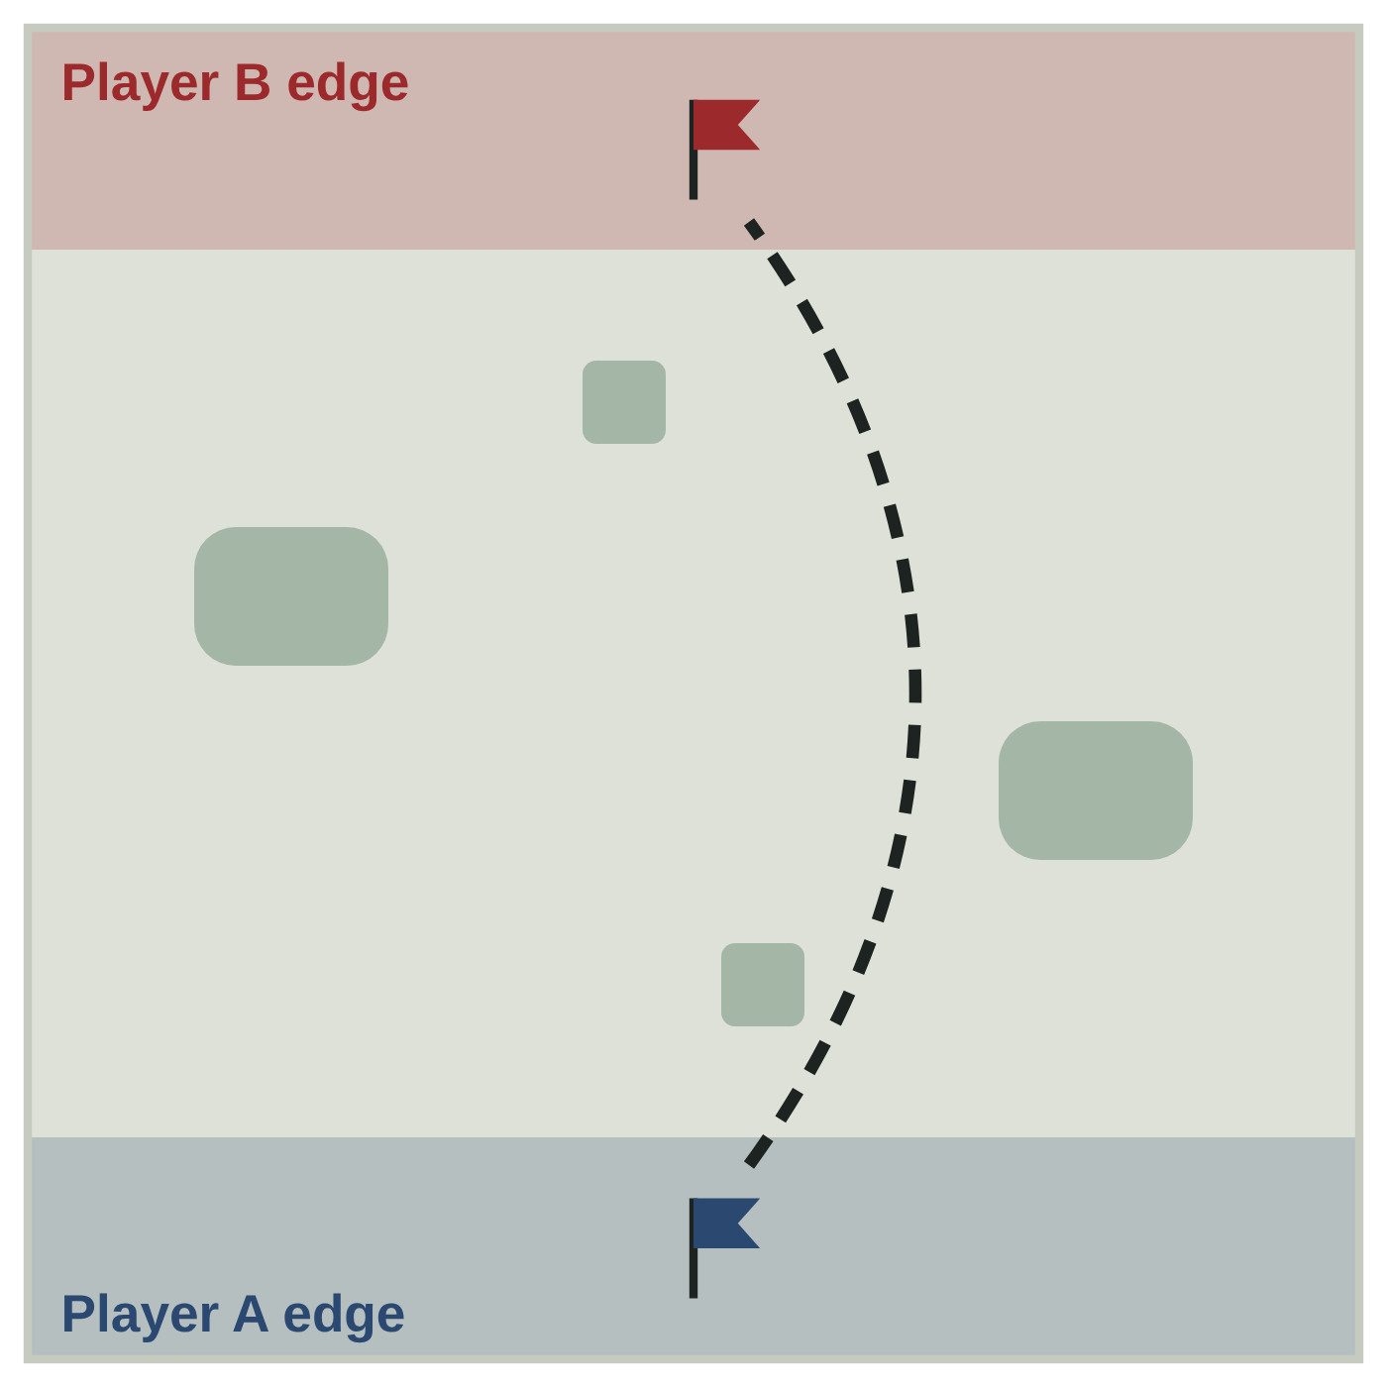
- Setup: Each player places a flag 4" from their own edge, centered.
- Taking the flag: A model that ends a Move activation in base contact with the enemy flag picks it up. The carrier gets -2" M and can't shoot or cast.
- Dropping it: If the carrier is slain, the flag drops where it stood. A model that ends a Move activation touching its own dropped flag returns it to its starting spot.
- Scoring: 3 VP when your carrier ends a Move activation touching your own flag at its starting spot. The captured flag then resets. The game ends at once if a player makes 2 captures.

5. Bridge Battle
A river splits the field, and the bridges are the only easy way across. (Revives: Standard)
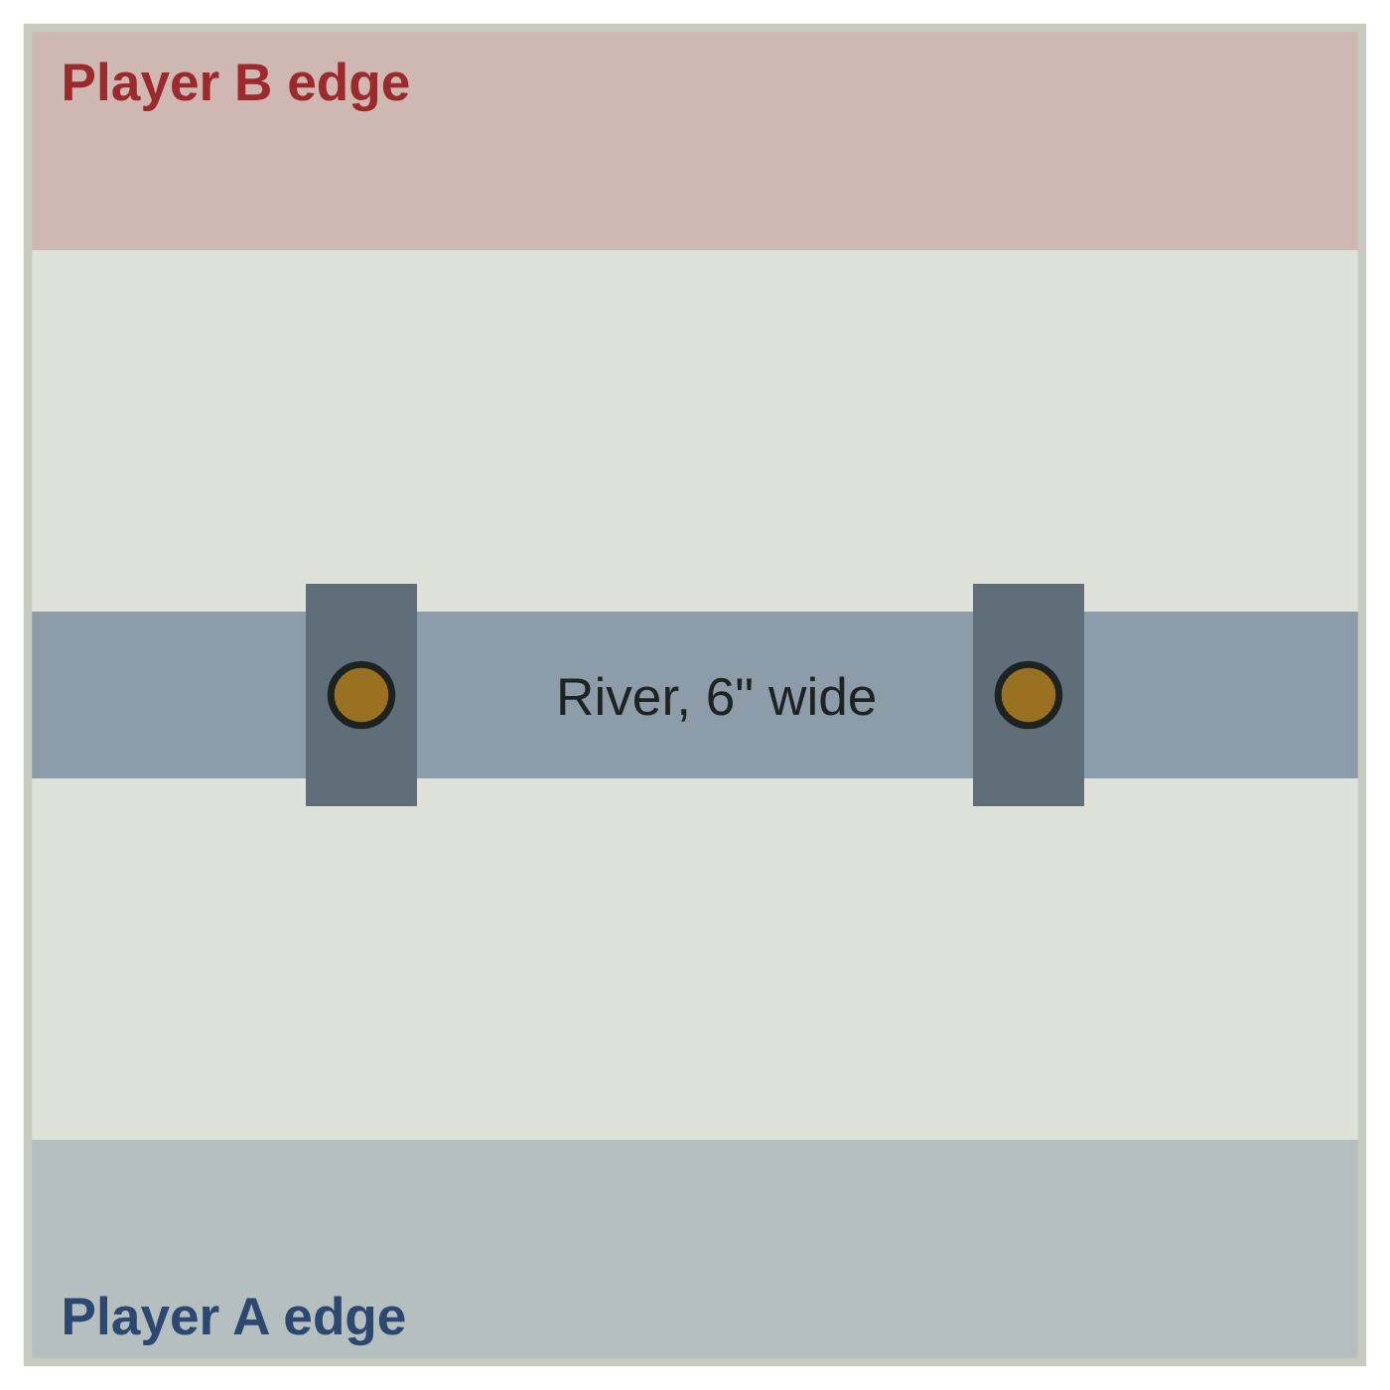
- Setup: A river 6" wide runs across the center, parallel to the deployment edges. Two bridges 4" wide sit 12" from each side edge, each with an objective at its center.
- River: Models wading in the river have M 2", can't charge, and get -1 to hit.
- Scoring: In each End phase, 1 VP per bridge you control, plus kill points at the end of the game.

6. Escort the Monarch
One side must get its Monarch across the field alive. The other must stop it. (Revives: Standard; Monarch none)
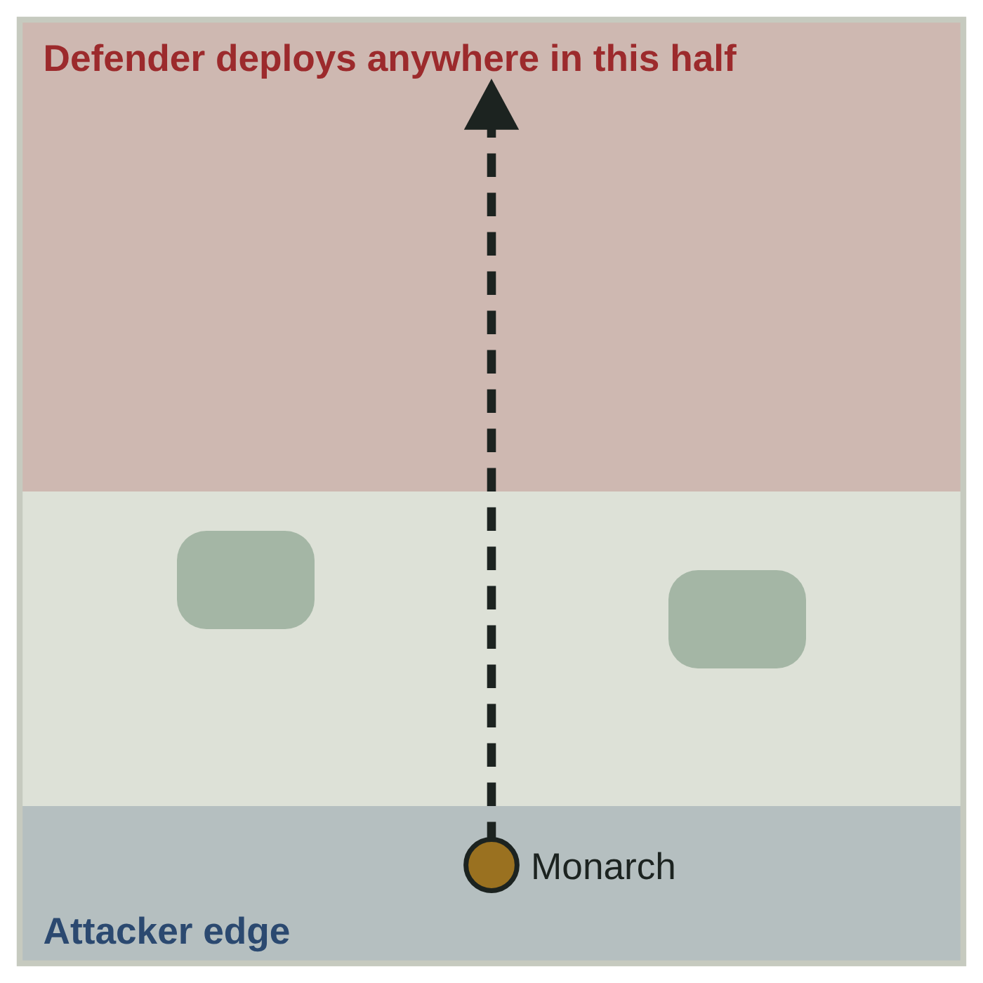
- Setup: Roll off. The winner is the Attacker and names one of their characters as the Monarch. The Defender deploys first, anywhere in their half.
- Winning: The Attacker wins if the Monarch moves off the Defender's table edge. The Defender wins if the Monarch is slain. Otherwise the game is a draw.
- Special: The Monarch can't use Heroic Actions and has no revives, even if it is the General.

7. The Ditch
Two lines meet in a narrow lane, and the fallen rejoin the back of the line. (Revives: Unlimited)
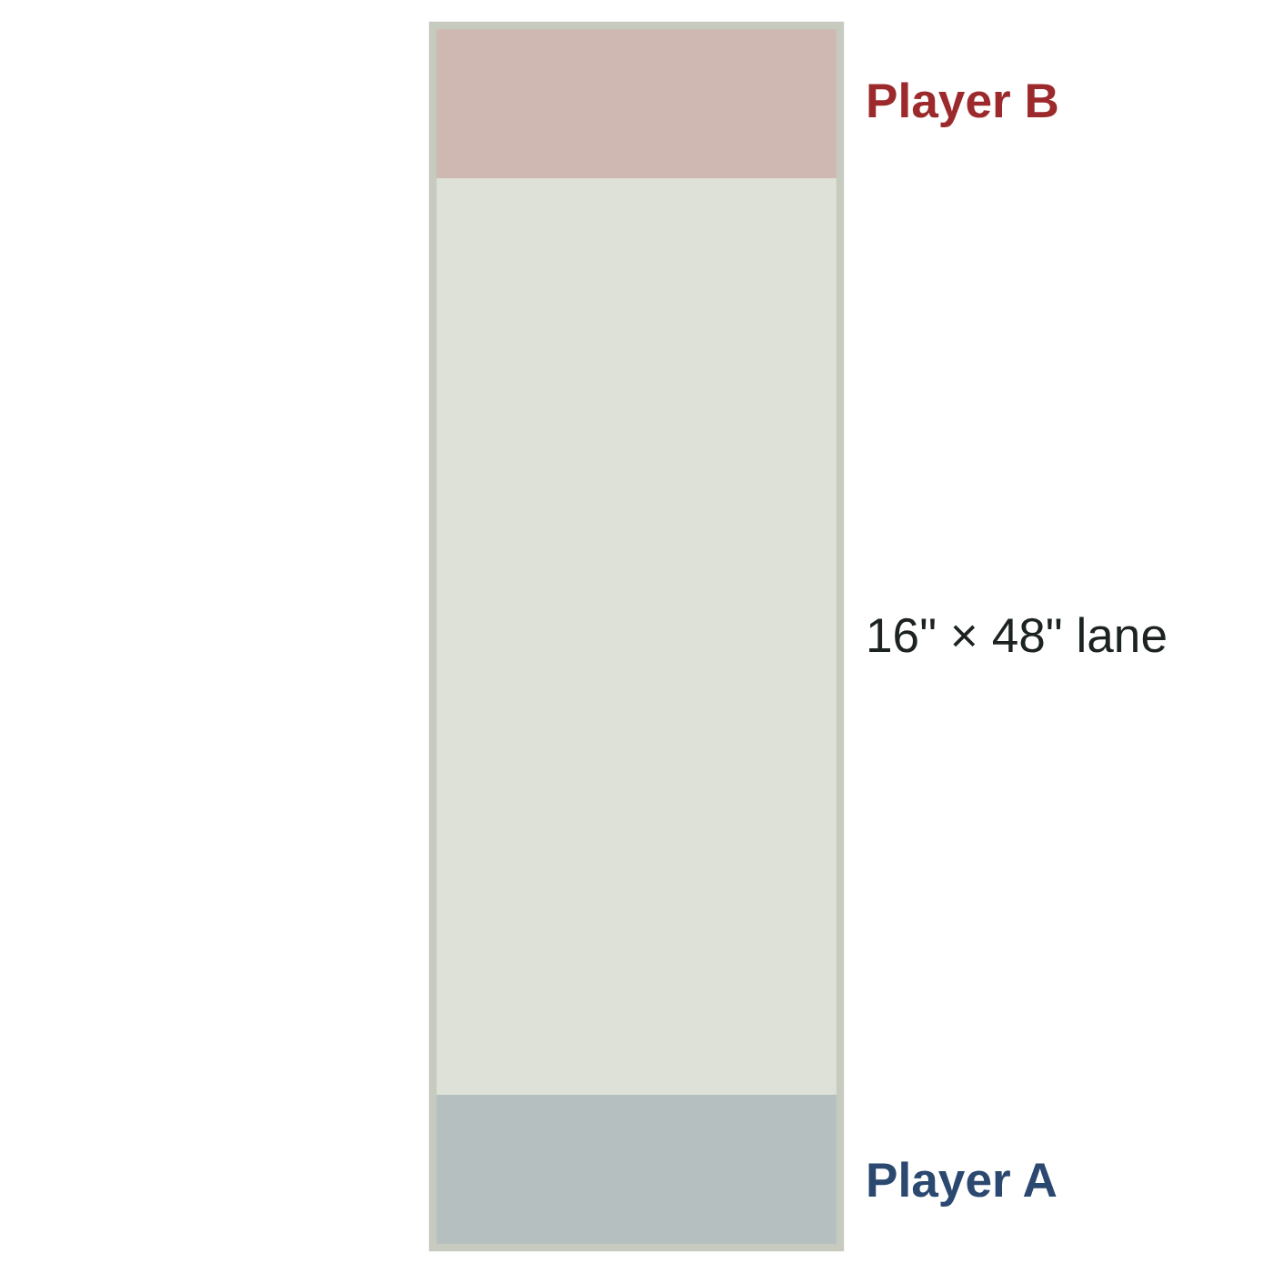
- Setup: Play on a 16" × 48" lane with no terrain. Deploy within 6" of your short edge.
- Scoring: Kill points only, counting every kill, including repeat kills of the same model.
- Special: Returning models are placed touching their own short edge.

8. Relic Hunt
Lost relics lie scattered across the field, and not all of them are what they seem. (Revives: Standard)
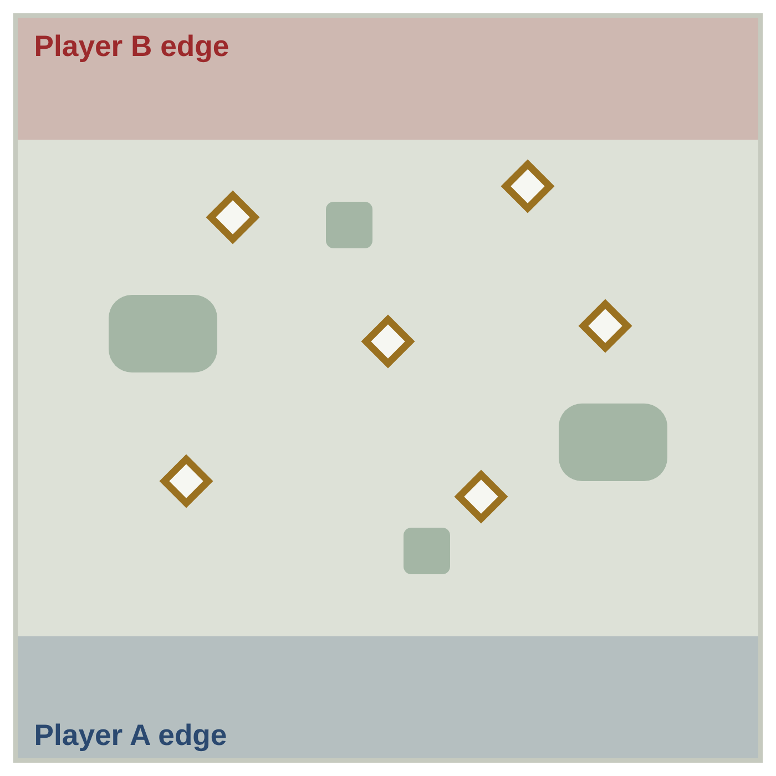
- Setup: After deployment, players take turns placing 6 relic markers, each more than 8" from any table edge and 6" from other relics.
- Picking up: A model that ends a Move activation touching a relic picks it up and rolls a D6. 1: a trap; the model takes a limb hit and the relic is removed. 2–5: a relic worth 2 VP. 6: a Great Relic worth 3 VP.
- Carrying: A model can carry one relic. If the carrier is slain, the relic drops where it stood.
- Scoring: A relic scores when its carrier ends a Move activation within 8" of its own edge. The relic is then removed.

XV Reference Sheet
The rules you'll look up most, on one page.

The round
- Priority. D6 each, high roll first
- Move. returning models, then alternate moves and charges
- Shoot. alternate shots and spells
- Fight. alternate picking combats; chargers first
- End. score, morale, end effects

An attack
- Hit. D6 per Attack vs weapon Hit
- Wound. S vs T chart
- Save. Sv worsened by AP
- Ward. AP doesn't apply
- Result. limb (1–3 arm, 4–6 leg) or Lethal

Lethal
- Natural 6 to wound, or any wound from a D2+ weapon
- Troop: slain outright. Character: lose D + 1 W
- 5+/4+ Lethal rules don't stack

Lives
- Knight 3 revives · Paragon 4 · Troop 5
- Return next Move phase within 3" of your edge
- General out of lives: 2D6 ≤ best Ld, or -1 to hit for the rest of the game

Modifiers
- Cover: -1 to hit (spellballs -1 to cast)
- Natural 6 hits, natural 1 misses
- Hit penalties never worse than -2
- Re-roll a die only once

A Playtest Notes
These are the rules most likely to need tuning. Check them first at the table.
- Character limit vs. upgrades: a fully equipped Knight costs 125, leaving 25 of the 150-point limit, which is not enough for a Paragon. Consider raising the limit to 40% (200 points).
- Knight cost: 75 points is about five troops for a champion-level model. If Knights dominate, tighten the character limit before raising their cost.
- Knight of the Sword: Heroic plus Bladesong gives 6 attacks with Dual Short, hitting on 3+ and Lethal on 5+ to wound.
- Battle Knight aura: with about 22 models on the table, a 6" aura reaches many of them. Fallbacks: a 3" radius, or a limit of 3 models.
- Warband size: about 22 models per side is closer to Warcry or Mordheim than Kill Team. Play 300 points for a smaller game.
- Lethal thresholds: damage boosts are written as "wound rolls of 5+ are Lethal" rather than +1 D, since +1 D on a D1 weapon would make every wound Lethal. Watch whether 5+ Lethal on Barbarians is still too strong.
- Lives and game length: with 4–6 lives per model, few warbands will be wiped out in 6 rounds. Objectives and kill points decide most games.
- Named characters: the Knights and Paragons are real Westmarch players. Get their blessing before sharing the game widely.

Still to write
- Signature abilities for each named Knight, gathered through the Court of Blades site
- A castle or keep siege scenario, with gates, walls and towers

