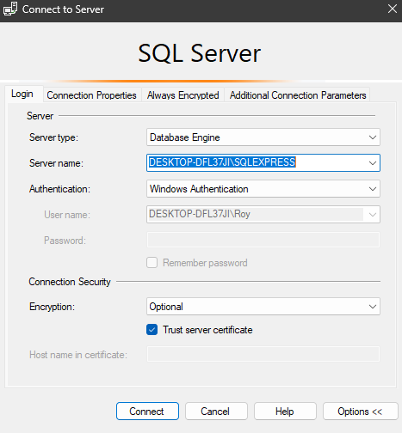My settings for MSQL  
Copy and paste server name somewhere

Create a new database named “Zoolirante”  
Copy and paste creation script into new database’s query and make database

Connect to server on visual studio  
Insert Server Name from msql, these are my settings for the connection make sure to set encrypt to false and trust server certificate

Everything else should be set up for you guys you just need to change the connection string in the appsettings.json  
  
Change the data source to yours