**KCT ABAPdoc BPMN converter (**[**http://verify.kctdata.cz/bpmnconverter**](http://verify.kctdata.cz/bpmnconverter) **)** helps you document and analyze processes of variety types, defined in your SAP systems, by means of a BPMN editor.

BPMN converter can be used to transform XML definition files of following types to BPMN format:

* SAP Business Workflow ( use BPML 0.9 export format )
* SAP PI/XI ccBPMN Integration process ( use BPEL4WS 1.1 export format )
* SAP PI Integrated scenario (use XML export format )
* ABAPdoc internal format

BPMN format can be displayed in many BPMN editors. We test it with RIGRR (<http://rigrr.rapilabs.com/> ) and Eclipse BPMN2 editor plug-in.

The BPMN representation of the input process can be little-bit „licentia poetica“, because in some cases, there are no clear rules how to do it exactly.

At document directory of KCT ABAP Doc’s GitHub (https://github.com/kctdata/abapDoc), you can also find examples of both input & output files for all of the process definition format types mentioned above.

1/export XML definition to local file

**For SAP Business Workflow:**

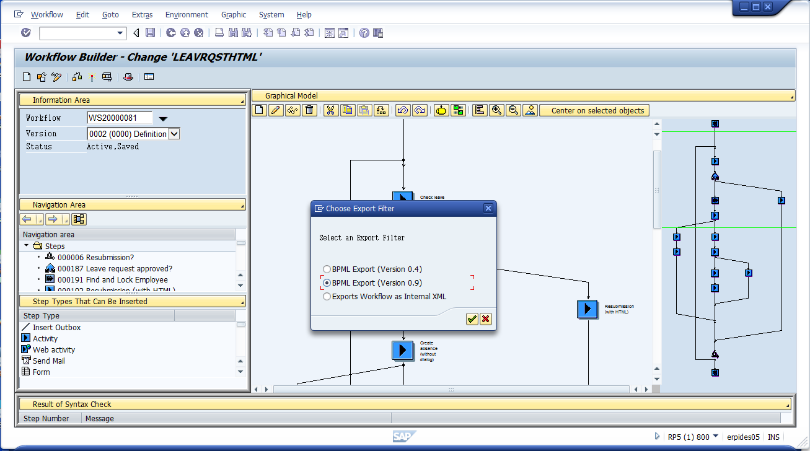

**For SAP PI/XI Integration Process**

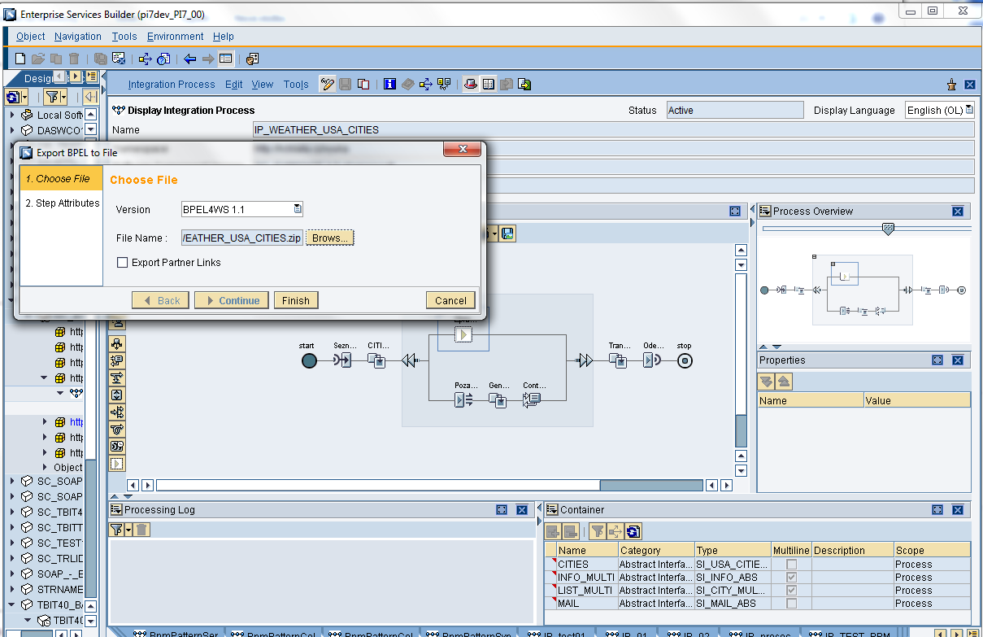

From exported ZIP file choose the BPEL output file (you can ignore the other *.wsdl file) and change but change its suffix to .xml.

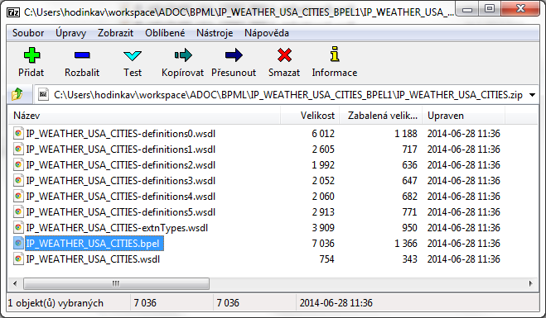

**For SAP PI/XI Integrated Scenario**

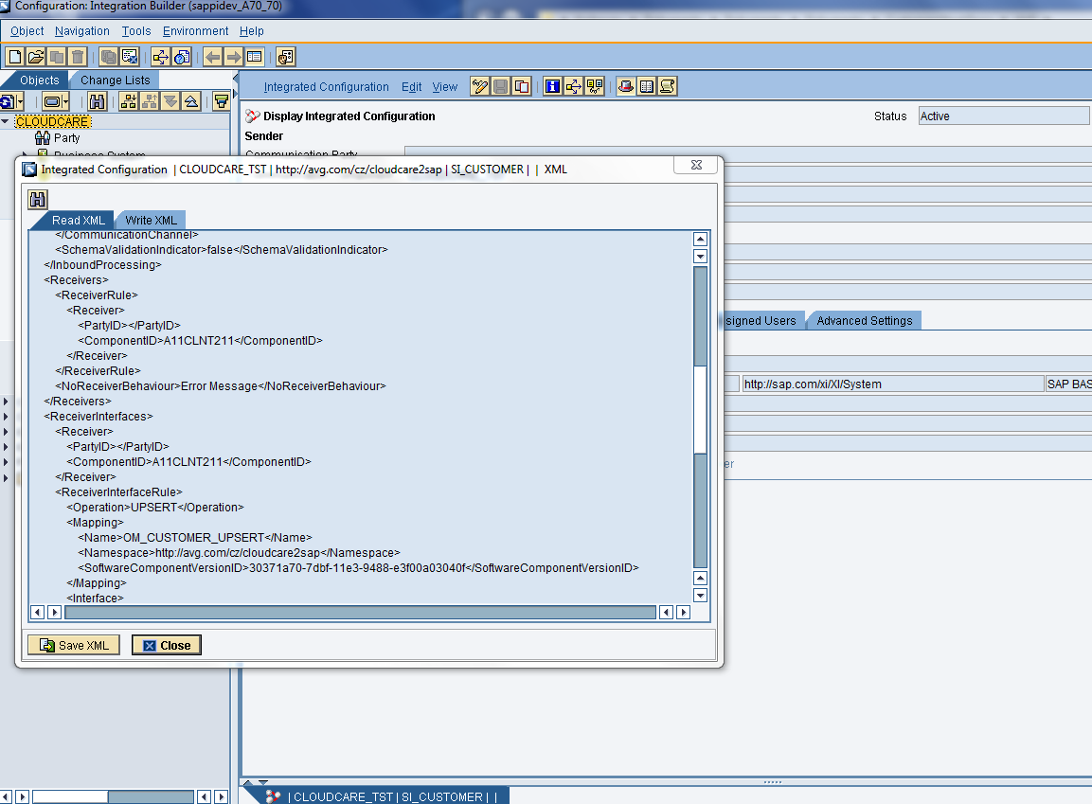

**For ABAPdoc internal format** – it is a format to which all the formats above are transformed in the first step. It is just logical representation of the process, based on a Block-Branches process flow logic description and still without any lay-out attributes ( sizes and coordinates ) and even Activities connections ( BPMN seqFlows), which are calculated later during next steps of BPMN conversion.

You can see file WS2000000081_aDocIntern.xml as an example of Internal format file, generated from SAP Workflow input file example.

You can use this format when you need to transform some other types of process notations to BPMN. It can save you a lot of work. But we recommend to contact us before doing so, to be sure you can rely on this tool/service.

2/transform it to BPMN format

1. Select the input file and choose the corresponding input file format (input file suffix must be „xml“ ). Also make sure you really set value of the “Box shape off-set” field ( otherwise Processing error occurs )

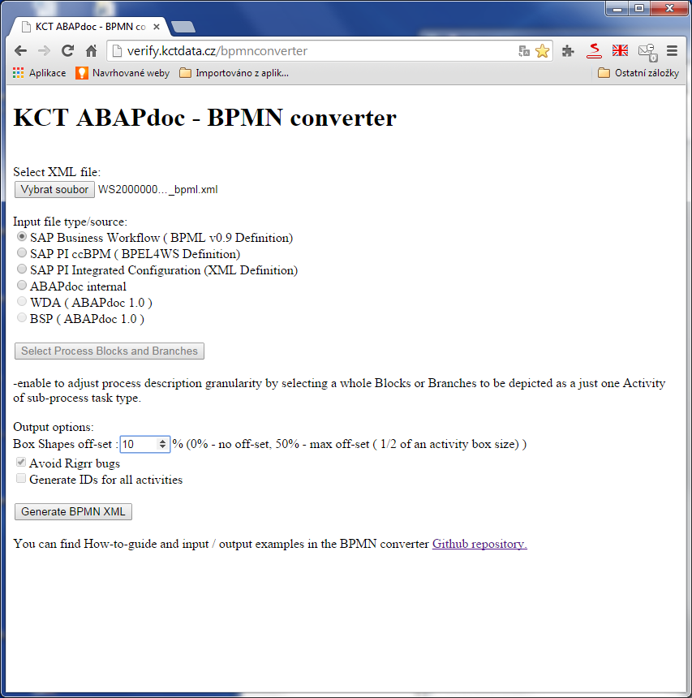

1. Press „Generate BPMN XML“ button, then the transformation is executed and an output displayed

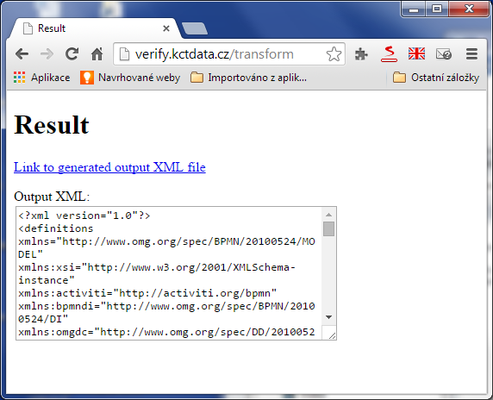

1. Save the output to a local file – either by downloading the output file link or by copy&paste of the “Output XML” Text area content

3/use it in a BPMN editor

Drag and drop the local file to the RIGRR editor

