 

**PROJECT REPORT**

Rhythmic Tunes :Your Melodic

Companion

YEAR : **2024 – 2025**

COLLEGE NAME : **K.C.S KASI NADAR COLLEGE OF ARTS & SCIENCE**

CODE : UNM203

DEPARTMENT : **COMPUTER SCIENCE**

PROGRAM : **B.C.A**

SEMESTER **VI**

PROJECT SUBMITTED TO: UNIVERSITY OF MADRAS / NAAN MUDALVAN

Course Name : **Front End Development and Database Administration**

**TEAM LEADER:** ASWIN . S **Email id :**ll6532637@gmail.com

**MEMBERS:**

1.DANUSHNATHAN . L **Email id :** danushnathandanush@gmail.com

2.KAREEMULLAH . S **Email id :** kareemu.2003.kareemu@gmail.com

3. RAGHUL . K **Email id :** raghulmass134@gmail.com

4. RAHUL . R **Email id :** rahul4845h@gmail.com

**GUIDED BY: MRS.R.PADMADEVI**

**SPOC NAME: Dr.K. LALITHAKAMESWARI**

Rhythmic Tunes :Your Melodic

**Companion (React)**

**Introduction:-**

Welcome to the future of musical indulgence – an unparalleled audio experience awaits you with our cutting-edge Music Streaming Application, meticulously crafted using the power of React.js. Seamlessly blending innovation with user-centric design, our application is set to redefine how you interact with and immerse yourself in the world of music.

Designed for the modern music enthusiast, our React-based Music Streaming Application offers a harmonious fusion of robust functionality and an intuitive user interface. From discovering the latest chart-toppers to rediscovering timeless classics, our platform ensures an all-encompassing musical journey tailored to your unique taste.

The heart of our Music Streaming Application lies in React, a dynamic and feature-rich JavaScript library. Immerse yourself in a visually stunning and interactive interface, where every click, scroll, and playlist creation feels like a musical revelation. Whether you're on a desktop, tablet, or smartphone, our responsive design ensures a consistent and enjoyable experience across all devices.

Say goodbye to the limitations of traditional music listening and welcome a world of possibilities with our React-based Music Streaming Application. Join us on this journey as we transform the way you connect with and savor the universal language of music. Get ready to elevate your auditory experience – it's time to press play on a new era of music streaming.

Imagine stepping onto a bustling city street, the sounds of cars honking, people chatting, and street performers playing in the background. You're on your way to work, and you need a little something to elevate your mood. You pull out your phone and open your favorite music streaming app, "RythimicTunes."

With just a few taps, you're transported to a world of music tailored to your tastes. As you walk, the app’s smart playlist kicks in, starting with an upbeat pop song that gets your feet tapping. As you board the train, the music shifts to a relaxing indie track, perfectly matching your need to unwind during the commute.

**Key Features:-**

* **Song Listings:** Display a comprehensive list of available songs with details such as title, artist, genre, and release date.
* **Playlist Creation:** Empower users to create personalized playlists, adding and organizing songs based on their preferences.
* **Playback Control:** Implement seamless playback control features, allowing users to play, pause, skip, and adjust volume during music playback.
* **Offline Listening:** Allow users to download songs for ofline listening, enhancing the app's accessibility and convenience.
* **Search Functionality:** Implement a robust search feature for users to easily find specific songs, artists, or albums within the app.

**Project Goals and Objectives:-**

The primary goal of Music Streaming is to provide a seamless platform for music enthusiasts, enjoying, and sharing diverse musical experiences. Our objectives include:

* **User-Friendly Interface**: Develop an intuitive interface that allows users to effortlessly explore, save, and share their favorite music tracks and playlists.
* **User-Friendly Interface:** Develop an intuitive interface that allows users to effortlessly explore, save, and share their favorite music tracks and playlists.
* **Comprehensive Music Streaming:** Provide robust features for organizing and managing music content, including advanced search options for easy discovery.
* **Modern Tech Stack:** Harness cutting-edge web development technologies, such as React.js, to ensure an efficient and enjoyable user experience while navigating and interacting with the music streaming application.

**Project structure:**

The project structure may vary depending on the specific library, framework, programming language, or development approach used. It's essential to organize the files and directories in a logical and consistent manner to improve code maintainability and collaboration among developers. app/app.component.css, src/app/app.component: These files are part of the main AppComponent, which serves as the root component for the React app. The component handles the overall layout and includes the router outlet for loading different components based on the current route.

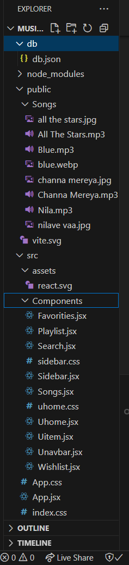 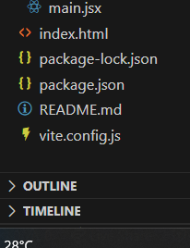

**Sample Code For Fetching And Displaying Songs:**

import React, { useState, useEffect } from 'react';

import { Button, Form, InputGroup } from 'react-bootstrap';

import { FaHeart, FaRegHeart, FaSearch } from 'react-icons/fa';

import axios from 'axios';

import './sidebar.css'

function Songs() {

  const [items, setItems] = useState([]);

  const [wishlist, setWishlist] = useState([]);

  const [playlist, setPlaylist] = useState([]);

  const [currentlyPlaying, setCurrentlyPlaying] = useState(null);

  const [searchTerm, setSearchTerm] = useState('');

  useEffect(() => {

    // Fetch all items

    axios.get('http://localhost:3000/items')

      .then(response => setItems(response.data))

      .catch(error => console.error('Error fetching items: ', error));

  // Fetch favorities items

      axios.get('http://localhost:3000/favorities')

      .then(response => setWishlist(response.data))

      .catch(error => {

        console.error('Error fetching Favvorities:', error);

        // Initialize wishlist as an empty array in case of an error

        setWishlist([]);

      });

    // Fetch playlist items

    axios.get('http://localhost:3000/playlist')

      .then(response => setPlaylist(response.data))

      .catch(error => {

        console.error('Error fetching playlist: ', error);

        // Initialize playlist as an empty array in case of an error

        setPlaylist([]);

      });

      // Function to handle audio play

    const handleAudioPlay = (itemId, audioElement) => {

        if (currentlyPlaying && currentlyPlaying !== audioElement) {

          currentlyPlaying.pause(); // Pause the currently playing audio

        }

        setCurrentlyPlaying(audioElement); // Update the currently playing audio

      };

      // Event listener to handle audio play

      const handlePlay = (itemId, audioElement) => {

        audioElement.addEventListener('play', () => {

          handleAudioPlay(itemId, audioElement);

        });

      };

      // Add event listeners for each audio element

      items.forEach((item) => {

        const audioElement = document.getElementById(`audio-${item.id}`);

        if (audioElement) {

          handlePlay(item.id, audioElement);

        }

      });

      // Cleanup event listeners

      return () => {

        items.forEach((item) => {

          const audioElement = document.getElementById(`audio-${item.id}`);

          if (audioElement) {

            audioElement.removeEventListener('play', () => handleAudioPlay(item.id, audioElement));

          }

        });

      };

  }, [items,currentlyPlaying, searchTerm]);

  const addToWishlist = async (itemId) => {

    try {

      const selectedItem = items.find((item) => item.id === itemId);

      if (!selectedItem) {

        throw new Error('Selected item not found');

      }

      const { title, imgUrl, genre, songUrl, singer, id: itemId2 } = selectedItem;

      await axios.post('http://localhost:3000/favorities', { itemId: itemId2, title, imgUrl, genre, songUrl, singer });

      const response = await axios.get('http://localhost:3000/favorities');

      setWishlist(response.data);

    } catch (error) {

      console.error('Error adding item to wishlist: ', error);

    }

  };

  const removeFromWishlist = async (itemId) => {

    try {

      // Find the item in the wishlist by itemId

      const selectedItem = wishlist.find((item) => item.itemId === itemId);

      if (!selectedItem) {

        throw new Error('Selected item not found in wishlist');

      }

      // Make a DELETE request to remove the item from the wishlist

      await axios.delete(`http://localhost:3000/favorities/${selectedItem.id}`);

      // Refresh the wishlist items

      const response = await axios.get('http://localhost:3000/favorities');

      setWishlist(response.data);

    } catch (error) {

      console.error('Error removing item from wishlist: ', error);

    }

  };

  const isItemInWishlist = (itemId) => {

    return wishlist.some((item) => item.itemId === itemId);

  };

  const addToPlaylist = async (itemId) => {

    try {

      const selectedItem = items.find((item) => item.id === itemId);

      if (!selectedItem) {

        throw new Error('Selected item not found');

      }

      const { title, imgUrl, genre, songUrl, singer, id: itemId2 } = selectedItem;

      await axios.post('http://localhost:3000/playlist', { itemId: itemId2, title, imgUrl, genre, songUrl, singer });

      const response = await axios.get('http://localhost:3000/playlist');

      setPlaylist(response.data);

    } catch (error) {

      console.error('Error adding item to wishlist: ', error);

    }

  };

  const removeFromPlaylist = async (itemId) => {

    try {

      // Find the item in the wishlist by itemId

      const selectedItem = playlist.find((item) => item.itemId === itemId);

      if (!selectedItem) {

        throw new Error('Selected item not found in wishlist');

      }

      // Make a DELETE request to remove the item from the wishlist

      await axios.delete(`http://localhost:3000/playlist/${selectedItem.id}`);

      // Refresh the wishlist items

      const response = await axios.get('http://localhost:3000/playlist');

      setPlaylist(response.data);

    } catch (error) {

      console.error('Error removing item from wishlist: ', error);

    }

  };

  const isItemInPlaylist = (itemId) => {

    return playlist.some((item) => item.itemId === itemId);

  };

  const filteredItems = items.filter((item) => {

    const lowerCaseQuery = searchTerm.toLowerCase();

    return (

      item.title.toLowerCase().includes(lowerCaseQuery) ||

      item.singer.toLowerCase().includes(lowerCaseQuery) ||

      item.genre.toLowerCase().includes(lowerCaseQuery)

    );

  });

    return (

      <div style={{display:"flex", justifyContent:"flex-end"}}>

      <div className="songs-container" style={{width:"1300px"}}>

        <div className="container mx-auto p-3">

          <h2 className="text-3xl font-semibold mb-4 text-center">Songs List</h2>

          <InputGroup className="mb-3">

            <InputGroup.Text id="search-icon">

              <FaSearch />

            </InputGroup.Text>

            <Form.Control

              type="search"

              placeholder="Search by singer, genre, or song name"

              value={searchTerm}

              onChange={(e) => setSearchTerm(e.target.value)}

              className="search-input"

            />

          </InputGroup>

          <br />

          <div className="row row-cols-1 row-cols-md-2 row-cols-lg-3 row-cols-xl-4 g-4">

            {filteredItems.map((item, index) => (

              <div key={item.id} className="col">

                <div className="card h-100">

                  <img

                    src={item.imgUrl}

                    alt="Item Image"

                    className="card-img-top rounded-top"

                    style={{ height: '200px', width: '100%' }}

                  />

                  <div className="card-body">

                    <div className="d-flex justify-content-between align-items-center mb-2">

                      <h5 className="card-title">{item.title}</h5>

                      {isItemInWishlist(item.id) ? (

                        <Button

                          variant="light"

                          onClick={() => removeFromWishlist(item.id)}

                        >

                          <FaHeart color="red" />

                        </Button>

                      ) : (

                        <Button

                          variant="light"

                          onClick={() => addToWishlist(item.id)}

                        >

                          <FaRegHeart color="black" />

                        </Button>

                      )}

                    </div>

                    <p className="card-text">Genre: {item.genre}</p>

                    <p className="card-text">Singer: {item.singer}</p>

                    <audio controls className="w-100" id={`audio-${item.id}`} >

                      <source src={item.songUrl} />

                    </audio>

                  </div>

                  <div className="card-footer d-flex justify-content-center">

                    {isItemInPlaylist(item.id) ? (

                      <Button

                        variant="outline-secondary"

                        onClick={() => removeFromPlaylist(item.id)}

                      >

                        Remove From Playlist

                      </Button>

                    ) : (

                      <Button

                        variant="outline-primary"

                        onClick={() => addToPlaylist(item.id)}

                      >

                        Add to Playlist

                      </Button>

                    )}

                  </div>

                </div>

              </div>

            ))}

          </div>

        </div>

      </div>

      </div>

    );

  }

export default Songs;

**Project Execution:**

After completing the code, run the react application by using the command “npm start” or “npm run dev” if you are using vite.js.

And the Open new Terminal type this command “json-server --watch ./db/db.json” to start the json server too.

After that launch the Rythimic Tunes.

Here are some of the screenshots of the application.

* **Hero components**

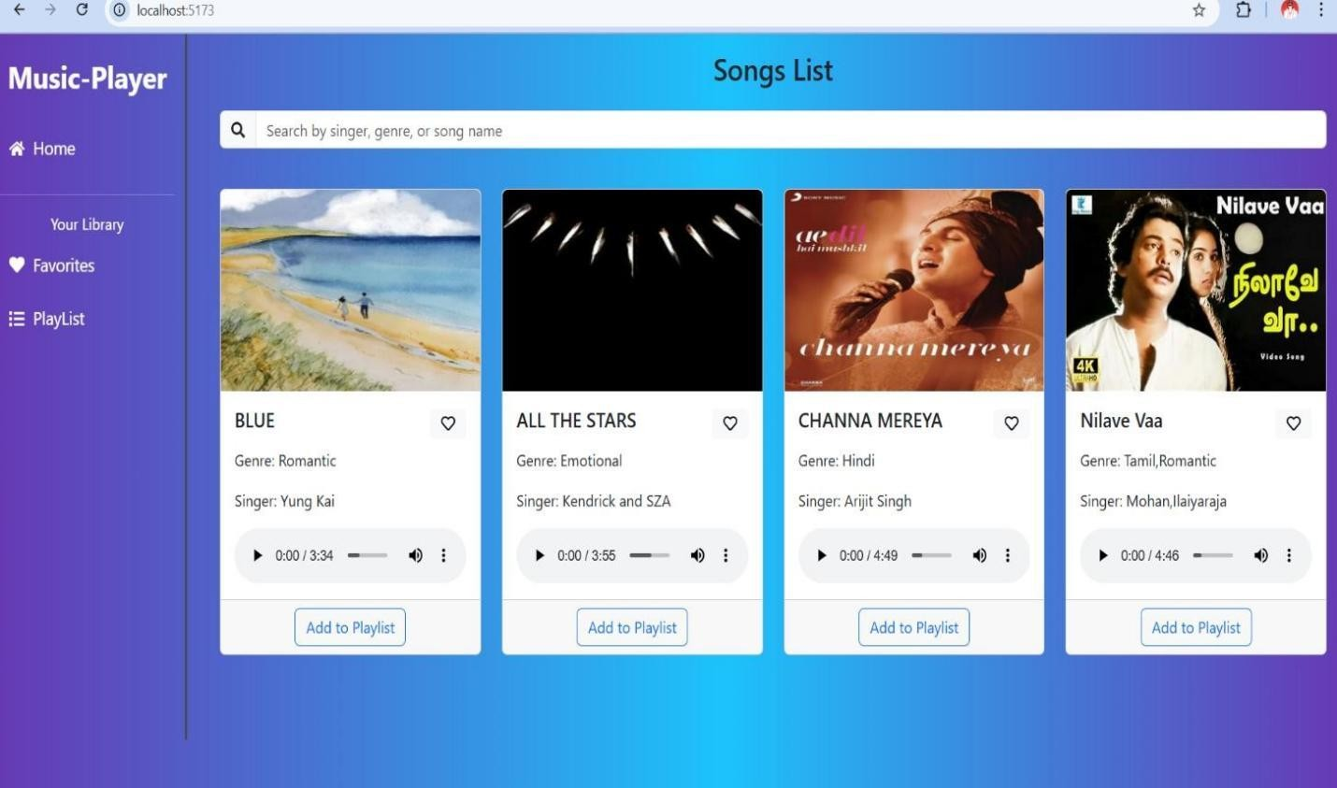

* **Search**

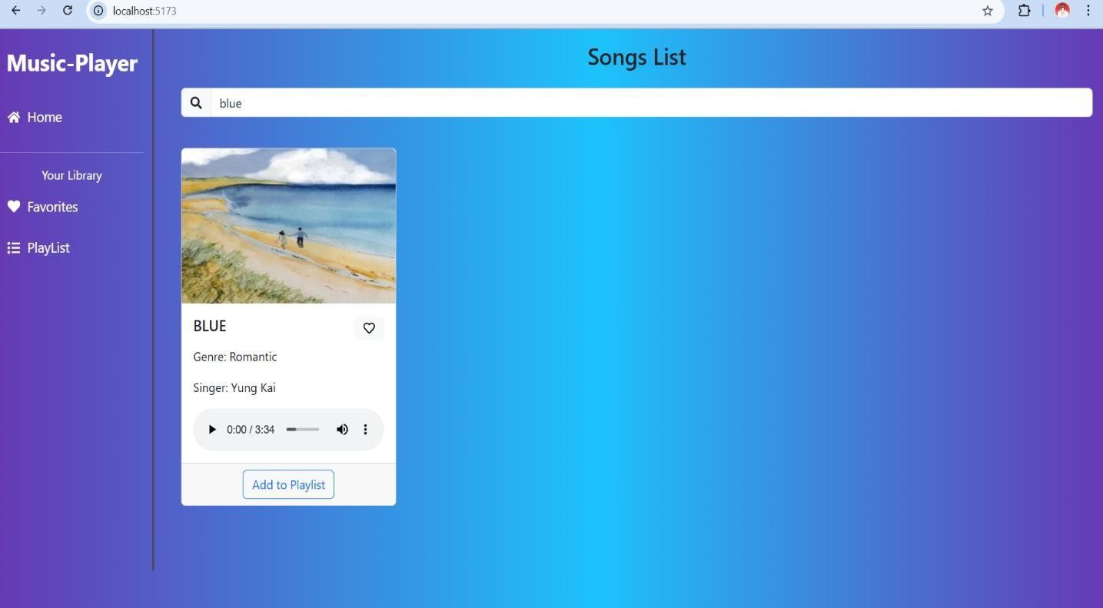

* **Favourite**

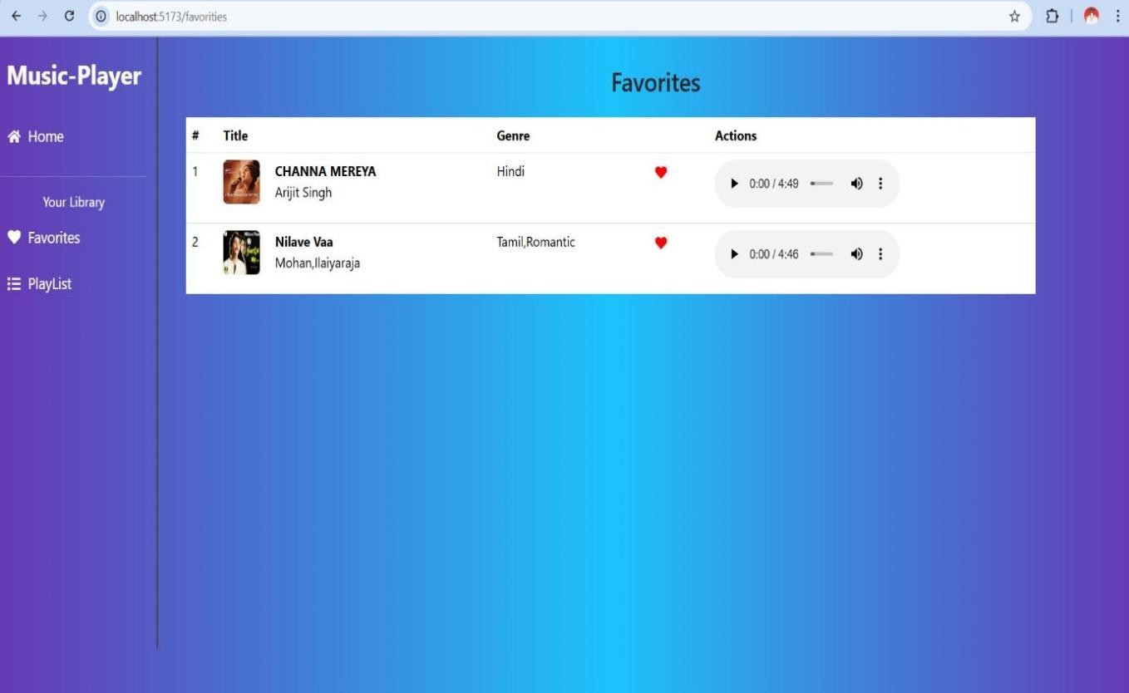

* **Playlist**

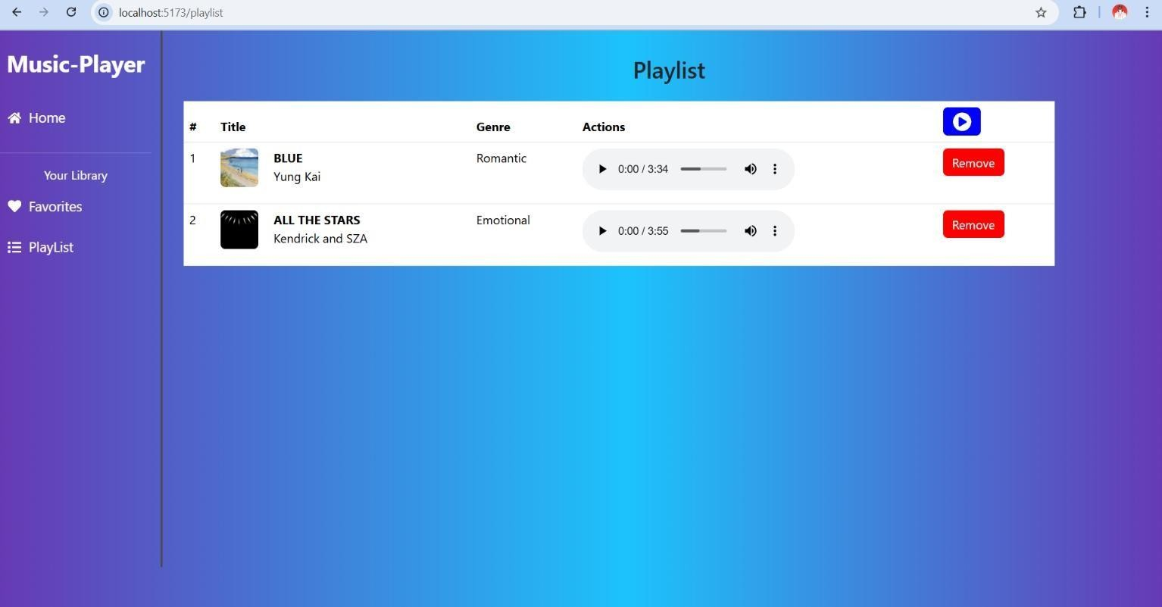

**Project Demo link :**

<https://drive.google.com/file/d/1SFm7Co-Lg6-Ql65uVn9KZbGtRLW7_8i5/view?usp=sharing>

**Project Source Code :**

<https://github.com/Archer1306/Rhythmic_Tunes_App.git>