Matthew Archer

04/02/23

Module 5.2 Assignment

Color Palette

* Prussian Blue #003049
* Fire Engine Red #D62828
* Orange #F77F00
* Xanthous #FCBF49
* Vanilla #EAE2B7

Wireframes, Sketches, Prototypes

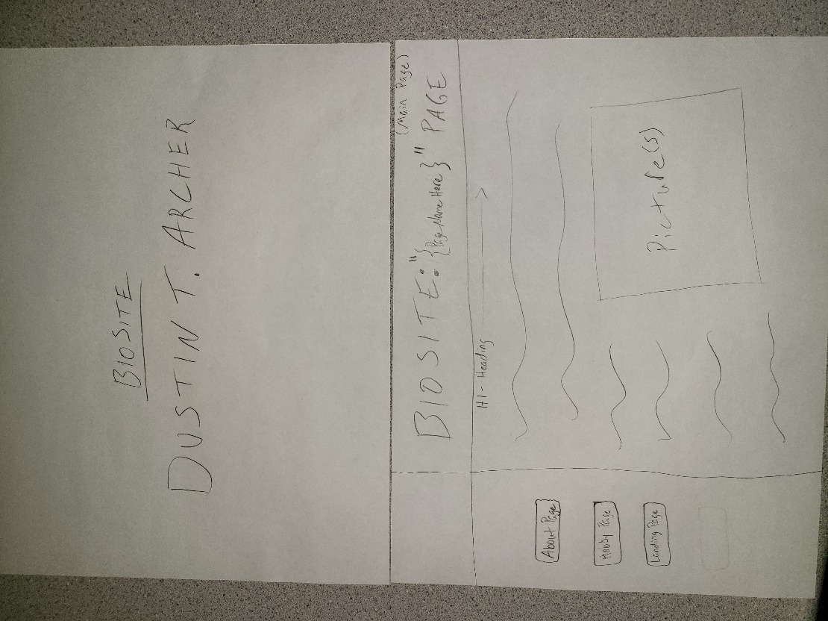

Interview Questions

1. What is your name?
   1. Dustin Todd Archer
2. Where were you born?
   1. Red Oak, Iowa
3. Who are the special people in your life?
   1. My two children, and my husband.
4. Something you wish you were better at?
   1. (Regarding job). The RAI (Resident Assessment Instrument) process. Although being recently certified in it, there are so many aspects to it that I don’t know yet that I want to learn. I am always learning as I go though.
   2. (In general). Handling situations in a more thought-out process rather than jumping to conclusions.
5. Who is your hero?
   1. My dad. He was very level headed and was able to take the time to process issues and identify potential causes and identify multiple solutions.
6. If you could live anywhere, where would it be?
   1. A warmer climate than Iowa, where I can still partake in my hobby of gardening. No where specific but definitely not the desert, but maybe somewhere tropical?
7. Is your glass half full, or half empty? Why?
   1. My glass is half full. I have accomplished many things, I have a lot of good things going for me but still have many goals to achieve that I am currently working on. I feel that in my current situation I will be able to accomplish my future goals to make my glass full.
8. What is your biggest fear?
   1. I would have to say making a mistake and losing what I have already accomplished.
9. What is the craziest thing you have done for love?
   1. Move half way across the country for someone that I did not know that well.
10. Is it ever okay to lie?
    1. In certain circumstances, yes it is okay to lie but in others it is not okay to lie. It really depends on the situation and if you tell the truth at the wrong time the results could be devastating than a different situation. Only in very minimal circumstances and to preserve the stability of someone.
11. What is your best accomplishment to date?
    1. Taking on the role of Director of Nursing at Glenhaven Village at a not stable time in my life but still putting in the time and effort to make it a stable, well-functioning facility. Using my 28 years of nursing experience to be the support of this accomplishment. Also, moving the facility beyond the standards of generalized standard of expectations.
12. What is your favorite hobby?
    1. Baking. Definitely baking some ooey-gooey pastries from fresh out of the oven and making the whole house smell like it. I love to challenge myself with something that I have never baked before, or if I have then try to improve upon it or embellish it in some way.

7 Pictures to use for the website.

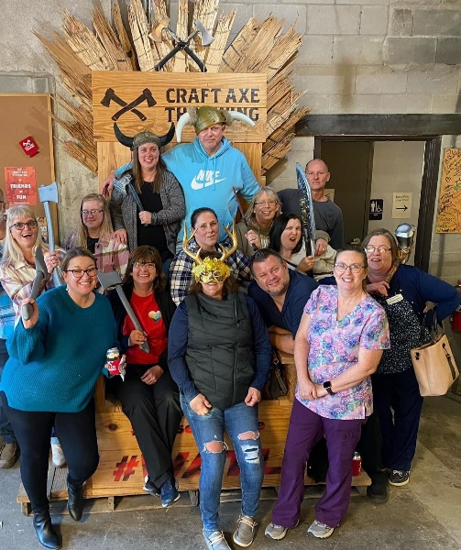

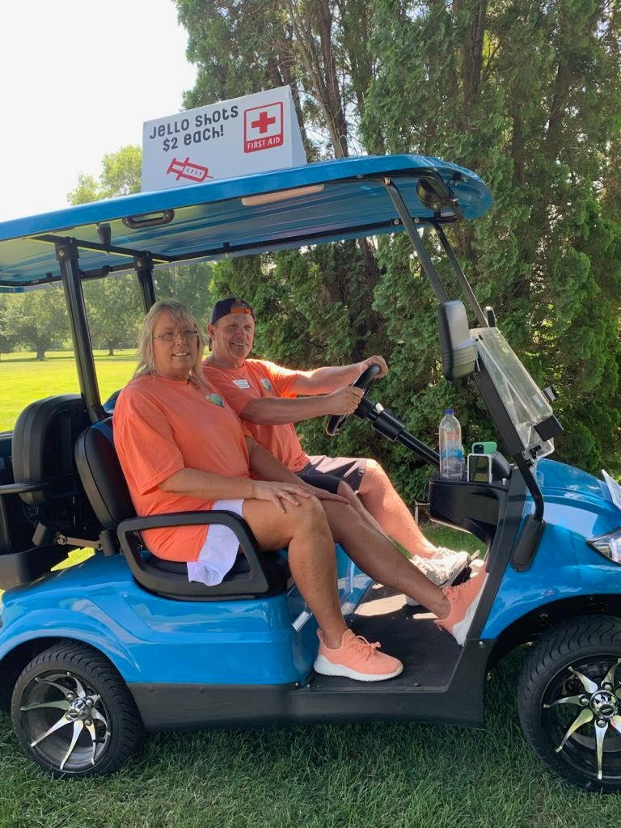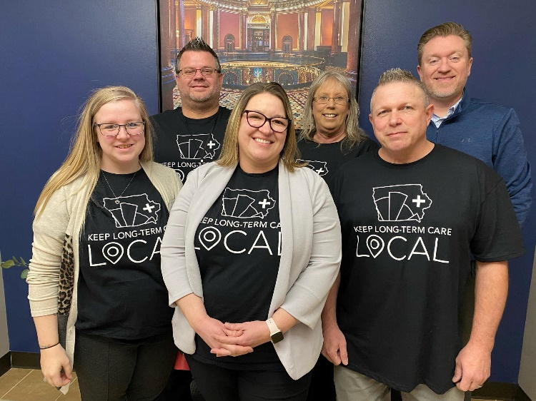

About Page

~~During this interview, I got to get to know my dad a little bit better from these 12 questions that I got to ask of him.~~ ~~He goes by the name of~~ Dustin Todd Archer ~~who~~ was born in Red Oak, Iowa on December 13th, 1970. As he was growing up he was always running around outside, getting dirty and playing with toys. His favorite hobby back then was fishing with his dad Russ. They would spend countless hours fishing on different sandbars up and down the river and in and out of many different creeks. Growing up fast though he sailed by middle school and landed in high school where he made some life long friends and had the times of his life. This is where he met Joanna, had his two loving sons, Mick, and Matthew, and got married. Around 1993 was when Dustin started pursuing Nursing because he didn’t know what to do but was ushered into the field by his mother-in-law Katherine. Soon accomplishing many degrees and certifications this would be the start to his long career in the Nursing field. From working as an RN to an ER Nurse to Hospice to Acute Rehab and finally a Director of Nursing at Glenhaven Village in Glenwood, Iowa. Though he still works a lot he is not just about the work he does have baking goods to ease the mind along with sowing and embroidering. Baking is his passion as he loves to challenge himself with it. Also, spreading love through baked treats really warms his heart. A fun way he likes to show himself with his baking is embellishing himself into his pastries sometimes and adding his own unique flare to the designs that being something colorful, funny, lovable or putting his own family crest as a signature. This way you can always say “Oh you know Dusty made this!”