Dear HR,

I am a final-year student at XMU reading computer engineering, and would like to apply for the position of hardware engineer in your company, as advertised on the XX newspaper. With a strong background in electrical engineering and a passion for hardware design, I believe that my skills and aptitude make me a suitable candidate for this role.

I am highly motivated to join your company as a Hardware Engineer because of my keen interest in designing and developing innovative hardware solutions. I am particularly drawn to the opportunity to work on tree processors, chipsets, and digital components, as well as contribute to the design and testing of new products. Your company's focus on developing cutting-edge hardware solutions aligns perfectly with my career aspirations.

Throughout my academic and professional journey, I have acquired a strong foundation in electrical engineering and computer science. My experience includes designing and implementing hardware solutions, conducting system modeling, and verifying component specifications. My technical skills include proficiency in programming languages such as C++ and Python, as well as experience for circuit design. During my internship at xxx company, I was actively involved in designing and implementing hardware solutions for next-generation computing systems. I also played a key role in developing and integrating chipsets.

Outside of my professional endeavors, I have a keen interest in exploring the fusion of technology and art. I enjoy tinkering with electronics, creating unique DIY projects, and participating in hardware hackathons. Engaging in these activities not only enhances my technical skills but also fosters creativity and a passion for continuous learning. Furthermore, I possess excellent spoken and written English skills, which will enable effective communication within a diverse team.

I enclose a copy of my CV and hope very much to be invited for an interview.
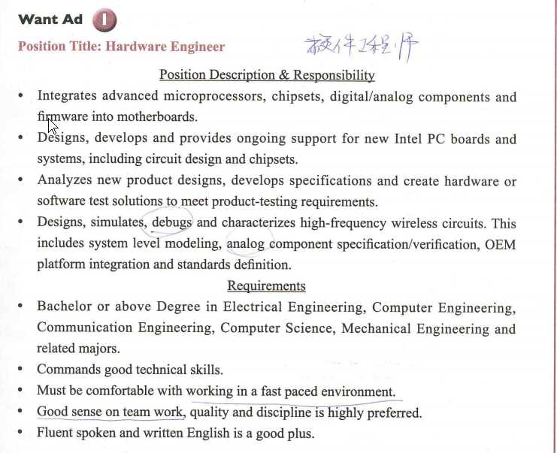
Yours Sincerely,
Zhang San

