Exercise 1:
1. Singleton Pattern (Logger)
Problem Analysis
The objective is to ensure that a logging utility maintains a single shared instance throughout the application lifecycle. This avoids inconsistent logging states and redundant object creation. The design enforces controlled access via a global access point while preventing direct instantiation.

Time Complexity
- Get Instance() : O(1)
Constant-time access to the singleton instance; initialization occurs only once.
- Log() :O(1)
Direct execution of a logging operation.

Space Complexity
- O(1)
Only one instance of the Logger exists regardless of application size.

Optimization
Using Lazy<T> ensures:
- Thread-safe initialization
- Lazy loading (object created only when needed)
- No synchronization overhead

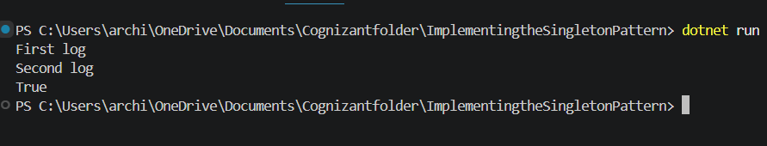

Exercise 2:
2. Factory Method Pattern (Document System)
Problem Analysis
The goal is to design a system that can create multiple types of documents (Word, PDF, Excel) without tightly coupling the client to concrete classes. The Factory Method Pattern delegates object creation to subclasses, enabling scalability and adherence to the Open/Closed Principle.

Time Complexity
- CreateDocument() → O(1)
Instantiates a specific document type in constant time.
- Open() → O(1)
Executes a simple method on the created object.

Space Complexity
- O(1) per object creation
- O(n) overall if multiple document objects are created during runtime

Optimization
- Eliminates conditional logic (if-else / switch)
- Improves extensibility (new document types added without modifying existing code)
- Promotes loose coupling between client and implementation

