**Git**

**URL :--** [**https://github.com/Archichambial10/Archi_Chambial.git**](https://github.com/Archichambial10/Archi_Chambial.git)

**Switching branch**



**Bug in registration where initially user added user details where not remove from textfield. The is fixed**

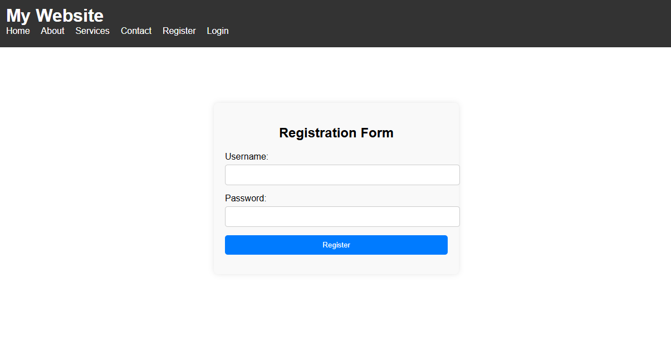

**Correction_bug in registration**

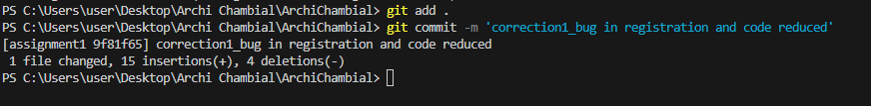

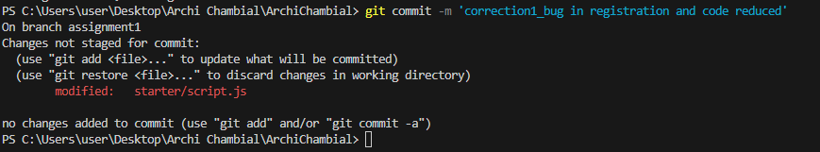

**Correction_bug in login**

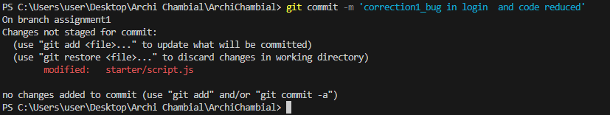

**First initial commit**

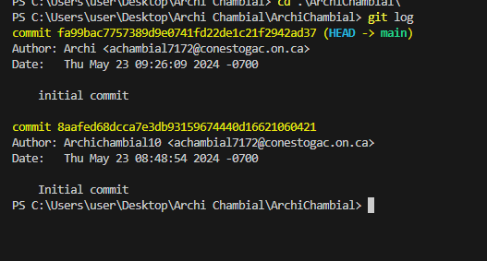

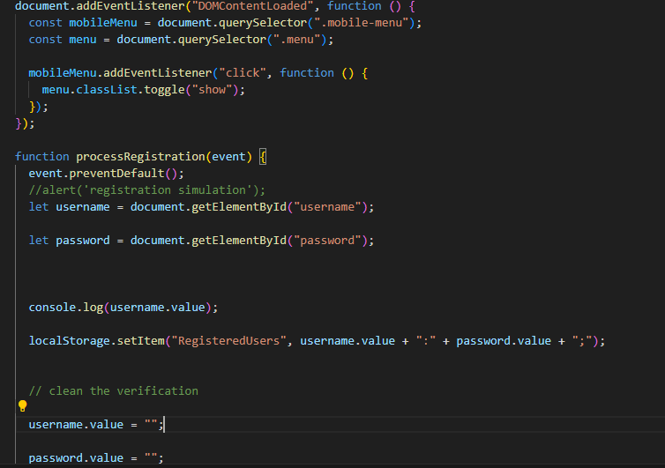

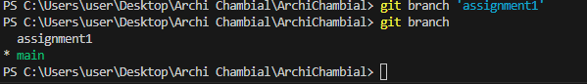

**Creating branch inlocally**



**Login bugs.**

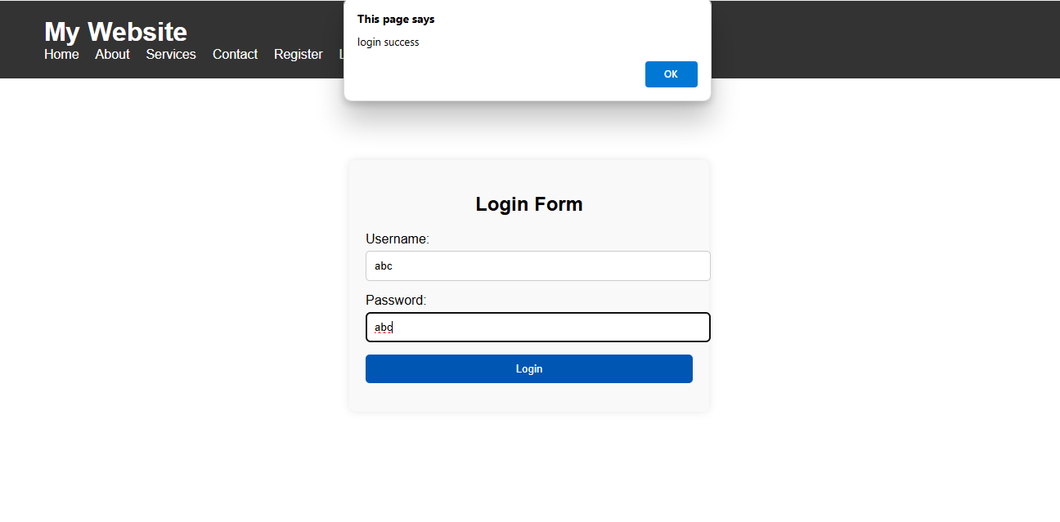**registration**

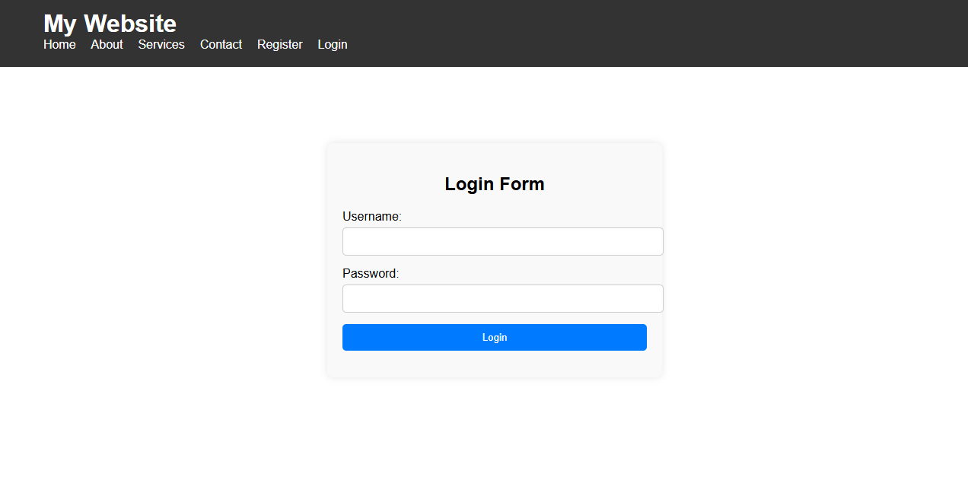

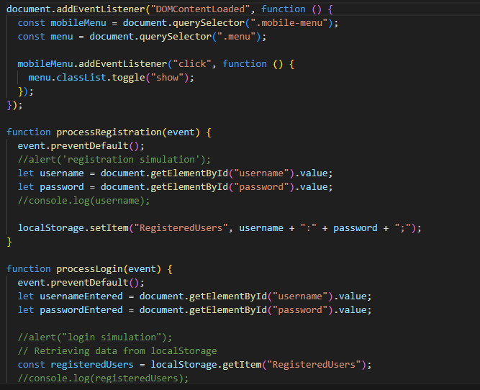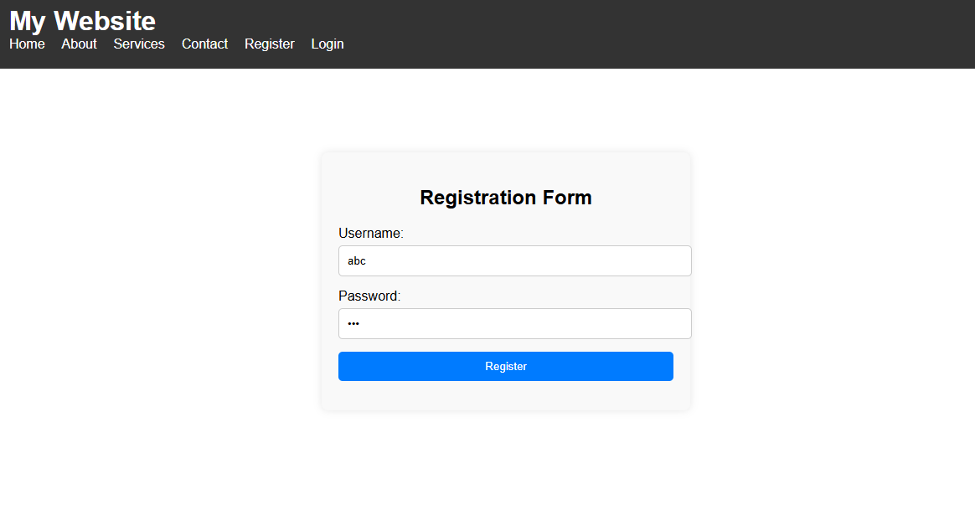

**Correction 2**

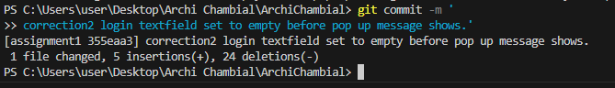

**Correction 3**

