Course: Data Structures (CSE CS203A)
Assignment V: Tree

Due date: 2025.12.30 23:59:59

Important Notice – Use of AI Tools
In this assignment, you must use at least one AI assistant (e.g. ChatGPT, Gemini, Claude, Grok, M365 Copilot) as a learning tool to help you:
- review definitions,
- compare tree variants, and
- organize your report.
You are not allowed to let the AI directly produce your final diagrams or final report content without your own understanding and rewriting.
You must log all AI prompts and services used (see “AI Usage Log” section below).

Goal of This Assignment
In the lectures, we introduced the concept of the tree as a data structure, starting from the general tree and then moving to more specialized forms.
In this assignment, you will:
- Understand and clearly define:
  - General tree
  - Binary tree
  - Complete binary tree
  - Binary search tree (BST)
  - AVL tree
  - Red-Black tree
  - Max heap
  - Min heap
- Build a hierarchy and transformation path from the general tree to these variants, and explain how each variant adds more structure or constraints.
- Use a fixed list of integers to construct multiple tree variants and visualize them.
- Choose one real-world application for each tree type and explain why that data structure fits the application.
- Practice using AI tools as study companions and keep a simple Q&A log.

Given Data
Use the following 20 integers as the input data for all your tree constructions:
37, 142, 5, 89, 63, 117, 24, 176, 58, 133, 92, 11, 151, 72, 39, 184, 7, 101, 54, 160
You will reuse this same sequence for every tree type (binary tree, complete binary tree, BST, AVL, Red-Black, max heap, min heap).

Deliverables
Please complete your work in the Student Worksheet Companion and upload it to the YZU Portal System.
Your report should include the following parts:
- Definitions (Concept Review)
Provide clear, concise definitions for each of the following:
- General tree
- Binary tree
- Complete binary tree
- Binary search tree (BST)
- AVL tree
- Red-Black tree
- Max heap
- Min heap
You are encouraged to use AI tools to help you understand these concepts, but you must rewrite the definitions in your own words.
- Hierarchy and Transformation of Tree Variants
Based on the definitions above, build a “tree family hierarchy” that shows how these structures are related. For example:
- General tree → Binary tree
- Binary tree → Complete binary tree / Binary search tree
- BST → AVL tree / Red-Black tree
- Binary tree → Max heap / Min heap
Tasks:
- Draw a diagram or flow chart that shows the transformation or specialization path:
general tree → binary tree → complete binary tree → BST → AVL/Red-Black, etc.
- For each arrow (transformation), briefly explain:
  - What new constraint or property is added?
  - e.g., “Binary tree = tree with at most 2 children per node”,
“BST = binary tree with left < root < right”,
“AVL = BST with strict height-balance rule”, etc.
- Tree Construction with the Given Integers
Using the given 20 integers, construct the following tree variants:
- Binary tree
- Complete binary tree
- Binary search tree (BST)
- AVL tree
- Red-Black tree
- Max heap
- Min heap
Important Hint / Restriction:
- For these trees, you must use tree visualization tools (e.g., online visualizers or software) to build and display the tree.
- You may not ask AI tools to directly generate the final tree pictures for you.
- Instead:
  - Use AI only to help you understand algorithms,
  - Then apply those algorithms in a visualizer (or your own implementation).
What to submit for this part:
For each tree type:
- A snapshot (image) of the constructed tree.
- The URL / name of the visualization tool you used.
- A short note on how you inserted the integers (e.g., “insert in the given order as BST”, “build max heap using heapify”, etc.).
- Application Example for Each Tree
For each of the following:
- Binary tree
- Complete binary tree
- Binary search tree (BST)
- AVL tree
- Red-Black tree
- Max heap
- Min heap
Choose one application (real-world or system-level) and explain:
- Application description
  - e.g., priority scheduling, dictionary lookup, memory allocation, database indexing, etc.
- Why this tree structure fits
  - What property of this data structure makes it suitable?
  - Example:
    - Max heap → good for priority queue because the largest element is always at the root, so extracting max is efficient.
    - Red-Black tree → good for standard library maps/sets because it guarantees O(log n) operations even under many insertions/deletions.
Your explanation should show that you understand the link between the data structure and its use case.
- Report Layout and Organization
You are free to design the layout of your report, but it should:
- Be well-structured (use sections, headings, tables, and diagrams).
- Have a clear flow from:
  - definitions →
  - hierarchy/transformation →
  - constructed trees →
  - applications →
  - AI usage log.
- Be easy for another student to read and learn from.
Feel free to use AI to suggest a good outline, but you must decide and finalize the layout yourself.
- AI Usage Log (Q&A Table)
Every time you use an AI copilot service for this assignment, record:
- Index (1, 2, 3, …)
- Prompt (what you asked)
- Service (e.g., ChatGPT, Gemini, Copilot, …)
Example log table:
Index | Prompt | Service
1 | Assist me to have the definition of general tree, binary tree, complete binary tree, binary search tree, AVL tree, red-black tree, max heap and min heap for self-learning. | ChatGPT
2 | Explain the difference between AVL tree and Red-Black tree in terms of balancing strategy and use cases. | Gemini
… | … | …
Place this table at the end of your report.

Evaluation (100 pts)
A possible breakdown (you can adjust if needed):
- Concept definitions (20 pts)
  - Correctness and clarity of all 8 tree type definitions.
- Hierarchy & transformation explanation (20 pts)
  - Clear diagram / explanation of how each tree variant evolves from the general tree.
  - Correct identification of constraints/invariants.
- Tree constructions & visualizations (25 pts)
  - Correct constructions for each tree type using the given integers.
  - Proper screenshots and tool URLs.
  - Consistent insertion / heap-building strategy descriptions.
- Applications & explanations (20 pts)
  - One application per tree type.
  - Clear explanation linking data structure properties to the application.
- Report organization & AI usage log (15 pts)
  - Logical report structure and readability.
  - AI log completeness (all prompts listed with service names).
  - Thoughtful use of AI as a learning assistant, not as a copy-paste generator.

Course: Data Structures (CSE CS203A)
Assignment V: Tree
Student Worksheet Companion

Due date: 2025.12.30 23:59:59

Academic Integrity and AI Usage Statement
In this assignment, you must use AI tools (such as ChatGPT, Gemini, Claude, Grok, M365 Copilot, etc.) as learning assistants, but you must also take full responsibility for understanding and organizing your own work.

Permitted Use of AI Tools
You may use AI to:
- Review or clarify definitions and concepts.
- Compare different tree data structures.
- Get suggestions for report layout or examples.
- Ask for explanations of algorithms (e.g., BST insertion, AVL rotation, heapify process).
You should read, think about, and rewrite the content in your own words.

Not Permitted
- Do not copy/paste AI-generated content directly as your final answer.
- Do not ask AI to draw the final diagrams or directly produce the final tree screenshots.
- Do not ask AI to complete the whole assignment report for you.

Your Responsibility
- You are responsible for understanding the definitions and algorithms.
- You are responsible for verifying whether AI answers are correct or not.
- You must produce your own original explanations and diagrams.

AI Usage Log
- You must record all AI queries related to this assignment.
- At the end of your report, include an AI Usage Log table with: Index, Prompt, AI service name.
By submitting this assignment, you acknowledge that you have used AI tools only as study aids, and that the final content of this assignment represents your own understanding and work.

Section 1. Definitions of Tree Variants
Task: Write your own definitions for each tree type. You may use AI for learning, but rewrite in your own words.
- General Tree
Definition: 一種樹狀資料結構，每個節點可以有任意數量的子節點，沒有規則限制
- Binary Tree
Definition: 每個節點最多只能有兩個子節點，分為左子樹與右子樹
- Complete Binary Tree
Definition: 除了最後一層外，其餘每一層都填滿節點
- Binary Search Tree (BST)
Definition: 一種binary tree，具規則左子樹所有節點值 < 根節點，右子樹所有節點值 > 根節點
- AVL Tree
Definition: 一種自平衡二元搜尋樹，要求任一節點左右子樹高度差 ≤ 1
- Red-Black Tree
Definition: 一種自平衡 BST，透過「顏色規則」維持近似平衡
- Max Heap
Definition: 一種完全二元樹，具規則：每個父節點 ≥ 子節點
- Min Heap
Definition: 一種完全二元樹與 Max Heap相反 具規則：每個父節點 ≤ 子節點

Section 2. Tree Family Hierarchy and Transformations
Task: Show how these structures are related (general → specialized). Use a simple diagram and explanations of what constraints are added at each step.
2.1 Tree Family Diagram
You may draw this by hand and paste a photo, or use drawing tools.
Suggested chain example (you may extend or adjust):
General Tree → Binary Tree → Complete Binary Tree
Binary Tree → Binary Search Tree → AVL / Red-Black
Binary Tree → Max Heap / Min Heap
Your Diagram:
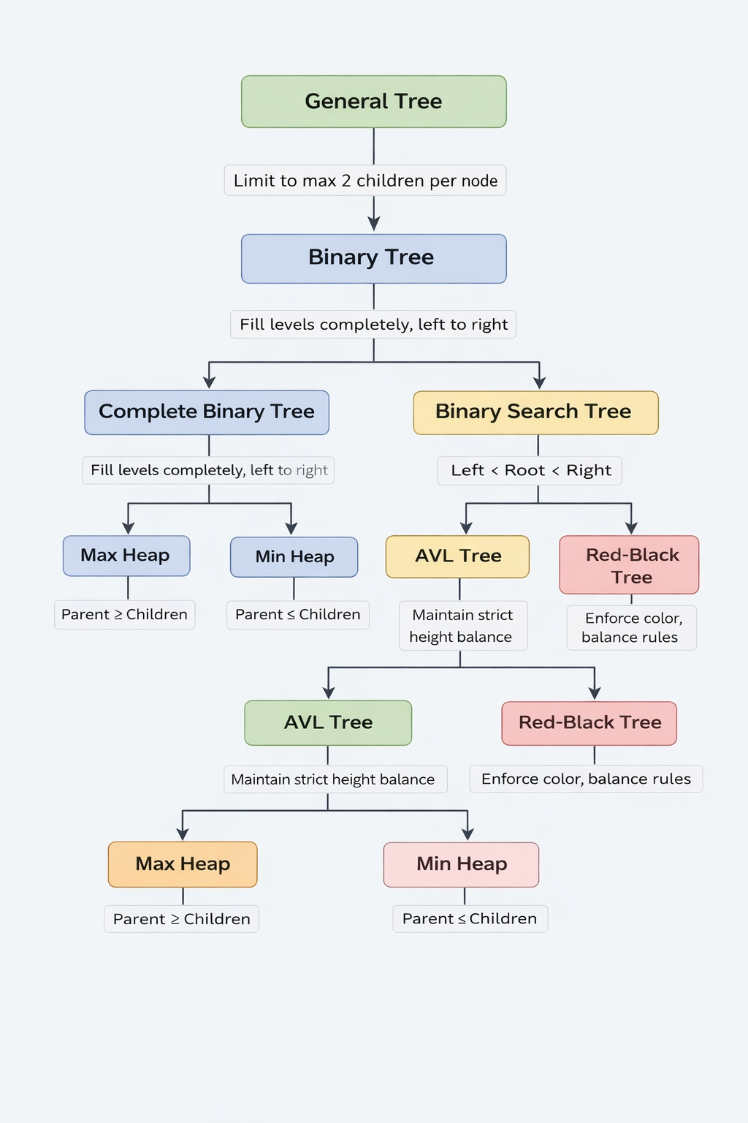

2.2 Explanation of Transformations
Fill in what new property or constraint is added at each step.
From | To | New property / constraint added
General Tree | Binary Tree | 限制degree數，degree<=2
Binary Tree | Complete Binary Tree | 除了最後一層外，其餘每一層都填滿，且最後一層的節點 由左至右依序填入
Binary Tree | Binary Search Tree | 左子樹所有節點值 < 根節點，且右子樹所有節點值 > 根節點
BST | AVL Tree | 任一節點左右子樹高度差 ≤ 1
BST | Red-Black Tree | 具顏色規則:節點非紅即黑;根節點為黑;紅節點不能有紅子節點;任一路徑黑節點數相同
Binary Tree | Max Heap | 每個父節點 ≥ 子節點
Binary Tree | Min Heap | 每個父節點 ≤ 子節點

Section 3. Tree Constructions Using Given Integers
Given integers (fixed for all parts):
37, 142, 5, 89, 63, 117, 24, 176, 58, 133, 92, 11, 151, 72, 39, 184, 7, 101, 54, 160
Task: For each tree type below, construct the tree using these integers, take a screenshot of the tree from your chosen tool, record the tool name/URL, and describe the insertion / heap-building procedure.
3.1 Binary Tree
Tool name / URL:
ChatGPT

Construction / insertion description:
每個節點最多兩個子節點，依照給定整數順序插入，插入時「由左到右」填滿子節點位置
插入順序只影響結構，不考慮數值大小

Screenshot of Binary Tree (paste below):
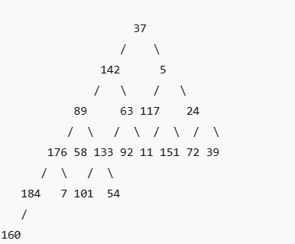

3.2 Complete Binary Tree
Tool name / URL:
ChatGPT

Construction / insertion description:
除最後一層外皆填滿，且最後一層依整數順序由左到右插入，不做任何比較或交換

Screenshot of Complete Binary Tree (paste below):
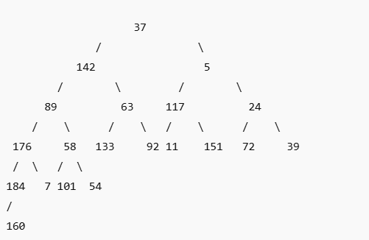

3.3 Binary Search Tree (BST)
Tool name / URL:
https://www.cs.usfca.edu/~galles/visualization/BST.html

Insertion rule (e.g., “insert in given order using BST rules”):
依給定整數順序插入，具規則：左子樹 < 父節點且右子樹 > 父節點，另不進行平衡調整

Screenshot of BST (paste below):
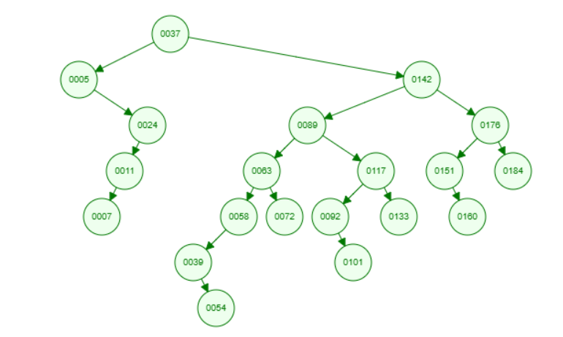

3.4 AVL Tree
Tool name / URL:
https://www.cs.usfca.edu/~galles/visualization/AVLtree.html

Insertion & balancing description:
先依 BST 規則插入節點
插入後檢查左右子樹高度差，若 |高度差| > 1，執行各種旋轉(LL、RR、LR、RL rotation)

Screenshot of AVL Tree (paste below):
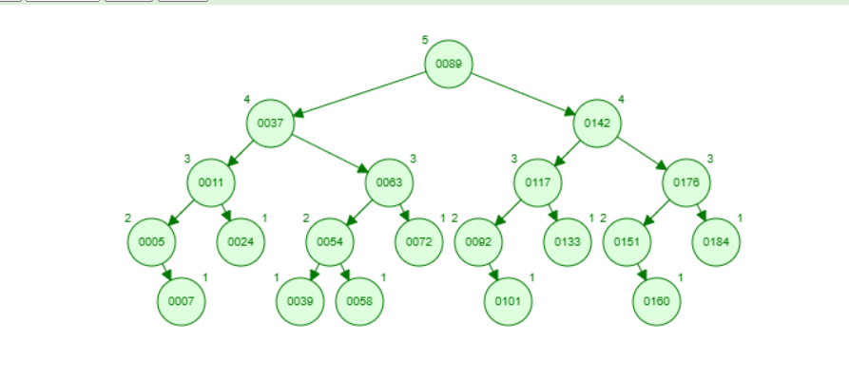

3.5 Red-Black Tree
Tool name / URL:
https://www.cs.usfca.edu/~galles/visualization/RedBlack.html

Insertion & balancing description:
依 BST 規則插入新節點（新節點初始為紅色），依紅黑樹性質進行：顏色翻轉（recoloring）、左旋 / 右旋，維持紅黑樹性質
Screenshot of Red-Black Tree (paste below):
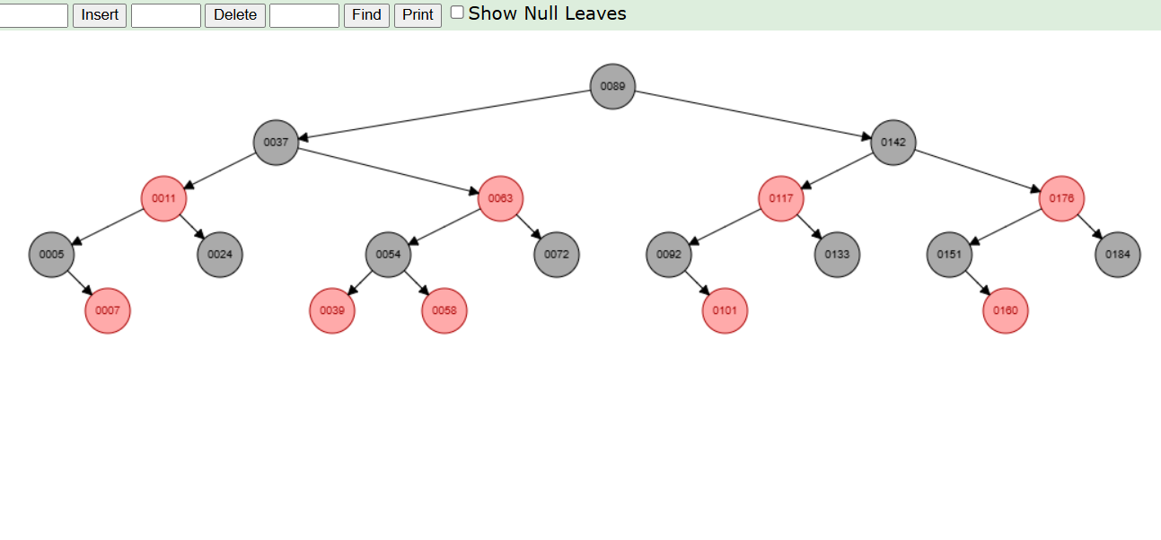

3.6 Max Heap
Tool name / URL:
https://www.cs.usfca.edu/~galles/visualization/Heap.html

Construction / heap-building description (e.g. heapify, insert-and-sift-up):
每次插入到最底層最左邊，若子節點 > 父節點，向上交換維持：完全二元樹父節點 ≥ 子節點

Screenshot of Max Heap (paste below):
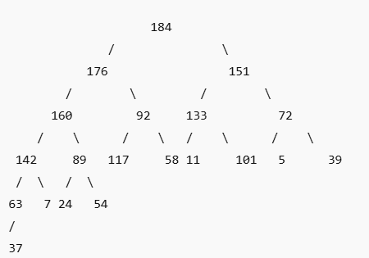

3.7 Min Heap
Tool name / URL:
https://www.cs.usfca.edu/~galles/visualization/Heap.html

Construction / heap-building description:
插入到最底層最左側，若子節點 < 父節點，向上交換維持：完全二元樹父節點 ≤ 子節點

Screenshot of Min Heap (paste below):
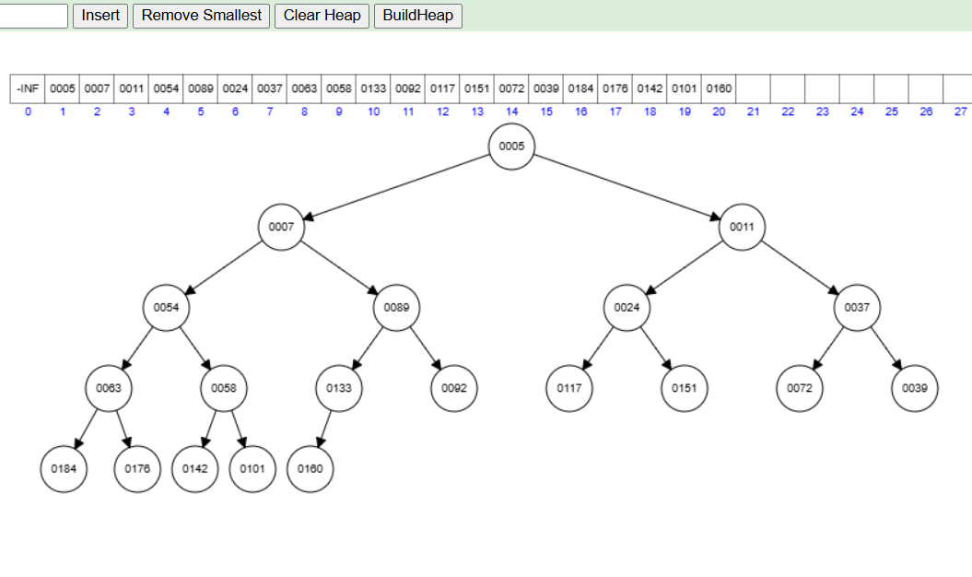

Section 4. Application Examples
Task: For each tree type, choose one application and explain why this tree is suitable.
Tree Type | Application Example (name / context) | Why this tree fits (properties that matter)
Binary Tree | 運算式樹（Expression Tree） | 可透過order順序代表運算符號權重
Complete Binary Tree | Heap 底層結構 | 空間效率高
Binary Search Tree | 資料庫索引 | 已被排序過，可快速搜尋
AVL Tree | 即時查詢系統 | Level上有做過調整，故搜尋時間穩定
Red-Black Tree | C++ map、set | 插入刪除頻繁仍高效
Max Heap | 工作排 | 快速取得最大值
Min Heap | Dijkstra 最短路徑 | 每次取最小距離節點

Section 5. Reflection on Tree Family and Performance (Optional but recommended)
Among BST, AVL, and Red-Black trees, which one would you pick for:
Mostly search (few updates)? Why?
AVL tree.
由於AVL tree的特性任一節點左右子樹高度差 ≤ 1，樹高較小，在搜尋時平均時常較小，提供穩定的查詢效能
Frequent insertions and deletions? Why?
Red-Black tree.
在Red-Black tree中的規則可避免在插入和刪除時有過多的旋轉，調整成本較低

If you must store these 20 integers for static search only (no updates), which structure or representation would you prefer (sorted array + binary search, BST, AVL, etc.)? Why?
sorted array + binary search.
在資料量小、不需要插入、刪除 實作最簡單、常數時間小

Section 6. AI Usage Log (Required)
Task: Record every time you ask an AI assistant about this assignment.
Index | Date / Time | AI Service (ChatGPT, Gemini, etc.) | Your Full Prompt / Question
1 | 12/21 | ChatGPT | Assist me to have the definition of general tree, binary tree, complete binary tree, binary search tree, AVL tree, red-black tree, max heap and min heap.
2 | 12/22 | ChatGPT | Give me some applications about general tree, binary tree, complete binary tree, binary search tree, AVL tree, red-black tree, max heap and min heap
3 | 12/25 | ChatGPT | Give me tool/URL about general tree, binary tree, complete binary tree, binary search tree, AVL tree, red-black tree, max heap and min heap
4 | 12/26 | ChatGPT | 用37, 142, 5, 89, 63, 117, 24, 176, 58, 133, 92, 11, 151, 72, 39, 184, 7, 101, 54, 160按照此順序輸入，幫我畫出Binary Tree、 Complete Binary Tree、 Max Heap
You may extend this table as needed.

