REQUIREMENTS FOR WEBSITE KREDITTSENTRALN AS.

**ABOUT US**

The structure of the website requires that several requirements fullfill. In this way, as a user and owner of "Kredittsentralen AS", I will provide loans to other finance agents in the field of consumer loan and refinancing of existing consumer loans and expensive credit card debt with an average nominal interest rate of well over 22%. We in "Kredittsentralen AS" are a comparison service that ensures that your loan application is rated from 15 different banks completely unconditionally and free of charge. It is important that you, as a customer, take an assessment with several banks, as the interest rate can vary widely for each bank. Through close follow-up with the customer, we will keep the customer informed and assist in submitting information from the start to payout.

**HOW DOES THE WEBSITE WORK?**

When a customer clicks on my website, it should be clear how easy it is to apply for refinancing of existing debt as expensive consumer loans and credit card debt. The website will consist of simple design with a comparison calculator (fast nominal interest rate of 13%, effective interest rate of 15%). This example that appears on the calculator will have a "slide-bar" where you can choose from 1 - 15 years, the desired loan amount, and will calculate what the month's cost will be over the chosen term. Furthermore, it will appear that the customer must be able to enter the email address and telephone number to proceed from the "SEARCH" buttons and to the contact form. When the customer arrives at the contact form, the customer will have to enter the rest of the contact information, such as the national ID number, housing situation, existing debt items, purpose etc. When the customer has added this to the contact form, the customer must tick off to have "read and understood" our terms and tick off if customer wants newsletter. The customer must read and accept "Kreidttsentralen AS" terms in order to proceed to the submission of the application. Customer can optionally tick off if customer wants to receive newsletter or not The customer will now be able to submit an application. This application should come to us and through the API to our partners and be mapped over in a safe and clear manner.

***I add pictures where I have translated into English on how I wish our website should look.***

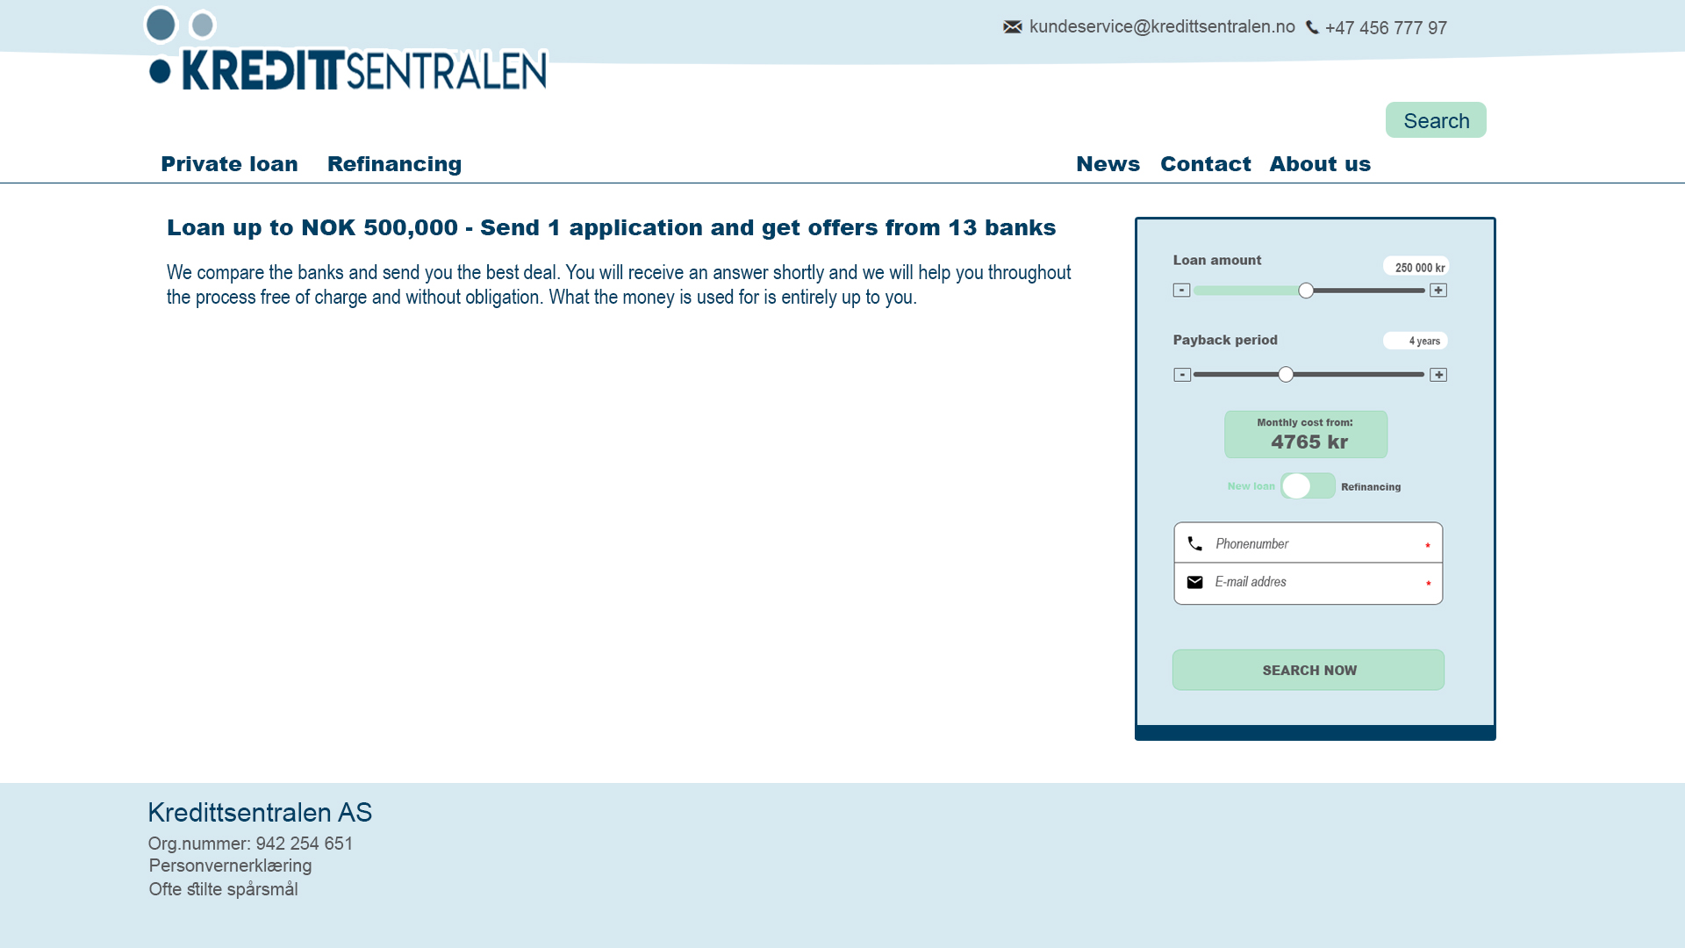

Here we see that on the "loan calculator" you can enter contact information such as e-mail address and telephone number, and then get to the contact form where the customer must enter. "By clicking on" Private loan "then you will be able to get information about what" private loan " is, what criteria each customer must meet in order to apply and of course easily apply for a" private loan ".

By clicking on "Refinancing" you will be able to get information about what this entails and good examples of how much you can actually save by refinancing. Here we see different scenarios so that the customer will feel hit.

By clicking on "News" you will get new updates in the field of private economy, good instructions and free templates will also be posted so that customers can easily stay up to date.

***This is the Contact form:***

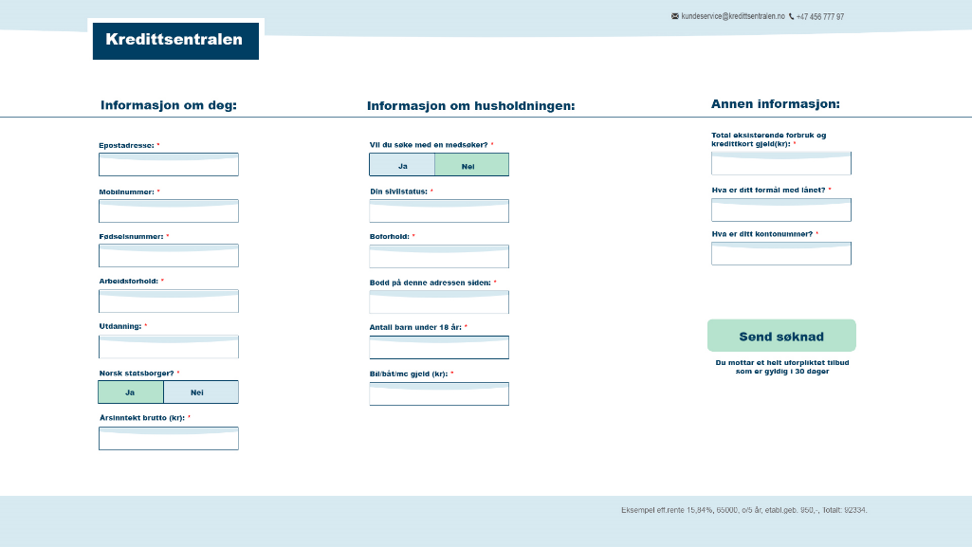

In the contact form customer has to fill out personal information, information about household and existing debt information. Here the custumer would apply for private loan and refinansiering by clicking “Send Sønkad (Apply for loan)”

As mentioned earlier, the application form is an important tool for us - and must therefore make it optimal for the customer and for us that contact information ends up with our partner through the API.

This was quickly through the process. Ask any questions you have so that we can clarify it and get started with the project. We must also discuss the price. So feel free to consider what this project will cost.

With best regards,

Arton Vladi

*Oslo, Norway*

Kredittsentralen AS