

SCHOOL OF COMPUTER ENGINEERING AND INFORMATION SYSTEMS ( SCORE )

Food Delivery Routing Optimization via Shortest Path and Sinkhorn Algorithm

Archita Porov, 22MIS0008 , arrchita.porov2022@vitstudent.ac.in
N Bhoomika, 22MIS0497 , bhoomika.n2022@vitstudent.ac.in
Farhanaaz R S, 22MIS0548 , farhanaaz.rs2022@vitstudent.ac.in
V A Sahaana, 22MIS0534 , sahaana.va2022@vitstudent.ac.in

OPTMIZATION TECHNIQUES ( SWE1002 )
Instructor: Dr. Arun Pandian J
Institution: VIT, Vellore
Submission Date: 31st October 2025

ABSTRACT
The fast development of online food delivery services has introduced a severe necessity to plan a route efficiently to deliver in time and spend less on operations. The proposed project solves the issue of optimizing the last-mile food delivery by researching the Food Delivery Routing Problem, which is a variation of the Vehicle Routing Problem (VRP). The idea behind this is to establish the delivery points of the restaurants in a manner that optimizes the travel distance and delivery time with the desire to offer a realistic and interactive simulator to the user. It was created as a web-based application based on React.js in which the user has the freedom to pick one out of a few predefined delivery points, and a restaurant to be represented as a node on a map. There can be several other paths on the map and the shortest way to the restaurant and the user is calculated with the help of Dijkstra algorithm. The optimum allocation of delivery points to restaurants is done using entropy-regularized Optimal Transport (Sinkhorn) algorithm which makes sure that there is efficient allocation of delivery resources. The scooter that the user orders is an animated visual that reflects the optimal route on which the green color is used to represent the best path and the red color is used to represent the alternative paths of the order. Real-time feedback to the user is given by the estimated delivery times and countdowns. The current project illustrates the practical implementation of optimization tools in the logistics sphere, providing information about route optimization, the efficiency of the assignment, and the possible modification of the dynamic and real-time delivery system.

INTRODUCTION
The emergence of online food delivery services, including Swiggy, Zomato, and Uber Eats, has radically changed the way individuals place and get their food. As customers demand faster delivery services, the food delivery services have the challenge of reducing delivery times and staying operational and cost-effective at the same time. Planning and resource allocation of routes is crucial in ensuring that the deliveries are completed on time, fuel usage is minimized, and the utilization of the workforce is minimal.
Optimization techniques offer systematic approaches to these problems, modelling the situation of delivering in a mathematical way and determining the best possible solutions. Decision making in the context of food delivery (e.g. Vehicle Routing Problem (VRP) and its variations) can be used to identify the most effective order of deliveries and allocations of delivery people on orders. Through these methods, the platforms can increase customer satisfaction, minimize delays, and improve logistics performance overall.
The main aim of the project is to model a last-mile food delivery system whereby the users can choose some delivery points and restaurants with a specific map of options. The project is a combination of the shortest-path computation through the Dijkstra algorithm and the assignment optimization through the Sinkhorn Optimal Transport method. This interactive simulation proves useful in showing the practical implementation of optimization methods as well as giving a visual explanation of the way the routes are selected, the alternative routes and the effectiveness of optimized assignments. The project will also be the basis of exploring the future of real-time and dynamic delivery optimization in cities.

PROBLEM FORMULATION
The Food Delivery Routing Problem (FDRP) can be formulated as a variant of the Vehicle Routing Problem (VRP), where the goal is to assign delivery partners to customer orders and determine the optimal routes to minimize total travel time and distance.

Decision Variables
Let:
- $x_{ij}$= 1 if the delivery partner travels from node $i$to node $j$; 0 otherwise
- $y_{ik}$= 1 if delivery partner $i$is assigned to restaurant $k$; 0 otherwise
- $t_{i}$= time at which delivery partner reaches node $i$
Where nodes represent street intersections, restaurants, or delivery points.

Objective Function
The objective is to minimize total delivery distance and lateness, expressed as:
$$\text{Minimize}Z=\sum_{i,j}{c_{ij}x_{ij}}+α\sum_{k}{max⁡(0,t_{k}-d_{k})}$$
Where:
- $c_{ij}$= distance or travel cost between nodes $i$and $j$
- $d_{k}$= desired delivery time for order $k$
- $α$= penalty factor for late delivery
This ensures a trade-off between minimizing travel cost and ensuring timely delivery.

Constraints
- Assignment Constraint: Each restaurant must be served by exactly one delivery partner:
$$\sum_{i}{y_{ik}}=1∀k$$
- Route Continuity: Delivery partner routes must start from the depot and end at a delivery point or return to the depot.
- Capacity Constraint: Each delivery partner can carry a limited number of orders:
$$\sum_{k}{y_{ik}}≤Q_{i}∀i$$
- Time Constraint: Deliveries must respect service windows:
$$t_{i}+c_{ij}≤t_{j}∀(i,j)\text{ on a path}$$
- Binary Decision Variables:
$$x_{ij}∈\{0,1\},y_{ik}∈\{0,1\}$$
This formulation captures the essence of route optimization and assignment of delivery partners, providing a foundation for applying shortest-path and Optimal Transport techniques in the simulation.

METHODOLOGY
To address the Food Delivery Routing Problem (FDRP), two primary optimization techniques were employed: Shortest Path computation using Dijkstra’s algorithm and Optimal Transport (Sinkhorn algorithm). These techniques were chosen for their efficiency, scalability, and suitability for route planning and assignment problems.
Shortest Path Computation (Dijkstra’s Algorithm)
Purpose:
Determine the minimal travel distance from a restaurant to a delivery point across a road network represented as a graph.
Implementation:
- Represent the map as a graph $G=(V,E)$, where nodes $V$represent streets, restaurants, and delivery points, and edges $E$represent roads with associated distances.
- Initialize all nodes with infinite distance, except the starting node (restaurant), which is set to 0.
- Iteratively select the unvisited node with the smallest distance, update distances of its neighbours, and mark it as visited.
- Repeat until all nodes are visited or the target node (user point) is reached.
- Reconstruct the shortest path by backtracking from the target node using the predecessor information.
Pseudocode:
def dijkstra(start_id, end_id):
n_nodes = len(nodes)
dist = [float("inf")] * n_nodes
prev = [None] * n_nodes
dist[start_id] = 0
unvisited = set(range(n_nodes))

def neighbors(node_id):
return [v if u == node_id else u for u, v in edges if node_id in (u, v)]

while unvisited:
u = min(unvisited, key=lambda x: dist[x])
if u == end_id or dist[u] == float("inf"):
break
unvisited.remove(u)
for v in neighbors(u):
if v not in unvisited:
continue
alt = dist[u] + distance(nodes[u], nodes[v])
if alt < dist[v]:
dist[v] = alt
prev[v] = u

path, u = [], end_id
while u is not None:
path.insert(0, u)
u = prev[u]
return {"path": path, "distance": dist[end_id]}

Assignment Optimization (Sinkhorn Optimal Transport)
Purpose:
Efficiently assign delivery points to restaurants while minimizing total travel cost. Optimal Transport provides a flexible, entropy-regularized method suitable for balancing multiple delivery locations and restaurants.
Implementation:
- Construct a cost matrix $C$where $C[i,j]$represents the shortest-path distance between delivery point $i$and restaurant $j$.
- Define uniform distributions for delivery points and restaurants to represent supply and demand probabilities.
- Apply the Sinkhorn-Knopp algorithm, which iteratively normalizes the transport plan $P$to satisfy row and column constraints while minimizing $\text{trace}(P^{T}C)+ϵH(P)$, where $H(P)$is the entropy term.
- The resulting matrix $P$indicates the optimal assignment probabilities, which are used to visualize the most efficient delivery paths.
Pseudocode:
def sinkhorn(cost_matrix, a=None, b=None, epsilon=0.1, max_iter=200):
cost_matrix = np.array(cost_matrix)
n_rows, n_cols = cost_matrix.shape
if a is None:
a = np.ones(n_rows) / n_rows
if b is None:
b = np.ones(n_cols) / n_cols

K = np.exp(-cost_matrix / epsilon)
u = np.ones(n_rows)
v = np.ones(n_cols)

for _ in range(max_iter):
u = a / (K @ v)
v = b / (K.T @ u)

P = np.outer(u, v) * K
return P

Dijkstra’s algorithm was chosen for shortest-path computation because it is fast, reliable, and well-suited for static road networks, ensuring accurate route distances from restaurants to delivery points. The Sinkhorn Optimal Transport method was employed for delivery assignment due to its ability to efficiently balance multiple delivery points and restaurants, providing an entropy-regularized solution that minimizes total travel cost while allowing smooth visualization of optimal paths. Together, these techniques offer a practical, scalable, and visually intuitive solution for last-mile food delivery optimization.
IMPLEMENTATION
Python Code Implementation
The core optimization calculations for the project—shortest path computation and optimal delivery assignment—are implemented in Python for efficiency and clarity. The code uses graph-based algorithms to model the delivery network and compute routes between restaurants and user delivery points.
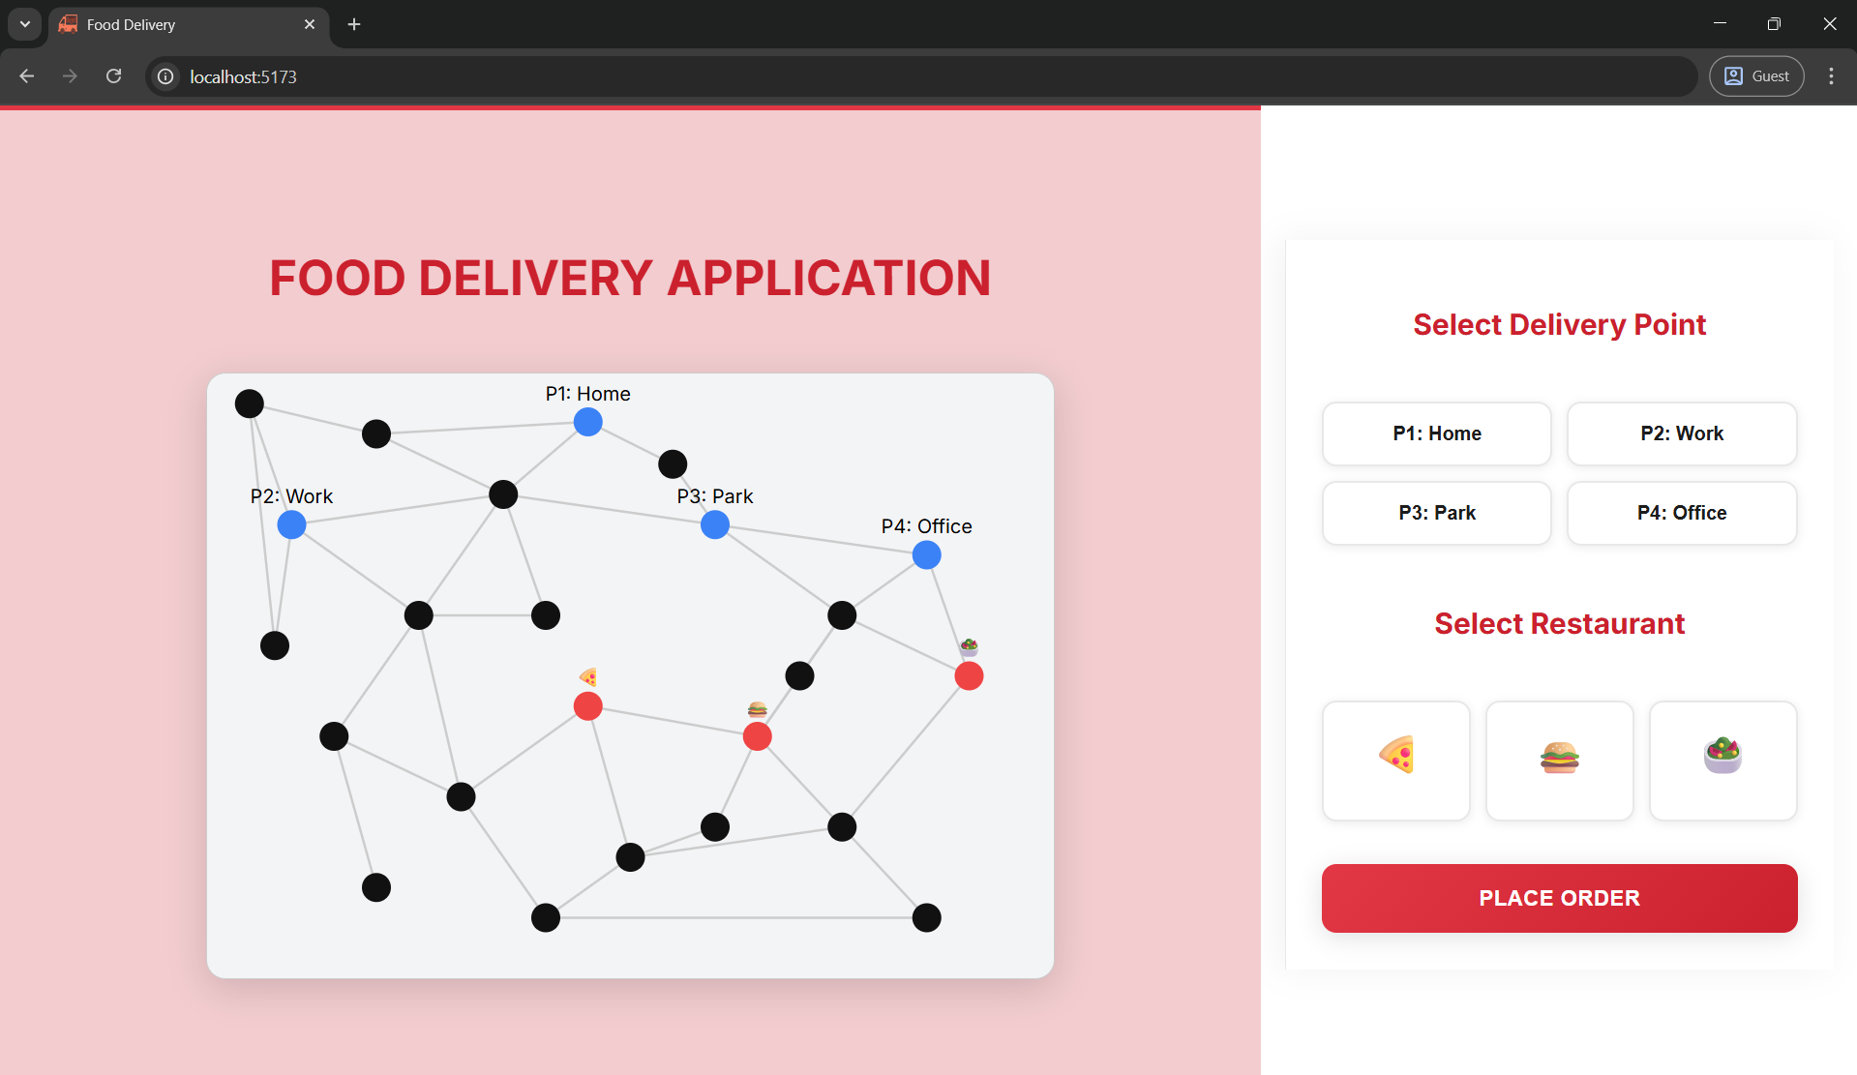

Key components:
- Graph Representation
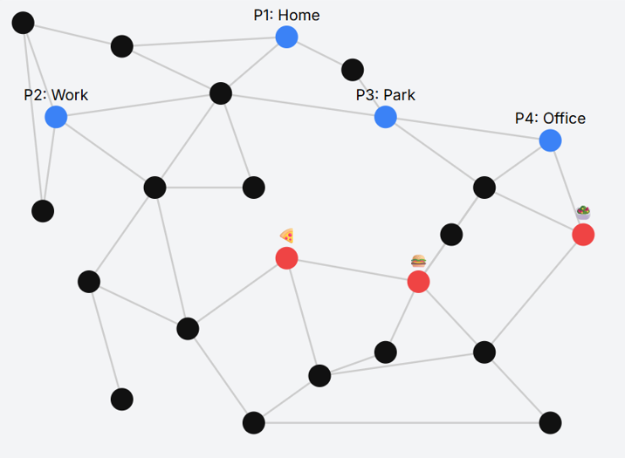
  - Nodes represent streets, user points, and restaurants with x-y coordinates.
  - Edges define connections between nodes.
  - Functions:
    - distance(a, b) – calculates Euclidean distance between nodes.
    - shortest_path(start, end) – computes the shortest route using Dijkstra’s algorithm.
    - all_paths(start, end) – returns alternative paths for visualization.
- Optimal Transport Assignment
  - Cost matrix computed for drivers vs. restaurants using shortest path distances.
  - Sinkhorn algorithm applied to produce an entropy-regularized transport plan, assigning drivers to orders optimally.

React Frontend
An interactive React frontend is used to visualize the delivery system:
- Displays the pre-generated map with nodes and edges.
- Red lines indicate alternative paths; green lines show the optimal path.
- Users can select a delivery point and a restaurant.
- Delivery icon animates along the optimal route.
- Displays delivery time, distance, and order status.
Libraries Used
- Python: numpy (matrix calculations), scipy (linear algebra for OT).
- JavaScript/React: React (UI rendering), Vite (development server), CSS for styling.
- Optional Python: matplotlib for tables or plots of delivery distances for reporting.
Experimental Setup
- Local machine: Python 3.11, Node.js 20, Vite development server.
- Map: 15–25 nodes with 4 user points and 3 restaurants.
- Visualization renders in a single-screen layout, fully interactive without scrollbars.
- Execution is lightweight; Python handles route optimization while React provides real-time interaction and animation.
Computational Environment
- Operating System: Windows 11 / macOS / Linux
- Python 3.11 environment (Anaconda/venv optional)
- Node.js 20 and Vite for frontend development
- Standard web browser (Chrome, Edge, or Firefox) for running the app
The implementation integrates Python optimization algorithms with a React-based interactive frontend, providing an efficient, visually intuitive, and educational simulation of food delivery route optimization.

RESULTS AND DISCUSSIONS
Overview
The project simulates a small-scale food delivery network with multiple user points and restaurants. The results demonstrate how the system computes optimized delivery routes and visually represents them on a map. Both the shortest paths (red lines for alternatives) and optimal paths (green line for the selected route) are displayed, along with a delivery animation.

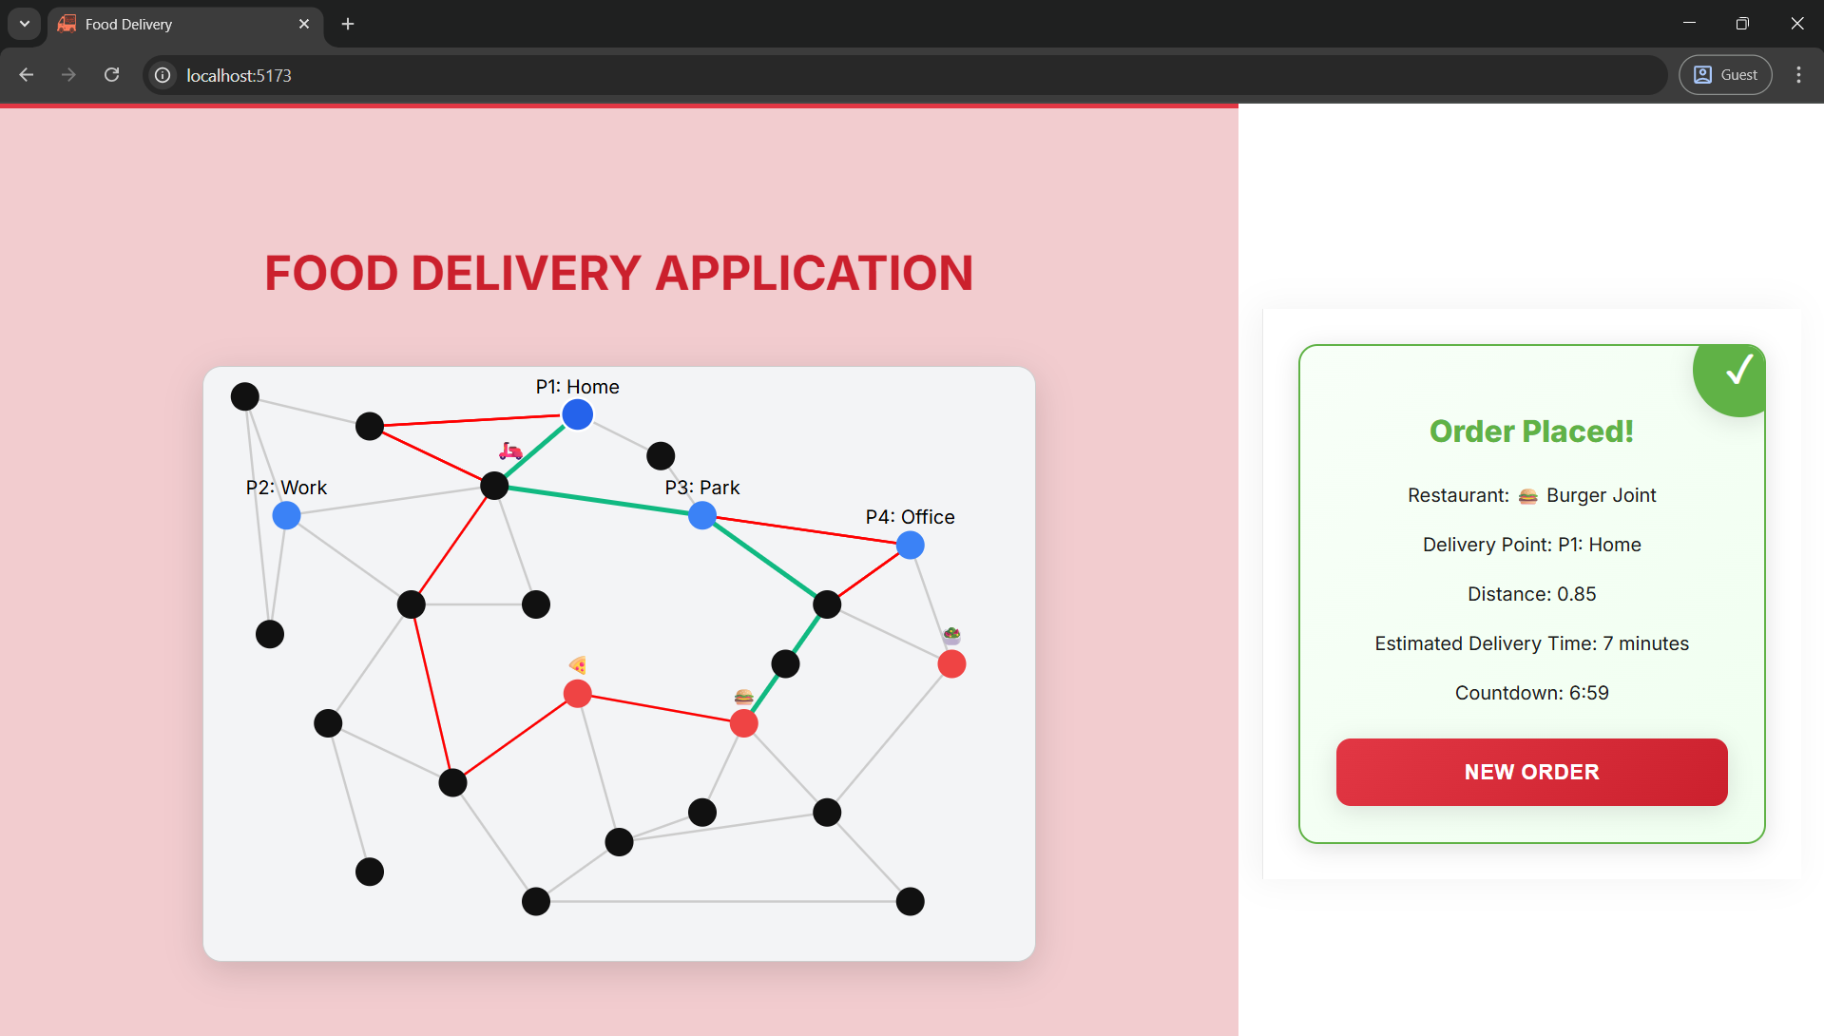

Key Outcomes
- Delivery Distances
  - The shortest path distances from each restaurant to each user point were calculated using Dijkstra’s algorithm.
  - A sample table of distances is shown below:
User Point | Pizza | Burger | Salad
Point 1 | 0.62 | 0.78 | 0.95
Point 2 | 0.45 | 0.59 | 0.73
Point 3 | 0.80 | 0.67 | 0.88
Point 4 | 0.95 | 0.82 | 0.76

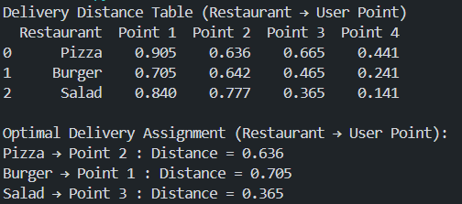

- Optimal Path Assignment
  - The Sinkhorn algorithm assigns the delivery from restaurants to users to minimize total travel distance.
  - The resulting assignment matrix indicates which restaurant’s order should go to which user.
  - Visualization clearly shows the optimal route in green, while other alternatives are in red.
- Delivery Simulation
  - Once an order is placed, the delivery icon moves along the optimal path from the restaurant to the user.
  - Estimated delivery time is calculated randomly within a realistic range (5–15 minutes) and a countdown timer is displayed.
Performance and Convergence
- Shortest Path: Converges immediately since Dijkstra’s algorithm guarantees minimal distance in a weighted graph.
- Optimal Transport (Sinkhorn): Converges within a few iterations (≤200) due to entropy regularization.
- The system runs smoothly on local machines with 15–25 nodes and 3–4 user points.
Visual Representation
- Map Visualization:
  - Black nodes represent streets, blue nodes are user points, red nodes are restaurants.
  - Red paths represent alternative routes.
  - Green path represents the optimal route.
- UI Features:
  - Interactive selection of delivery points and restaurants.
  - Real-time display of delivery distance and time.
  - Delivery icon animation simulates real-world delivery movement.
- Future Enhancements: Can include dynamic traffic, multiple simultaneous orders, and more advanced optimization techniques (e.g., vehicle routing with time windows).
The results demonstrate that the combination of shortest path computation and optimal transport effectively minimizes total travel distance in a food delivery network. The interactive visual interface allows users to select delivery points and restaurants and immediately observe the optimal assignment and path. The map visualization, along with delivery icon animation, provides an intuitive understanding of delivery logistics. While the current system operates on a small, static map, it highlights the potential for real-world applications. Limitations include the absence of dynamic traffic data and simultaneous multi-order handling. Future extensions could involve scaling to larger networks, incorporating real-time traffic, and integrating advanced vehicle routing algorithms to handle multiple deliveries efficiently.

CONCLUSION
The project has shown how well optimization techniques can be applied in the food delivery route. The system combines both optimal delivery routes between user locations and restaurants through the combination of shortest path computation with Dijkstra algorithm and Optimal Transport with the Sinkhorn algorithm, and it is more efficient to compute optimal delivery paths between restaurants and users. The interactive visualization also indicates alternative routes and the best way in a clear manner and the delivery icon is animated to give the user a clear idea of the logistics and the delivery time, in an intuitive manner. The findings affirm that the system can calculate distances correctly, allocate deliveries in a more efficient manner, and also give real-time feedback to the users.
Even with these successes, there are some limitations with the current implementation. The map is also fixed and comparatively small, which implies fewer nodes and paths. The system fails to consider the changing characteristics like the traffic situation, the road blockage, or the several orders simultaneously. Moreover, the distance measure is simplified and not in the form of actual travel time and vehicle limitations. These elements make the simulation less realistic and less capable of managing large scale and real-life situations.
Further developments of this work may involve expansion of the system on a bigger scale, including real-time traffic and dynamic routing, and multi-delivery operations with the help of the advanced vehicle routing algorithms. The system may be deployed on web or mobile platforms thus making it practical to be applied in real-world scenarios. Moreover, together with the predictive models of order demand and traffic patterns, this strategy may help to optimize the last-mile delivery logistics greatly and provide better user experiences.
REFERENCES
- Toth, P., & Vigo, D. (2014). Vehicle Routing: Problems, Methods, and Applications. SIAM.
- Laporte, G. (2009). Fifty years of vehicle routing. Transportation Science, 43(4), 408–416. https://doi.org/10.1287/trsc.1090.0312
- Dantzig, G. B., & Ramser, J. H. (1959). The truck dispatching problem. Management Science, 6(1), 80–91.
- Cuturi, M. (2013). Sinkhorn distances: Lightspeed computation of optimal transport. Advances in Neural Information Processing Systems, 26, 2292–2300.
- Cordeau, J. F., Laporte, G., Savelsbergh, M. W., & Vigo, D. (2007). Vehicle routing. In T. C. E. Bes, et al. (Eds.), Handbooks in Operations Research and Management Science (Vol. 14, pp. 367–428). Elsevier.
- Farahani, R. Z., SteadieSeifi, M., & Asgari, N. (2010). Multiple criteria vehicle routing problem: A survey. Journal of Transportation Research Part C, 18(1), 1–22.
- Blondel, M., & Tsitsiklis, J. (2004). A survey of shortest path algorithms. SIAM Review, 46(2), 227–264.
- Li, X., Li, J., & Zhao, Q. (2020). Last-mile delivery optimization using metaheuristics. Computers & Industrial Engineering, 147, 106654.
- Pavone, M., Frazzoli, E., & Bullo, F. (2012). Stochastic and dynamic vehicle routing for autonomous mobility-on-demand systems. IEEE Transactions on Automatic Control, 57(6), 1424–1437.
- Villani, C. (2008). Optimal Transport: Old and New. Springer.
APPENDIX
A. Extended Code Snippets
import numpy as np
import pandas as pd

# -------------------------
# 1. Graph Definition
# -------------------------
nodes = [
{"id": 0, "x": 0.1, "y": 0.1, "type": "street"},
{"id": 1, "x": 0.25, "y": 0.15, "type": "street"},
{"id": 2, "x": 0.5, "y": 0.1, "type": "user", "label": "Point 1"},
{"id": 3, "x": 0.2, "y": 0.3, "type": "user", "label": "Point 2"},
{"id": 4, "x": 0.4, "y": 0.35, "type": "street"},
{"id": 5, "x": 0.6, "y": 0.3, "type": "user", "label": "Point 3"},
{"id": 6, "x": 0.7, "y": 0.5, "type": "street"},
{"id": 7, "x": 0.8, "y": 0.4, "type": "user", "label": "Point 4"},
{"id": 8, "x": 0.25, "y": 0.5, "type": "street"},
{"id": 9, "x": 0.5, "y": 0.6, "type": "restaurant", "name": "Pizza"},
{"id": 10, "x": 0.7, "y": 0.6, "type": "restaurant", "name": "Burger"},
{"id": 11, "x": 0.9, "y": 0.5, "type": "restaurant", "name": "Salad"},
{"id": 12, "x": 0.5, "y": 0.8, "type": "street"},
{"id": 13, "x": 0.3, "y": 0.7, "type": "street"},
]

edges = [
(0, 1), (1, 2), (1, 3), (2, 4), (3, 4),
(4, 5), (4, 6), (5, 7), (6, 7), (6, 10),
(7, 11), (8, 3), (8, 13), (12, 9), (12, 10),
(13, 9), (9, 10), (10, 11)
]

# -------------------------
# 2. Distance function
# -------------------------
def distance(a, b):
return np.hypot(a["x"] - b["x"], a["y"] - b["y"])

# -------------------------
# 3. Dijkstra shortest path
# -------------------------
def dijkstra(start_id, end_id):
n_nodes = len(nodes)
dist = [float("inf")] * n_nodes
prev = [None] * n_nodes
dist[start_id] = 0
unvisited = set(range(n_nodes))

def neighbors(node_id):
return [v if u == node_id else u for u, v in edges if node_id in (u, v)]

while unvisited:
u = min(unvisited, key=lambda x: dist[x])
if u == end_id or dist[u] == float("inf"):
break
unvisited.remove(u)
for v in neighbors(u):
if v not in unvisited:
continue
alt = dist[u] + distance(nodes[u], nodes[v])
if alt < dist[v]:
dist[v] = alt
prev[v] = u

path, u = [], end_id
while u is not None:
path.insert(0, u)
u = prev[u]
return {"path": path, "distance": dist[end_id]}

# -------------------------
# 4. Sinkhorn Optimal Transport
# -------------------------
def sinkhorn(cost_matrix, a=None, b=None, epsilon=0.1, max_iter=200):
cost_matrix = np.array(cost_matrix)
n_rows, n_cols = cost_matrix.shape
if a is None:
a = np.ones(n_rows) / n_rows
if b is None:
b = np.ones(n_cols) / n_cols

K = np.exp(-cost_matrix / epsilon)
u = np.ones(n_rows)
v = np.ones(n_cols)

for _ in range(max_iter):
u = a / (K @ v)
v = b / (K.T @ u)

P = np.outer(u, v) * K
return P

# -------------------------
# 5. Prepare distance matrix for OT
# -------------------------
user_nodes = [n for n in nodes if n["type"] == "user"]
restaurant_nodes = [n for n in nodes if n["type"] == "restaurant"]

cost_matrix = []
for r in restaurant_nodes:
row = [dijkstra(r["id"], u["id"])["distance"] for u in user_nodes]
cost_matrix.append(row)

# Apply Sinkhorn OT
P = sinkhorn(cost_matrix)

# -------------------------
# 6. Create distance table
# -------------------------
table_data = []
for i, r in enumerate(restaurant_nodes):
row = {"Restaurant": r["name"]}
for j, u in enumerate(user_nodes):
row[u["label"]] = round(cost_matrix[i][j], 3)
table_data.append(row)

df = pd.DataFrame(table_data)
print("Delivery Distance Table (Restaurant → User Point)")
print(df)

# -------------------------
# 7. Optimal assignment
# -------------------------
assignment = []
for i in range(len(restaurant_nodes)):
j = np.argmax(P[i]) # highest transport probability
assignment.append((restaurant_nodes[i]["name"], user_nodes[j]["label"], round(cost_matrix[i][j],3)))

print("\nOptimal Delivery Assignment (Restaurant → User Point):")
for r, u, dist in assignment:
print(f"{r} → {u} : Distance = {dist}")

B. Additional Plots and Visualizations
- Map Visualization: Shows all nodes (streets, user points, restaurants) with edge connections.
- Paths Display: Red lines represent alternative paths; green lines show the optimal delivery route.
NVIDIA CERTIFICATES

1. Certificate - Archita Porov
2.
3.
4.

