Case 1 Baseline Assessment — C1 Hotspot Cluster
Abu Dhabi stormwater · scenario testing · 2026-10-03
Capacity assessment of the C1 hotspot cluster under a 61 mm / 2 h design storm, computed with a coupled 1D–2D hydrodynamic model (SWMM 5.2 + ANUGA) on the authoritative model-version domain. Four asset states are compared: existing network (L1), plus temporary measures (L2), plus the consultant's proposed works (L2+planned), plus our suggested measures (L2+suggested v3).

Run summary
Item | Value
Scheme | C1 · 8 hotspots (ADM-21 / 90 / 94 / 104 / 192 / 202 / 486 / 487)
Rainfall case | 61 mm / 2 h design storm
Net rain | 23.5 mm · CN 82 · Tc 30 min
Peak intensity | 313 mm/h at 0 h 55
Domain | 38.1 km² · model version (client models RB3 + Musaffah_RD09 + B_C)
1D / 2D | SWMM 5.2 · ANUGA, coupled two-way, 15 m grid
Simulated | 6 h (2 h rain + 4 h recession), 72 frames at 5-minute steps
States | L1 · L2 · L2+planned · L2+suggested v3

1. Peak flow and network capacity
The model reports peak flow for every link and every node. 68,238 links carry flow.
State | Peak link flow (m³/s) | Time of peak | Links over capacity | Share over capacity | Peak node flooding (m³/s)
L1 existing network | 32.81 | 2 h 22 | 41,770 | 61.2 % | 12.48
L2 + temporary measures | 32.84 | 2 h 22 | 41,777 | 61.2 % | 12.16
L2+planned (consultant) | 32.83 | 2 h 22 | 41,751 | 61.2 % | 12.62
L2+suggested v3 | 32.82 | 2 h 22 | 41,788 | 61.2 % | 11.33

- The three highest flows sit on the same links in every state (peak 32.81 m³/s at the main outfall), so the capacity shortfall is structural, not caused by any one measure.
- 55,881 nodes flood at some point during the storm; 11,521 of them stay flooded for 30 minutes or more.
- Adding measures rearranges flow at the margin — peak node flooding falls 9 % under L2+suggested v3 — but does not lift the network above capacity.
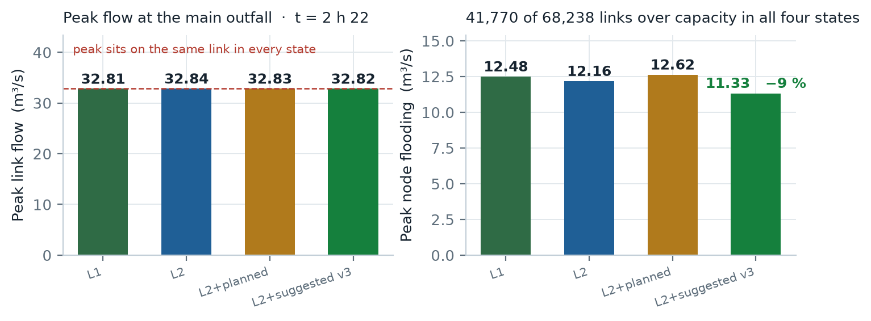
Figure 1 — Peak flow and network capacity. Left: the peak sits on the same link in every state. Right: peak node flooding, the one capacity figure the measures do move.

2. Runoff volume
Volumes come from the 1D flow-routing continuity table and from the 1D–2D exchange account, so the two sides reconcile against each other.

Water account for the 61 mm / 2 h event — L1 existing network
Component | Volume | Share of inflow
Inflow to the network | 3,054,493 m³ | 100 %
Discharged at outfalls | 731,651 m³ | 24.0 %
Lost as node flooding (surplus) | 1,858,089 m³ | 60.8 %
Still stored at end of simulation | 410,432 m³ | 13.4 %
Continuity error | 1.78 % | —

1D–2D exchange — the surplus on the surface, by state (m³)
Component | L1 | L2 | L2+planned | L2+suggested v3
Network spill to surface | 732,413 | 729,200 | 717,765 | 710,914
Surface return to network | 569,293 | 566,986 | 559,883 | 555,059
Rain falling directly on the 2D grid | 492,717 | 492,717 | 492,717 | 492,717
Captured into ponds | 0 | 0 | 17,287 | 17,278
Water still on the surface at 6 h | 556,293 | 556,124 | 535,351 | 529,700

The measured spill — a node-by-node sum of 1,855,691 m³ — matches the continuity loss above to within 0.13 %. That reconciliation is the check applied to every run.
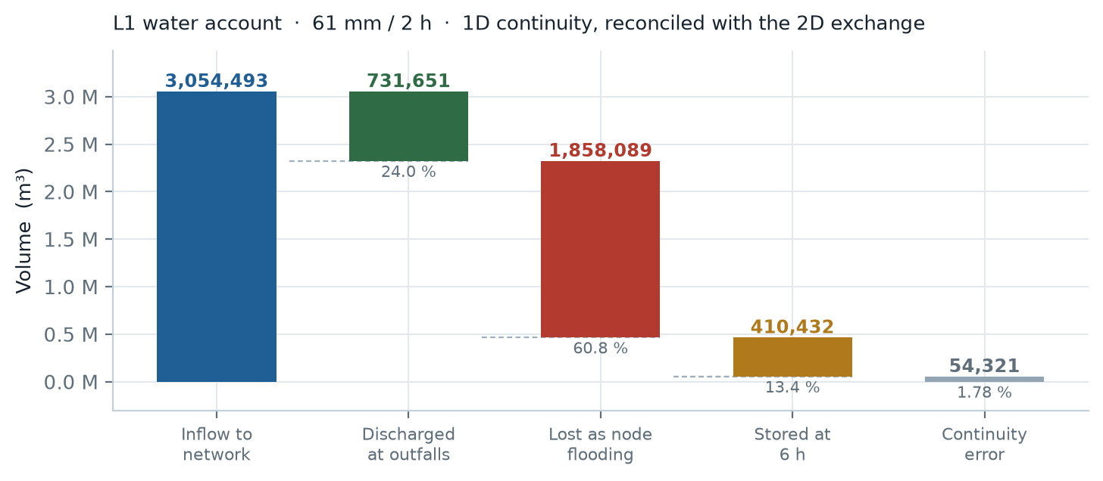
Figure 2 — L1 water account. Inflow is written down step by step; what is left over is the continuity error, which is the run's own check on itself.

3. Time to peak
Each stage of the event peaks at a different hour. The lag between the rainfall peak and the flood peak sets the mobilisation window.
Stage | Peak at | What peaks
Rainfall | 0 h 55 | 313 mm/h
Network flow | 2 h 22 | 32.81 m³/s at the main outfall
Surface flooding | 2 h 20 | 668,446 m³ ponded (L1)
Wet surface area | 2 h 00 | 679.9 ha with water on it (L1)

- Rainfall peaks at 0 h 55; flooding peaks about 1.4 h later. That lag is the response time of the cluster and bounds how late a measure can be deployed and still act on the peak.
- Individual hotspot catchments peak between 2 h 05 and 2 h 35 — a spread of about 30 minutes.
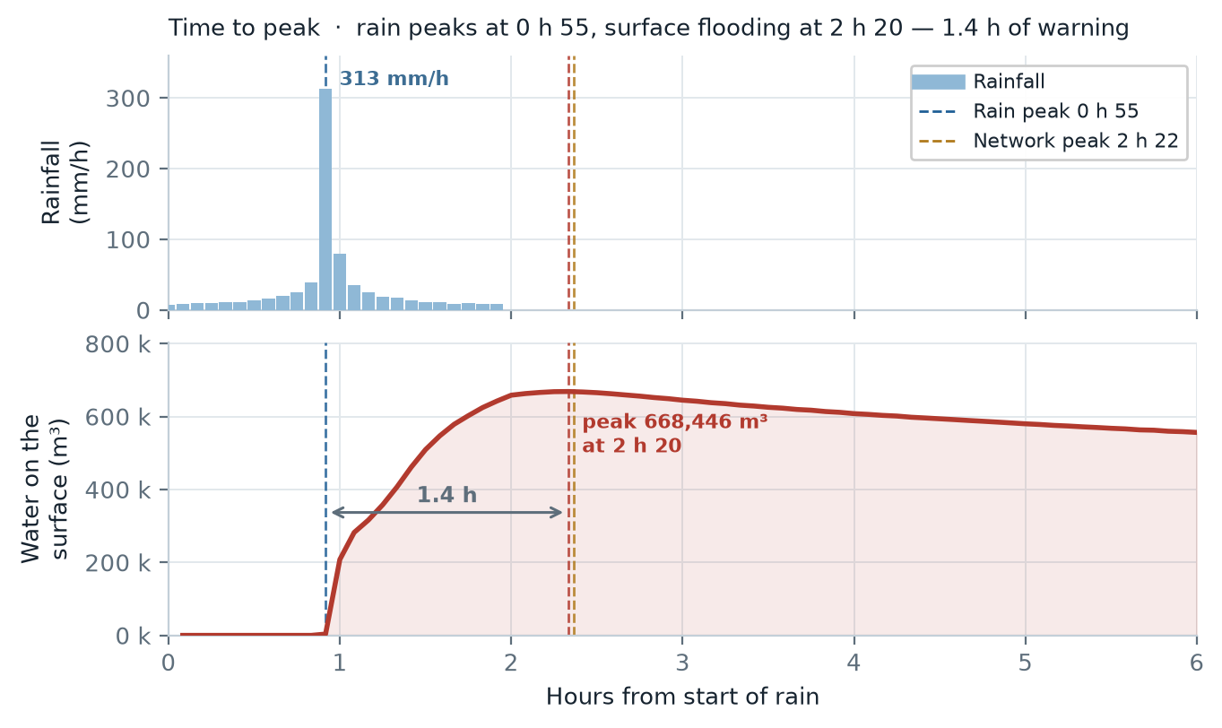
Figure 3 — Time to peak. The rain peaks at 0 h 55, the network at 2 h 22, the surface at 2 h 20; the 1.4 h gap is the mobilisation window.

4. Expected flood extent
The 2D model gives flooded area, depth and volume at 5-minute resolution, which is the part a 1D model alone cannot produce. Volumes below are the peak ponded volume; areas use the maximum depth reached during the event.

Flood extent and volume by state — whole domain
State | Area ≥ 0.10 m (ha) | Area ≥ 0.30 m (ha) | Peak volume (m³) | Wet area at peak (ha) | Max depth (m)
L1 existing network | 268.3 | 25.86 | 668,446 | 679.9 | 1.94
L2 + temporary measures | 267.8 | 25.82 | 667,146 | 679.0 | 1.94
L2+planned (consultant) | 259.1 | 25.07 | 650,713 | 665.0 | 1.94
L2+suggested v3 | 256.9 | 24.50 | 645,754 | 662.8 | 1.94

The eight hotspots
Flooded area and volume inside each hotspot catchment, existing network versus suggested measures.
Hotspot | L1 ≥ 0.10 m (ha) | L1 ≥ 0.30 m (ha) | L1 peak vol (m³) | v3 ≥ 0.10 m (ha) | v3 ≥ 0.30 m (ha) | v3 peak vol (m³) | Area change
ADM-21 | 1.00 | 0.00 | 2,538 | 0.93 | 0.00 | 2,392 | −7 %
ADM-90 | 114.96 | 14.43 | 276,829 | 107.61 | 13.71 | 262,245 | −6 %
ADM-94 | 4.77 | 0.30 | 10,275 | 3.87 | 0.10 | 8,545 | −19 %
ADM-104 | 9.37 | 0.32 | 21,503 | 6.54 | 0.06 | 15,772 | −30 %
ADM-192 | 11.72 | 1.06 | 28,753 | 10.72 | 0.86 | 26,061 | −9 %
ADM-202 | 2.14 | 0.09 | 6,765 | 1.38 | 0.00 | 4,986 | −36 %
ADM-486 | 12.58 | 0.46 | 30,074 | 11.60 | 0.15 | 28,334 | −8 %
ADM-487 | 0.98 | 0.09 | 2,257 | 0.40 | 0.00 | 965 | −59 %
Eight hotspots, combined | 143.46 | 15.99 | 346,024 | 133.25 | 14.73 | 325,168 | −7 %

- The deepest water — 1.94 m — sits inside the ADM-90 catchment in every state. No measure in any scenario changes it, which points to a capacity problem upstream of the hotspot rather than a local one.
- Measures help most at the hotspots with shallow, localised ponding: ADM-202 loses 36 % of its flooded area, ADM-487 loses 59 %. The two large catchments, ADM-90 and ADM-192, barely move at 6 % and 9 %.
- Within 200 m of the hotspots, the ≥ 0.30 m area falls from 0.40 ha to 0.04 ha — a 90 % reduction. Extents, depths and velocities are also delivered as GeoTIFF and as an ANUGA .sww file for GIS use.
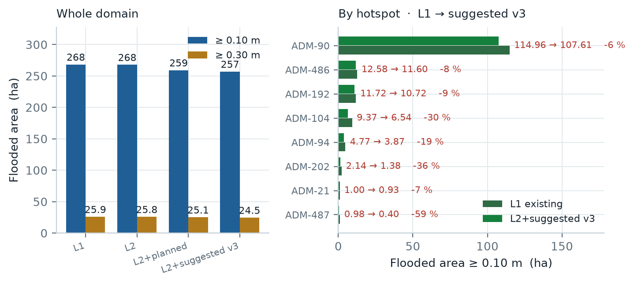
Figure 4 — Flood extent. Left: whole domain, by state and depth threshold. Right: the eight hotspots, existing network versus suggested measures; the small hotspots lose the largest share of their area.

Still open
Network resilience (24 h). The current runs simulate 6 hours (2 h of rain plus 4 h of recession). At the 6-hour mark the surface still holds 490–510 ha of water, so the event is not over. A 24-hour resilience figure needs two steps not yet taken: agreed metrics (time to drain, duration above capacity, recovery time), and runs extended to 24 hours.
ERP resources required. The model reports what each facility actually does during the storm, not what would be needed to clear the water. Turning it into "pumps, tankers and manpower required" is a conversion layer on top of the model: peak volume against a target drain-down time, unit pump and tanker capacities, crew per unit, and access. The inputs are all in hand — peak ponded volume 668,446 m³, pump capacities, recession curves — so this is rule work, not new simulation.
Rainfall cases from the brief. The 1-in-10-year +20 % case (61.34 mm / 24 h) was run earlier on the older domain and has been withdrawn, because that domain is not the authoritative one; the 2024 event has not been run for this cluster. Both are straightforward to add on the model-version domain, at roughly 21 simulated hours per state for a 24-hour storm.

How to read these numbers
Rainfall is the client's own 2-hour design hyetograph (Mussafah model), scaled to 61 mm. 1D is SWMM 5.2 and 2D is ANUGA at 15 m, coupled two-way at every step. Flood depth is triangle-centroid depth; ground below 0.02 m counts as dry. Flooded area counts triangles whose maximum depth reaches the threshold. Every state was built and run with the same model, so the four columns are directly comparable.
Checks on this run. 1D continuity error 1.7–1.8 %; the node-summed spill reconciles with the continuity loss to 0.13 %; the 1D↔2D exchange is accounted in both directions; 72 frames render with no NaN. Results are reconciled against the consultant's own model for the same area as a cross-check.
Known limits. One catchment (ADM-90) extends past the analysis window, so inflow from outside it is not counted, which understates that area. Runoff uses a uniform CN of 82. Ground elevation comes from the 5 m DTM. Two existing pump stations have no operating data and were not modelled, and the location of two others is inferred.

