***Orthanc Tools Js***

***Documentation Guide***

***Salim Kanoun***

***Salim.kanoun@gmail.com***

1. ***Architecture***

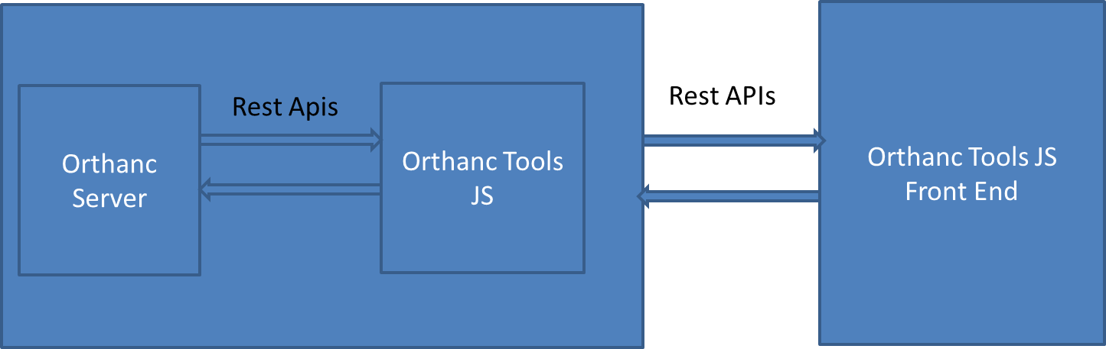

Orthanc Tools JS create a Restful API server on the top of Orthanc, this server extends Orthanc capabilities of Orthanc server to add some automation features like user identification and automations of tasks like anonymization or batch retrieve.

This server exposes new APIs that can be used by different client. One of these possible clients is the provided web Front end which is a React web app that can be accessed by simple connexion at the server address on port 4000 with any browser.

This web app notably include OHIF as dicom viewer.

1. ***Installation & upgrade***
   1. ***On Windows / Mac OS***

Requirement:

Install NodeJS LTS version: <https://nodejs.org/fr/>

Nb : In case of failed install, deactivate ETW option in the NodeJS installer (see https://github.com/nodejs/node/issues/17025)

Orthanc installed with Osimis installer (<https://www.orthanc-server.com/download.php>)

1. Download Orthanc-Tools-JS from GitHub :
   1. Go To : <https://github.com/salimkanoun/Orthanc-Tools-JS/releases>
   2. In the last Release, in the assets download : OrthancToolsJS.zip
2. Extract zip content in a folder with write access granted (ex : user folder)
3. Open the terminal and put the current directory the extracted folder (cmd in windows than “cd c:\{my_Destnation}” )
4. Download and Install dependencies by running : “npm install” in terminal (internet access is required)
5. Start Orthanc-Tools-JS server by running “npm start” in terminal
6. Browser should open automatically or go to http://{you-server-ip}:4000 (The interface can be accessed remotely)
7. Configure Orthanc (orthanc.json)

To Benefit for AET/Peers declaration from OrthancToolsJS and to benefit for OHIF integration, edit the following settings in orthanc JSON

* ORTHANC__DICOM_MODALITIES_IN_DATABASE: "true"
* ORTHANC__ORTHANC_PEERS_IN_DATABASE: "true"
* *ORTHANC__DICOM_WEB__ENABLE: "true"*
* *ORTHANC__DICOM_WEB__ROOT: "/dicom-web/"*
* *ORTHANC__DICOM_WEB__ENABLEWADO: "true"*
* *ORTHANC__DICOM_WEB__WADOROOT: "/wado"*
* *ORTHANC__DICOM_WEB__STUDIESMETADATA: "MainDicomTags"*
* *ORTHANC__DICOM_WEB__SERIESMETADATA: "Full"*

*Italicized item are for OHIF integration*

* 1. ***With Docker***

Orthanc deployment is preferred as it ship a full install ready to use (NodeJS + OrthancToolJs)

The Docker Image name is: salimkanoun/orthanctoolsjs

A docker compose sample for deployment of Orthanc and OrthancToolsJs is available here: https://github.com/salimkanoun/Orthanc-Tools-JS/blob/master/docker-compose.yml

* 1. ***Upgrade***

To upgrade :

* For windows install download new source and replace existing file by new ones, execute npm install et npm start
* For Docker : update container

Warning: Until version 1.0.0 will be reached, the database schema is not stable. If upgrading for a version <1.0.0 you will have to manually erase the database file in the data/database/database.sqlite3

And so you preferences will be lost at upgrade. Starting 1.0.0 the database versioning will be managed to provide a smooth upgrade.

1. ***Login***

Default Access :

Login : admin

Password : admin

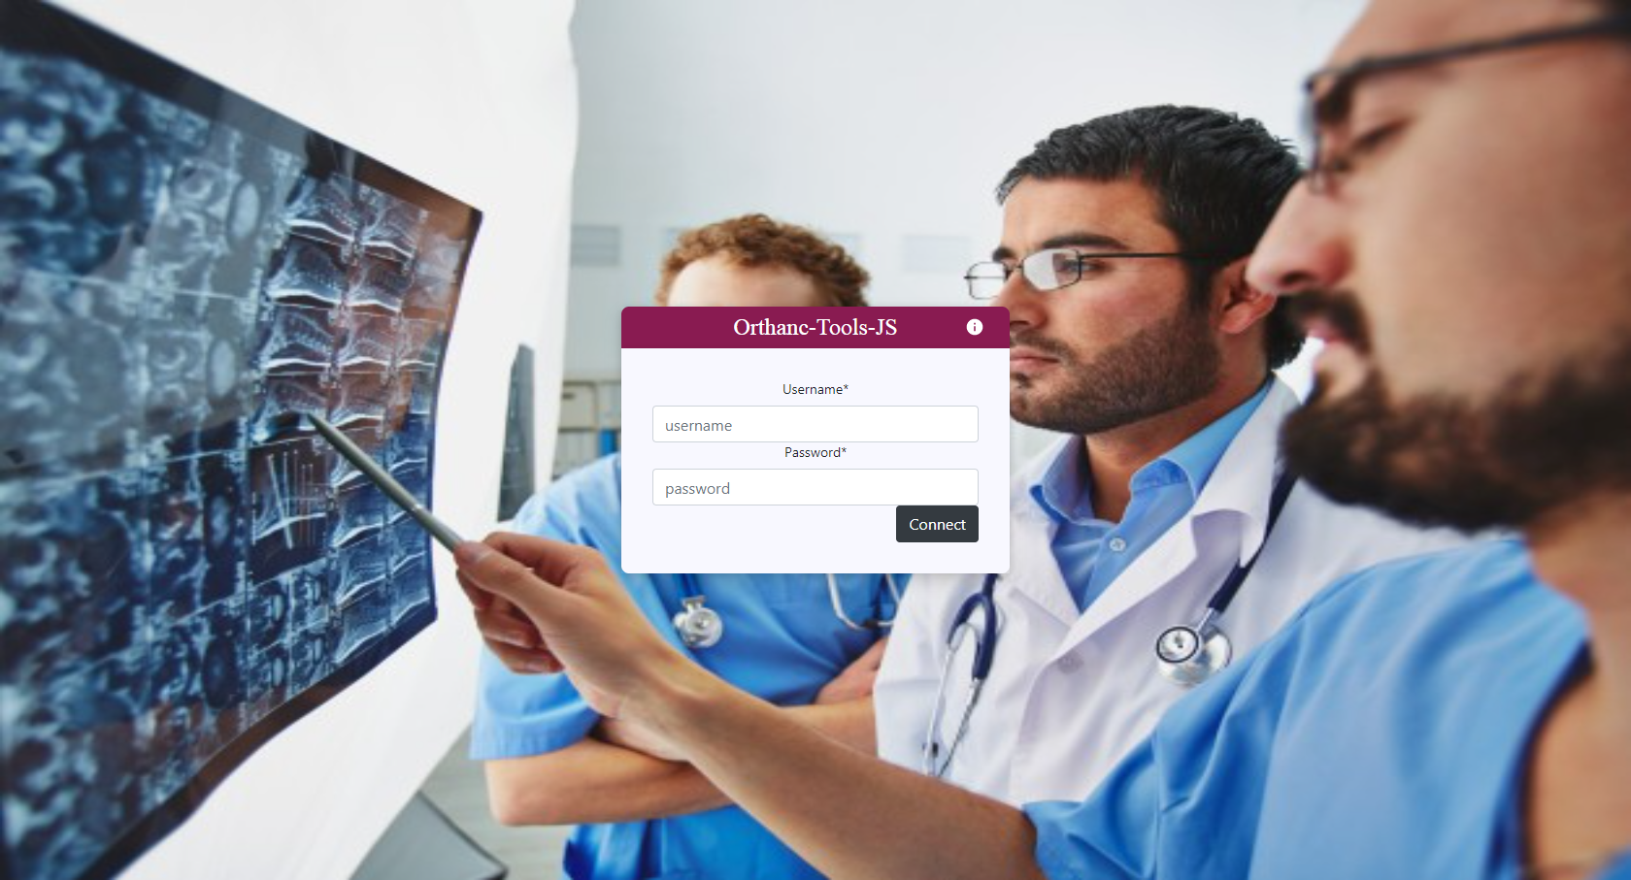

1. ***Orthanc Server declaration***

By default the Orthanc server connexion settings is set to <http://localhost:8042>, with no login or password.

If you have a different Orthanc location or if you add login / password, go to Options -> General and fill the form accordingly, click “update” to apply new connexion settings.

Press “test connexion” to check that your Orthanc server can be correctly reached

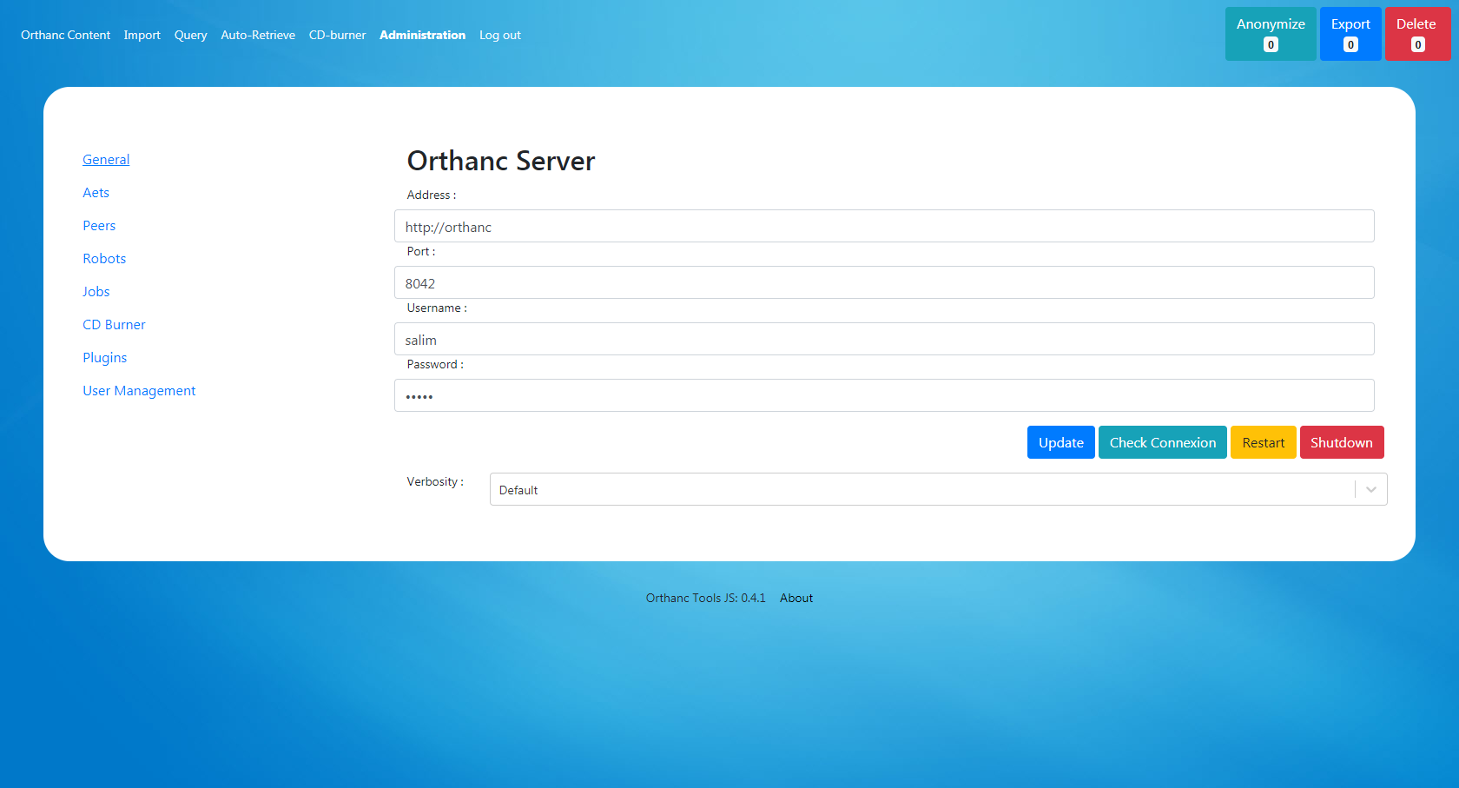

1. ***Main features***
   1. ***Orthanc Content***
   2. ***Import Dicom files***
   3. ***Anonymize / Export / Delete***
   4. ***Query / Retrieve***
   5. ***Auto Retrieve***
   6. ***CD Burner – Epson / Primera DiscProducers***

In the options define:

* The Monitored Folder
* The Viewer Folder to include with Dicoms
* The Label File (see Epson/Primera template editor)
* The Transfer Syntax of Dicoms
* The CD Burner Manufacturer (Epson or Primera)
* The monitoring Level
* The Support Type (CD/DVD/Auto)

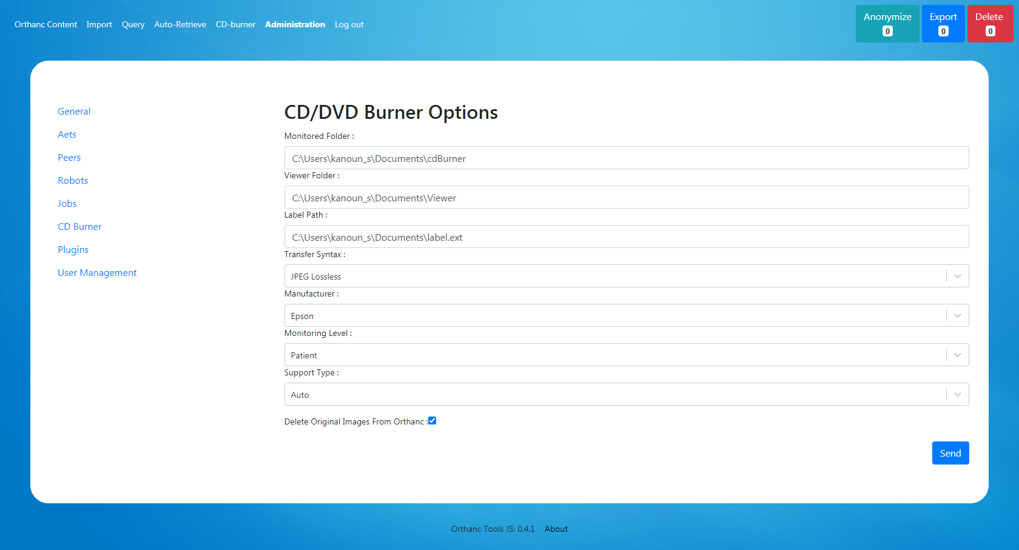

Start CD Burner Service, each time Orthanc will recieve a Study / Patient, a burning request will be triggered (the service continue to run even if the browser is closed)

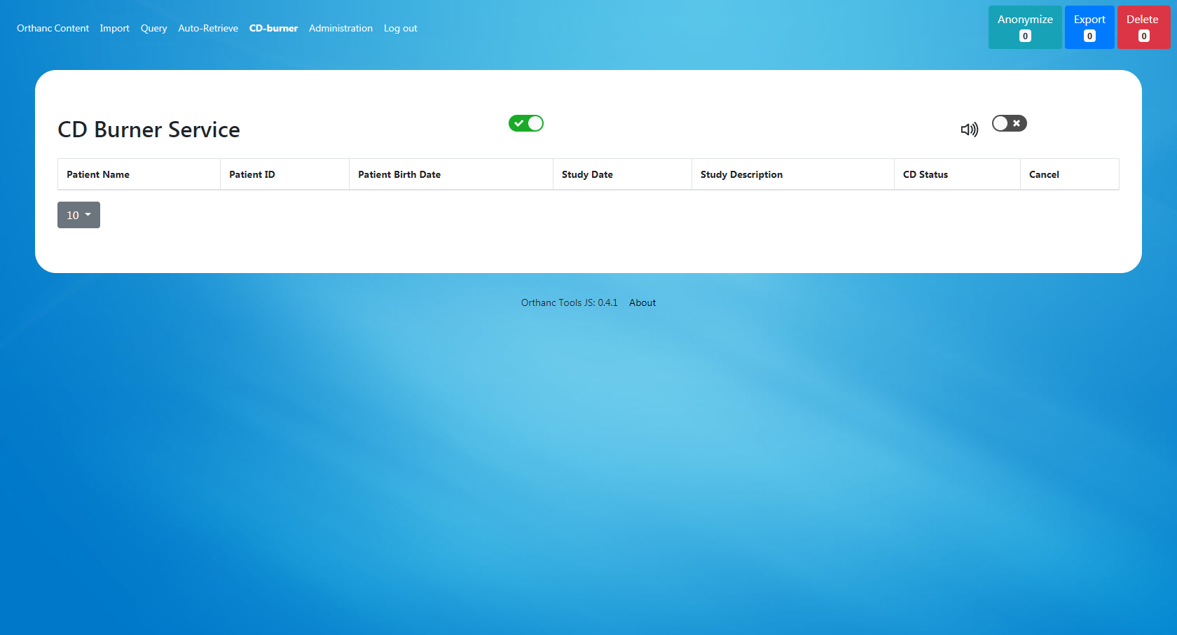

1. ***Administration panel*** 
   1. ***User Access***
   2. ***AET / Orthanc Peers Declaration***

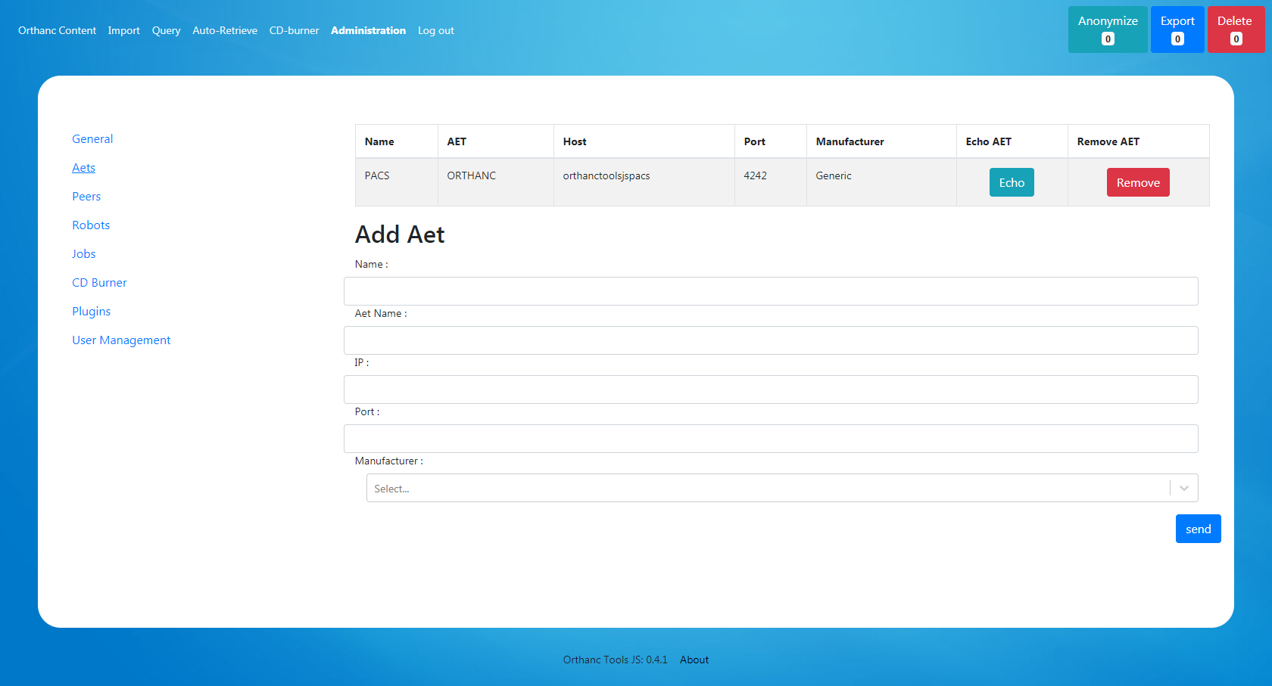

* 1. ***Orthanc Jobs / Plugins***

This interface allows you to see Orthanc asynchronous Jobs (and pause / cancel / resubit them)

The plugin page list the available plugin in the current orthanc installation

* 1. ***Auto Retrieve Robot***

1. AutoQuery/Retrieve

Go to Query tab, click « Add » to open a new line.

In the created line all fields are editable by simple click, add search keys according your needs, and don’t forget to select the modalities that will be queried in the last column

Let empty the column that you don’t want to use for your search.

You can add as many line you want.

Once your query list ready press “Query”.

The queries will be processed one by one and the results answers of all queries will be displayed in “Result answer tab”

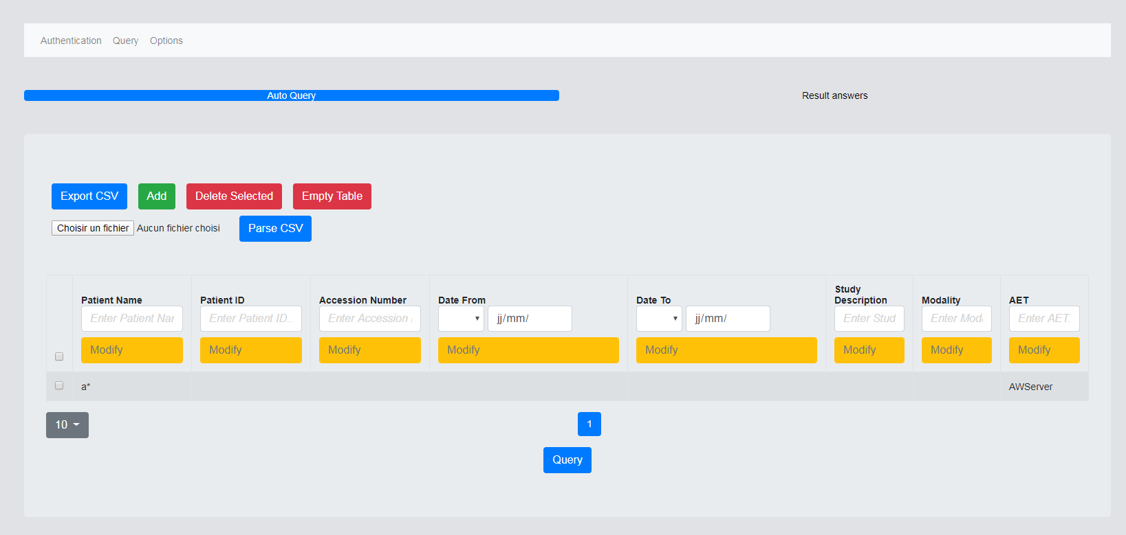

After click on “Query” go to result answer

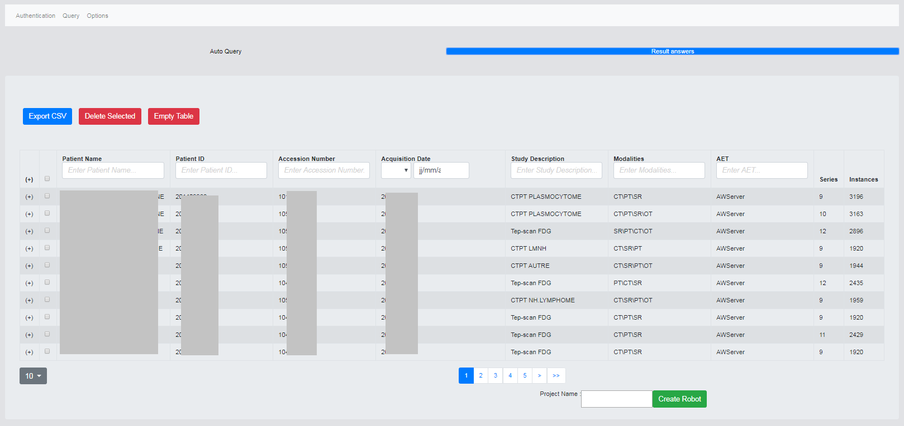

You can select and remove lines using “delete selected”

You can export the result with “Export CSV” to be able to edit the retrieve list with any spreadsheet editor and be able to re import it later with “Parse CSV” in the previous query tab

To build a retrieve robot, fill a robot name and press “Create Robot”, the entire list will be scheduled for an automatic retrieve

1. Retrieve Robot
   1. Set Retrieve hour

You can change the robot time execution by updating the retrieve hour settings (default 22h 00)

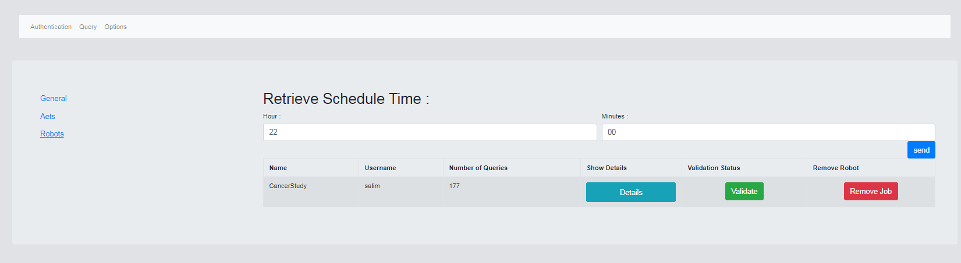

* 1. Validate Robot

A robot must be validated before execution.

Press “Validate” to validate it, in this process the server will check that each query item will return one dicom answer and will store the number of instance to be retrieved to be able to monitor robot progression.

In few seconds “Done” should appear once the process end and the robot validated.

* 1. Follow Robot Progression

Click on « Details » to see robot content and follow progression of robot

Before execution of robot you can remove some items using “Remove” button

