Testing

In this section I will be executing tests that will ensure that my technical solution works and meets the objectives outlined in my analysis. When relevant I will be testing normal user input, user input on the boundary of what is acceptable and erroneous data to ensure every eventuality is covered. Testing normal data will all me to see that the program will normally give the expected result and boundary data ensures that my error checking/ boundary checking is appropriate. Erroneous data is just data I know will display an error or not work allowing me to make sure my error checking works.

I will also be testing that button clicks change the state as one would expect.

Analysis objective 1:

“Loads simple landing page that says chess or Welcome “user” if logged in”.

|  |  |  |  |  |  |
| --- | --- | --- | --- | --- | --- |
| Test Number | Test Description | Test Input | Expected Results | Actual Result | Test Pass |
| 1 | Program is first opened without username cached. | No data in just a raw run. | Chess message seen. | Chess message seen. | Yes |
| 2 | User logs in and reaches the landing page. | Users login information cached | Welcome user message seen. | Welcome user message seen. | Yes |

Evidence for Test 1

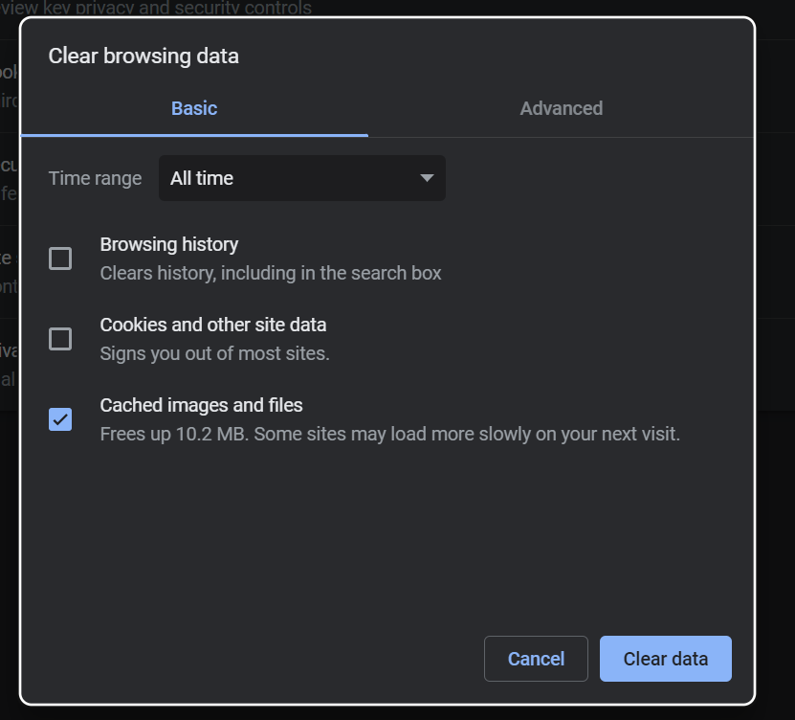First clearing testing browsers cache so that we ensure the test is not tampered.

This will be repeated for all of the tests involving login.

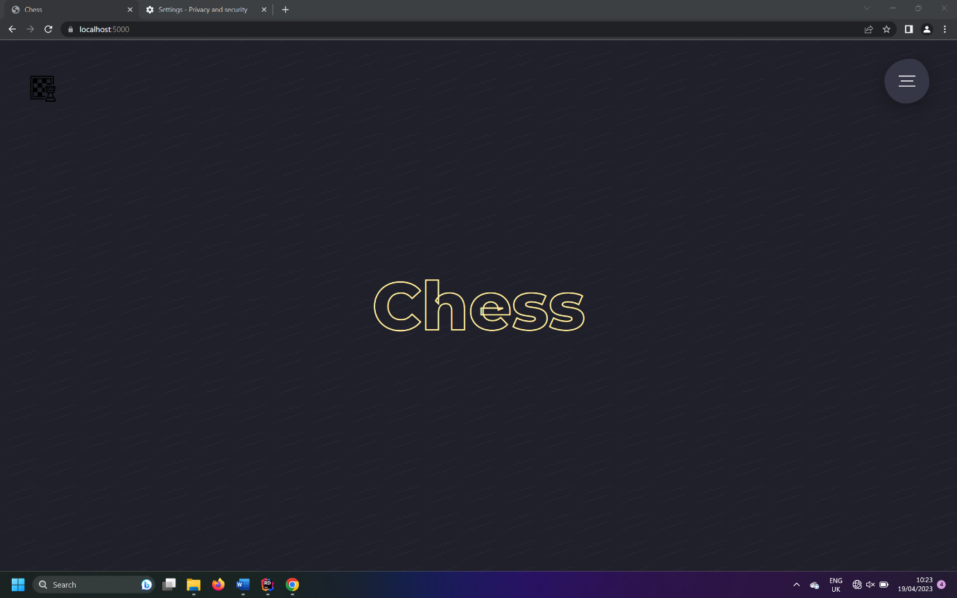Now when we run the program the Chess message is observed.

Evidence for Test 2

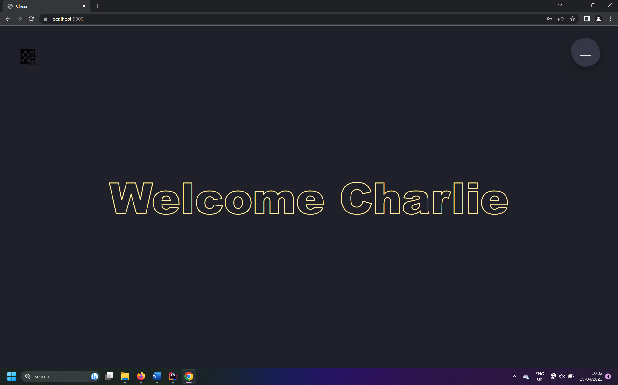

After login welcome <username> is observed.

Analysis objective 2:

“Animated nav menu that has a list of features inside.”

|  |  |  |  |  |  |
| --- | --- | --- | --- | --- | --- |
| Test Number | Test Description | Test Input | Expected Results | Actual Result | Test Pass |
| 3 | Nav menu appears when icon is pressed | Click Nav menu icon | Animation plays displaying options | Animation played displaying options | Yes |
| 4 | Nav menu is closed when the icon is pressed | Cross icon is clicked | Welcome user message seen. | Welcome user message seen. | Yes |

Evidence for Test 3

Before

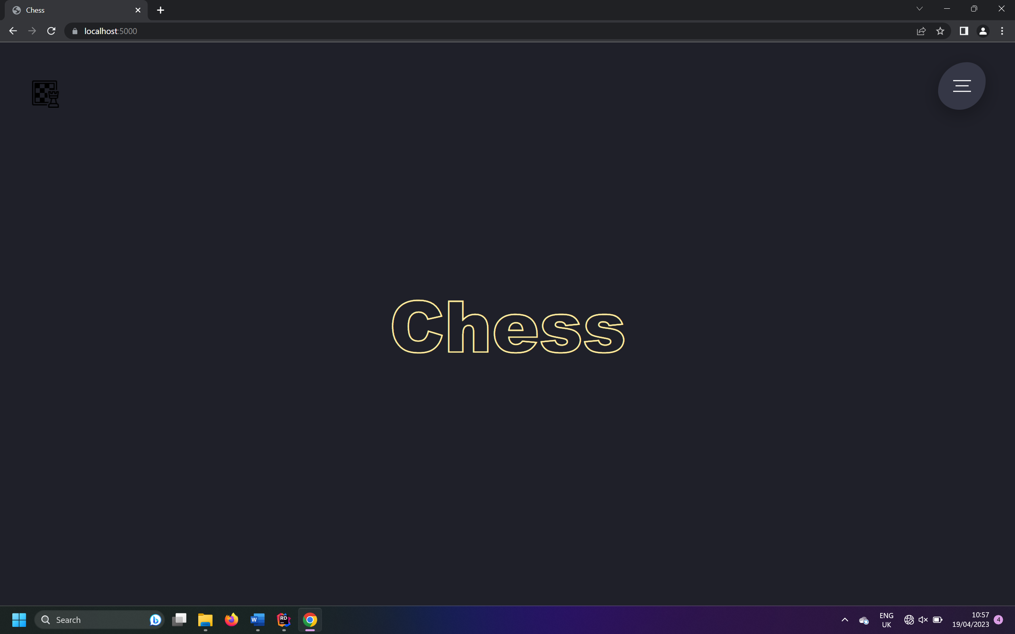

After

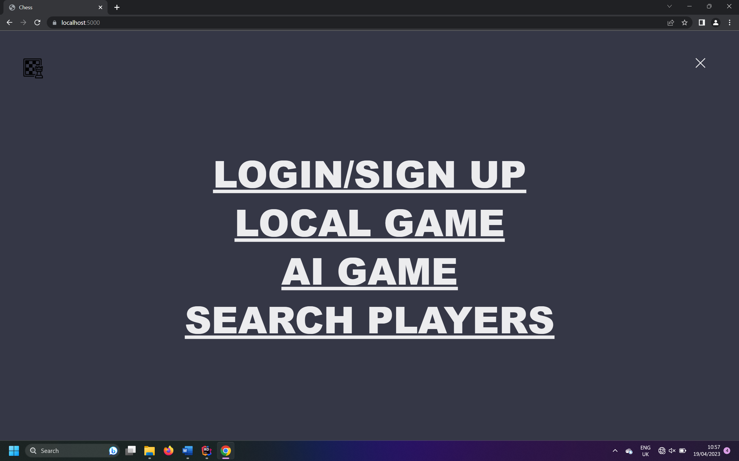

Evidence for Test 4

Before

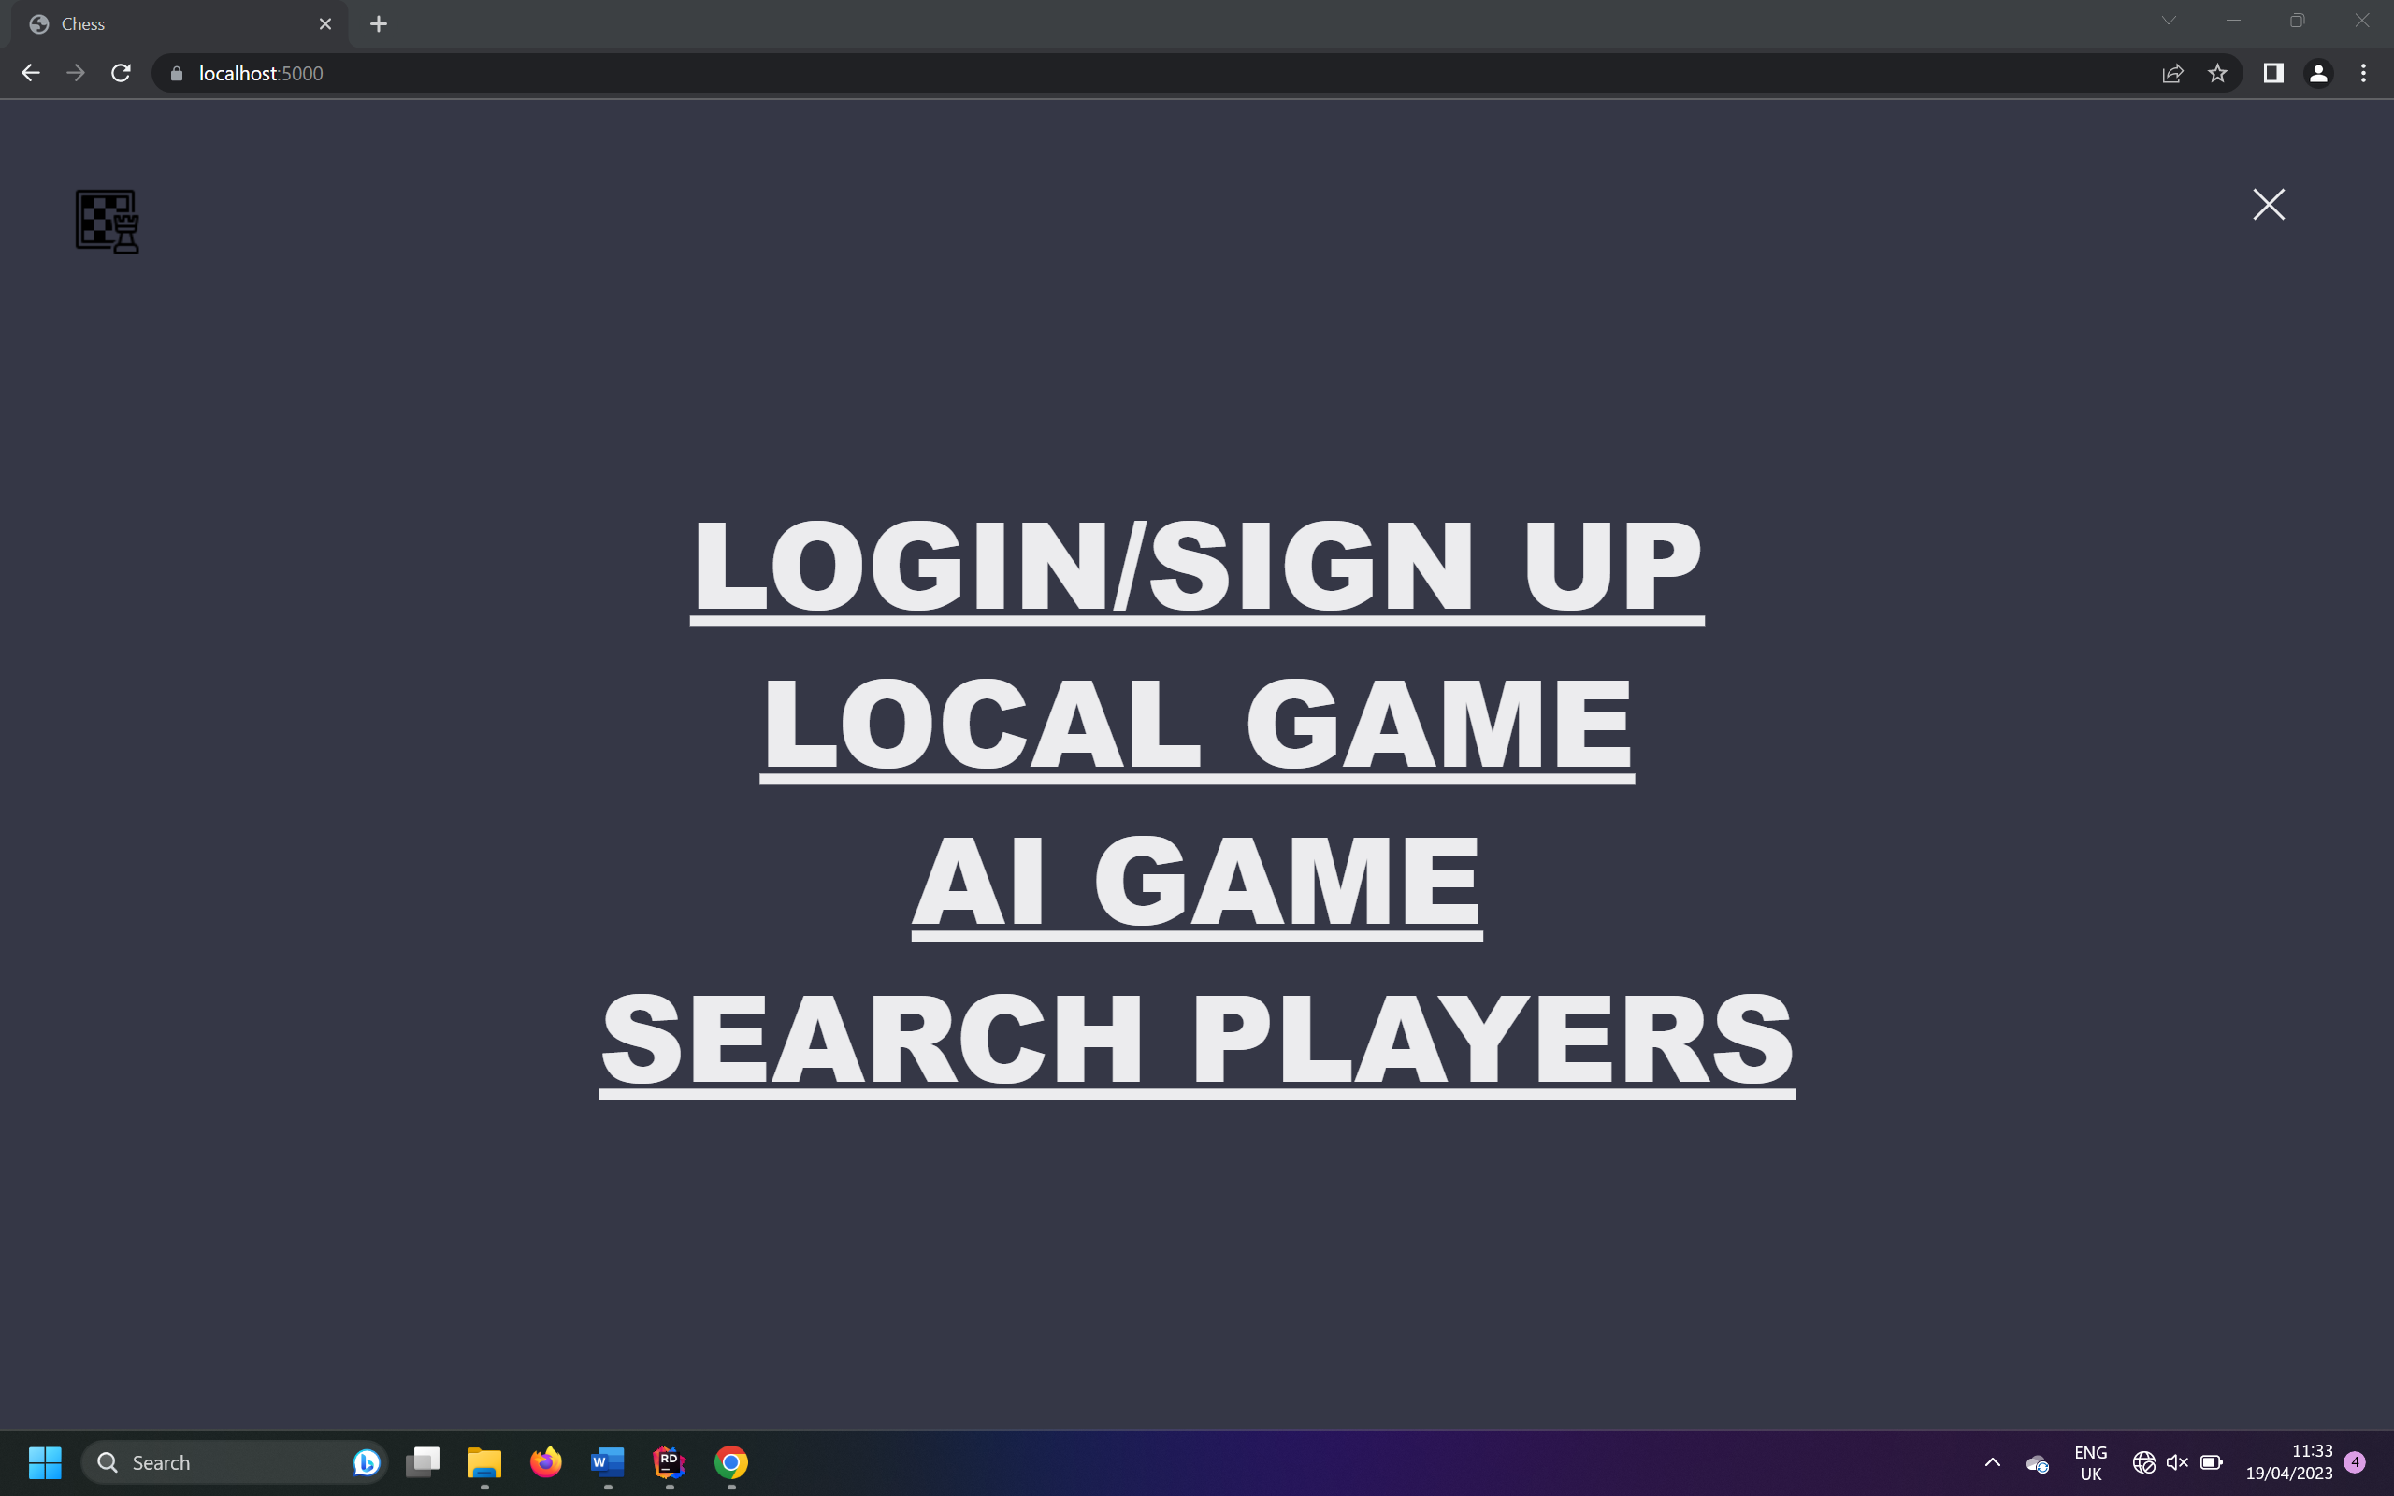

After

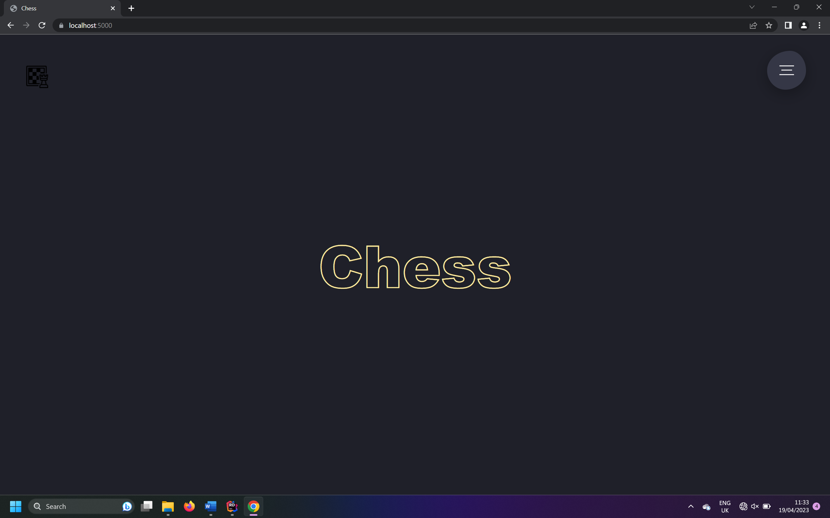

Analysis Objective 3:

“Logo on every page that when clicked returns user to landing page”

|  |  |  |  |  |  |
| --- | --- | --- | --- | --- | --- |
| Test Number | Test Description | Test Input | Expected Results | Actual Result | Test Pass |
| 5 | Logo pressed on login page returns to landing page | Click the logo button on the page | Returns to landing page | Returns to landing page | Yes |
| 6 | Logo pressed on chess game page returns to landing page | Click the logo button on the page | Returns to landing page | Returns to landing page | Yes |

Evidence for Test 5:

Before

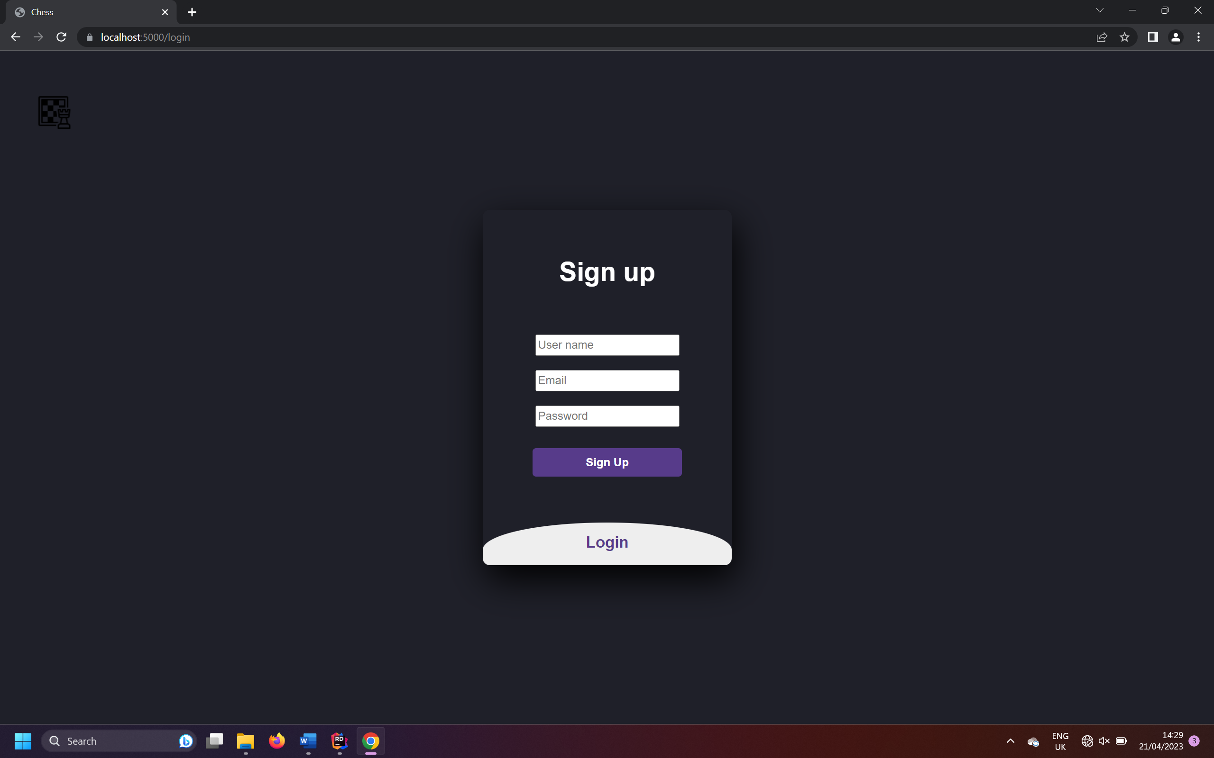

After

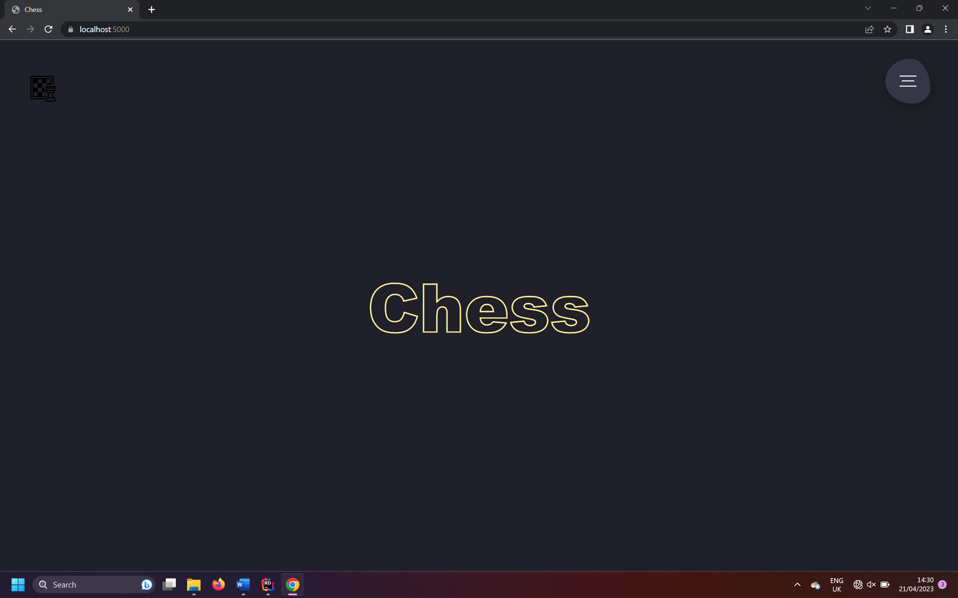

Evidence for Test 6:

Before

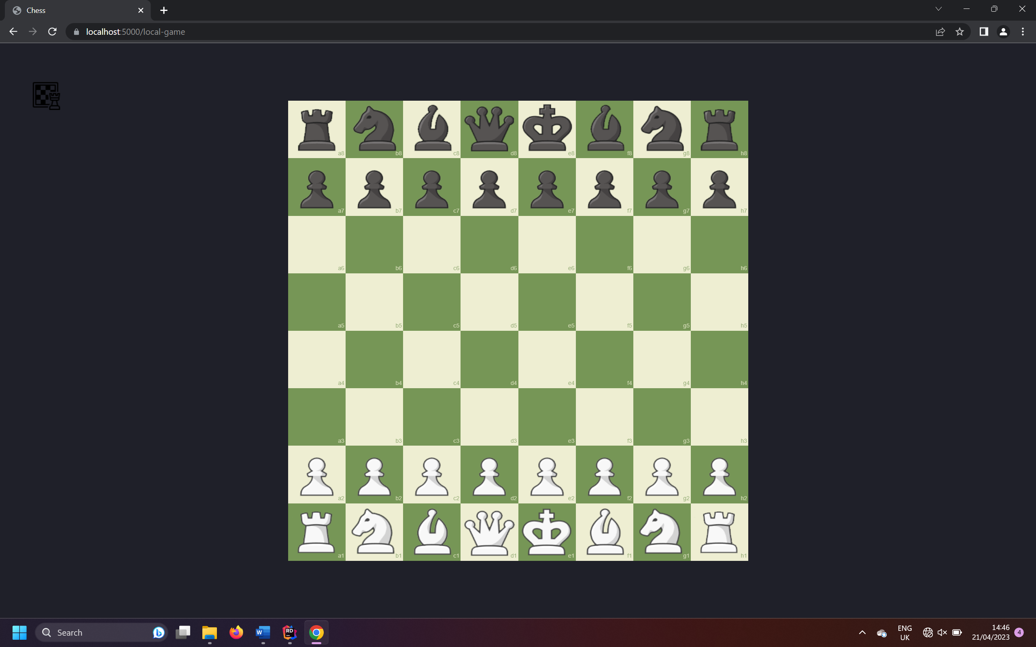

After

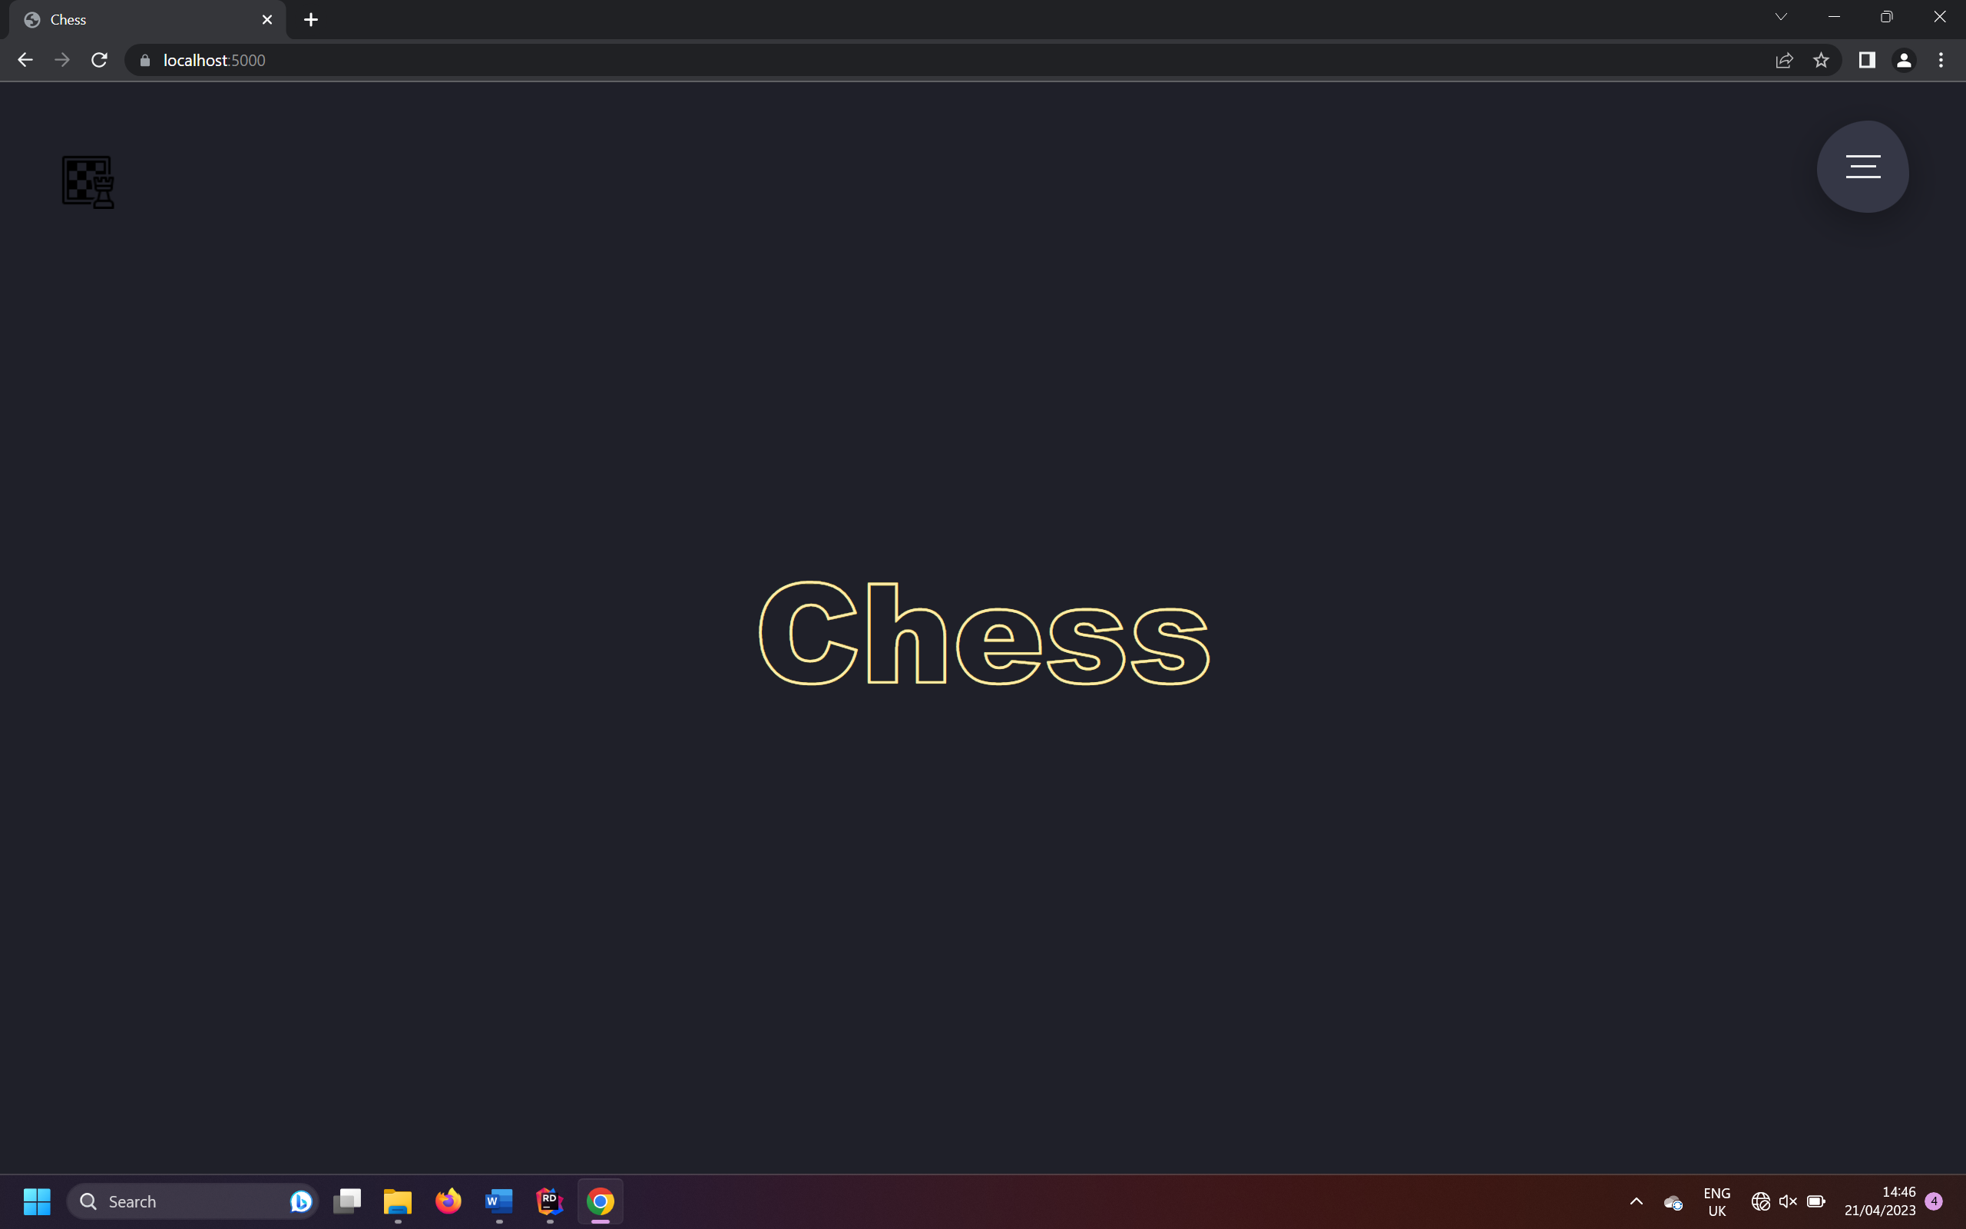

Analysis Objective 4:

“Login/Signup page”

Covered by next objectives.

Analysis Objective 5:

“On Signup if username already exists display message”