Analysis
Background and problem definition
Landau Forte Academy Tamworth Sixth Form is in Tamworth, England and has a large body of A-Level/ BTEC students. The students attending the sixth form are typically 16-18, studying 2-4 courses. Mr. Dave, a computer science teacher at the school, manages and attends a chess games club every Wednesday after school closing hours. Recently, the number of attendees at the club has been declining this is due to students becoming frustrated by the lack of boards and pieces. To stop the decline and to remove the need to buy more and more boards as members increase, he has asked me to develop a digital chess solution that will allow players to log in and play against each other saving their win and loss counts. This will hopefully bring back leaving players and remove any issues in the future.
Dave wants the chess sessions to be local so that a game can be played at one computer. This will remove the need for unnecessary networking that can result in issues since they are all playing in the same room anyway. This will also half the number of computes required to play games. This also retains the community in the chess club that would be lost if playing on a network since players will be able to directly verbally communicated with each other. Players wins and losses will be stored allowing students to compare their statistics and abilities in chess.
He also wants me to include a play against the AI option for students that do not have a partner to play against. This ensures players always have something to do at the club and gives members an option to practice rather that always having the pressure of a real game against a real opponent. Wins against the ai will also count as wins on the stats sheet so players will be able to stay competitive using this feature even if they have no one to play with.
The main aim of my project is to create a chess app that can be played player vs player and player vs ai. It will be able to store wins and losses creating a more competitive environment at the school’s chess club. I feel this will allow new members to not be as intimidated waiting to play on the few boards and instead they can feel comfortable playing locally on a computer or against ai hopefully keeping them attending the club sessions.
This a general overview I will be interviewing a member of the club named Jim to gather further information towards my solution allowing me to set out objectives for my project.

Description of the Current System
The chess club is currently held after school on a Wednesday specifically from 15:05-16:00. When the club members arrive they go to the front of the room to collect a chess board if available. If there are no chess boards available, they must wait for a pair to finish their match. Sometimes players go the entire session without playing a game due to the length of the games. When a game is finished the pair reassemble the pieces into their starting configurations and allow another pair to play, no pair is able to play multiple games in a row. When the chess club is over the players pack up the board sets and return them to the front of the room where they are stored. To maintain a competitive environment the wins and losses of each player are tallied in a notebook. When a match is finished the pair must open the notebook and tally themselves in there; any player can open the book and look at the statistics of other players to compare.
Chess is an abstract strategy board game for two players. Each player controls his 16 of his 6 types of pieces on the chessboard. Each type of piece moves differently. The object of the game is to checkmate (necessarily capture) the opponent's king. A game can end in several ways besides checkmate. A player can resign, and there are several ways the game can end in a draw. The 6 pieces are: king, queen, pawn, rook, knight, bishop.
The king moves exactly one square horizontally, vertically, or diagonally. A special move involving the King known as castling is only allowed once per player per game
A rook moves any number of vacant squares horizontally or vertically. It also is moved when castling.
A bishop moves any number of vacant squares diagonally.
The queen moves any number of vacant squares horizontally, vertically, or diagonally.
A knight moves to one of the nearest squares not on the same rank, file, or diagonal. (This can be thought of as an L pattern.) The knight is not blocked by other pieces; it jumps to the new location.
Pawns have the most complex rules of movement: A pawn moves straight forward one square, if that square is vacant. If it has not yet moved, a pawn also has the option of moving two squares straight forward, provided both squares are vacant. Pawns cannot move backwards. A pawn, unlike other pieces, captures differently from how it moves. A pawn can capture an enemy piece on either of the two squares diagonally in front of the pawn. It cannot move to those squares when vacant except when capturing en passant.
The pawn is also involved in the two special moves en passant and promotion. En passant is where a pawn jumps, and an enemy pawn takes it as if it has moved only 1 square. Promotion is where a pawn can change into any piece excluding the king and itself upon reaching the end of the board.

On the next page are some examples of the moves.
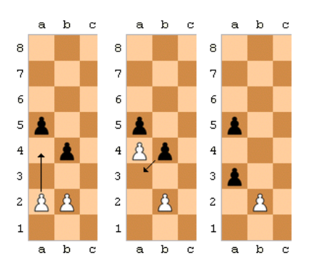
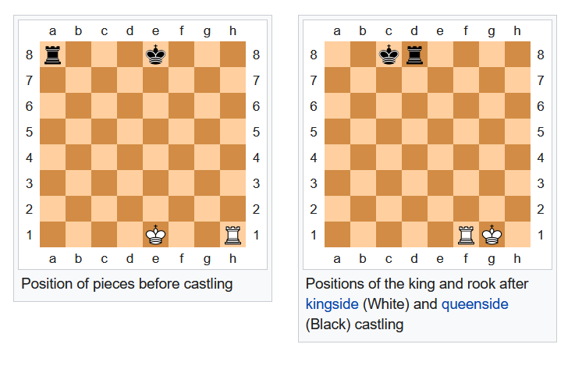
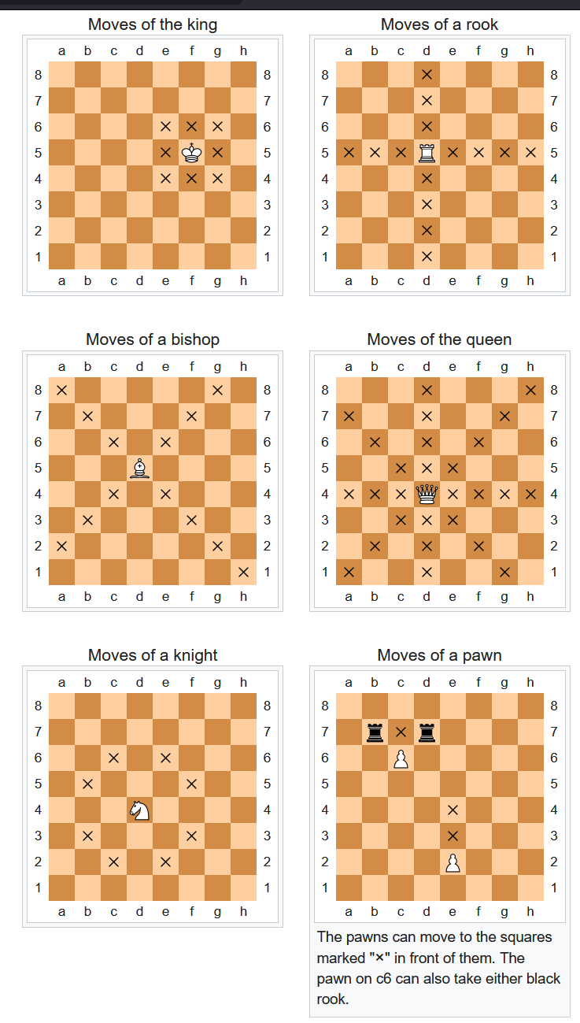

Enpassant

