**WEEK-6**

**React HandsOn**

**Lab 1: Getting Started with React**

**You will learn how to:**

* Set up the React development environment
* Use the create-react-app tool to start a new project

function App(){

return (

<h1>First React App</h1>

);

}

export default App;

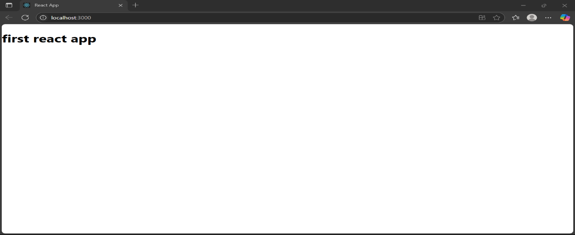

**Lab 2: Creating and Rendering Components**

**You will learn how to:**

* Create class-based components
* Create and organize multiple components
* Display/render these components inside the main App

**App.js:**

jsx

CopyEdit

import './App.css';

import Home from './Components/Home';

import About from './Components/About';

import Contact from './Components/Contact';

function App() {

return (

<div className="container">

<Home />

<About />

<Contact />

</div>

);

}

export default App;

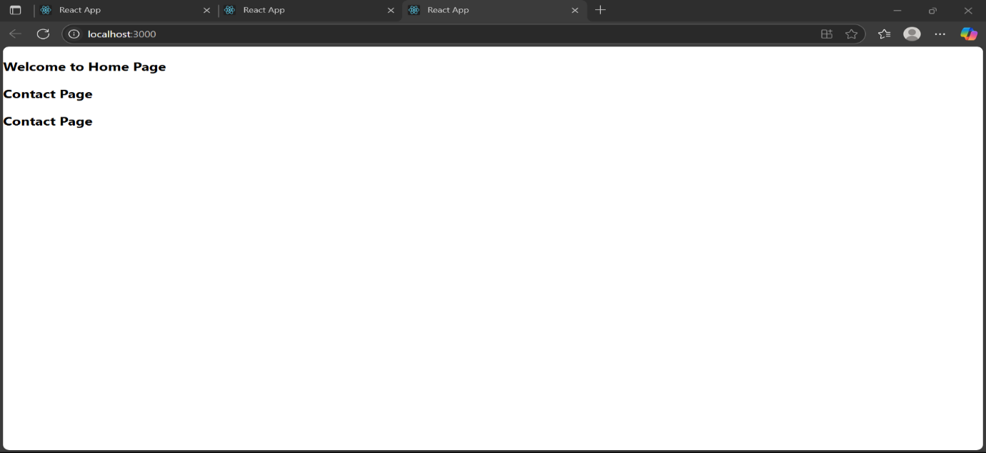

**Lab 3: Functional Components and Styling**

**You will learn how to:**

* Build functional components
* Pass data using props
* Style components using inline styles or external CSS

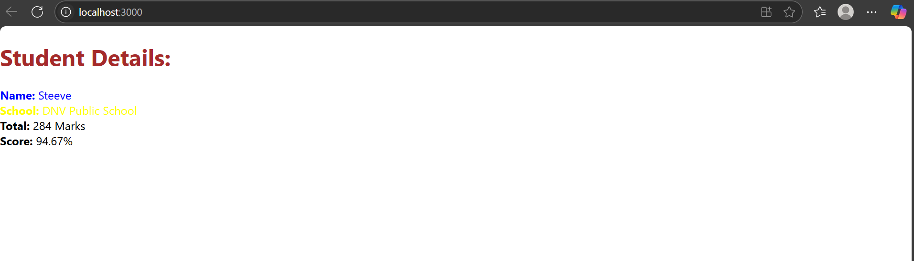

**App.js:**

jsx

CopyEdit

import CalculateScore from './Components/CalculateScore';

function App() {

return (

<div>

<CalculateScore

Name="Steeve"

School="DNV Public School"

total={284}

goal={300}

/>

</div>

);

}

export default App;

**Lab 4: React Lifecycle Methods**

**You will learn how to:**

* Use the componentDidMount() lifecycle method to run code when the component loads
* Handle errors in components using componentDidCatch()

**Posts.js (Conceptual Outline):**

jsx

CopyEdit

class Posts extends React.Component {

constructor(props) {

super(props);

// Initialize state here

}

loadPosts() {

// Logic to load data

}

componentDidMount() {

this.loadPosts(); // Example

}

componentDidCatch(error, info) {

// Handle any rendering errors

}

render() {

return (

<div>

{/* Render posts here */}

</div>

);

}

}

**Lab 5: Styling Components**

**You will learn how to:**

* Add styles to React components
* Use CSS Modules for scoped styling
* Use className and style attributes to apply styles