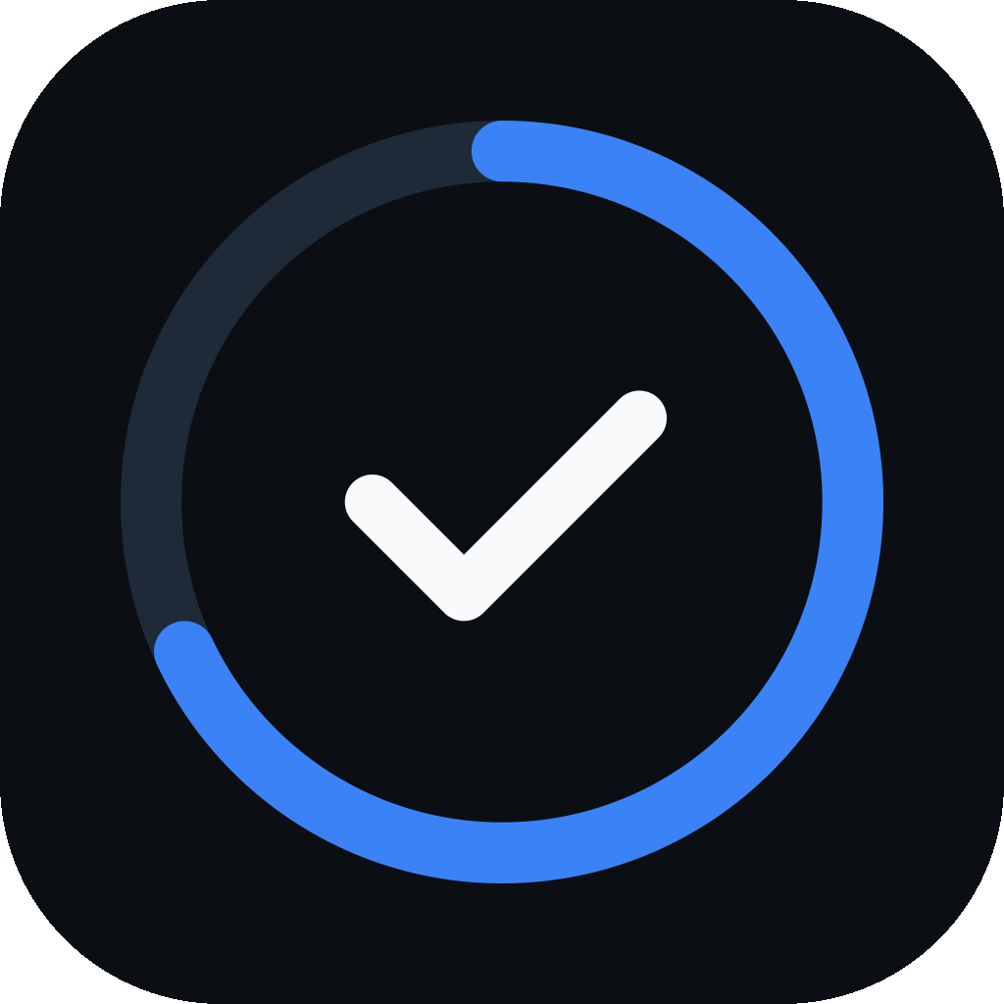
DETAILED PROJECT REPORT
PrepPilot
An Offline-First, AI-Assisted Study and Examination Preparation Platform

Prepared by
Archit Jain
October 2026

Abstract
PrepPilot is a mobile application that helps a student organise an examination syllabus, record what has genuinely been completed, time their study and revise, with or without an internet connection. A syllabus is modelled as a hierarchy of Subject → Chapter → Topic → optional Sub-topic, and every other feature — study timers, flashcards, notes, quizzes, reminders and an AI assistant — is attached to that hierarchy rather than living in a separate tool.
The application is offline-first: the SQLite database on the device is the source of truth, every read and write completes locally, and a synchronisation engine later reconciles the device with a Supabase (PostgreSQL) backend using client-generated UUIDv7 identifiers, tombstones and deterministic conflict rules. Progress is computed topic-weighted — a subject with one finished chapter of one topic and an unfinished chapter of ninety-nine topics is reported as 1% complete, not 50%. AI assistance is provided by Google Gemini through a server-side Edge Function, so the API key never reaches a device, and any syllabus change the assistant proposes must be reviewed and confirmed by the student before it is applied.
The system is built with React Native and Expo in TypeScript, as a monorepo of about 36,000 lines of non-test source. It is verified by an automated suite of 2,283 tests (2,231 executed for this report, all passing), has been built as an Android APK, and is also published as a browser demonstration. This report describes the problem, the requirements, the design and implementation, the evidence of testing, and the known limitations of the delivered system.
Keywords: offline-first, local-first software, study tracking, React Native, SQLite, Supabase, Row Level Security, synchronisation, Google Gemini, spaced repetition.

Table of Contents
1. Introduction 7
1.1 Project overview 7
1.2 Problem statement 7
1.3 Objectives 7
1.4 Scope 7
1.5 Organisation of the report 8
2. Literature Review and Existing Systems 8
2.1 The spacing effect 8
2.2 The SM-2 scheduling algorithm 8
2.3 Local-first software 8
2.4 Conflict resolution between replicas 8
2.5 Review of existing applications 8
3. Feasibility Study 9
3.1 Technical feasibility 9
3.2 Economic feasibility 9
3.3 Operational feasibility 9
4. Requirements Specification 9
4.1 Functional requirements 9
4.2 Non-functional requirements 10
4.3 Hardware and software requirements 10
5. System Design 11
5.1 Architecture 11
5.2 Working flow 11
5.3 Data model 12
5.4 Synchronisation design 13
5.5 AI assistant design 14
5.6 Security design 15
6. Implementation 15
6.1 Technology stack 15
6.2 Repository structure 16
6.3 Progress engine 16
6.4 Feature modules 16
6.5 Development timeline 17
7. User Interface and Screenshots 17
7.1 Syllabus tracker 18
7.2 Templates and building a course 19
7.3 Timers 19
7.4 Focus Mode 20
7.5 Dashboard and sessions 21
7.6 Revision, notes and reminders 21
7.7 AI assistant 22
7.8 Downloadable themes 23
8. Testing and Validation 24
8.1 Strategy 24
8.2 Test results 24
8.3 What is tested against something real 24
8.4 Continuous integration 24
8.5 Device testing 24
9. Results and Discussion 24
10. Limitations 25
11. Future Scope 25
12. Conclusion 25
References 26
Appendix A: Glossary 26

List of Figures
Figure 5.1: System architecture 11
Figure 5.2: Every feature attaches to the syllabus hierarchy 11
Figure 5.3: Working flow of the system 12
Figure 5.4: Entity relationships of the core syllabus tables (notes, chats and quizzes, added later, are listed in Table 5.1) 13
Figure 5.5: Offline write and later synchronisation 14
Figure 5.6: Conflict resolution decision flow 14
Figure 5.7: AI request flow through the Supabase Edge Function 15
Figure 7.1: Tracker with the JEE Main 2026 template
Figure 7.2: A subject expanded into chapters
Figure 7.3: Chapter expanded into topics
Figure 7.4: Topic options menu
Figure 7.5: Quiz settings: count, difficulty, multi-answer
Figure 7.6: Tracker in light mode
Figure 7.7: Template library 19
Figure 7.8: Template preview before import
Figure 7.9: Build a course from scratch
Figure 7.10: Timer sheet 19
Figure 7.11: Pomodoro mode before starting
Figure 7.12: Pomodoro interval running
Figure 7.13: Full-screen timer, Flip cards face (paused)
Figure 7.14: Minimal face 20
Figure 7.15: Ring face 20
Figure 7.16: Time wedge face 20
Figure 7.17: Hourglass face 20
Figure 7.18: Rising tide face 20
Figure 7.19: Focus Mode set-up 20
Figure 7.20: End alert and capability list
Figure 7.21: Focus Mode 20
Figure 7.22: Dashboard 21
Figure 7.23: Sessions history 21
Figure 7.24: Sessions with Quiz deck, light mode
Figure 7.25: Flashcard review with 1d / 2d / 4d
Figure 7.26: Notes by topic 21
Figure 7.27: Reminders 21
Figure 7.28: Attach a photo or screenshot
Figure 7.29: Picture attached to a question
Figure 7.30: Answer about the picture
Figure 7.31: Formatted reply
Figure 7.32: Proposal review before adding
Figure 7.33: Settings 22
Figure 7.34: Theme list in Settings
Figure 7.35: Notebook theme, dark
Figure 7.36: Notebook dashboard, dark
Figure 7.37: Flight deck theme, dark
Figure 7.38: Bold bento theme, dark
Figure 7.39: Notebook theme, light
Figure 7.40: Flight deck theme, light
Figure 7.41: Bold bento theme, light

List of Tables
Table 2.1: Comparison with existing applications 8
Table 3.1: Development and running cost 9
Table 4.1: Functional requirements and delivery status 9
Table 4.2: Non-functional requirements 10
Table 4.3: Development and runtime environment 10
Table 5.1: Database tables 12
Table 5.2: Conflict resolution rules 13
Table 6.1: Technology stack 15
Table 6.2: Repository layout and size (non-test source lines, 6 Oct 2026) 16
Table 6.3: Feature modules 16
Table 6.4: Milestones, from the repository history and decision log 17
Table 8.1: Automated test results 24
Table 9.1: Objectives against outcomes 24

1. Introduction

1.1 Project overview
PrepPilot is an offline-first, AI-assisted study tracking application for students preparing for school board examinations, competitive entrance examinations and professional qualifications. Its organising idea is that a syllabus is a structure and progress is a measurement over that structure. The student loads a syllabus — from one of 22 bundled templates or built from scratch — ticks off topics as they are genuinely finished, times study sessions against a subject, chapter or topic, and sees honest progress figures on the tracker, the dashboard and the sessions history.
The guiding principle of the product is Tracker first, AI second. The tracker is complete and useful without any network connection; the Gemini-powered assistant supports the workflow — explaining, summarising, quizzing and suggesting additions — but never drives it and can never change the syllabus without the student's explicit confirmation. PrepPilot is a tool for individual self-improvement and has no social features.
Android is the primary platform. The same codebase is exported to the web with react-native-web as a demonstration build, hosted at https://preppilottdemo.netlify.app.

1.2 Problem statement
Students commonly use several unrelated applications for syllabus tracking, timing, reminders, revision and AI help, none of which holds the syllabus they should all refer to. A CBSE Class 12, JEE Main or UPSC Civil Services syllabus contains hundreds of individually learnable topics; paper cannot compute a percentage, spreadsheets are laborious on a phone, and memory is least reliable when it matters most. Study also frequently happens without connectivity — in libraries, hostels and on trains — so a tool that needs a network round-trip to tick a box fails exactly where it is needed.
A more serious problem is inaccurate measurement. Averaging chapter percentages — the obvious implementation — reports a subject with a 1-of-1 chapter and a 0-of-99 chapter as (100% + 0%) ÷ 2 = 50% complete, when the truthful figure is 1 ÷ 100 = 1%. A student who believes they are halfway through a subject they have barely begun will plan their remaining weeks wrongly. PrepPilot therefore treats correct measurement as its central obligation.

1.3 Objectives
- Accurate measurement — model a syllabus as a hierarchy and compute progress topic-weighted; report an empty portion as unmeasured (—), never as 0%.
- Offline-first data — every read and write completes against the device database; changes on several devices reconcile later by a deterministic rule.
- Safe AI — keep the AI credential server-side and require human review and confirmation for any change the assistant proposes.
- One integrated workflow — bind timers, flashcards, notes, quizzes and reminders to the same syllabus so effort, revision and progress stay connected.

1.4 Scope
In scope: an Android application and a browser demonstration build covering syllabus tracking, progress, timers and study sessions, dashboard and history, templates and a course builder, multiple courses, notes, flashcards, quizzes, reminders, Focus Mode, downloadable themes, an AI assistant, authentication, cloud synchronisation and account deletion.
Out of scope: social or collaborative features, teacher or institution dashboards, an iOS release, blocking other applications (not permitted on Android without restricted privileges) and payments.

1.5 Organisation of the report
Chapter 2 reviews related work and existing applications. Chapter 3 assesses feasibility. Chapter 4 specifies requirements. Chapter 5 presents the system design and Chapter 6 its implementation. Chapter 7 walks through the user interface with screenshots. Chapter 8 reports testing, Chapter 9 results, Chapter 10 limitations and Chapter 11 future scope; Chapter 12 concludes.

2. Literature Review and Existing Systems

2.1 The spacing effect
Ebbinghaus [1] showed that retention decays predictably over time and that review restores it. Cepeda et al. [2] synthesised distributed-practice studies and confirmed that material reviewed at spaced intervals is retained substantially better than material reviewed in a single massed session. This justifies a spaced review facility and informs PrepPilot's flashcard module.

2.2 The SM-2 scheduling algorithm
Wozniak and Gorzelanczyk [3] proposed SM-2, which keeps an ease factor and interval per item, lengthening the interval on successful recall and resetting it on failure; it underlies widely used software such as Anki. PrepPilot implements SM-2 in full and keeps its statistics up to date, but its review screen deliberately offers three fixed intervals (1, 2 and 4 days) so that each button says exactly what it will do. The scheduling PrepPilot performs today is therefore fixed-interval spaced repetition, not SM-2 scheduling.

2.3 Local-first software
Kleppmann et al. [4] argue that applications should keep primary data on the user's own device while still supporting synchronisation, and set out ideals including that the network should be optional. PrepPilot follows this directly: the device database is authoritative and the server is a copy.

2.4 Conflict resolution between replicas
Shapiro et al. [5] introduced Conflict-free Replicated Data Types (CRDTs), which converge without coordination but carry implementation and storage overhead. For PrepPilot's data — independently owned fields, infrequent edits — last-write-wins with tombstones, plus a separate timestamp for topic completion, converges deterministically at far lower cost. The review therefore informed a deliberate decision not to adopt CRDTs.

2.5 Review of existing applications
Table 2.1: Comparison with existing applications
Application type | Example | Syllabus structure | Weighted progress | Works offline | Study tooling
Flashcard apps | Anki, Quizlet | No | No | Yes (Anki) | Revision only
Task managers | Todoist | Flat lists | No | Partly | None
Focus timers | Forest (Pomodoro [6]) | No | No | Yes | Time only
Coaching portals | Institute apps | Their own | Varies | No | Varies
PrepPilot | — | 4 levels, any syllabus | Topic-weighted | Yes | Timers, cards, notes, quizzes, AI

No reviewed application combines a structured syllabus, an honest progress calculation, offline-first operation and integrated study tooling. That gap is what PrepPilot addresses.

3. Feasibility Study

3.1 Technical feasibility
Expo provides a mature cross-platform runtime with modules for local SQLite storage, secure credential storage, notifications, image picking and screen orientation, while Supabase supplies managed PostgreSQL, authentication, file storage and serverless Edge Functions, so no custom server has to be operated. The principal technical risks were addressed in the design: identifier collisions on offline creation are prevented by client-generated UUIDv7 keys, lost deletions by tombstones, and device clock skew by rewinding the synchronisation watermark. Two platform limits are genuine and are stated in the app: Android does not let one app block another without privileges restricted by Play Store policy, and no available module exposes the permission needed to toggle Do Not Disturb.

3.2 Economic feasibility
Every framework and library used is open source, and Supabase and Gemini both offer free tiers adequate for development and demonstration. The only cost that grows with use is the Gemini API. The figures below are the project's own estimates from what the app sends, using Google's published paid-tier prices as checked on 24 September 2026; they should be re-checked before being relied on.
Table 3.1: Development and running cost
Item | Cost | Notes
React Native, Expo, SQLite, Drizzle ORM, PostgreSQL | Free | Open-source licences
Supabase (database, auth, storage, functions) | Free tier | Adequate at project scale
Gemini API — free tier | Free | ~20 requests/day on the main model, ~500 on Flash-Lite, shared by all users; content may be used by Google
Gemini API — paid tier, per busy student | ≈ US$2.40 / month | 20 questions + 2 quizzes a day on Gemini 3.6 Flash at 2026 prices; about half on Flash-Lite
Expo Application Services (APK builds) | Free tier | Used to build the Android package
Hosting of the web demo (Netlify) | Free tier | Static files only

Uncontrolled spending is bounded by a per-account limit of 20 AI requests an hour in the Edge Function. That limit is held in memory per function instance, so it bounds runaway use rather than acting as a durable quota.

3.3 Operational feasibility
The primary interaction — expand a subject, tick a topic — needs no instruction. Because the app works without connectivity it places no dependency on an institution's network, and bundled templates remove most of the initial setup, which is where such tools are usually abandoned. Synchronisation runs automatically, so the student never has to remember to back up.

4. Requirements Specification

4.1 Functional requirements
Table 4.1: Functional requirements and delivery status
ID | Requirement | Delivered as
FR-1 | Authentication | Email and password with confirmation link, Forgot password reset link, native Google sign-in, guest use; phone OTP implemented behind a flag
FR-2 | Syllabus management | Create, rename, reorder and delete subjects, chapters, topics and optional sub-topics; several courses
FR-3 | Topic completion and progress | Checkboxes; topic-weighted progress for chapter, subject, course
FR-4 | Timers and study sessions | Stopwatch, Pomodoro (25/5/15 min, long break every 4) and custom; full-screen landscape timer with six faces
FR-5 | History and statistics | Dashboard: completion, today, total, streak, last 7 days, time by subject; Sessions history
FR-6 | Templates and custom syllabus | 22 bundled templates plus 2 examples; preview, pick subjects, import; Build from scratch
FR-7 | Revision | Flashcards with 1d / 2d / 4d review; quizzes of 1–15 questions at four difficulties saved to a Quiz deck
FR-8 | Notes | Any number of notes per topic or sub-topic, including saved AI summaries and replies
FR-9 | Reminders | Student-created weekday and one-off reminders
FR-10 | Focus Mode | 1–240 min, up to six presets, end alert choice, keep-screen-on, pause
FR-11 | AI assistance | Ask, summarise, quiz, photo questions, saved chats, follow-ups, propose-then-confirm additions
FR-12 | Offline operation and sync | SQLite on device; Supabase sync on sign-in, every 5 min, on leaving the app, on reconnecting
FR-13 | Themes | Classic built in; Notebook, Flight deck and Bold bento downloaded on demand
FR-14 | Account deletion | Removes local data and, through an Edge Function, the server account

4.2 Non-functional requirements
Table 4.2: Non-functional requirements
Quality | How it is met
Offline capability | All reads and writes go to local SQLite; sync is a separate, later step
Correctness | Progress, timer, scheduling and merge logic are pure functions in a shared package, tested exhaustively
Security | Row Level Security on every table; server-only AI key; sessions in the device keystore; validated input
Performance | The tracker reads a course in four queries; sync pulls in pages of 1,000 rows
Accessibility | Tests query by accessibility role and name, so unreachable controls fail the suite; theme packs checked for WCAG contrast
Maintainability | TypeScript throughout; decision log (entries D1–D110); CI on every change; coverage thresholds
Portability | One codebase for Android and the browser

4.3 Hardware and software requirements
Table 4.3: Development and runtime environment
Category | Requirement
Development machine | At least 8 GB RAM; Windows, macOS or Linux
Test device | Physical Android phone, Android 8.0 or later (notifications, keep-awake, keystore and app-state changes cannot be verified reliably in an emulator or browser)
Runtime and tools | Node.js 22, pnpm 10+, Expo CLI and EAS, Supabase CLI, Deno (Edge Functions), Git and GitHub
Cloud accounts | Supabase project; Google AI Studio key for Gemini; Google Cloud OAuth clients for sign-in
End user | Android phone; internet needed only for first sign-in, sync, AI and theme downloads

5. System Design

5.1 Architecture
The client is layered. Expo Router screens and design-system components form the presentation layer; one Zustand store per feature holds state; repositories give typed access to SQLite through Drizzle ORM; and a framework-independent domain package (packages/shared) holds the progress engine, timer, scheduling, merge rules, AI parsing and design tokens. Because the Android app and the web build use the same domain package and tokens, they cannot disagree about a percentage or a colour. The backend is Supabase: PostgreSQL with Row Level Security, authentication, a public read-only Storage bucket for themes, and two Deno Edge Functions, ask-gemini and delete-account.
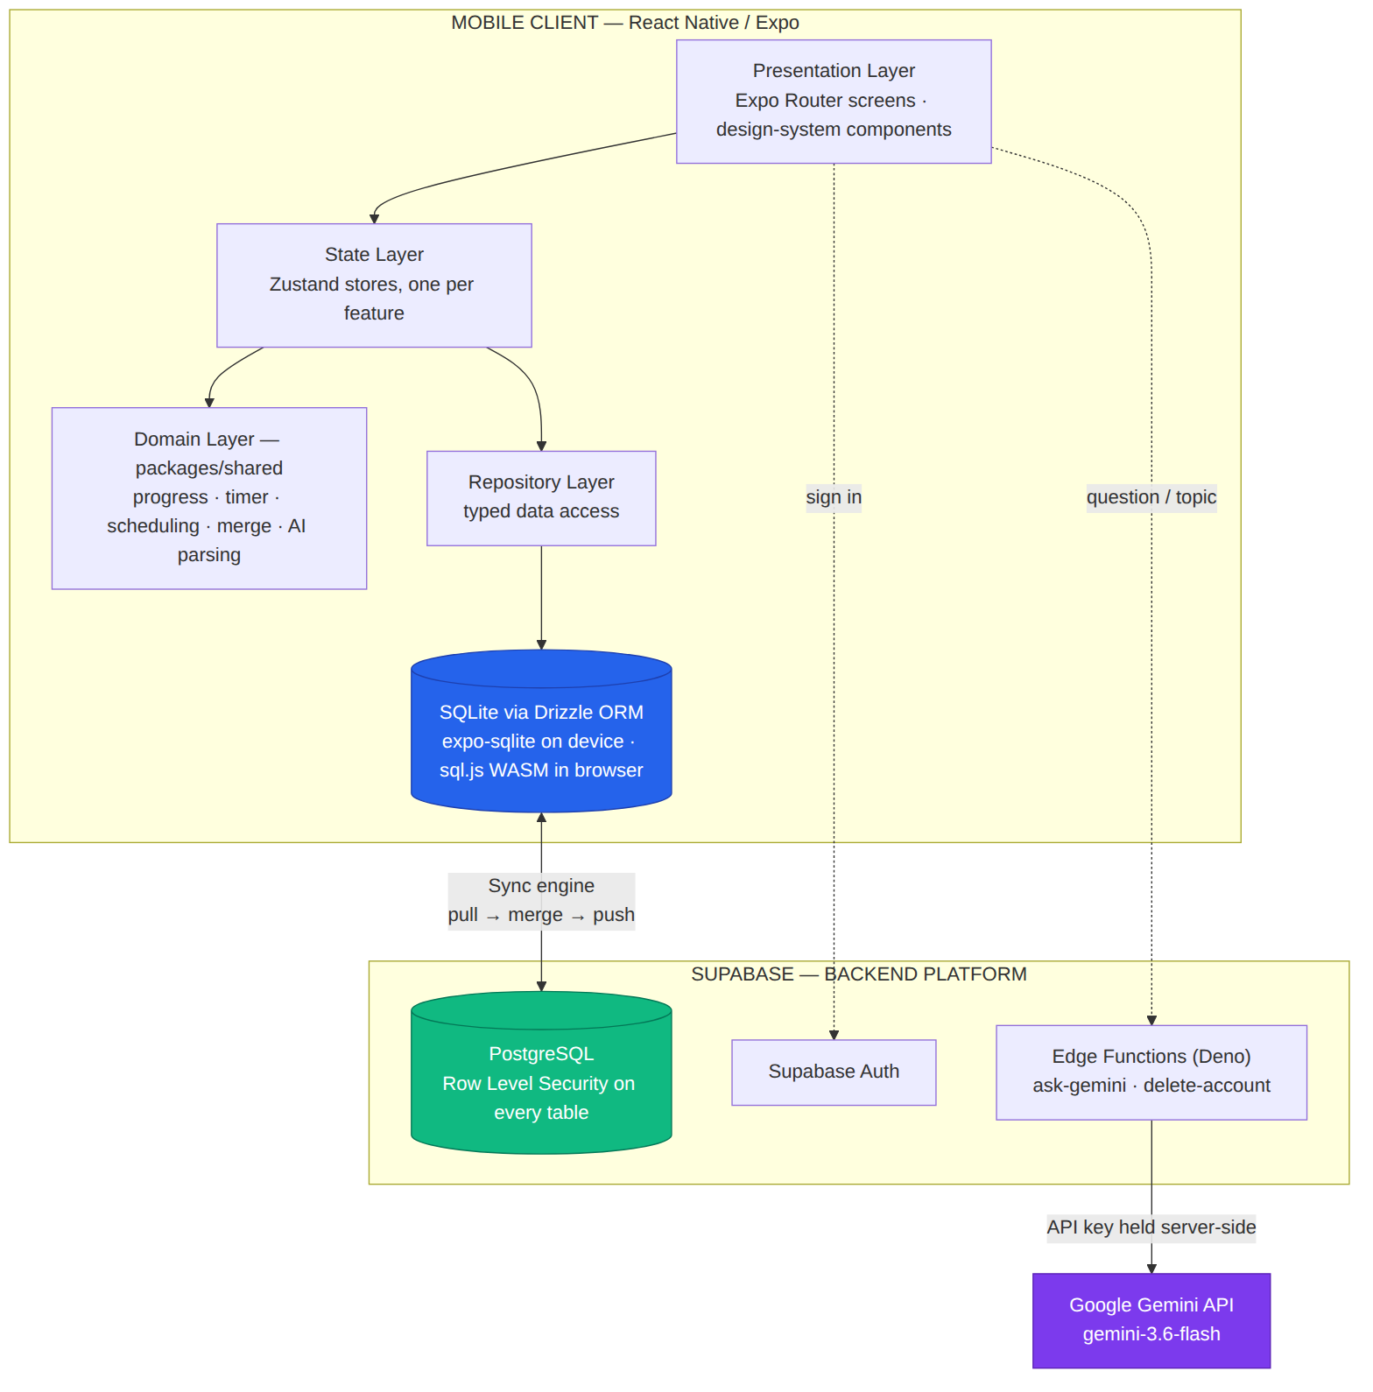
Figure 5.1: System architecture
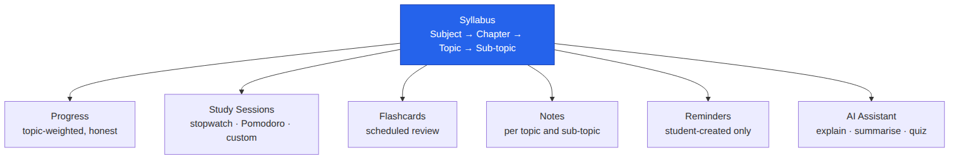
Figure 5.2: Every feature attaches to the syllabus hierarchy

5.2 Working flow
A student signs in, imports or builds a syllabus and works against it. Every action writes to the local database immediately and is marked pending; the synchronisation engine later pulls remote changes, merges them and pushes the agreed result. No student action waits on the network.
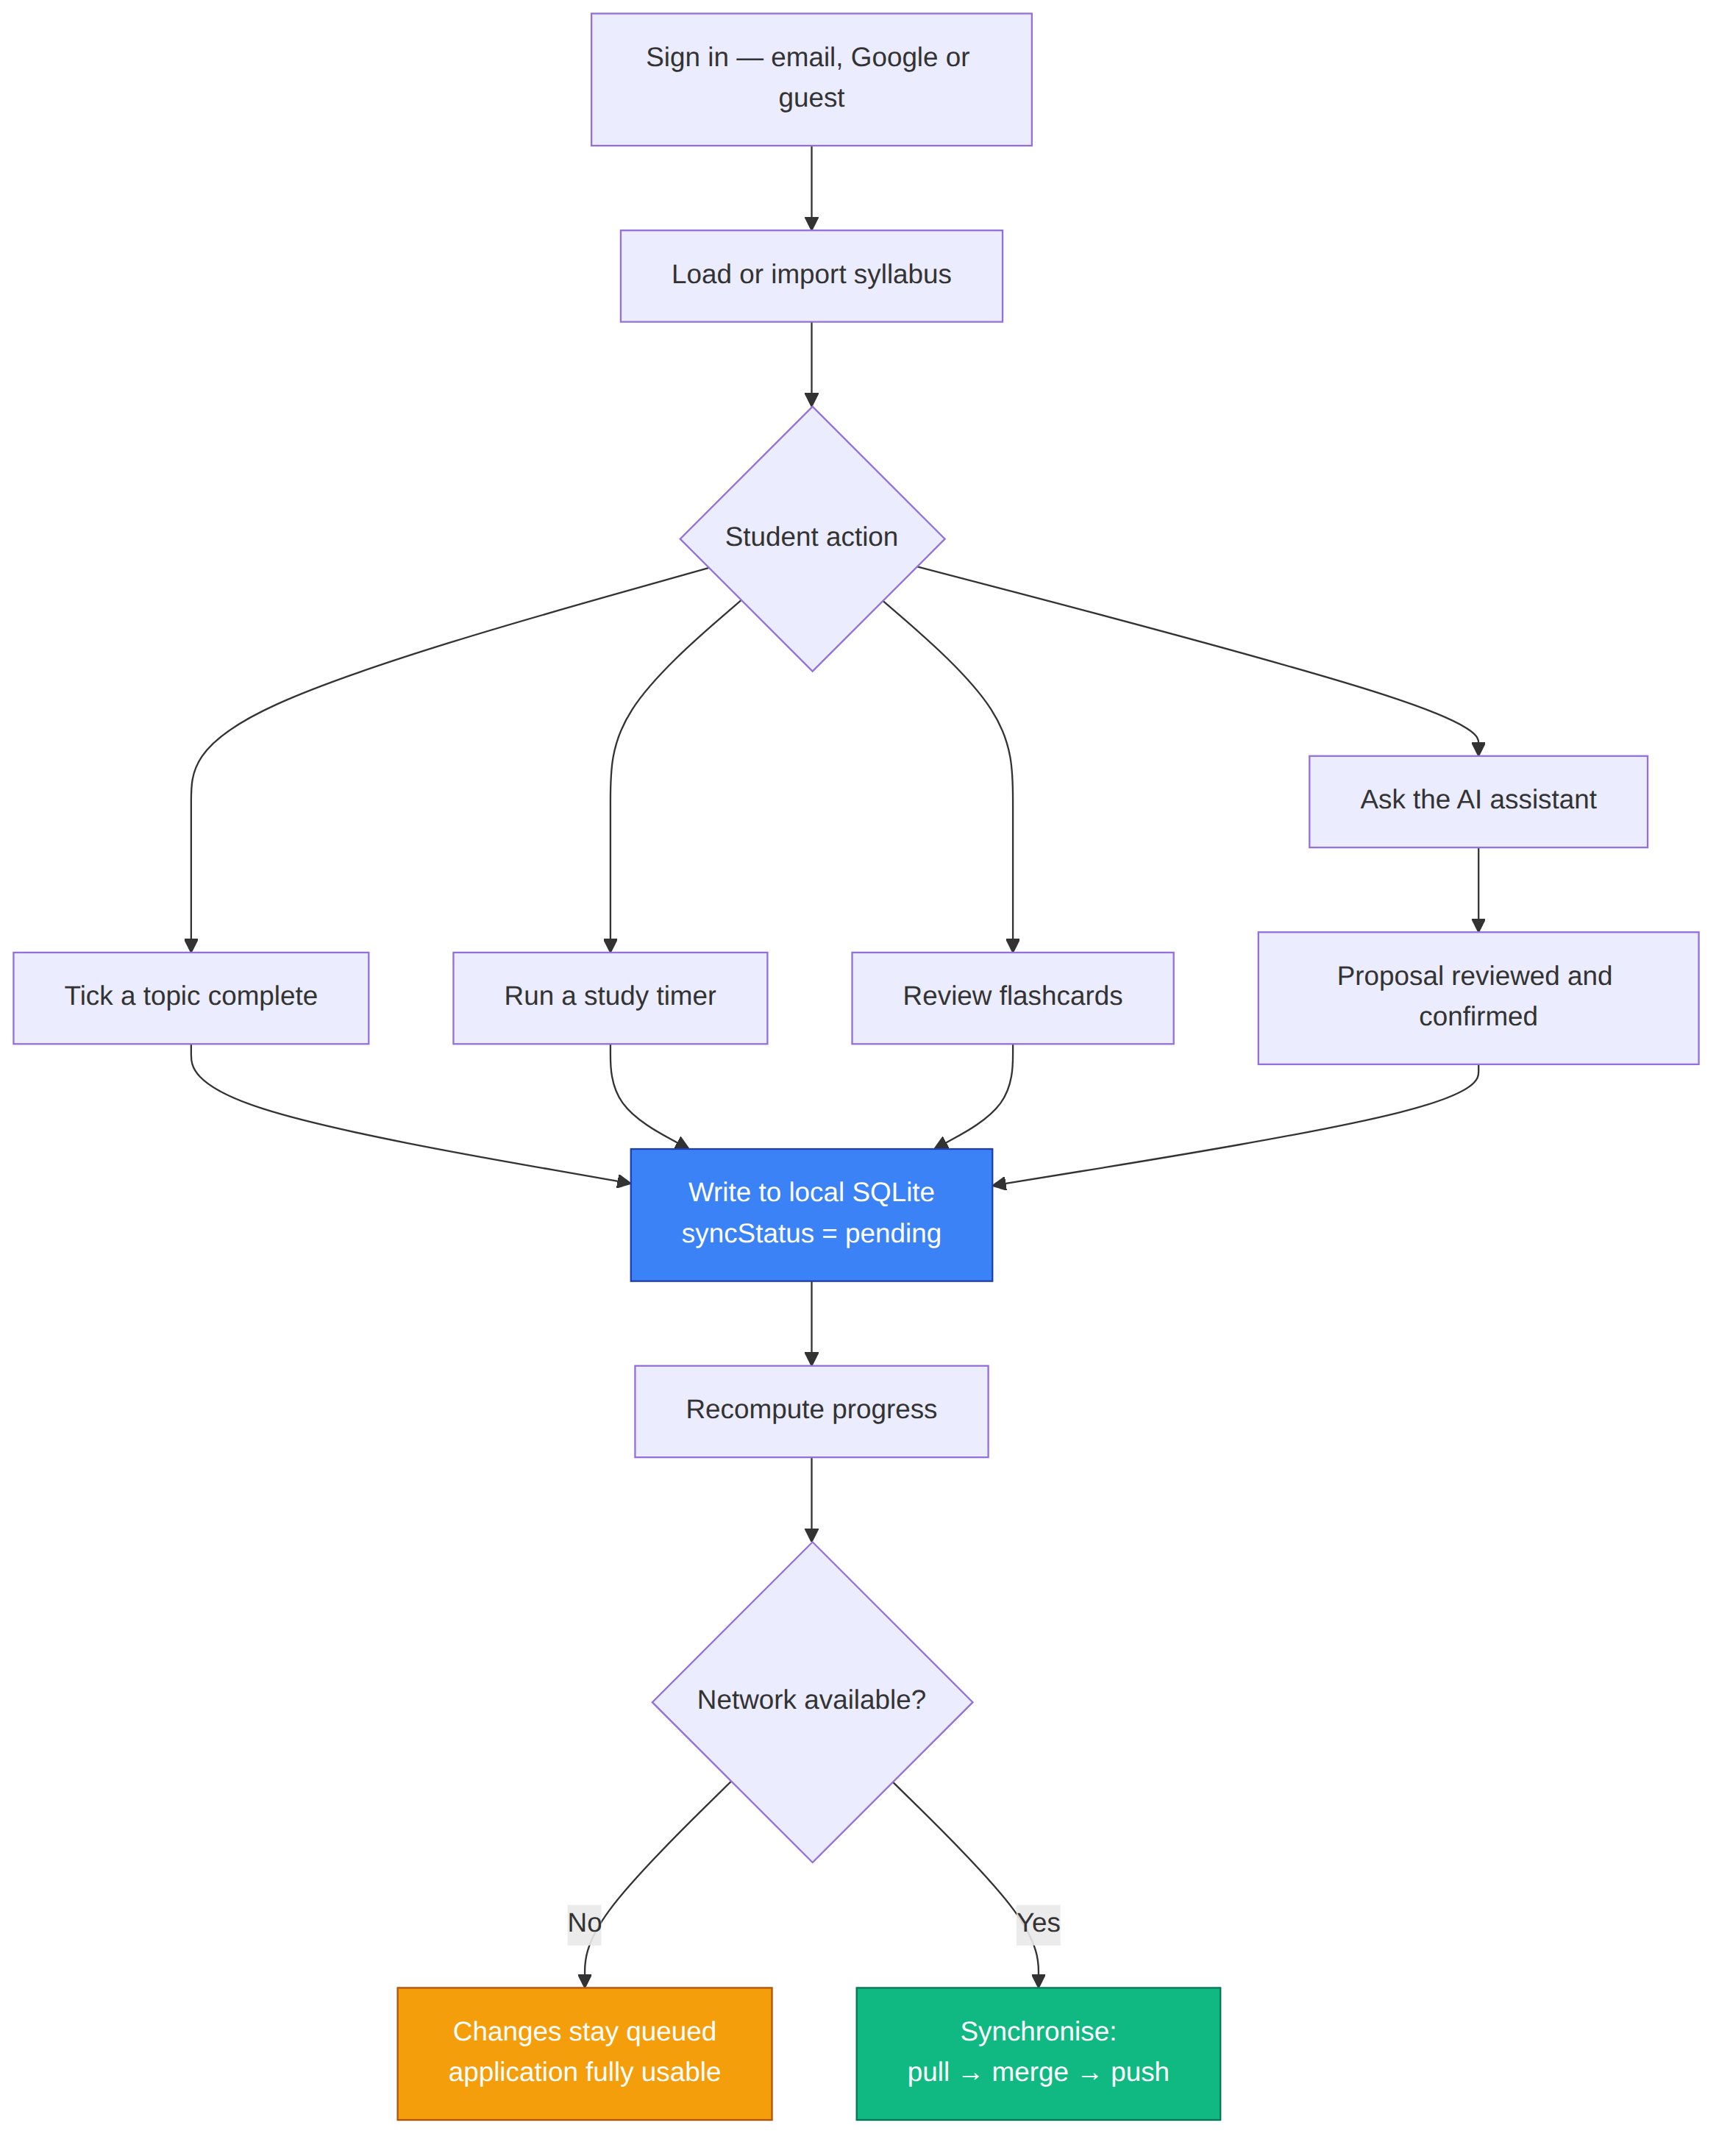
Figure 5.3: Working flow of the system

5.3 Data model
The device holds 13 SQLite tables; the server mirrors the 12 synchronised ones and adds profiles. Every synchronised row carries a client-generated UUIDv7 id, a denormalised user_id, created_at, updated_at, a deleted_at tombstone and, locally only, a sync_status of pending or synced.
Table 5.1: Database tables
Table | Purpose | Synced
trackers | Courses (a student may have several) | Yes
subjects, chapters, topics, subtopics | The syllabus hierarchy; topics carry a second timestamp for completion | Yes
study_sessions | Timed sessions; no foreign keys and name snapshots so history survives deletes and renames | Yes
flashcards | Cards with due date and SM-2 statistics | Yes
notes | Any number per topic; source manual, summary or assistant | Yes
reminders | Student reminders; the scheduled notification id stays local | Yes
chat_threads, chat_messages | Saved assistant conversations; pictures stay on the device | Yes
quiz_attempts | Finished quizzes with settings, answers and score | Yes
preferences | Device settings, including the sync watermark | No
profiles | Server only; created by a trigger on sign-up | Server

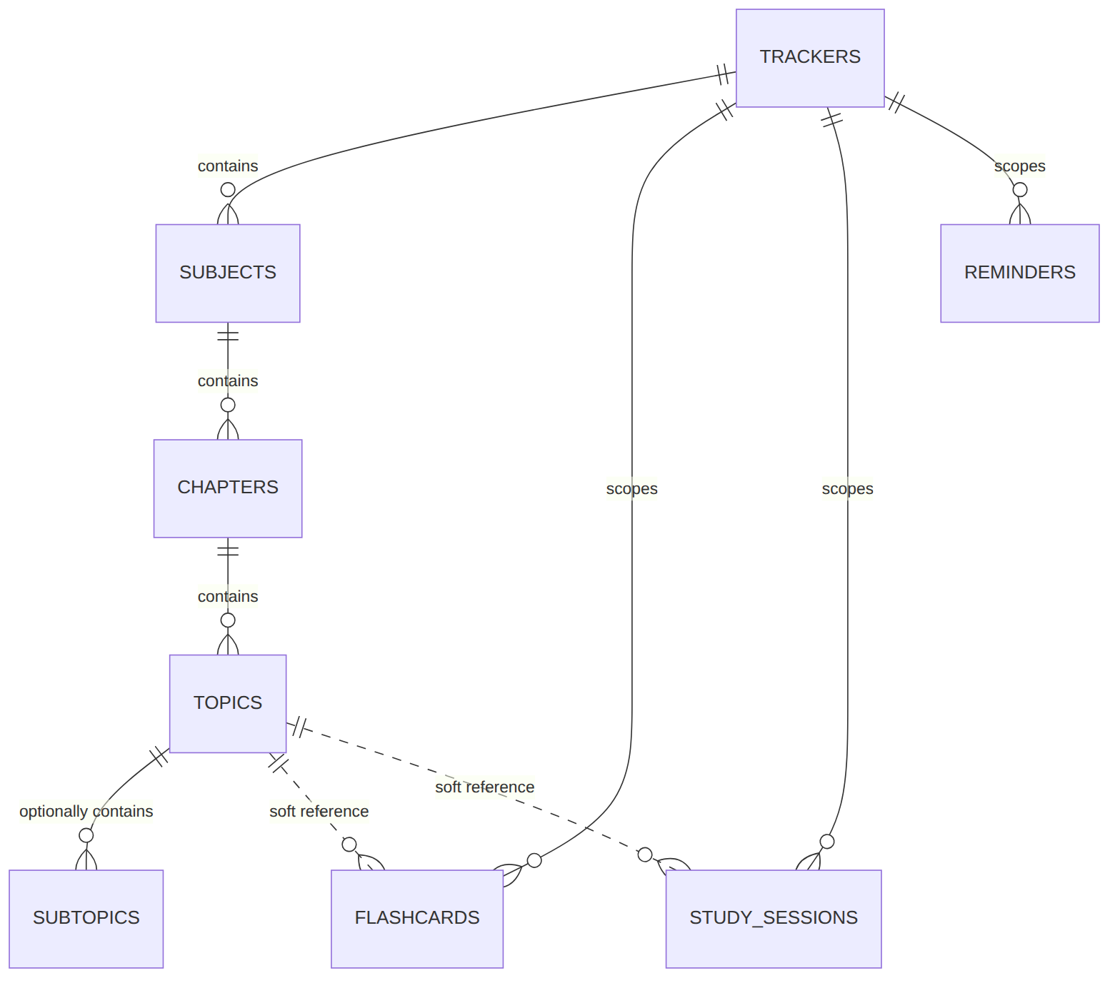
Figure 5.4: Entity relationships of the core syllabus tables (notes, chats and quizzes, added later, are listed in Table 5.1)

5.4 Synchronisation design
For each table, in dependency order so that a chapter never arrives before its subject, the engine pulls rows changed since a watermark, reconciles them with local rows by id, merges conflicts and writes the winner locally, then pushes everything still pending. Pulling before pushing is essential: pushing first would upload an unreconciled row and silently overwrite a change made elsewhere. The watermark is rewound 60 seconds on each pull to absorb clock differences and advanced only after a successful pass; every write is an idempotent upsert, so a failed pass can always be repeated.
Table 5.2: Conflict resolution rules
Situation | Winner | Reason
Either side tombstoned | The tombstone | Resurrecting a deleted row is worse than losing an edit
topics.completed differs | Later completed_changed_at | A rename on one device must not undo a tick on another
Completion timestamps equal | Completed | Un-ticking finished work is the least forgivable outcome
Anything else | Later updated_at | Last write wins
updated_at exactly equal | Local | Prevents devices rewriting rows they agree on

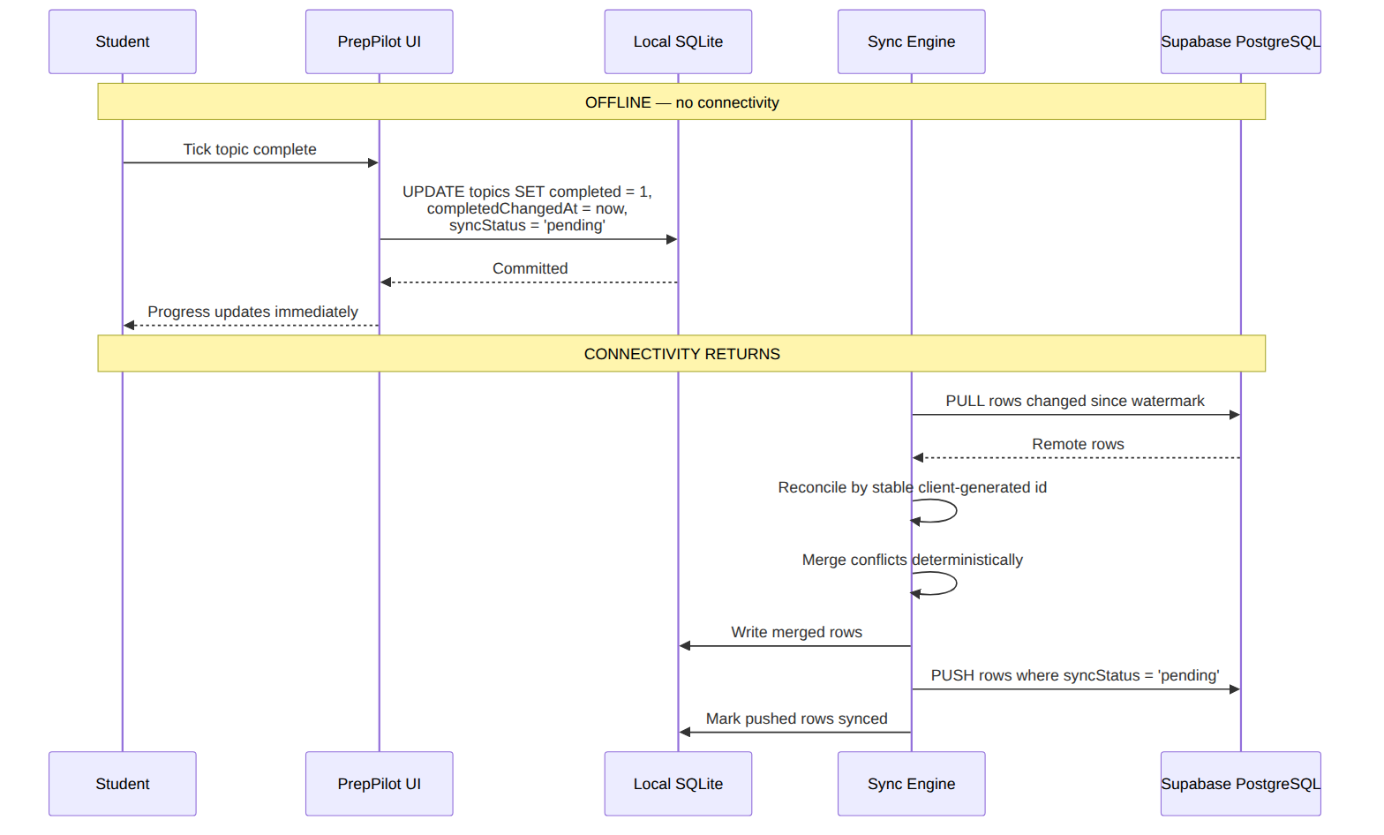
Figure 5.5: Offline write and later synchronisation
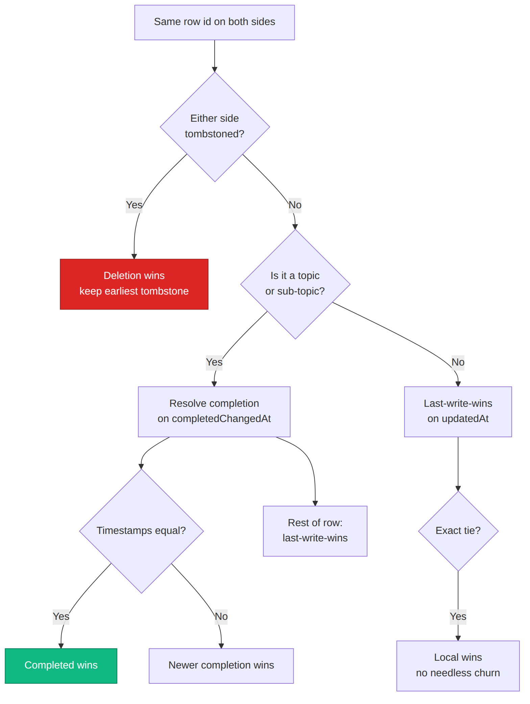
Figure 5.6: Conflict resolution decision flow

5.5 AI assistant design
The app calls the ask-gemini Edge Function, which holds the Gemini key as a Supabase secret, applies the per-user rate limit, and never forwards an upstream error body. It asks Gemini 3.6 Flash, retries once on 429 or 503, then falls back to Gemini 3.5 Flash-Lite and Gemini 3.1 Flash-Lite. A reply that suggests syllabus changes is parsed into an inert proposal whose grammar has only two verbs, addChapters and addTopics; there is no way to express deleting or completing anything. The student sees exactly what would be added and must confirm, and proposals over 200 topics are refused.
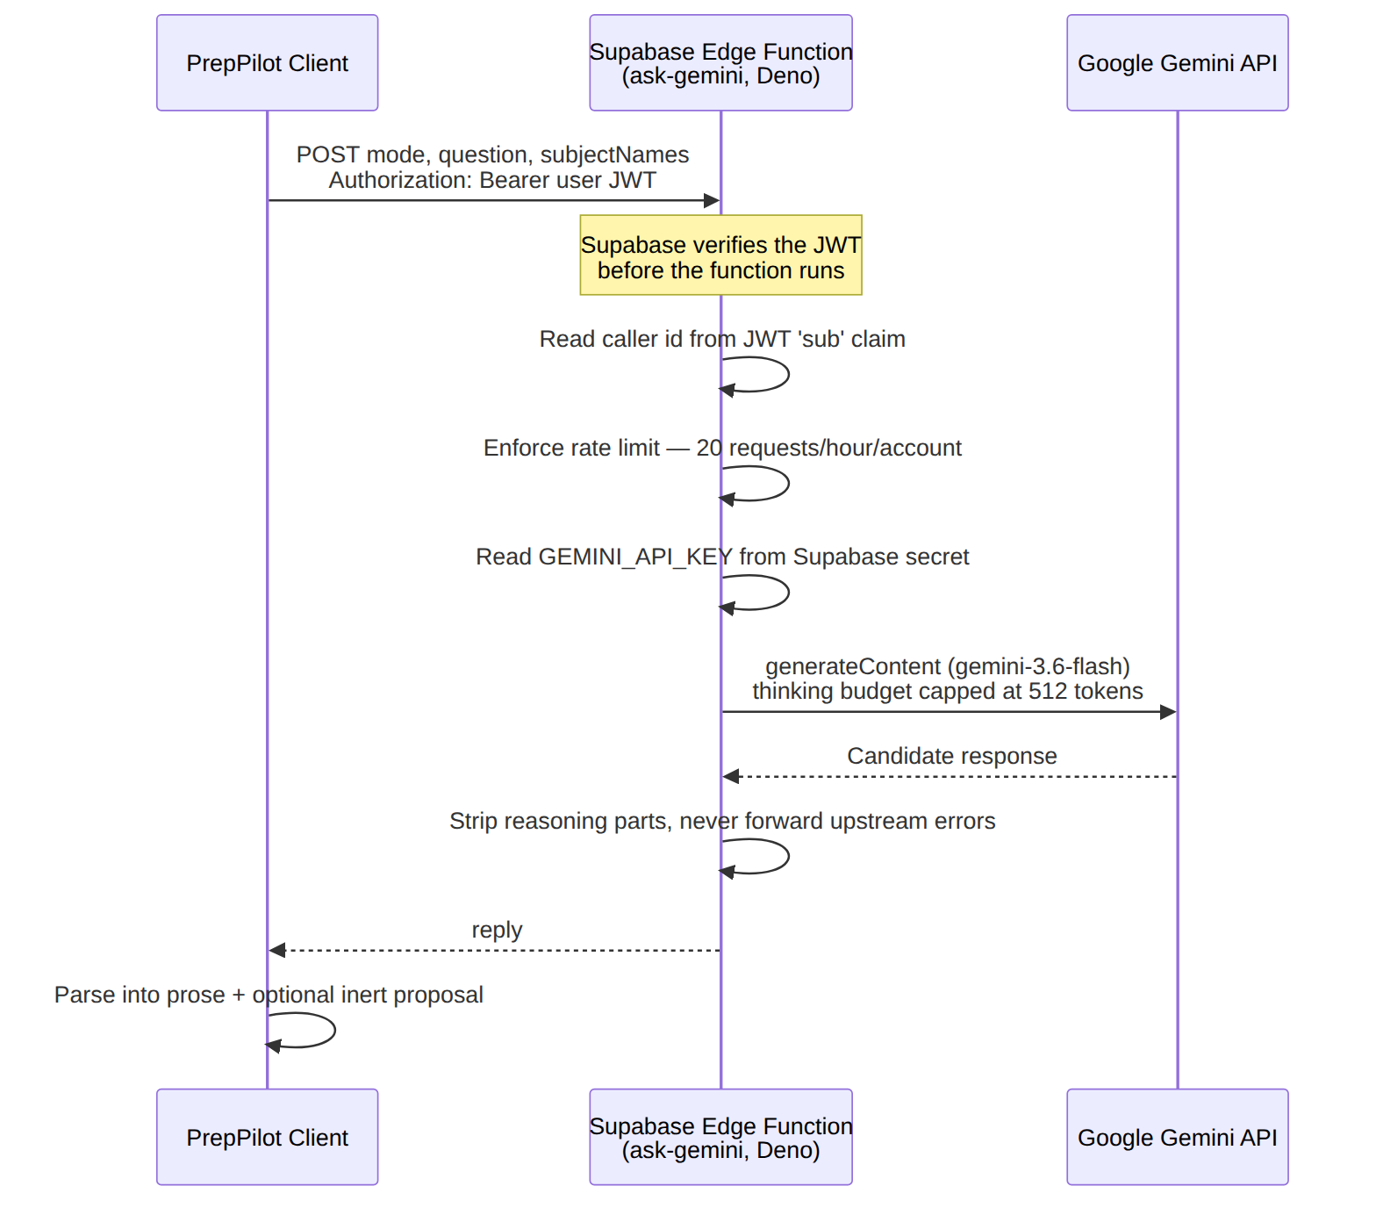
Figure 5.7: AI request flow through the Supabase Edge Function

5.6 Security design
- Row Level Security is enabled and forced on every table, every policy is scoped to auth.uid(), and no delete privilege is granted anywhere — rows are tombstoned.
- Secrets: only the publishable Supabase key is in the app; the service-role key is nowhere in the repository and the Gemini key exists only as a server secret.
- Sessions are stored in the device keystore through expo-secure-store, with an adapter that chunks values over its 2,048-byte limit.
- Sign-in uses PKCE for email links and password reset, and Google ID tokens from Android's account picker verified by Supabase.
- Input validation happens before any request; passwords are capped at 72 bytes because bcrypt ignores everything after that.
- Errors never leak: tests assert that keys, constraint names and driver errors never appear on screen.

6. Implementation

6.1 Technology stack
Table 6.1: Technology stack
Layer | Technology
Language | TypeScript
Mobile framework | React Native 0.86, Expo SDK 57, Expo Router
State | Zustand
Local database | SQLite via Drizzle ORM — expo-sqlite on Android, sql.js (WebAssembly) in the browser
Backend | Supabase: PostgreSQL, Auth, Storage, Edge Functions (Deno)
AI | Google Gemini 3.6 Flash, with 3.5 and 3.1 Flash-Lite fallbacks
Testing | Jest with React Native Testing Library (app), Vitest (shared), Deno test (functions)
Build and CI | pnpm workspaces, GitHub Actions, Expo Application Services, Netlify

6.2 Repository structure
Table 6.2: Repository layout and size (non-test source lines, 6 Oct 2026)
Path | Contents | Lines
apps/mobile | The Expo app: screens, features, stores, repositories, web build | 25,138
packages/shared | Progress engine, timer, scheduling, sync merge, AI parsing, templates, theme validation, tokens | 10,482
supabase/functions | Edge Functions ask-gemini and delete-account | 773
supabase/migrations | PostgreSQL schema, policies and grants | 832
docs | Product, technical and developer documentation; this report | —

6.3 Progress engine
Progress is the product's core promise, so it lives in one pure module and is tested exhaustively. Subject progress sums completed and total topic units across all of the subject's chapters, rather than averaging chapter percentages; a topic split into sub-topics contributes its sub-topics. An explicit regression test fails if averaging is ever introduced. The excerpt below is from packages/shared/src/progress/progress.ts.
export function makeProgress(completed: number, total: number): Progress {
...
return {
completed,
total,
percent: total === 0 ? null : (completed / total) * 100,
isEmpty: total === 0,
};
}

export function calculateSubjectProgress(subject: SubjectLike): Progress {
let completed = 0;
let total = 0;
for (const chapter of subject.chapters) {
for (const topic of chapter.topics) {
const units = topicUnits(topic);
completed += units.completed;
total += units.total;
}
}
return makeProgress(completed, total);
}

Rounding is also honest: 9,999 of 10,000 topics displays as 99%, never 100%, and a chapter with no topics shows — instead of 0%.

6.4 Feature modules
Table 6.3: Feature modules
Module | Implementation notes
Tracker | Expandable subjects and chapters, per-level progress rings and bars, play button per row, options menu (rename, summarise, test me, sub-topic, note, move, delete)
Timers | Stopwatch, Pomodoro and custom modes from a pure timer state machine; Pomodoro breaks are excluded from study time; full-screen landscape view with Flip cards, Minimal, Ring, Time wedge, Hourglass and Rising tide faces
Focus Mode | Configurable countdown; an in-app capability list states what the platform does and does not allow
Templates | 22 syllabi: JEE Main, JEE Advanced, NEET UG; ten CBSE streams (classes 9–12); UPSC CSE, SSC CGL, GATE CS & IT, NEET PG, CA Foundation, Intermediate and Final, MBBS, DevOps
Flashcards | Review with 1d / 2d / 4d buttons; SM-2 statistics maintained underneath
Quizzes | 1–15 multiple-choice questions, Easy / Medium / Hard / Competitive, optional multi-answer; each question validated separately; finished quizzes saved to the Quiz deck and can be redone offline
AI assistant | Photo questions resized on the device to 1,600 px JPEG; Markdown and LaTeX rendered as formatted text by an in-house parser; saved chats; follow-ups that send the summary and last six messages
Themes | JSON packs and fonts validated whole before use (colours, ranges, font paths, WCAG contrast), downloaded to the device, restored before the first frame
Sync | Runs on sign-in and launch, every 5 minutes in the foreground, on leaving the app, on reconnecting, and from Settings

6.5 Development timeline
Table 6.4: Milestones, from the repository history and decision log
Date (2026) | Milestone
30 Aug | Repository history begins
10 Sep | Repository audit, synopsis and first project presentation added
12 Sep | APK confirmed working on a physical Android phone against the live backend
21 Sep | All tables live on the hosted Supabase project; reinstall restores data
23 Sep | Native Google sign-in configured on the live project
24 Sep | Several notes per topic, saved chats, configurable quizzes and the Quiz deck
25 Sep | Follow-up questions on summaries; second Flash-Lite fallback
26 Sep | Forgot password and branded authentication emails
2 Oct | Downloadable themes: Notebook, Flight deck, Bold bento
3 Oct | Full-screen landscape timer and configurable Focus Mode
4 Oct | Continue-tracking card removed; web build deployable to Netlify

7. User Interface and Screenshots
This chapter walks through the application screen by screen. Screenshots come from two sources, named under each one: screens captured 24 Sep 2026 are the set already kept in the repository (docs/assets/screenshots/app); screens marked web demo, 6 Oct 2026 were captured for this report from the browser build of the same code at a phone-sized viewport, to cover features added since then. The browser build runs in demo mode with a small seeded syllabus, so its figures (such as 10.00%) are sample data. Sign-in, registration and password-reset screens are not shown because demo mode bypasses authentication.

7.1 Syllabus tracker
The tracker is the home screen: the course selector, overall completion ring, and one card per subject with its own progress ring and a play button that starts a timer. Expanding a subject shows chapters with progress bars, and expanding a chapter shows topics with checkboxes.
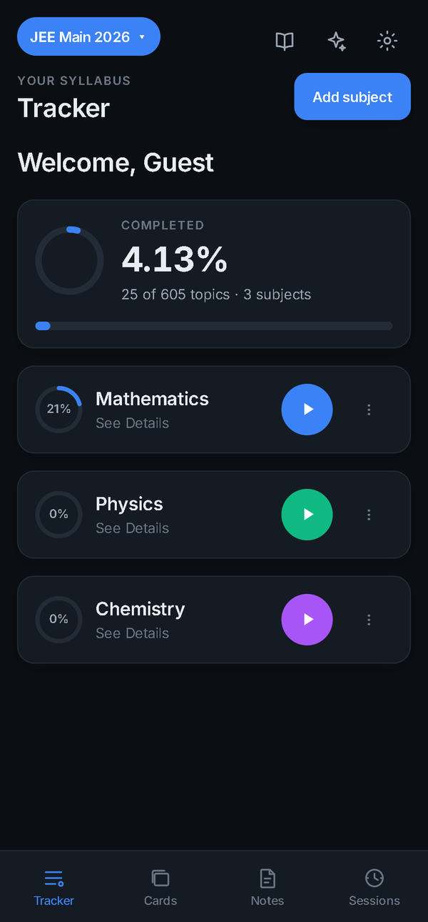  Figure 7.1: Tracker with the JEE Main 2026 template  captured 24 Sep 2026 | 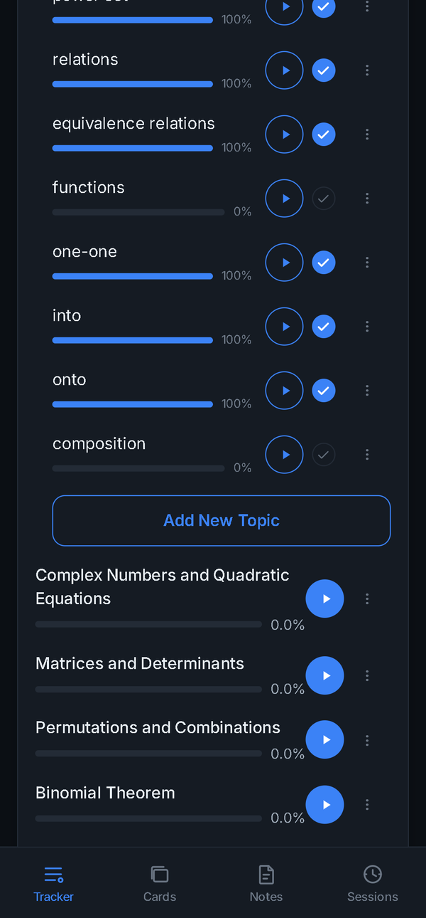  Figure 7.2: A subject expanded into chapters  captured 24 Sep 2026 | 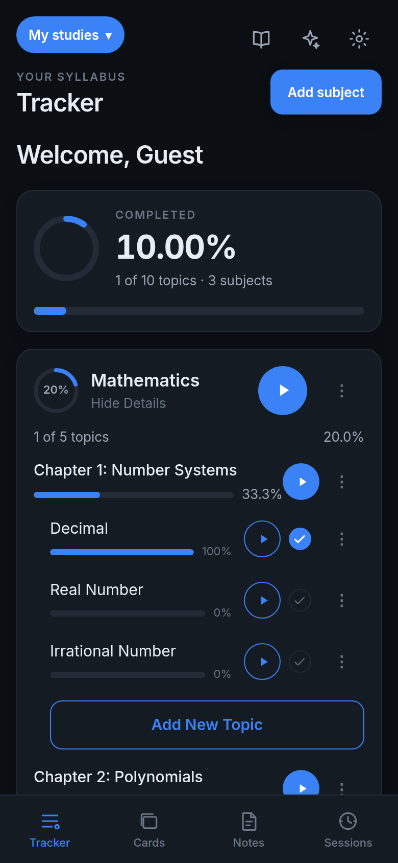  Figure 7.3: Chapter expanded into topics  web demo, 6 Oct 2026 | 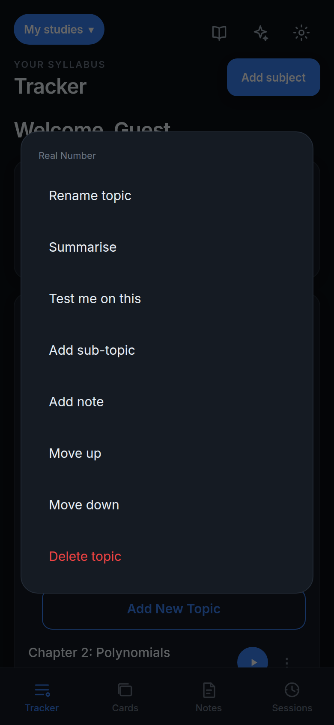  Figure 7.4: Topic options menu  web demo, 6 Oct 2026

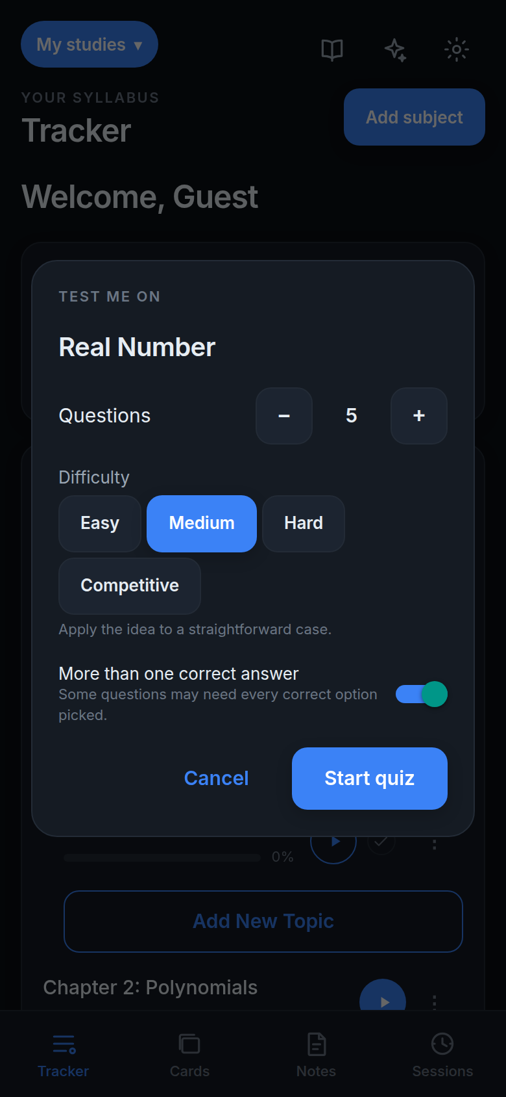  Figure 7.5: Quiz settings: count, difficulty, multi-answer  web demo, 6 Oct 2026 | 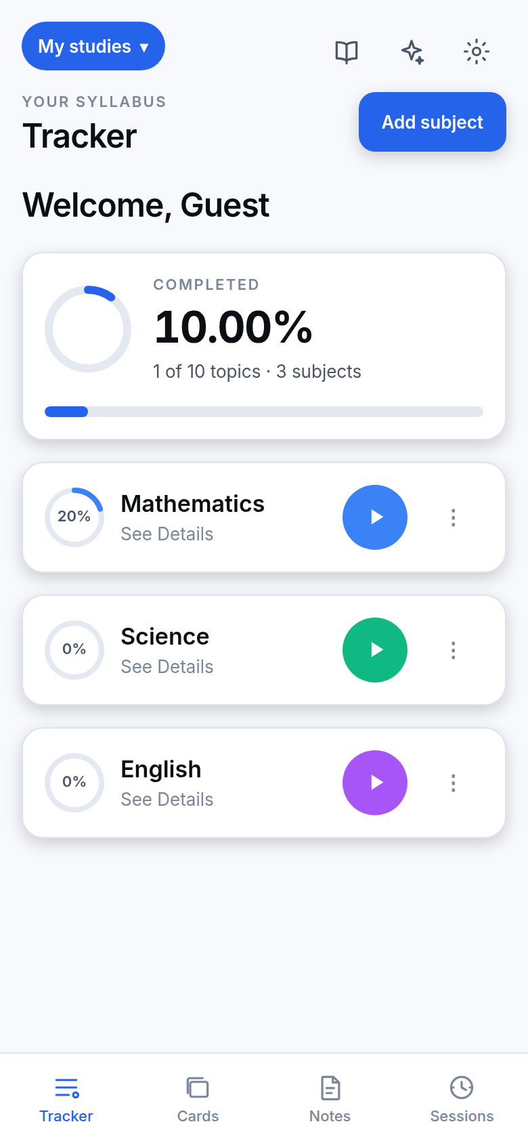  Figure 7.6: Tracker in light mode  web demo, 6 Oct 2026

7.2 Templates and building a course
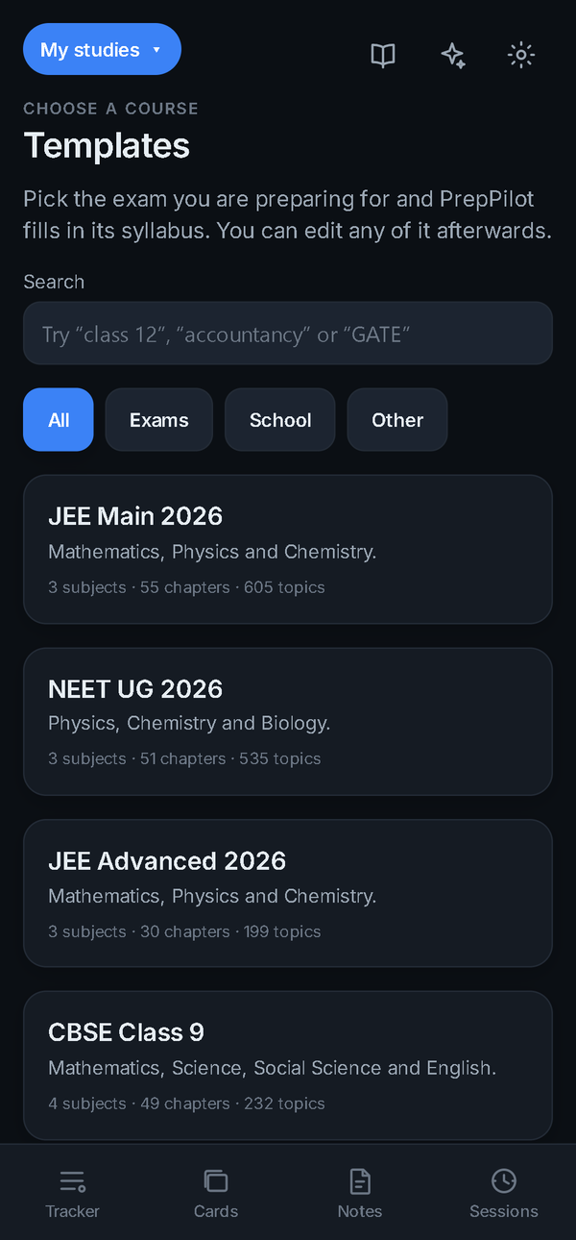  Figure 7.7: Template library  captured 24 Sep 2026 | 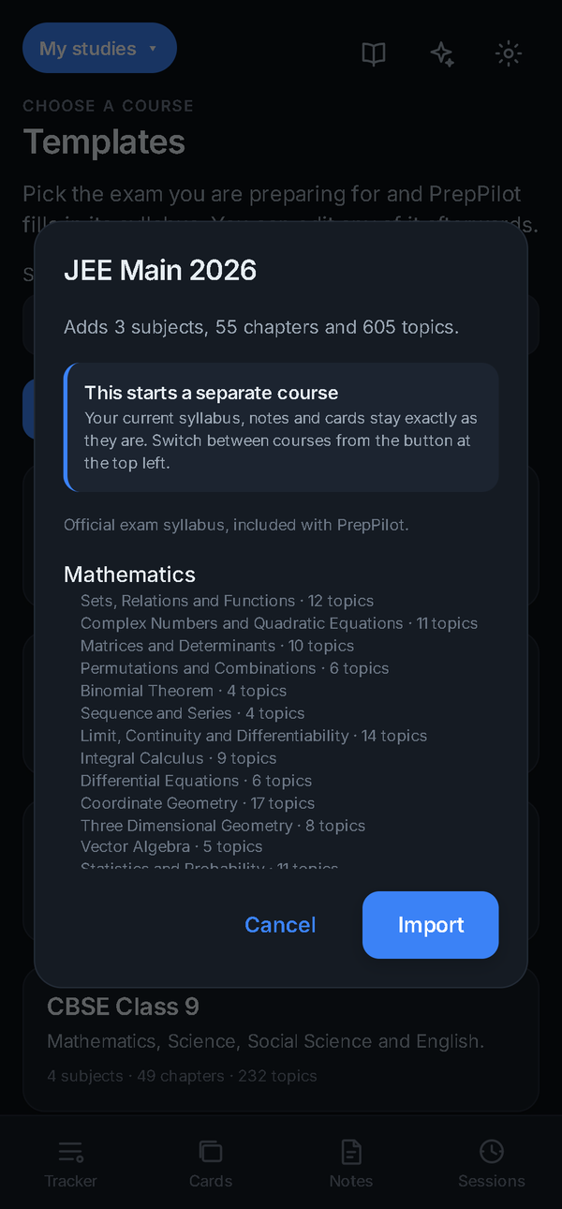  Figure 7.8: Template preview before import  captured 24 Sep 2026 | 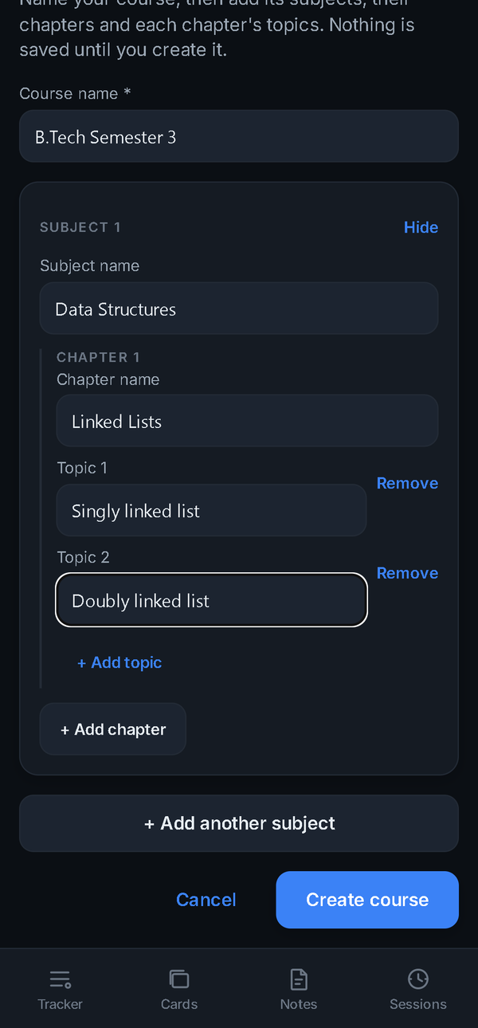  Figure 7.9: Build a course from scratch  captured 24 Sep 2026

7.3 Timers
Starting a timer from any row opens the timer sheet with Stopwatch, Pomodoro and Custom modes. Full screen turns the phone to landscape; a tap pauses or resumes, and while paused the student can pick one of six faces.
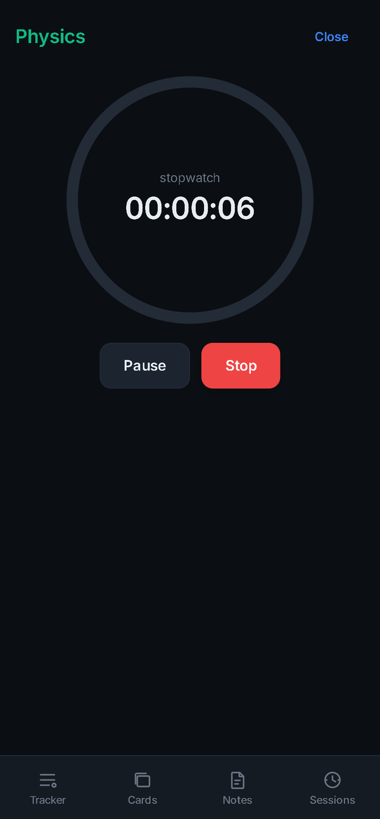  Figure 7.10: Timer sheet  captured 24 Sep 2026 | 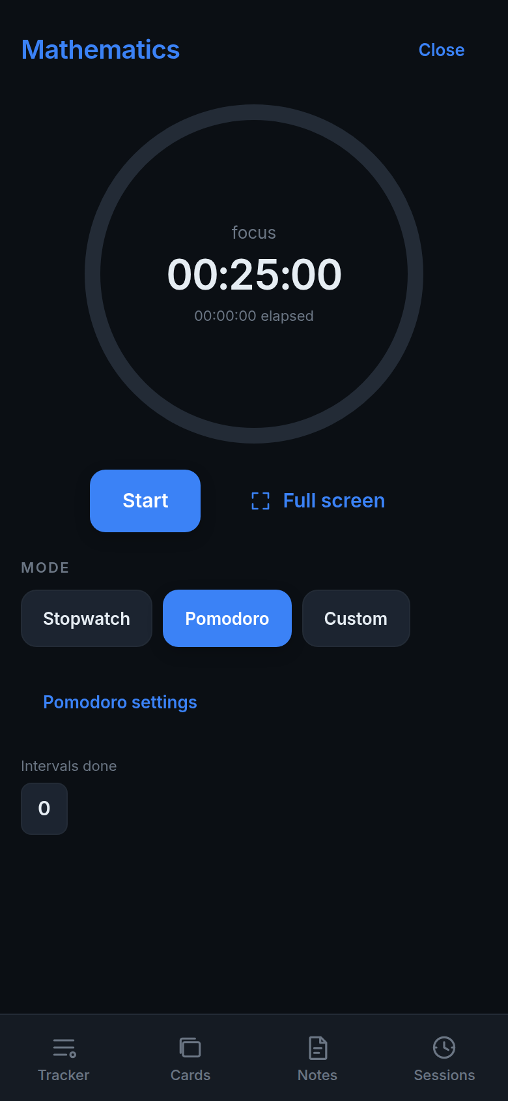  Figure 7.11: Pomodoro mode before starting  web demo, 6 Oct 2026 | 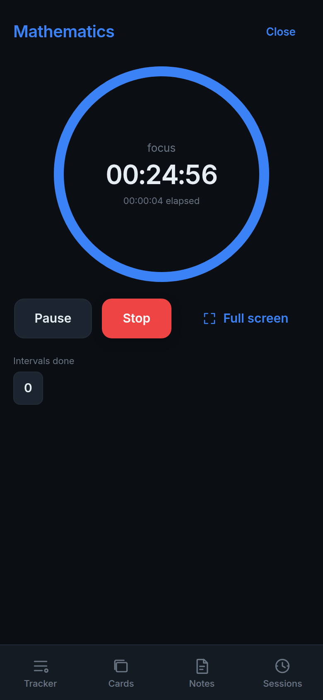  Figure 7.12: Pomodoro interval running  web demo, 6 Oct 2026

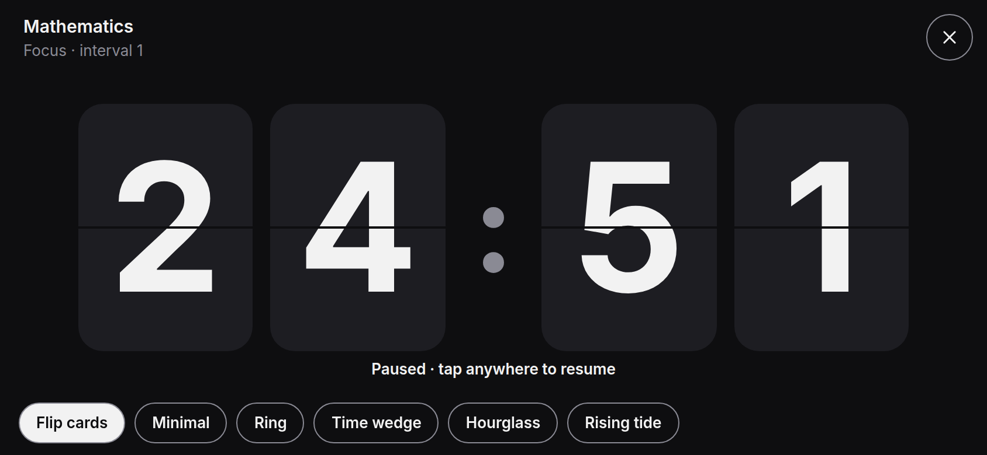  Figure 7.13: Full-screen timer, Flip cards face (paused)  web demo, 6 Oct 2026 | 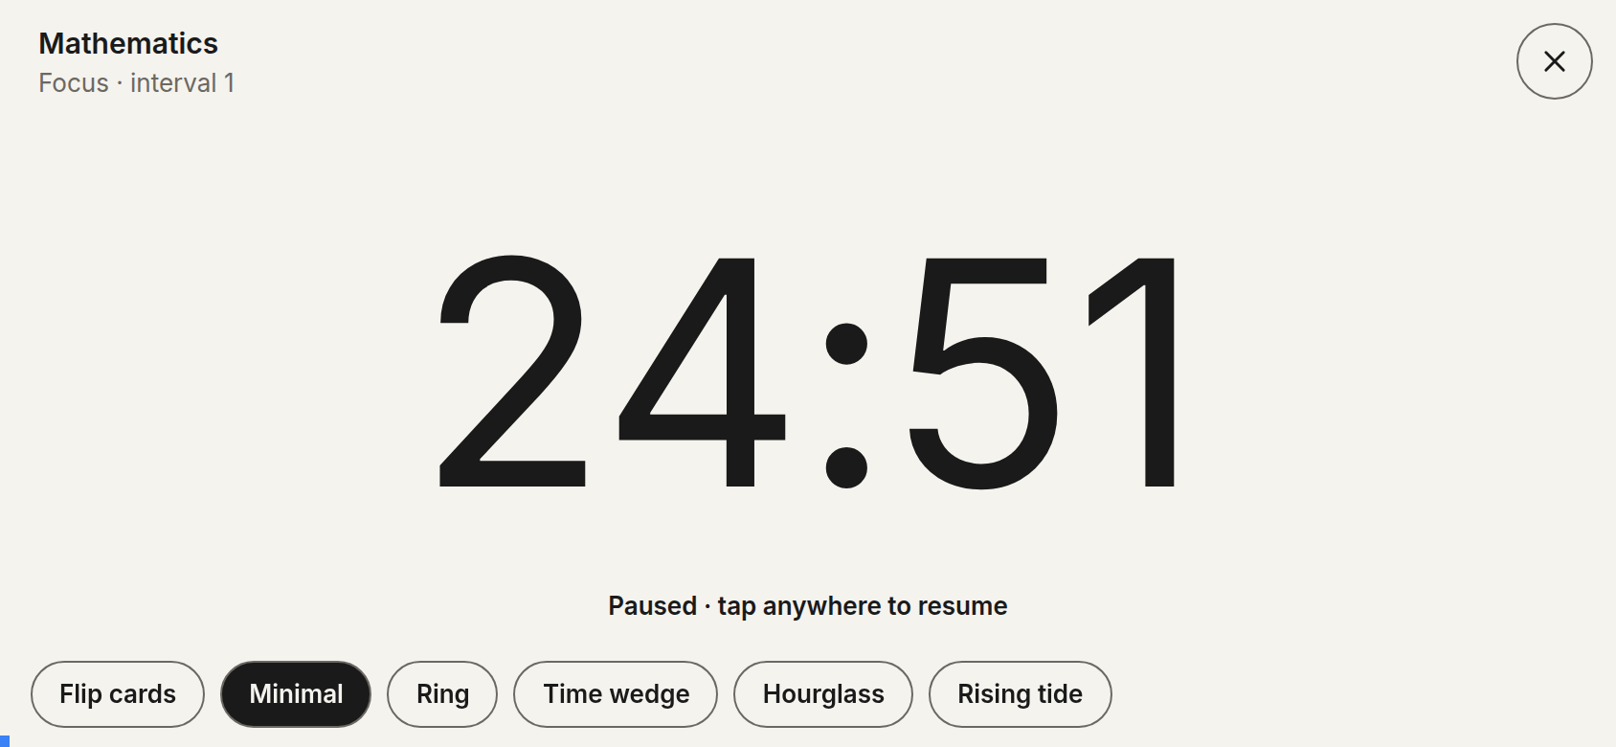  Figure 7.14: Minimal face  web demo, 6 Oct 2026 | 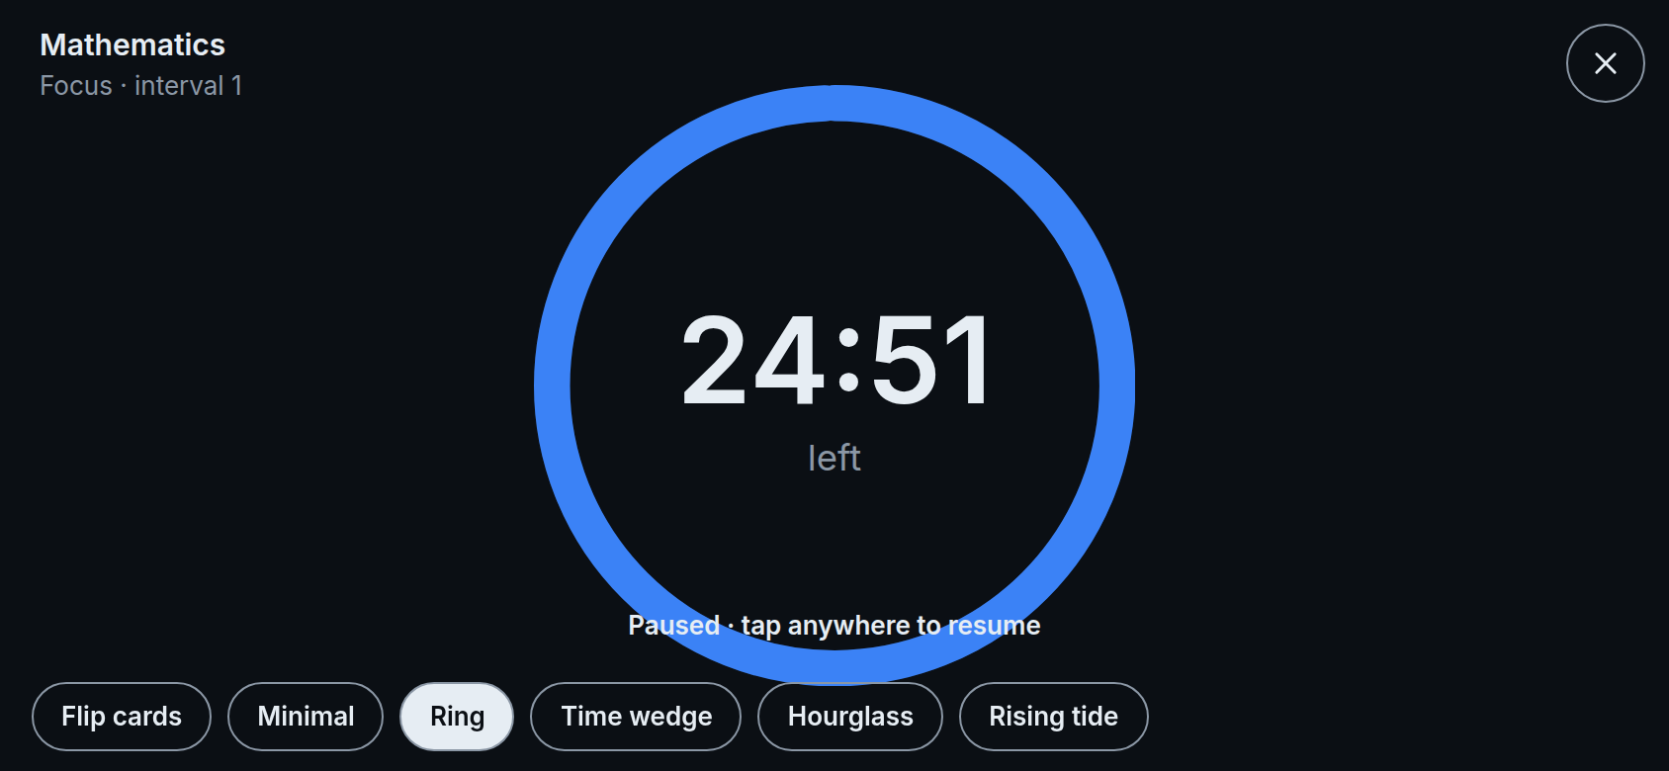  Figure 7.15: Ring face  web demo, 6 Oct 2026

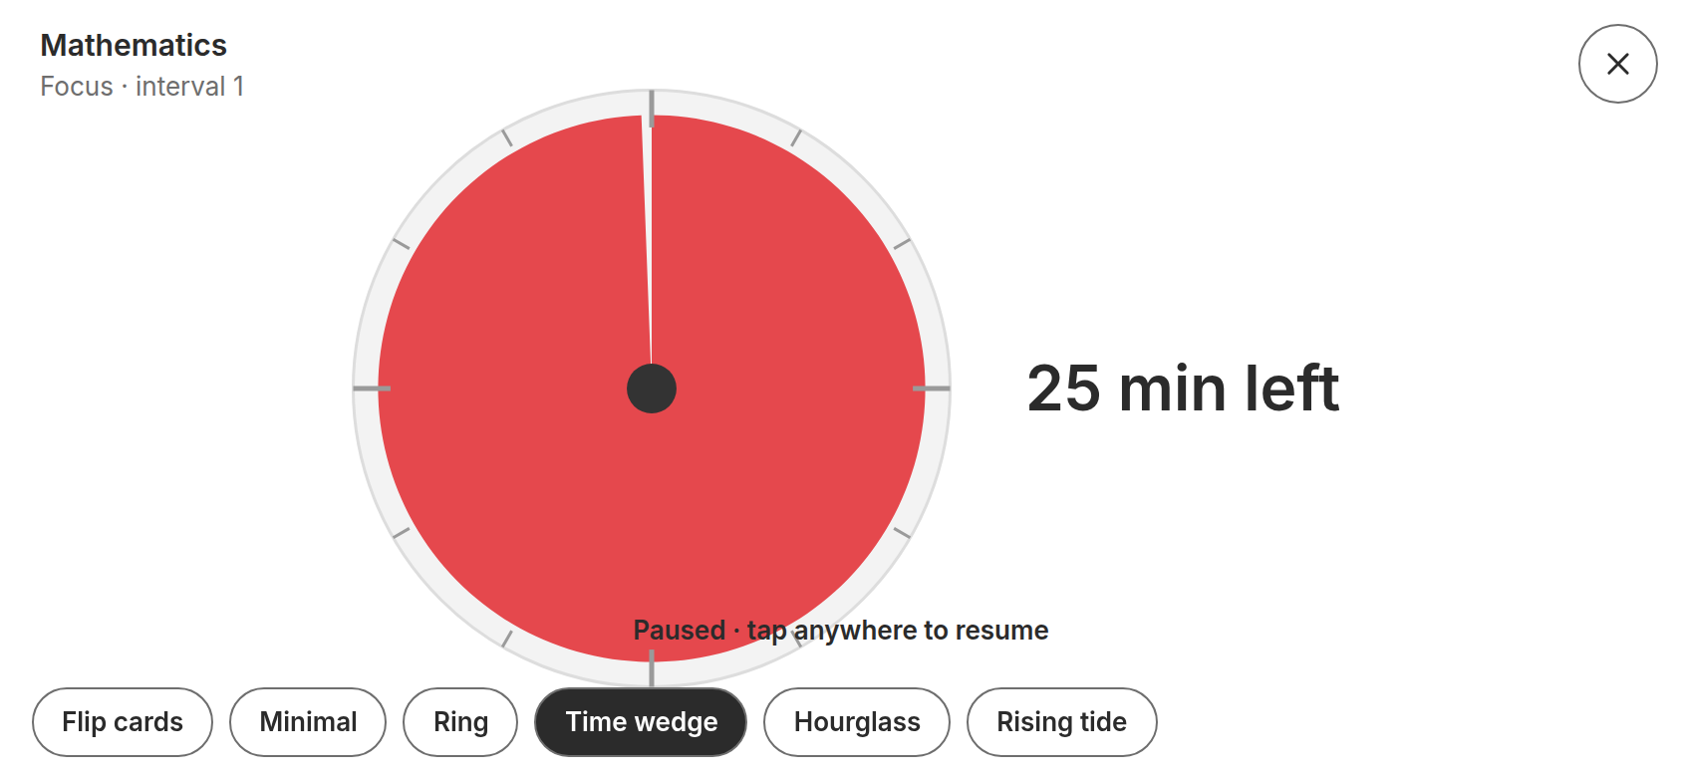  Figure 7.16: Time wedge face  web demo, 6 Oct 2026 | 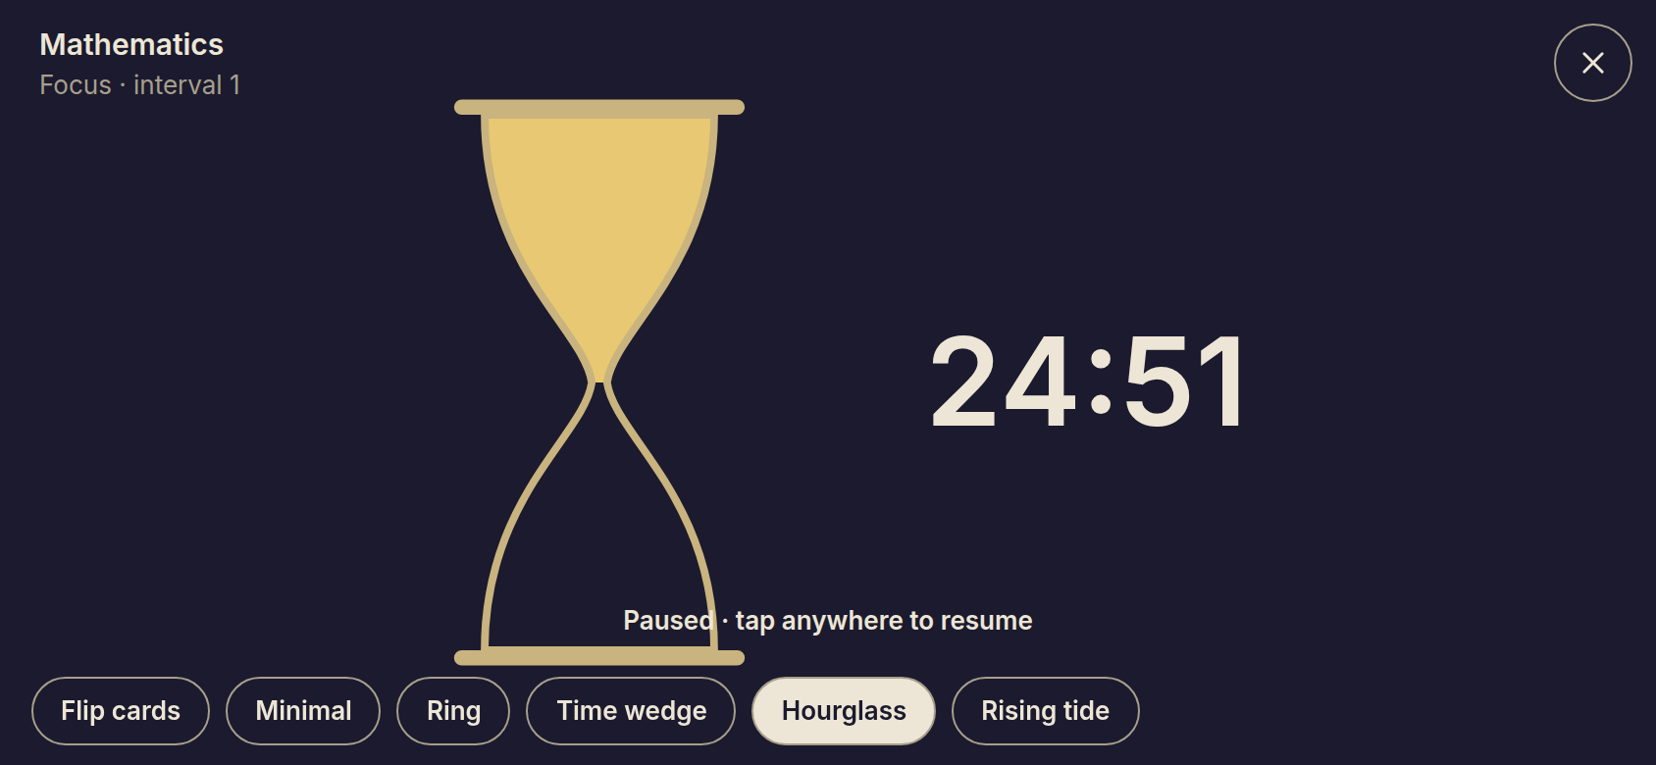  Figure 7.17: Hourglass face  web demo, 6 Oct 2026 | 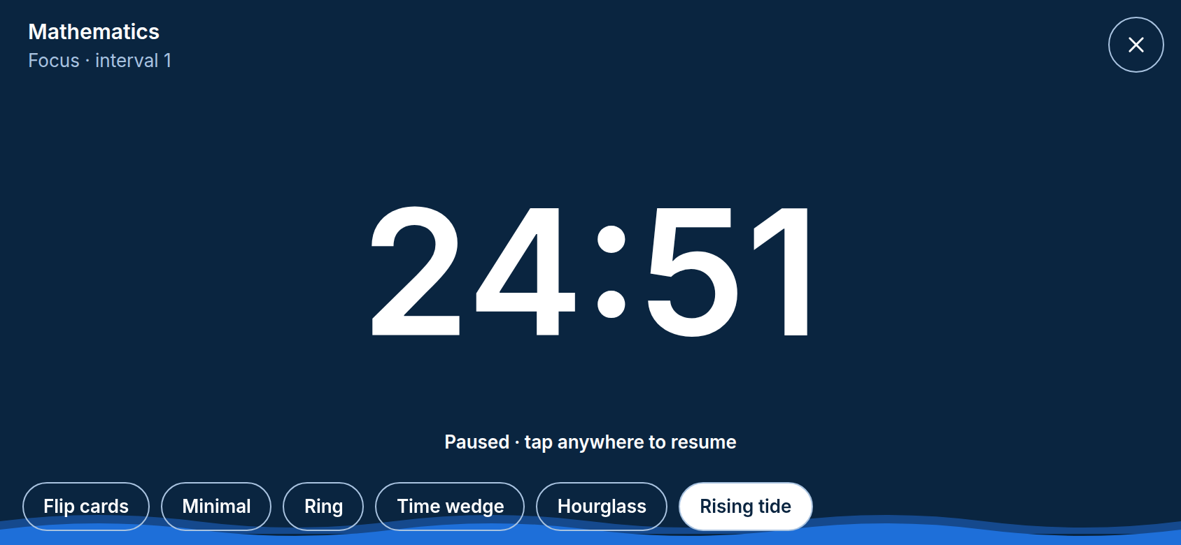  Figure 7.18: Rising tide face  web demo, 6 Oct 2026

7.4 Focus Mode
Focus Mode is a countdown of 1 to 240 minutes with presets, a choice of end alert and a keep-screen-on option. Its capability list says plainly what it cannot do on the current platform — the browser build marks screen-on and departure counting as app only, and app blocking as impossible.
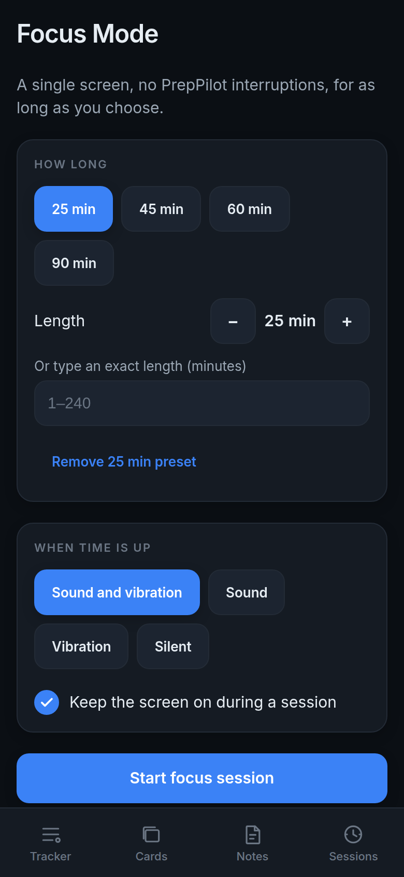  Figure 7.19: Focus Mode set-up  web demo, 6 Oct 2026 | 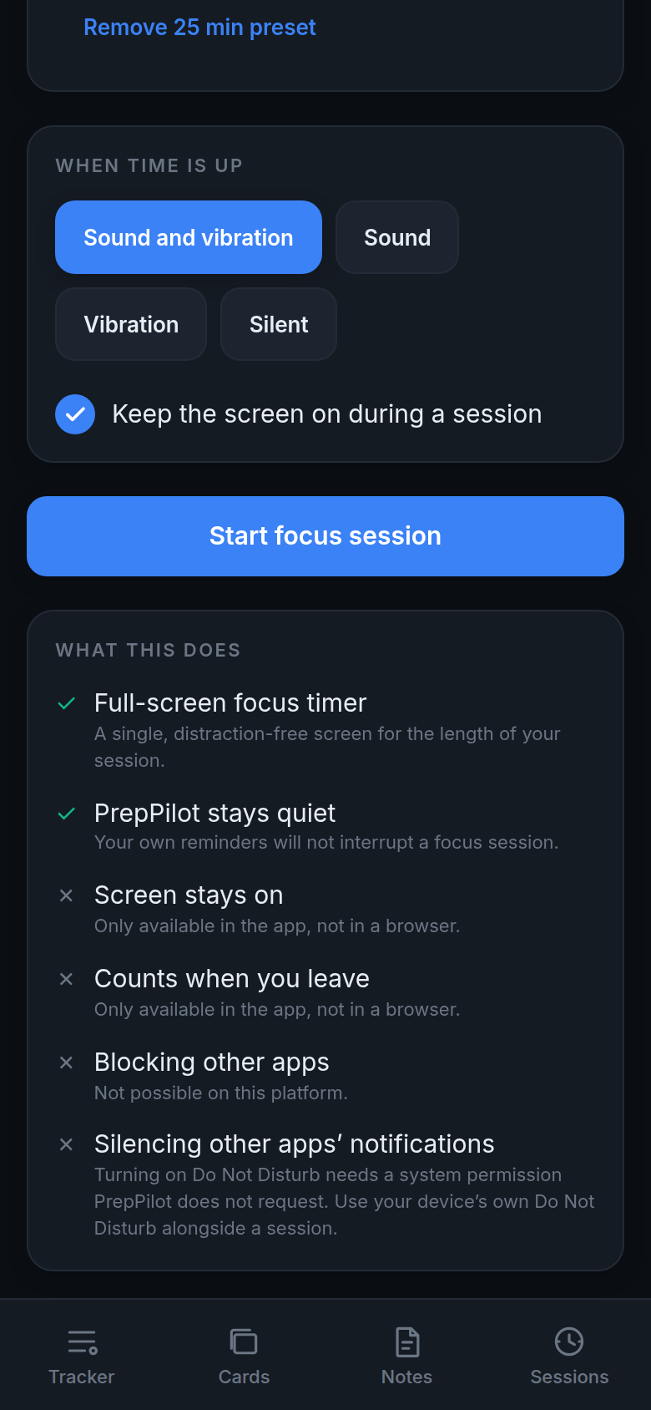  Figure 7.20: End alert and capability list  web demo, 6 Oct 2026 | 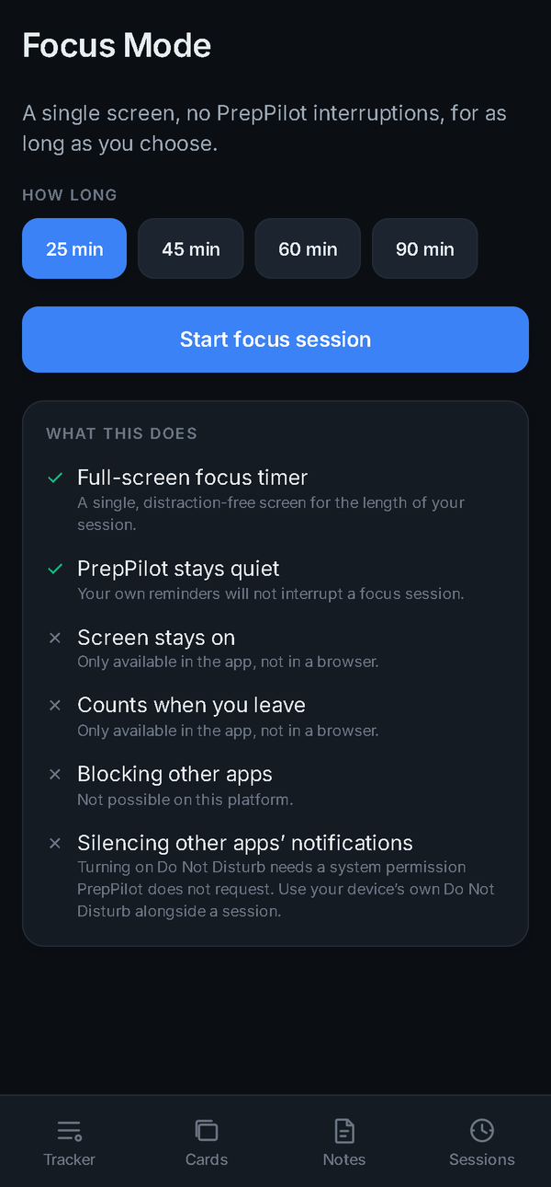  Figure 7.21: Focus Mode  captured 24 Sep 2026

7.5 Dashboard and sessions
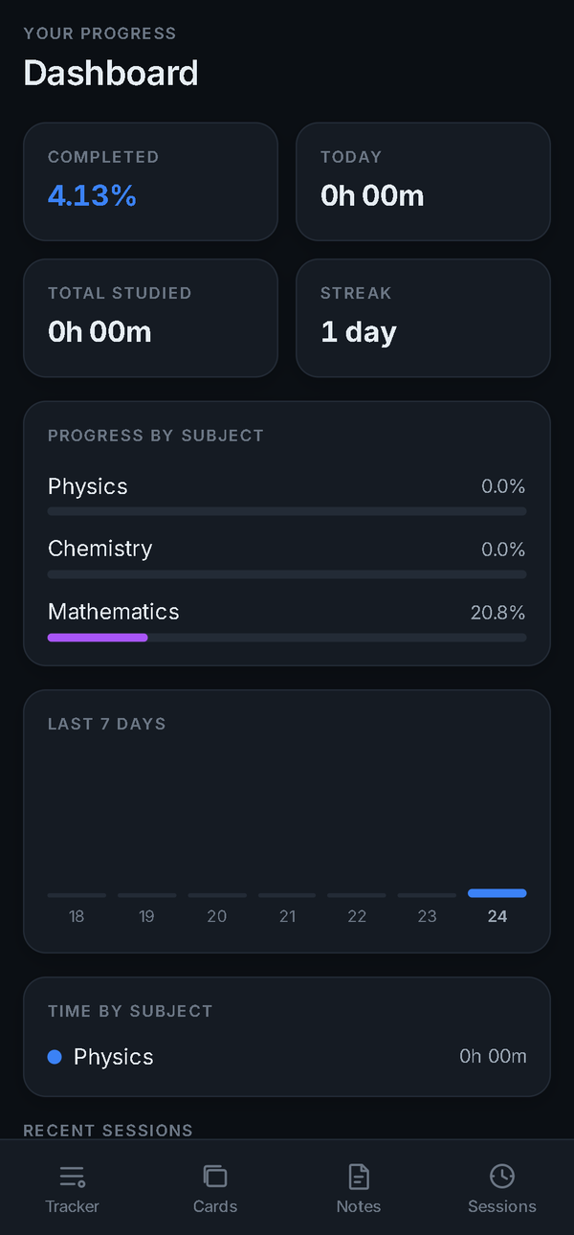  Figure 7.22: Dashboard  captured 24 Sep 2026 | 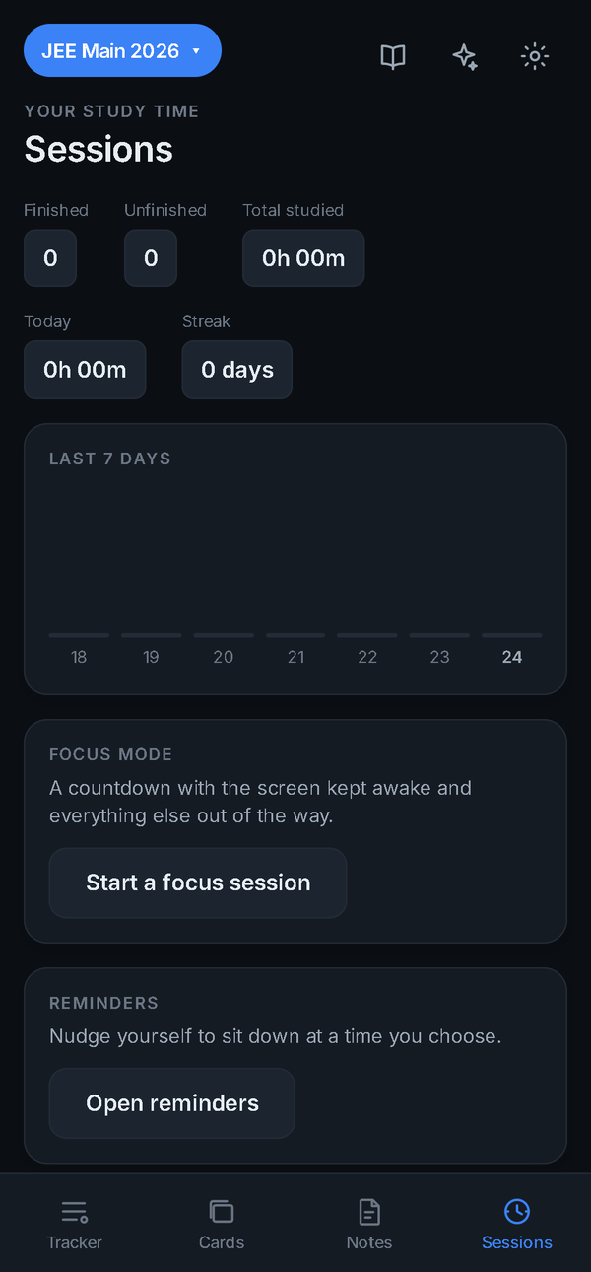  Figure 7.23: Sessions history  captured 24 Sep 2026 | 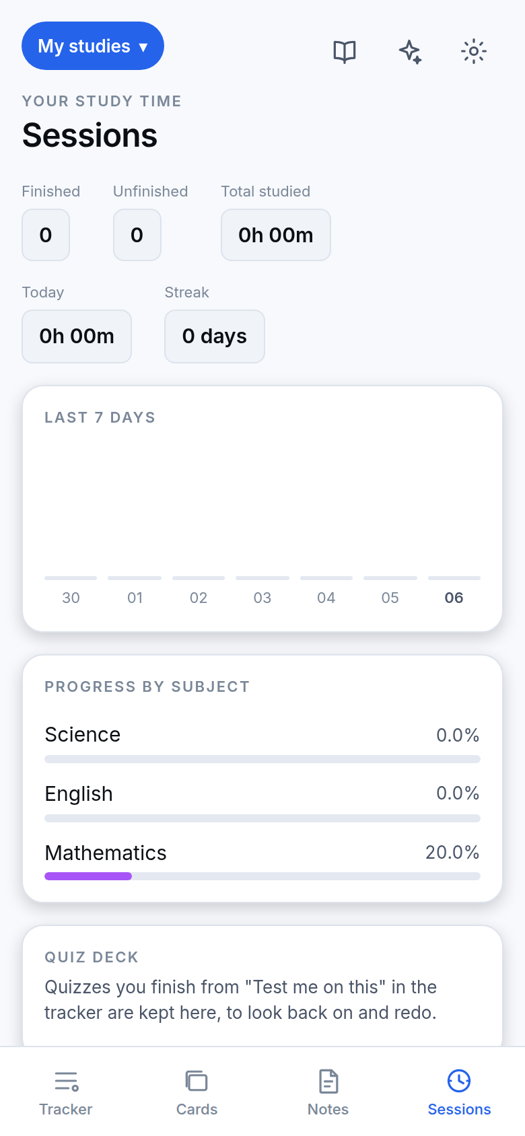  Figure 7.24: Sessions with Quiz deck, light mode  web demo, 6 Oct 2026

7.6 Revision, notes and reminders
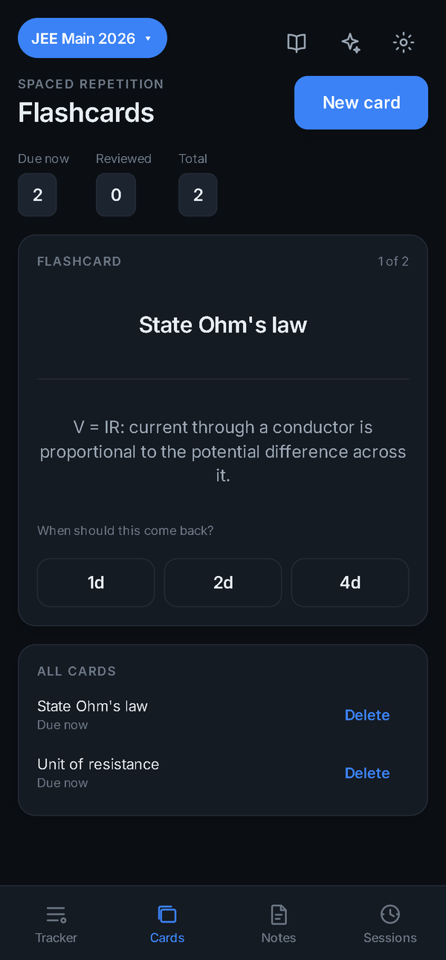  Figure 7.25: Flashcard review with 1d / 2d / 4d  captured 24 Sep 2026 | 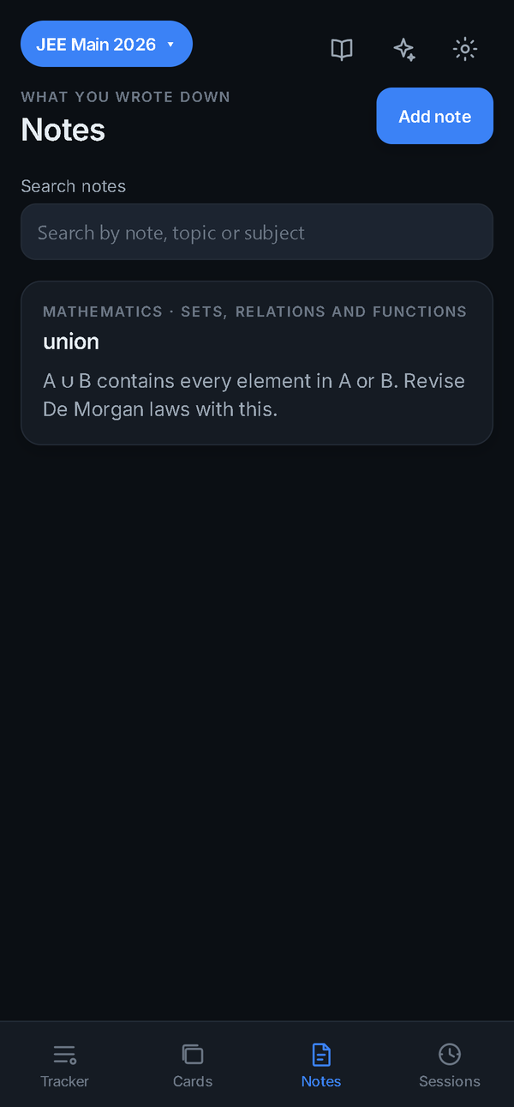  Figure 7.26: Notes by topic  captured 24 Sep 2026 | 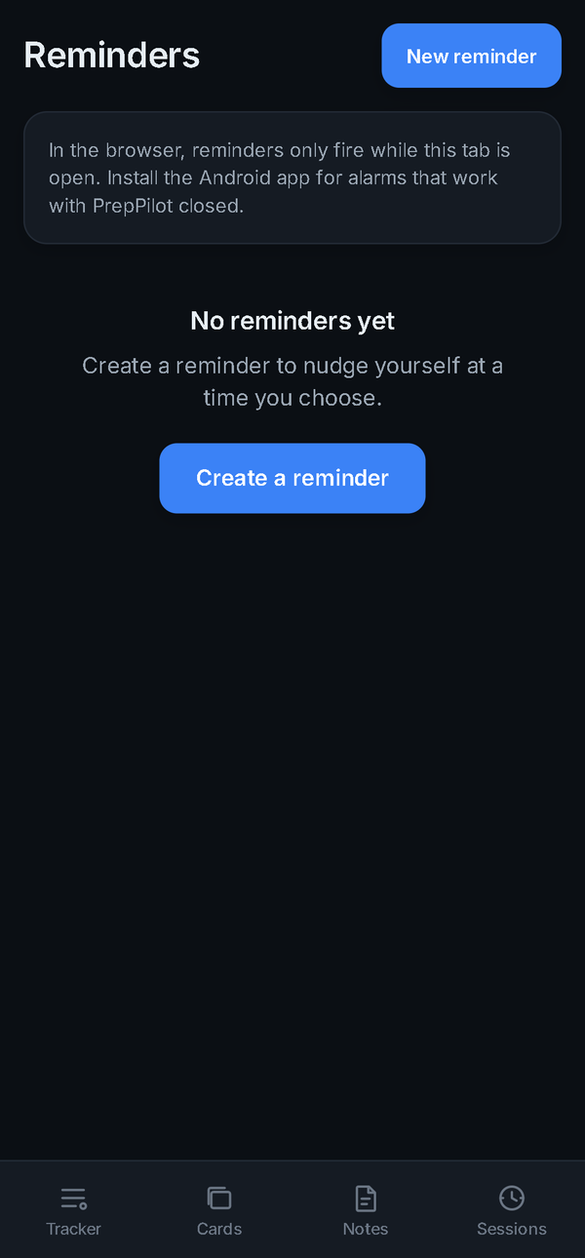  Figure 7.27: Reminders  captured 24 Sep 2026

7.7 AI assistant
The assistant answers questions, can read a photographed page, formats its replies, and turns a request for new material into a proposal the student must confirm.
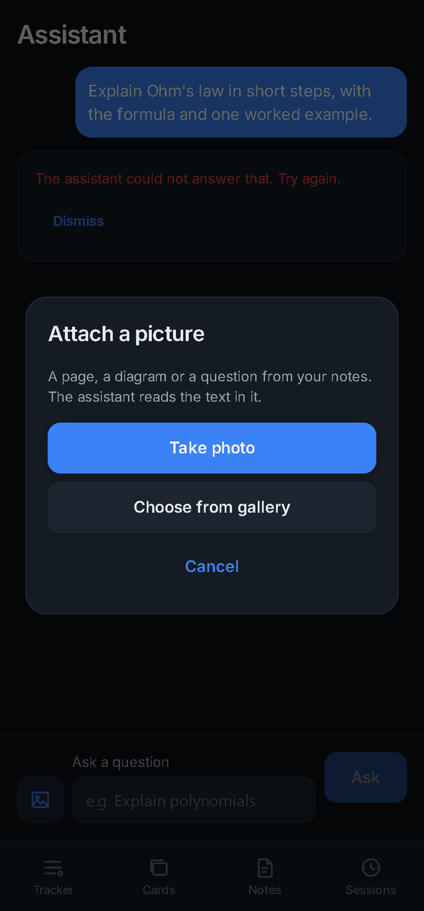  Figure 7.28: Attach a photo or screenshot  captured 24 Sep 2026 | 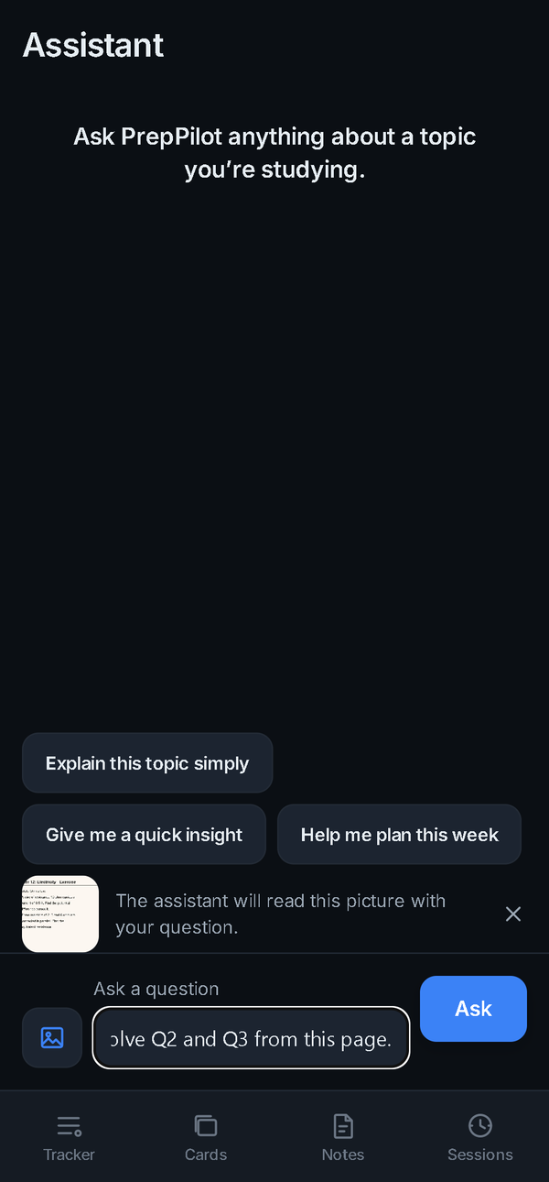  Figure 7.29: Picture attached to a question  captured 24 Sep 2026 | 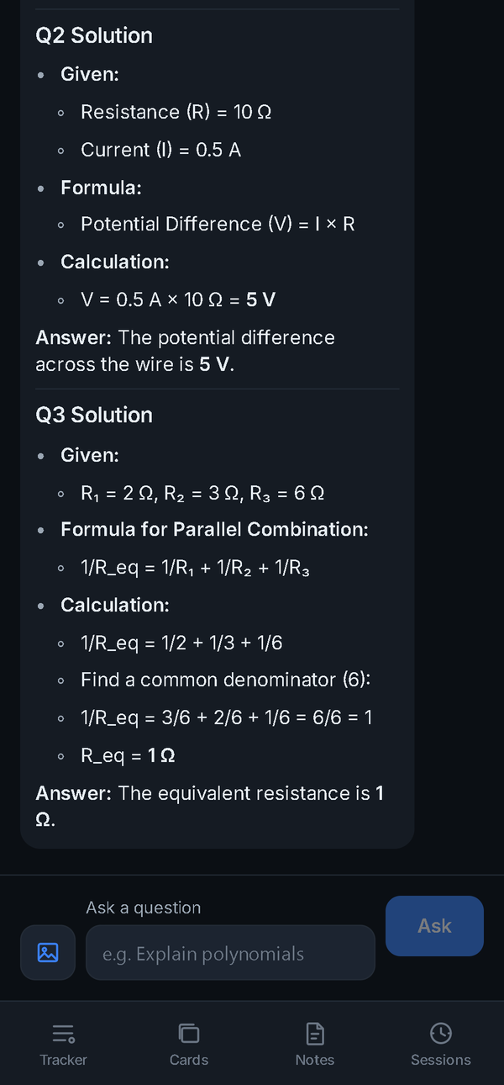  Figure 7.30: Answer about the picture  captured 24 Sep 2026 | 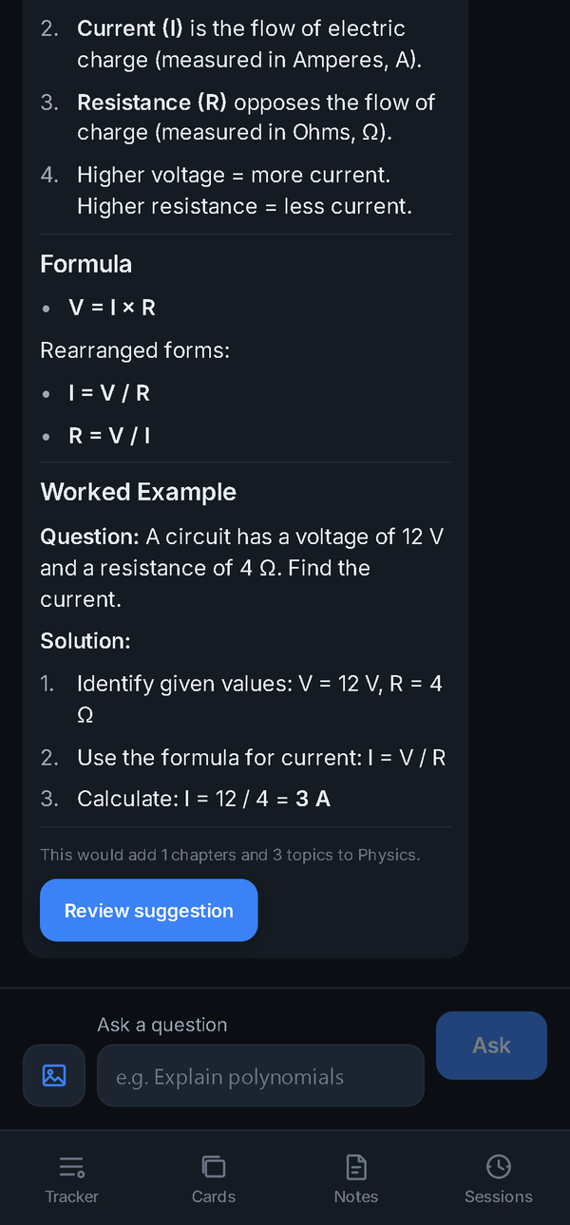  Figure 7.31: Formatted reply  captured 24 Sep 2026

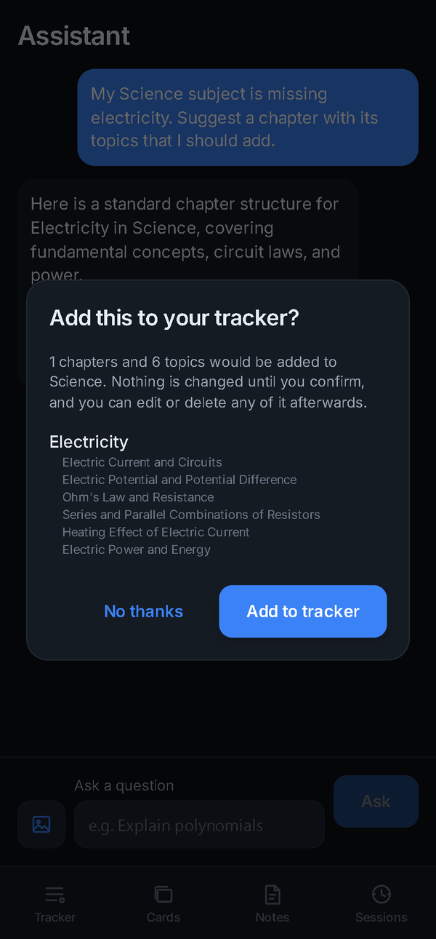  Figure 7.32: Proposal review before adding  captured 24 Sep 2026 | 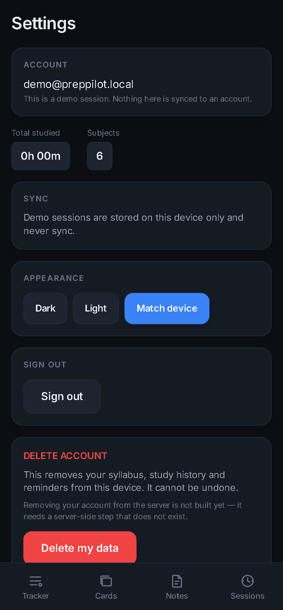  Figure 7.33: Settings  captured 24 Sep 2026

7.8 Downloadable themes
Settings → Themes lists Classic and three downloadable looks. Each downloads only when chosen (340–770 KB) and then works offline. For these captures the theme files were built from the repository and served locally.
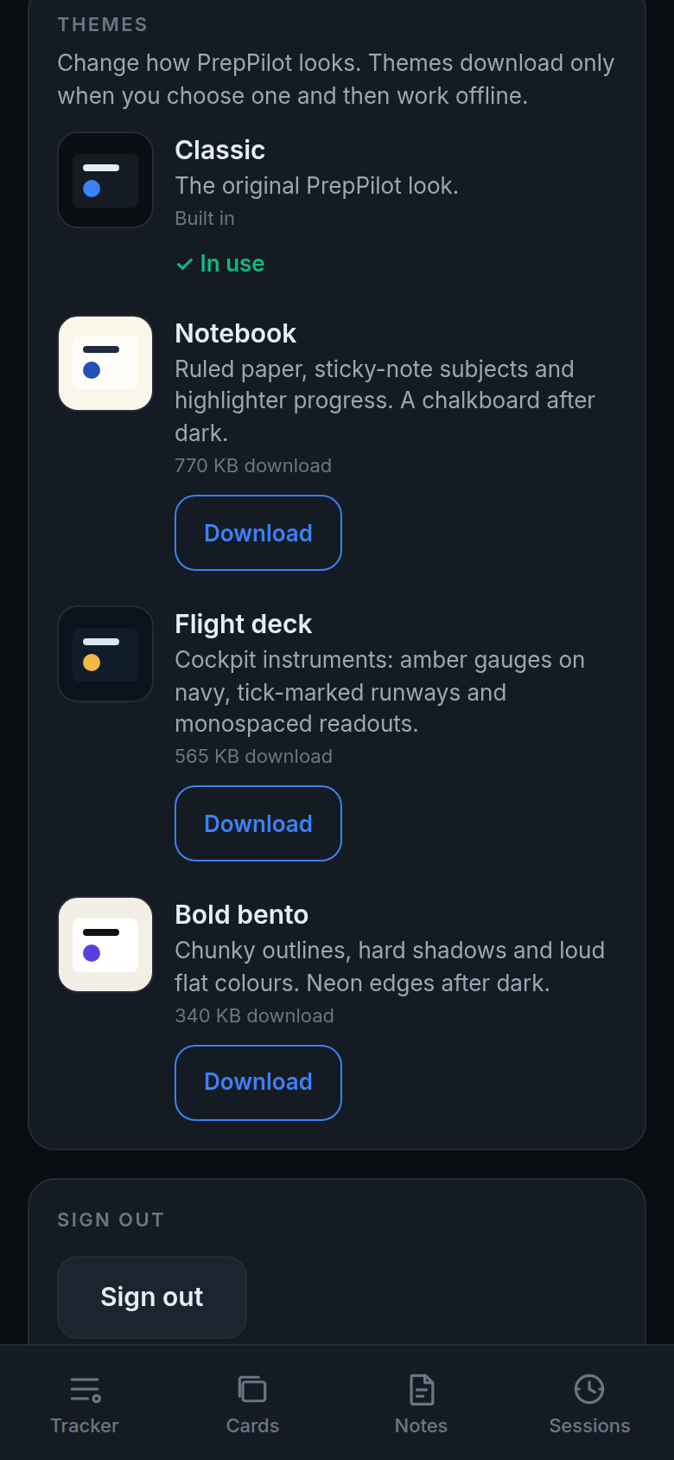  Figure 7.34: Theme list in Settings  web demo, 6 Oct 2026 | 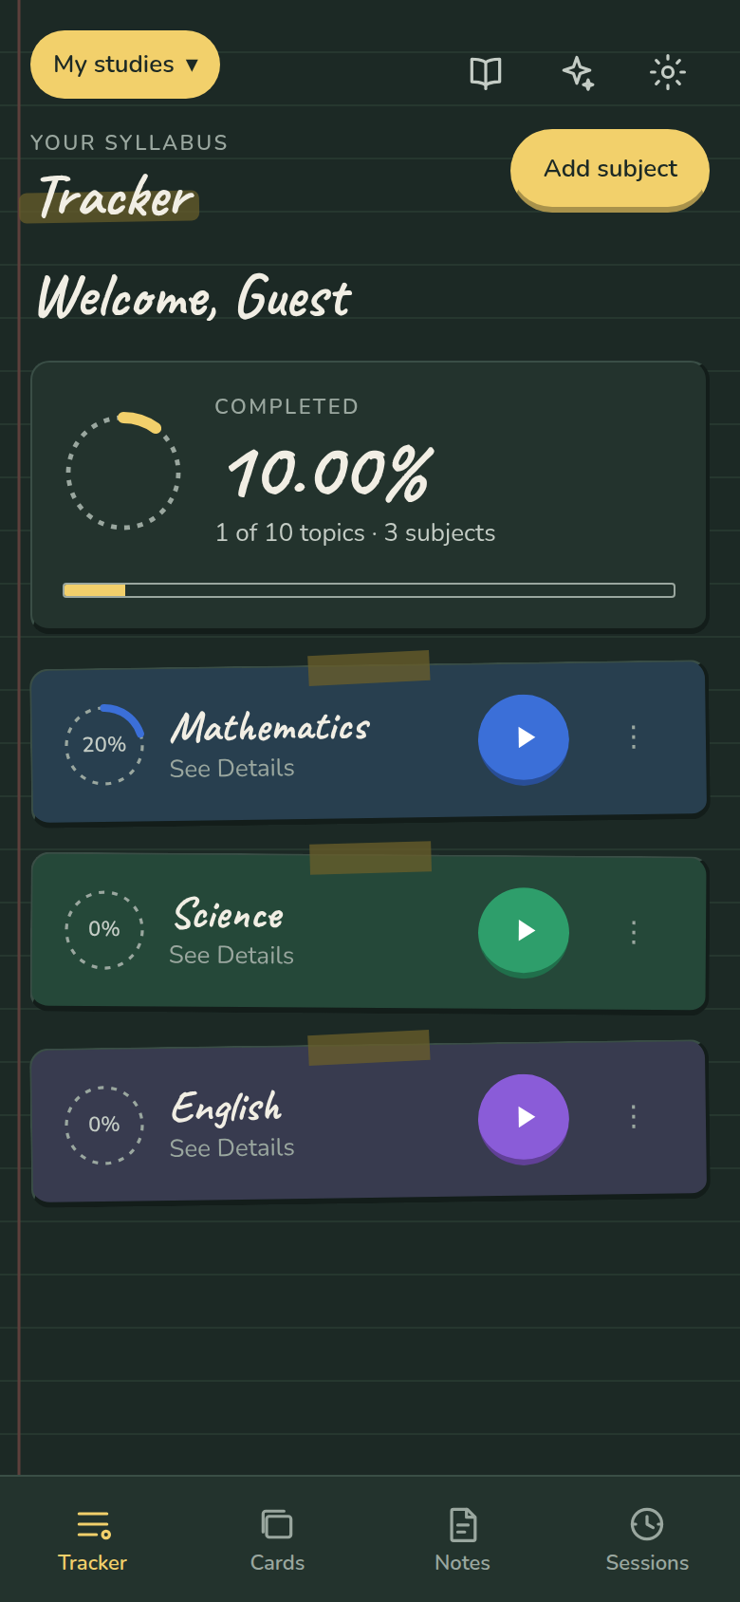  Figure 7.35: Notebook theme, dark  web demo, 6 Oct 2026 | 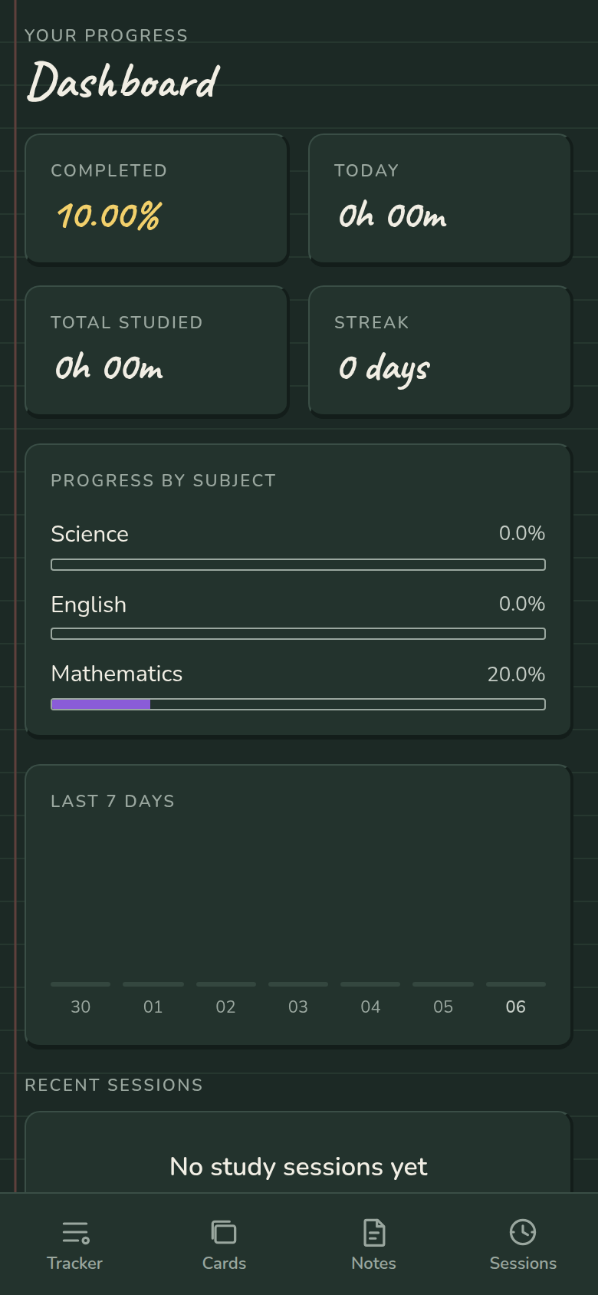  Figure 7.36: Notebook dashboard, dark  web demo, 6 Oct 2026 | 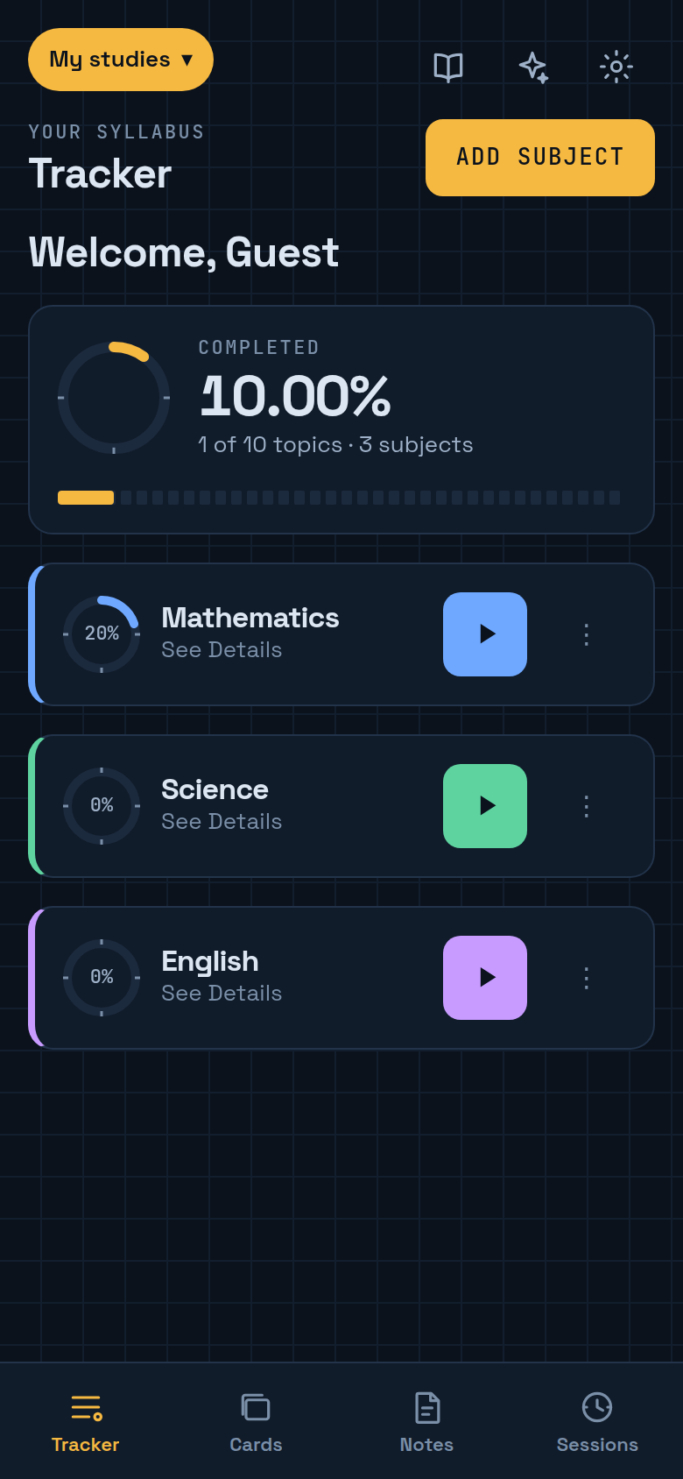  Figure 7.37: Flight deck theme, dark  web demo, 6 Oct 2026

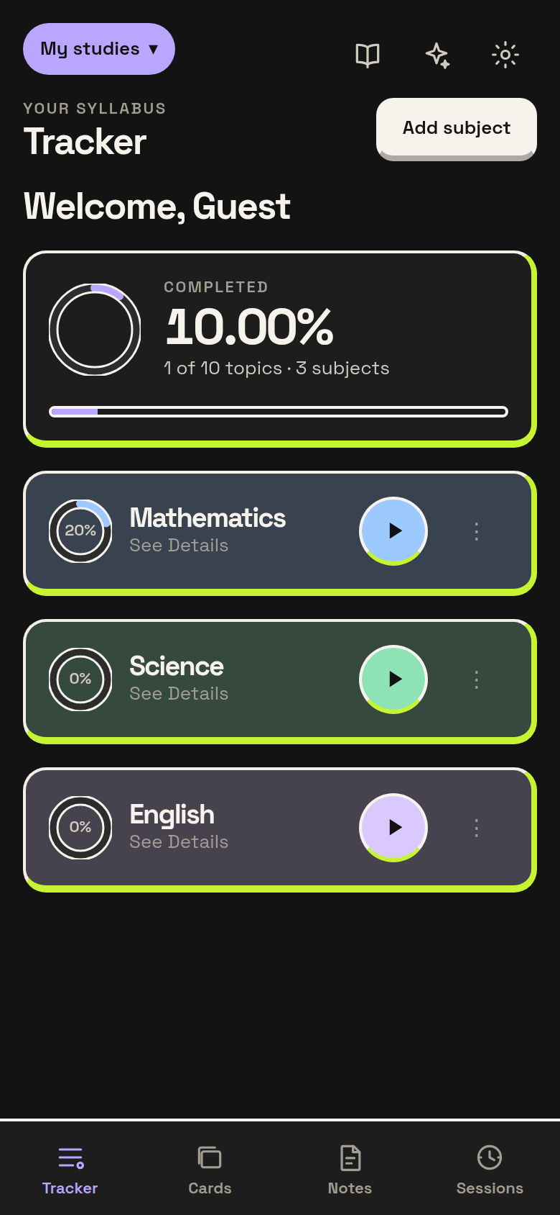  Figure 7.38: Bold bento theme, dark  web demo, 6 Oct 2026 | 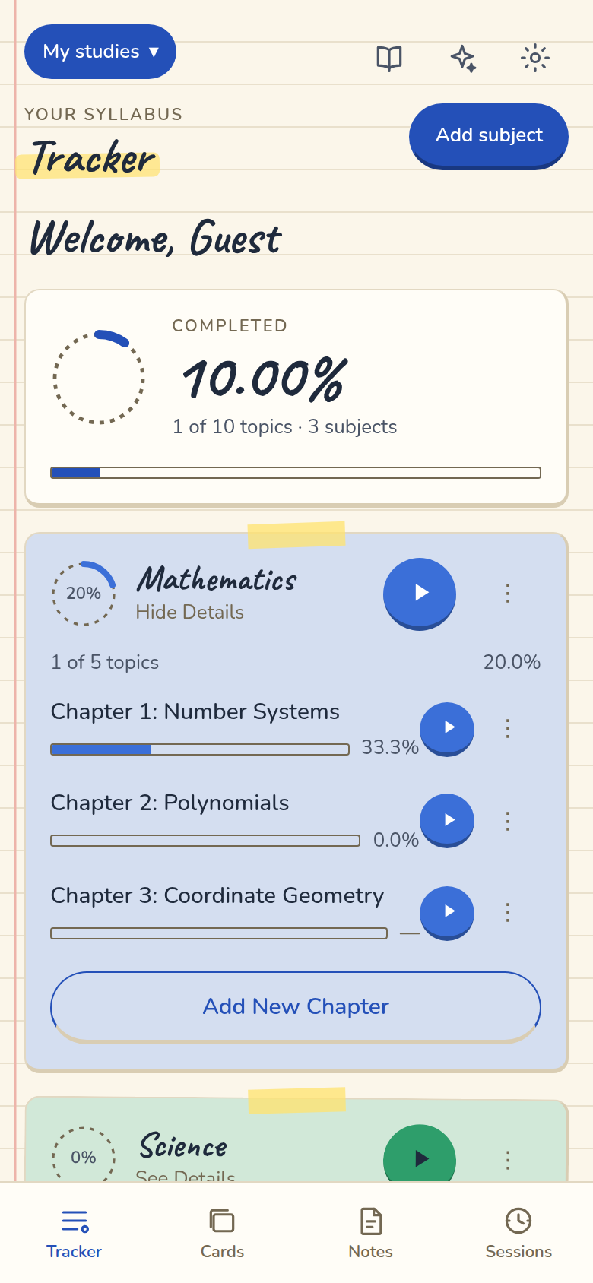  Figure 7.39: Notebook theme, light  web demo, 6 Oct 2026 | 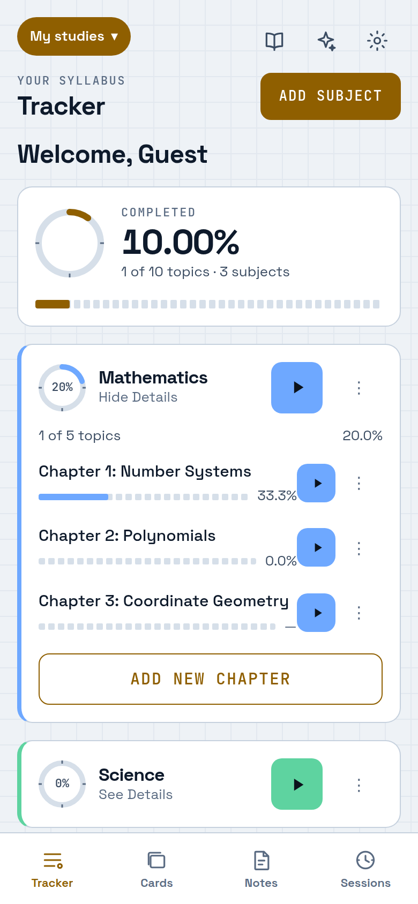  Figure 7.40: Flight deck theme, light  web demo, 6 Oct 2026 | 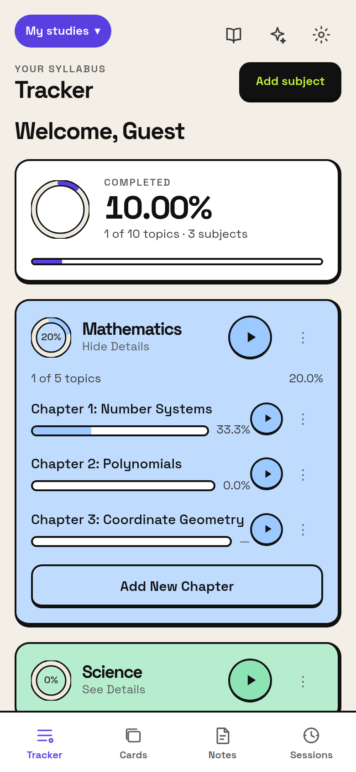  Figure 7.41: Bold bento theme, light  web demo, 6 Oct 2026

8. Testing and Validation

8.1 Strategy
Verification is automated. Pure logic in the shared package is tested with Vitest; the app's screens, stores and repositories with Jest and React Native Testing Library; and the Edge Functions with Deno's test runner, stubbing Gemini. Tests find controls by accessibility role and name rather than test IDs, so a control that a screen reader cannot reach fails the ordinary suite.

8.2 Test results
Table 8.1: Automated test results
Package | Runner | Suites | Tests | Result
apps/mobile | Jest | 86 | 1,658 | All passed (run 6 Oct 2026)
packages/shared | Vitest | 17 | 573 | All passed (run 6 Oct 2026)
supabase/functions | Deno test | 2 | 52 | Counted from source; run in CI, not re-run for this report
Total |  | 105 | 2,283

These figures are higher than the 2,073 tests recorded in the repository's README, which predates the themes and full-screen timer work.

8.3 What is tested against something real
- Repository tests run the generated migrations against in-memory SQLite (better-sqlite3), so they execute the SQL the app ships, including constraints and cascades.
- The sync engine runs the real local database against an in-memory server that behaves as PostgREST does, covering tombstones, rename-versus-tick, repeated passes and failed passes.
- The server schema was applied to a real PostgreSQL database and RLS isolation checked in both directions.
- Theme packs are checked against the validator, including WCAG contrast in both modes.

8.4 Continuous integration
Every push runs a GitHub Actions pipeline that checks formatting, type-checks every package, runs the tests with coverage thresholds (95% statements, 90% branches, 95% functions, 95% lines), runs the Edge Function tests, and verifies that both the Android and web bundles still build.

8.5 Device testing
The Android APK (about 41 MB, arm64) has been run on a physical phone against the live Supabase project: sign-in by email and by Google, restoring data after a reinstall, and the assistant including picture questions. This is recorded in the project's documentation as the developer's confirmation. Testing has not been systematic across Android versions, manufacturers' battery-optimisation policies or locales.

9. Results and Discussion
Table 9.1: Objectives against outcomes
Objective | Outcome
Accurate measurement | Achieved. Topic-weighted progress in one pure module, protected by a regression test; empty portions shown as —
Offline-first data | Achieved. Local SQLite is authoritative; automatic sync with deterministic merge; reinstall restore observed on the live project. A two-device conflict has been verified only by engine tests
Safe AI | Achieved. Key server-side only; proposals limited to additions and always reviewed; 200-topic cap
Integrated workflow | Achieved. Timers, flashcards, notes, quizzes and reminders all reference the syllabus

Beyond the original objectives, the delivered system adds photo questions to the assistant, saved conversations and follow-ups, a Quiz deck, a full-screen timer with six faces, a configurable Focus Mode and downloadable themes that do not enlarge the app download. Engineering decisions are recorded with their reasoning — entries D1–D110 in DECISIONS.md — so the system can be examined for why it was built as it was, not only for what it does.

10. Limitations
- Flashcard scheduling is fixed-interval, not SM-2, although SM-2 statistics are kept.
- Focus Mode cannot block other apps or toggle Do Not Disturb on Android; it says so in the app.
- The local database is not encrypted. The session token is in the keystore; the syllabus is not.
- The AI rate limit is in memory and resets when the function cold-starts.
- The Gemini key is on the free tier, shared by all users, and free-tier content may be used by Google; a long competitive quiz can take 30–60 seconds.
- Only follow-up chats send earlier messages; an ordinary chat sends each question alone. One picture per question; pictures do not sync.
- Weekday reminders are re-armed by the app, so they stop if the app is never opened.
- Phone OTP is implemented behind a flag but untested with a real SMS provider.
- Sign-in is required once: offline-first applies after the first successful sign-in.
- A two-device conflict has not been observed end to end on the hosted project.
- No penetration test or security audit has been carried out.
- The APK is about 41 MB; a Play Store app bundle would reduce the download.

11. Future Scope
- Switch flashcard review to adaptive SM-2 scheduling, using the statistics already kept.
- Move the AI rate limit into the database and log real token counts; move to Gemini's paid tier before real users arrive.
- Encrypt the local database.
- Systematic device testing across Android versions and manufacturers, and an observed two-device conflict test against the hosted project.
- Drag-to-reorder in the tracker (repositories already support reordering).
- Phone OTP with a real SMS provider; an iOS build; a Play Store release as an app bundle.
- More templates and community-contributed syllabi.

12. Conclusion
PrepPilot shows that a study tracker can be both offline-first and honest about progress. By making the device database authoritative, it works where students actually study; by computing progress topic-weighted and showing an empty portion as unmeasured, it gives students a figure they can plan with; and by keeping the AI key on the server and limiting the assistant to reviewed additions, it adds AI help without giving up control of the student's work. The system is implemented, runs on Android and in the browser, and is supported by more than two thousand automated tests and a documented record of its design decisions and limitations.

References
[1] H. Ebbinghaus, Memory: A Contribution to Experimental Psychology. New York: Teachers College, Columbia University, 1913 (orig. 1885).
[2] N. J. Cepeda, H. Pashler, E. Vul, J. T. Wixted and D. Rohrer, “Distributed practice in verbal recall tasks: A review and quantitative synthesis,” Psychological Bulletin, vol. 132, no. 3, pp. 354–380, 2006.
[3] P. A. Wozniak and E. J. Gorzelanczyk, “Optimization of repetition spacing in the practice of learning,” Acta Neurobiologiae Experimentalis, vol. 54, no. 1, pp. 59–62, 1994.
[4] M. Kleppmann, A. Wiggins, P. van Hardenberg and M. McGranaghan, “Local-first software: You own your data, in spite of the cloud,” in Proc. Onward! 2019, pp. 154–178.
[5] M. Shapiro, N. Preguiça, C. Baquero and M. Zawirski, “Conflict-free replicated data types,” in Proc. SSS 2011, pp. 386–400.
[6] F. Cirillo, The Pomodoro Technique. London: Virgin Books, 2018.
[7] Meta Platforms, “React Native documentation.” https://reactnative.dev/
[8] Expo, “Expo documentation.” https://docs.expo.dev/
[9] Supabase, “Supabase documentation.” https://supabase.com/docs
[10] Drizzle Team, “Drizzle ORM documentation.” https://orm.drizzle.team/
[11] Google, “Gemini API documentation.” https://ai.google.dev/docs
[12] K. Davis, B. Peabody and P. Leach, Universally Unique IDentifiers (UUIDs), IETF RFC 9562, 2024.

Appendix A: Glossary
Term | Meaning
Offline-first | The device database is the source of truth; the network is optional and sync happens later
Tombstone | A row marked deleted (deleted_at) instead of removed, so the deletion can be synchronised
UUIDv7 | A time-ordered unique identifier generated on the device, so offline records have their final id at once
Row Level Security (RLS) | PostgreSQL rules attached to rows, so each user can read and write only their own data
Watermark | The time of the last successful sync; the next pull asks for rows changed since then
Edge Function | A small server-side function on Supabase, used here to hold the AI key and delete accounts
Proposal | An inert, parsed AI suggestion that can only add chapters or topics and needs confirmation
Demo mode | A browser build with a fixed local account and seeded data, no backend and no sync

