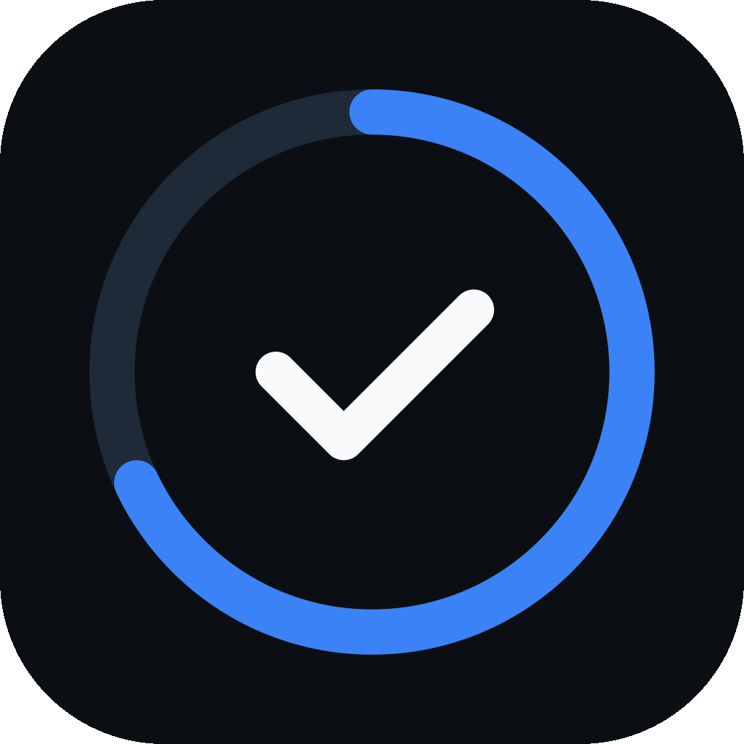
PrepPilot
An Offline-First, AI-Assisted Study and Examination Preparation Platform
Quick Report · Archit Jain · October 2026

1. What PrepPilot Is
PrepPilot helps a student organise an examination syllabus as Subject → Chapter → Topic → optional Sub-topic, tick off what is genuinely finished, time study sessions, revise, and see honest progress — with or without an internet connection. Timers, flashcards, notes, quizzes, reminders and the AI assistant all attach to that same syllabus, so effort, revision and progress stay connected instead of being spread over several apps. Its principle is Tracker first, AI second: the tracker is complete without the network, and the assistant can never change the syllabus without the student's confirmation.
Table 1.1: Project at a glance
Item | Details
What it is | Offline-first study tracker with optional AI help
Platform | Android app; the same code also runs as a browser demo (preppilottdemo.netlify.app)
Built with | React Native, Expo and TypeScript; SQLite with Drizzle ORM on the device
Backend | Supabase: PostgreSQL with Row Level Security, Auth, Storage, Edge Functions
AI | Google Gemini, called only through a server-side Edge Function
Content | 22 bundled syllabus templates (JEE, NEET, CBSE, UPSC, GATE, CA, …)
Size and tests | About 36,000 lines of source; 2,283 automated tests

2. The Problem
Students track syllabi of hundreds of topics on paper, in spreadsheets or from memory, and switch between separate apps for timing, revision and AI help. Many study where connectivity is poor. Worse, the obvious way to compute progress — averaging chapter percentages — is wrong: a subject with a finished 1-topic chapter and an untouched 99-topic chapter shows as 50% done when the truth is 1%. PrepPilot computes progress topic-weighted and shows an empty chapter as — rather than 0%.

3. Key Features
- Syllabus tracker with progress rings and bars at every level, several courses, 22 templates and a Build-from-scratch form.
- Timers: stopwatch, Pomodoro (25/5/15) and custom, plus a full-screen landscape timer with six faces; every session is recorded against the syllabus.
- Dashboard and sessions: completion, today, total time, streak, last 7 days.
- Revision: flashcards (1d / 2d / 4d), quizzes of 1–15 questions at four difficulties saved to a Quiz deck, and any number of notes per topic.
- AI assistant: explain, summarise, quiz, answer questions about a photo, and suggest syllabus additions that the student reviews before they are added.
- Focus Mode (1–240 min) and student-created reminders.
- Downloadable themes: Classic built in; Notebook, Flight deck and Bold bento downloaded only when chosen.
- Accounts and sync: email, Google and guest sign-in; automatic cloud sync.

4. How It Works
The SQLite database on the phone is the source of truth: every action is saved there first, so nothing waits for the network. A sync engine then pulls changes from Supabase, merges them by fixed rules — a deletion wins, a topic's tick is resolved on its own timestamp so a rename elsewhere cannot undo it, otherwise the later edit wins — and pushes the result. It runs on sign-in, every five minutes, on leaving the app and on reconnecting. Row Level Security in PostgreSQL keeps each student's data private. The Gemini key exists only on the server, and the assistant's suggestions can only add chapters or topics, never delete or complete anything.
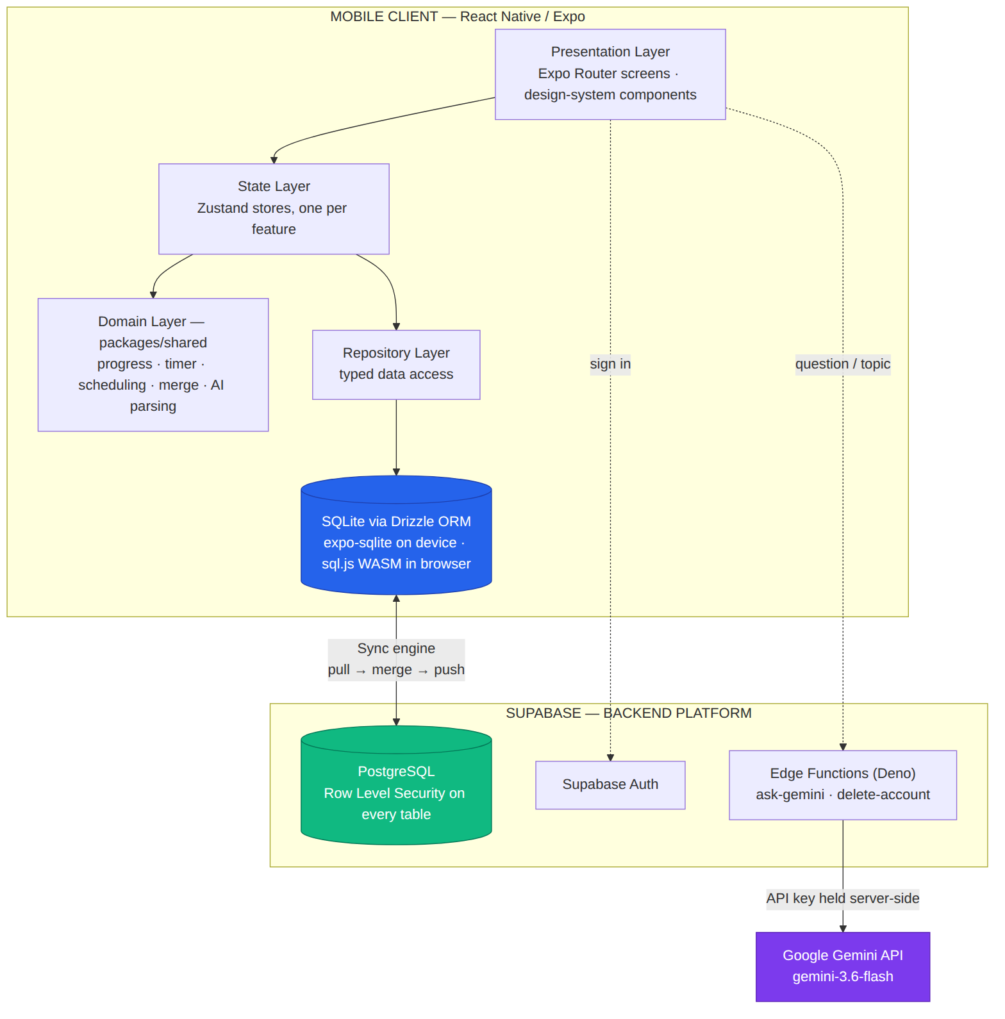
Figure 4.1: System architecture

5. Screens
Screens marked “captured 24 Sep 2026” are from the repository; those marked “web demo, 6 Oct 2026” were captured from the browser build, which uses sample data.
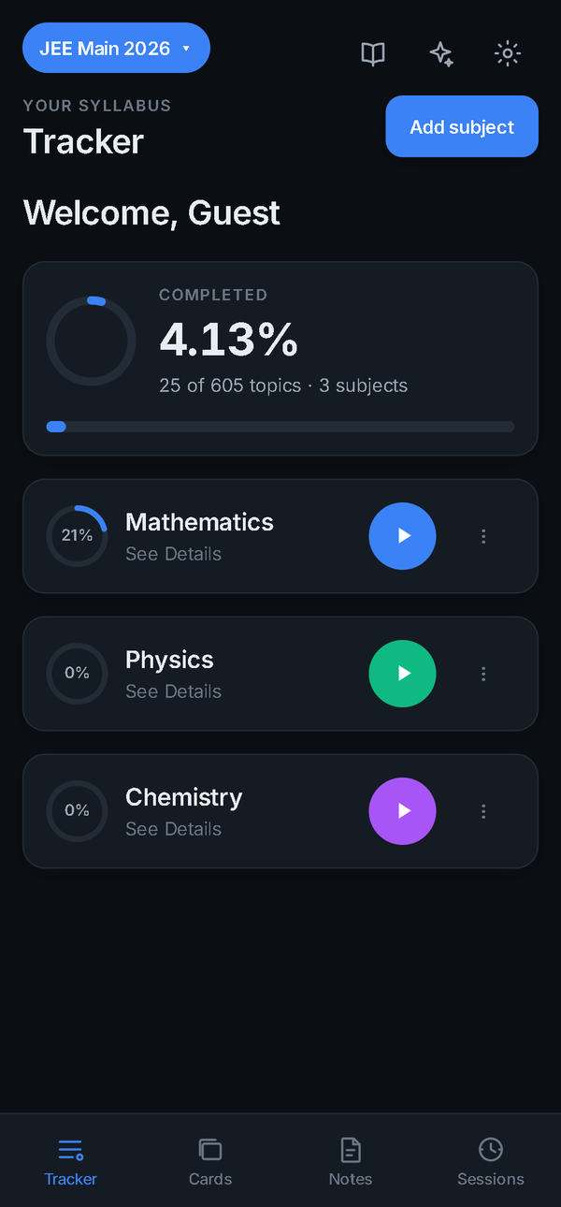  Figure 5.1: Tracker  captured 24 Sep 2026 | 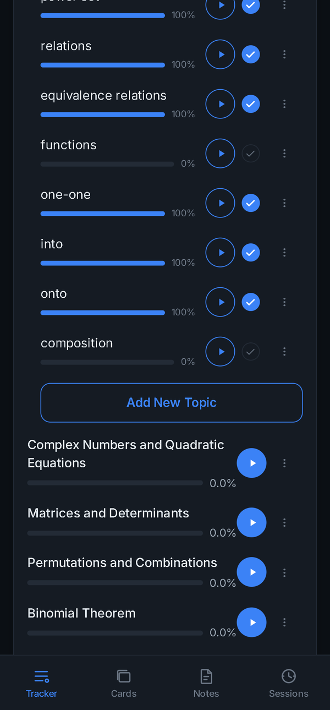  Figure 5.2: Subject expanded into chapters  captured 24 Sep 2026 | 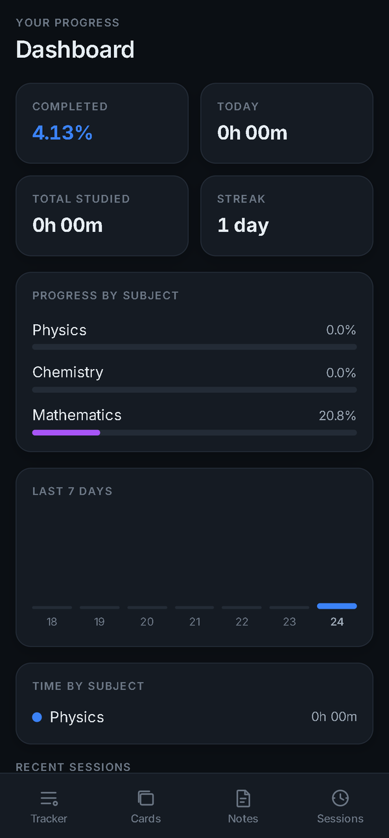  Figure 5.3: Dashboard  captured 24 Sep 2026 | 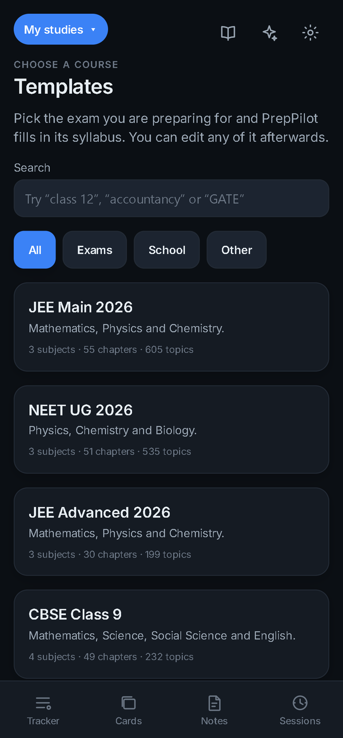  Figure 5.4: Template library  captured 24 Sep 2026

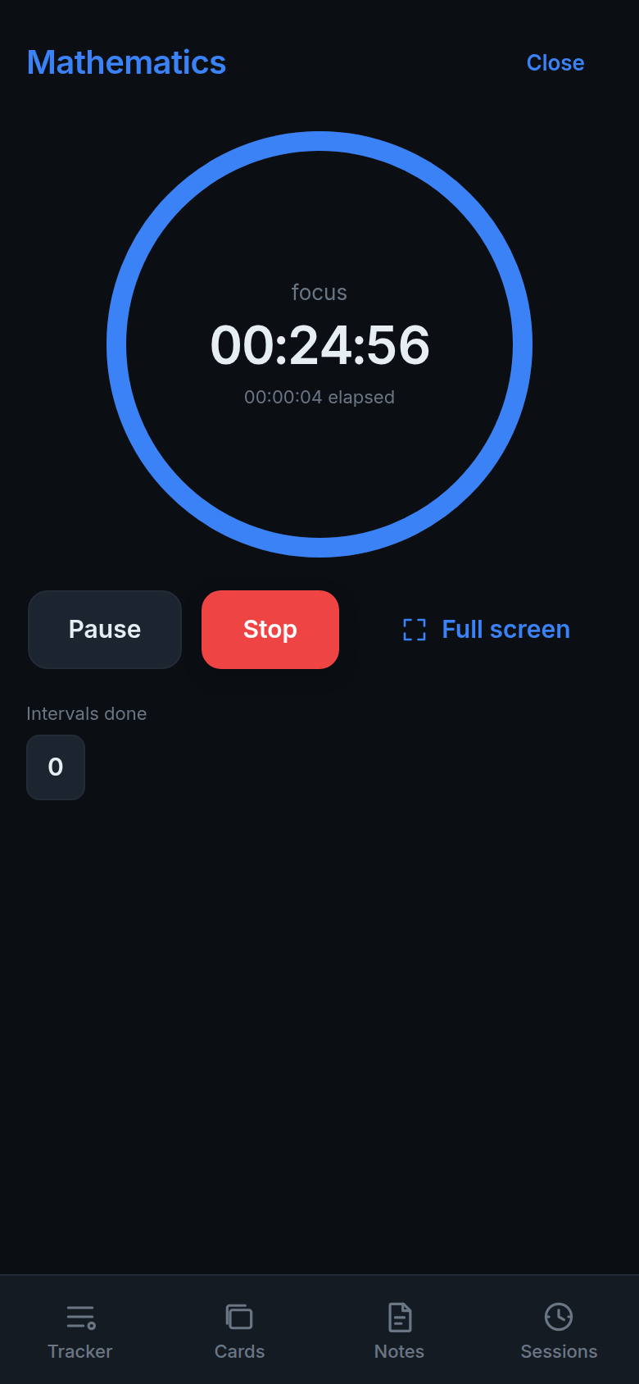  Figure 5.5: Pomodoro timer  web demo, 6 Oct 2026 | 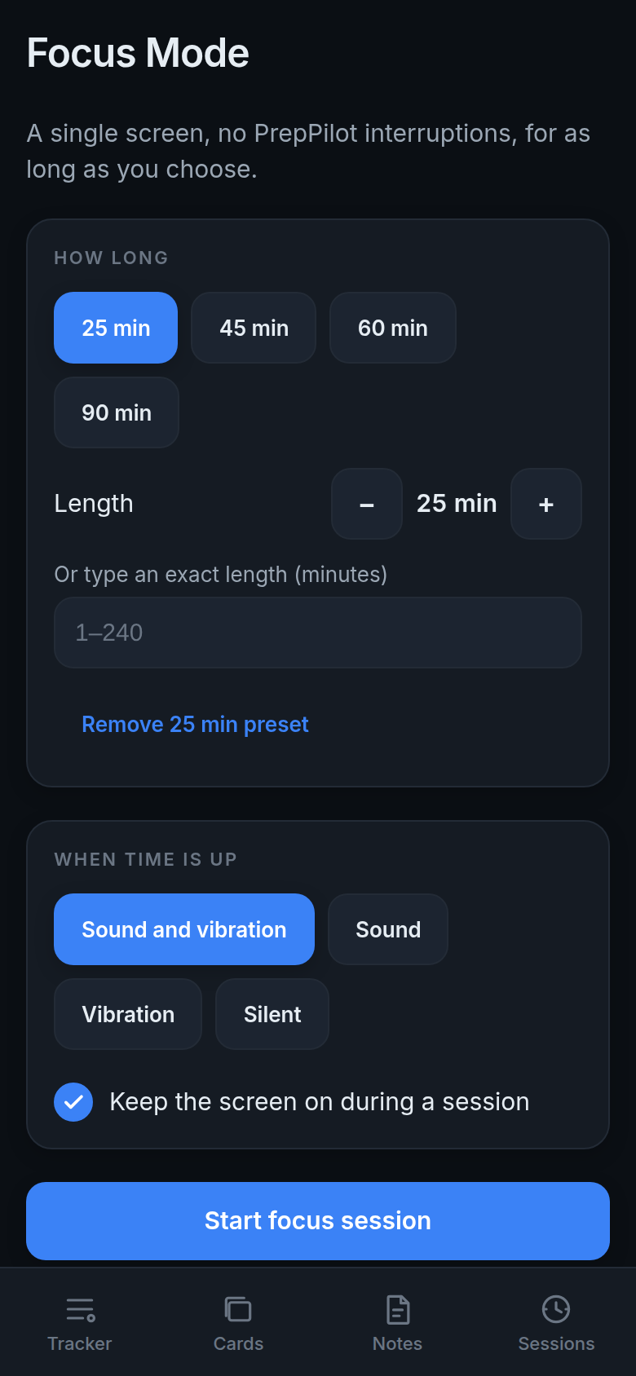  Figure 5.6: Focus Mode set-up  web demo, 6 Oct 2026 | 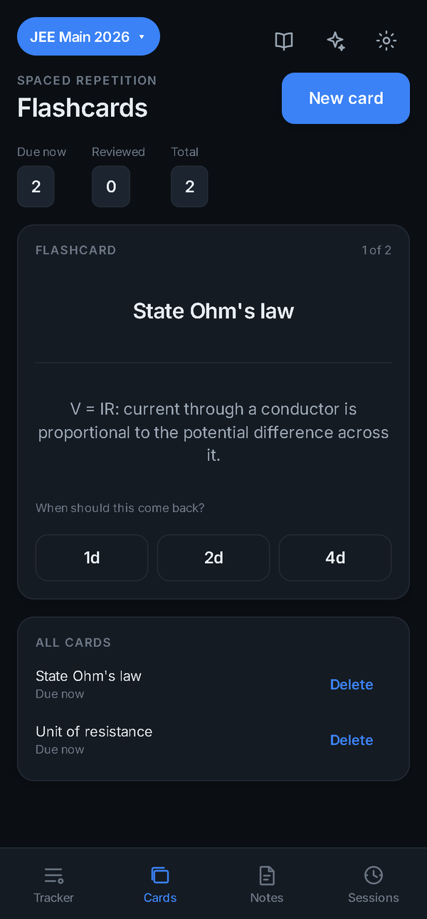  Figure 5.7: Flashcard review  captured 24 Sep 2026 | 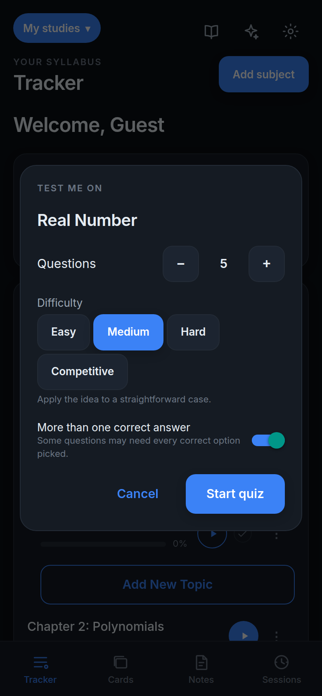  Figure 5.8: Quiz settings  web demo, 6 Oct 2026

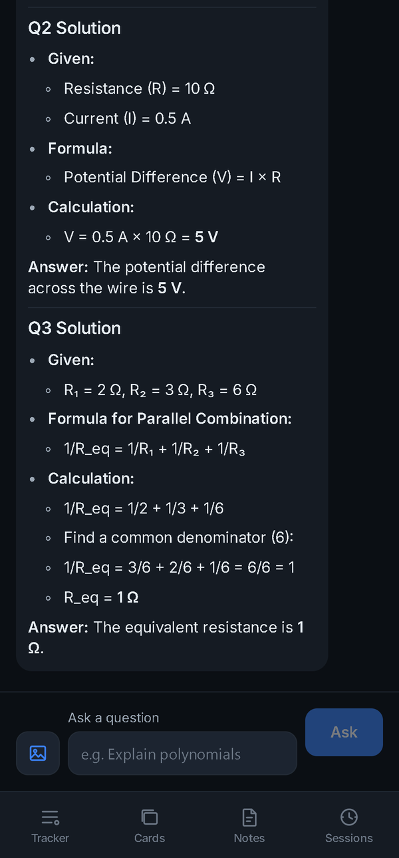  Figure 5.9: Assistant answering about a photo  captured 24 Sep 2026 | 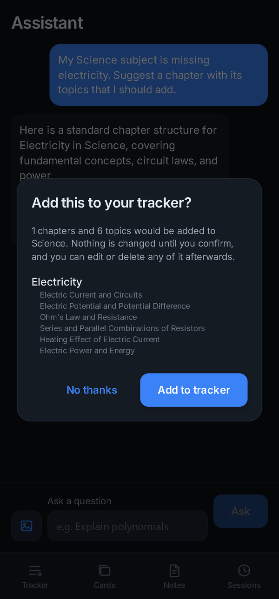  Figure 5.10: Reviewing an AI suggestion  captured 24 Sep 2026 | 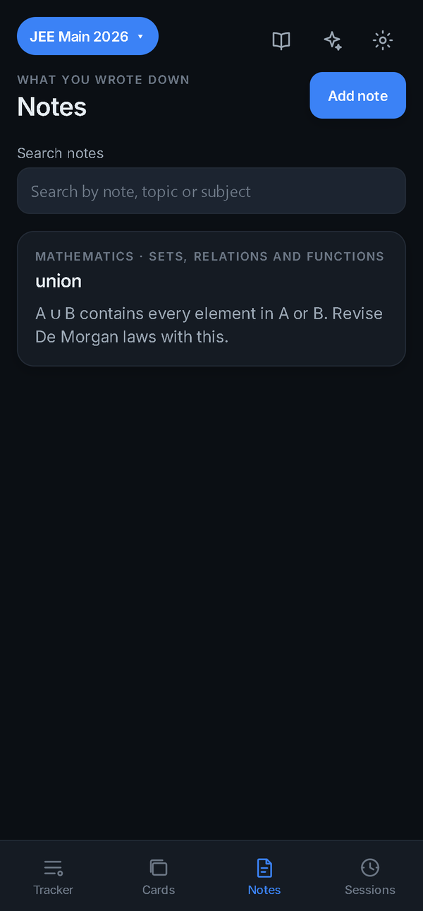  Figure 5.11: Notes  captured 24 Sep 2026 | 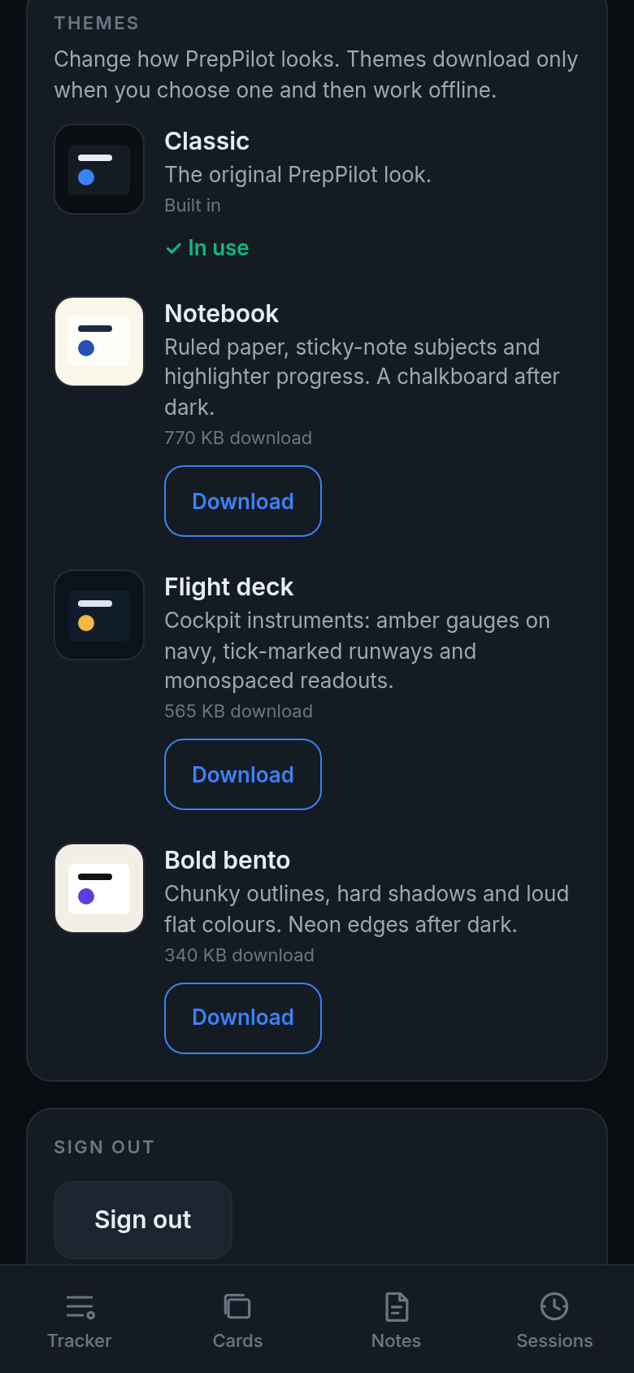  Figure 5.12: Themes in Settings  web demo, 6 Oct 2026

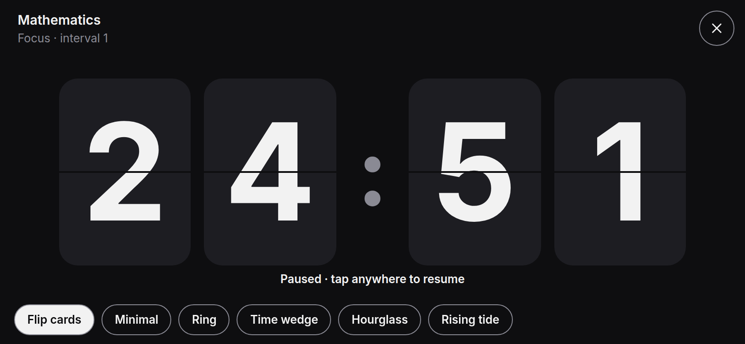  Figure 5.13: Full-screen timer: Flip cards  web demo, 6 Oct 2026 | 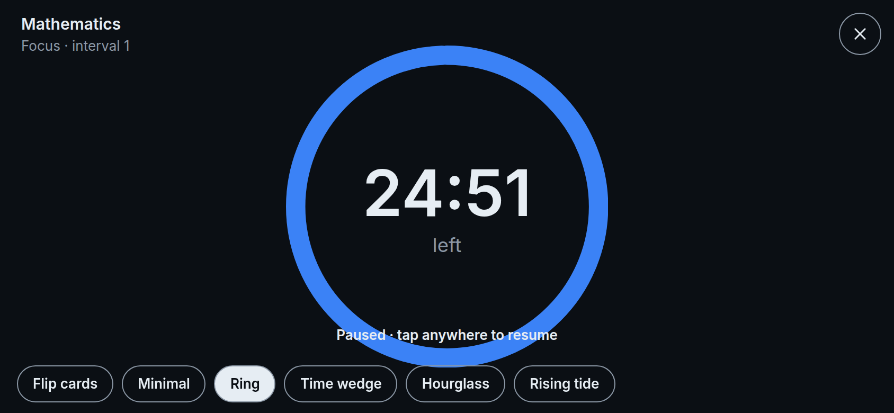  Figure 5.14: Ring face  web demo, 6 Oct 2026 | 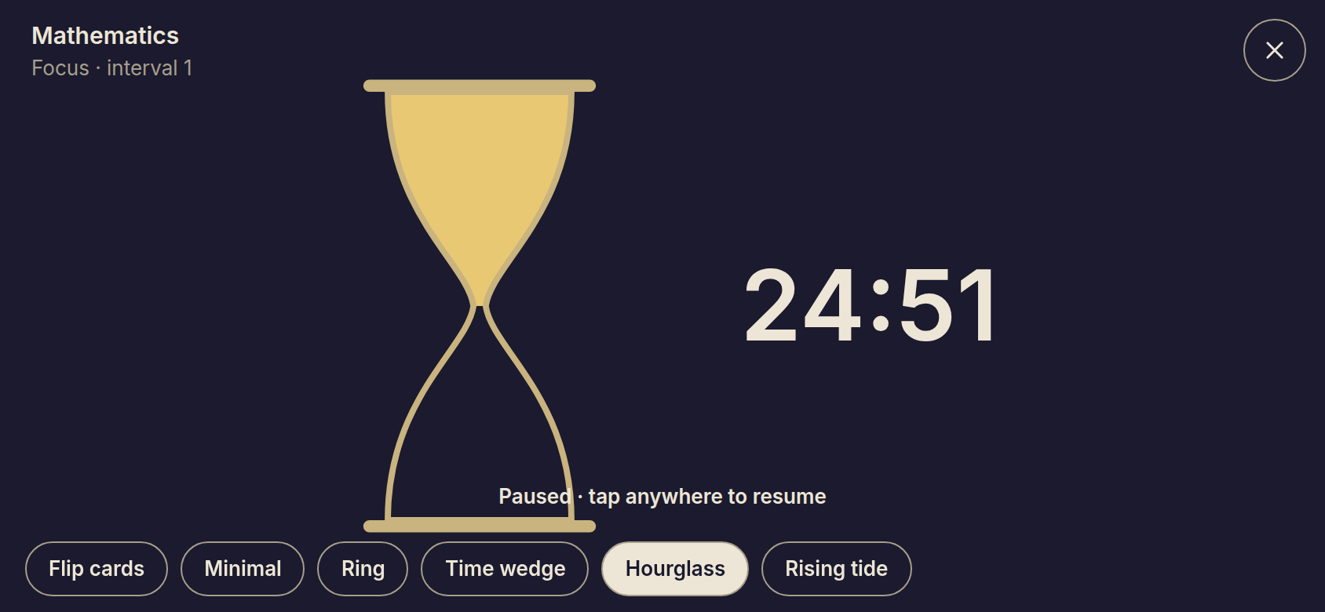  Figure 5.15: Hourglass face  web demo, 6 Oct 2026

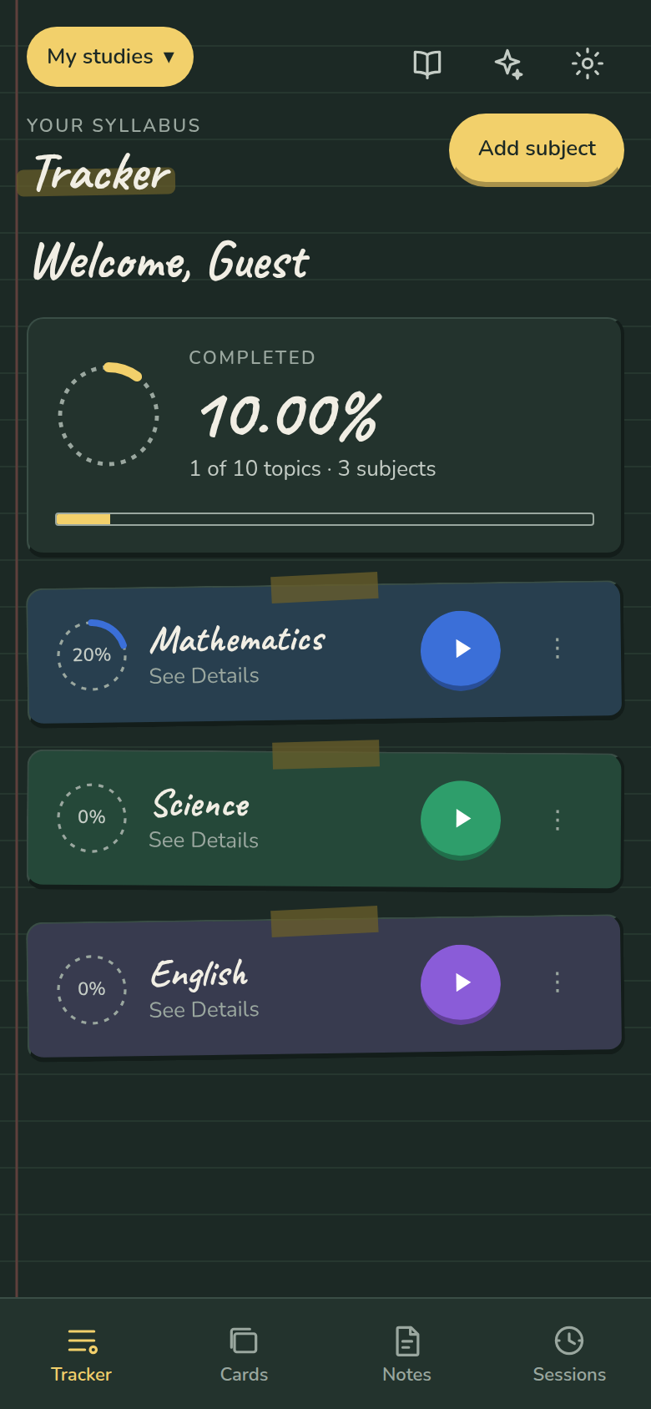  Figure 5.16: Notebook theme  web demo, 6 Oct 2026 | 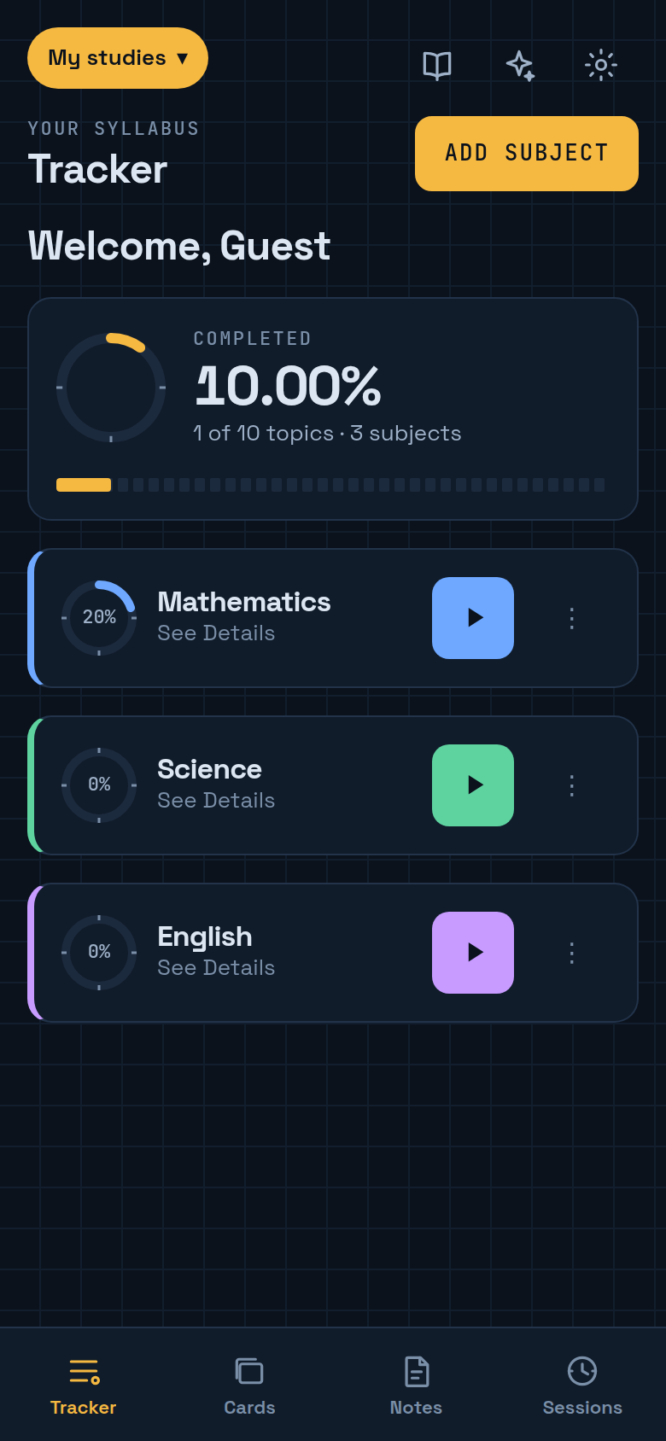  Figure 5.17: Flight deck theme  web demo, 6 Oct 2026 | 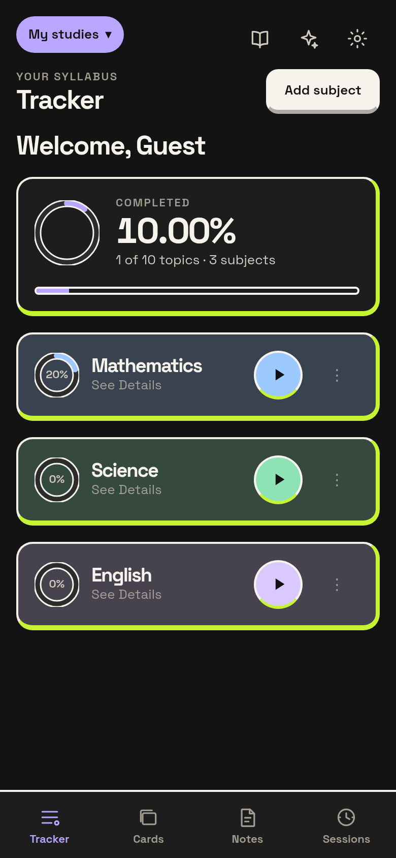  Figure 5.18: Bold bento theme  web demo, 6 Oct 2026 | 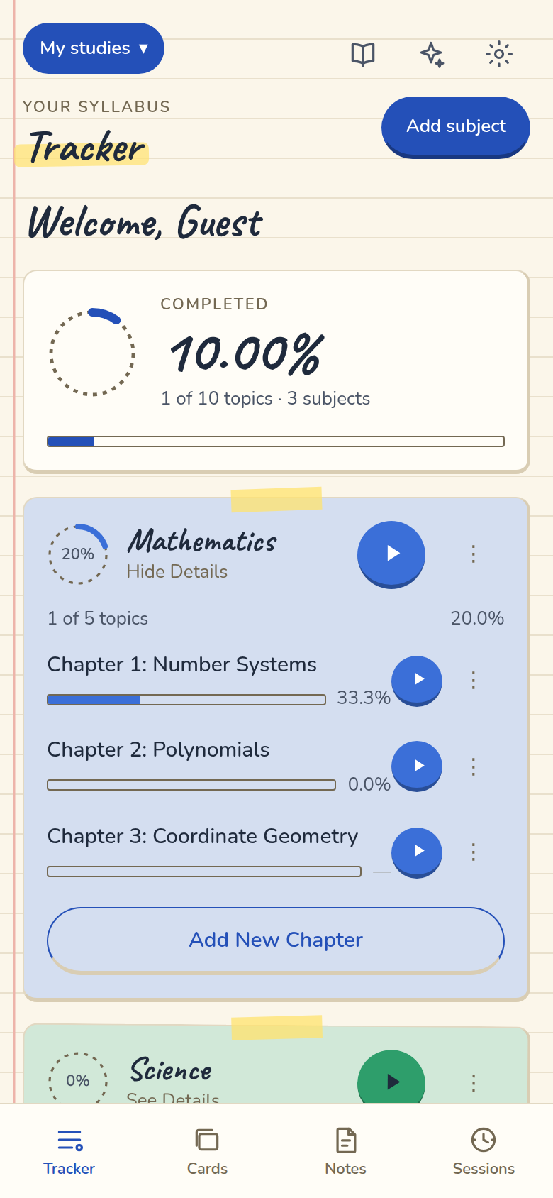  Figure 5.19: Notebook, light mode  web demo, 6 Oct 2026

6. Testing and Results
Table 6.1: Automated tests
Package | Tests | Result
App (Jest) | 1,658 in 86 suites | All passed, run 6 Oct 2026
Shared logic (Vitest) | 573 in 17 files | All passed, run 6 Oct 2026
Edge Functions (Deno) | 52 in 2 files | Counted from source; run in CI

Continuous integration checks formatting and types, enforces coverage thresholds (95% statements and lines, 90% branches), and confirms the Android and web bundles build. Database tests run the app's real migrations against SQLite, and the sync engine is tested against an in-memory server that behaves like Supabase. According to the project documentation, the Android APK (about 41 MB) has been tested on a physical phone against the live backend, including Google sign-in, restoring data after a reinstall and photo questions. All four project objectives — accurate measurement, offline-first data, safe AI and one integrated workflow — are met.

7. Limitations and Next Steps
- Flashcards use fixed intervals; SM-2 statistics are kept so adaptive scheduling can be switched on later.
- Focus Mode cannot block other apps or turn on Do Not Disturb — Android does not allow it — and the app says so.
- The local database is not encrypted, and the AI rate limit is held in memory.
- Gemini runs on the free tier; a real launch needs the paid tier.
- Next: adaptive flashcards, local encryption, a durable rate limit, wider device testing and a Play Store release.

8. Conclusion
PrepPilot delivers a study tracker that works offline, measures progress honestly and adds AI help without giving up control of the student's work. It runs on Android and in the browser, and is backed by more than two thousand automated tests. The full Detailed Project Report covers the design, implementation and testing in depth.

