
A
Project Report
on
PrepPilot — An Offline-First, AI-Assisted Study and
Examination Preparation Platform
Submitted in partial fulfillment of the requirements
for the award of the degree of
Bachelor of Technology
in
Computer Science and Engineering
(Artificial Intelligence and Machine Learning)
by
Archit Jain (University Roll No. ____________________)
Vanshika Rajput (University Roll No. ____________________)
Lavi Chaudhary (University Roll No. ____________________)
Jasmine Chaudhary (University Roll No. ____________________)

Under the Supervision of
Ms. Kareena
DEPARTMENT OF ENGINEERING
FACULTY OF COMPUTER SCIENCE & ENGINEERING
VIDYA UNIVERSITY, MEERUT
Baghpat Road, Delhi-Meerut Bypass, Meerut U.P.
India-250002
September, 2026

Student Details
Table 1: Candidate and project particulars
Field | Details
Name of Students | Archit Jain; Vanshika Rajput; Lavi Chaudhary; Jasmine Chaudhary
University Roll No. | ____________________
Class Roll No. | ____________________
Branch | Computer Science and Engineering (Artificial Intelligence and Machine Learning)
Batch | ____________________
Semester | 3rd Semester
Proposed Topic | PrepPilot — An Offline-First, AI-Assisted Study and Examination Preparation Platform
Submitted by | Archit Jain; Vanshika Rajput; Lavi Chaudhary; Jasmine Chaudhary
Supervisor | Ms. Kareena
Table of Contents
Table 2: Contents
S. No. | Content | Page No.
1 | Introduction | 3
2 | Rationale | 4
3 | Objectives | 4
4 | Literature Review | 5
5 | Feasibility Study | 6
6 | Methodology / Planning of Work | 7
7 | Facilities Required for Proposed Work | 8
8 | Expected Outcomes | 9
9 | References | 10
— | Appendix A: System Diagrams | 11

1. Introduction
PrepPilot is an offline-first, AI-assisted mobile application that helps a student organise an examination syllabus, record what has genuinely been completed, time their study, and revise — with or without an active internet connection. The project lies in the field of mobile application development, drawing on offline-first distributed systems and applied artificial intelligence.
The application is built around one organising idea: a student's syllabus is a structure, and progress is a measurement over that structure. A syllabus is represented as a four-level hierarchy — Subject → Chapter → Topic → optional Sub-topic — and every other feature attaches to it. Study timers, flashcards, notes and the AI assistant all reference a topic.
The system is implemented using React Native with the Expo framework, written in TypeScript. Data is stored on the device in an SQLite database accessed through the Drizzle ORM. The cloud component uses Supabase, providing PostgreSQL, authentication and serverless Edge Functions. AI assistance is provided by Google Gemini, reached only through a server-side Edge Function so that the API credential never reaches a student's device.
1.1 Special technical terms
Offline-first. The local device database is the authoritative source of truth and the network is optional. Every read and write completes locally, and synchronisation is a separate, later concern.
Tombstone. A record marked as deleted rather than physically removed. Without one, a row deleted while offline would be re-inserted by the next synchronisation, which cannot distinguish “deleted here” from “not yet seen”.
UUIDv7. A time-ordered unique identifier generated on the client, so a record created offline carries its final identity at once and is later recognised as the same record rather than as a duplicate.
Row Level Security. A PostgreSQL feature attaching access rules to rows, so isolation between users is enforced by the database itself.
2. Rationale
Students preparing for board examinations, competitive entrance examinations and professional qualifications face a problem that is organisational rather than academic. A CBSE Class 12, JEE Main or UPSC Civil Services syllabus each contains hundreds of individually learnable topics spread across subjects and chapters. Students commonly track these on paper, in spreadsheets, or from memory. Paper cannot compute a percentage, spreadsheets are laborious to maintain on a phone, and memory is least reliable exactly when reliability matters most. Meanwhile revision tooling, study timing and note-taking are spread across three or four unrelated applications, none of which holds the syllabus they should all refer to. Study also frequently happens where connectivity does not — in libraries, hostels and on trains — so an application that needs a network round-trip to tick a checkbox is unusable precisely where it is needed.
A second and more serious concern motivates the project: an inaccurate progress figure is worse than no figure at all. Consider a subject of two chapters, one with a single completed topic and one with ninety-nine topics of which none is complete. Averaging the chapter percentages gives (100% + 0%) ÷ 2 = 50%. The truthful figure, completed topics divided by total topics, is 1 ÷ 100 = 1%. The averaging method is the obvious implementation and it is wrong by a factor of fifty. A student who believes they are halfway through a subject they have barely begun will allocate their remaining weeks incorrectly. PrepPilot therefore treats correct measurement as its central obligation rather than a display detail.
3. Objectives
The project has four principal objectives.
Objective 1 — To model an examination syllabus as a structured hierarchy and measure progress over it accurately. Completion must be computed in a topic-weighted manner rather than by averaging chapter percentages, and a portion of the syllabus containing nothing to measure must be reported as unmeasured rather than as zero per cent complete.
Objective 2 — To design and implement an offline-first data architecture in which the device database is authoritative. Every read and write must complete against local storage regardless of network availability, and changes made on more than one device must later reconcile through a deterministic, device-independent rule.
Objective 3 — To integrate AI assistance without exposing credentials and without permitting unsupervised modification of the student's work. The AI credential must remain server-side at all times, and any change the assistant proposes must pass through explicit human review and confirmation before it is applied.
Objective 4 — To provide an integrated study workflow bound to the same syllabus structure. Study timing, flashcard revision, note-taking and reminders must all reference the syllabus, so that recorded effort, revision material and progress remain connected rather than fragmented across separate tools.
4. Literature Review
4.1 The spacing effect. Ebbinghaus [1] established that retention decays predictably over time and that review restores it. Cepeda et al. [2] synthesised distributed-practice studies quantitatively and confirmed that material reviewed at spaced intervals is retained substantially better than material reviewed in a single massed session. This provides the justification for a spaced review facility, and informs PrepPilot's flashcard module.
4.2 The SM-2 scheduling algorithm. Wozniak and Gorzelanczyk [3] proposed SM-2, which assigns each item an ease factor and an interval, grows the interval on successful recall and resets it on failure. It remains the basis of widely used revision software, notably Anki. PrepPilot implements SM-2 in full, but its review screen presently offers three fixed intervals (one, two and four days) instead, because an adaptive schedule changes its button labels on every review and a student cannot learn what a given option will do. The SM-2 statistics are still maintained, preserving the record needed to adopt adaptive scheduling later.
4.3 Local-first software. Kleppmann et al. [4] argue that applications should keep primary data on the user's own device while still supporting synchronisation, setting out seven ideals including that the network should be optional. PrepPilot follows this directly.
4.4 Conflict resolution in distributed replicas. Shapiro et al. [5] introduced Conflict-free Replicated Data Types, which guarantee convergence without coordination but carry significant implementation and storage overhead. For this project's data, where fields are independently owned and edits infrequent, last-write-wins with tombstones and a per-field timestamp for completion converges deterministically far more cheaply. The review therefore informed a deliberate decision not to adopt CRDTs.
4.5 Review of existing applications. Anki and Quizlet revise well but hold no syllabus structure and no progress model. Task managers such as Todoist offer flat lists with no weighted progress. Timer applications such as Forest, built on Cirillo's Pomodoro Technique [6], record time alone with no record of what was studied. Coaching portals require continuous connectivity and track their own syllabus. No reviewed application combines a structured syllabus, an honest progress calculation, offline-first operation and integrated study tooling — the gap this project addresses.
5. Feasibility Study
5.1 Technical feasibility. The project is technically feasible and has been implemented. Expo provides a mature cross-platform runtime with established modules for local SQLite storage, secure credential storage and notifications, while Supabase supplies managed PostgreSQL, authentication and serverless functions, removing any need to operate custom server infrastructure. The principal risks were addressed in the design: identifier collision on offline creation is prevented by client-generated UUIDv7 keys, deletion loss across synchronisation by tombstones, and device clock skew by taking the synchronisation watermark from the server's clock rather than the device's. Two platform limits proved genuinely insurmountable and are stated rather than concealed: Android does not permit one application to block another without privileges restricted by Play Store policy, and no available module exposes the permission needed to toggle Do Not Disturb.
5.2 Economic feasibility. The project incurs no licensing cost. React Native, Expo, SQLite, Drizzle ORM and PostgreSQL are open-source, and Supabase and Gemini both offer free tiers adequate for this scale. Because the AI credential is server-side, usage is bounded by a per-account rate limit enforced in the Edge Function, preventing uncontrolled expenditure.
5.3 Operational feasibility. The primary interaction — expanding a syllabus and marking topics complete — requires no instruction. Because the system works without connectivity it imposes no dependency on the institution's network, and bundled syllabus templates reduce initial setup, which is where such tools are most often abandoned.
5.4 Need and significance. The significance of the project lies less in any individual feature than in the correctness of the measurement it provides. A tool that reports progress inaccurately actively misleads the student it is meant to help.
6. Methodology / Planning of Work
6.1 Research type and approach. The work follows a constructive, design-and-build methodology in which a software artefact is designed, implemented and then evaluated against stated requirements. The unit of study is the application itself. Development was incremental and decision-logged: each significant architectural choice was recorded with its reasoning and rejected alternatives, so the system can be examined not only for what it does but for why it was built that way.
6.2 Methods and tools of data collection and analysis. Requirements were derived from published examination syllabi and from the structured review of existing applications in Section 4. Verification is automated rather than anecdotal: correctness is established by a test suite executed by continuous integration on every change. The topic-weighting rule of Section 2, for instance, is protected by an explicit regression test that fails if progress is ever computed by averaging.
6.3 Steps followed
- Requirement analysis and syllabus modelling.
- Design of the shared domain layer — progress, timing, scheduling and conflict resolution as pure, framework-independent logic.
- Local data layer: the SQLite schema through Drizzle ORM, with client-generated identifiers, tombstones and synchronisation status.
- User interface, against a shared design system.
- Cloud layer: PostgreSQL migrations with Row Level Security policies.
- Synchronisation engine: the pull, merge and push cycle.
- AI integration: the Edge Function holding the Gemini credential, and the proposal and confirmation flow.
- Testing and validation on a physical Android device.
6.4 Working flow. The operational flow is shown in Figure 1 of Appendix A. A student signs in, imports or creates a syllabus, and works against it. Every action writes to the local database immediately and is marked pending. When connectivity returns, the engine pulls remote changes, merges them and pushes the agreed result. The critical property is that the local write completes regardless of network state, so no student action waits on connectivity. The system architecture and the AI request path are shown in Figures 2 and 3 of the same appendix.
7. Facilities Required for Proposed Work
Software. Node.js 22 or later with the pnpm package manager, the Expo command-line tooling and Expo Application Services build service, the Supabase command-line tools, the Deno runtime for Edge Functions, and Git with a GitHub repository for version control and continuous integration. Accounts are required on Supabase, for the cloud database, authentication and function hosting, and on Google AI Studio for a Gemini API credential. Development is performed in Visual Studio Code with TypeScript tooling.
Hardware. A development computer with at least 8 GB of RAM, and a physical Android device running Android 8.0 or later for testing, since notification delivery, keeping the screen awake, secure credential storage and application state transitions cannot be verified reliably in an emulator or a browser. No server hardware is required, as the cloud components are hosted services.
8. Expected Outcomes
The expected outcome is a working Android application, and this has been achieved. The delivered system provides a four-level syllabus tracker with topic-weighted progress; three study timer modes recording sessions against the syllabus with Pomodoro break time excluded; a dashboard reporting completion, study time and streaks; flashcards, notes and reminders bound to the syllabus; a Focus Mode that states its own platform limits in the interface; an AI assistant providing explanation, summarisation and quiz generation through a server-side proxy, which can also read a photographed page; twenty-two syllabus templates and a course builder; multiple courses; and automatic cross-device synchronisation with deterministic conflict resolution, each user's data isolated by Row Level Security. Correctness is evidenced by 1,934 automated tests across 91 suites, all passing under continuous integration, and the application has been built as an Android package and tested on a physical device against the live cloud project. Known limitations are documented rather than concealed: flashcard review uses fixed intervals rather than adaptive scheduling, the local database is not encrypted, browser-build reminders do not survive the tab closing, and testing has not been systematic across Android versions and manufacturer battery-optimisation policies.

9. References
[1] H. Ebbinghaus, Memory: A Contribution to Experimental Psychology. New York, NY, USA: Teachers College, Columbia University, 1913. (Original work published 1885.)
[2] N. J. Cepeda, H. Pashler, E. Vul, J. T. Wixted, and D. Rohrer, “Distributed practice in verbal recall tasks: A review and quantitative synthesis,” Psychological Bulletin, vol. 132, no. 3, pp. 354–380, 2006.
[3] P. A. Wozniak and E. J. Gorzelanczyk, “Optimization of repetition spacing in the practice of learning,” Acta Neurobiologiae Experimentalis, vol. 54, no. 1, pp. 59–62, 1994.
[4] M. Kleppmann, A. Wiggins, P. van Hardenberg, and M. McGranaghan, “Local-first software: You own your data, in spite of the cloud,” in Proc. ACM SIGPLAN Int. Symp. New Ideas, New Paradigms, and Reflections on Programming and Software (Onward!), Athens, Greece, 2019, pp. 154–178.
[5] M. Shapiro, N. Preguiça, C. Baquero, and M. Zawirski, “Conflict-free replicated data types,” in Proc. 13th Int. Symp. Stabilization, Safety, and Security of Distributed Systems (SSS), Grenoble, France, 2011, pp. 386–400.
[6] F. Cirillo, The Pomodoro Technique: The Life-Changing Time-Management System. London, U.K.: Virgin Books, 2018.
[7] Meta Platforms, Inc., “React Native documentation.” [Online]. Available: https://reactnative.dev/
[8] Expo, “Expo documentation.” [Online]. Available: https://docs.expo.dev/
[9] Supabase, Inc., “Supabase documentation.” [Online]. Available: https://supabase.com/docs
[10] Drizzle Team, “Drizzle ORM documentation.” [Online]. Available: https://orm.drizzle.team/
[11] Google, “Gemini API documentation.” [Online]. Available: https://ai.google.dev/docs
[12] P. Leach, M. Mealling, and R. Salz, A Universally Unique IDentifier (UUID) URN Namespace, IETF RFC 4122, 2005; superseded by RFC 9562, 2024.

Appendix A: System Diagrams
The diagrams below support Section 6. They are placed here so that the Methodology section remains within its stated one-page limit.
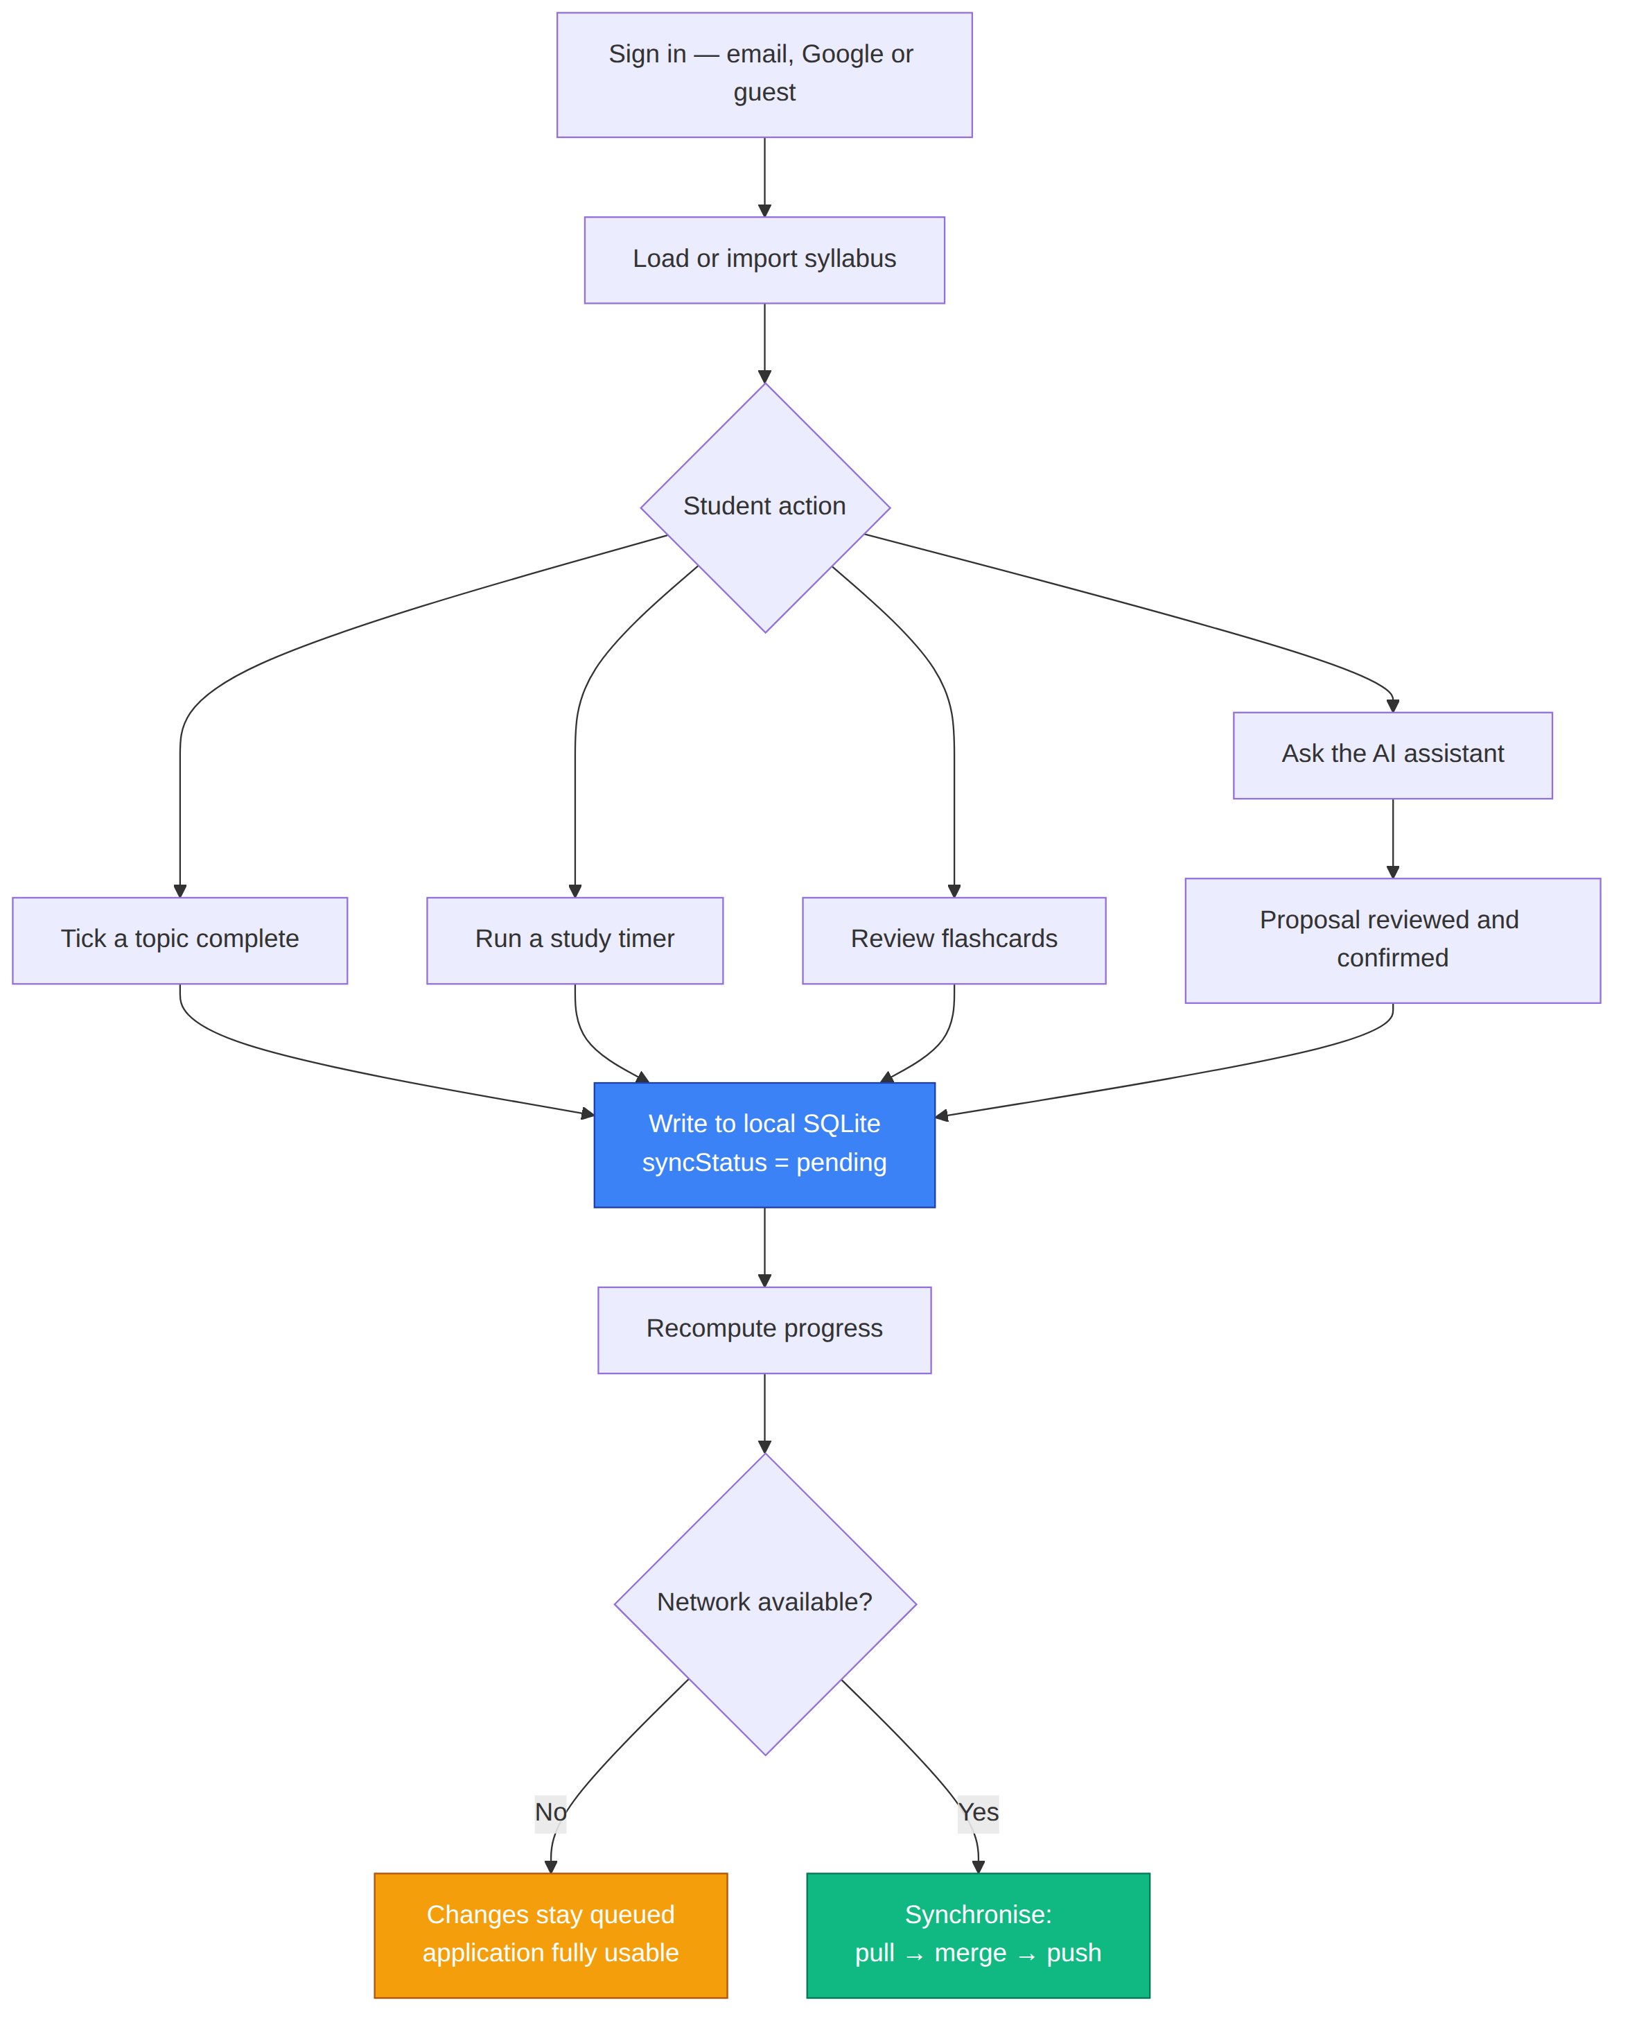
Figure 1: Working flow of the PrepPilot system
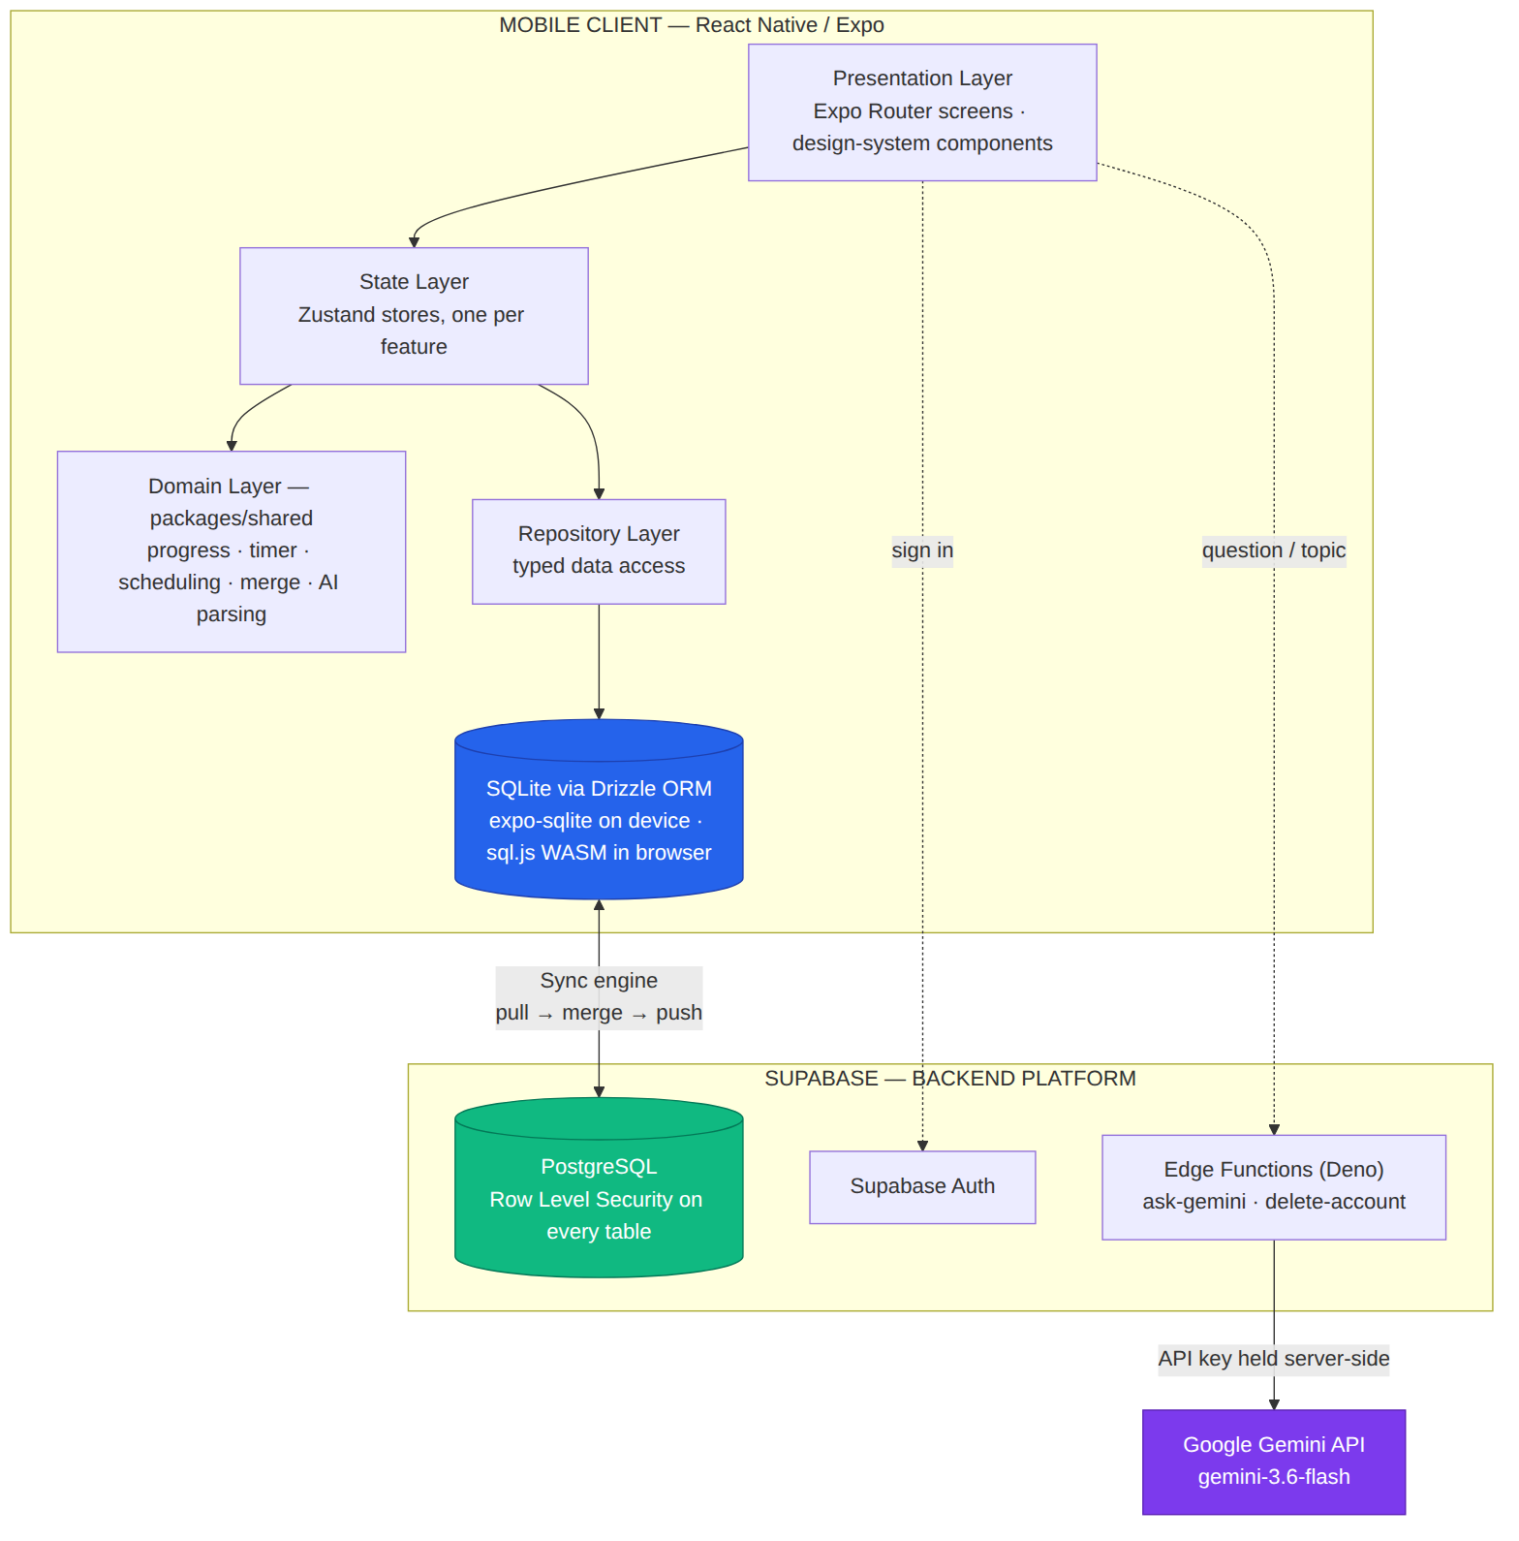
Figure 2: System architecture
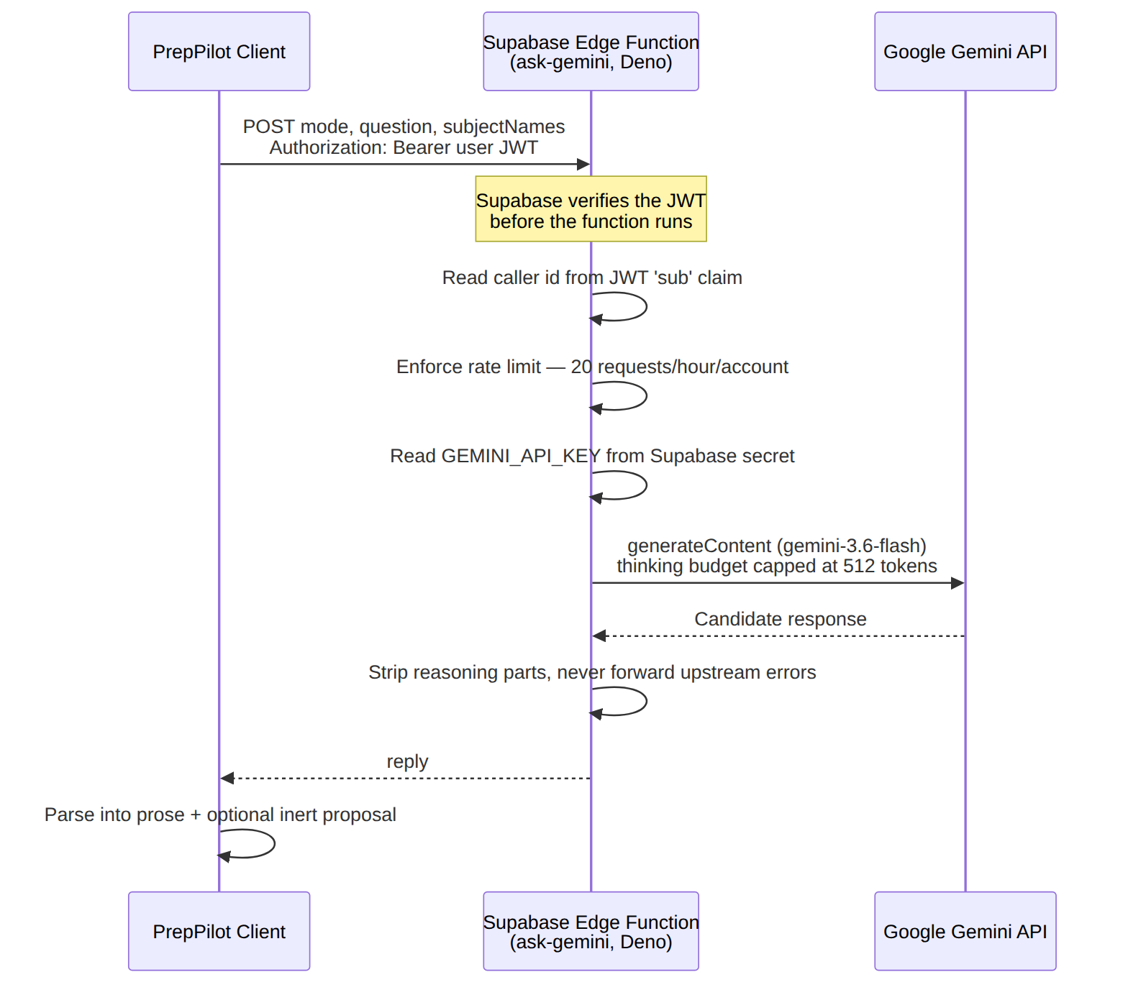
Figure 3: AI request flow through the Supabase Edge Function

