1. **the specific form of $T_{n}^{(34)}$**

From ${\overset{⃑}{e}}_{n,3}^{ }$ to ${\overset{⃑}{e}}_{n,4}^{ }$ is a process of fixed-axis rotation, with the unit vector in the direction of the rotation axis given by $\overset{⃑}{p_{n,1}^{ }p_{n,2}^{ }}/\left|p_{n,1}^{ }p_{n,2}^{ }\right|$, and the rotation angle $β_{n}$ already specified. First, provide the coordinate representation of $\overset{⃑}{p_{n,1}^{ }p_{n,2}^{ }}$ in ${\overset{⃑}{e}}_{n,3}^{ }$.



The value of $\left|p_{n,1}^{ }p_{n,2}^{ }\right|$ is:



Define two dimensionless length quantities:



Reference [1] provides the coordinate transformation matrix for general axis rotation as follows:



In the equation, $p_{1},p_{2}$, and $p_{3}$ represent the coordinate components of the unit direction vector of the rotation axis, $θ$ is the rotation angle, and $c$ and $s$ are shorthand notations for $cos$ and $sin$ respectively.

The expression for $T_{n}^{(34)}$ can be obtained as:



To determine the undetermined terms in the last column of $T_{n}^{(34)}$, further quantitative analysis of the specific axis rotation is needed. This analysis will involve considering the displacement of $O_{n}$ to determine the final form of the transformation matrix.

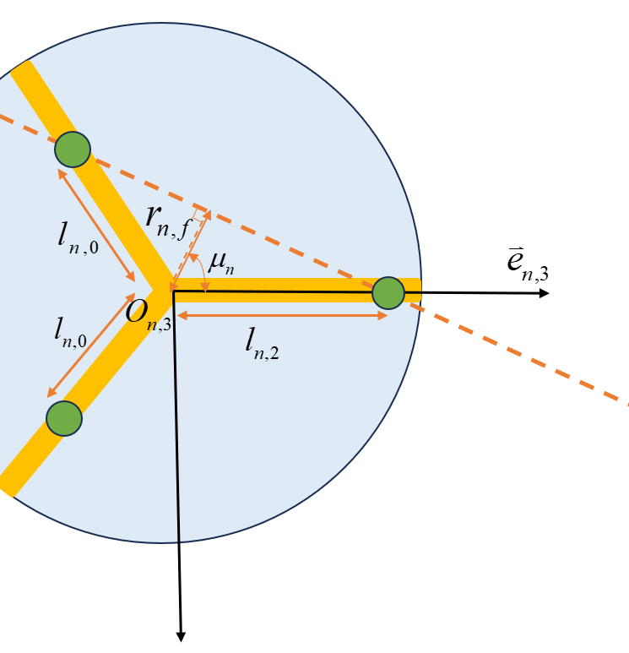

Fig.A pseudo-rotation illustration.

As shown in *Fig.A* ,the value of $r_{n,f}$ can be determined based on the area equation of triangle $p_{n,1}O_{n}p_{n,2}$.



Then:



The displacement vector $\overset{⃑}{r_{n,O}}$ of $O_{n}$ is represented in the coordinates of ${\overset{⃑}{e}}_{n,3}^{}$ as:



The vector $\overset{⃑}{r_{n,O}}$ corresponds to the three undetermined terms of $T_{n}^{(34)}$ from top to bottom, with each coordinate component from left to right.