**Appendix B. Method for solving γ_n**

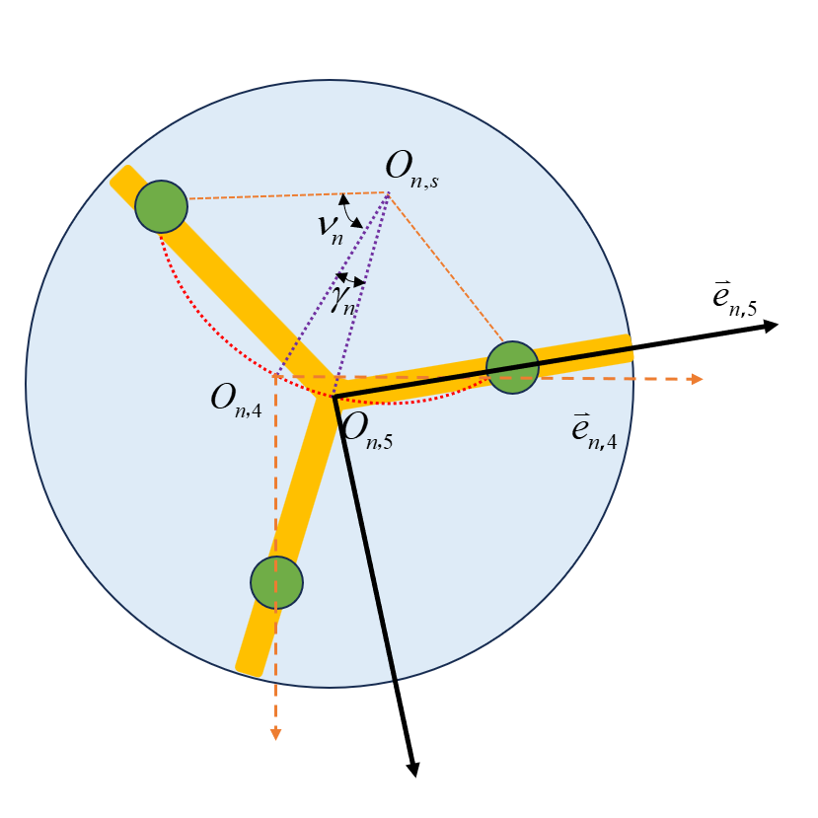

Fig.B Supplementary-rotation illustration

As shown in Fig.B, in order to determine the rotation angle $γ_{n}$ for the supplementary-rotation, it is necessary to determine the position information of point $p_{n,3}$. Let the homogeneous coordinates of point $p_{n,3}$ in the coordinate system ${\overset{⃑}{e}}_{n,4}^{ }$ be.



At the same time, it is easy to obtain the homogeneous coordinates of point $p_{n,3}$ in the coordinate system ${\overset{⃑}{e}}_{n,0}^{ }$.



Based on the coordinate transformation matrix mentioned above, we can obtain this.



The above equation is a linear system of equations involving $x_{p,n,3}$ and $y_{p,n,3}$. Solving it will give us the positional information of point $p_{n,3}$. Next, when considering the rotation by $γ_{n}$, we can use the cosine rule for the triangles $p_{n,1}O_{n,4}p_{n,2}$ and $p_{n,1}O_{n,s}p_{n,2}$ to obtain the distance $r_{n,s}$ between the rotation axis and $O_{n}$.



Then:



Provide the coordinate representation of $O_{n,5}^{ }$ in the basis ${\overset{⃑}{e}}_{n,4}^{ }$ based on the geometric relationship:



Using the coordinates in the basis ${\overset{⃑}{e}}_{n,4}^{ }$, the following vector relationship provides a nonlinear equation regarding $γ_{n}$, solving which will give us the value of $γ_{n}$.

