**Licence Plate Recognition using Deep Learning**

| Archis Khuspe | Ashfan Khan |
| --- | --- |
| *SY, E&TC* | *SY, E&TC* |
| *Vishwakarma Institute of Technology* | *Vishwakarma Institute of Technology* |
| *Pune, India* | *Pune, India* |
| archis.khupse20@vit.edu | ashfan.khan20@vit.edu |

| Atharva Patil |  | Avdhut Asore |
| --- | --- | --- |
| *SY, E&TC* |  | *SY, E&TC* |
| *Vishwakarma Institute of Technology* |  | *Vishwakarma Institute of Technology* |
| *Pune, India* |  | *Pune, India* |
| atharv.patil20@vit.edu |  | avdhut.asore20@vit.edu |
|  |  |

*Abstract— In the past decade, the number of road vehicles has increased. Tracking individual vehicles becomes very challenging with the massive growth in the vehicular sector every day. This paper suggests an automated vehicle tracking system for fast-moving vehicles with the help of surveillance cameras on the roadside. The process of getting CCTV footage in the real-time background is very tedious. The use of deep learning in Automatic Licence Plate Recognition has been a topic of standard research in the past few years. Recognition of Indian plates has always been a challenge due to their unusual nature with different fonts, sizes of letters, padding and number of lines. In this project, a fully functional, end-to-end solution for licence plate recognition in India, considering all irregularities. The system uses a series of state-of-the-art Convolutional Neural networks to create a pipeline that efficiently solves the Indian situation under various scenarios.*

***Keywords— Licence Plate, TesseractOCR, OpenCV, Haar Cascade, Numpy, Vehicle***

I. INTRODUCTION

The drastic increase in vehicular traffic on the roadways stimulates a massive demand for traffic monitoring and management technology. In this scenario, manual tracking vehicles running fast on the road is practically impossible. It would reflect huge difficulties and enormous errors. There are already available solutions for tracking vehicles and number plates using machine learning algorithms. But in real-time, these algorithms fail due to their complexity of processing in the real-time background. Hence, it is necessary to develop an automatic system that would help track the vehicles by tracing their number plates most efficiently.

Besides playing an important role in vehicle tracking, Automatic Number Plate Recognition also plays an inevitable role in systems like parking management systems, toll payment processing systems, and several systems where authorization is much needed. It dramatically helps security officers to save time by automating the process. In recent decades, computer vision technology has taken great strides on several real-world issues. Earlier, vehicle number plates were identified using template matching techniques by identifying the width, height and contour area. Several deep learning models trained over an enormous amount of data are widely used in Number Plate Recognition.

In recent years, Automatic Number Plate Recognition has made vast progress in machine vision technology applications. It is expected to come up with more advancements in future. It can support many communities with its efficient and valuable applications like parking management systems, toll fee collecting systems, vehicle penalty collecting systems, and on-road vehicle tracking systems. Many of the population resides in cities where they need a secure parking space to avoid the access of unauthorised persons. The system also helps collect the toll fee by identifying the vehicle's number plate. Vehicle tracking also helps with the fine collection for those trying to violate the traffic and road rules. It also aids in maintaining a database of the moving vehicles on the road. This paper creates an efficient base system for all these applications. At the moving speed of the vehicles, the images captured must be sufficient enough in brightness, intensity, and clarity to be processed further.

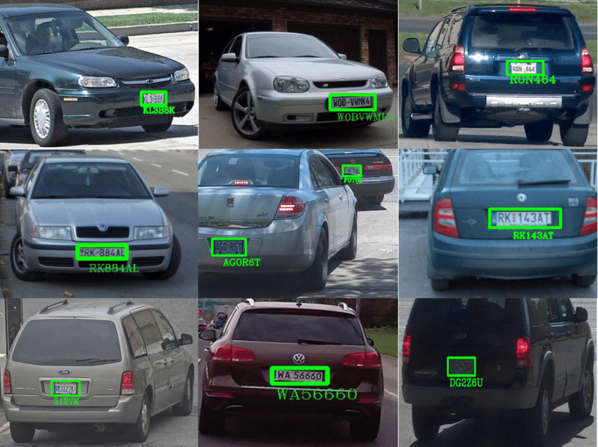

Fig. 1 Licence Plate Recognition in real time

The project's main scope is to detect and recognize Indian number plates with higher accuracy. Furthermore, the angle at which the images are taken forms a major part. The most complex part is that every nation has a unique standard for printing number plates. It may have variations in the font, spaces, letters and numbers.

II. LITERATURE REVIEW

[1] The project was completed using an AI framework. Morphological processing was employed for licence plate localization, but the algorithm performed poorly under bright illuminated environments. All the architecture of the neural network can be implemented in IMAGE AI. The neural network parameters were optimised to enhance the neural network's performance and efficiency, and the code complexity is reduced using this framework. The system was tested in a dynamic environment that automatically detected the vehicles. [2] The algorithm consists of one module for locating and the other for identifying licence numbers by compensating for uncertainties caused by noise and imperfect processing. Although the algorithm works with the licence plates of one specific country, many parts in it are readily extended to use with licence plates of other countries. Since colour and edge are two fundamental features of licence plates, the detector adapts to different colour schemes by replacing the colour parameters of the sensor. Since numerals and letters are commonly used to form licence numbers, the OCR technique applies to any similarly constituted licence plates. [3] The goal of Automatic Licence Plate Recognition(ALPR) is localising the licence plate of a vehicle from an image and extracting text from it to recognize and track the vehicle.Each year, the amount of vehicles in Bangladesh is increasing at a significant rate.This paper has proposed an optimal end-to-end approach for the ALPR system for Bangladeshi vehicles by experimenting with the various Deep Neural Network(DNN) models.These models have been trained and evaluated on our rich datasets of Bangladeshi vehicles and licence plates.The paper is mainly focused on finding the best solution for an automatic licence plate recognition system for Bangladeshi vehicles. [4] Licence plate recognition systems have a very important role in many applications such as toll management, parking control, and traffic management. In this paper, a framework of deep convolutional neural networks is proposed for Iranian licence plate recognition.In this paper a licence plate recognition system based on deep convolutional neural networks is proposed. In the first main part a YOLOv3 network has been used for detection of licence plates from input images. YOLOv3 uses Darknet as a feature extractor. [5] In this paper, we propose a multivehicle detection and licence plate recognition system based on a hierarchical region convolutional neural network (RCNN). Firstly, a higher level of RCNN is employed to extract vehicles from the original images or video frames. Secondly, the regions of the detected vehicles are input to a lower level (smaller) RCNN to detect the licence plate. Thirdly, the detected licence plate is split into single numbers. Finally, the individual numbers are recognized by an even smaller RCNN.This paper proposed a hierarchical strategy for vehicle and vehicle licence plate detection and identification based on RCNN. [6] Automatic Licence Plate Recognition (ALPR) systems have shown remarkable performance on licence plates (LPs) from multiple regions due to advances in deep learning and the increasing availability of datasets. The evaluation of deep ALPR systems is usually done within each dataset; therefore, it is questionable if such results are a reliable indicator of generalisation ability. In this paper, we propose a traditional-split versus leave-one-dataset-out experimental setup to empirically assess the cross-dataset generalisation of 12 Optical Character Recognition (OCR) models applied to LP recognition on nine publicly available datasets with a great variety in several aspects (e.g., acquisition settings, image resolution, and LP layouts).

III. METHODOLOGY

1. *Requirements of the project:*

***OpenCV (CV2)***: OpenCV (Open Source Computer Vision Library) is an open-source computer vision and machine learning software library. It mainly focuses on image processing, video capture and analysis, including features like face detection and object detection, and it helps to provide a common infrastructure for computer vision applications.

***TesseractOCR:*** TesseractOCR is an open-source optical character recognition (OCR) engine. It is recognized as one of the most popular and accurate open-source OCR engines. This engine started as proprietary software developed by Hewlett Packard but was later open-sourced in 2005, and Google has since sponsored its development.

***Numpy:*** Known as Numerical Python, it is a library consisting of multidimensional array objects and a collection of routines for processing those arrays. Using NumPy, mathematical and logical operations on arrays can be performed.

***Haar Cascade XML:*** In 2001, Paul Viola and Michael Jones developed the object detection technique using Haar feature-based cascade classifiers. It is a machine learning-based approach where a cascade function is trained from many positive and negative images. It efficiently extracts numerical values for features (e.g. edges, lines) with the concept of integral image (or summed-area table), which trumps the default computationally-heavy way of subtracting sums of pixels across multiple regions of an entire image. In addition, it uses the 'Cascade of Classifiers'. This means that instead of applying hundreds of classifiers for the many features within the image at one go (which is very inefficient), the classifiers are applied one by one. OpenCV comes with pre-trained XML files of various Haar Cascades, where each XML file contains the feature set.

1. *Implementation:*

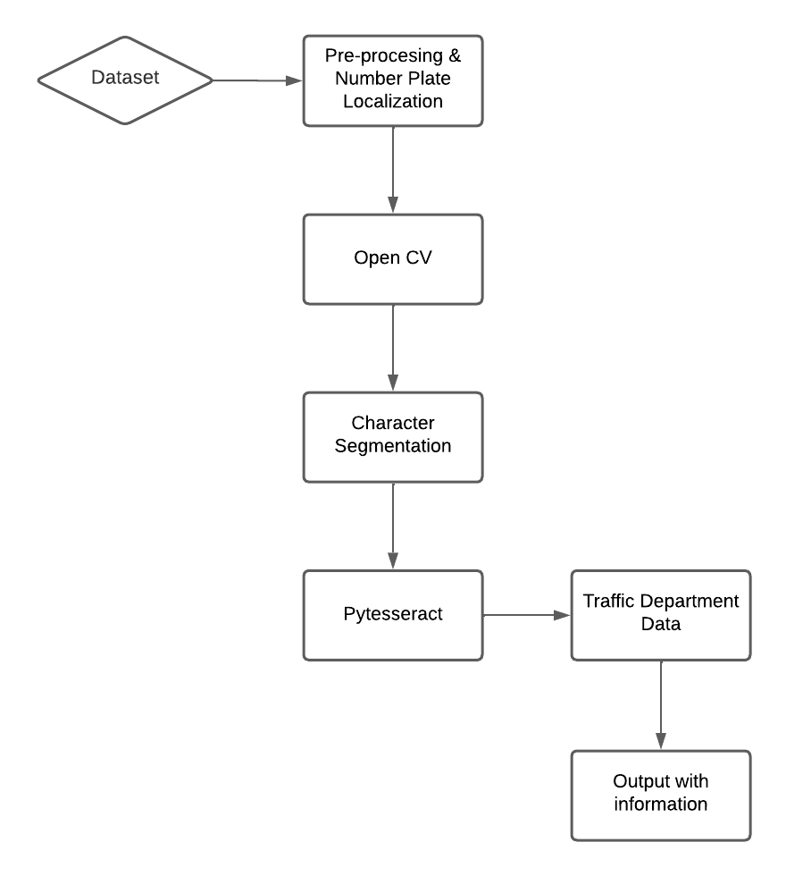

Fig. 2 Flowchart of the project

* 1. *Number Plate Recognition and Extraction with Tesseract*

First, the libraries are initialised. The path where Tesseract is installed in the system is written. Then, the cascade file is read, and a number plate dictionary is created according to India's states and union territories. The Haar Cascade feature set (XML file) for Russian car plates is initialised using OpenCV's CascadeClassifier function. Further, the detectMultiScale method of the CascadeClassifier is used to run the detection. The method enables the detection of objects of different sizes in the input image and returns a list of rectangle bounds where objects are detected. For each rectangle, there would be 4 values returned, and they correspond to the following respectively:

* x-coordinate of the bottom-left corner of rectangle (x)
* y-coordinate of the bottom-left corner of rectangle (y)
* width of rectangle (w)
* height of the rectangle (h)

The key parameters involved in the detectMultiScale function are scaleFactor and minNeighbours.

***scaleFactor:*** It specifies how much the image size is reduced at each image scale (as part of the scale pyramid, which is a multi-scale representation of an image). As part of the scale pyramid, the image is resized several times in the hopes that a car plate would end up being a "detectable" size. When object detection models are trained, they are trained to detect objects (i.e., car plates in this case) of a fixed size and might miss car plates that are bigger or smaller than expected.

***minNeighbours:*** It allows to specify how many neighbours each candidate rectangle should have for it to be retained. In simpler terms, this parameter influences the quality of the detected objects. A higher value results in fewer detections, but the detections come with higher quality and accuracy. This means that a higher value can help with reducing the number of false positives.

* 1. *Extracting the car licence plate and enlarging the image*

To ensure the success of the OCR function, a series of image processing steps need to be performed. The car licence plate is isolated as an image. In addition, the car licence plate is enlarged (using OpenCV's resizemethod) since it was only a tiny segment of the original input image. Running these two functions would give the region of interest, the car licence plate itself.

* 1. *Grey-scale conversion*

Next up is to convert the image from RGB colour to grayscale. This purpose is to decrease the number of colours in the image, which may interfere with OCR detection. This is because the focus is only on the crucial edges and shapes of the image, and converting to grayscale helps optimise this detection process.

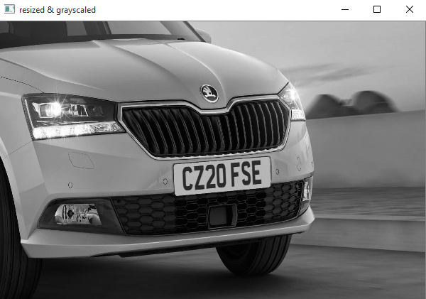

Fig. 3 Grey-scale conversion

* 1. *Smoothing*

This is a de-noising step, making the text characters in the image more distinct and recognisable. The smoothing technique helps eliminate noise and makes the application focus on the general details of the image.

Median blur is used for the smoothing (usingcv2.medianBlur), which computes the median of all the pixels under the kernel window and replaces the central pixel with this median value. After these transformations, the image is now ready for OCR application. The image is passed into the Tesseract image_to_string function.

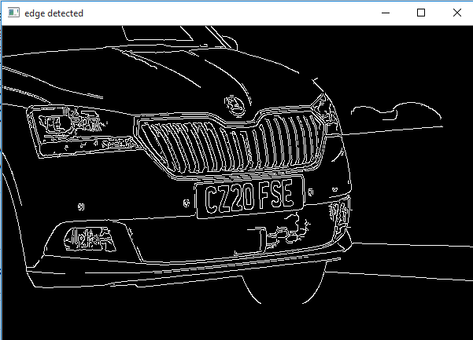

Fig. 4 Edge Detection

Some additional details about the above Tesseract image_to_string function:

***tessedit_char_whitelist:*** It helps restrict the TesseractOCR function to a set of pre-defined (white-listed) characters. Since we know that the licence plate text ranges from 0–9 and A-Z, we can specify it.

***--psm:*** It refers to Page Segmentation Modes (PSM), which gets the TesseractOCR to run a subset of layout analysis and assume a specific form of an image.

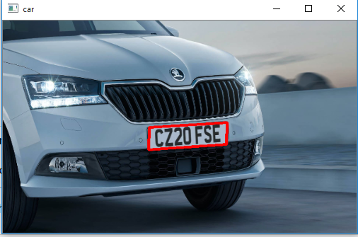

Fig. 5 Detected Licence Plate

After that, the car's regional information is fetched from the state and union territory dictionary (traffic department’s data) specified before. And finally, the image's address on the system is called to initiate it into the program.

IV. RESULT

The program would give out the detected licence plate along with its number. It would also specify the place from where the vehicle belongs (place of registration). The cropped licence plate would be presented separately.

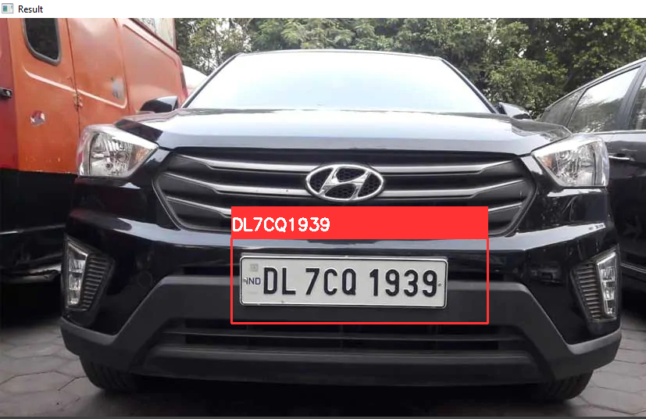

Fig. 6.1 Detected Licence Plate (Example 1)

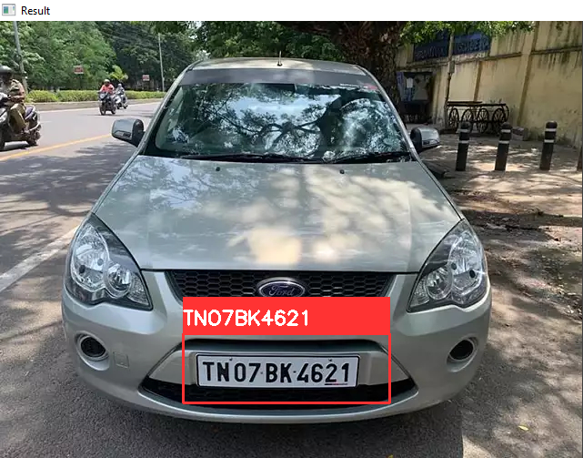

Fig. 6.2 Detected Licence Plate (Example 2)

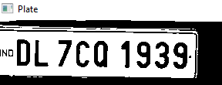

Fig. 7.1 Cropped Licence Plate (Example 1)

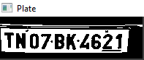

Fig. 7.2 Cropped Licence Plate (Example 2)

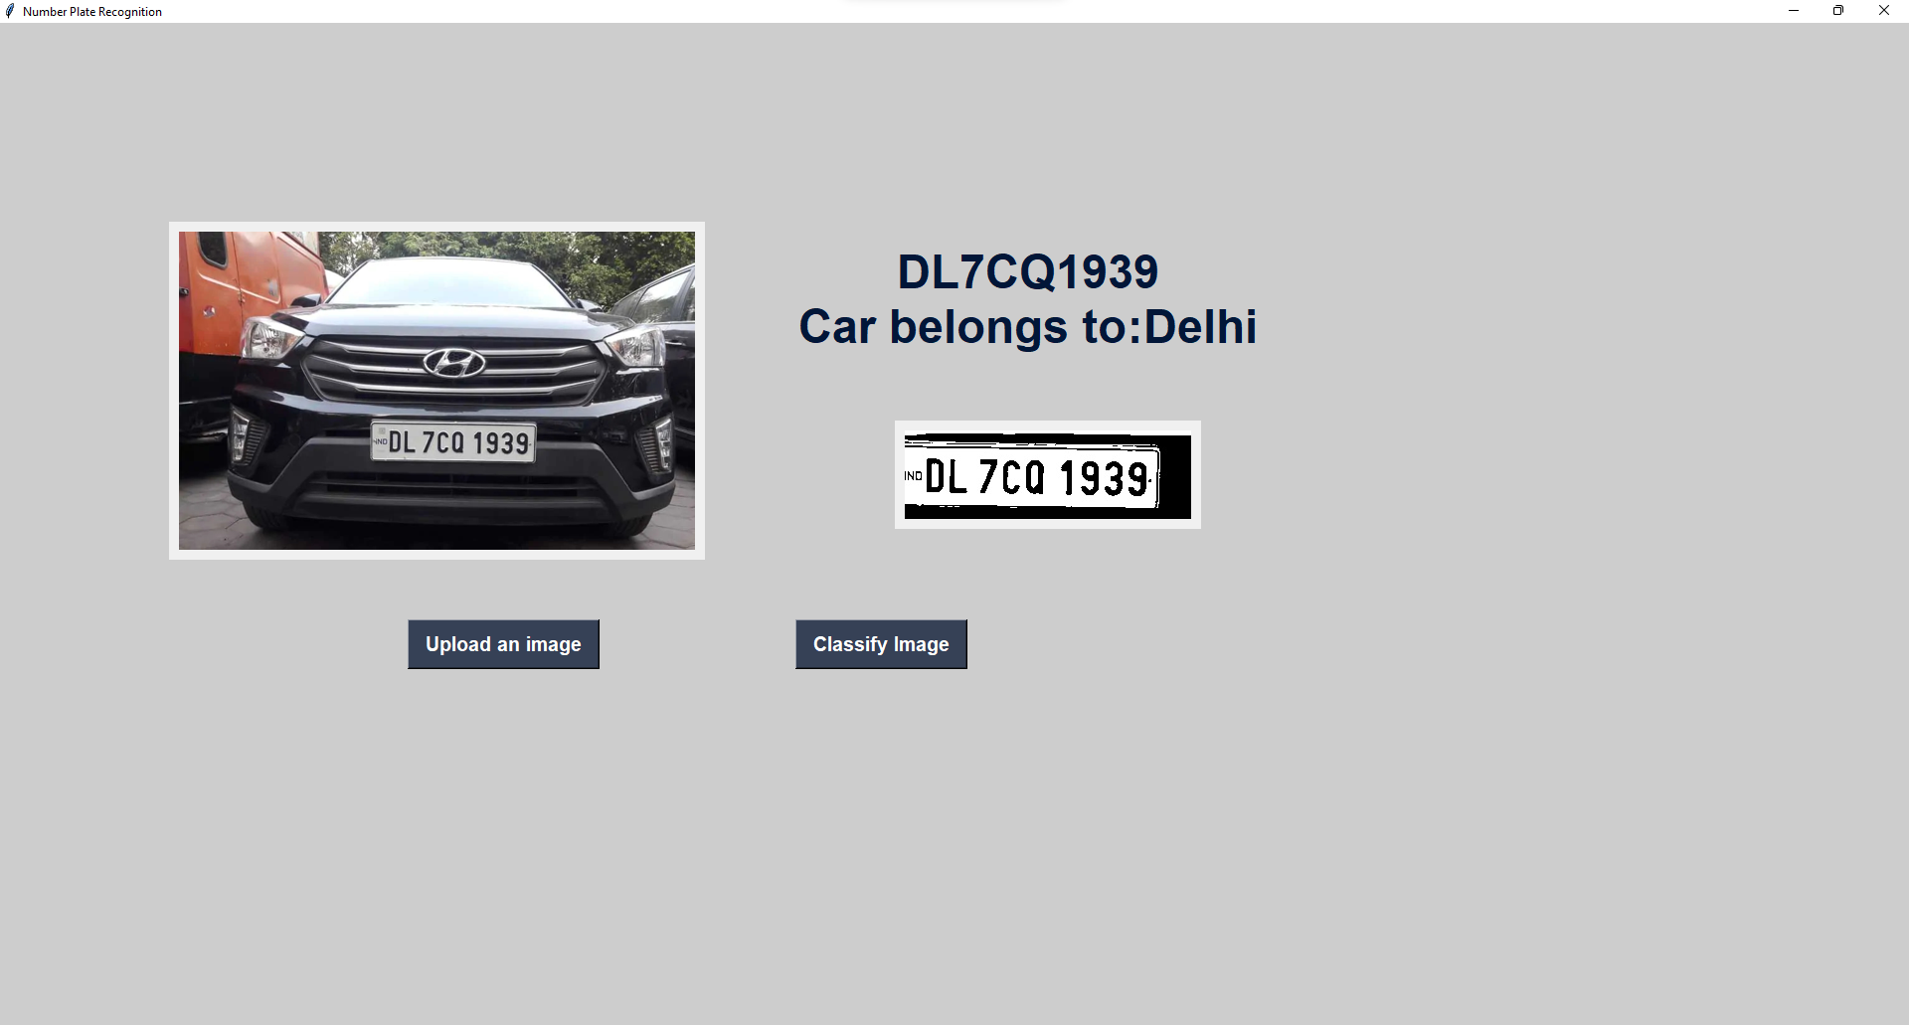

Fig. 8.1 Licence Number along with the place of registration (Example 1)

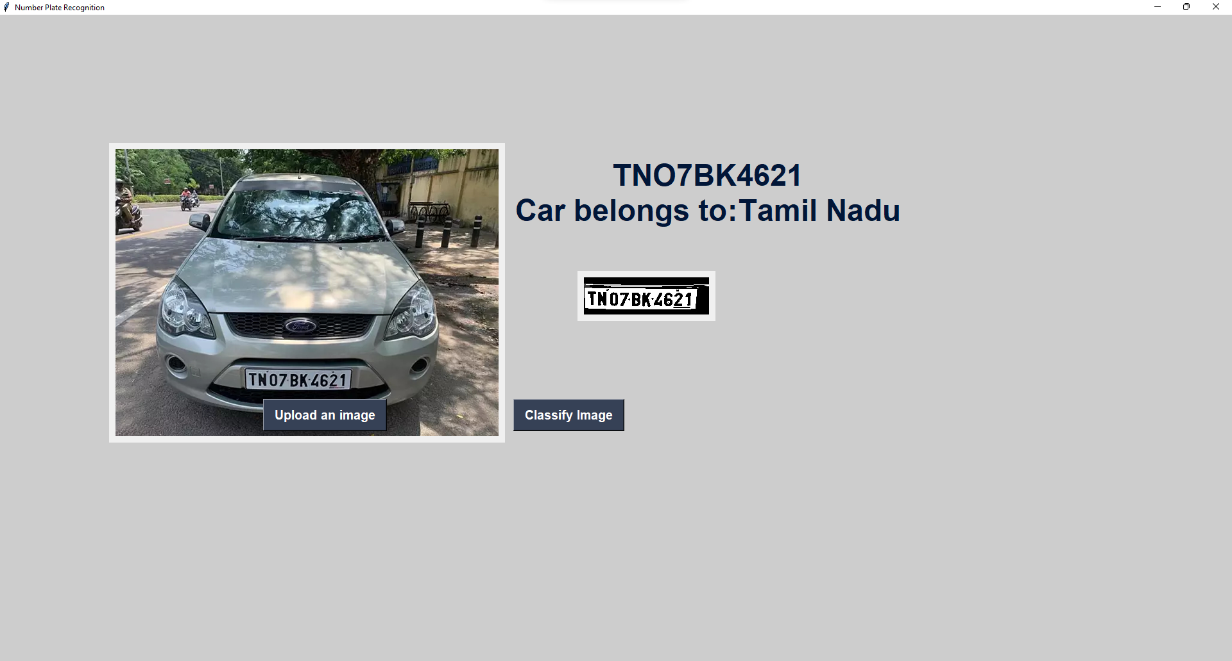

Fig. 8.2 Licence Number along with the place of registration (Example 2)

V. FUTURE SCOPE

The detection of plates in low-light images can be improved by more training. The program could be designed to tackle many intricacies present in plates, including multiple lines, irregular padding, different plate shapes, different fonts and non-uniform font size. Finally, the model is trained, with most images head-on. So, another improvement aimed is training for angled plates. This can help read a plate from a traffic light or toll booth. Support for regional scripts such as Devanagari is also considered.

VI. CONCLUSION

In this paper, it is shown how deep learning techniques can significantly simplify the process of licence plate recognition in India. The use of deep learning also allows the inclusion of all the aberrant features in India's plates. Thus, the proposed methodology for licence plate recognition achieves results for the Indian context. This system can be incorporated ubiquitously as-is, especially in cities with high stochasticity, to improve road safety and the overall driving experience.

REFERENCES

[1] Gnanaprakash, V., N. Kanthimathi, and N. Saranya. "Automatic number plate recognition using deep learning." IOP Conference Series: Materials Science and Engineering. Vol. 1084. No. 1. IOP Publishing, 2021.

[2] Shyang-Lih Chang, Li-Shien Chen, Yun-Chung Chung and Sei-Wan Chen, "Automatic licence plate recognition," in IEEE Transactions on Intelligent Transportation Systems, vol. 5, no. 1, pp. 42-53, March 2004, doi: 10.1109/TITS.2004.825086

[3] Hossain, S. N., Hassan, M., Masba, M., & Al, M. (2022). Automatic Licence Plate Recognition System for Bangladeshi Vehicles Using Deep Neural Network. In *Proceedings of the International Conference on Big Data, IoT, and Machine Learning* (pp. 91-102). Springer, Singapore.

[4]Zandi, M. S., & Rajabi, R. (2022). Deep Learning Based Framework for Iranian Licence Plate Detection and Recognition. *arXiv preprint arXiv:2201.06825*.

[5] Tu, C., & Du, S. (2022). A hierarchical RCNN for vehicle and vehicle licence plate detection and recognition. *International Journal of Electrical and Computer Engineering*, *12*(1), 731.

[6] Laroca, R., Cardoso, E. V., Lucio, D. R., Estevam, V., & Menotti, D. (2022). On the Cross-dataset Generalisation for Licence Plate Recognition. *arXiv preprint arXiv:2201.00267*.