

Name: A Archishman Course Code: ITA0330
Reg No: 192425341 Course Name: Mobile Computing Slot: D

Experiment 3: Network Switching Subsystem Flowchart

Aim: To develop a flowchart illustrating the operation of a Network Switching Subsystem (NSS) in a mobile cellular system using Figma.

Procedure:

- Open Figma and create a new design frame.
- Add a Start symbol at the top of the flowchart.
- Draw process boxes for receiving and processing a call request.
- Add a decision diamond to check whether the destination is in the same network.
- Connect the branches to connection setup or an external network, followed by call termination.
- Add arrows, labels, and colors to complete the flowchart.

Output:

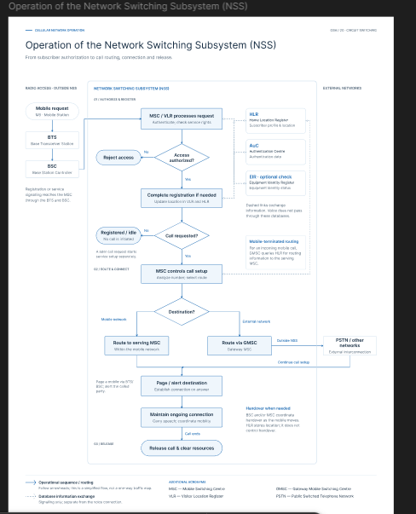

Result: A flowchart representing the major operations of the Network Switching Subsystem was created successfully.

