

Name: A Archishman Course Code: ITA0330
Reg No: 192425341 Course Name: Mobile Computing Slot: D

Experiment 5: Mobile Application Wireframe with Localization Features Using Figma

Aim: To design a wireframe for a mobile application incorporating localization features using Figma.
Procedure:

- Open Figma and create a new design file.
- Select a mobile frame from the available device presets.
- Design the home screen with an application title and search bar.
- Add a location icon to display the user's current location.
- Create a map screen with location markers and nearby places.
- Add categories such as hospitals, hotels, restaurants, and shopping centers.
- Design a place details screen with address and distance information.
- Create location permission and settings screens with language options.
- Connect the screens using buttons in the Prototype tab.
- Preview the prototype to verify navigation and the overall design.

Output:
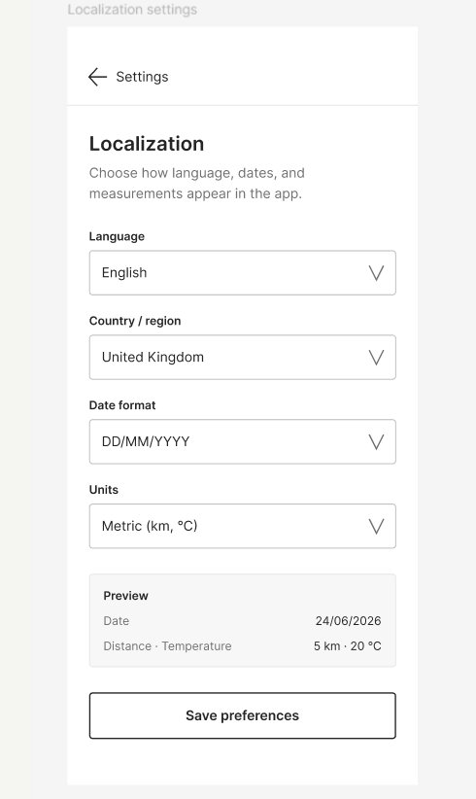

Result: A mobile application wireframe with localization features was successfully designed using Figma.

