

ITA0330-Mobile Computing
Name: - A Archishman Reg no: -192425341
Slot: -D Course: ITA0330-Mobile Computing

Experiment 6: Mobile connection transfers from BTS 1 to BTS 2

Aim

To simulate a handoff scenario in a mobile network and visualize the process using Figma.

Procedure

- Open Figma and create a new design file.
- Draw two circles representing Cell A and Cell B.
- Label them BTS 1 and BTS 2.
- Add a mobile phone icon and an arrow showing movement between the cells.
- Draw five rectangular boxes to represent the handoff steps.
- Connect the boxes using arrows.
- Apply light blue, green, and yellow colors.
- Arrange the elements neatly and preview the design.

Output: -

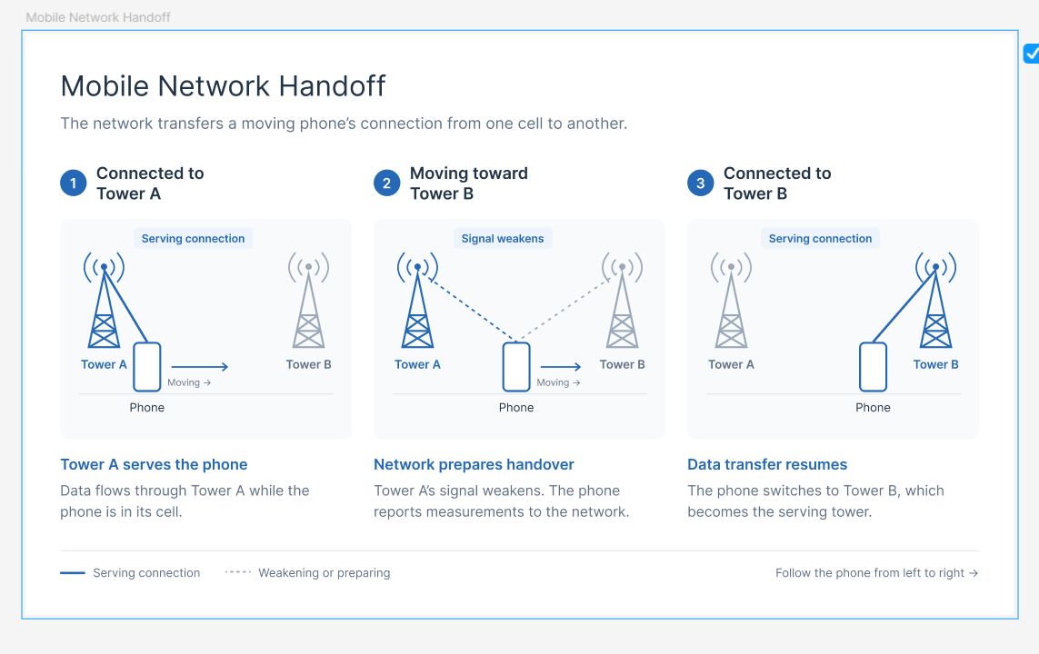

Result: -Thus, a mobile network handoff process was visualized successfully using Figma. The diagram shows how a mobile connection transfers from BTS 1 to BTS 2 while maintaining an ongoing call.

