TIDEBOUND

Technical Architecture
and Design Reference
A project guide to the Pygame platform game
Runtime design • Gameplay systems • Software diagrams
Prepared 16 October 2026
Based on the Tidebound workspace source

Project report contents
This report describes the project purpose, scope, requirements, implementation, verification, delivery approach, and recommended next steps. It is a project-facing companion to the technical architecture reference.
Project definition
Project overview • Project background and motivation • Problem statement • Vision and success criteria • Project objectives • Stakeholders and users • User profile and needs • Scope and boundaries • Assumptions and constraints • Product context and operating environment
Requirements and product design
Project lifecycle and delivery approach • Work breakdown structure • Milestones and release gates • Feasibility assessment • Requirements approach and priority • Functional requirements • Non-functional requirements • Use cases and player journey • Acceptance criteria • System overview • Game flow and scene transitions
Implementation and quality
Player interaction design • Stage and content design • Overworld and progression design • Health, death, and retry design • Enemy and item design • Interface, audio, and feedback • Implementation structure • Technology stack and compatibility • Data management and persistence • Security, privacy, and licensing • Risk register • Quality strategy • Verification performed and evidence limits
Delivery and handoff
Test plan and coverage • Performance and optimization plan • Deployment and installation • Operations and support • Change management and contribution workflow • Maintenance plan • Accessibility and usability opportunities • Limitations and technical debt • Roadmap and future enhancements • Requirements traceability • Project glossary • Release readiness checklist • Conclusion and project handoff

Project overview
Tidebound is a single-player, side-view platform game implemented in Python with Pygame. Players move through tile-based stages, avoid hazards, fight enemies, collect items, and travel between stages through an overworld. The project combines an existing open-source game foundation with modernization and recovery-flow work in the current workspace.
This report frames the work as a maintainable software project: it records the product purpose, scope, requirements, design decisions, implementation state, verification evidence, delivery guidance, and a practical future roadmap. It is based on source files and assets available in the workspace as of 16 October 2026.
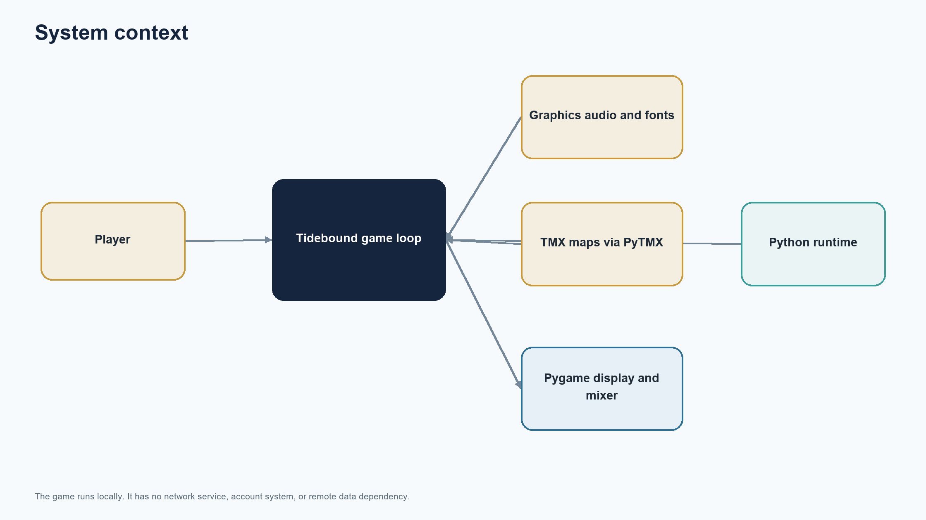
Figure 0 Project overview

Project background and motivation
The source project was built against an older Pygame environment. Older game projects can become difficult to install and run as Python and library versions change, especially when they depend on asset paths, map formats, timing assumptions, or deprecated APIs. A modernization effort therefore needs to preserve the intended game while making startup and gameplay behavior predictable in a current environment.
A second motivation came from the player experience around failure. The requested behavior is that losing health does not silently discard stage progress: a player who dies during a stage can retry that same stage, and complete health depletion leads to a game-over screen with an explicit retry action.
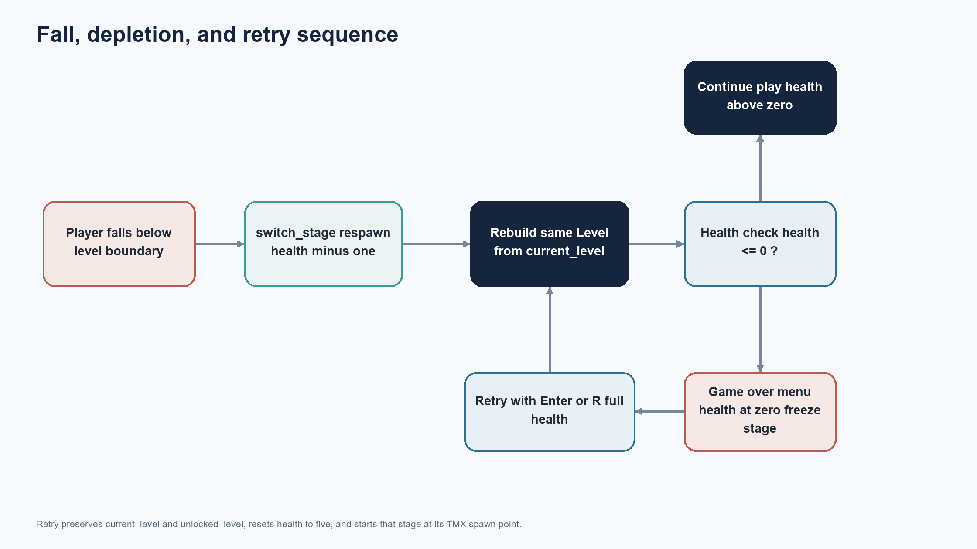
Figure 0 Project background and motivation

Problem statement
The project needs a clear, reproducible way to run a Pygame platform game on current Python, a coherent stage and overworld flow, and understandable recovery after failure. Without explicit requirements and checks, changes to retry logic can accidentally return players to the overworld, quit the process, reset the wrong progress, or leave the game in a partially initialized state.
This document turns those concerns into a project baseline. It does not claim formal user research, a commercial release, or a complete defect-free guarantee; it describes code-backed behavior and identifies further evidence needed before a public release.
IMPLEMENTATION REFERENCE This document turns those concerns into a project baseline. It does not claim formal user research, a commercial release, or a complete defect-free guarantee; it describes code-backed behavior and identifies further evidence needed bef

Vision and success criteria
The project vision is a small, approachable platform adventure that launches consistently, communicates its controls, and treats stage failure as a recoverable gameplay event. The project should remain easy for a contributor to install, understand, verify, and extend without requiring online services.
Success is measured by repeatable launch, correct stage selection, responsive controls, stable collision and item behavior, same-stage respawn, a visible game-over/retry path at zero health, and documentation that lets a new contributor reproduce the setup. Performance should remain smooth at the existing 60 FPS cap on supported desktop hardware.
IMPLEMENTATION REFERENCE Success is measured by repeatable launch, correct stage selection, responsive controls, stable collision and item behavior, same-stage respawn, a visible game-over/retry path at zero health, and documentation that lets a new contributo

Project objectives
The primary objectives are to establish a current Python/Pygame baseline, preserve the existing game content, make failure and retry behavior explicit, keep stage progression coherent, and document the system for future maintenance. These are product outcomes, not claims that every desired enhancement has already been implemented.
The implementation visible in the workspace includes Python 3.13.3 and Pygame 2.6.1 compatibility checks, an in-game game-over overlay with Enter/R retry and Escape quit behavior, same-stage reload after a fall while health remains, and a retry that restores the current stage and unlocked-stage progress.
IMPLEMENTATION REFERENCE The implementation visible in the workspace includes Python 3.13.3 and Pygame 2.6.1 compatibility checks, an in-game game-over overlay with Enter/R retry and Escape quit behavior, same-stage reload after a fall while health remains, an

Stakeholders and users
The direct user is a desktop player using a keyboard. The project owner or maintainer is responsible for accepting changes, distributing the source, and deciding whether proposed future work is in scope. Contributors need the repository layout, dependency instructions, map conventions, and a dependable way to run checks.
No named team roles, external customers, or organizational sponsor are evidenced by the project. For a small open-source project, these responsibilities can be held by one maintainer; release notes should identify who reviewed and approved each public release.
IMPLEMENTATION REFERENCE No named team roles, external customers, or organizational sponsor are evidenced by the project. For a small open-source project, these responsibilities can be held by one maintainer; release notes should identify who reviewed and a

User profile and needs
A typical player expects to start the game, understand movement and action keys, reach a stage, recognize damage, and recover from a mistake without guessing whether progress was lost. Feedback should distinguish temporary damage from a full game over, and controls should be consistent between stages.
A contributor expects standard Python packaging conventions, a concise setup guide, meaningful error messages when assets or maps are missing, and checks that can run without specialized hardware. The current report recommends improving these onboarding aids as a future maintenance task.
IMPLEMENTATION REFERENCE A contributor expects standard Python packaging conventions, a concise setup guide, meaningful error messages when assets or maps are missing, and checks that can run without specialized hardware. The current report recommends improvin

Scope and boundaries
Included scope covers desktop gameplay, Pygame rendering and input, TMX-authored levels, the overworld route map, player/enemy/item behavior, session health and coin state, same-stage respawn, game-over retry, and project documentation. The current code loads six numbered stage maps and one overworld map.
The project is local and single-player. Accounts, online play, cloud saves, analytics, network services, mobile controls, console support, and a formal content pipeline are outside the current scope. Persistent save data and broad accessibility features are recommendations rather than implemented capabilities.
IMPLEMENTATION REFERENCE The project is local and single-player. Accounts, online play, cloud saves, analytics, network services, mobile controls, console support, and a formal content pipeline are outside the current scope. Persistent save data and broad acce

Assumptions and constraints
The application assumes a desktop environment supported by Pygame, keyboard input, readable project assets, and compatible TMX files. The dependency range in the project is Pygame 2.6.x and PyTMX 3.x. The game loop targets 60 frames per second and uses elapsed time for movement and timers.
The report is grounded in the current workspace snapshot; a live review of every upstream project revision was not performed for this document. No budget, delivery date, staffing plan, or measured frame-time profile is asserted. Those values should be established if the project adopts a formal release schedule.
IMPLEMENTATION REFERENCE The report is grounded in the current workspace snapshot; a live review of every upstream project revision was not performed for this document. No budget, delivery date, staffing plan, or measured frame-time profile is asserted. Tho

Product context and operating environment
Tidebound runs as a local desktop process. Pygame owns the display, event queue, clock, and audio mixer; PyTMX reads level data; project assets supply sprites, backgrounds, fonts, and sound. The user interacts through the keyboard and receives output through the display and speakers.
Because there is no server or account system, a run does not depend on an internet connection after installation. Stage progress and collected currency live in memory. Closing the program ends the session and does not create a persistent save.
Figure 0 Product context and operating environment

Project lifecycle and delivery approach
A suitable lifecycle for this project is iterative: establish a runnable baseline, make one behavior change at a time, check it in the game, update documentation, and package a small release. This is a recommended approach, not a claim about the historical process used to build the repository.
Each iteration should include a short acceptance note, a reproducible environment, source review, a focused regression check, and an update to the changelog. Changes to core loop, collision, assets, or map loading should receive broader smoke testing because those systems affect multiple stages.
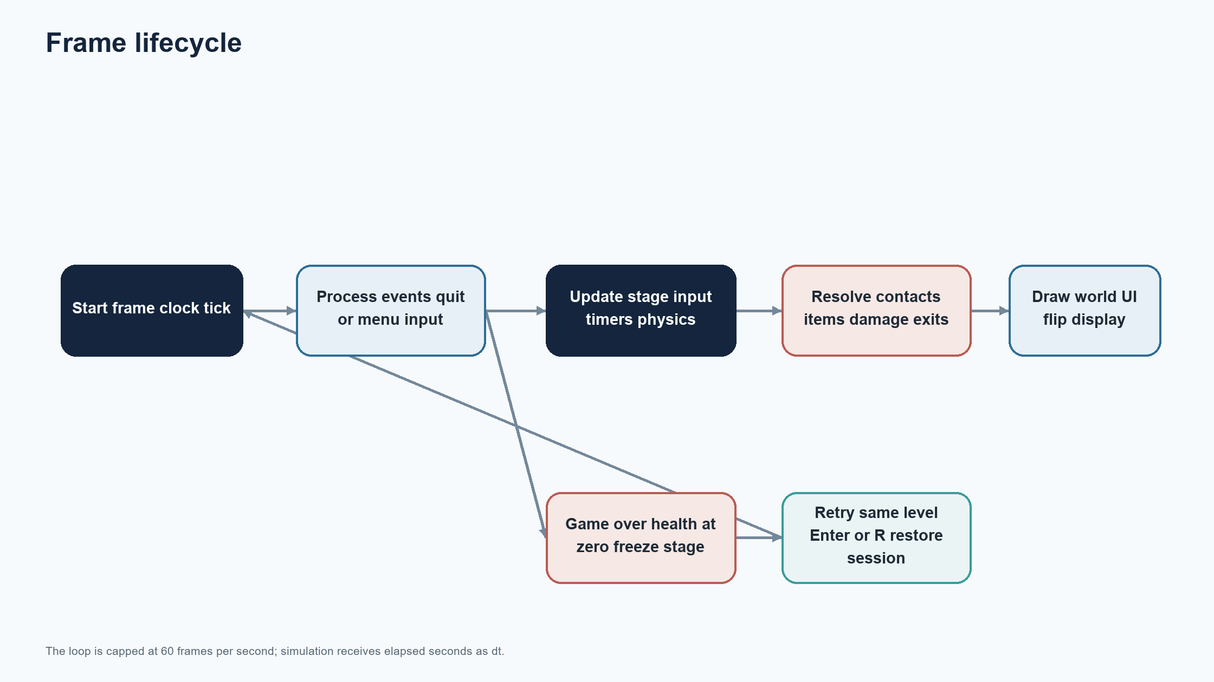
Figure 0 Project lifecycle and delivery approach

Work breakdown structure
A practical work breakdown separates project setup, dependency compatibility, gameplay flow, UI and feedback, content integrity, verification, documentation, and release preparation. Work should be sized so that each change has a clear player-visible result and can be reviewed independently.
The existing workspace already contains the gameplay code and assets. This report and its diagrams are documentation deliverables. The roadmap later in this report identifies suggested follow-up work and does not represent committed dates or completed work.
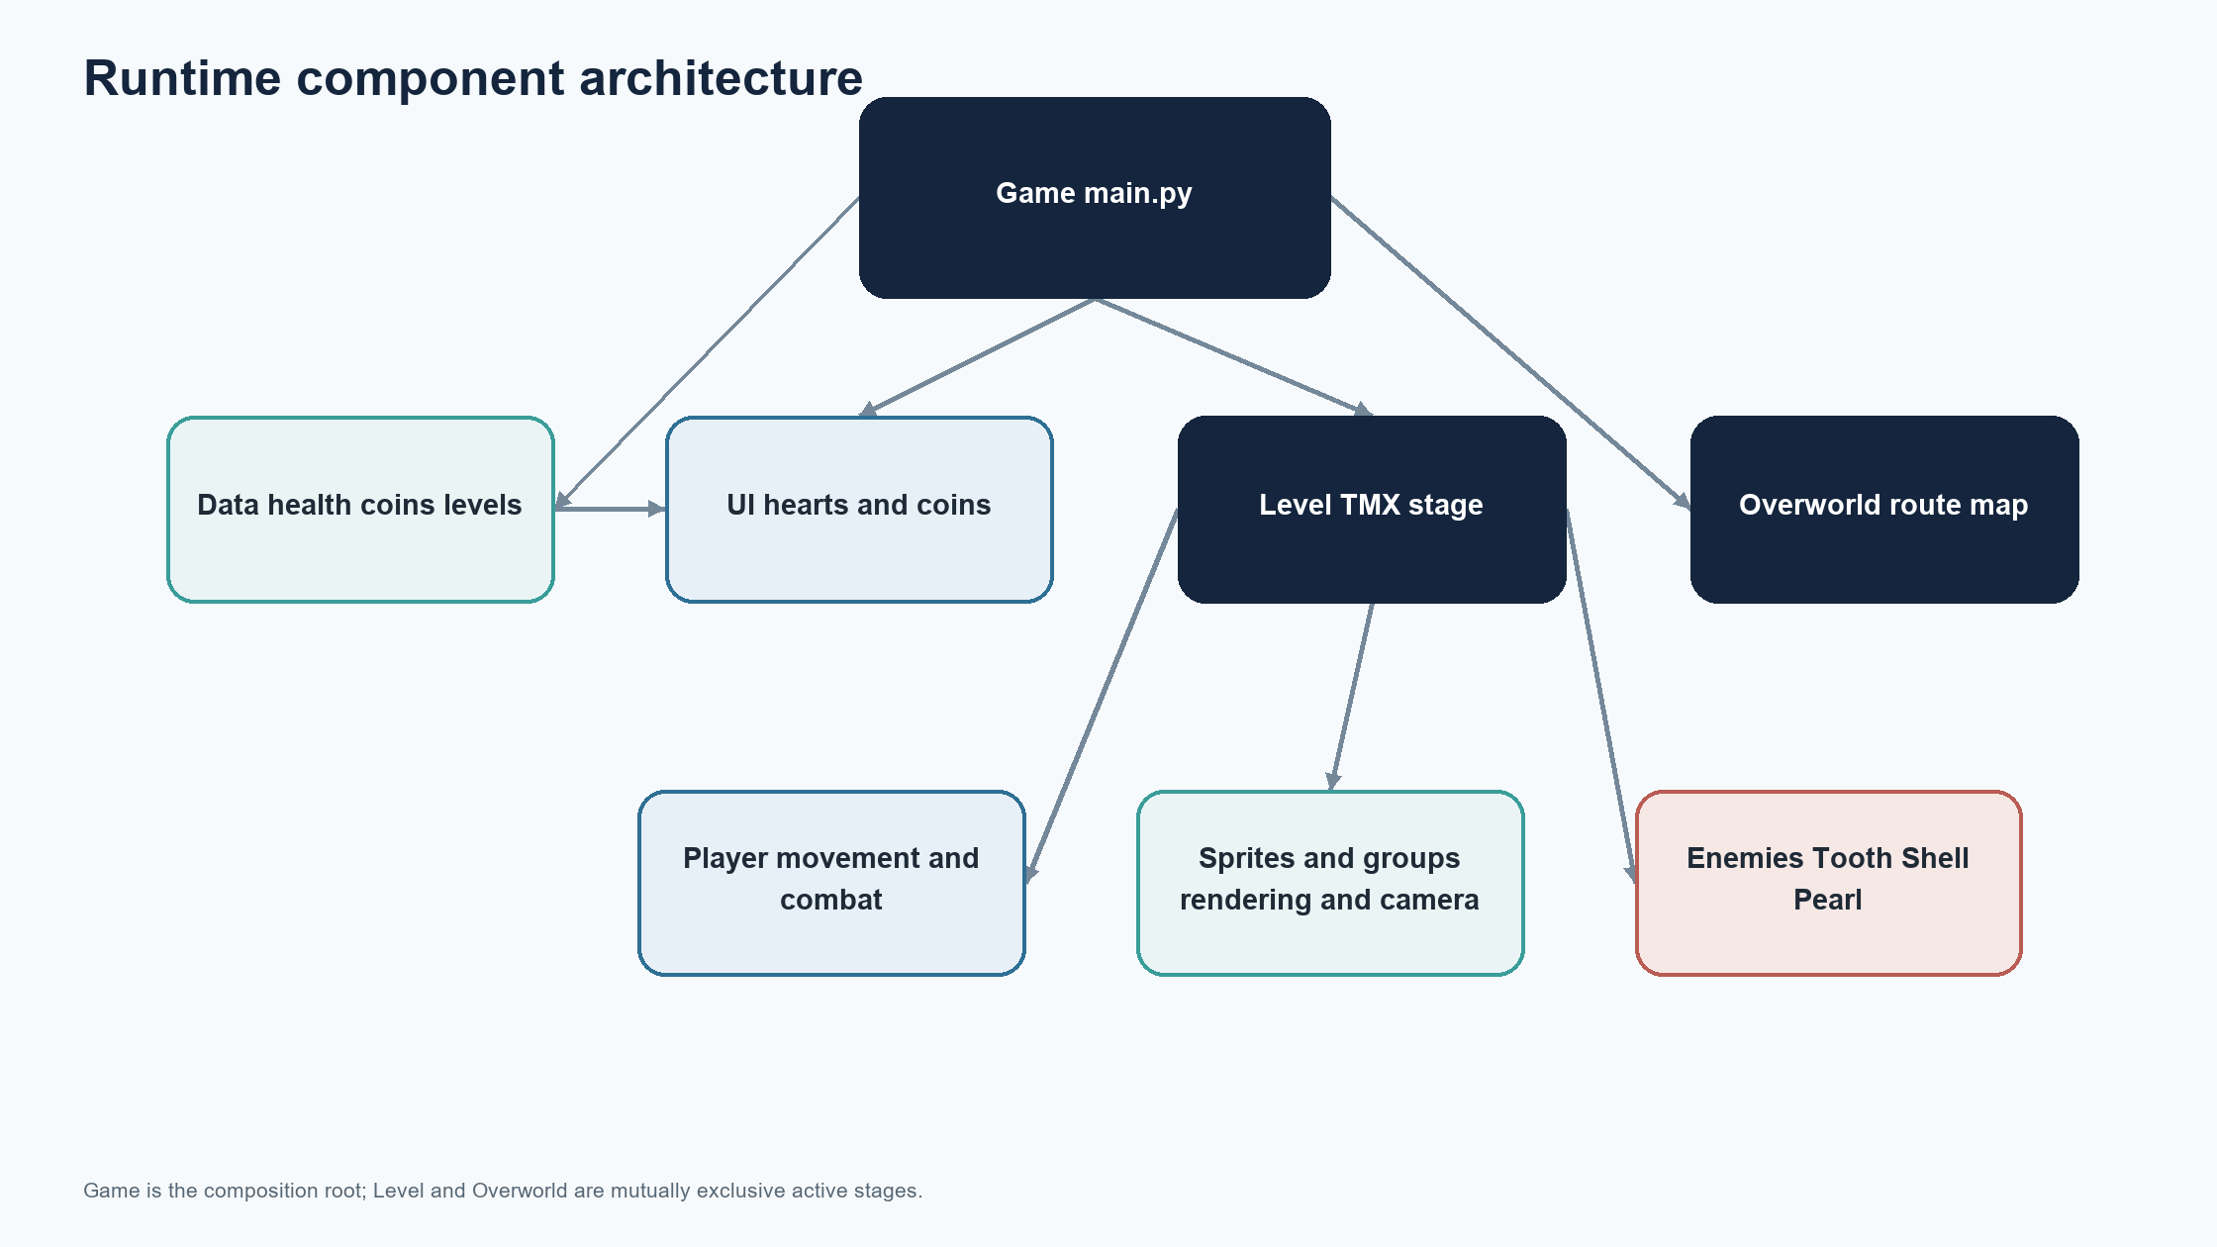
Figure 0 Work breakdown structure

Milestones and release gates
Recommended milestone gates are: baseline launch; core stage loop; death and retry flow; content and asset audit; regression pass; and documented release candidate. A gate is complete when its acceptance evidence is recorded, not merely when code has been written.
Before release, confirm the supported Python and Pygame versions, install dependencies from a clean environment, start the game from the documented location, traverse representative stages, verify recovery, and ensure the distribution includes every required asset and license notice.
IMPLEMENTATION REFERENCE Before release, confirm the supported Python and Pygame versions, install dependencies from a clean environment, start the game from the documented location, traverse representative stages, verify recovery, and ensure the distribution

Feasibility assessment
Technical feasibility is favorable for a small desktop game: Python, Pygame, and PyTMX are established components, the game is already split into modules, and content is stored in local files. The key engineering risk is integration quality across runtime versions and game-state transitions rather than an unknown platform dependency.
Operational feasibility is also favorable because the game has no server to deploy. The main cost is maintainer time for testing, packaging, and content checks. Commercial or schedule feasibility cannot be assessed without an agreed release target, contributor capacity, and distribution plan.
IMPLEMENTATION REFERENCE Operational feasibility is also favorable because the game has no server to deploy. The main cost is maintainer time for testing, packaging, and content checks. Commercial or schedule feasibility cannot be assessed without an agreed re

Requirements approach and priority
Requirements in this report are grouped as essential behavior, quality attributes, and deferred enhancements. Essential requirements describe what a player and maintainer need for a usable build. Quality attributes describe how reliably and clearly those functions should operate.
Priorities below are a recommended baseline. The maintainer should confirm them before a public roadmap is treated as binding. Requirements are phrased so that a test can demonstrate whether each one is satisfied.
IMPLEMENTATION REFERENCE Priorities below are a recommended baseline. The maintainer should confirm them before a public roadmap is treated as binding. Requirements are phrased so that a test can demonstrate whether each one is satisfied.

Functional requirements
The game shall launch into a playable overworld or stage; allow the player to select an unlocked stage; load stage geometry, objects, enemies, and items from TMX content; accept movement and action input; update health and currency; and transition between stages through the level exit.
When the player falls below a stage boundary and health remains, the game shall reload the current stage and reduce health. At zero health it shall show a game-over state. Enter or R shall retry the stage while retaining the current and unlocked stage values; Escape shall quit. These behaviors reflect the current workspace implementation.
Figure 0 Functional requirements

Non-functional requirements
The game should run on the documented current Python and Pygame combination, use a bounded frame rate, and keep motion based on elapsed time rather than assuming a fixed update duration. Asset and map paths should work when launched using the documented method.
The application should provide a stable recovery path from ordinary gameplay failure, avoid unexpected process termination during that flow, and make controls discoverable. A future release should define supported operating systems, minimum display/audio expectations, and any measurable performance threshold.
IMPLEMENTATION REFERENCE The application should provide a stable recovery path from ordinary gameplay failure, avoid unexpected process termination during that flow, and make controls discoverable. A future release should define supported operating systems, mi

Use cases and player journey
The primary player journey is: launch, choose an available route, enter a stage, move and interact, collect items, reach an exit or die, then continue, respawn, retry, or quit. The overworld gates locked routes using unlocked progress.
The maintainer journey is: create an environment, install dependencies, run the entry point, edit code or TMX content, execute relevant checks, and package the project with assets. These journeys define the acceptance paths that should be exercised before release.
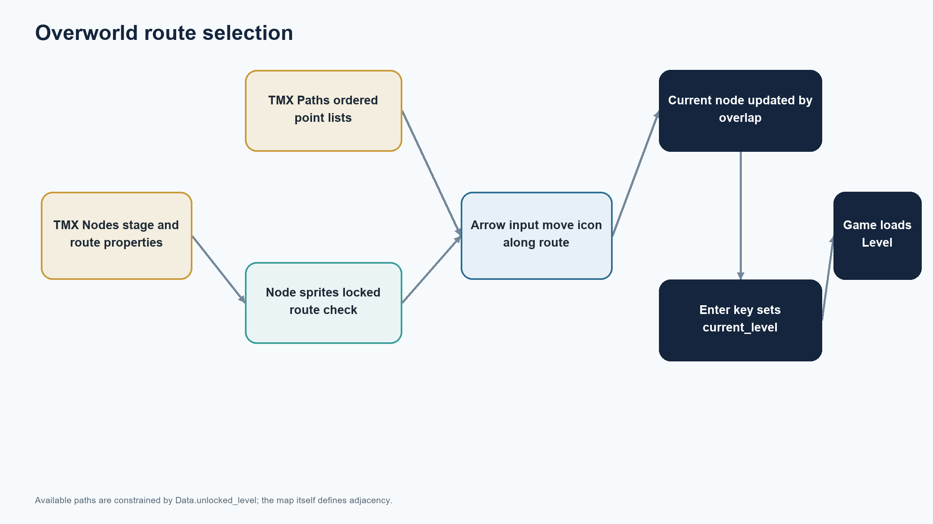
Figure 0 Use cases and player journey

Acceptance criteria
A release candidate is acceptable when a clean launch succeeds; keyboard controls work in both overworld and stage; the stage exit updates progression; ordinary fall recovery keeps the stage identity; zero health displays a stable retry menu; retry reconstructs the same stage; and quit input closes the application cleanly.
Content acceptance also requires all referenced maps and assets to load, no missing-file exceptions during representative play, and no severe gameplay stall during a short session. Evidence should include environment versions, a check log, and a manual play checklist.
IMPLEMENTATION REFERENCE Content acceptance also requires all referenced maps and assets to load, no missing-file exceptions during representative play, and no severe gameplay stall during a short session. Evidence should include environment versions, a check

System overview
The Game object coordinates the active stage, shared Data object, interface, and main loop. A Level builds the active stage from TMX data and sprite groups. The Overworld presents nodes and routes. Player, enemies, items, and UI update or read shared session state.
The game is modular at the source-file level but remains a single process and shared-memory application. There is no separate persistence or service layer. This keeps the runtime simple while making ownership of state and scene transitions important to verify.
Figure 0 System overview

Game flow and scene transitions
At startup the game creates the display, loads assets and map content, initializes session data, and starts in the first stage/overworld flow defined by the Game setup. During play, the current stage updates and draws each frame. A flag or exit returns control to the overworld and records unlocked progress.
A fall requests a respawn transition that rebuilds the current Level. If health reaches zero, the gameplay stage is frozen behind the game-over interface until retry or quit. Keeping transitions explicit avoids mixing scene construction with individual sprite behavior.
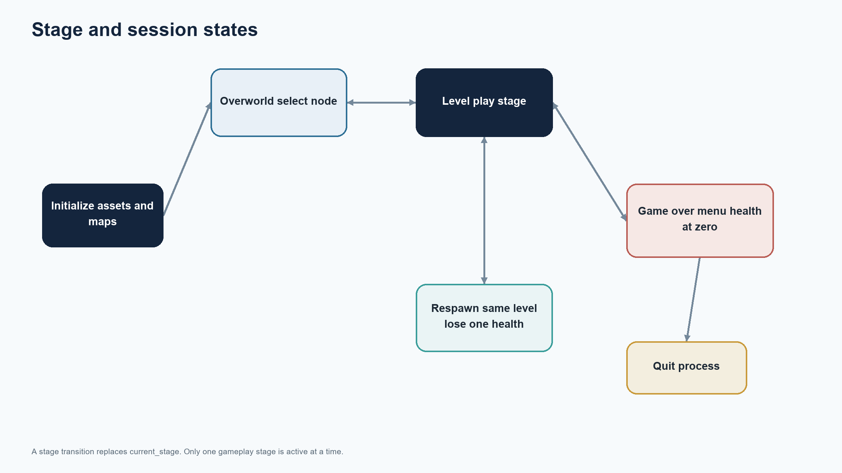
Figure 0 Game flow and scene transitions

Player interaction design
The player uses keyboard input for horizontal movement, jumping, dropping through suitable platforms, and an action/attack key. Motion applies horizontal speed and gravity using frame time. Animation states communicate movement and damage, while temporary invulnerability reduces repeated damage from a single contact.
For a release, controls should be displayed in a start/help screen or README, and remapping should be considered if accessibility is a goal. Current default keys are documented in the technical reference and should be confirmed against the source when control changes are made.
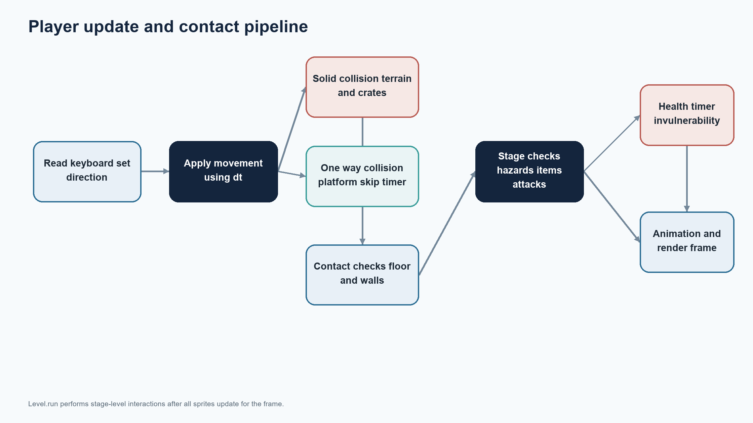
Figure 0 Player interaction design

Stage and content design
Stages use TMX layers for background, terrain, foreground, platforms, scenery, moving objects, enemies, items, and water. Object properties identify player starts, exits, hazards, and other entities. The level loader translates those conventions into runtime sprite groups.
This separation lets a content contributor tune layouts without changing core code, but it creates a schema contract: renaming a layer or property can break loading or behavior. Map edits should be validated against the authoring guide and loaded in a smoke test.
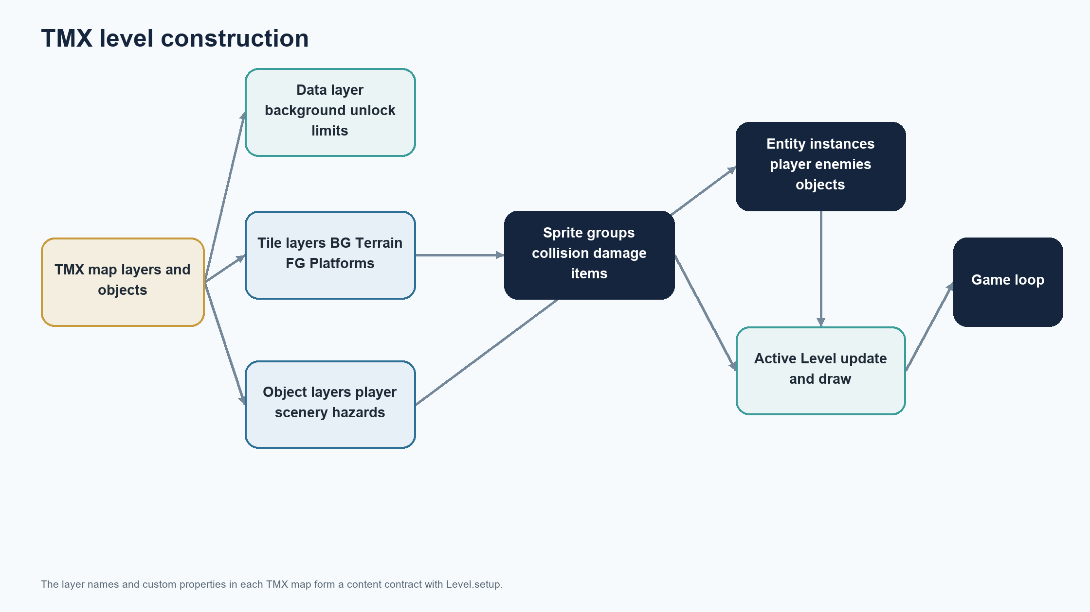
Figure 0 Stage and content design

Overworld and progression design
The overworld uses TMX-defined nodes and paths to represent stage selection. A moving icon follows available routes, and locked routes are constrained by unlocked progress. Enter on the selected node requests the corresponding stage.
Progress is in-memory for the current run. The retry flow preserves the selected/current stage and unlocked stage in a newly initialized session, while ordinary collected currency is reset with the new Data instance. The intended reset policy should be stated in player-facing messaging.
Figure 0 Overworld and progression design

Health, death, and retry design
Health begins at five in the current Data implementation. Damage can occur through stage interactions; falling below the map requests a same-stage respawn while subtracting one health. When health is depleted, the stage stops and a game-over menu accepts Enter or R to retry, or Escape to quit.
Retry creates a fresh UI and Data instance, restores current and unlocked stage identifiers, and reconstructs that stage. This makes the stage repeatable but resets transient health and currency. The policy should be revisited if checkpoints or persistent collectibles are later introduced.
Figure 0 Health, death, and retry design

Enemy and item design
The current enemy set includes a patrolling Tooth, a Shell that can fire Pearls, and Pearl projectiles with limited lifetime. Items award different currency amounts or restore health. The behavior is implemented through entity classes and stage-level sprite groups.
Balancing is best treated as a content iteration: adjust one parameter at a time, record the player outcome, and test the same encounter after changes. Future work may add enemy telemetry or designer-facing configuration, but neither is required for the current small project.
IMPLEMENTATION REFERENCE Balancing is best treated as a content iteration: adjust one parameter at a time, record the player outcome, and test the same encounter after changes. Future work may add enemy telemetry or designer-facing configuration, but neither i

Interface, audio, and feedback
The interface includes animated heart indicators and temporary coin feedback. Background music is loaded for the game session. Health loss, item pickup, stage change, and game over are high-value events that should have distinct visual or audio cues.
The retry overlay is important because it communicates both the failure state and the next action. Future usability review should test text contrast, readable sizing at the target resolution, audio volume, and whether the game remains understandable when sound is muted.
IMPLEMENTATION REFERENCE The retry overlay is important because it communicates both the failure state and the next action. Future usability review should test text contrast, readable sizing at the target resolution, audio volume, and whether the game remains

Implementation structure
The code is organized around modules for the game controller, level, overworld, player, enemies, data, UI, sprites/groups, support utilities, timers, and settings. The entry point creates the Game and starts the loop. Content files live under data, including TMX maps and art/audio assets.
This organization provides clear functional areas but still has shared state and cross-module coupling. When extending it, prefer small interfaces and centralized transition rules. Avoid duplicating stage-reset logic across enemy, player, and UI classes.
Figure 0 Implementation structure

Technology stack and compatibility
The declared dependencies are Pygame 2.6.1-compatible releases and PyTMX 3.32-compatible releases. The workspace check used Python 3.13.3 and Pygame 2.6.1. Settings include a fallback around floating-point rectangle support, and asset paths are resolved relative to project files.
A release should pin or constrain versions in a lock or requirements file, identify tested operating systems, and verify a clean installation. Compatibility claims should be updated only after actual checks on each listed Python/Pygame combination.
IMPLEMENTATION REFERENCE A release should pin or constrain versions in a lock or requirements file, identify tested operating systems, and verify a clean installation. Compatibility claims should be updated only after actual checks on each listed Python/Pygame

Data management and persistence
Session state consists of health, coins, current level, and unlocked level. Item collection and damage update in-memory values; UI reflects the data. The game does not currently write save files, user profiles, or settings to disk.
This is a reasonable scope choice for a short session-based game. If persistence is added, define a versioned save format, safe write strategy, reset behavior, and recovery from corrupt data before implementation. Do not treat an in-memory retry as a durable save.
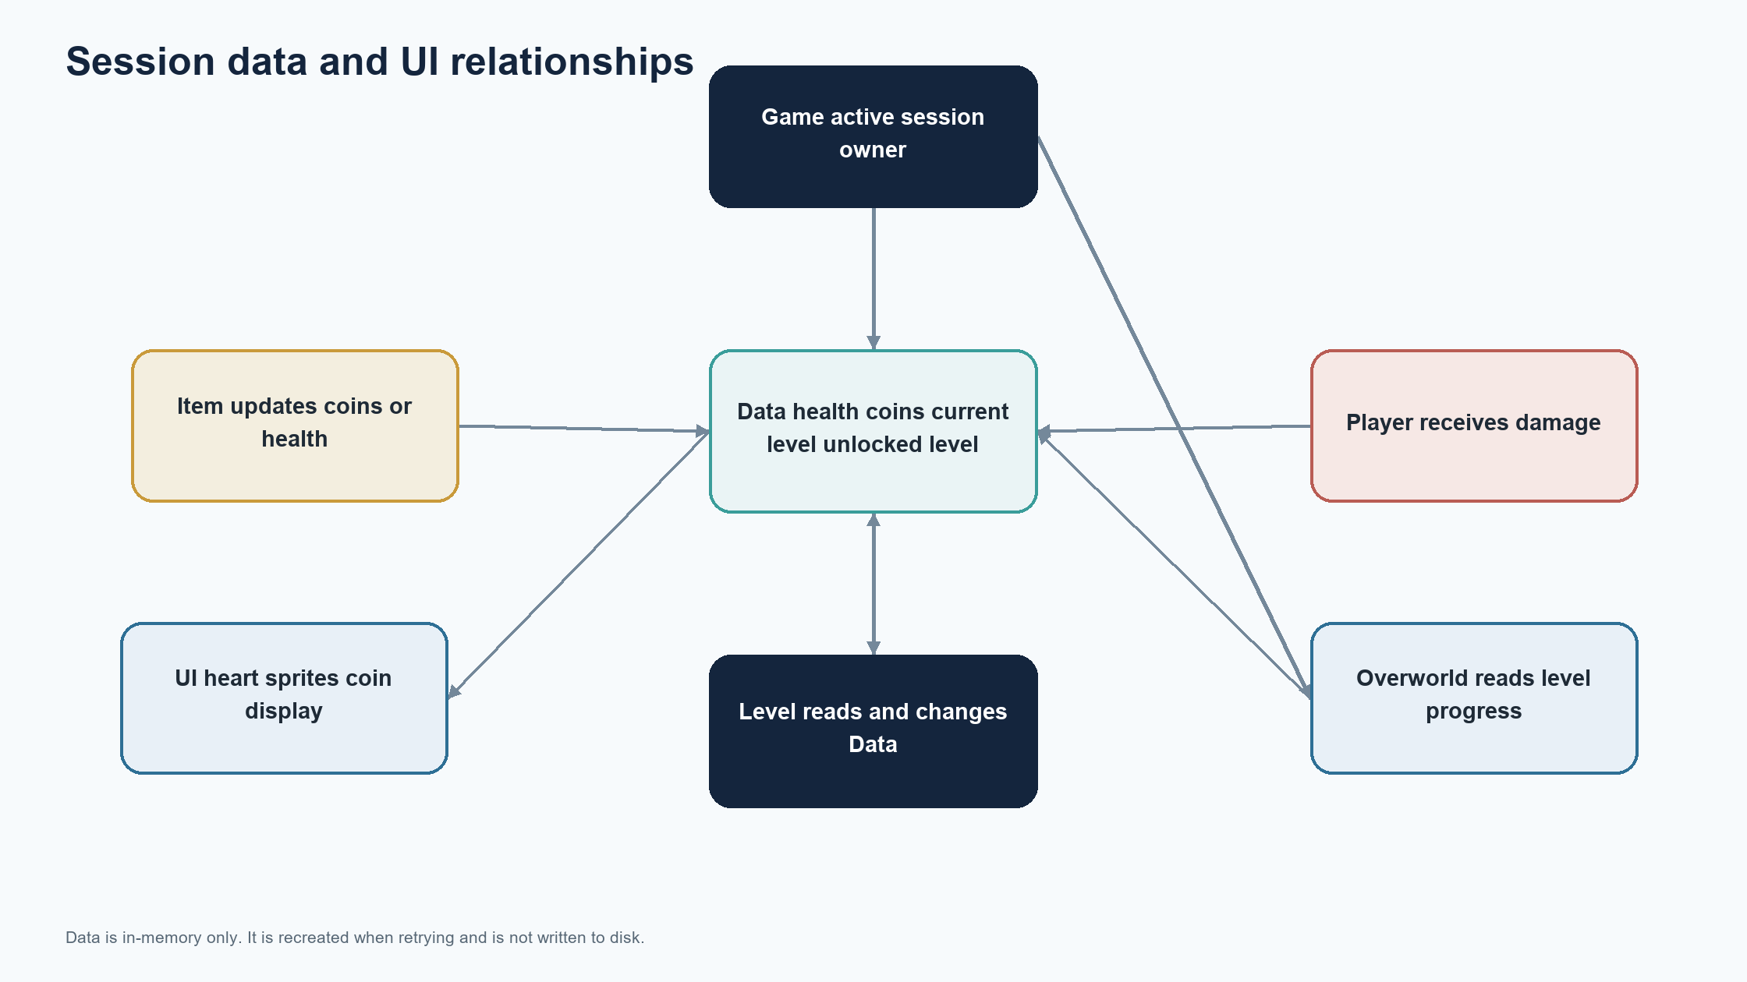
Figure 0 Data management and persistence

Security, privacy, and licensing
The runtime has no network or account feature in the inspected project, so it does not transmit player data. Distribution should preserve the upstream open-source license and attribution requirements, and any added assets should carry compatible licenses.
A release review should inspect dependency provenance, bundled asset licenses, and any executable packaging configuration. This report does not make a legal determination about licensing; the maintainer should verify obligations against the project's actual license and included content.
IMPLEMENTATION REFERENCE A release review should inspect dependency provenance, bundled asset licenses, and any executable packaging configuration. This report does not make a legal determination about licensing; the maintainer should verify obligations agains

Risk register
Key risks include dependency drift, missing or mislocated assets, TMX schema mismatch, regression in stage transitions, confusing retry reset semantics, platform-specific display/audio behavior, and insufficient manual coverage of all stages. The impact is highest when a failure prevents launch or loses session progress unexpectedly.
Mitigations include version constraints, clean-environment startup checks, map validation, focused transition tests, explicit reset messaging, and a release checklist. Risks should be reviewed after any change to core state, content structure, or packaging.
IMPLEMENTATION REFERENCE Mitigations include version constraints, clean-environment startup checks, map validation, focused transition tests, explicit reset messaging, and a release checklist. Risks should be reviewed after any change to core state, content st

Quality strategy
Quality assurance should combine static checks, focused automated tests where practical, and manual gameplay checks. Static compilation can catch syntax issues; launch smoke tests can catch import and asset-path failures; gameplay checks are needed for movement feel, collision, and visual feedback.
The highest-value regression cases follow the player’s state path: start, select stage, fall once, lose final health, retry, complete a stage, and quit. Checks should be repeatable and record the runtime versions used.
Figure 0 Quality strategy

Verification performed and evidence limits
Workspace verification previously recorded for this project includes Python compilation, startup with dummy display/audio, a one-frame load of the overworld and six numbered stages, same-stage respawn, and game-over overlay/retry reset checks. These checks support basic integration confidence for the observed snapshot.
They do not prove absence of all bugs, full playability of every stage, compatibility across every operating system, or performance on user hardware. A full manual regression and clean installation test remain appropriate before release.
IMPLEMENTATION REFERENCE They do not prove absence of all bugs, full playability of every stage, compatibility across every operating system, or performance on user hardware. A full manual regression and clean installation test remain appropriate before releas

Test plan and coverage
The recommended test plan covers startup and shutdown, map loading, control input, solid and one-way collision, health and invulnerability, each item type, enemy movement and projectiles, stage exits, unlock gating, fall respawn, game over, retry, and audio initialization failure handling.
Automated tests should target deterministic logic such as progression rules and item values. Integration tests can load maps with a dummy display. Manual tests remain necessary for animation, camera behavior, level balance, and end-to-end play.
Figure 0 Test plan and coverage

Performance and optimization plan
The game is capped at 60 frames per second and uses Pygame sprite groups and a camera. No benchmark data is claimed here, so optimization should begin with profiling rather than assumptions. Likely review areas include repeated surface loading, unnecessary per-frame allocations, collision-group size, and image conversion/loading strategy.
Preserve gameplay behavior while optimizing. Record frame time and memory before and after changes on representative scenes. Avoid reducing visual quality or changing physics constants solely to improve an unmeasured metric.
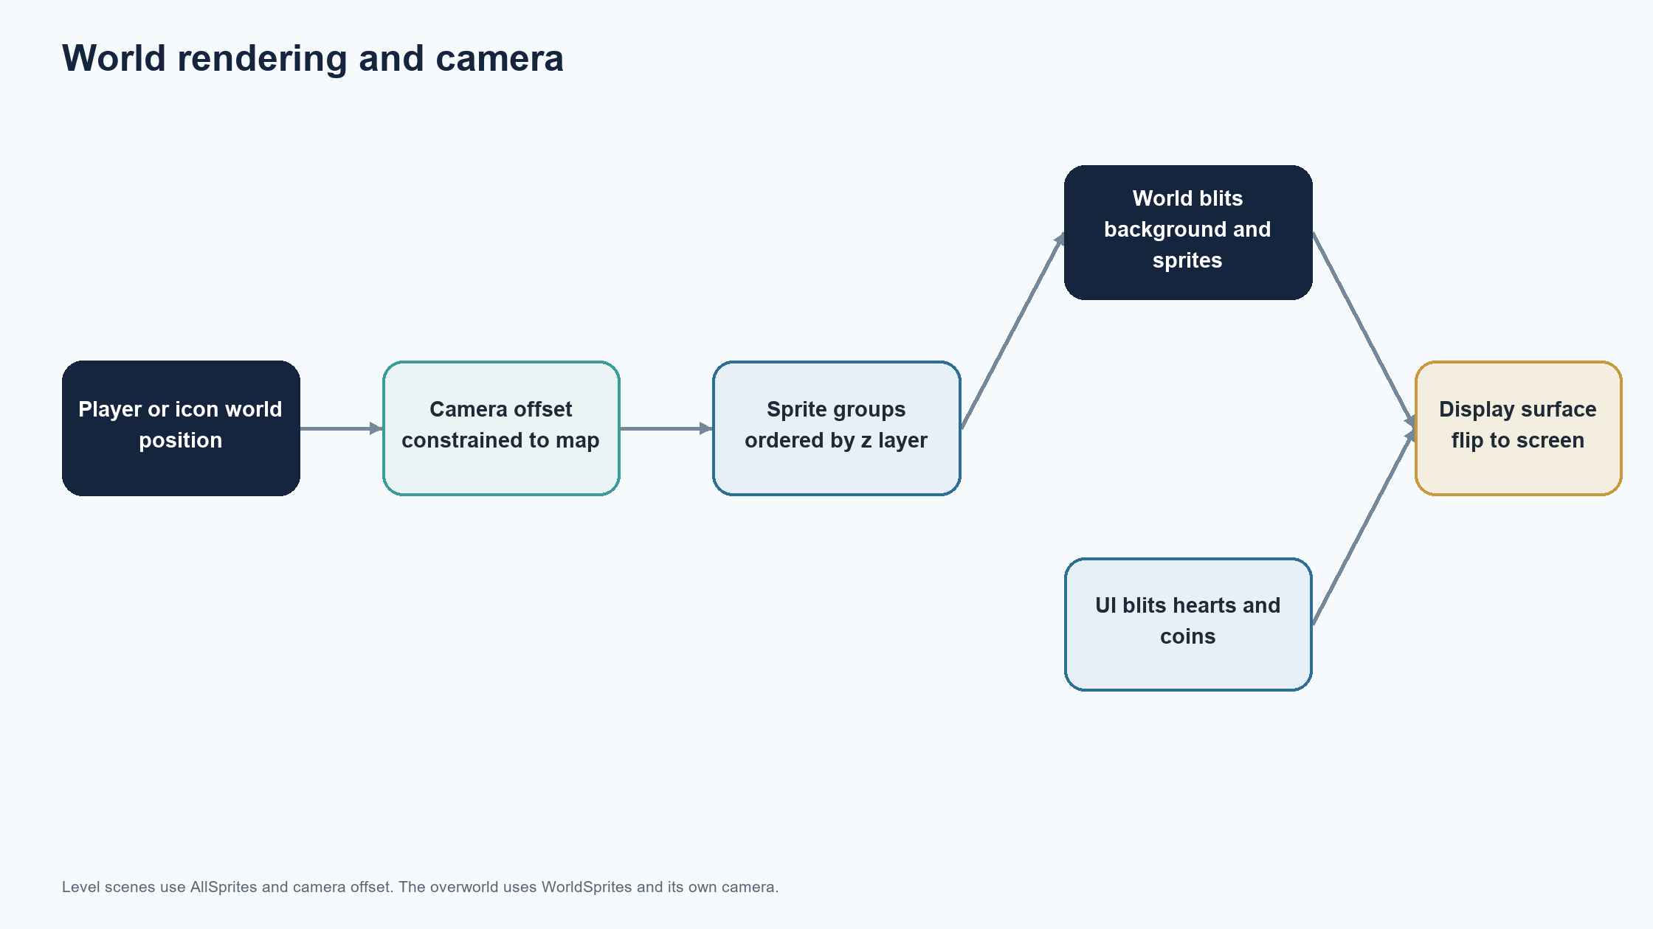
Figure 0 Performance and optimization plan

Deployment and installation
For source execution, create a supported Python environment, install the declared dependencies, and launch the project entry point from the project folder. Keep the data folder and assets in the relative layout expected by the path helper.
For packaged distribution, build on each target platform or use a tested packaging workflow, include map and asset files, and verify the packaged build on a clean machine. Document controls, supported runtime, and troubleshooting steps alongside the release.
IMPLEMENTATION REFERENCE For packaged distribution, build on each target platform or use a tested packaging workflow, include map and asset files, and verify the packaged build on a clean machine. Document controls, supported runtime, and troubleshooting steps

Operations and support
Support for a local game primarily means collecting reproducible bug reports: operating system, Python/Pygame versions, stage, steps to reproduce, expected behavior, actual behavior, and relevant traceback. Visual issues should include a screenshot when possible.
A maintainer should triage reports by severity, reproduce the issue, identify whether it is code or content, and add a regression check for the fix. Release notes should summarize behavior changes and any known limitations.
IMPLEMENTATION REFERENCE A maintainer should triage reports by severity, reproduce the issue, identify whether it is code or content, and add a regression check for the fix. Release notes should summarize behavior changes and any known limitations.

Change management and contribution workflow
A lightweight contribution workflow is sufficient: create a focused branch, explain the player-visible problem, make a minimal change, run relevant checks, inspect the diff, and submit a reviewable change. Content edits should identify affected TMX maps and use screenshots or a short test note.
Changes that alter health, unlock, or retry semantics need explicit acceptance review because those rules affect player expectations. Dependencies and license-sensitive assets need maintainer review before inclusion.
IMPLEMENTATION REFERENCE Changes that alter health, unlock, or retry semantics need explicit acceptance review because those rules affect player expectations. Dependencies and license-sensitive assets need maintainer review before inclusion.

Maintenance plan
Routine maintenance should review Python and library support, dependency vulnerabilities or deprecations, asset and map integrity, and issue reports. Update the documented environment only after validation, and preserve a known-good release configuration.
A small regression checklist is more valuable than a large unmaintained test suite. Keep the project’s setup instructions, control mapping, and retry policy synchronized with code changes.
IMPLEMENTATION REFERENCE A small regression checklist is more valuable than a large unmaintained test suite. Keep the project’s setup instructions, control mapping, and retry policy synchronized with code changes.

Accessibility and usability opportunities
Potential improvements include a controls screen, adjustable sound levels, larger interface text, color-independent damage feedback, pause support, remappable keys, and options for reduced flashing or screen shake if such effects are added. These are recommendations, not current features.
Prioritize improvements by player impact and implementation cost. At minimum, confirm that critical status is communicated by more than color alone and that retry/quit instructions remain readable at the game’s target display size.
IMPLEMENTATION REFERENCE Prioritize improvements by player impact and implementation cost. At minimum, confirm that critical status is communicated by more than color alone and that retry/quit instructions remain readable at the game’s target display size.

Limitations and technical debt
Current limitations include no persistent save system, limited automated gameplay coverage, dependence on TMX layer/property conventions, and no measured performance baseline. Retry resets transient session data while preserving stage progression identifiers, which may need clearer player-facing explanation.
This report cannot confirm every upstream asset license or platform behavior. It also does not claim a formal security audit, full accessibility compliance, or exhaustive bug elimination. These limits should inform release messaging and future work.
IMPLEMENTATION REFERENCE This report cannot confirm every upstream asset license or platform behavior. It also does not claim a formal security audit, full accessibility compliance, or exhaustive bug elimination. These limits should inform release messaging an

Roadmap and future enhancements
A sensible next sequence is: strengthen clean-install documentation and smoke tests; add deterministic tests for progression and retry rules; perform a complete manual stage regression; improve onboarding and settings; then consider persistence, checkpoints, or content expansion based on player feedback.
Roadmap items are proposals. The maintainer should select a small release goal, estimate it from available contributor capacity, and defer features that do not support that goal.
IMPLEMENTATION REFERENCE Roadmap items are proposals. The maintainer should select a small release goal, estimate it from available contributor capacity, and defer features that do not support that goal.

Requirements traceability
Core requirements map to code and evidence: launch maps to Game startup and smoke testing; stage content maps to Level and TMX loading; progression maps to Data and overworld; same-stage recovery maps to fall handling and respawn; zero-health behavior maps to game-over state; and retry maps to session reconstruction.
A release checklist should carry each requirement through implementation, verification, and documentation. If code changes move a responsibility, update the trace links rather than assuming old evidence still applies.
Figure 0 Requirements traceability

Project glossary
Stage or level: a playable TMX map. Overworld: the route-selection scene. Current level: the stage selected for the active session. Unlocked level: the progression boundary used to gate routes. Respawn: reconstruct the same stage after a fall while health remains. Retry: start the current stage again from the game-over menu.
TMX: the Tiled map format consumed by PyTMX. Sprite group: a Pygame collection used to update, draw, or query entities. Game loop: the repeated event, update, and render cycle. These terms are used consistently throughout this report.
IMPLEMENTATION REFERENCE TMX: the Tiled map format consumed by PyTMX. Sprite group: a Pygame collection used to update, draw, or query entities. Game loop: the repeated event, update, and render cycle. These terms are used consistently throughout this report.

Release readiness checklist
Before publishing, verify the license and asset attribution; confirm dependency declarations; install from a clean environment; launch from the documented directory; load all maps; exercise stage selection, exits, fall recovery, zero-health retry, and quit; inspect audio and display; and record the tested runtime/platform.
Update the changelog and user instructions, ensure the packaged build contains data files, and label known limitations. A release should be approved by the maintainer after reviewing evidence, not solely because the application starts once.
IMPLEMENTATION REFERENCE Update the changelog and user instructions, ensure the packaged build contains data files, and label known limitations. A release should be approved by the maintainer after reviewing evidence, not solely because the application starts

Conclusion and project handoff
Tidebound has a workable foundation for a local Pygame platform game: modular gameplay code, TMX-driven stages, an overworld, health and currency, enemies and items, and an explicit same-stage failure recovery path. The project can be maintained incrementally with clear requirements and focused verification.
The next handoff should preserve this document with the source, keep the setup and retry behavior documented, and prioritize repeatable regression checks and a clean release procedure. The report distinguishes current implementation from proposed work so future contributors can make informed decisions.
IMPLEMENTATION REFERENCE The next handoff should preserve this document with the source, keep the setup and retry behavior documented, and prioritize repeatable regression checks and a clean release procedure. The report distinguishes current implementation fr

How to use this document
This technical reference describes the completed Tidebound game and its runtime design. The diagrams use the same module names as the source code. Current behavior is described as implemented; improvement ideas are identified as recommendations.
System design
Executive summary • Purpose scope and evidence • Product profile and boundaries • System context • Runtime component architecture • Frame lifecycle • Stage state model
Gameplay systems
Controls and player interaction • Session data model • TMX level construction • Player movement model • Collision and contact pipeline • Enemy behavior • Projectile and attack behavior • Items health and coins • Overworld route selection
Runtime engineering
Rendering camera and depth • Animation sprite and effects • Audio and timers • Interface and game-over menu • Death respawn and retry sequence • Asset loading and path resolution • Python Pygame and PyTMX compatibility • Tuning parameters and configuration
Operations and reference
Project files and module inventory • Core class contracts • Startup and run operations • Diagnostics and contributor workflow • Verification matrix • Performance profile • Reliability and failure handling • Privacy and security posture • Accessibility and usability review • Packaging and release procedure • TMX authoring guide • Technical debt and constraints • Extension roadmap • Requirements traceability • Glossary and map inventory • Reference tables and final checklist

Executive summary
Tidebound is a single-player, side-scrolling platform game written in Python with Pygame. The completed implementation combines a tile-based stage, a node-and-path overworld, animated entities, hazards, collectibles, health, audio, and a small heads-up display. TMX files provide level geometry and object placement; Python classes turn those authored records into live sprites and collision groups.
The central Game object owns the display, clock, loaded assets, session Data, maps, and the active stage. A frame updates the selected stage, updates the UI, checks health, and presents the display. Level and Overworld implement different interaction and rendering rules while sharing the same session data.
This document describes the implementation present in the Tidebound workspace. It distinguishes observed behavior from suggested improvements. The current runtime uses a 1280 by 720 display, a 60 FPS frame cap, Python 3.10 or later syntax, Pygame, and PyTMX. The project is an offline local game with no network service or persistent save file.
IMPLEMENTATION REFERENCE This document describes the implementation present in the Tidebound workspace. It distinguishes observed behavior from suggested improvements. The current runtime uses a 1280 by 720 display, a 60 FPS frame cap, Python 3.10 or later syn

Purpose scope and evidence
The document is for maintainers and contributors who need to run, explain, maintain, or extend the game. It explains the project file structure, runtime architecture, map contract, data flow, gameplay systems, failure behavior, diagrams, and verification approach. It is not a player walkthrough or a claim that every gameplay path has been tested on every operating system.
The source of truth is the checked-out `code_complete` implementation and its TMX map files. `code_start` is a tutorial scaffold with a smaller API and should not be treated as the runnable game. The dependency file declares Pygame and PyTMX. The graphics, audio, and map folders are runtime inputs.
Implementation facts in this document follow the inspected source. The verification checklist is a proposed repeatable release practice unless it explicitly reports a performed check. Runtime behavior can still vary with display drivers, audio devices, and user-created map data.
IMPLEMENTATION REFERENCE Implementation facts in this document follow the inspected source. The verification checklist is a proposed repeatable release practice unless it explicitly reports a performed check. Runtime behavior can still vary with display driver

Product profile and boundaries
The player begins at level zero. The overworld represents stages as nodes connected by route objects. Direction keys move the icon where a route is available and unlocked; Enter selects the current node and loads its level. In a level, the player moves, jumps, attacks, collects items, avoids hazards, and reaches a flag to return to the overworld.
The implemented loop is local and single-user. Session values live only in memory. A restart from the game-over overlay rebuilds the current stage, restores health to five, resets coins, and preserves the current level and highest unlocked level. Falling below a stage costs one health and reconstructs the same level. Reaching zero health pauses gameplay at the overlay.
the current build does not implement online play, cloud saves, accounts, a settings menu, a level editor, or automatic package building. PyTMX loads the authored maps; Pygame handles input, timing, drawing, sprites, and sound. These boundaries inform the architectural diagrams and the proposed extension points later in the document.
IMPLEMENTATION REFERENCE the current build does not implement online play, cloud saves, accounts, a settings menu, a level editor, or automatic package building. PyTMX loads the authored maps; Pygame handles input, timing, drawing, sprites, and sound. These bound

System context
The player interacts through keyboard input and observes the game through a Pygame display. The Game loop receives input and elapsed time, delegates to one active stage, and draws the result. Stage data and visual assets are local files. PyTMX turns the TMX document into layers and objects that Level and Overworld consume.
The Pygame mixer loads sound effects and background music. There is no request to a remote service during normal play. The Python process owns all mutable session state, including health, coins, current level, and unlocked level. Closing the window terminates the process rather than saving a session.
This context boundary is useful when debugging: a missing asset is a local path or packaging issue; a malformed object is a content contract issue; and an input or display issue is usually inside the Pygame runtime or its driver.
Figure 0 System context

Runtime component architecture
Game is the composition root. It initializes Pygame, creates the display and clock, imports assets, loads six numbered TMX stages and the overworld map, creates UI and Data, and chooses the initial Level. It also owns the stage-switch callback and the game-over menu.
Level assembles scenery, terrain, player, moving objects, enemies, water, and collectible items from one map. It keeps groups for solid collision, one-way platforms, damage, enemies, projectiles, and items. Overworld builds nodes and route sprites and moves an icon between selectable stages. These stage classes are alternatives held by `Game.current_stage`.
Player and enemy classes encapsulate movement or behavior. Sprite subclasses carry images, rectangles, z-order values, and update routines. AllSprites and WorldSprites specialize camera and draw ordering. UI reads session values through Data and maintains animated hearts and temporary coin display.
Figure 0 Runtime component architecture

Frame lifecycle
At the top of each iteration, Game asks the Pygame clock for elapsed milliseconds and caps the loop at 60 frames per second. It converts the tick duration to seconds and passes `dt` to the stage and UI. This makes movement and animation rates independent of the nominal frame rate, subject to the chosen collision and rectangle precision.
Window-close events quit the process. While the game-over flag is active, gameplay updates stop; Enter or R rebuilds the current level and Escape quits. During play, the stage updates its sprite group, resolves collisions and constraints, and draws the world. The UI then draws health and coin indicators. If health is zero, Game draws the overlay before flipping the completed frame to the display.
The loop is intentionally synchronous. Asset loading, TMX parsing, simulation, rendering, and input all execute on the main thread. That is appropriate for this project size and avoids coordination between worker threads and Pygame surfaces.
Figure 0 Frame lifecycle

Stage state model
The runtime has three visible gameplay conditions: overworld, level, and game over. Startup constructs Level zero directly. Entering a node switches to a Level. Touching a level flag returns to the overworld and may increase `unlocked_level`. Falling below the bottom boundary reloads the same level and decreases health. Zero health changes the presentation to the game-over overlay.
There is no separate title screen or pause state. The game-over overlay is a state of Game rather than a stage class. It freezes the active stage by skipping updates, while preserving the last rendered scene behind a dark translucent surface. The retry action retains the selected level and progression but creates new Data and UI instances.
The switch callback uses a target string and, for successful exits, an unlock value. This is simple for the current set of transitions. If more stages or outcomes are added, a small enum or explicit transition object would reduce the risk of misspelled target names.
Figure 0 Stage state model

Controls and player interaction
In a level, Left and Right set horizontal movement. Space requests a jump. Down activates the one-way platform skip timer. X requests an attack when the attack cooldown is inactive. Holding Space can repeatedly request jumps when the player is grounded because the implementation reads the current key state each frame rather than only key-down events.
In the overworld, arrow keys request movement along the selected node’s available route. The icon follows the map-authored path points. Enter writes the selected node’s stage number to `Data.current_level` and invokes the stage switch. The current node is updated by sprite overlap after the icon moves.
The game-over overlay accepts Enter or R to retry the same stage and Escape to quit. Window close also quits. Keyboard input is polled through `pygame.key.get_pressed()` for movement; discrete window and retry actions use the event queue.
IMPLEMENTATION REFERENCE The game-over overlay accepts Enter or R to retry the same stage and Escape to quit. Window close also quits. Keyboard input is polled through `pygame.key.get_pressed()` for movement; discrete window and retry actions use the event que

Session data model
Data owns four session values: `_health`, `_coins`, `current_level`, and `unlocked_level`. Health starts at five, coins at zero, and both level values at zero. The fields have no disk serialization, so a new process begins a new run.
The coin property setter stores the requested amount, exchanges each full hundred coins for one health point, and asks UI to show the remaining coin count. The health setter updates the value and recreates the heart sprites. Item objects update coins for gold, silver, diamond, or skull pickups, and increase health for a potion.
Game creates Data and passes the same object into the active stage and UI path. This shared reference keeps effects visible without a separate database or event bus. The tradeoff is tighter coupling: item and player logic can mutate session state directly. A future event model could make such changes easier to audit, but is not required for the current offline game.
Figure 0 Session data model

TMX level construction
Each stage map is parsed by `pytmx.util_pygame.load_pygame`. Level reads its dimensions and the custom properties in the Data layer, including background selection, level unlock value, top limit, and horizon line. It creates the camera-aware AllSprites group from that metadata before building the level entities.
Tile layers named BG, Terrain, FG, and Platforms are iterated as `(x, y, surface)` tiles. Terrain tiles join the solid collision group, while Platforms tiles join the one-way platform group. Background and foreground tiles receive z values according to the current implementation’s layer mapping.
Object layers then create background details, player and scenery, moving hazards and platforms, enemies, items, and water. Custom object properties configure values such as speed, direction, platform behavior, spike radius, and level unlock. A renamed layer or property can therefore cause a runtime failure; map edits must preserve the expected names and types.
Figure 0 TMX level construction

Player movement model
Player stores a visual rectangle and a smaller hitbox rectangle. The hitbox is derived by shrinking the image rectangle by 76 pixels horizontally and 36 vertically. Movement uses a direction vector, a horizontal speed of 200 units per second, gravity of 1300 units per second squared, and a jump impulse of 900 units per second upward.
Each update snapshots the old hitbox, advances timers, reads input, applies horizontal movement, applies vertical movement and gravity, resolves solid and one-way collisions, carries the player with a moving platform when applicable, checks nearby floor and wall contacts, chooses an animation state, and applies flicker after damage.
Wall sliding reduces vertical acceleration while the player touches a wall and the wall-slide block timer is inactive. Wall jumps set a horizontal impulse away from the contacted side. All movement uses elapsed time, while collision resolution compares old and current rectangles to infer which face crossed a surface.
IMPLEMENTATION REFERENCE Wall sliding reduces vertical acceleration while the player touches a wall and the wall-slide block timer is inactive. Wall jumps set a horizontal impulse away from the contacted side. All movement uses elapsed time, while collision re

Collision and contact pipeline
Solid collision iterates the collision sprite group and checks rectangle overlap. Horizontal resolution compares the old hitbox with each solid sprite’s old rectangle to determine whether the player crossed a left or right boundary. Vertical resolution applies the same crossing approach to ceilings and floors and zeroes the vertical velocity after contact.
One-way platform collision is a separate pass. It only blocks downward crossings from above and is disabled while the platform-skip timer is active. A short floor probe and side probes establish floor, left-wall, and right-wall contact for animation and wall movement decisions. Moving platforms are detected near the floor probe and carry the player by their own direction and speed.
After sprite updates, Level checks projectile contacts with solid objects, hazard overlaps with the player hitbox, collectible overlaps with the player, and player attacks against Tooth and Pearl targets. The current loops are straightforward group scans. For larger maps, spatial hashing or pygame sprite collision helpers could reduce work, but should be measured before adding complexity.
Figure 0 Collision and contact pipeline

Enemy behavior
Tooth is a ground patrol enemy. It chooses an initial direction, advances horizontally at 200 units per second, animates its run frames, and reverses when a floor probe detects a ledge or a wall probe detects an obstacle. Its hit timer limits how often an attack can reverse its direction.
Shell is a stationary ranged enemy. It checks player distance, whether the player lies in front of its firing direction, and whether the vertical separation is below 30 units. If all conditions hold and its 3000 millisecond timer is inactive, it plays a fire animation and creates one Pearl at animation frame three.
Enemies are created from the Enemies TMX layer. Tooth uses solid collision rectangles copied at construction. Shell receives a reference to the player and a callback for projectile creation. The current behavior is deterministic apart from Tooth’s initial direction and animation details; there is no pathfinding or enemy difficulty scaling.
IMPLEMENTATION REFERENCE Enemies are created from the Enemies TMX layer. Tooth uses solid collision rectangles copied at construction. Shell receives a reference to the player and a callback for projectile creation. The current behavior is deterministic apart

Projectile and attack behavior
Pearl is a moving projectile created by Shell. It begins offset from the shell by 50 pixels in its travel direction, moves at 150 units per second, and activates a five-second lifetime timer. A short reverse timer prevents repeated attack reversals in quick succession.
The player’s attack state is driven by the X key, an attack cooldown timer, and animation frames. The Level attack pass checks whether the player is attacking, overlaps a Tooth or Pearl, and is facing toward that target. A valid contact calls the target’s reverse method rather than removing it.
A projectile that hits a solid collision sprite is removed and creates a particle effect. A projectile that overlaps the player reduces health through the Player damage timer, is killed, and creates a particle. Hazard and projectile contact share the player’s damage cooldown, so multiple simultaneous overlaps do not repeatedly decrement health during the same brief invulnerability interval.
IMPLEMENTATION REFERENCE A projectile that hits a solid collision sprite is removed and creates a particle effect. A projectile that overlaps the player reduces health through the Player damage timer, is killed, and creates a particle. Hazard and projectile co

Items health and coins
Item sprites are animated and centered at their map object positions. Gold adds five coins, silver adds one, diamond adds twenty, and skull adds fifty. A potion adds one health. Collection removes the first overlapping item, activates its effect, creates a particle animation, and plays the coin sound.
Every full hundred coins converts into one health point. The setter subtracts one hundred and increments health once per assignment. As implemented, a single item cannot exceed 100 coins, so this conversion is adequate for current pickups. If larger rewards are introduced, the conversion should use a loop or quotient arithmetic so multiple lives are awarded correctly.
Health is represented as an integer and displayed through a row of animated heart sprites. Health can decrease from hazards, enemy projectiles, and falling below the map. A fall triggers a same-level reconstruction and costs one health; zero health activates the game-over presentation.
IMPLEMENTATION REFERENCE Health is represented as an integer and displayed through a row of animated heart sprites. Health can decrease from hazards, enemy projectiles, and falling below the map. A fall triggers a same-level reconstruction and costs one health

Overworld route selection
Overworld parses its tile layers, animated water, decorative objects, Paths, and Nodes. Each path object supplies start and end stage identifiers and a point list. Each node object supplies a stage number and directional properties that reference route identifiers, with an optional reverse marker.
Node.can_move allows a direction only when the node declares that route and the destination stage number does not exceed `Data.unlocked_level`. The icon follows the route’s ordered points at 400 units per second. On arrival, sprite collision updates the current node; Enter then loads that node’s stage.
PathSprites are synthesized from route points and node grid positions. The algorithm identifies vertical, horizontal, and corner tiles to select the matching path graphic. Route direction and map topology are thus content data rather than hard-coded navigation. When editing the overworld, node stage IDs, path IDs, and route endpoint properties must remain consistent.
Figure 0 Overworld route selection

Rendering camera and depth
Level rendering uses AllSprites. The group stores world dimensions, camera borders, optional tiled background, cloud data, and horizon information. On draw, it centers the camera around the target and clamps the offset to the map limits. Sky scenes draw a background fill, sea, horizon line, large cloud strip, and sprites.
Sprites carry a `z` value. AllSprites sorts them by z before blitting, allowing background tiles, clouds, scenery, main entities, water, and foreground effects to appear in a stable order. The overworld uses WorldSprites, centers its camera around the icon, draws background layers first, and sorts main sprites by vertical position.
The display surface is cleared or painted by the stage, then the UI draws hearts and coin text over the world. The main loop flips the display once per frame. This arrangement makes camera behavior a responsibility of the sprite groups rather than each entity.
Figure 0 Rendering camera and depth

Animation sprite and effects
AnimatedSprite stores an ordered frame list and a floating frame index. Each update advances the index by animation speed multiplied by elapsed seconds, then selects a frame modulo the frame count. This supports looping effects such as water, candles, palms, and player movement.
ParticleEffectSprite uses the same frame progression but kills itself after the last frame. Heart animations are triggered randomly and return to an inactive state when their finite sequence completes. Player animation state is selected from idle, run, jump, fall, wall, attack, and air-attack states, with horizontal flipping when facing left.
The asset importer sorts frame filenames numerically for folder-based animations and builds dictionaries from filename stems for keyed assets. Animation folder conventions are therefore part of the runtime contract. Missing or empty frame folders fail during entity construction rather than producing a fallback frame.
IMPLEMENTATION REFERENCE The asset importer sorts frame filenames numerically for folder-based animations and builds dictionaries from filename stems for keyed assets. Animation folder conventions are therefore part of the runtime contract. Missing or empty fr

Audio and timers
Game loads coin, attack, jump, damage, and Pearl sound effects into a dictionary. It loads the background music as a Sound object, sets its volume to 0.5, and loops playback continuously. Level adjusts coin and damage volume locally and plays effects at the point where interactions occur.
Timer stores a duration, optional callback, start timestamp, active flag, and repeat behavior. It uses Pygame’s millisecond tick count. Player timers cover wall jump, wall-slide blocking, platform skipping, attack cooldown, and damage invulnerability. Shell uses a firing interval; Pearl uses lifetime and reverse intervals; AllSprites uses a repeating timer to create clouds.
Timers are updated by the owning object. This keeps timing logic near the behavior it controls, but requires every active timer to receive update calls. A future central scheduler is unnecessary unless timer count and cross-system coordination grow substantially.
IMPLEMENTATION REFERENCE Timers are updated by the owning object. This keeps timing logic near the behavior it controls, but requires every active timer to receive update calls. A future central scheduler is unnecessary unless timer count and cross-system coor

Interface and game-over menu
UI draws animated hearts at the upper-left and temporarily displays coin count and a coin icon after a coin change. A one-second timer controls coin visibility. Health changes rebuild the heart sprite group to match the current value. The UI is rendered after the active stage so it remains above world art.
Game checks health after a stage update. At zero or below, it sets `game_over` and draws a full-screen translucent overlay with a centered panel. The stage stops updating while the overlay is active, leaving the last scene visible beneath the menu.
Enter or R retries the current level, restores health to five, resets coins, and preserves the current level and highest unlocked level. Escape or a window-close event quits. There is no mouse selection, options screen, or persisted best score in the current implementation.
IMPLEMENTATION REFERENCE Enter or R retries the current level, restores health to five, resets coins, and preserves the current level and highest unlocked level. Escape or a window-close event quits. There is no mouse selection, options screen, or persisted be

Death respawn and retry sequence
Falling is detected when the player hitbox bottom passes the level’s pixel height. Level calls the `respawn` transition and returns from its constraint check. Game decrements health, reconstructs a Level using the same `Data.current_level`, and places a new Player at the spawn object defined in that TMX map.
The game loop checks health after the stage runs. If the fall used the last health, the same-level reload is created and the game-over overlay is shown before the next update. This preserves the level context during the menu. Hazard damage can also reduce health to zero while the player stays in the current stage; the same game-over behavior follows.
Retry captures the selected level and unlocked progress before creating new UI and Data objects. It then restores those progress values, constructs the same Level, and clears the game-over flag. The session remains in memory only; closing the process discards it.
Figure 0 Death respawn and retry sequence

Asset loading and path resolution
The asset root is derived from the location of `code_complete/settings.py`. `asset_path` joins a sequence of path components to the project root and removes a leading parent marker for older import calls. This lets the game launch from a shell whose current directory is from another folder.
Support helpers load single images, ordered animation folders, keyed image dictionaries, and immediate subfolders. Pygame image conversion uses alpha for sprites and optional opaque conversion for backgrounds. The display must already be initialized before converted surfaces are loaded, which is satisfied because Game calls `pygame.init()` before `import_assets()`.
The code keeps loaded surfaces and audio objects in dictionaries for reuse by stages. Stages create sprites from those shared assets rather than reloading image files for each entity. That reduces repeated disk access and keeps stage construction predictable.
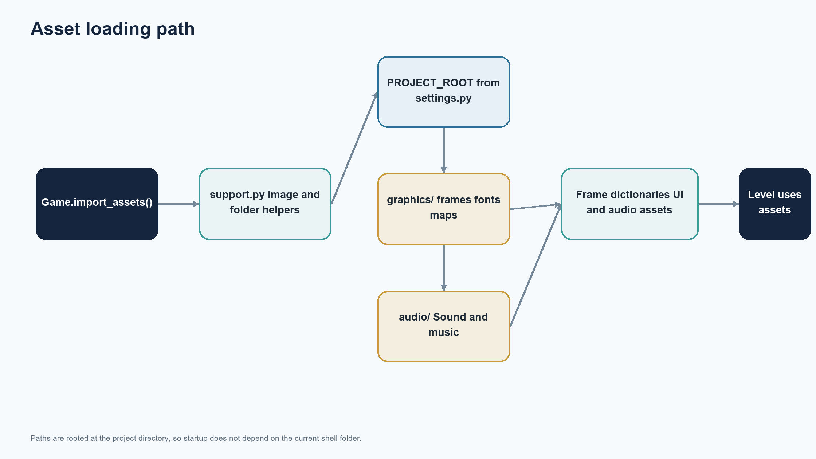
Figure 0 Asset loading and path resolution

Python Pygame and PyTMX compatibility
The implementation uses structural pattern matching in Level.setup, so Python 3.10 or newer is required. The declared dependency bounds request Pygame 2.6.1 or newer while remaining below major version 3, and PyTMX 3.32 or newer below major version 4.
Some Pygame builds expose floating rectangles through `Surface.get_frect` and `pygame.FRect`; others expose only integer Rect APIs. The settings module selects the floating API where available and provides a Rect fallback. Float rectangles preserve subpixel movement more accurately; the fallback prioritizes startup compatibility but quantizes coordinates to integers.
The runtime also relies on mixer support for WAV and MP3 decoding, image conversion after display initialization, Pygame sprite groups, vector arithmetic, and PyTMX’s Pygame loader. A clean install should use a virtual environment and install from requirements.txt so the game dependencies do not conflict with unrelated Python applications.
IMPLEMENTATION REFERENCE The runtime also relies on mixer support for WAV and MP3 decoding, image conversion after display initialization, Pygame sprite groups, vector arithmetic, and PyTMX’s Pygame loader. A clean install should use a virtual environment and

Tuning parameters and configuration
Global presentation parameters live in settings.py: window width and height are 1280 by 720, tile size is 64 pixels, and baseline animation speed is six frames per second multiplier. Z-layer constants define the broad drawing order. Game’s run method caps its clock at 60 frames per second.
Player movement values are local to Player: horizontal speed 200, gravity 1300, jump impulse 900, and a hitbox inset from the sprite image. Enemy and projectile values live in their classes or map properties. TMX values configure patrol speed, platform status, flipping, spike radius and angular bounds, background tile selection, and unlock stage.
Keeping configuration close to behavior makes the tutorial code easy to follow. For a larger project, a validated configuration object could collect tunable values and report missing or invalid map properties at startup. Any configuration refactor should preserve the values currently authored in map objects.
IMPLEMENTATION REFERENCE Keeping configuration close to behavior makes the tutorial code easy to follow. For a larger project, a validated configuration object could collect tunable values and report missing or invalid map properties at startup. Any configurat

Project files and module inventory
`code_complete` contains the playable implementation. `main.py` coordinates startup and the game loop; `level.py` builds and runs a stage; `overworld.py` handles node selection; `player.py` implements the player; `sprites.py` contains common sprite, item, effect, platform, node, icon, and path classes.
`enemies.py` implements Tooth, Shell, and Pearl. `groups.py` contains camera-aware level and overworld groups. `ui.py` contains health and coin display. `data.py` owns session values. `timer.py` provides elapsed-time timers. `settings.py` defines shared constants and asset paths. `support.py` loads art. `debug.py` is a small display helper.
`code_start` is a reduced tutorial starting point and does not implement the complete game systems. `data/levels` and `data/overworld` contain TMX maps; `data/tilesets` contains tileset definitions; `graphics` and `audio` contain runtime assets. requirements.txt declares the Python packages.
IMPLEMENTATION REFERENCE `code_start` is a reduced tutorial starting point and does not implement the complete game systems. `data/levels` and `data/overworld` contain TMX maps; `data/tilesets` contains tileset definitions; `graphics` and `audio` contain runti

Core class contracts
Game constructs Level with a parsed map, level frame dictionary, audio dictionary, Data object, and stage-switch callback. Overworld receives its map, Data, overworld assets, and the same callback. Both stages expose `run(dt)` and own the sprites they create.
Player receives a position, sprite groups, collision groups, player frames, Data, attack sound, and jump sound. Level creates it before enemy objects that need a player reference. Enemy projectiles call Level.create_pearl through a callback, keeping the projectile constructor independent of stage internals.
Sprite constructors generally register themselves into one or more Pygame groups. Group membership drives updates, collision passes, and drawing. Because registration often occurs during construction, constructors require a valid display surface, loaded assets, and initialized groups. These implicit preconditions should be retained or made explicit if classes are reused outside Game.
IMPLEMENTATION REFERENCE Sprite constructors generally register themselves into one or more Pygame groups. Group membership drives updates, collision passes, and drawing. Because registration often occurs during construction, constructors require a valid displ

Startup and run operations
from the project folder, create and activate a virtual environment, install requirements.txt, then run `python code_complete/main.py`. Asset paths resolve from the source file, so launching from another working directory is supported. The game opens a 1280 by 720 window titled Tidebound and starts the background track.
Pygame initialization happens before font, image, and sound loading. The TMX files are then loaded into a dictionary keyed from zero through five, along with the overworld map. Data begins at level zero, and Game constructs that first Level before starting the music and frame loop.
To exit during gameplay, close the window. At game over, press Escape or close the window. To continue after depletion, press Enter or R to retry. For a headless smoke check, use Pygame dummy video and audio drivers and instantiate Game; interactive controls still require a real window.
IMPLEMENTATION REFERENCE To exit during gameplay, close the window. At game over, press Escape or close the window. To continue after depletion, press Enter or R to retry. For a headless smoke check, use Pygame dummy video and audio drivers and instantiate Gam

Diagnostics and contributor workflow
When startup fails, first confirm that dependencies installed in the same interpreter used to launch the game. A `ModuleNotFoundError` points to environment setup. A file-not-found error usually points to an absent asset, incorrect asset name, or incomplete repository checkout. An image conversion failure can indicate initialization order or a damaged image.
When TMX loading succeeds but stage construction fails, inspect the referenced layer and object names in the map, then compare required custom properties with the Level or Overworld constructor. Key lookups such as `get_layer_by_name` and dictionary indexing deliberately fail loudly when content contracts are broken.
For movement bugs, check the player’s hitbox and old rectangle values, the relevant collision group, and `dt`. For progression bugs, inspect node stage IDs, route endpoints, directional route properties, and `Data.unlocked_level`. The debug helper can draw a value to the display but should be removed from production paths if it interferes with layout.
IMPLEMENTATION REFERENCE For movement bugs, check the player’s hitbox and old rectangle values, the relevant collision group, and `dt`. For progression bugs, inspect node stage IDs, route endpoints, directional route properties, and `Data.unlocked_level`. The

Verification matrix
A release check should cover startup from the project folder and an unrelated working directory; loading all six numbered maps and the overworld; one update and draw pass per stage; movement, jumping, wall interaction, and platform dropping; and item, hazard, projectile, and flag interactions.
Progression checks should confirm that locked nodes remain unavailable, successful completion raises the unlock value monotonically, and the selected node loads the matching map. Failure checks should confirm that falling costs one health, rebuilds the same stage at its spawn, and zero health pauses gameplay at the overlay. Retry should preserve current level and unlock progress while restoring health and resetting coins.
The workspace checks performed for this document include Python compilation, Game initialization under dummy video and audio drivers, one frame through each of six maps and the overworld, same-stage respawn, game-over drawing, and retry state reset. These checks do not replace interactive play testing or cover every frame timing and display driver.
IMPLEMENTATION REFERENCE The workspace checks performed for this document include Python compilation, Game initialization under dummy video and audio drivers, one frame through each of six maps and the overworld, same-stage respawn, game-over drawing, and retr

Performance profile
The project is a small 2D game with sprite counts expected to remain modest. Pygame draws surfaces through blits and the game loop has a 60 FPS cap. Images and sounds load once during initialization and are reused. Animation changes a sprite’s surface reference rather than rebuilding assets each frame.
The most visible scaling costs are full sprite-group update and draw passes, repeated sorting for z-order, and player collision checks that iterate groups and rebuild probe rectangle lists. These operations are simple and readable. Optimizing them without an observed frame-time problem would add complexity without a measured benefit.
If levels grow, profile representative scenes first. Likely options include caching stable draw order, culling sprites outside the camera, reusing probe structures, and indexing collision candidates by tile or spatial cell. Any optimization must preserve visual order and moving-platform collision behavior.
IMPLEMENTATION REFERENCE If levels grow, profile representative scenes first. Likely options include caching stable draw order, culling sprites outside the camera, reusing probe structures, and indexing collision candidates by tile or spatial cell. Any optimiz

Reliability and failure handling
The current program relies on Python exceptions for missing required data. This is suitable during development because it identifies the bad lookup. A packaged game could catch startup failures at the top level and show a useful message naming the asset or layer that could not load.
TMX authoring is trusted input. A missing player object can leave `self.player` unset; a missing flag can leave the finish rectangle unset; missing properties can trigger key errors; and an empty animation folder can cause an index error. The shipped maps satisfy these contracts in the inspected run, but the classes do not validate them explicitly.
The game-over menu and same-stage respawn provide recovery from gameplay failure. There is no crash-reporting, autosave, or recovery after process failure. A future validation command could scan every map at startup and report missing layers, required objects, and properties before play begins.
IMPLEMENTATION REFERENCE The game-over menu and same-stage respawn provide recovery from gameplay failure. There is no crash-reporting, autosave, or recovery after process failure. A future validation command could scan every map at startup and report missing

Privacy and security posture
The application operates as a local game. The inspected runtime does not create user accounts, transmit gameplay data, call web APIs, or write save files. Session health, coins, and progression exist only in memory until the process ends.
The principal trust boundary is the local project directory: TMX files, images, fonts, and audio are loaded from it. The project uses PyTMX and Pygame decoders, so distributable builds should include only assets from trusted sources and supported file types. The game should not be run with elevated permissions because it does not require them.
A packaged release should document its third-party dependency versions and asset licensing. The original repository describes the tutorial code as CC0; that statement does not automatically establish the license for every third-party asset included in a redistributed build. Confirm asset rights before publishing.
IMPLEMENTATION REFERENCE A packaged release should document its third-party dependency versions and asset licensing. The original repository describes the tutorial code as CC0; that statement does not automatically establish the license for every third-party a

Accessibility and usability review
Keyboard controls cover movement, level selection, retry, and quit. The screen uses a fixed 1280 by 720 window. Health is shown through heart graphics, while coins use both text and an icon. There is no rebinding, controller support, scaling menu, audio slider, subtitles, or color-blind mode.
The game-over menu communicates the available keys in text and uses a high-contrast panel over the frozen scene. Important status is not conveyed only by color: heart count is visual and coin count is numeric. The menu text is rendered with Pygame’s default font, while gameplay UI uses the project font.
Useful next steps include separating key mapping from gameplay logic, adding window scaling that preserves aspect ratio, providing independent music and effect volume controls, and testing text size at common display resolutions. These are recommendations, not features already present.
IMPLEMENTATION REFERENCE Useful next steps include separating key mapping from gameplay logic, adding window scaling that preserves aspect ratio, providing independent music and effect volume controls, and testing text size at common display resolutions. These

Packaging and release procedure
A source release needs the Python files, requirements.txt, maps, tileset definitions, graphics, and audio. Running only the Python modules without the content directories will fail during asset loading. The `code_start` tutorial scaffold is optional for a player-focused release but is part of the project's teaching context.
A release candidate should be installed into a clean virtual environment, launched from from another folder, and smoke-tested with every level map. Verify that audio decodes on the target platform and that the included font and image paths preserve case and spaces. Windows and case-sensitive filesystems differ in path handling.
If producing a standalone executable, use a packaging tool only after checking how it collects dynamic asset directories and PyTMX map dependencies. Bundle assets in a known resource directory and derive runtime paths from the packaged application location. the current project has no build script or executable configuration.
IMPLEMENTATION REFERENCE If producing a standalone executable, use a packaging tool only after checking how it collects dynamic asset directories and PyTMX map dependencies. Bundle assets in a known resource directory and derive runtime paths from the packaged

TMX authoring guide
Level maps depend on named layers: Data, BG, Terrain, FG, Platforms, BG details, Objects, Moving Objects, Enemies, Items, and Water. Level construction queries these names directly. Keep the expected layer present even when it contains no objects if the loader expects it.
Object names select constructors and frame dictionaries. The player object creates Player; flags define the finish rectangle; barrels and crates become solid sprites; saws and floor spikes become damage sources; moving objects require speed, flip, and platform properties; spike objects require radius and angle metadata; shells require reverse; items use item names as keys.
The overworld requires tile layers named main and top, plus Objects, Paths, and Nodes. Node properties define stage and directional routes. Path objects declare start and end stage IDs and ordered points. Since map data is executable configuration, every change should be validated by loading the map and constructing its stage.
IMPLEMENTATION REFERENCE The overworld requires tile layers named main and top, plus Objects, Paths, and Nodes. Node properties define stage and directional routes. Path objects declare start and end stage IDs and ordered points. Since map data is executable c

Technical debt and constraints
The code uses wildcard imports from settings and support, which makes dependencies less explicit. Several methods depend on string layer names and dynamic object names. A rename can therefore fail at runtime without static type support. Typed data structures and explicit imports would improve navigation as the project grows.
Data setters update UI directly, coupling model and presentation. Some collision logic scans all sprites and sorts all sprites each frame. The compatibility fallback from floating rectangles to integer rectangles can reduce subpixel movement precision in standard Pygame builds. TMX properties are accessed without a schema validation pass.
The game has no automated regression suite, persistent saves, logging strategy, packaging configuration, or user settings. These are manageable constraints for a tutorial-scale game. Prioritize changes by observed failure or a concrete feature requirement rather than broad refactoring.
IMPLEMENTATION REFERENCE The game has no automated regression suite, persistent saves, logging strategy, packaging configuration, or user settings. These are manageable constraints for a tutorial-scale game. Prioritize changes by observed failure or a concrete

Extension roadmap
A low-risk next step is a map validator that checks required layers, objects, and custom properties for every TMX file before launch. It can report the map name and missing field without changing gameplay. A second step is a small regression suite for data setters, route unlocks, stage transitions, and retry semantics.
A content expansion can introduce a settings panel for audio and controls, a persistent save file for progression, and support for resolution scaling. These require decisions about save format migration, key binding representation, and aspect-ratio behavior before implementation.
A performance step should begin with frame-time profiling on the busiest level. Cache draw order or add camera culling only if measurements show a meaningful cost. An architecture step can replace string transition targets with explicit transition types and decouple UI notifications from Data setters.
IMPLEMENTATION REFERENCE A performance step should begin with frame-time profiling on the busiest level. Cache draw order or add camera culling only if measurements show a meaningful cost. An architecture step can replace string transition targets with explici

Requirements traceability
The runtime requirement to load gameplay content is implemented by Game’s asset and map loading and by Level.setup. Player movement and combat requirements are handled by Player, Level collision passes, Tooth, Shell, and Pearl. Overworld navigation is implemented by Node, Icon, PathSprite, and Overworld.
Progression and failure requirements are carried by Data and Game.switch_stage. Successful flags use the level’s `level_unlock` property; a fall uses the `respawn` target and reloads `current_level`; health at or below zero activates the game-over overlay; retry restores health and reconstructs that same level while preserving unlock progress.
Visual requirements are handled by AllSprites, WorldSprites, z-layer constants, and UI. Runtime timing uses Clock and Timer. This mapping helps reviewers locate the code that owns a behavior before changing it and identifies areas where a future automated test can provide direct coverage.
IMPLEMENTATION REFERENCE Visual requirements are handled by AllSprites, WorldSprites, z-layer constants, and UI. Runtime timing uses Clock and Timer. This mapping helps reviewers locate the code that owns a behavior before changing it and identifies areas wher

Glossary and map inventory
A stage is one playable TMX level. The overworld is the route-selection map. A node is a selectable stage marker. A path is a sequence of points connecting nodes. A sprite group is a Pygame collection used for update, draw, or collision membership. A hitbox is the player’s reduced collision rectangle. A z layer is a draw-order value.
The level directory contains numbered files `0.tmx` through `5.tmx`, plus `omni.tmx`. The running Game loads the six numbered maps into the playable map dictionary. The overworld map is loaded separately. `omni.tmx` remains in the repository but is not included in the current six-stage dictionary.
Tiles are authored on a 64-pixel grid. Map object coordinates and dimensions are converted into world positions using those tile values. The camera centers on the player or overworld icon and clamps to the world boundaries calculated from map dimensions.
IMPLEMENTATION REFERENCE Tiles are authored on a 64-pixel grid. Map object coordinates and dimensions are converted into world positions using those tile values. The camera centers on the player or overworld icon and clamps to the world boundaries calculated f

Reference tables and final checklist
Key runtime values are: window 1280 by 720 pixels; tile size 64 pixels; frame cap 60 FPS; initial health five; initial coins zero; player horizontal speed 200; gravity 1300; jump impulse 900; Tooth speed 200; Pearl speed 150; Shell fire interval 3000 milliseconds; Pearl lifetime 5000 milliseconds; and hit invulnerability 400 milliseconds.
Before publishing a change, install declared dependencies in a clean environment, compile Python files, launch from from another folder, instantiate all numbered maps and the overworld, exercise a representative interaction, and inspect the game-over and retry paths. For map changes, validate all required layers and object properties. For asset changes, confirm filenames, image conversion, and audio decoding.
The architecture is deliberately compact: Game coordinates, stage classes own play modes, sprite classes own entity behavior, groups own drawing, Data owns session values, and TMX files own authored layout. Keeping those responsibilities clear is the safest basis for adding content or improving the game.
IMPLEMENTATION REFERENCE The architecture is deliberately compact: Game coordinates, stage classes own play modes, sprite classes own entity behavior, groups own drawing, Data owns session values, and TMX files own authored layout. Keeping those responsibiliti

