A MINOR PROJECT REPORT ON

SMART ATTENDANCE AND ANALYTICS SYSTEM
(Web-based Attendance Management with Analytics Dashboards)

Submitted in partial fulfilment of the requirements for the degree of
MASTER OF COMPUTER APPLICATIONS (MCA)

Submitted by
Archit Kumar
UID: 25MCC20013 Section: 25MCC-101(A)
Chandigarh University

Under the guidance of
Project Guide: ______________________________
Academic Session: ________________

Contents
1. Abstract
2. Introduction
3. Problem Statement
4. Existing System
5. Proposed System
6. Objectives
7. Scope
8. Technologies Used
9. System Requirements
10. Functional Requirements
11. Non-Functional Requirements
12. System Architecture
13. Database Design
14. ER Diagram Description
15. Data Flow Description
16. Module Description
17. Implementation
18. Testing
19. Results
20. Limitations
21. Future Scope
22. Conclusion
References

1. Abstract
Attendance is an important indicator of a student's academic progress, and most institutions require a minimum attendance percentage for a student to appear in examinations. In many colleges attendance is still recorded in paper registers, which is slow, error-prone and makes it difficult to notice students whose attendance is falling.
The Smart Attendance and Analytics System is a web application developed with Python (Flask), MySQL, HTML5, CSS3, JavaScript, Bootstrap 5 and Chart.js. It provides three role-based logins: Admin, Teacher and Student. Teachers mark attendance online, and the system automatically calculates attendance percentages using the formula (Present classes / Total classes) x 100. The system provides low-attendance warnings, subject-wise analysis, monthly trends, lists of students at risk, top and lowest attendance students, a marks/performance module and downloadable CSV/PDF reports.
The analytics are rule-based (formulas, thresholds and aggregations on stored data); no artificial intelligence or machine learning is used. The system is secured with password hashing, session-based authentication, role-based access control, parameterised SQL queries and CSRF protection. Automated test cases verify the important functions.

2. Introduction

2.1 Background
Regular attendance is closely related to good academic performance. Teachers must record attendance for every lecture, calculate percentages for each student and identify those who are short of the required minimum. When this is done manually the process consumes teaching time and calculation mistakes are common.

2.2 About the project
The project digitises the complete attendance workflow. The administrator maintains master data (students, teachers, classes, subjects) and assigns teachers to subjects. Teachers mark or correct attendance and enter marks. Students log in to see their own attendance, marks and warnings. All dashboards and reports are generated from the MySQL database at run time, so the information is always up to date.

3. Problem Statement
Manual attendance systems suffer from the following problems: (i) marking attendance in registers takes time in every lecture; (ii) percentages are calculated manually and may be wrong; (iii) students and parents do not get early warning about shortage of attendance; (iv) records are difficult to search, summarise or share; (v) registers can be lost, damaged or altered; and (vi) there is no easy way to view trends or compare subjects and months.
Therefore, a web-based system is required that records attendance accurately, prevents duplicate entries, calculates percentages automatically, warns students with low attendance and gives teachers and administrators simple analytical dashboards and reports.

4. Existing System
In the existing system teachers use paper registers or spreadsheets. Its main limitations are:
- Time consuming: every lecture needs manual roll calls and register entries.
- Calculation errors: percentages are calculated by hand at the end of a term.
- No early warning: students discover shortage of attendance only when it is too late.
- No analytics: subject-wise, month-wise and student-wise analysis is difficult.
- Poor data security and availability: paper records can be lost, and spreadsheets have no access control.
- Duplicate and inconsistent data: the same student may be entered differently in different files.
- Reports must be prepared manually for the administration.

5. Proposed System
The proposed Smart Attendance and Analytics System is a centralised web application that stores all data in a relational MySQL database and provides separate interfaces for the administrator, teachers and students.

Advantages
- Attendance is marked in one screen with Mark All Present / Mark All Absent shortcuts.
- The database enforces one attendance record per student, subject and date, so duplicates are impossible.
- Attendance percentage is calculated automatically and is always correct.
- Students see warnings when their attendance falls below the configurable minimum (default 75%).
- Interactive charts (Chart.js) give instant subject-wise, monthly and student-wise insight.
- Reports can be filtered by date range, student, subject and class and exported to CSV or PDF.
- Role-based access control protects data: each user sees only what he or she is allowed to see.

6. Objectives
- To develop a web-based system for recording student attendance subject-wise and date-wise.
- To calculate attendance percentage automatically using (Present / Total) x 100.
- To implement three roles (Admin, Teacher, Student) with secure session-based login.
- To generate analytical dashboards: overall, subject-wise, monthly trend, present vs absent, top and lowest students.
- To warn students and teachers about low attendance using a configurable threshold.
- To provide a marks module and show student performance with charts.
- To generate filtered attendance reports and export them as CSV and PDF.
- To apply good security practices: password hashing, parameterised queries, CSRF protection and server-side validation.

7. Scope

In scope
- Management of students, teachers, classes and subjects by the admin.
- Assignment of teachers to (subject, class) pairs.
- Marking, editing and viewing of attendance.
- Entering and viewing marks for Assignment, Internal, Quiz and Exam assessments.
- Dashboards, warnings and reports for all three roles.

Out of scope
- Biometric, RFID, QR-code or face-recognition attendance.
- E-mail / SMS notifications.
- Fee management, timetable generation and leave management.
- Machine-learning based prediction (listed as future scope).

8. Technologies Used
Layer | Technology | Use in the project
Backend | Python 3, Flask | Routing (blueprints), sessions, business logic, Jinja2 templates
Database | MySQL | Relational storage with primary/foreign keys, unique constraints and indexes
DB connectivity | mysql-connector-python | Parameterised queries and transactions
Frontend | HTML5, CSS3, JavaScript | Pages, validation, Add/Edit modal, Mark All buttons
UI framework | Bootstrap 5, Bootstrap Icons | Responsive layout, sidebar, cards, tables, forms, modals
Charts | Chart.js | Doughnut, bar, line, pie and horizontal bar charts
Reports | csv module, ReportLab | CSV and PDF export
Security | Werkzeug (PBKDF2-SHA256) | Password hashing
Testing | unittest | 29 automated test cases
Version control | Git | Source code management

9. System Requirements

Hardware
Item | Minimum requirement
Processor | Intel Core i3 or equivalent
RAM | 4 GB (8 GB recommended)
Storage | 500 MB free space
Display | 1366 x 768 or higher (mobile browsers are also supported)

Software
Item | Requirement
Operating system | Windows 10/11 (Linux and macOS also work)
Python | 3.9 or higher
Database | MySQL Server 8.x (MariaDB 10.5+ also works)
Python packages | Flask, mysql-connector-python, python-dotenv, reportlab
Browser | Chrome, Edge or Firefox (latest)
Tools | VS Code / PyCharm, Git, MySQL Workbench (optional)

10. Functional Requirements
ID | Role | Requirement
FR1 | All | Login with username and password; logout; access only to pages allowed for the role.
FR2 | Admin | Add, edit and delete students, teachers, subjects and classes.
FR3 | Admin | Assign a teacher to a subject for a class.
FR4 | Admin | View overall dashboard, analytics and reports; set the minimum attendance percentage.
FR5 | Teacher | View assigned subjects/classes and the student list with attendance %.
FR6 | Teacher | Select subject, class and date; mark each student Present/Absent; Mark All Present/Absent; save.
FR7 | System | Prevent duplicate attendance for the same student, subject and date; allow editing an earlier record.
FR8 | Teacher | View attendance history and statistics; view dashboard charts.
FR9 | Teacher | Enter Assignment / Internal / Quiz / Exam marks; the system calculates percentage.
FR10 | Admin/Teacher | Generate attendance reports filtered by date range, student, subject and class; export CSV and PDF.
FR11 | Student | View overall and subject-wise attendance, attendance history, marks and performance charts.
FR12 | System | Show a low-attendance warning when a student is below the minimum percentage.
FR13 | Student | View profile and change own password.

11. Non-Functional Requirements
- Security: passwords stored as salted hashes, role-based authorisation on every route, CSRF token on every POST, parameterised SQL.
- Performance: pages load within a few seconds for typical class sizes; indexes exist on frequently searched columns.
- Usability: responsive Bootstrap interface, sidebar navigation, flash messages, confirmation before deleting.
- Reliability / integrity: foreign keys and unique constraints keep data consistent; multi-step writes use transactions.
- Maintainability: modular structure (routes, models, utils, templates) with comments; easy to extend.
- Portability: runs on any operating system that supports Python and MySQL; no internet required after installation because Bootstrap and Chart.js are stored locally.
- Accuracy: all figures come from the database; no values are hard-coded.

12. System Architecture
The system follows a three-tier architecture. The presentation tier is the browser (HTML, CSS, Bootstrap, JavaScript, Chart.js). The application tier is a Flask application organised into blueprints (auth, admin, teacher, student), a utils package (database helper, authentication, validation) and a models package (analytics and report logic). The data tier is a MySQL database.
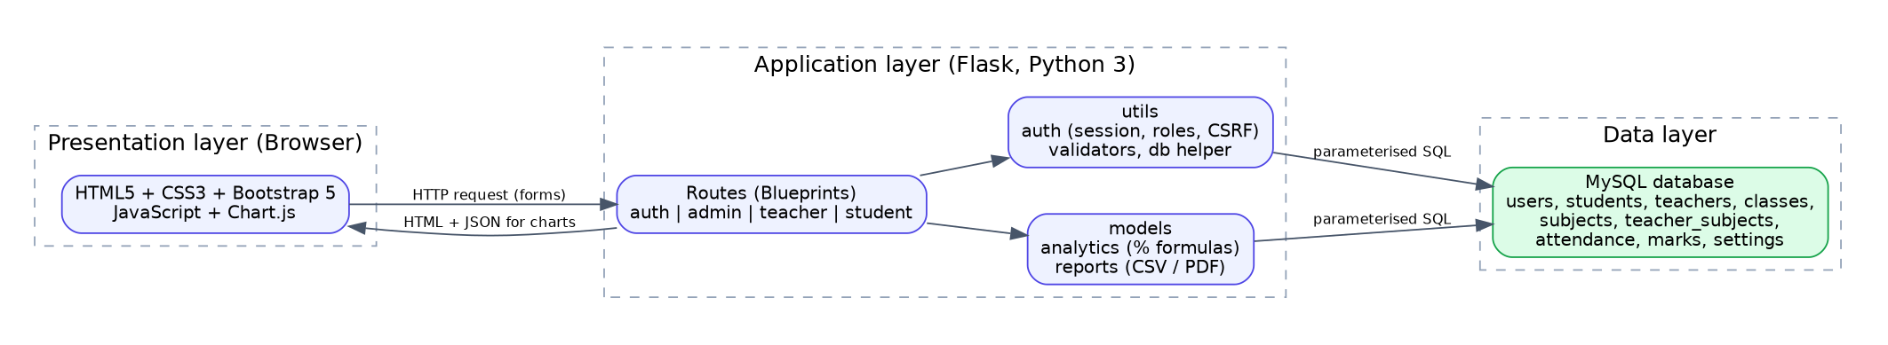
Figure 1: System architecture
A request travels as follows: the browser sends an HTTP request; a before_request hook checks the CSRF token and the role; the route runs parameterised SQL through the database helper; the result is rendered by a Jinja2 template (chart data is passed as JSON) and returned to the browser.

13. Database Design
The database smart_attendance contains nine InnoDB tables in third normal form. Derived values such as attendance percentage are calculated by queries and are never stored.
Table | Important columns | Keys / constraints
users | id, username, password_hash, role (admin/teacher/student), created_at | PK id; UNIQUE username
classes | id, class_name, semester, section, created_at | PK id; UNIQUE (class_name, semester, section)
teachers | id, user_id, teacher_id, name, email, created_at | PK id; FK user_id -> users (CASCADE); UNIQUE user_id, teacher_id, email
students | id, user_id, student_id, name, email, class_id, created_at | PK id; FK user_id -> users (CASCADE); FK class_id -> classes (RESTRICT); UNIQUE student_id, email; INDEX class_id
subjects | id, subject_code, subject_name, created_at | PK id; UNIQUE subject_code
teacher_subjects | id, teacher_id, subject_id, class_id | PK id; FKs to teachers, subjects, classes (CASCADE); UNIQUE (subject_id, class_id)
attendance | id, student_id, subject_id, attendance_date, status (Present/Absent), marked_by, created_at, updated_at | PK id; FKs to students, subjects (CASCADE), teachers (SET NULL); UNIQUE (student_id, subject_id, attendance_date); INDEXES on (subject_id, attendance_date) and attendance_date
marks | id, student_id, subject_id, assessment_type, assessment_name, marks_obtained, total_marks, entered_by, created_at | PK id; FKs to students, subjects, teachers; UNIQUE (student_id, subject_id, assessment_name); CHECK 0 <= marks <= total
settings | setting_key, setting_value | PK setting_key (stores min_attendance)

Differences from the suggested schema
- subjects.teacher_id is replaced by the teacher_subjects link table because one teacher may teach many subjects and classes.
- student_classes is not used; each student belongs to one class through students.class_id, which keeps queries simple.
- A settings table was added to make the minimum attendance percentage configurable.

14. ER Diagram Description
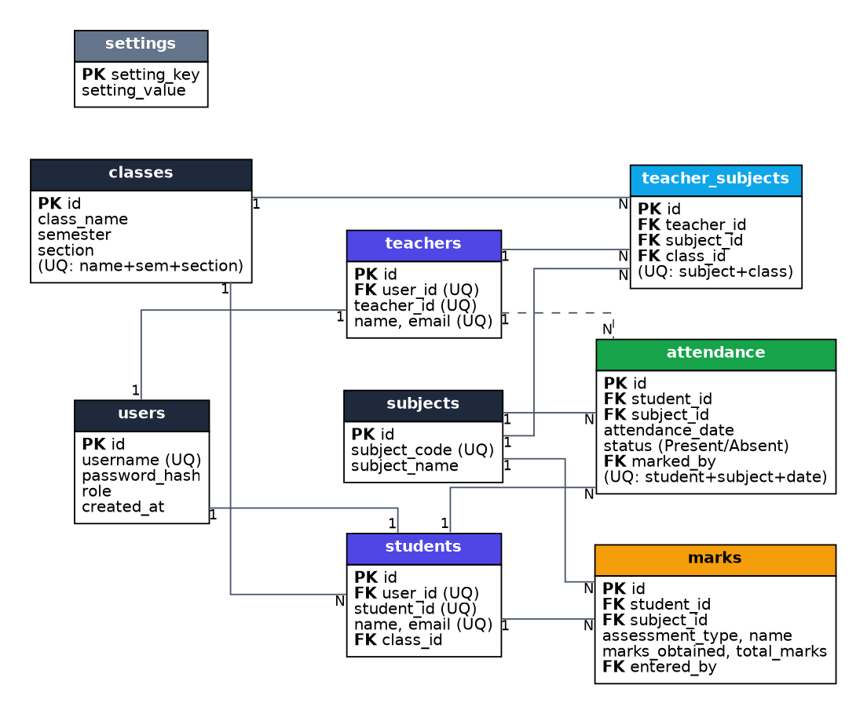
Figure 2: Entity Relationship diagram
The main entities and relationships are:
- users - students (1:1) and users - teachers (1:1): every profile has exactly one login account.
- classes - students (1:N): a class has many students; each student belongs to one class.
- teachers, subjects and classes are linked through teacher_subjects: a teacher teaches a subject to a class. The combination (subject, class) is unique.
- students - attendance (1:N) and subjects - attendance (1:N): each attendance row belongs to one student and one subject; teachers - attendance (1:N, optional) records who marked it.
- students - marks (1:N) and subjects - marks (1:N): marks are stored per student, subject and assessment.

15. Data Flow Description
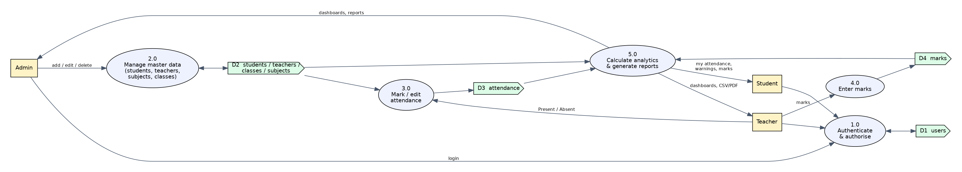
Figure 3: Data flow diagram (level 1)
External entities are Admin, Teacher and Student. Process 1.0 authenticates users against the users table. Process 2.0 lets the admin maintain master data. Process 3.0 lets teachers mark or edit attendance, reading the student list and writing to the attendance table. Process 4.0 stores marks. Process 5.0 reads attendance, marks and master data to calculate analytics and produce dashboards, warnings and CSV/PDF reports for each role.

16. Module Description
- Authentication module: login, logout, password verification, session creation, role-based route protection and CSRF check.
- Admin module: CRUD operations for students, teachers, subjects and classes; teacher-subject-class assignment; settings; overall dashboard and reports.
- Attendance module: teacher selects subject-class and date, marks Present/Absent for each student, saves (insert or update), and can browse the attendance history and open any past date for correction.
- Analytics module: calculates overall and subject-wise percentages, monthly trend, students at risk, top and lowest students and present/absent totals; supplies data to Chart.js.
- Marks / performance module: teacher enters marks by assessment; the system calculates percentage; students see tables and charts.
- Report module: filters by date range, student, subject and class; shows totals and percentage; exports CSV and PDF.
- Student module: personal dashboard with warning message, attendance history, performance and profile/password change.

17. Implementation

17.1 Project structure
smart-attendance-system/
app.py config.py requirements.txt README.md .env.example
database/ schema.sql seed.sql init_db.py generate_seed.py
routes/ auth.py admin.py teacher.py student.py shared.py
models/ analytics.py reports.py
utils/ db.py auth.py validators.py
templates/ base.html login.html dashboard.html reports.html admin/ teacher/ student/
static/ css/ js/ (app.js, charts.js) vendor/ (Bootstrap, Chart.js)
tests/ test_app.py

17.2 Attendance percentage calculation
Attendance % = (Present classes / Total classes) x 100. For example, a student present in 45 of 60 classes has 45 / 60 x 100 = 75%. In SQL the counts are obtained with COUNT(a.id) and SUM(a.status = 'Present'), grouped by student, subject or month. If a student has no classes yet, 0 is shown instead of dividing by zero.
def pct(present, total):
return round(present * 100.0 / total, 2) if total else 0.0

17.3 Marking attendance without duplicates
The attendance table has a UNIQUE key on (student_id, subject_id, attendance_date). The save operation uses INSERT ... ON DUPLICATE KEY UPDATE, so saving a date for the first time inserts rows and saving it again edits the existing rows. All rows of one class are saved in a single transaction.
INSERT INTO attendance (student_id, subject_id, attendance_date, status, marked_by)
VALUES (%s, %s, %s, %s, %s)
ON DUPLICATE KEY UPDATE status = VALUES(status), marked_by = VALUES(marked_by)

17.4 Smart features
- Low attendance warning: a student whose overall percentage is below min_attendance (settings table, default 75) sees a red warning; subjects below the limit are listed separately.
- Students at risk: the admin/teacher dashboard lists every student below the limit with a colour-coded progress bar.
- Attendance trend: percentage per month using GROUP BY LEFT(attendance_date, 7).
- Top / lowest students: students sorted by overall percentage (first five and last five).
- Teacher scope: a teacher sees data only for subject-class pairs assigned to him or her (EXISTS sub-query on teacher_subjects).

17.5 Security implementation
- Passwords: Werkzeug PBKDF2-SHA256 salted hashes; plain text is never stored.
- Sessions: Flask signed cookie, cleared on login and logout; HttpOnly and SameSite cookie flags.
- Authorisation: @role_required decorator in a before_request hook of every role blueprint (403 for wrong role, redirect to login when not logged in).
- SQL injection: every query uses %s placeholders with separate parameters.
- CSRF: random token in the session, hidden field in every form, verified for every POST.
- Validation: server-side checks for IDs, e-mail, dates, marks range, percentages; browser checks are only a convenience.
- Cache-Control: no-store so that the Back button does not display private pages after logout.

18. Testing
Testing was done at two levels. (1) Automated tests: 29 unittest cases (tests/test_app.py) run against a separate database (smart_attendance_test) that is recreated with demo data before every test. (2) Manual testing of every page in Chrome for all three roles. All tests passed in the final run (Ran 29 tests, OK). Run with: python -m unittest tests.test_app -v
TC | Test case | Input / steps | Expected result | Actual result
TC01 | Valid login | admin / admin123; teacher1 / teacher123; MCA2601 / student123 | Redirect to the dashboard of the role | Redirected to /admin, /teacher and /student dashboards. Pass
TC02 | Invalid login | admin / wrong-password | Error message; no session | HTTP 401, "Invalid username or password". Pass
TC03 | SQL injection attempt | Username ' OR '1'='1' -- | Login must fail | HTTP 401, login refused. Pass
TC04 | Role authorization | Student opens /admin/dashboard; teacher opens /admin/students; anonymous opens /admin/dashboard | 403 for wrong role; redirect to login if anonymous | 403, 403 and redirect to /login. Pass
TC05 | Logout | Login then POST /logout | Session cleared; dashboard not accessible | Dashboard redirected to login. Pass
TC06 | CSRF protection | POST /login without token | Request rejected | HTTP 400. Pass
TC07 | Password hashing | Read users.password_hash | Hashes only, no plain text | All values start with pbkdf2: . Pass
TC08 | Add student | Valid student form with class and password | Student saved; can log in | Message "Student added successfully"; new student logged in. Pass
TC09 | Add student - invalid / duplicate | Bad e-mail, short password; existing student ID | Validation error; duplicate refused | "valid email" and "already exists" messages shown. Pass
TC10 | Add subject | Code NET106, name Computer Networks | Subject stored | Row present in subjects. Pass
TC11 | Delete student | Admin deletes a student | Attendance/marks of the student removed | Cascade delete verified. Pass
TC12 | Mark attendance | Teacher1, PYT101, class A, today; one student Absent | 10 rows saved, 1 Absent | 10 rows, 1 Absent. Pass
TC13 | Duplicate attendance prevention / edit | Save same subject-class-date twice | Still 10 rows; second save updates status | 10 rows, statuses updated. Pass
TC14 | DB unique constraint | Direct INSERT of an existing (student, subject, date) | Database rejects | IntegrityError raised. Pass
TC15 | Future date | Date 2099-01-01 | Rejected | "future dates are not allowed". Pass
TC16 | Other teacher's subject | Teacher1 saves DSA104 (teacher2) | Rejected, nothing saved | Refused, 0 rows. Pass
TC17 | Attendance calculation | 45 of 60; 0 of 0; 2 of 3 | 75.0; 0.0; 66.67 | 75.0, 0.0, 66.67; matches SQL. Pass
TC18 | Low attendance warning | Student MCA2613 (about 55%) and MCA2611 (about 97%) | Warning only for the first | Warning shown only for MCA2613. Pass
TC19 | Students at risk / threshold | Admin dashboard; change minimum to 90 | Low student listed; count increases | Listed; count increased. Pass
TC20 | Marks calculation | 45/50, 17/20, 0/0 | 90.0, 85.0, 0.0 | 90.0, 85.0, 0.0. Pass
TC21 | Enter marks | Quiz 2, total 20, student marks 17 | Saved; student sees 85.0% | Student performance page shows Quiz 2 and 85.0%. Pass
TC22 | Marks validation | 15 marks out of 10 | Rejected | "must be between 0 and 10". Pass
TC23 | CSV export | /admin/reports?export=csv&subject_id=1 | CSV file with header and 20 rows | text/csv attachment, correct header, 20 rows. Pass
TC24 | Report filters | Date range July 2026, one student, one subject | One row, totals equal database count | Totals matched. Pass
TC25 | Teacher report scope | Teacher1 CSV | Only PYT101/DBM102/WEB103 | DSA104 absent from file. Pass
TC26 | PDF export | export=pdf | Valid PDF file | Starts with %PDF. Pass
TC27 | All pages load | 17 pages across three roles | HTTP 200 | All returned 200. Pass

19. Results
After running seed.sql (1 admin, 2 teachers, 20 students, 5 subjects, 2 classes, 3,360 attendance records, 400 marks records) the admin dashboard shows the following values, all calculated from MySQL:
Dashboard item | Value
Total students | 20
Total teachers | 2
Total subjects | 5
Attendance records | 3,360
Average attendance | 81.46%
Students below 75% | 5

Subject | Attendance % | Status (minimum 75%)
PYT101 Python Programming | 79.70% | Above minimum
DBM102 DBMS | 82.50% | Above minimum
WEB103 Web Technologies | 77.14% | Above minimum
DSA104 Data Structures | 82.00% | Above minimum
MAT105 Discrete Mathematics | 86.21% | Above minimum

Monthly trend: July 82.25%, August 81.67%, September 80.21% (slight decline). Students at risk (lowest first): MCA2613 (54.8%), MCA2616 (60.7%), MCA2612 (68.5%), MCA2607 (73.2%) and MCA2608 (73.8%). The highest attendance is 97.0% (MCA2611).
Screenshots of the login page, admin dashboard, mark-attendance page, student dashboard with warning and reports page can be inserted here after running the project.
[ Insert screenshots here ]

20. Limitations
- Attendance is marked manually by teachers; there is no QR, biometric or face-recognition support.
- No e-mail or SMS alerts are sent for low attendance.
- Only one attendance mark per student, subject and date (multiple lectures of the same subject on one day are not separated).
- No forgot-password e-mail flow and no login-attempt limiting.
- The built-in Flask server (debug mode) is meant for local demonstration; a production server and HTTPS are needed for real deployment.
- The analytics are rule-based and do not predict future attendance.

21. Future Scope
- QR-code or face-recognition based attendance.
- E-mail / SMS / WhatsApp alerts to students and parents.
- Lecture-slot wise attendance and timetable integration.
- Leave and medical-certificate management.
- Machine-learning model to predict students likely to fall short of attendance.
- Bulk import of students from Excel and REST API with a mobile application.
- Parent portal and multi-institution support.

22. Conclusion
The Smart Attendance and Analytics System replaces manual registers with a secure, database-driven web application. It records attendance quickly, prevents duplicate entries, calculates percentages automatically, warns students about shortage of attendance and gives administrators and teachers clear dashboards and exportable reports. The project uses only the required technologies (Flask, MySQL, HTML/CSS/JavaScript, Bootstrap and Chart.js), follows a modular structure that is easy to explain, and was verified with automated test cases. It can be extended in future with notifications, automatic attendance capture and predictive analytics.

References
- Flask documentation - https://flask.palletsprojects.com
- MySQL 8.0 Reference Manual - https://dev.mysql.com/doc
- MySQL Connector/Python documentation - https://dev.mysql.com/doc/connector-python
- Bootstrap 5 documentation - https://getbootstrap.com
- Chart.js documentation - https://www.chartjs.org
- OWASP Cheat Sheets (SQL injection, CSRF, password storage) - https://cheatsheetseries.owasp.org

