ISTE-608 Database Design and Implementation

## Homework # 2 – Entity-Relationship Modeling

DUE:

**Name: ____Archit Jain_________________________________________**

**Submit to the Homework #2 dropbox, this document edited to include your answers**

**Part 1 – 20 points**

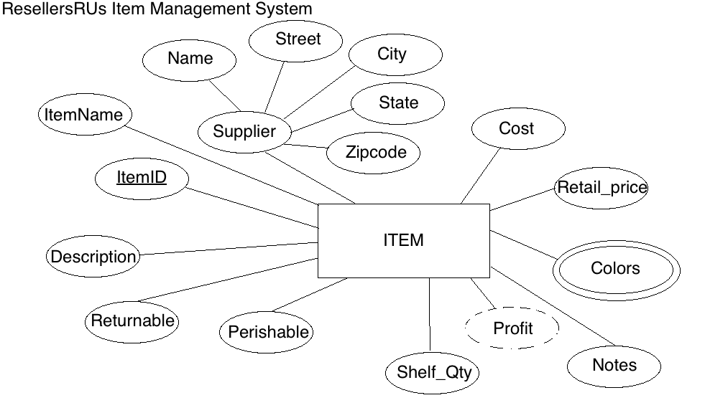

For the table below, please classify each attribute specified based on the E-R diagram above. Please place the best answer for each column that best describes the attribute.

|  |  |  |  |  |
| --- | --- | --- | --- | --- |
| Attribute | **Composite or Simple** | **Single-valued or Multi-valued** | **Stored or Derived** | **Identifier ? (Yes or No)** |
| Profit | Simple | Single-valued | Derived | No |
| Street | Simple | Single-Valued | Stored | No |
| ItemID | Simple | Single-Valued | Stored | Yes |
| Supplier | Composite | Single-Valued | Stored | No |
| Colors | Simple | Multi-Valued | Stored | No |

**Part 2 – 80 points**

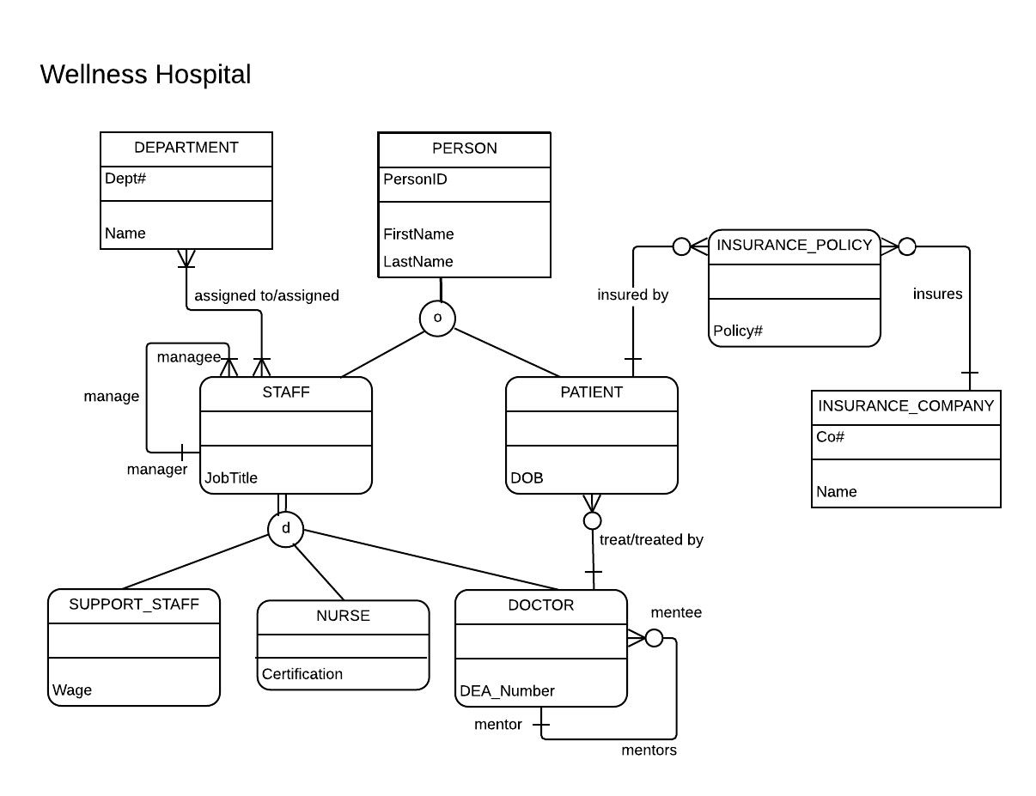

Using the E-R diagram for Wellness Hospital, please provide your answer to the following 22 questions.

1. (4 points) List the relationship verb phrase for each 'HAS-A' relationship that appears in the diagram.

**YOUR ANSWER:**

DEPARTMENT must **be assigned** to a STAFF.

STAFF **must be assigned** a DEPARTMENT.

A DEPARTMENT can be **assigned to many** STAFF.

A STAFF can be **assigned many** DEPARTMENTs.

A STAFF: manager must **manage** a STAFF: mentee.

A STAFF: manager can **manage** many STAFF: mentee

A STAFF: mentee can be only **managed by** one STAFF: manager

A STAFF: mentee must be **managed** **by** a STAFF: mentor.

A DOCTOR can **treat** many PATIENTS.

A PATIENT must be **treated** **by** only one DOCTOR.

A DOCTOR does not have to **treat** a PATIENT.

A PATIENT must be **treated by** a DOCTOR.

A PATIENT does not have to be **insured by** INSURANCE_POLICY

An INSURANCE_POLICY must be **insured by** a PATIENT.

A PATIENT can be **insured by** many INSURANCE_POLICY.

An INSURANCE_POLICY can be **insured by** no more than one PATIENT

An INSURANCE_POLICY must **insure** an INSURANCE_COMPANY

An INSURANCE_COMPANY does not have to be **insures** by an INSURANCE_POLICY.

An INSURANCE_COMPANY can **insure** many INSURANCE_POLICY.

An INSURANCE_POLICY can **insures** no more than one INSURANCE_COMPANY

1. (3 points) List the relationship verb phrase for each binary relationship that appears in the diagram.

**YOUR ANSWER:**

* Assigned to/assigned
* treat/treated by
* insured by
* Insures

1. (3 points) List the relationship verb phrase for each recursive relationship that appears in the diagram.

**YOUR ANSWER:**

Staff (manager) **manages** staff(manage)

Staff (manage) **is managed by** staff (manager)

Doctor(mentor) **mentors** Doctor (mentee)

Doctor (mentee) **is mentored by** Doctor (mentor)

1. (3 points) List the name of each supertype entity that appears in the diagram.

**YOUR ANSWER:**

* Person
* Staff

1. (4 points) List the name of each subtype entity that appears in the diagram.

**YOUR ANSWER:**

* Staff
* Person
* Support staff
* Nurse
* Doctor

1. (3 points) List the name of each associative entity that appears in the diagram.

**YOUR ANSWER:**

INSURANCE_POLICY acts as a associative entity between PATIENT and INSURANCE_COMPANY

1. (3 points) Provide an example of an entity instance of PERSON.

**YOUR ANSWER:**

PersonID: 511

First name: James

Last name: Bond

1. (3 points) List the relationship verb phrase for every 1:1 relationship that appears in the diagram.

**YOUR ANSWER:**

* There is no 1:1 relationship in the ER diagram.

1. (3 points) List the relationship verb phrase for every 1:N (N:1) relationship that appears in the diagram.

**YOUR ANSWER:**

A STAFF: Manager **manages** many STAFF: Managee.

A STAFF: Managee **is managed by** at most one STAFF: manager.

A DOCTOR: Mentor **mentors** many DOCTORs: Mentee.

A DOCTOR: Mentee **mentored by** at most one DOCTOR: Mentor

A DOCTOR **treats** many PATIENTs

A PATIENT is **treated by** at most one DOCTOR

A PATIENT is **insured by** many INSURANCE_POLICY

An INSURANCE_POLICY **insured by** at most one PATIENT.

An INSURANCE_COMPANY **insures** many INSURANCE_POLICY

An INSURANCE_POLICY **insures** at most one INSURANCE COMPANY

1. (3 points) List the relationship verb phrase for every M:N relationship that appears in the diagram.

**YOUR ANSWER:**

A DEPARTMENT can be **assigned to** many STAFF.

A STAFF cab be **assigned** many DEPARTMENT

1. (3 points) List the name of each strong entity that appears in the diagram.

**YOUR ANSWER:**

* DEPARTMENT
* PERSON
* INSURANCE_COMPANY

1. (4 points) List the name of each weak entity that appears in the diagram.

**YOUR ANSWER:**

* STAFF
* PATIENT
* SUPPORT_STAFF
* NURSE
* DOCTOR
* INSURANCE_POLICY

1. (4 points) Must a STAFF: managee be managed by a manager? Explain how you determined your answer from the E-R diagram provided.

**YOUR ANSWER:** Yes, Minimum cardinality is **one** for that relationship. As we can see (**+**) symbol on the manager side which denotes minimum cardinality of one.

1. (4 points) Can there be an instance of DOCTOR that is not an instance of STAFF? Explain your answer.

**YOUR ANSWER:** No, Since STAFF is a SUPERTYPE entity and DOCTOR is its (STAFF’s) subtype entity.

1. (4 points) Can a DOCTOR treat more than one PATIENT? Explain how you determined your answer from the E-R diagram provided.

**YOUR ANSWER:** Yes, a doctor can treat multiple patients since it has the maximum cardinality denoted by crow’s foot(representing more than one ) which is on the PATIENT’s side.

1. (4 points) Must every instance of PERSON belong to a subtype? Fully explain how you determined your answer from the E-R diagram provided.

**YOUR ANSWER:**  No, PERSON instance can exist independently denoted by the single line from the supertype PERSON entity to subtype entity. It is partial specialization.

1. (4 points) Could an instance of PERSON be both a STAFF and a PATIENT? Fully explain how you determined your answer from the E-R diagram provided.

**YOUR ANSWER:** Yes, PERSON can exist as both STAFF and PATIENT as it is denoted by ‘o’ inside the supertype/subtype indicator indicating overlap rule is in effect.

1. (4 points) Must every instance of STAFF belong to a subtype? Fully explain how you determined your answer from the E-R diagram provided.

**YOUR ANSWER:** Yes, every instance of STAFF needs a subtype as it has double lines from STAFF supertype to its subtypes indicating it is total specialization.

1. (4 points) Could an instance of STAFF be both a SUPPORT_STAFF and a DOCTOR? Fully explain how you determined your answer from the E-R diagram provided.

**YOUR ANSWER:** No, STAFF cannot be both SUPPORT_STAFF and DOCTOR as it has ‘d’ inside its supertype/subtype indicator, indicating disjoint rule is in effect.

1. (4 points) If a discriminator were to be added to PERSON, fully explain what that would entail and why?

**YOUR ANSWER:** Since overlap rule is in effect in case of the PERSON. An attribute for each subtype i.e. STAFF and PATIENT is required. Example a Boolean value for the Staff= y/n or Patient = Y/N. Since PERSON can be both STAFF and PATIENT

1. (4 points) If a discriminator were to be added to STAFF, fully explain what that would entail and why?

**YOUR ANSWER:** Since the disjoint rule is in effect, we will need only one attribute to distinguish STAFF’s subtype. STAFF can either be SUPPORT_STAFF or NURSE or DOCTOR. Example Staff_type = Nurse/Doctor/Support will tell us which subtype STAFF belongs to.

1. (5 points) Fully state the business rules for the **assigned to/assigned** relationship without using technical terms.

**YOUR ANSWER:** A Department must have a staff and a staff must have a department.

A department can have multiple staff assigned to it. A Staff can have assigned multiple department to it.

Here, a department may have multiple staff as a doctor or a nurse. A general physician department may have 4 doctors in a single department.

There might be also a case of single nurse for example may work in different department of medical science.

Also, a department will have at least one staff and staff will have at least of single department assigned to them.