ISTE-608 Introduction to Database & Data Modeling

## Homework # 3 – Transposing and E-R Diagram

DUE: Sunday, September 15, 2019 by 11:59pm

**Name: ____ARCHIT JAIN_________________________________________**

**Submit this document edited to include your answers, for the two parts, to the HW#3 Dropbox by the stated deadline.**

**Part #1 – 50 points**

1. (45 points) Transpose the E-R diagram above into relations, implementing all relationships. Denote primary keys and foreign keys appropriately. Use proper relation notation. You need to provide reference statements. There is a distinction between identifying and non-identifying relationships.

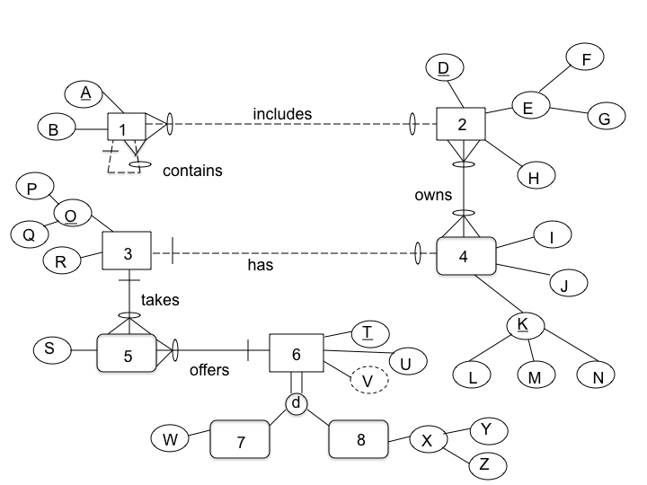

**YOUR TRANSPOSED RELATIONS:**

**1**

1(A,B,*D,A2*)

2 (D,F,G,H)

2_4(*D,L,M,N*)

2_4(D)mei 2(D)

2_4(L,M,N) mein 4(L,M,N)

3(P,Q,R)

4(L,M,N , I,J,*P,Q*)

5(S,*P,Q,T*)

6(T,U)

7(W,*T*)

8(*T*,Y,Z)

1(D) mei 2(D)

1(A2) mei 1(A)

2_4(D) mei 2(D)

2_4(L,M,N) mei(L,M,N)

4(P,Q) mei 3(P,Q)

5(P,Q) mei 3(PQ)

5(T) mei 6(T)

T(T) mei 6(T)

8(T) mei 6(T)

2. (2 points) Using the E-R diagram above, please explain why entity 7 is weak and what the specific term for that type of entity is.

**REASON: It is weak because entity 7 can exist without participating in relation with entity 6**

**TERM: Entity 7 is a subtype Entity**

3. (2 points) Using the E-R diagram above, please explain why entity 5 is weak and what the specific term for that type of entity is.

**REASON: it is weak because entity 5 can’t exist without entity 3 and 6**

**TERM: Entity 5 is associative entity also an ID-dependent weak entity**

4. ( 1 point) Using the E-R diagram above, please explain what relationship makes entity 4 weak and what about that relationship causes it to be weak.

**EXPLANATION: The entity 4 is weak because of the ‘has’ relationship which requires**

**total participation from entity 4.**

**Part 2 – RIT Savings and Loan (50 points)**

1. (50 points) Transpose the E-R diagram above into relations, implementing all relationships. Denote primary keys and foreign keys appropriately. Use proper relation notation. You need to provide reference statements.

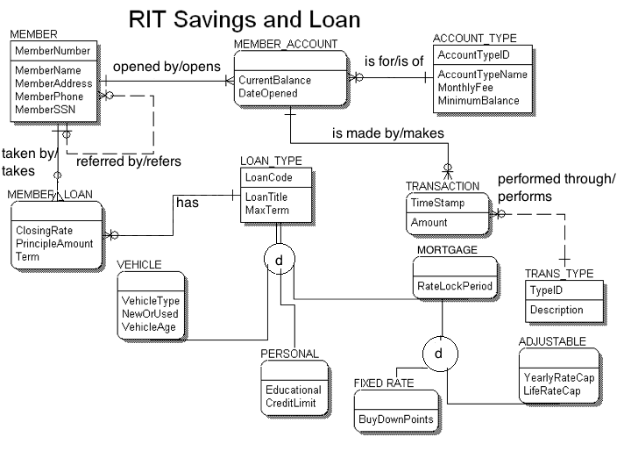**YOUR TRANSPOSED RELATIONS:**

MEMBER(MemberNumber, MemberName, MemberAdderess, MemberPhone,MemberSSN)

MEMBER_LOAN(*MemberNumber*, ClosingRate, PrincipleAmount, Term, *LoanCode*)

MEMBER_ACCOUNT(*MemberNumber,AccountTypeID,* CurrentBalance,DateOpened)

ACCOUNT_TYPE(AccountTypeID,AccountTypeName,MonthlyFee, MinimumBalance)

LOAN_TYPE(LoanCode,LoanType, MaxTerm)

VEHICLE(*LoanCode*,VehicleType,NewOrUsed,VehicleAge)

PERSONAL(*LoanCode*,Educational, CreditLimit)

MORTGAGE(*LoanCode*,RateLockPeriod)

FIXEDRATE(*LoanCode*,BuyDownPoints)

ADJUSTABLE(*LoanCode*, YearlyRateCap, LifeRateCap)

TRANSACTION(TimeStamp,Amount, *MemberNumber,AccountTypeID, TypeID* )

TRANS_TYPE( TypeID, Description)

* MEMBER(MemberReffered) mei MEMBER(MemberReffered)
* MEMBER_LOAN(MemberNumber) mei MEMBER(MemberNumber)
* MEMBER_ACCOUNT(MemberNumber) mei MEMBER(MemberNumber)
* MEMBER_ACCOUNT(AccountTypeID) mei ACCOUNT_TYPE(AccountTypeID)
* MEMBER_LOAN(LoanCode) mei LOAN_TYPE(LoanCode)
* VEHICLE(LoanCode) mein LOAN_TYPE(LoanCode)
* PERSON(LoanCode) mei LOAN_TYPE(LoanCode)
* MORTGAGE(LoanCode) mei LOAN_TYPE(LoanCode)
* FIXEDRATE(LoanCode) mei MORTGAGE(LoanCode)
* ADJUSTABLE(LoanCode) mei MORTGAGE(LoanCode)
* TRANSACTION(MemberNumber,AccountTypeID) mei MEMBER_ACCOUNT(MemberNumber,AccountTypeID)
* TRANSACTION(TypeID) mei TRANSACTION(TypeID)