Contemporary Databases

PE05 – Practice Exercise – Java regex

**Name: _____Archit Jain ________________________________________**

In this exercise, you will repeat the question used in PE04 only within a Java program. You may start with the examples given in class.

Find all the Tweets that have the word “dish” in the text field as a full word and also the full word “good”. The query should be case insensitive. The words can also be in either order. For this program do not use the user input in the search field, just formulate the query like PE04.

Show only the text field. You should get the same results as in PE04

**Name the Program Regex.java and submit it to the MyCourses dropbox. Do not submit the .class files.**

**Also, copy and paste the results of your query and submit it to the dropbox.**

**Do not zip the files.**

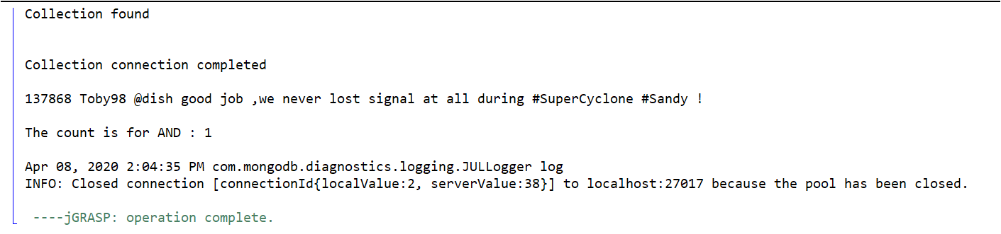

**Signature: _________________________ Date: _____________________**

**Have your instructor or TA sign here when PE is completed.**