Practice Exercise – Neo4j PE 03 Commands

**Name: _________Archit Jain____________________________________**

Like we did in PE02, back up the data folder containing your database and save it in your backup folder. Delete the data in the data folder and start Neo4j to create a new database. Remember the password should be student.

Create a neo4j database that has the following characteristics:

* It contains people with a property of name
* There are two possible relationships between people:
  + FRIEND_OF: has no properties
  + MANAGES: has no properties
* People have a LIVES_IN relationship with another node called city with a particular date in the format of ‘YYYYMMDD’

People/City/Date:

John Walsh Rochester 20141102

Sally Person Dubrovnik 20141102

James Baker Zagreb 20130901

Carol Lindsey Syracuse 20130815

John Smith Dubrovnik 20110401

Friends:

Walsh and Baker

Person and Lindsey

Baker and Smith

Walsh and Smith

Walsh Manages Person, Baker and Smith

1. Create a database that reflects the above scenario.
2. Answer the following queries:
   1. Show all the nodes and relationships (show graph)?
   2. Who has the same first names (duplicates OK)?
   3. Who lives in the same city (duplicates OK)?
   4. Who has lived in Dubrovnik the longest?
   5. Update the database to show that Baker moved to Rochester on 20151126

Paste the creation code and the queries into a Word document along with the results of the queries as you did in PE02 and submit to the MyCourses dropbox.

**ANSWERS**

CREATE (a:People{name:'John Walsh'})

CREATE (b:People{name:'Sally Person'})

CREATE (c:People{name:'James Baker'})

CREATE (d:People{name:'Carol Lindsey'})

CREATE (e:People{name:'John Smith'})

CREATE (j:city{name:'Rochester'})

CREATE (k:city{name:'Dubrovnik'})

CREATE (l:city{name:'Zagreb'})

CREATE (m:city{name:'Syracuse'})

MATCH (p1{name:'John Walsh'}),(p2 {name:'Rochester'}) CREATE(p1)-[:LIVES_IN{date:'20141102'}]->(p2)

MATCH (p1{name:'Sally Person'}),(p2 {name:'Dubrovnik'}) CREATE(p1)-[:LIVES_IN{date:'20141102'}]->(p2)

MATCH (p1{name:'James Baker'}),(p2 {name:'Zagreb'}) CREATE(p1)-[:LIVES_IN{date:'20130901'}]->(p2)

MATCH (p1{name:'Carol Lindsey'}),(p2 {name:'Syracuse'}) CREATE(p1)-[:LIVES_IN{date:'20130815'}]->(p2)

MATCH (p1{name:'John Smith'}),(p2 {name:'Dubrovnik'}) CREATE(p1)-[:LIVES_IN{date:'20110401'}]->(p2)

MATCH (p1{name:'John Walsh'}),(p2 {name:'James Baker'}) CREATE(p1)-[:FRIEND_OF]->(p2)

MATCH (p1{name:'Sally Person'}),(p2 {name:'Carol Lindsey'}) CREATE(p1)-[:FRIEND_OF]->(p2)

MATCH (p1{name:'James Baker'}),(p2 {name:'John Smith'}) CREATE(p1)-[:FRIEND_OF]->(p2)

MATCH (p1{name:'John Walsh'}),(p2 {name:'John Smith'}) CREATE(p1)-[:FRIEND_OF]->(p2)

MATCH (p1{name:'John Walsh'}),(p2 {name:'James Baker'}) CREATE(p1)-[:MANAGES]->(p2)

MATCH (p1{name:'John Walsh'}),(p2 {name:'John Smith'}) CREATE(p1)-[:MANAGES]->(p2)

MATCH (a)-[r]-(b)

return a, r, b

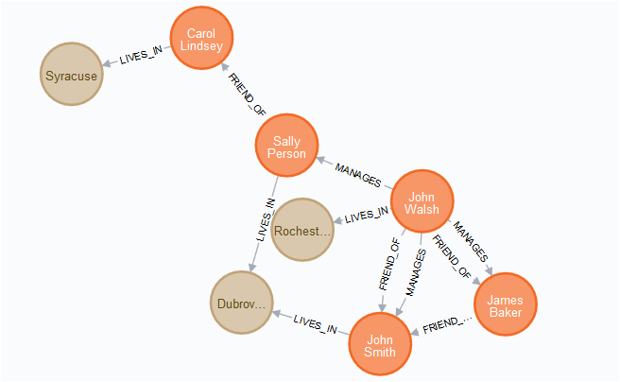

2) MATCH (s1:People),(s2:People)

WHERE s1.name = s2.name

and s1.name =~ '(?i)^john.*'

RETURN s1.name

s1.name" │

╞════════════╡

│"John Walsh"│

├────────────┤

│"John Smith"│

└────────────┘

3.) Match (a1:People)-[r:LIVES_IN]-(b1:city)

with b1,a1

MATCH (a:People)-[r:LIVES_IN]-(b:city)

where b1.name=b.name

and a1.name <> a.name

return a

│"a" │

╞═══════════════════════╡

│{"name":"Sally Person"}│

├───────────────────────┤

│{"name":"John Smith"} │

d) MATCH (a:People)-[r:LIVES_IN]-(b:city)

where b.name = "Dubrovnik"

return a

order by r.date Limit 1

│"a" │

╞═════════════════════╡

│{"name":"John Smith"}│

e)

MERGE (a:People {name: 'James Baker'})-[r:LIVES_IN]-(b:city)

SET b.name = "Rochester",r.date="20151126"

RETURN a, b, r

╒══════════════════════╤════════════════════╤═══════════════════╕

│"a" │"b" │"r" │

╞══════════════════════╪════════════════════╪═══════════════════╡

│{"name":"James Baker"}│{"name":"Rochester"}│{"date":"20151126"}│

└──────────────────────┴────────────────────┴───────────────────┘