Contemporary Databases

PE06 – Geo Queries

**Name: _______Archit Jain_____________________**

In this exercise, you are going to convert the Tweets collection to have a Geo loc field and create an index. You will also query by geolocation.

1. As shown in class add the loc field to the Tweets collection (if not already done).
2. In a .js file, do a find() with a limit of 5 to show that the field was created. Paste the results into an MS Word document.
3. In another .js file, create the 2dsphere index needed to support geo queries (if not aldready done). Paste the results into the MS Word document.
4. Look up the latitude and longitude for your home town. As an alternative you can use Syracuse, NY.
5. Do geo queries to find tweets close to the above selected town. To do this you can start with a small number kilometers and increase it like I did in class to find queries near Dubrovnik. When you start getting results, paste the results into the MS Word document (one or two results are enough).

**Zip the .js files into a .zip file and submit the .zip file to the dropbox. Submit the (one) MS Word document also. Do not zip the Word document.**

**1&2.**

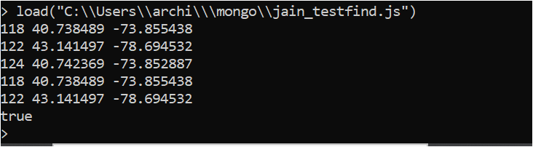

3.

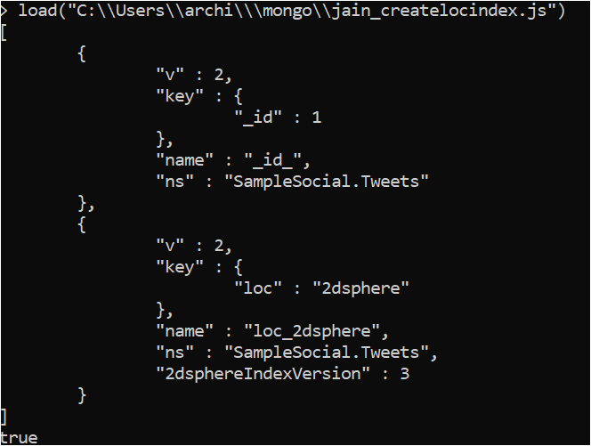

4.

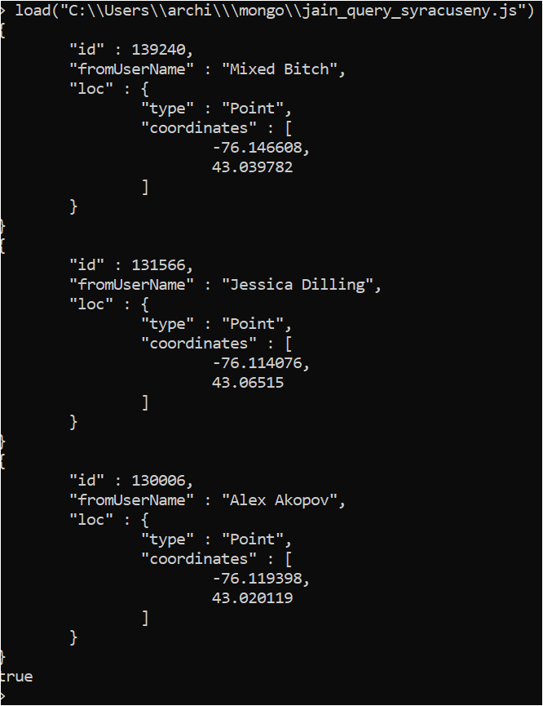

5.

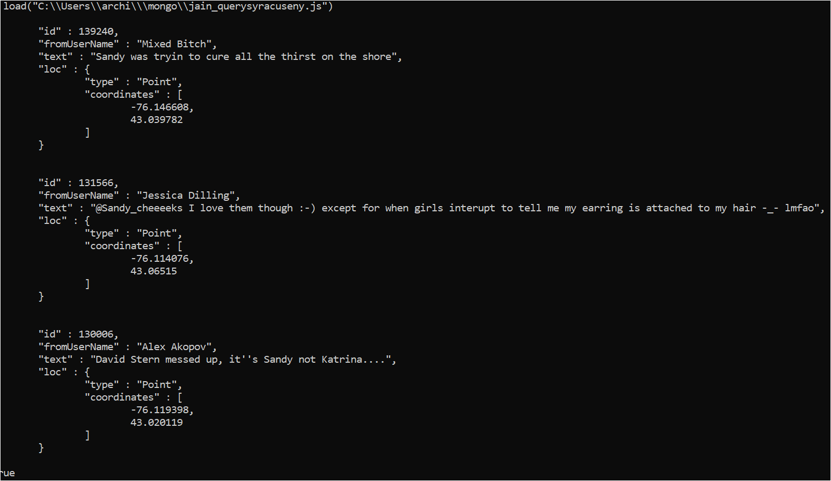

**Signature: _________________________ Date: _____________________**

**Have your instructor or TA sign here when PE is completed.**