A Comprehensive Survey On Deepfake Detection

Mrs. Abhilasha P. Kumar
Assistant Professor
Dept. Of Artificial Intlligence and Machine Learning and Engineering
B.N.M Institute of Technology
Bengaluru, Karnataka, India
priyankas@bnmit.in

Archit Pragyesh
Student
Dept. Of Artificial Intlligence and Machine Learning and Engineering
B.N.M Institute of Technology
Bengaluru, Karnataka, India
23aiml021@bnmit.in

Gopal Krishna Aithal YJ
Student
Dept. Of Artificial Intlligence and Machine Learning and Engineering
B.N.M Institute of Technology
Bengaluru, Karnataka, India
gopalkrishna6605@gmail.com

Abstract— The emergence of deepfakes, empowered by great strides in the field of deep learning paradigms, has placed these tools right at the edge of forensic analysis of digital data. The work presents a complete assessment of the latest state-of-the-art tools being utilized for the analysis of deepfakes from various modalities, such as images, videos, and audio. A brief summary of the work is given, including general insights and recent improvements relevant to the domain of CNNs, RNNs, transformer models, and forensic features extraction techniques. These models can be identified as image-based, video-based, audio-based, or hybrid models, explaining their relative advantages and disadvantages, together with common concerns about generalization and robustness against the ever-changing nature of generative models being applied for the analysis of deepfakes. Additionally, the discussion is extended towards exploring possible future directions and opportunities for enhanced real-time capability and robustness against the ever-changing nature of generative models for the analysis of deepfakes. The paper shall attempt to equip researchers and practitioners with a substantial knowledge base connected to the burgeoning field of deepfake analysis.
Keywords— Deepfake Detection, Deep Learning, Multimedia Forensics, Convolutional Neural Networks, Transformer Models, Audio Forensics, Video Analysis, Adversarial Robustness, Hybrid Detection.

- Introduction
Advances in the area of deep learning enabled the creation of advanced generative models for deepfakes' high-fidelity synthetic media. Not only are they much more creativity-friendly and convenient useful, but they also pose significant concerns of misinformation, privacy invasion, and resulting security concerns. As there is growing potential for the creation of deepfakes, there is correspondingly growing need for efficient countermeasures.
The paper presents a summary of the most active deepfake detection literature. Our summary gives a complete list of common modalities like images, videos, and audio, survey papers, and individual papers that introduce new detection approaches. By classifying the literature into specialized domains—image-based, video-based, audio-based, and hybrid—our aim is to give a systematic overview with focus on both existing methods as well as emerging trends in the literature.
The rest of the paper is structured as follows. Section 2 gives background and fundamental concepts behind detection and deepfake generation.
Section 3, which constitutes the majority of the paper, is an extensive review of existing state-of-the-art detection techniques. We then conclude with discussion on challenges, future work directions, and potential real-time implementation strategies.

- Background and Preliminaries

Deepfakes are artificial media in which a human actor in readily available image or video is swapped with the face of someone else relying on sophisticated machine learning models. Deepfake operations are enabled by models such as Generative Adversarial Networks (GANs), Variational Autoencoders (VAEs), and even recent diffusion models. The models make visual and audio content, editable in an imperceptible manner whose output is barely distinguishable from real content.
Detection processes need to be able to solve an incredibly large set of challenges. For the case of images and videos, pixel- or frame-level descriptors like face motion artifacts, light, and texture can be employed as possible signatures of deepfake manipulation. In the case of audio, very slight changes to speech patterns, e.g., at the level of phonemes, can be used for finding imposter sources. It is where the chapter defines defining terms (i.e., AUC, ACC, and EER) as well as closes the gap between the traditional measurement metrics and test collections (e.g., FaceForensics++, Celeb-DF, and ASVspoof) that have established standards in measurement of detection performance to benchmark.
Understanding these foundational concepts is critical, as they underpin the diverse methodologies discussed in subsequent sections.

- Overview of State-of-the-Art Techniques and Popular Approaches
In article [1] by Arash Heidari et al., there is an extensive and well-structured overview of deepfake detection techniques, overviewing various deep learning approaches utilized in the fight against deepfake media. The article considers image, video, audio, and multi-modal multimedia methods for deepfake detection and delves into their pros and cons in depth.
The authors categorize deepfake detection methods into four broad categories:
Image-Based Detection:
Gives special focus to manipulated image detection with the assistance of Convolutional Neural Networks (CNNs) and feature extraction methods like Error Level Analysis (ELA) and Manipulation Trace Extraction Networks (AMTEN).
Research suggests that images generated by GAN have few inconsistencies, such as unrealistic texture, pixel-level defects, or lighting and shadow inconsistency.
Video-Based Detection:
Identifies deepfakes using face motion inconsistency check, irregular blinking patterns, and frame-by-frame inconsistency.
Long Short-Term Memory (LSTMs), Recurrent Neural Networks (RNNs), and Temporal Convolutional Networks (TCNs) are methods used in tracking inconsistency over time.
It is in comparison with other methods that others verify consistency of head orientation, inconsistency in lip syncing, and inconsistency of facial expressions upon detecting counterfeit data.

Audio-Based Detection:
Identifies the spoofed voice or manipulated voice recording through speech analysis models, spectral analysis, and waveform comparison.
TTS and VC deepfakes lack natural variation in pitch and are full of artifacts that AI can easily pick up.

Hybrid Multimedia Detection:
Blends image, video, and audio analysis more accurately. Multimodal fusion networks fuse together several data streams, and this stabilizes the detection of deepfakes.
The paper addresses deep learning architecture commonly applied for deepfake detection:
CNN-based Models: Well suited to recognize inconsistency at image level for detecting deepfake images and frames.
RNN-based Models: Optimally suited to detect video deepfake using temporal inconsistency tracking.
Transfer Learning (TL): Enhances detection performance through the use of pre-trained models on big datasets. Attention Mechanisms and Transformer-Based Models: Enhances detection through attention to the significant manipulation regions in deepfakes.
Forensic Feature Extraction: Methods like Expectation-Maximization (EM) and Convolutional Trace (CT) Analysis allow for manipulation feature extraction from manipulated media.
In Gan Pei et al.'s paper [2], present an overview of the topic of deepfake technology coming into being in recent times. The paper discusses generation and detection of deepfakes in detail and provides an overall framework with challenges and success in different tasks.
Key Contributions:
Unified Problem Formulation:
•Authors briefly mathematically characterize deepfake generation to make the task an off-policy or controlled content generation issue. Authors similarly characterize deepfake detection as an image-level or pixel-level classification issue. This simultaneous characterization fills in the discriminative-generative gap and contributes towards end-to-end deepfake study comprehension.
In-Depth Survey of Generation Techniques
• There are four general categories of deepfake generation based on the article: face swapping, face reenactment, talking face generation, and facial attribute editing. The article illustrates how the initial VAE and GAN-based methods improved over time, and recent developments have cemented the supremacy of diffusion models in generating extremely realistic outputs. Classification not only shows how generative models have evolved over time but also serves as a reminder of the distinction between being identity invariant and being naturalistic.
Comprehensive Analysis of Detection Techniques
• On the detection front, the survey follows strategies on three fronts—spatial, temporal, and frequency domains. Hand-crafted feature-based to deep learning-based methods, transition is considered in the paper with a particular emphasis on hybrid methods encouraged by multiple cues. Traditional performance measures (e.g., AUC, ACC, and EER) and performance benchmarks (e.g., FF++ and Celeb-DF) useful towards enabling detection performance comparison are explored in the paper.
Critical Perspectives and Future Directions
One of the deficiencies of the paper is full sampling method benchmarking, gaining quality knowledge of where the detection systems are robust and resilient. Authors also discuss briefly front-burning adversarial robustness and generalization problems of detection systems and look forward to future research that will be committed to building stronger models and studies of regulatory mechanisms of abuse prevention.
Khan et al. [3] proposed a comparison of deepfake detection models using supervised and self-supervised learning. They contrasted CNN and transformer-based models such as DINO and CLIP on data such as FakeAVCeleb, CelebDF-V2, DFDC, and FaceForensics++. Experiments revealed in-built vulnerabilities of deepfake detection in the context that models could not generalize when they were applied to new datasets. The authors further compared model and augmentation performance and concluded that a larger model does not always translate to improved generalization.
Patil et al. [4] explained deepfake detection as biological signals including eyebrow movement, eye blink, ear and mouth detection, and heartbeat signal. Their work was devoted to the increasingly pressing problem of their detection with traditional forensic methods because GANs can generate highly realistic media today. The paper contrasted a number of the biometric feature-based classifiers and illustrated promising advances in physiological measurement methods that can be helpful in terms of enhancing detection rates.
Nguyen et al. [5] had given a concise overview of the deepfake generation and detection process and classified deepfake generation as face swap, lip-sync, and puppet-master. Nguyen et al. discussed some of the detection approaches based on deep learning such as CNNs, autoencoders, and transformer models. Double-edged sword character of deepfake technology was described in the paper by its beneficial uses (i.e., entertainment and accessibility) and adverse uses (i.e., misinformation and identity fraud). Authors documented the continuous battle between the creation and the detection methods of deepfakes, with examples drawn from research studies always in demand trying to be robust enough to resist future deepfake methods.
Hashmi et al. [6], for instance, centered their research on detecting audiovisual deepfakes, an area relatively less studied compared to the unimodal detection mechanisms. They gave vision and audio inputs to existing detection models to improve the detection results. The authors compared existing multimodal detection datasets and established human cognitive susceptibility to deepfake manipulation. Multimodally combined visuotactically and audiotactically proved very well-supported highly deepfake-detectable and hypothesized multimodal detection systems in the distant future, its survey asserts.
- Advancements in Deepfake Detection Techniques
The work [7] by Kuiyuan Zhang et al spoke of the serious matter of deepfake speech—a field where new breakthroughs in text-to-speech (TTS) and voice conversion (VC) have been rendering the speech artificial yet incredibly natural.
– Rather than pursuing the frame-level features, the authors suggest capitalizing on the phoneme-level inconsistencies, according to the line of reasoning that if neural synthesizers are ever going to sound natural at all, then they are certainly not going to be able to capture the high-resolution, dynamic phoneme contours of natural speech.
- Adaptive Phoneme Pooling:
Frame-level features are aggregated into phoneme-level representations by averaging consecutive frames that share the same phoneme label.
– This adaptive pooling generates sample-specific features that retain the temporal dynamics of speech, effectively reducing noise and emphasizing phoneme transitions.
- Graph Attention Network (GAT):
– The paper constructs a graph where nodes represent phoneme-level features and edges capture the temporal transitions between phonemes.
– A graph attention module is used to learn dependencies across the phoneme sequence, enhancing the model’s ability to detect subtle anomalies in synthesized speech.
- Random Phoneme Substitution Augmentation (RPSA):
– To improve robustness and generalization, the authors introduce a data augmentation technique that randomly substitutes phonemes across samples.
– This increases feature diversity during training and helps the model avoid overfitting to specific phoneme patterns.
- Loss Function and Multi-Task Learning:
– The overall loss function combines a binary cross-entropy loss for deepfake classification with a contrastive loss (inspired by CLIP) that aligns frame-level features from different branches of the network.
The paper [8] by Rohit Kundu et al., aims to address the limitations of conventional DeepFake detectors, which are predominantly designed to detect face-centric manipulations, such as face-swapping and lip-syncing.
– With the advent of advanced text-to-video (T2V) and image-to-video (I2V) generative models, synthetic videos are no longer limited to face manipulations but also include background alterations and fully AI-generated content. The authors introduce UNITE—a universal network that can detect a diverse range of video manipulations across the entire frame.
- Frame Sampling and Data Preparation:
– Videos are segmented into fixed-length clips (64 consecutive frames) to maintain temporal coherence.
– If a video has fewer than 64 frames, padding is applied to ensure uniform input size.
- Domain-Agnostic Feature Extraction:
– Each frame is resized and processed through the SigLIP-So400M foundation model, a pre-trained, “shape-optimized” Vision Transformer (ViT).
– This model extracts robust, domain-invariant feature embeddings, helping bridge the gap between diverse training and real-world datasets.
- Learnable Transformer Architecture:
– The extracted frame-level features are concatenated in order to form a video segment encoding.
– A multi-head self-attention transformer (with an optimal depth of 4 encoder blocks) processes these embeddings.
– Positional encodings are added using a sine-cosine scheme to retain temporal ordering and contextual information.
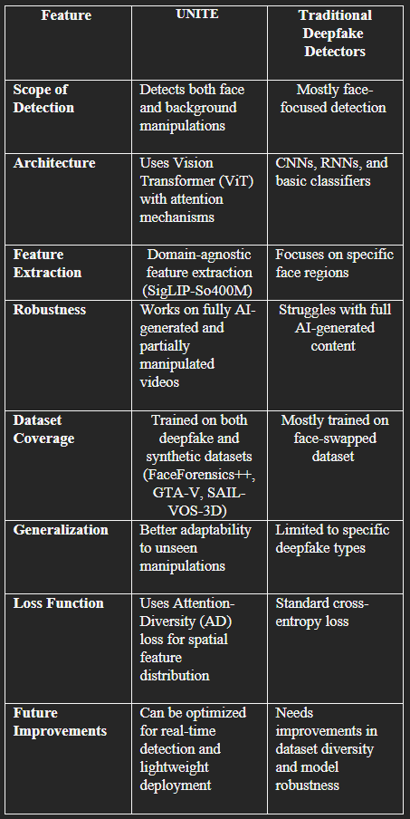

Attention-Diversity Loss (AD Loss):
- The authors acknowledge that training with cross-entropy loss only causes the model to focus most on face regions.
- To deal with this, they propose the AD loss, which encourages the attention heads to spread their attention across diverse spatial regions.
- This is achieved by specifying a loss that minimizes the within-class distances (between the pooled features and their dynamically updated feature centers) and maximizes the between-class distances
Training Strategy:
- Given the scarcity of datasets with face/background manipulations and fully synthetic content, training is performed over a mix of task-specific datasets (e.g., FaceForensics++) and synthetic ones from GTA-V and SAIL-VOS-3D.

- The full objective function is a weighted sum of the standard cross-entropy loss and the AD loss.
- The research [9] by Gunwoo Lee et al.,deepfake technology has also been utilized in audio forgery so that AI-created speech, voice cloning, and editing are achievable. While deepfakes of photos are identified with unnatural facial actions and all the above methods, deepfake sound is impossible to detect in cellular calls, SMS, and virtual assistants and is thus an enormously powerful tool for deception and misinformation.

- In order to identify such threats, researchers have proposed deepfake audio detection models but these are primarily single-channel waveform analysis-based without consideration for the actual sound propagation in the real world. Natural audio does have some patterns of reverberation dependent on the environment around it, whereas deepfake audio will not have this information.

- To counteract this, the dual channel deepfake audio detection system scans direct and reverberant sound waveforms to identify tiny acoustic anomalies that distinguish false speech from real recordings. With Direct-to-Reverberant Ratio (DRR) and multi-channel feature extraction, the system significantly enhances detection precision and is a thrilling breakthrough in AI-based speech forensics.
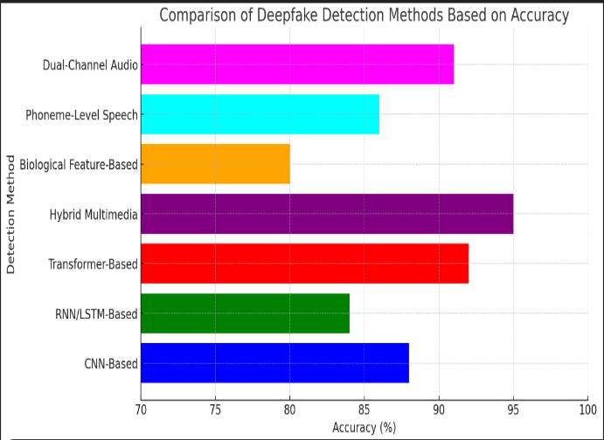
Key Innovations imposed
- Dual-Channel Model: Unlike conventional methods involving a single wave of sound, the model treats direct sound (traveling in a straight line from the source) and reverberant sound (bouncing off objects before it hits the microphone) as two distinct channels.
- Direct-to-Reverberant Ratio (DRR): The research brings out the discrepancy in DRR values between genuine and deepfake speech due to the absence of natural reverberation patterns in deepfake speech.
- New Sports Press Conference (SPC) Dataset: The authors gathered a longer, high-quality speech dataset, enabling more in-depth analysis than previous datasets.

Recent advances in deepfake detection have witnessed a broad array of new methods that bypass the loopholes of the traditional methods. Xie et al. [10] present SFake, a smartphone-deployed on-the-fly deepfake detector that selectively induces smartphone vibration to create controlled blur artifacts. Their method exploits the inability of the deepfake models to learn such physical interference, thereby enabling robust detection with high accuracy, low latency, and efficient memory usage.
- Likewise, Nguyen et al. [11] introduce FakeFormer, a Vision Transformer (ViT)-oriented deepfake detection approach. Notice the point that regular ViTs are prone to overusing global context and losing local forgery artifacts, and they introduce a learning‐based local attention module (L2-Att) as one of the proposed solutions. The module is specifically tailored to specifically focus on weak patches—weak patches in terms of blending artifacts—to enable the model to learn better finer inconsistency. Scale-up experiments show that FakeFormer is superior to state-of-the-art algorithms both in computation and generalization.
- Adding to the current literature, Chen et al. [12] approach deepfake detection from a spatio-temporal perspective. With spatial and temporal attention mechanisms, in their research, they learn the very subtle, finely localized artifacts of doctored videos. Using a spatial attention module with a boosted ResNet backbone to improve shallow texture details and a temporal attention module on optical flow to assess frame-to-frame continuity, their method can translate deepfake detection into a fine-grained classification task. Experiments verify that this two-attention approach greatly outperforms in discontinuity detection of deepfakes.
Together, these articles map out the varied terrain of deepfake detection challenges. Although Xie et al. [10] present the efficacy of real-time physical probing with mobile security as its focus, Nguyen et al. [11] enrich transformer models with vulnerability-informed local attention and Chen et al. [12] use spatio-temporal contradictions by way of incorporated attention mechanisms. Together, these solutions present an end-to-end image of current state-of-the-art technology in deepfake detection and hint at fertile grounds for future development.

Proposed Methodology
Waveform Decomposition:
The model employs a Dual Path Transformer Network (DPTNet) to separate direct and reverberant waveforms from raw speech recordings.

Feature Engineering:
The extracted waveforms are processed into different representations, including:
1D waveforms (raw signals)
2D Mel-Frequency Cepstral Coefficients (MFCCs)
2D Linear-Frequency Cepstral Coefficients (LFCCs)

Data Combination Strategies:

For the best deepfake detection, the paper addresses two data combination strategies in dual-channel mode:
Time-Axis Combination (Ct): The direct and reverberant waveforms are combined sequentially.

Channel-Axis Combination (Cch ): The reverberant and direct waveforms are stacked on top of each other, as individual channels, each with their usual properties (the former performed better).

Major Findings
Dual-Channel Processing Enhances Detection Precision:

The proposed approach outperforms traditional single-channel models because it better mimics the environmental differences between artificial and natural speech.

MFCC Features Perform Better than LFCC or Raw Waveforms:
The model performed best with MFCC features, followed by LFCC, and raw waveforms.

Best Audio Duration for Training is 6–10 Seconds:
Using very short (1–3 sec) or very long (30 sec) segments reduces accuracy, while 6–10 sec segments provide the best trade-off.

Channel-Axis Combination (Cch ) Better than Time-Axis Combination (Ct ):
Mixing direct and reverberant signals as separate channels improves model performance compared to simply mixing them in sequence.

Generalization is enhanced by training on Diverse Datasets:
The model trained with all three datasets (ASVspoof2019 + FakeAVCeleb + SPC) generalized more accurately than models trained with a single dataset.
The double-channel deepfake audio detection technique has shown superior enhancements over the conventional single-channel techniques based on environmental sound characteristics and the direct-to-reverberant ratio (DRR) for real and fake speech separation. The technique is improved in detection by considering both the direct and the reverberant waveforms and is more robust to different deepfake production techniques.
However, despite these advancements, several challenges remain.
Real-Time Implementation and future add-on's

Low-Latency Detection for Live Applications
- Current models handle pre-recorded audio, which is inappropriate for real-time monitoring in phone calls, virtual assistants, or fraud prevention systems.

- The research needs to address building lightweight architectures that process with minimal latency while achieving high accuracy.

- Some possible approaches are:
Lightweight deep learning models (e.g., TinyCNN, MobileNet) for real-time inference.

- Streaming-based analysis, where audio is handled in short segments instead of fixed-size segments.

- Frame-based DRR calculation rather than full-audio processing in order to minimize latency.

Edge AI for On-Device Deepfake Detection

Extending deepfake detection to smartphones, IoT, and embedded systems would make real-time security cloud-independent.

Challenges are:

- Low power consumption modeling with no loss in accuracy.

- Minimizing computational overhead by compressing the model (e.g., pruning, quantization, knowledge distillation).

- Integration with voice authentication systems for increased security in banking and personal devices.
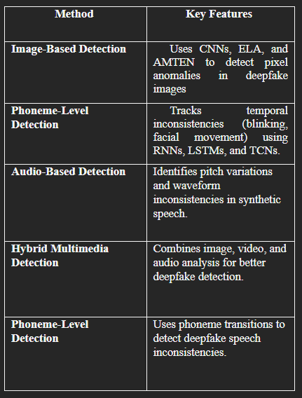
- Challenges and Future Scope

• Generalization to New Deepfakes:
Current models generalize very badly to deepfakes created by new or unseen processes. Future research can attempt to enable models to generalize over new, unseen deepfake processes through meta-learning or continuous learning methods.

• Real-Time Detection and Low-Latency Systems:
Operation detection is computationally too expensive to enable real-time detection. Edge-optimized light-weight models will be required to enable use cases like live video streaming and voice calls.

• Multi-Modality Fusion and Cross-Domain Analysis:
Most of the systems are single-modality specific (image, video, or audio), while two or more modality fusion can be utilized for robust detection. New fusion approaches based on visual, audio, and biometric modalities can be investigated in future research.

• Robustness to Adversarial Attacks:
Deepfake detectors are increasingly vulnerable to adversarial attacks. Future research would have to protect against fabrication defense such as adversarial training in order to provide detection model robustness against it.

• Dataset Diversity and Standardized Benchmarking:
The performance of a detection system also depends to a large degree upon diversity in training data sets. Dataset sizes being expanded to give greater variety of deepfakes and developing standardized benchmarks can enhance model reliability.

References
- “Deepfake Detection Using Deep Learning Methods: A Systematic and Comprehensive Review” by Arash Heidari1 , Nima Jafari Navimipour, Hasan Dag, Mehmet Unal, 2023
- “Deepfake Generation and Detection: A Benchmark and Survey” by Gan Pei1, Jiangning Zhang, Menghan Hu1, Zhenyu Zhang, Chengjie Wang, Yunsheng Wu, Guangtao Zhai, Jian Yang, Chunhua Shen, Dacheng Tao, 2025
- S. A. Khan and D.-T. Dang-Nguyen, "Deepfake Detection: A Comparative Analysis," ACM Transactions on Multimedia Computing, vol. 1, no. 1, pp. 1–28, Aug. 2023.
- K. Patil, S. Kale, J. Dhokey, and A. Gulhane, "Deepfake Detection Using Biological Features: A Survey," VJTI Research, Jan. 2023.
- T. T. Nguyen, Q. V. H. Nguyen, D. T. Nguyen, D. T. Nguyen, T. Huynh-The, S. Nahavandi, T. T. Nguyen, Q.-V. Pham, and C. M. Nguyen, "Deep Learning for Deepfake Creation and Detection: A Survey," Deakin University Research, Aug. 2022
- A. Hashimi , S. A. Shahzad, C.-W. Lin, Y. Tsao, and H.-M. Wang, “Understanding Audiovisual Deepfake Detection: Techniques, Challenges, and Human Factors," IEEE Transactions on Multimedia, Nov. 2024.
- Phoneme-Level Feature Discrepancies: A Key to Detecting Sophisticated Speech Deepfakes” by Khuiyuan Zhang, Zhongyun Hua, Rushi Lan,Yushu Zhang, Yifang Guo,2024
- “Towards a Universal Synthetic Video Detector: From Face or Background Manipulations to Fully AI-Generated Content” by Rohit Kundu1,2, Hao Xiong1, Vishal Mohanty1, Athula Balachandran1, Amit K. Roy-Chowdhury, 2024
- “Dual-Channel Deepfake Audio Detection: Leveraging Direct and Reverberant Waveforms” by Gunwoo Lee , Jungmin Lee , Minkyo Jung , Joseph Lee , Kihun Hong , (Member, Ieee), Souhwan Jung , (Member, Ieee), And Yoseob Han, 2024
- Z. Xie and J. Luo, “Shaking the Fake: Detecting Deepfake Videos in Real Time via Active Probes,” arXiv preprint arXiv:2409.10889, 2024.
- D. Nguyen, M. Astrid, E. Ghorbel, and D. Aouada, “FakeFormer: Efficient Vulnerability-Driven Transformers for Generalisable Deepfake Detection,” arXiv preprint arXiv:2410.21964, 2024.
- Y. Chen, N. Akhtar, A. Mian, and N. A. H. Haldar, “Deepfake Detection with Spatio-Temporal Consistency and Attention,” arXiv preprint arXiv:2502.08216, 2025.

