SCOPE OF WORK
BigCommerce Bundle Manager
Single-Click App for Product Bundling
Version | 1.0 — Initial Release
Date | May 2026
Status | Draft — Pending Review
Prepared by | 18th Digitech
Platform | BigCommerce

CONFIDENTIAL
This document contains proprietary and confidential information. Do not distribute without authorisation.

1. Executive Summary

BigCommerce does not offer native product bundling capabilities. Merchants who want to sell curated product groups — starter kits, complementary item sets, gift packages — currently have no platform-native way to do so, forcing workarounds through manual products, metafields, or expensive third-party solutions.

The BigCommerce Bundle Manager is a single-click app that fills this gap. It allows merchants to:

- Create named bundles from any combination of existing catalog products
- Set per-product quantities and a bundle-level price
- Assign bundles to one or more storefront categories
- Have bundle availability automatically managed — bundles are disabled when any component goes out of stock, and re-enabled when stock is restored
- Surface bundles on the component product's storefront page via a lightweight Script Manager injection

The app is delivered as a full-stack Node.js + React application deployable to any cloud platform, with a vanilla JS storefront script requiring no theme modifications.
2. Project Overview

2.1 Background
18th Digitech has identified bundling as a high-value feature gap in the BigCommerce ecosystem. Bundling is a proven upsell mechanism that increases average order value and helps clear complementary inventory. Existing workarounds require manual maintenance, are error-prone, and do not handle inventory synchronisation.

2.2 Objectives
- Provide merchants with a self-service bundling tool embedded in the BigCommerce control panel
- Automate inventory-driven bundle availability to eliminate manual maintenance
- Require zero theme code changes for the storefront integration — a single Script Manager entry is sufficient
- Build on BigCommerce platform primitives (products, metafields, webhooks, categories) to ensure long-term compatibility

2.3 Target Users
User | Description
Store Admin | Creates and manages bundles from within the BigCommerce control panel via the embedded app UI
Store Owner | Reviews bundle performance and availability; manages category placement
Store Customer | Discovers bundles via a link on component product pages; navigates directly to bundle product pages
Developer | Deploys and configures the app server; adds the Script Manager script to the storefront
3. Scope of Work

3.1 In Scope

3.1.1 App Authentication & Installation
- BigCommerce Single-Click OAuth 2.0 install flow
- Load and uninstall callback handlers with HMAC signature verification
- Session-based authentication for all admin API routes

3.1.2 Bundle Management (Admin UI)
- Create a bundle: name, description, price, category assignment, and component product selection
- Edit an existing bundle: modify all fields; component product list is re-synced
- Delete a bundle: removes the BC product and cleans up all metafields from component products
- List all bundles: paginated table with name, price, product count, stock level, and availability badge
- Real-time stock summary during creation: shows the number of complete bundles buildable from current component stock and quantities, and flags out-of-stock components

3.1.3 Product Picker
- Debounced keyword search against the BC product catalog (name or SKU)
- Thumbnail, name, SKU, price, and current stock displayed per result
- Per-product quantity selector (how many units of each product go into the bundle)
- Minimum 2 products required per bundle

3.1.4 Category Assignment
- Full category tree rendered with parent/child indentation
- Multi-select: a bundle can appear in multiple categories

3.1.5 Automatic Inventory Sync
- BigCommerce webhooks: store/product/inventory/updated and store/product/updated registered on first bundle creation (idempotent), each authenticated with a shared-secret custom header (BigCommerce does not HMAC-sign webhook bodies)
- On any inventory change, all bundles containing that product are recalculated
- Bundle availability set to "disabled" if any component has zero stock
- Bundle inventory_level set to the number of complete bundles buildable: the minimum of floor(component stock / required quantity) across all components
- Bundle re-enabled automatically when all components return to stock

3.1.6 Storefront Script (Script Manager)
- Single vanilla JS file — no npm, no build step, no theme modifications
- Detects the current product's ID from window.BCData.product_id
- Fetches bundle membership from the app's public CORS-enabled API
- Injects a styled "Available in N bundle(s)" link near the product price
- Two display modes selectable via config constant:
- Modal mode: slide-up panel listing all available bundles with thumbnail, name, and price — clicking a bundle card navigates to the bundle product page
- Redirect mode: navigates to a configurable URL with the component product ID as a query parameter, allowing theme-level filtering
- Fully self-contained styles (namespaced .bcb- CSS classes), no external dependencies
- XHR fallback for browsers without Fetch API
- Only available (non-disabled) bundles are shown to customers

3.1.7 Public Storefront API
- GET /storefront/bundles/:storeHash/:productId — CORS-open, no authentication
- Returns lightweight bundle list: id, name, price, thumbnail, URL, availability
- Filters to available bundles only before returning

3.2 Out of Scope

Feature / Capability | Notes
Bundle-level discount rules or coupon codes | Merchant sets a fixed bundle price manually
Variant-aware bundling (specific colour/size per component) | Components are product-level; default variant assumed
Bundle analytics or sales reporting dashboard | Out of scope for v1; can be added in a future phase
Customer-configurable bundles (pick-your-own items) | Fixed component sets only
Theme template modifications or custom bundle product page layout | Theme integration is limited to the Script Manager script
Multi-store / multi-currency support | Single store per app installation
Email / marketing automation triggers on bundle purchase | Not in scope
Persistent database (Redis, PostgreSQL) | Token storage uses an embedded SQLite database (better-sqlite3, single file, persists across restarts) requiring no external service; a Redis/PostgreSQL upgrade for multi-instance or zero-downtime scaling is documented as a recommended enhancement
App Marketplace listing / BC Partner certification | Client's responsibility post-delivery
4. Functional Requirements

ID | Requirement | Priority | Status
FR-01 | App installs via BC OAuth 2.0 single-click flow with HMAC-verified callbacks | Must Have | Delivered
FR-02 | Session persists for 24 hours; re-auth on session expiry | Must Have | Delivered
FR-03 | Merchant can create a bundle with name, description, price, categories, and 2+ products | Must Have | Delivered
FR-04 | Merchant can edit all bundle fields; component list is re-synced on save | Must Have | Delivered
FR-05 | Merchant can delete a bundle; all metafields are cleaned up from component products | Must Have | Delivered
FR-06 | Bundle list shows name, price, product count, stock level, and availability status | Must Have | Delivered
FR-07 | Bundle is set to "disabled" when any component product reaches zero stock | Must Have | Delivered
FR-08 | Bundle inventory_level equals the number of complete bundles buildable: the minimum of floor(component stock / required quantity) across all components | Must Have | Delivered
FR-09 | Inventory sync is triggered automatically via BC webhook on every inventory change | Must Have | Delivered
FR-10 | Bundle is re-enabled automatically when all components return to stock | Must Have | Delivered
FR-11 | Merchant can assign a bundle to one or more store categories | Must Have | Delivered
FR-12 | Category picker renders full parent/child tree with depth indentation | Should Have | Delivered
FR-13 | Storefront script detects product page and checks bundle membership via API | Must Have | Delivered
FR-14 | Bundle link is injected near the product price with a count of available bundles | Must Have | Delivered
FR-15 | Modal mode: accessible slide-up panel with bundle cards (thumbnail, name, price, link) | Must Have | Delivered
FR-16 | Redirect mode: navigate to configurable URL with component product ID as query param | Should Have | Delivered
FR-17 | Script is added via Script Manager — no theme file edits required | Must Have | Delivered
5. Technical Architecture

5.1 System Components

Component | Technology | Responsibility
App Server | Node.js 18+ / Express 4 | OAuth callbacks, session management, REST API, webhook receiver, serves built React SPA
Admin UI | React 18 + BigDesign | Embedded SPA inside BC control panel iframe; bundle CRUD, product picker, category picker
BC API Client | Axios / BC v2+v3 API | Product CRUD, metafield management, category retrieval, webhook registration
Bundle Service | Node.js module | All bundle business logic: create, update, delete, sync, metafield orchestration
Storefront API | Express route (CORS) | Public endpoint returning available bundles for a given product; called by storefront script
Storefront Script | Vanilla JS (ES5+) | Injected via Script Manager; detects product page, fetches bundles, renders modal or redirect

5.2 Data Model
Bundles are stored as native BigCommerce products. No external database is required. All bundle metadata is held in product metafields with the namespace bc_bundles, which is flagged as read_and_sf_access (storefront-readable).

Entity | Namespace / Key | Stored On | Value
Bundle config | bc_bundles / bundle_components | Bundle product | JSON: {is_bundle, products:[{product_id, qty, name, sku, thumbnail}]}
Membership | bc_bundles / bundle_memberships | Component product | JSON: {bundle_ids:[...product IDs...]}
Bundle marker | bc_bundles / is_bundle | Bundle product | "true" — used to identify bundle products in list queries

5.3 API Endpoints
Method | Path | Description
GET | /auth | OAuth install callback — exchanges code for access token
GET | /load | Load callback — verifies signed payload, starts session
GET | /uninstall | Uninstall callback — removes token from store
GET | /api/bundles | List all bundles (session-guarded)
POST | /api/bundles | Create a bundle
GET | /api/bundles/:id | Get a single bundle
PUT | /api/bundles/:id | Update a bundle
DELETE | /api/bundles/:id | Delete a bundle
GET | /api/products/search?q= | Product search for picker
GET | /api/categories | Category list for picker
POST | /webhooks/inventory | BC inventory webhook receiver (public)
GET | /storefront/bundles/:hash/:productId | Public CORS-open API for storefront script

5.4 Technology Stack
Layer | Technology | Notes
Runtime | Node.js 18+ | LTS; required for native fetch and modern crypto
Web framework | Express 4 | Lightweight; familiar to most Node.js developers
Session | express-session | In-memory store for v1; documented Redis upgrade path
HTTP client | Axios | BC API calls from server side
Frontend | React 18 + Vite | Fast builds; SPA served as static files from Express
UI library | @bigcommerce/big-design | Official BC component library; consistent look and feel
Routing | react-router-dom v6 | Client-side SPA routing
Storefront script | Vanilla JS (ES5+) | No dependencies; works across all BC themes
6. Deliverables

# | Deliverable | Format | Status
D-01 | Backend application — server, routes, services | Node.js source | Complete
D-02 | Admin UI — React SPA with BigDesign components | React / JSX source | Complete
D-03 | Storefront Script — bundle-link.js for Script Manager | Vanilla JS | Complete
D-04 | Configuration template — .env.example with all required variables | Text / .env | Complete
D-05 | Technical README — setup, deployment, webhook, Script Manager instructions | Markdown | Complete
D-06 | Scope of Work document (this document) | Word (.docx) | Complete
7. Assumptions & Dependencies

7.1 Assumptions
- The client will register a BigCommerce App in the Developer Portal and provide Client ID and Client Secret
- The app will be hosted at a publicly accessible HTTPS URL prior to installation in any store
- Products to be bundled already exist in the merchant's BigCommerce catalog with inventory tracking enabled
- The merchant's theme outputs window.BCData.product_id on product pages — this is standard for all BC Stencil themes
- The hosting environment supports persistent Node.js processes (not serverless) for session storage (OAuth tokens are persisted in an embedded SQLite database and survive restarts)
- One app instance serves one store installation; multi-tenant support requires a persistent token database

7.2 Dependencies
Dependency | Version / Tier | Purpose
BigCommerce Management API | v2 / v3 | Products, metafields, categories, webhooks
BigCommerce OAuth | Standard | App install and load authentication
BigCommerce Webhooks | store/product/inventory/updated, store/product/updated | Real-time inventory change notifications
Node.js | 18 LTS+ | Server runtime
@bigcommerce/big-design | 1.1.x | Admin UI component library
Hosting platform (HTTPS) | Client's choice | Railway, Render, Heroku, VPS — any Node.js host with HTTPS
8. Risks & Mitigations

Risk | Severity | Mitigation
Server restart loses the in-memory session store, so an admin re-authenticates on next load; OAuth tokens persist in SQLite, so background webhook syncs continue uninterrupted | Medium | Document clearly in README. Tokens are persisted in SQLite so syncs survive restarts; an upgrade path to a Redis/PostgreSQL token store is pre-designed for horizontal scaling. Webhook failures are logged and non-fatal — sync resumes on next inventory change.
BigCommerce API rate limits (150–400 req/min) may throttle large bundle operations with many components | Low | Bundle creation parallelises metafield writes with Promise.all. For stores with very large catalogs, consider sequential batching in a future version.
Storefront theme does not expose window.BCData.product_id | Low | All BC Stencil themes include BCData. For legacy Blueprint themes, the script silently exits if BCData is absent. Script placement (Pages with Products) limits execution to relevant pages.
Bundle product page URL path changes after creation | Low | Bundle cards use the custom_url.url from the BC API, which always reflects the current URL. No hardcoded paths stored.
BigCommerce API schema changes breaking metafield structure | Low | Metafields use a stable bc_bundles namespace. The app only uses standard v3 metafield endpoints with no undocumented fields.
9. High-Level Effort Estimate

Work Item | Estimate | Notes
Backend: OAuth, session, server setup | 0.5 days | Standard BC OAuth pattern
Backend: BigCommerce API service layer | 1 day | Products, metafields, categories, webhooks
Backend: Bundle service (create/update/delete/sync) | 1.5 days | Core business logic
Backend: API routes + storefront + webhook routes | 0.5 days | Thin route layer
Frontend: Scaffold + App + routing | 0.5 days | Vite + React + BigDesign setup
Frontend: BundleList page | 0.5 days | Table, delete modal, empty state
Frontend: BundleForm + ProductPicker + CategoryPicker | 1.5 days | Most complex UI work
Frontend: Create / Edit pages | 0.5 days | Wires form to API
Storefront Script (both modal + redirect modes) | 1 day | Vanilla JS, inline CSS, modal UI
Integration testing & bug fixes | 1 day | End-to-end on dev store
Documentation (README + Scope doc) | 0.5 days
TOTAL | ~8 days | 1–2 developer sprint

Note: Estimates assume a developer familiar with the BigCommerce API and React. Estimates exclude deployment environment setup (hosting, DNS, SSL certificate), BC App Marketplace submission, and any post-delivery change requests.
10. Acceptance Criteria

The delivery is considered complete when all of the following criteria are met:

- App installs successfully on a BigCommerce test store via OAuth with no errors
- A bundle can be created with 2+ products, a price, and a category; it appears as a purchasable product on the storefront
- Reducing a component product's stock to 0 in BC disables the bundle within the webhook response window (typically < 10 seconds)
- Restoring stock re-enables the bundle and updates its inventory level to the new buildable bundle count
- The storefront script, when added via Script Manager, shows a bundle link on the component product's page
- Clicking the link opens the bundle modal (or redirects, per configuration) with the correct bundles listed
- Deleting a bundle removes the BC product and cleans up all metafields on component products
- All source code, README, and this scope document are delivered to the client's repository
11. Change Management

Any features or requirements not listed in the In Scope section of this document are considered out of scope for this engagement. Requests for additional functionality will be assessed and quoted separately.

Changes to in-scope items that materially affect effort (e.g. adding variant-aware bundling, persistent database, or multi-store support) will require a change order signed by both parties before work commences.

Version | Date | Author | Changes
1.0 | May 2026 | 18th Digitech | Initial document

Approved by:

Client Representative | 18th Digitech Representative
Name: ___________________________ | Name: ___________________________
Signature: ______________________ | Signature: ______________________
Date: ___________________________ | Date: ___________________________

UI Screens & User Flow

The following screens illustrate the end-to-end flow for creating and managing bundles in the BigCommerce Bundle Manager app. All screens show the app embedded inside the BigCommerce control panel interface.

# | Screen | Description
1 | Bundle Manager — Home | Lists all existing bundles with status, stock, price, and quick-action edit/delete buttons. Entry point for creating a new bundle.
2 | Create Bundle — Step 1: Details | Merchant enters the bundle name, description, and price. A live savings hint compares the bundle price to the sum of individual product prices.
3 | Create Bundle — Step 2: Products | Debounced product search with live results. Selected products appear in a table with per-product quantity steppers. Bundle inventory preview shows the number of complete bundles buildable from current stock and quantities.
4 | Create Bundle — Step 3: Categories | Category tree with parent/child indentation and multi-select. A summary panel on the right previews the complete bundle before saving.
5 | Storefront — Product Page + Modal | A component product page showing the injected bundle link badge. Clicking the badge opens the slide-up modal listing all available bundles that include this product.

Screen 1 Bundle Manager — Home

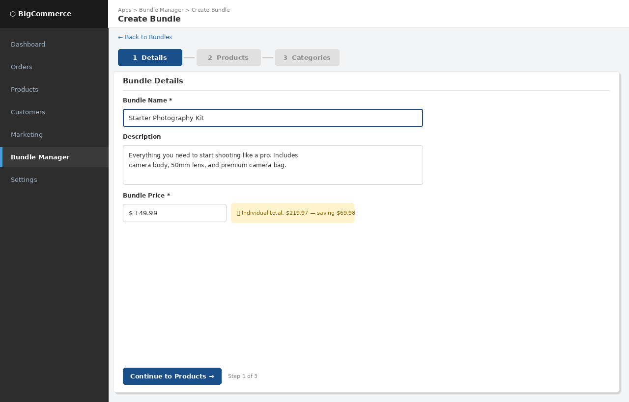
Figure 1 — Bundle list view embedded in the BigCommerce control panel
The home screen lists all bundles in a data table. Each row shows:
- Bundle name with thumbnail
- Bundle price and number of component products
- Current bundle stock level (minimum across all components)
- Availability badge — green for Available, red for Unavailable (auto-set by inventory webhook)
- Edit and Delete action buttons

The "Create Bundle" button in the top-right launches the three-step creation flow.

Screen 2 Create Bundle — Step 1: Details

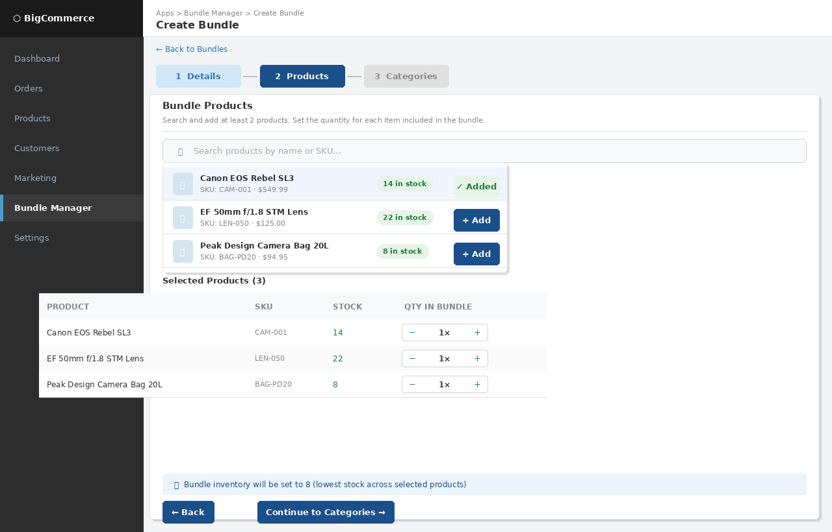
Figure 2 — Step 1: Bundle name, description, and price entry
Step 1 collects the core bundle metadata:
- Bundle Name — required, displayed on the storefront product page
- Description — optional, shown in the product description
- Bundle Price — required, set by the merchant. A savings hint dynamically calculates the difference between the bundle price and the sum of individual product prices, giving merchants an at-a-glance view of the discount they're offering customers.

A three-step progress indicator at the top keeps merchants oriented in the flow. Completed steps are shown in a lighter blue; the current step in solid navy.

Screen 3 Create Bundle — Step 2: Products

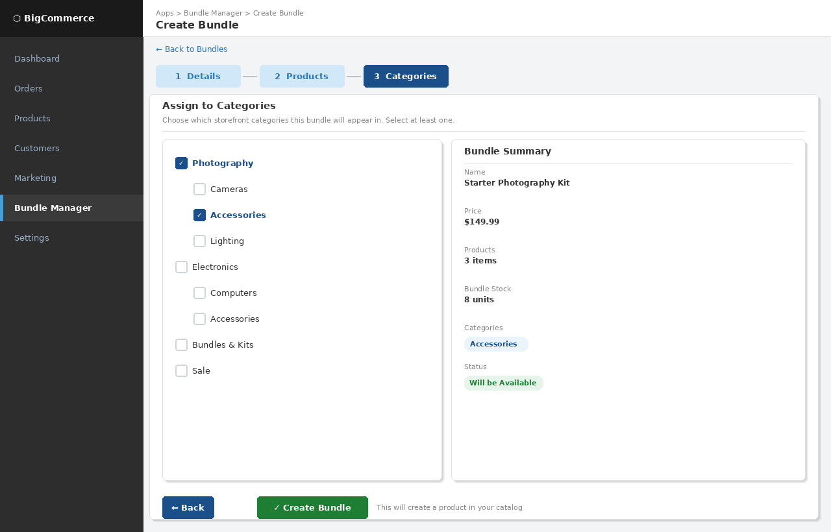
Figure 3 — Step 2: Product search, selection, and quantity configuration
Step 2 is the product picker:
- A search field with debounced live results — results appear after 350ms without requiring a button press
- Each search result shows a thumbnail, product name, SKU, price, and current stock badge
- Clicking "Add" moves the product into the selected products table below
- The selected products table provides a per-product quantity stepper — merchants set how many units of each product are included in one bundle
- A dynamic inventory preview banner at the bottom shows the calculated bundle stock level (minimum across all selections) and warns if any product is out of stock

A minimum of 2 products is enforced with an inline validation message.

Screen 4 Create Bundle — Step 3: Categories & Confirm

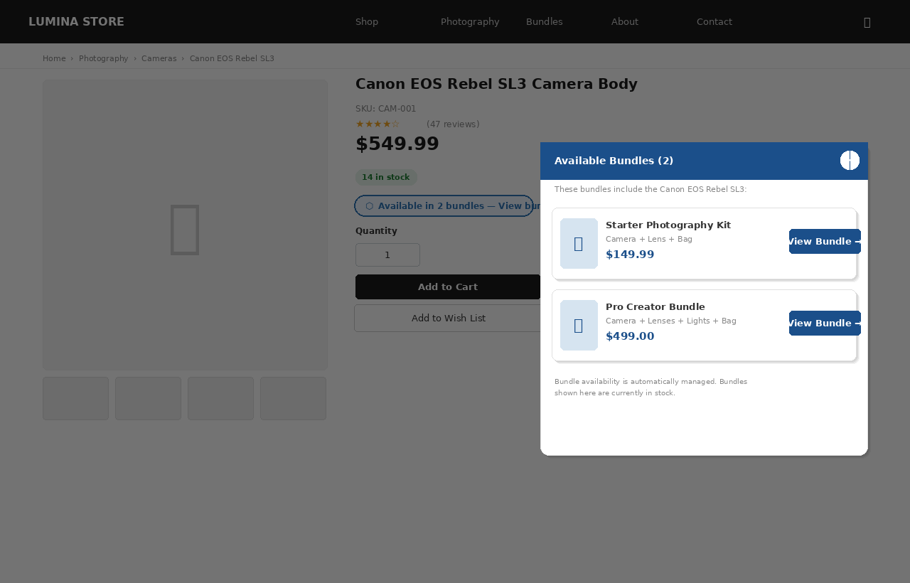
Figure 4 — Step 3: Category assignment and bundle summary before saving
Step 3 presents two panels side by side:
- Left panel — Category tree: the full store category hierarchy rendered with depth-based indentation. Merchants can select multiple categories by checking any combination of checkboxes. This determines which storefront category pages the bundle product appears on.
- Right panel — Bundle summary: a read-only preview of the complete bundle (name, price, product count, calculated stock, selected categories, and projected status). This gives merchants a final review before committing.

Clicking "Create Bundle" calls the API which creates the BigCommerce product, writes all metafields, and registers the inventory webhook. The merchant is then redirected back to the Bundle Manager home screen where the new bundle immediately appears.

Screen 5 Storefront — Product Page with Bundle Modal


Figure 5 — Storefront product page showing the bundle link badge and modal overlay
The storefront integration is handled entirely by a single JavaScript file added via BigCommerce's Script Manager — no theme modifications are required.

On any product page where that product belongs to one or more bundles:
- A styled pill badge "Available in N bundles — View bundles" is automatically injected near the product price
- The badge only appears if there are available (in-stock) bundles containing this product
- Clicking the badge opens a slide-up modal panel listing each available bundle with its thumbnail, name, price, and a direct link to the bundle product page
- An alternative redirect mode can be configured so clicking the badge navigates to a filtered category page instead of opening the modal

The modal is fully accessible: it traps keyboard focus, closes on Escape or overlay click, and carries ARIA dialog attributes. All styling is self-contained with namespaced CSS classes (.bcb-*) to prevent conflicts with theme styles.

Automatic Inventory Sync Flow

The diagram below illustrates what happens when a component product's stock changes:

Step 1 Inventory changes in the store
A merchant updates product stock in BigCommerce, an order is fulfilled, or an import runs.
Step 2 BC fires webhook
BigCommerce sends a POST to /webhooks/inventory with the changed product ID and store hash.
Step 3 App identifies affected bundles
The bundle service reads the bundle_memberships metafield on the changed product to find all bundles that include it.
Step 4 Stock recalculated
For each affected bundle, the app fetches current stock for all component products and calculates how many complete bundles can be built (the minimum of floor(stock / required quantity)).
Step 5 Bundle updated in BigCommerce
The app calls the BC products API to set availability (available / disabled) and inventory_level on the bundle product.
Step 6 Storefront reflects change
The bundle product is immediately available or unavailable on the storefront. The storefront script will not show disabled bundles.

The entire sync cycle — from webhook receipt to bundle availability update — completes in under 2 seconds in typical conditions, depending on BigCommerce API response times.

