UI Screens & User Flow

The following screens illustrate the end-to-end flow for creating and managing bundles in the BigCommerce Bundle Manager app. All screens show the app embedded inside the BigCommerce control panel interface.

# | Screen | Description
1 | Bundle Manager — Home | Lists all existing bundles with status, stock, price, and quick-action edit/delete buttons. Entry point for creating a new bundle.
2 | Create Bundle — Step 1: Details | Merchant enters the bundle name, description, and price. A live savings hint compares the bundle price to the sum of individual product prices.
3 | Create Bundle — Step 2: Products | Debounced product search with live results. Selected products appear in a table with per-product quantity steppers. Bundle inventory preview shows the minimum stock across all selected products.
4 | Create Bundle — Step 3: Categories | Category tree with parent/child indentation and multi-select. A summary panel on the right previews the complete bundle before saving.
5 | Storefront — Product Page + Modal | A component product page showing the injected bundle link badge. Clicking the badge opens the slide-up modal listing all available bundles that include this product.

Screen 1 Bundle Manager — Home

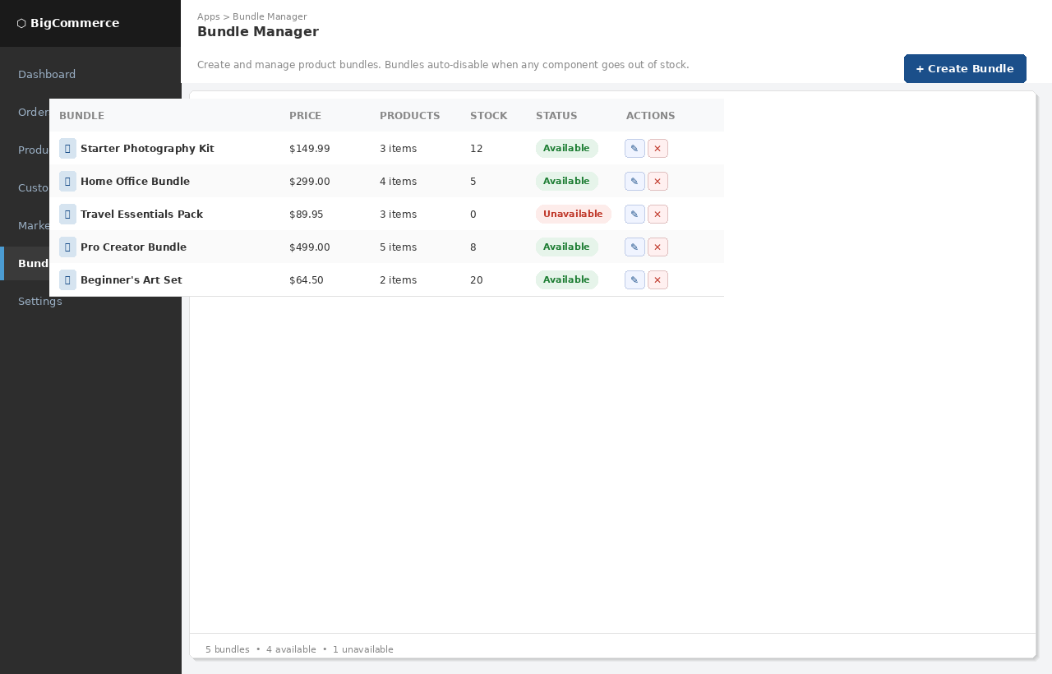
Figure 1 — Bundle list view embedded in the BigCommerce control panel
The home screen lists all bundles in a data table. Each row shows:
- Bundle name with thumbnail
- Bundle price and number of component products
- Current bundle stock level (minimum across all components)
- Availability badge — green for Available, red for Unavailable (auto-set by inventory webhook)
- Edit and Delete action buttons

The "Create Bundle" button in the top-right launches the three-step creation flow.

Screen 2 Create Bundle — Step 1: Details

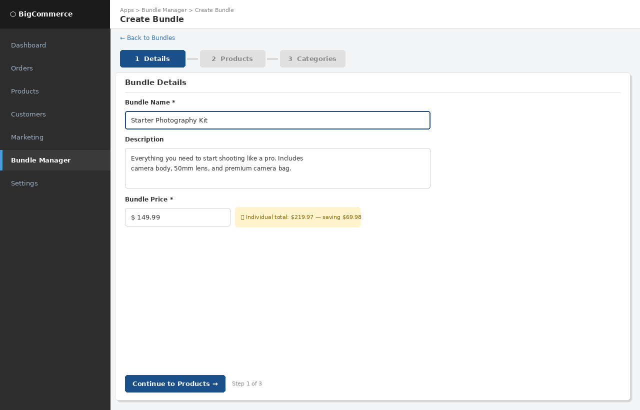
Figure 2 — Step 1: Bundle name, description, and price entry
Step 1 collects the core bundle metadata:
- Bundle Name — required, displayed on the storefront product page
- Description — optional, shown in the product description
- Bundle Price — required, set by the merchant. A savings hint dynamically calculates the difference between the bundle price and the sum of individual product prices, giving merchants an at-a-glance view of the discount they're offering customers.

A three-step progress indicator at the top keeps merchants oriented in the flow. Completed steps are shown in a lighter blue; the current step in solid navy.

Screen 3 Create Bundle — Step 2: Products

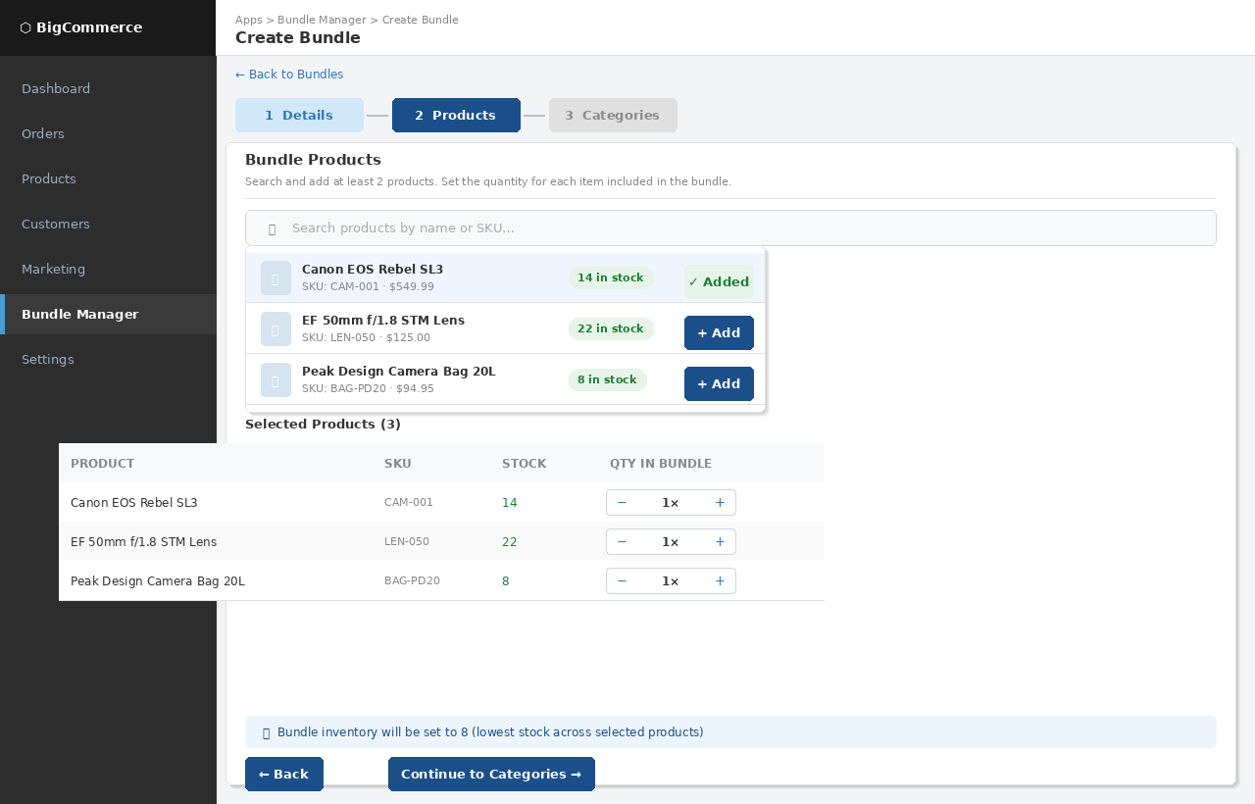
Figure 3 — Step 2: Product search, selection, and quantity configuration
Step 2 is the product picker:
- A search field with debounced live results — results appear after 350ms without requiring a button press
- Each search result shows a thumbnail, product name, SKU, price, and current stock badge
- Clicking "Add" moves the product into the selected products table below
- The selected products table provides a per-product quantity stepper — merchants set how many units of each product are included in one bundle
- A dynamic inventory preview banner at the bottom shows the calculated bundle stock level (minimum across all selections) and warns if any product is out of stock

A minimum of 2 products is enforced with an inline validation message.

Screen 4 Create Bundle — Step 3: Categories & Confirm

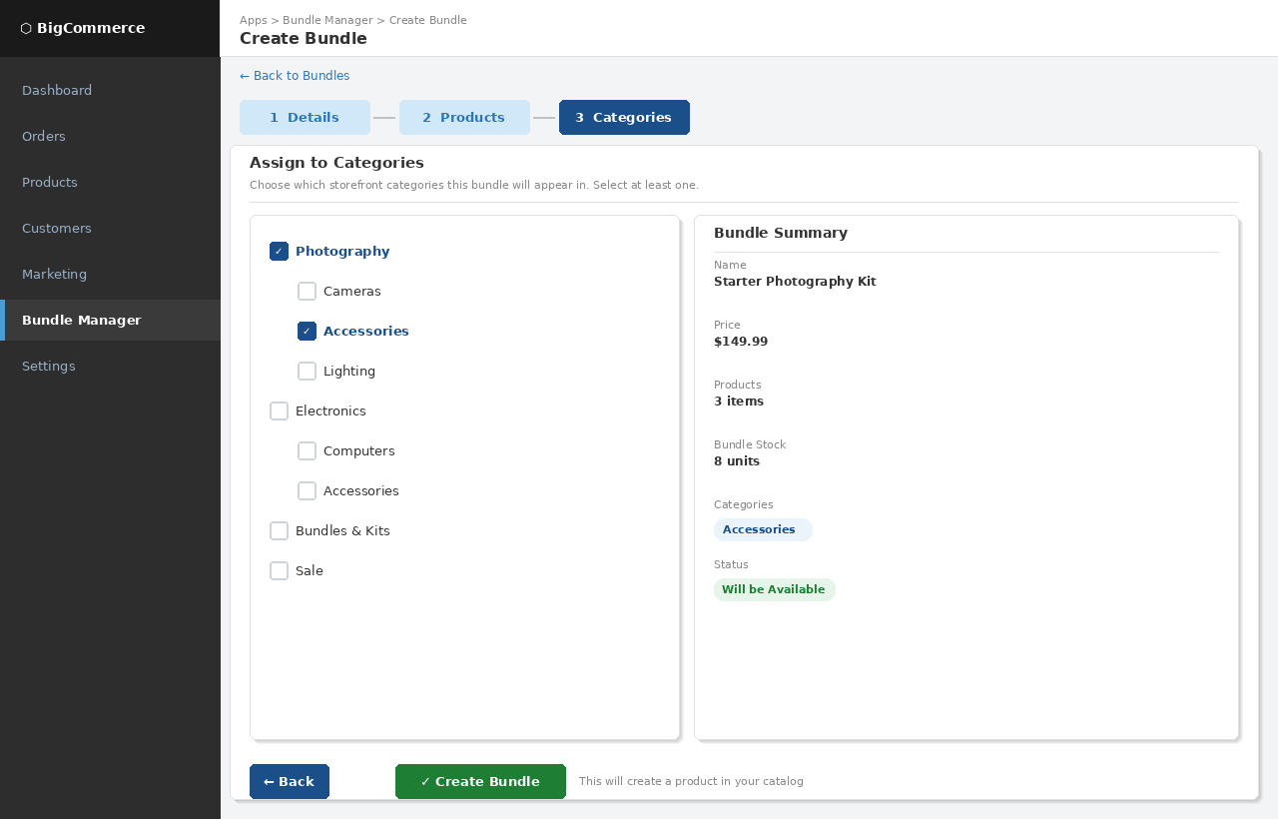
Figure 4 — Step 3: Category assignment and bundle summary before saving
Step 3 presents two panels side by side:
- Left panel — Category tree: the full store category hierarchy rendered with depth-based indentation. Merchants can select multiple categories by checking any combination of checkboxes. This determines which storefront category pages the bundle product appears on.
- Right panel — Bundle summary: a read-only preview of the complete bundle (name, price, product count, calculated stock, selected categories, and projected status). This gives merchants a final review before committing.

Clicking "Create Bundle" calls the API which creates the BigCommerce product, writes all metafields, and registers the inventory webhook. The merchant is then redirected back to the Bundle Manager home screen where the new bundle immediately appears.

Screen 5 Storefront — Product Page with Bundle Modal

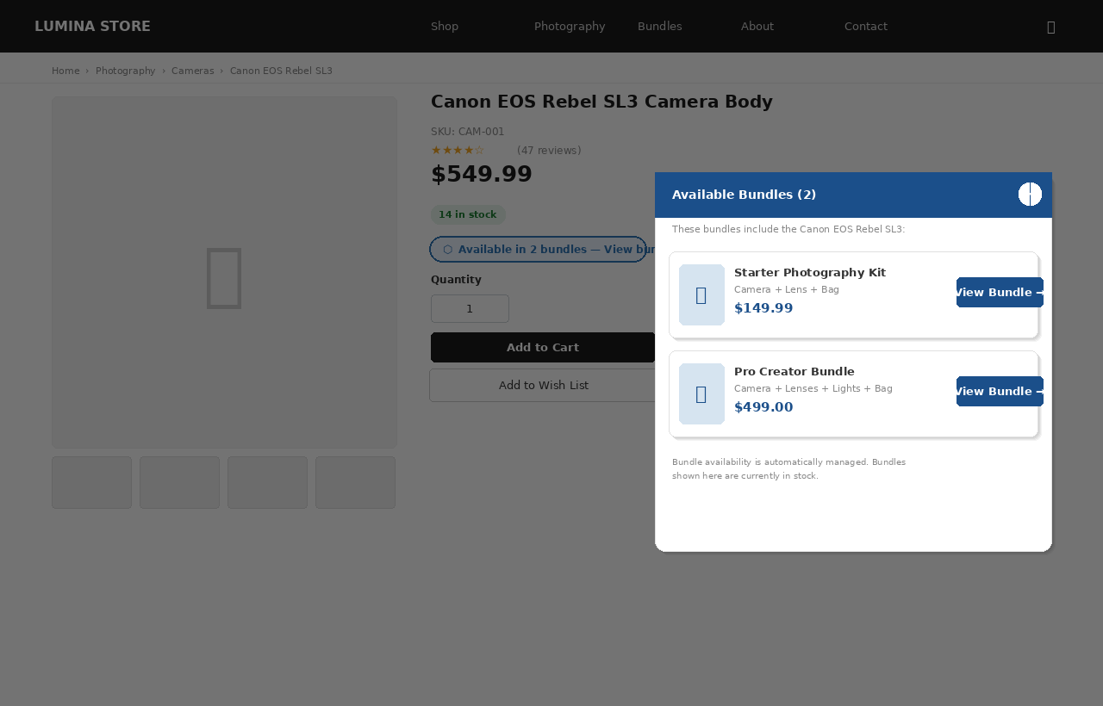
Figure 5 — Storefront product page showing the bundle link badge and modal overlay
The storefront integration is handled entirely by a single JavaScript file added via BigCommerce's Script Manager — no theme modifications are required.

On any product page where that product belongs to one or more bundles:
- A styled pill badge "Available in N bundles — View bundles" is automatically injected near the product price
- The badge only appears if there are available (in-stock) bundles containing this product
- Clicking the badge opens a slide-up modal panel listing each available bundle with its thumbnail, name, price, and a direct link to the bundle product page
- An alternative redirect mode can be configured so clicking the badge navigates to a filtered category page instead of opening the modal

The modal is fully accessible: it traps keyboard focus, closes on Escape or overlay click, and carries ARIA dialog attributes. All styling is self-contained with namespaced CSS classes (.bcb-*) to prevent conflicts with theme styles.

Automatic Inventory Sync Flow

The diagram below illustrates what happens when a component product's stock changes:

Step 1 Inventory changes in the store
A merchant updates product stock in BigCommerce, an order is fulfilled, or an import runs.
Step 2 BC fires webhook
BigCommerce sends a POST to /webhooks/inventory with the changed product ID and store hash.
Step 3 App identifies affected bundles
The bundle service reads the bundle_memberships metafield on the changed product to find all bundles that include it.
Step 4 Stock recalculated
For each affected bundle, the app fetches current stock for all component products and calculates the minimum.
Step 5 Bundle updated in BigCommerce
The app calls the BC products API to set availability (available / disabled) and inventory_level on the bundle product.
Step 6 Storefront reflects change
The bundle product is immediately available or unavailable on the storefront. The storefront script will not show disabled bundles.

The entire sync cycle — from webhook receipt to bundle availability update — completes in under 2 seconds in typical conditions, depending on BigCommerce API response times.

