**Predicting the appropriate location for ‘Medical Supply Store’ in Bronx, NY**

Archit Banwari

Aug, 2021

1. **Introduction:**

Healing-Touch is a famous pharmaceutical company that wishes to establish a 'Medical Supply Store' somewhere in Bronx Area. In this project we will try to find an optimal location for a 'Medical Supply'. Specifically, this report will be targeted to Healing-Touch Pharmaceuticals. Bronx may have some 'Medical Supply stores' in some neighborhoods already. So our target would be to get an overview about the locations having lack of Medical Supply stores.

We will use data science to generate a few most neighborhoods based on these criteria and suggestions can be made to client based on our analysis.

1. **Data acquisition and cleaning:**
2. **Data Sources:**

Following data sources will be needed to extract/generate the required information:

* Coordinate of Bronx, NY neighborhood can be extracted from the available New-York json data
* Coordinate of Bronx, NY city centre can be generated by using Google Maps API geocoding
* All kind of Venues in every neighborhood will be obtained using Foursquare API

1. **Data Cleaning:**

Data source is in json file format so first we needed to convert the Json file to Dataframe structure for ease of analysis. It contains other Boroughs as well other than Bronx. So we should filter out all other Bronx. After that, we need to find out the least common venues in all the neighborhoods of Bronx area. Whatever venues have ‘Medical Supply Store’ as the least common venue would be considered for the interest of stakeholders.

1. **Data exploration and Analysis – Segmentation and clustering :**

First of all, all the nearby venues of the Bronx neighborhoods were extracted using FourSquare API.

All the neighborhoods were grouped for several rows and by taking the mean of the frequency of occurrence of each category.

Venues were sorted in ascending order of frequency for each neighborhood of Bronx.

Some basic explanatory data analysis was done and some additional info from our raw data was found for the neighborhoods having Medical Supplies as the least occurring venue.

Distance of candidate neighborhoods from Bronx City Centre was calculated

Below neighborhoods were found as the ones having ‘Medical Supply Store’ as least occurring venue.

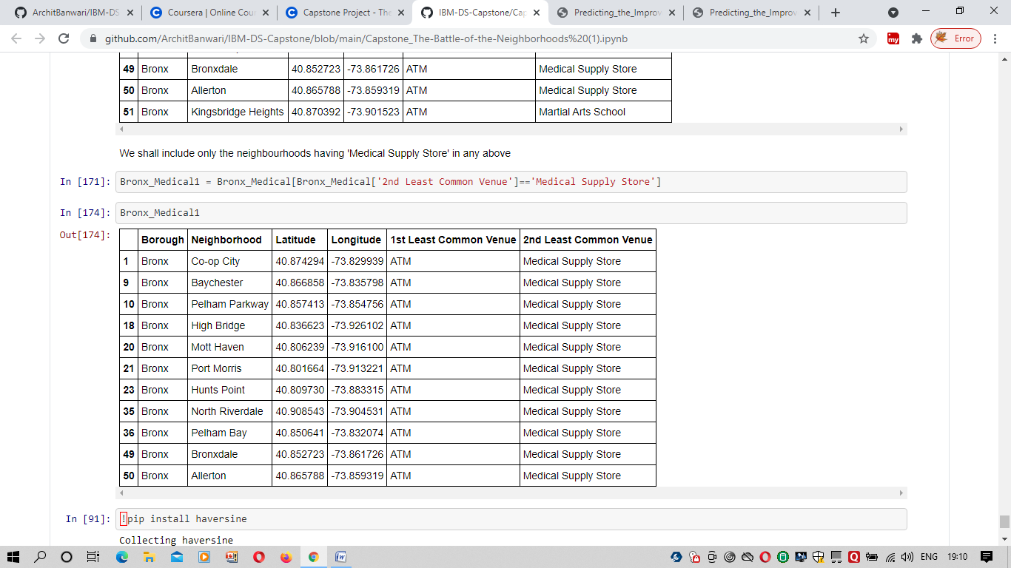

--------------------Distance from City Centre-------------------------

------Neighbourhood------------------------Distance from Bronx Centre (kms)------

Co-op City 5.12

Baychester 4.24

Pelham Parkway 2.33

High Bridge 4.15

Mott Haven 5.49

Port Morris 5.79

Hunts Point 4.12

North Riverdale 7.22

Pelham Bay 3.94

Bronxdale 1.57

Allerton 2.68

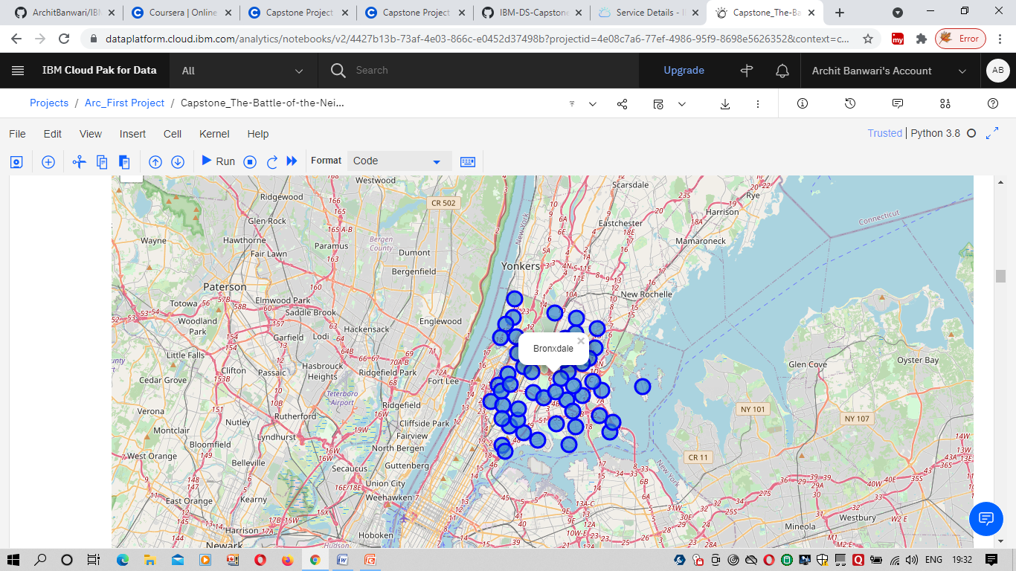

1. **Results and Discussion :**

Our analysis shows that although there are quite many neighborhoods in Bronx where lack of Medical Supply can be found, we have shortlisted the list where 'Medical Supply' is the least found venue.

After directing our attention to this more narrow area of interest, we found out the distance between the shortlisted neighborhoods and the Bronx city centre.

Result of all this is 11 neighborhoods with the distance from city centre ranging between 1.5 to 6 kms. Client can now be provided with these options for creating a 'Medical Supply Centre'

1. **Conclusion :**

Purpose of this project was to identify Bronx neighborhood close to center with low number of 'Medical Supply Centre' in order to aid stakeholders in narrowing down the search for optimal location. By calculating 'Medical Supply density' density distribution from Foursquare data we have first identified neighborhood that justify further analysis by stakeholders.

Final decision on optimal 'Medical Supply Centre' location will be made by stakeholders based on specific characteristics of neighborhoods and locations in every recommended zone, taking into consideration additional factors like social and economic dynamics of every neighborhood, convenience of transportation, etc.