Card Fraud Triage — Phase 1 GMM Report
Team T047 · Project 26 · October 21, 2026

Summary
A 3-component Gaussian Mixture Model trained only on legitimate transactions reaches a test average precision (AP) of 0.612 (95% CI 0.485–0.743), about 470× the 0.13% random baseline. At a 0.5% false-alarm budget fixed on validation, it catches 56 of 74 test frauds (75.7%) with a 0.28% false-positive rate. Of its 50 highest-scored alerts, 42 (84%) are real fraud.
Every modelling decision is made without touching the test period:
- Fraud labels used for feature ranking come from the training period only.
- The feature set, the number of components K, the random seed and the alarm threshold are all chosen on validation.
- The test set is scored once, and every test metric carries a 1,000-sample bootstrap confidence interval.
The central modelling finding is that GMM fraud-ranking quality depends heavily on which EM solution is reached. The same configuration can score anywhere from 0.34 to 0.67 validation AP depending on the random seed, so results are reported across 3 seeds per setting.
Notebook | Purpose | Key output
01 Data inspection & split | Clean, dedupe, chronological split | 169,893 legit train / 56,745 val / 56,746 test
02 EDA | Feature behaviour on the training period | log(1+Amount); 12-feature list saved to configs/gmm_features.json
03 GMM experiments | K = 1–8 × 3 seeds × 2 feature sets | Champion: all 29 features, K=3, validation AP 0.666
04 GMM evaluation | Threshold, test metrics, confidence intervals | Test AP 0.612; recall 75.7% at 0.28% FPR; top-50 precision 84%

Problem and dataset
The project (Team T047, Project 26) asks whether a density model of normal spending can rank suspicious card transactions well enough for an analyst triage queue. Phase 1 uses a GMM scored by negative log-likelihood (NLL).
The data is the public European cardholder dataset creditcard.csv: 284,807 transactions over 48 hours, with 492 frauds (0.173%). Features are Time (seconds from the first transaction), Amount in euros, and 28 anonymised PCA components V1–V28. There are no missing values. Because V1–V28 are anonymised, results cannot be explained in business terms.
With fraud this rare, accuracy is meaningless: predicting “normal” for everything scores 99.8%. The project therefore reports average precision, recall at a fixed false-alarm budget, and precision in the top-k alerts.

Data inspection and split (notebook 01)
After removing 1,081 exact duplicate rows (19 of them frauds), 283,726 transactions remain. They are sorted by Time and split 60/20/20 chronologically, so the model is always tested on transactions later than those it learned from, as a bank would deploy it.
Split | Time share | Rows | Frauds | Fraud rate
Train (legit only) | First 60% | 169,893 | 0 (342 removed) | —
Validation | Next 20% | 56,745 | 57 | 0.10%
Test | Last 20% | 56,746 | 74 | 0.13%

Removing fraud from training is the defining choice of the project: the GMM learns only what legitimate spending looks like, and anything it finds unlikely is flagged. Amounts are heavily right-skewed (median €22, mean €88, max €25,691). With only 57 validation frauds, each fraud caught or missed moves validation recall by about 1.8 points.

Exploratory analysis (notebook 02)
The EDA supports three modelling choices: log-transform Amount, build a candidate reduced feature set, and use a mixture rather than a single Gaussian. Every analysis that uses fraud labels runs on the training period only (170,235 rows: 169,893 normal, 342 fraud), so nothing here sees validation or test labels.
Time of day. Legitimate volume drops sharply between roughly 1 and 6 AM, while fraud is spread across the day with peaks near 2 AM and 11 AM. Fraud is therefore proportionally far more common at night. Hour is derived as (Time / 3600) mod 24, which assumes recording started at midnight.
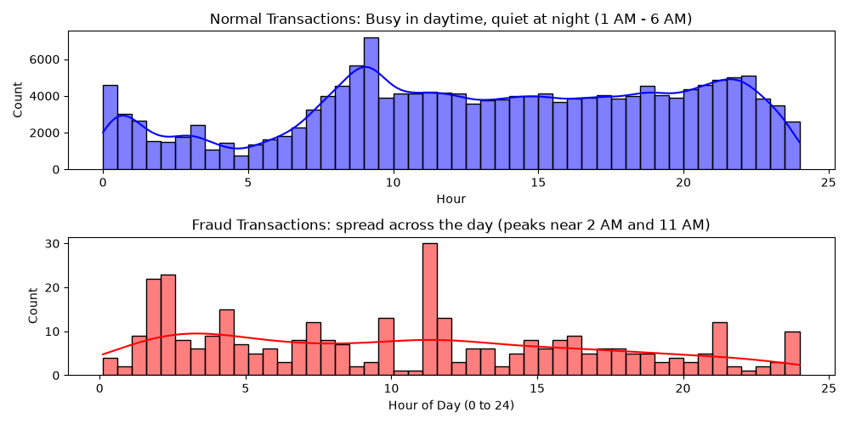
Figure 1. Hourly distribution of normal vs fraud transactions, training period
Amount. Raw amounts have a skewness of 15.77; log(1 + Amount) brings this to 0.16, close to symmetric and much better suited to a Gaussian model.
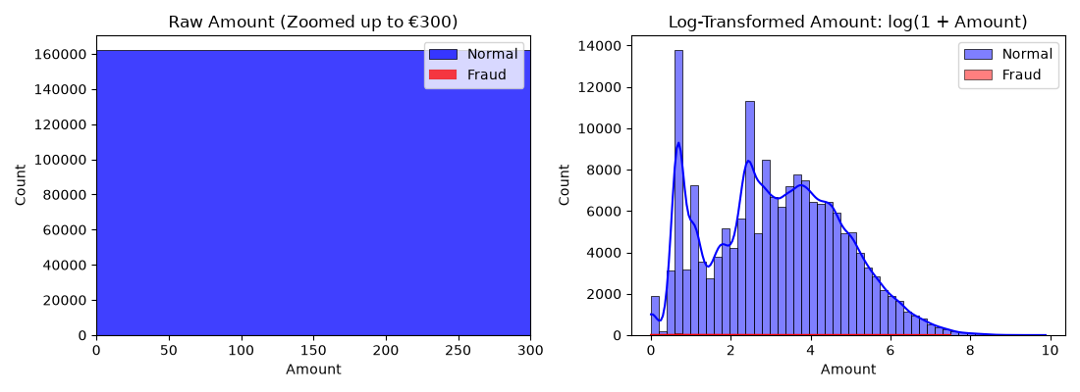
Figure 2. Raw vs log-transformed amount, training period
Separating features. A two-sample Kolmogorov–Smirnov (KS) test ranks V1–V28 by how differently they are distributed for fraud and normal transactions. The top 11 plus Amount form the 12-feature candidate set, saved to configs/gmm_features.json.
Rank | Feature | KS statistic | In 12-feature set
1 | V14 | 0.847 | Yes
2 | V10 | 0.824 | Yes
3 | V12 | 0.792 | Yes
4 | V11 | 0.776 | Yes
5 | V17 | 0.776 | Yes
6 | V4 | 0.774 | Yes
7 | V3 | 0.735 | Yes
8 | V16 | 0.732 | Yes
9 | V7 | 0.712 | Yes
10 | V2 | 0.658 | Yes
11 | V9 | 0.580 | Yes
12 | V18 | 0.568 | No

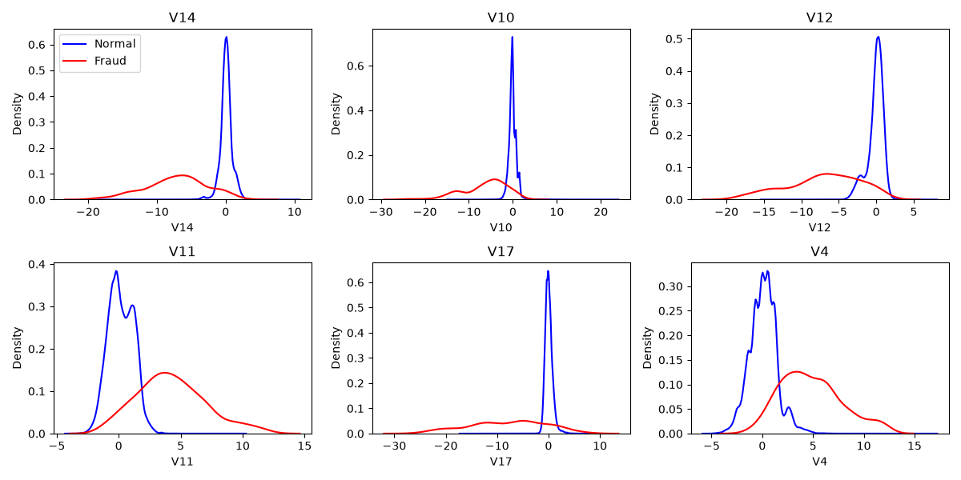
Figure 3. Density of the six most separating features, normal vs fraud
Correlation. The PCA components are close to uncorrelated. Hour correlates moderately with V12 (0.41) and weakly with V14 (−0.20), so these components partly encode time of day.
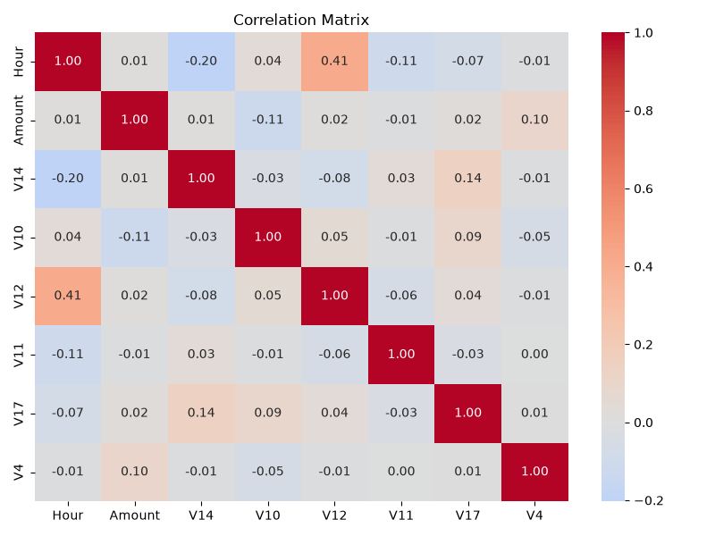
Figure 4. Correlation matrix of Hour, Amount and the top six features
Why a mixture. D’Agostino–Pearson tests on normal transactions reject a single Gaussian for every feature tested. The p-values are below 1e-300.
Feature (normal transactions) | Test statistic
V1 | 128,016.9
V14 | 44,187.6
V4 | 9,396.4
log(1 + Amount) | 7,495.5

GMM experiments (notebook 03)
The best setting is all 29 features with K=3: mean validation AP 0.549 across seeds, and 0.666 for the selected fit. Its performance depends strongly on the EM solution reached. The model fits a full-covariance GMM to standardised legitimate training data and scores each transaction by its negative log-likelihood:
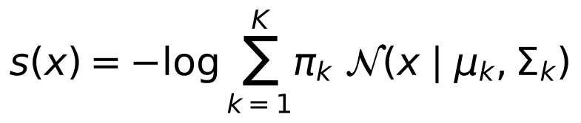
A higher score means the transaction is less like anything in the legitimate data.
Search protocol
- Feature sets: all 29 (V1–V28 + Amount) and the 12-feature set from notebook 02.
- Components: K = 1 to 8.
- Seeds: 3 random seeds per (feature set, K), each fit with 5 EM restarts (n_init=5), 144 fits in total.
- Fixed settings: covariance_type='full', reg_covar=1e-5, max_iter=200. Amount is log-transformed and the StandardScaler is fit on training data only.
- Metric: validation average precision (AP).
- Selection rule: the (feature set, K) with the highest mean validation AP is the champion. Among its seeds, the fit with the best validation AP is kept, so the seed is treated as a hyperparameter.
Validation AP, mean with the min–max range across 3 seeds (random guess = 0.001):
K | All 29 features | Selected 12 features
1 | 0.074 (0.074–0.074) | 0.266 (0.266–0.266)
2 | 0.176 (0.079–0.371) | 0.205 (0.201–0.213)
3 | 0.549 (0.343–0.666) | 0.201 (0.199–0.205)
4 | 0.068 (0.065–0.074) | 0.197 (0.197–0.198)
5 | 0.300 (0.058–0.647) | 0.203 (0.198–0.212)
6 | 0.068 (0.059–0.078) | 0.334 (0.081–0.628)
7 | 0.196 (0.128–0.232) | 0.067 (0.065–0.069)
8 | 0.323 (0.246–0.419) | 0.075 (0.065–0.095)

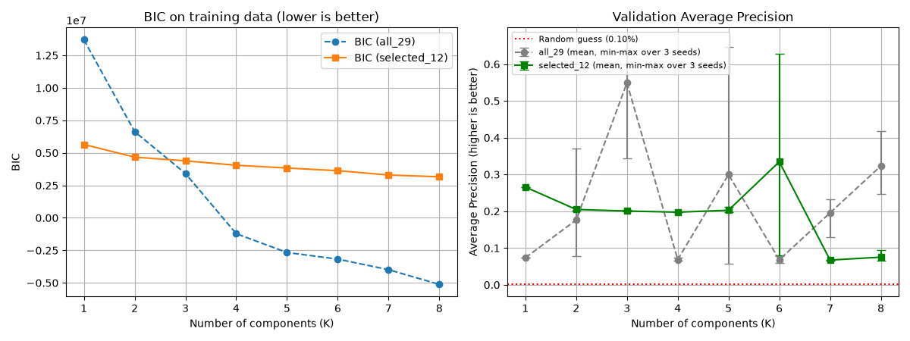
Figure 5. BIC and validation AP by number of components, both feature sets
Key findings
- EM solutions differ sharply in fraud-ranking quality. For all-29 K=3, the three seeds give 0.343, 0.638 and 0.666 validation AP. All-29 K=5 ranges from 0.058 to 0.647, and selected-12 K=6 from 0.081 to 0.628. A single-seed result can be badly misleading in either direction.
- Likelihood-based criteria do not identify good fraud rankers. BIC falls steadily up to K=8 for both feature sets. For all 29 features it turns negative from K=4, because some components collapse onto near-identical points and their likelihood explodes. Fits with the highest training likelihood often rank fraud poorly, so model choice relies on validation AP.
- Feature selection gives stability, not peak performance. The 12-feature set is very stable for K = 1–5 (AP about 0.20–0.27). At K=3, however, the full 29 features reach much higher AP: dimensions that look uninformative one at a time still help separate fraud once the mixture structure is right.
Champion: all 29 features, K=3, seed 2, validation AP 0.666. It is saved with its scaler and feature list in results/models/.

Test evaluation (notebook 04)
On the untouched test period, the champion GMM catches 75.7% of fraud at a 0.28% false-alarm rate, and 84% of its top 50 alerts are fraud. The alarm threshold (NLL ≥ 94.68) was fixed on validation as the 99.5th percentile of legitimate scores, targeting at most 0.5% false alarms, then applied once to test. Confidence intervals come from 1,000 bootstrap resamples of the test set with the threshold held fixed.
Metric | Test value | 95% CI
Average precision | 0.612 (random: 0.0013) | 0.485–0.743
PR-AUC, trapezoidal | 0.608 | —
ROC-AUC | 0.923 | 0.879–0.962
Recall at the 0.5% FPR threshold | 75.7% (56 of 74) | 65.8–84.7%
Realised false-positive rate | 0.28% (158 of 56,672) | —
Precision of all 214 alerts | 26.2% | —

Scenario A: fixed false-alarm budget. The realised false-positive rate (0.28%) came in under the 0.5% target, so the threshold transferred conservatively from validation to test. Analysts would review 214 alerts to find 56 frauds, about one real fraud in every four alerts, and 18 frauds pass undetected.
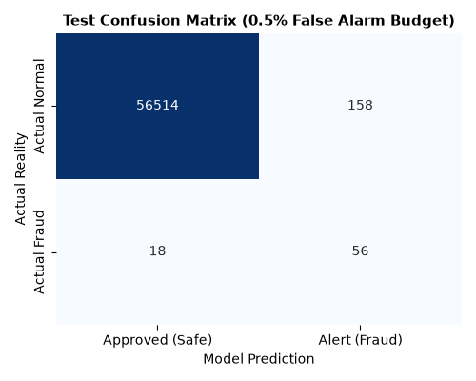
Figure 6. Test confusion matrix at the 0.5% false-alarm budget
Scenario B: fixed analyst capacity. If the team can only review the k highest-scored transactions:
Alerts reviewed | Real frauds found | Precision | Share of all 74 test frauds
Top 25 | 18 | 72% | 24%
Top 50 | 42 | 84% (95% CI 70–94%) | 57%
Top 100 | 56 | 56% | 76%

Shape of the ranking. Precision stays between about 0.7 and 0.85 up to roughly 75% recall, then collapses. About three quarters of the frauds receive clearly anomalous scores. The rest score like ordinary transactions and sit deep in the ranking, which is why ROC-AUC (0.923) is modest next to the strong top-of-queue precision.
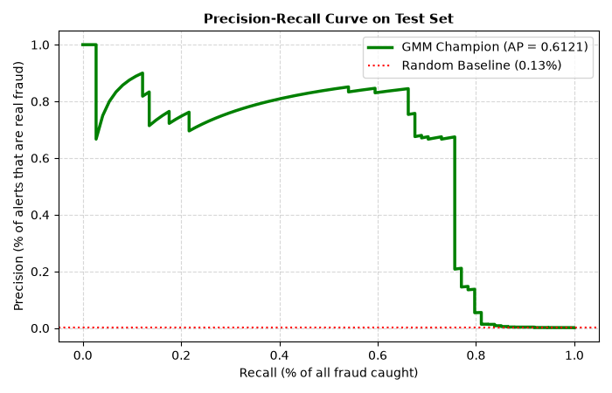
Figure 7. Precision–recall curve on the test set
Test AP (0.612) is slightly below the selected fit’s validation AP (0.666) and inside its bootstrap interval, consistent with a model that generalises across the time split. With 74 test frauds, the confidence intervals are wide: test AP is known only to within about ±0.13.

