ABMSM Project 2 - Distributed ML on Bank Marketing Data - Technical Documentation
Prepared for: ABMSM Project 2 Stakeholders
Notebook Sources: `start.ipynb` (Spark batch + streaming)
CLI Sources: WSL terminal (Hadoop Streaming, Hive)
Artifacts: `models/`, `streaming_data/`
Dataset: `bank.csv`
Last Updated: 27 Dec 2025

Table of Contents
- Introduction & Goal
- Project Workflow Overview
- Data Description
- Glossary of Key Terms
- Spark and PySpark Part 1 - Data Parallelism
- Spark and PySpark Part 2 - Spark Data Processing
- Spark and PySpark Part 3 - Spark ML Pipeline
- Spark and PySpark Part 4 - Spark Streaming
- Spark and PySpark Part 5 - Summary and Validation
- Hadoop MapReduce (Streaming)
- Hive Analytics
- Operational Recommendations
- Appendices

Introduction & Goal
This project demonstrates distributed data processing and machine learning on the bank.csv dataset using Spark, Hadoop, and Hive. The goal is to show how data parallelism, batch analytics, ML pipelines, and real-time streaming can be applied to a banking use case to support decision-making and customer insights.
The primary goal of this project is to demonstrate how distributed machine learning can transform banking data into actionable insights. Using the bank.csv dataset, students explore distributed computing across data storage and querying, predictive analytics, and real-time data processing. The project simulates a real-world banking data environment, offering insights into customer behavior, identifying key trends, and enabling data-driven decision-making.

Project Workflow Overview
1) Prepare the WSL environment (Java, Hadoop, Hive, Python venv for Spark).
2) Run Spark batch analyses in `start.ipynb` (Parts 1-3).
3) Run Spark Streaming section in `start.ipynb` (Part 4).
4) Load data into HDFS and run Hadoop Streaming jobs (MapReduce).
5) Create Hive database and table, then execute HiveQL analytics.
6) Capture outputs and screenshots for submission.

Data Description
- Dataset: `bank.csv` (4521 rows)
- Target column: `y` (yes/no term deposit subscription)
Dataset Overview:
- age: Age of the individual (integer).
- job: Job type (object/string).
- marital: Marital status (object/string).
- education: Education level (object/string).
- default: Indicates if the individual has credit in default (object/string).
- balance: Account balance (integer).
- housing: Indicates if the individual has a housing loan (object/string).
- loan: Indicates if the individual has a personal loan (object/string).
- contact: Type of communication contact (object/string).
- day: Last contact day of the month (integer).
- month: Last contact month of the year (object/string).
- duration: Last contact duration, in seconds (integer).
- campaign: Number of contacts performed during this campaign for this client (integer).
- pdays: Number of days that passed by after the client was last contacted from a previous campaign (integer, '-1' means client was not previously contacted).
- previous: Number of contacts performed before this campaign and for this client (integer).
- poutcome: Outcome of the previous marketing campaign (object/string).
- y: Indicates if the client has subscribed to a term deposit (object/string).

Glossary of Key Terms
- HDFS: Hadoop Distributed File System for distributed storage.
- YARN: Resource manager for Hadoop jobs.
- SparkSession: Entry point for Spark SQL and DataFrame APIs.
- DataFrame: Spark distributed tabular data abstraction.
- RDD: Resilient Distributed Dataset, Spark low-level data abstraction.
- Partition: A chunk of data processed in parallel.
- Shuffle: Data exchange between partitions during wide transformations.
- Stage: A set of tasks that can run without shuffle.
- Task: Smallest unit of work in Spark.
- Action: Spark operation that triggers execution (e.g., count, collect).
- Transformation: Lazy Spark operation (e.g., filter, groupBy).
- UDF: User Defined Function in Spark.
- Structured Streaming: Spark streaming engine for continuous data.
- Window: Time-based grouping in streaming queries.
- Watermark: Streaming technique to handle late data.
- Checkpoint: Streaming state store for fault tolerance.
- StringIndexer: Converts categorical strings to numeric indices.
- OneHotEncoder: Encodes categorical indices as one-hot vectors.
- VectorAssembler: Combines feature columns into a single vector.
- ParamGridBuilder: Defines hyperparameter grid for tuning.
- CrossValidator: Evaluates models across parameter combinations.
- AUC: Area Under the ROC Curve, binary classification metric.
- MapReduce: Distributed compute model with mapper and reducer stages.
- Mapper: Emits intermediate key-value pairs.
- Reducer: Aggregates mapper outputs by key.
- HiveQL: SQL-like query language for Hive.
- SerDe: Serializer/Deserializer for Hive table formats.
- Warehouse: Default HDFS location for Hive tables.

Spark and PySpark Part 1 - Data Parallelism
Covered in `start.ipynb` (Batch 1).
- Load `bank.csv` into a Spark DataFrame and inspect rows and schema.
- Partition the dataset for parallel processing and explain the strategy.
- Compute average balance by job category using parallel aggregation.
- Identify top 5 age groups with the highest loan amounts.
- Train a classification model on partitioned data and discuss challenges.
- Record resource monitoring and task scheduling observations.

Spark and PySpark Part 2 - Spark Data Processing
Covered in `start.ipynb` (Batch 2).
- Filtering and column transformations (month to quarter, balance filters).
- GroupBy aggregations (avg balance, median age, subscription counts).
- UDF for age groups and derived columns.
- Subscription rate by education and default-rate analysis.
- String manipulation and Spark SQL queries.
- Visualization after converting to pandas.

Spark and PySpark Part 3 - Spark ML Pipeline
Covered in `start.ipynb` (Batch 3).
- Missing value handling and outlier checks.
- Categorical encoding with StringIndexer and OneHotEncoder.
- Feature assembly using VectorAssembler.
- Logistic Regression model training and evaluation (AUC).
- Hyperparameter tuning and model selection.
- Feature impact review via coefficients or importance.

Spark and PySpark Part 4 - Spark Streaming
Covered in `start.ipynb` (Streaming section).
- Simulated stream created by batching `bank.csv` into files.
- Real-time aggregation by job (avg balance, avg duration).
- Real-time predictions using the trained ML pipeline.
- Windowed analytics with watermarking and trend checks.
- Short narrative on observed trends noted during runs.

Spark and PySpark Part 5 - Summary and Validation
Covered in `start.ipynb` (Final summary cell).
- Consolidated summary output for all batches.
- Validation checks for streaming outputs via memory tables.

Hadoop MapReduce (Streaming)
All tasks executed in WSL using Hadoop Streaming.
- Load `bank.csv` into HDFS under `/data/bank`.
- Run MapReduce streaming jobs for:
- Average balance by job type.
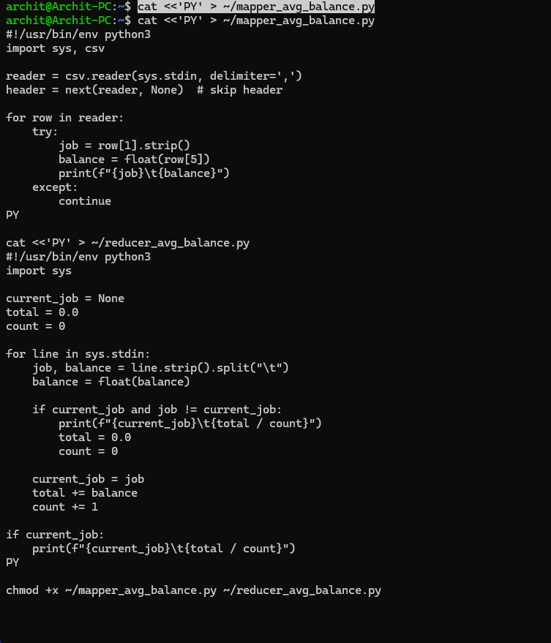
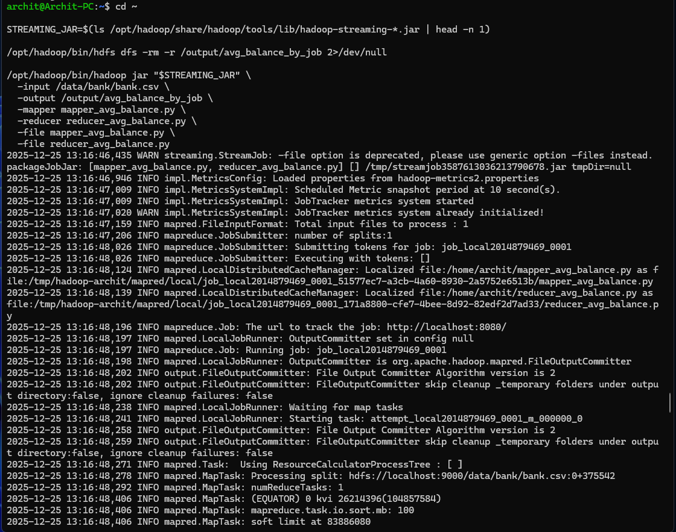
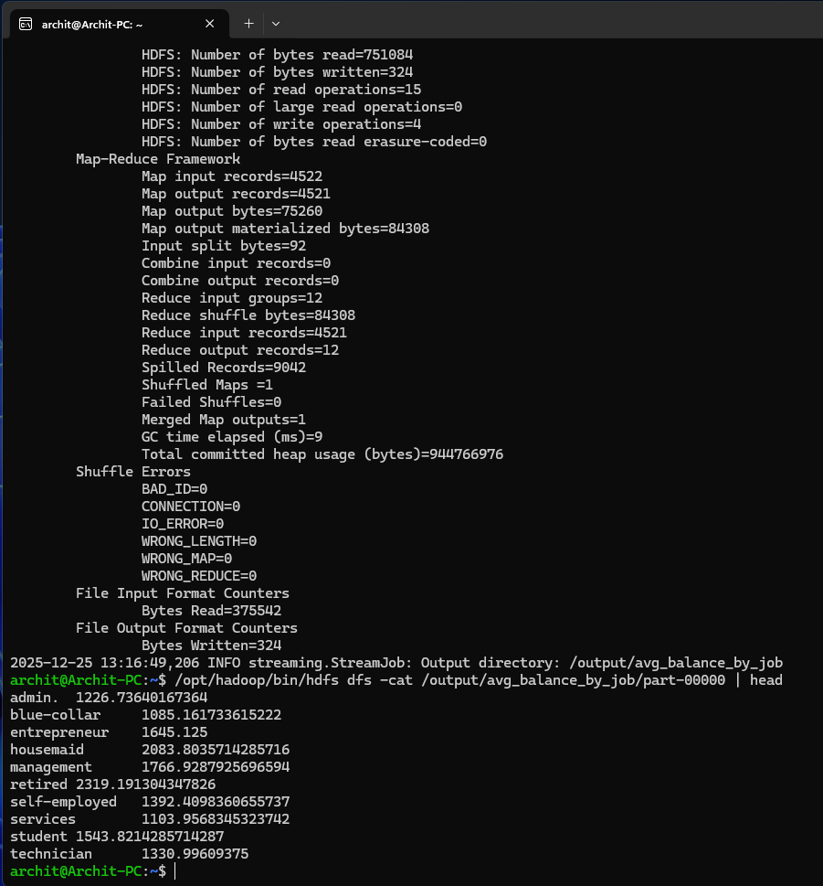
- Housing loan counts by education.
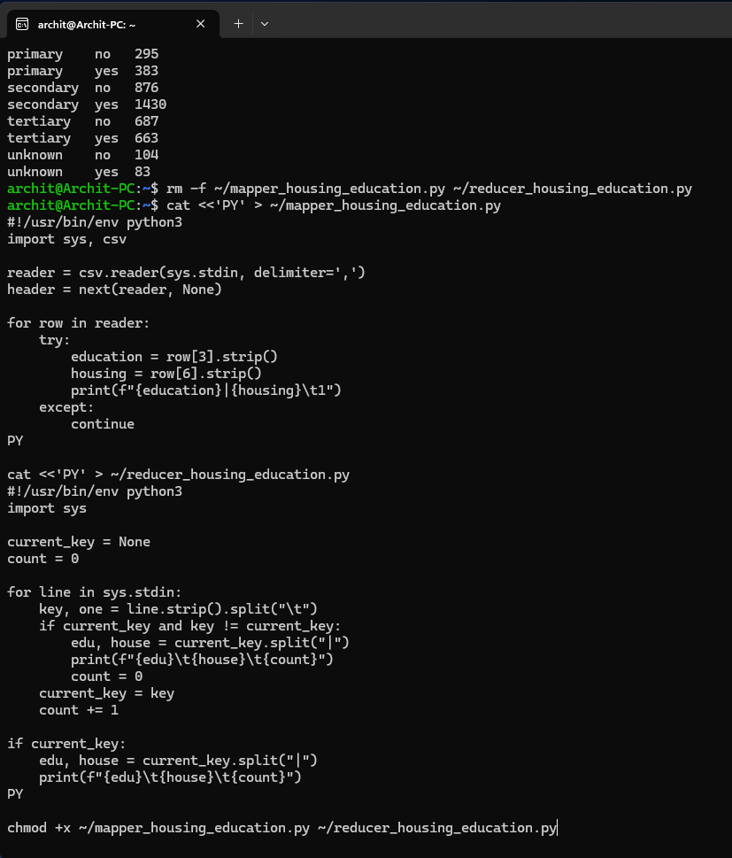
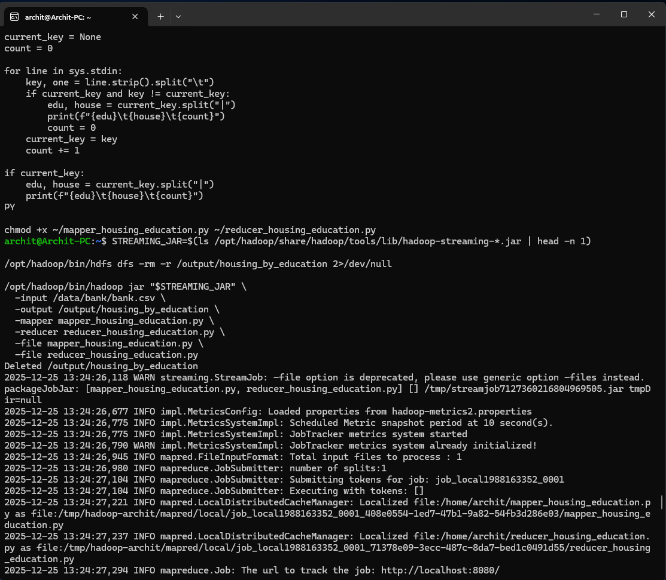
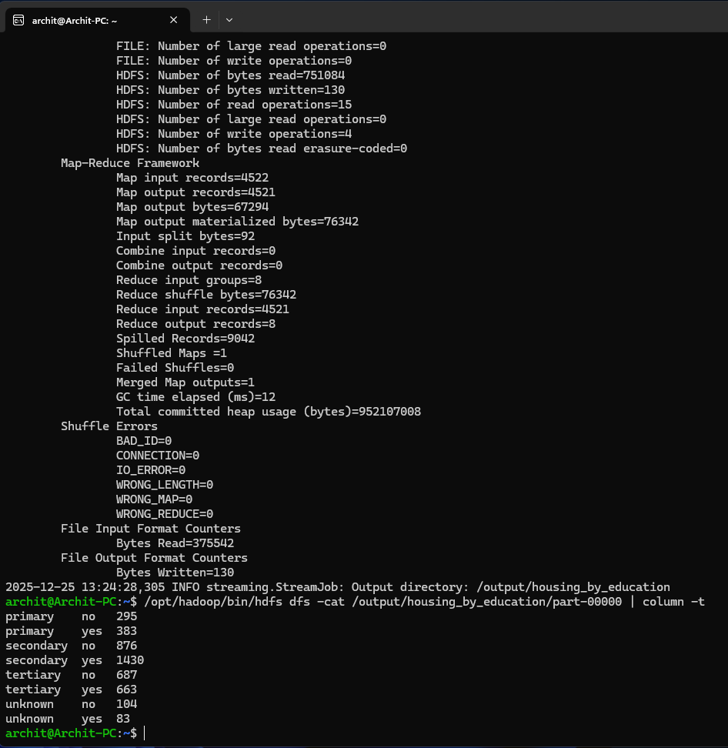
- Monthly contacts by subscription status.
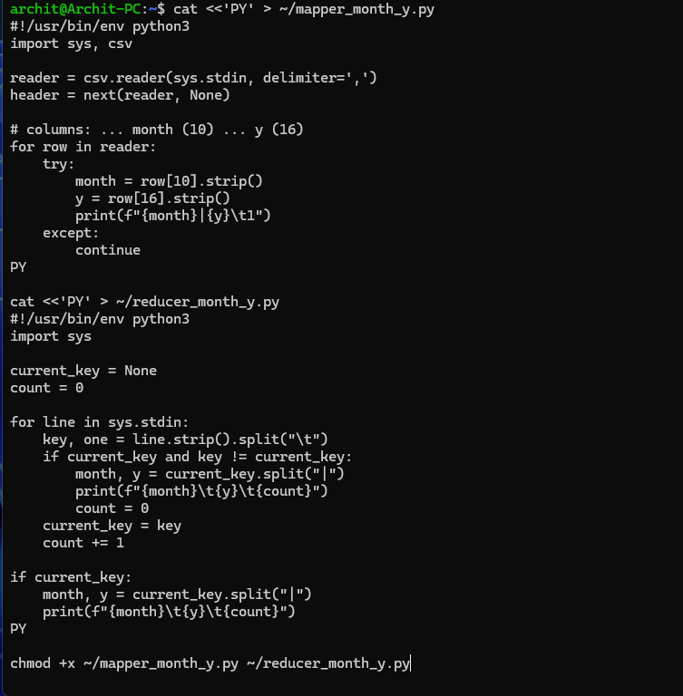
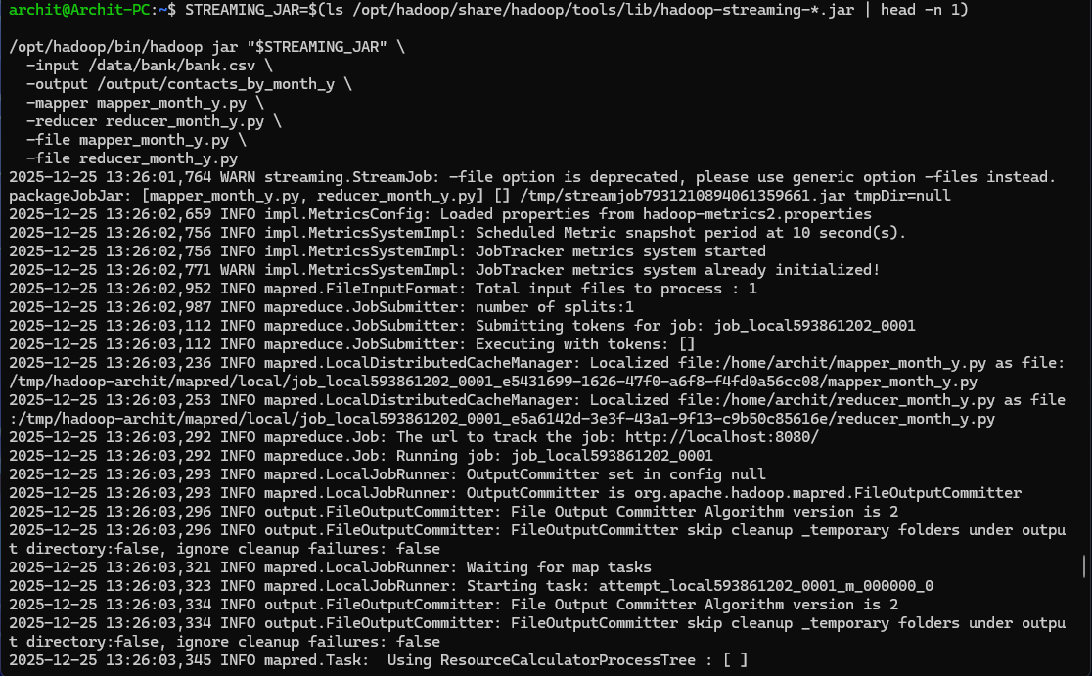
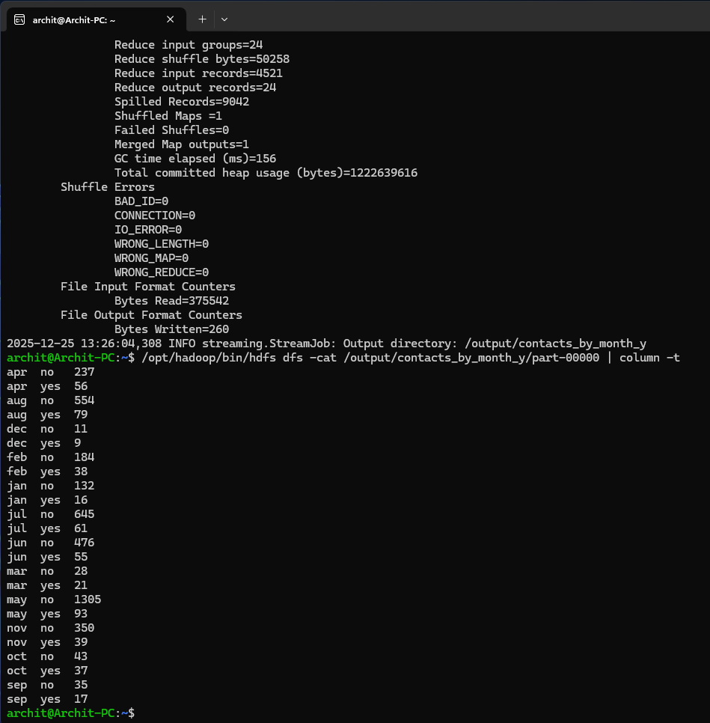
- Average duration by poutcome.
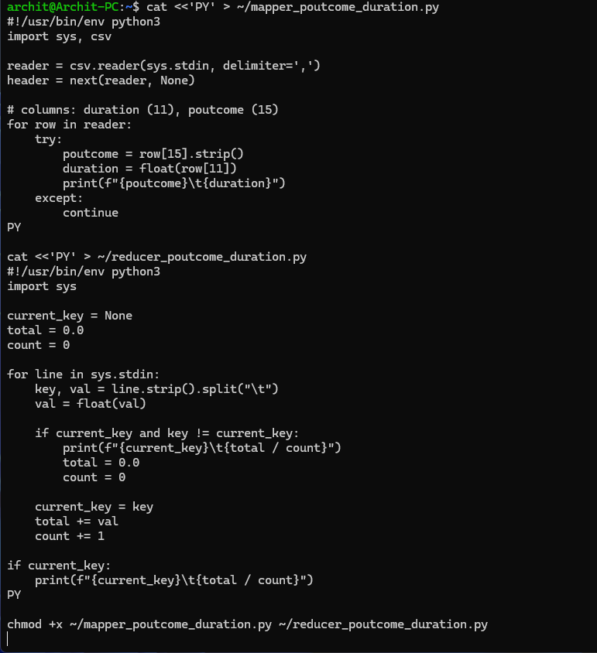
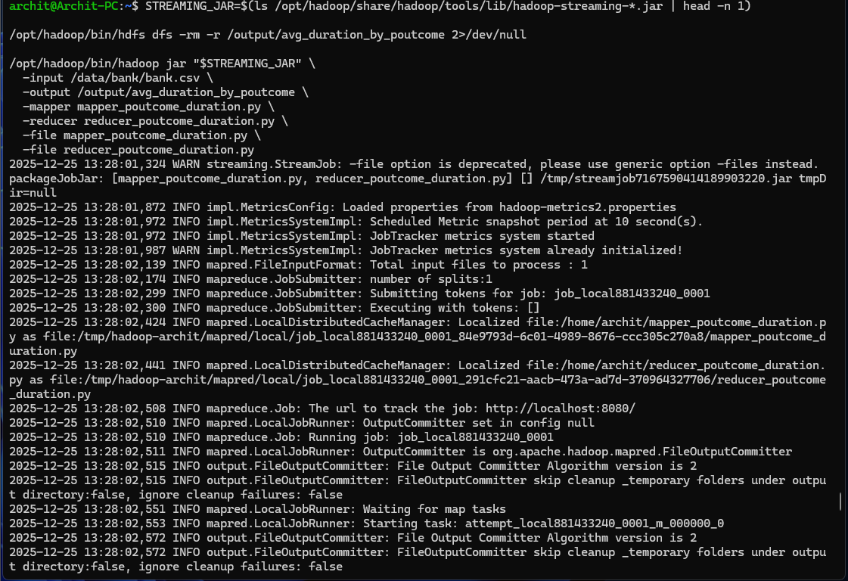
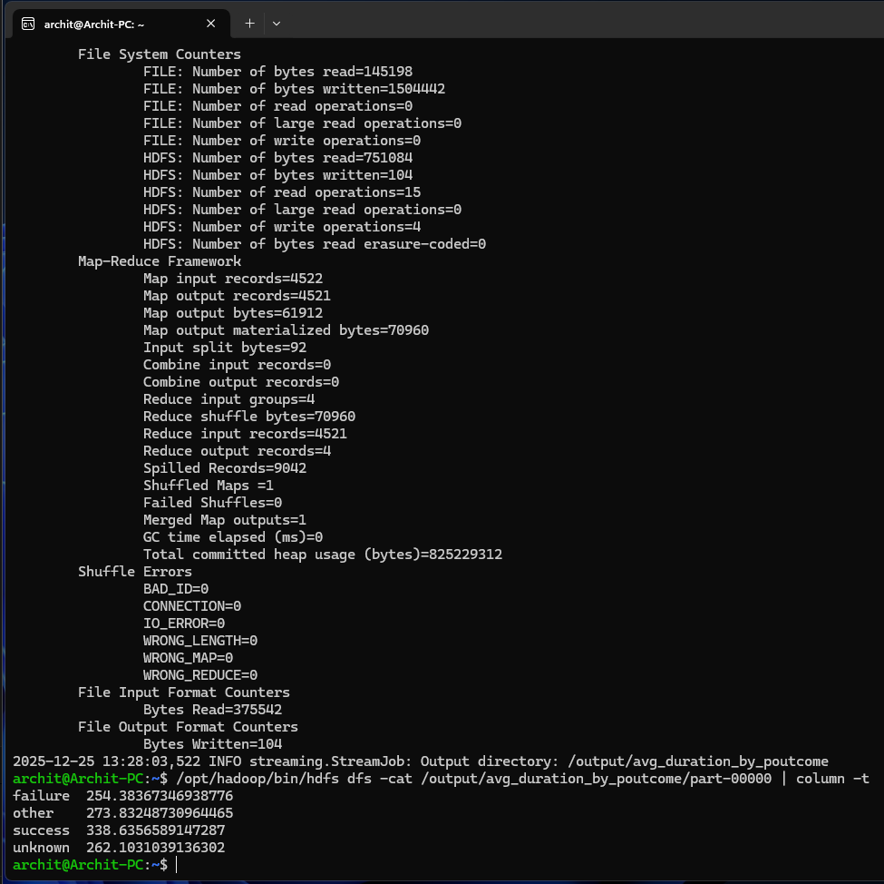

- Age vs balance summary using age buckets.
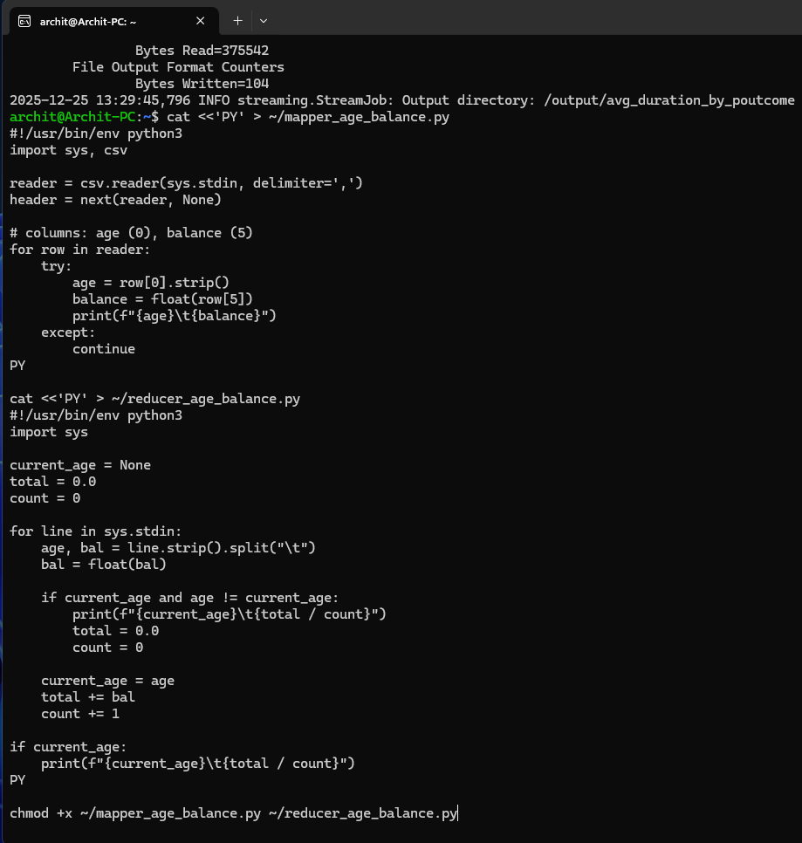
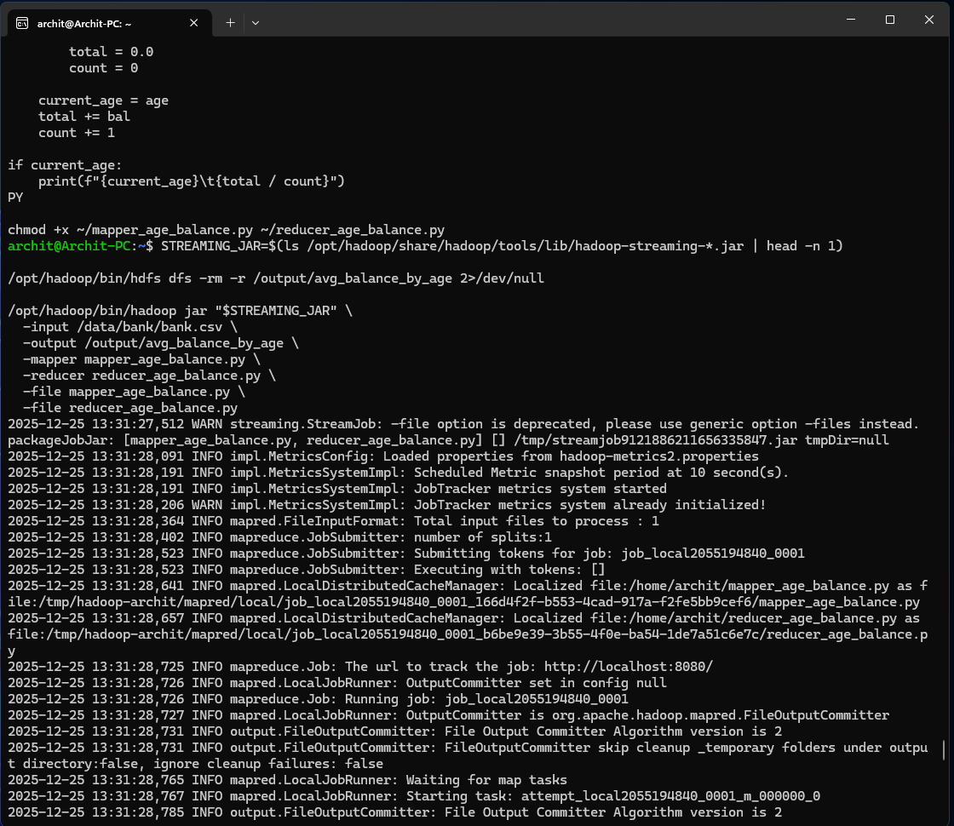
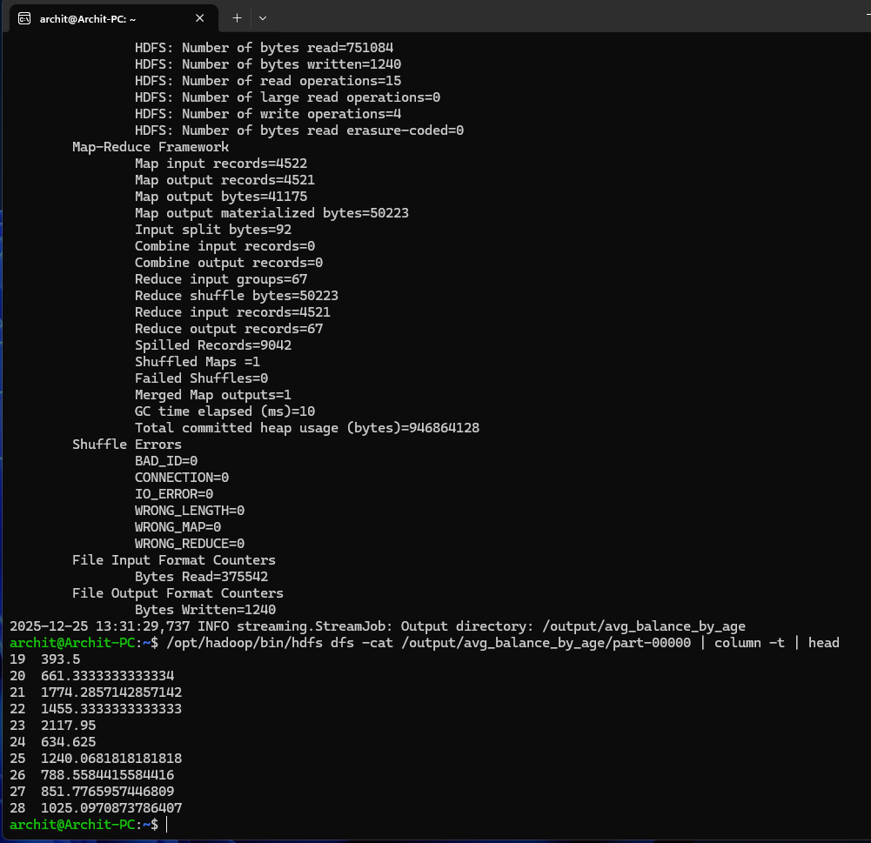

- Inspect HDFS output and capture screenshots.

Hive Analytics
All tasks executed inside the Hive CLI in WSL.
- Apply session settings for local execution and increased memory.
- Create the `banking_data` database and `client_info` table.
- Load `bank.csv` from HDFS into the table.
- Run HiveQL queries for:

- Total clients and first 10 rows.
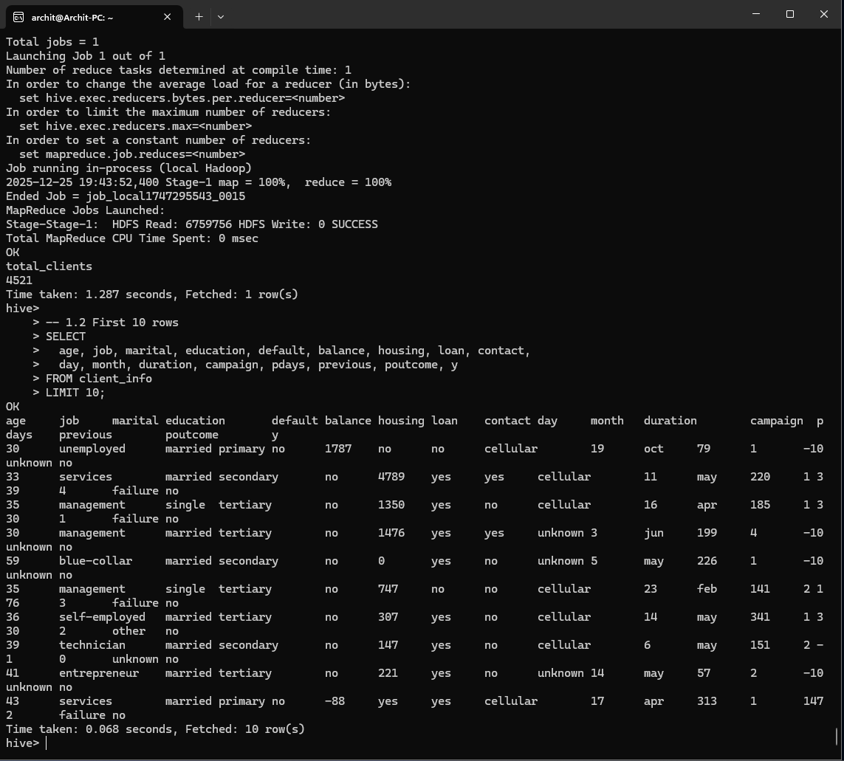
- Filtering by marital and loan status.
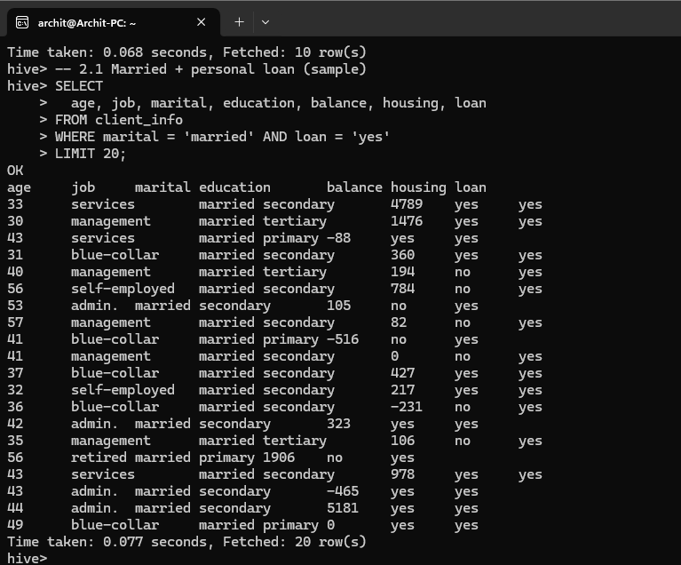
- Top balances, average age by job, defaults by education.
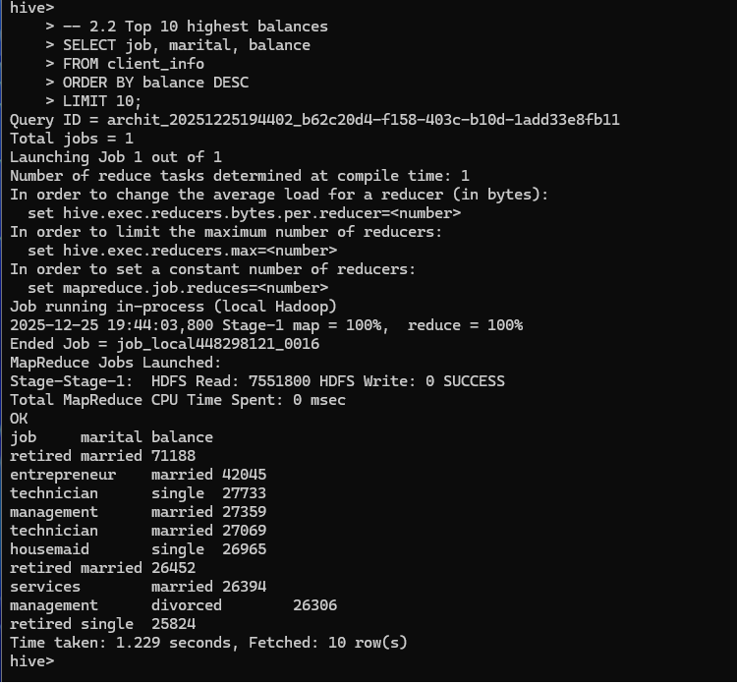
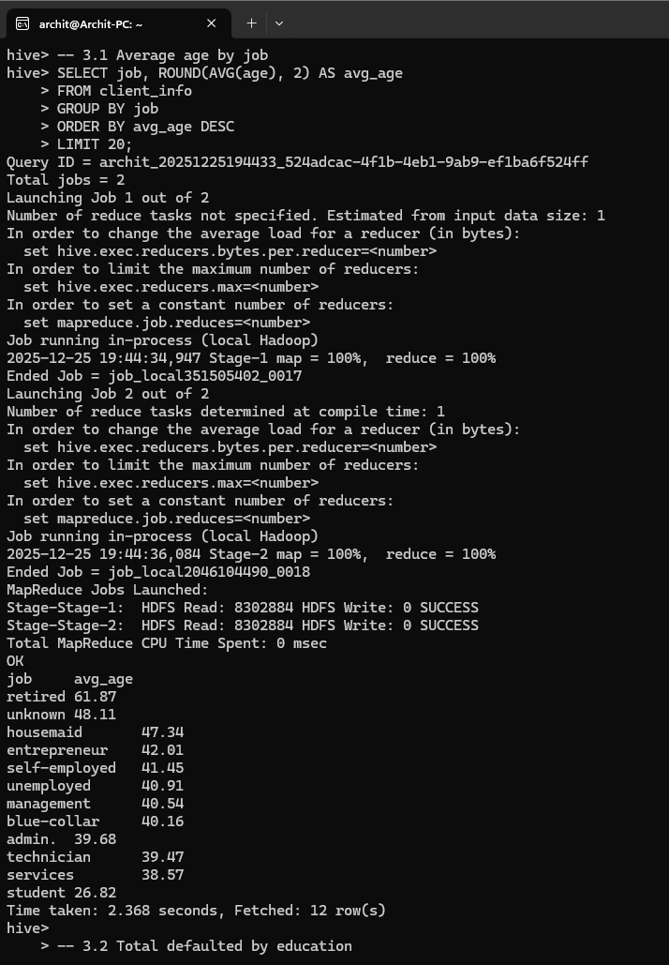
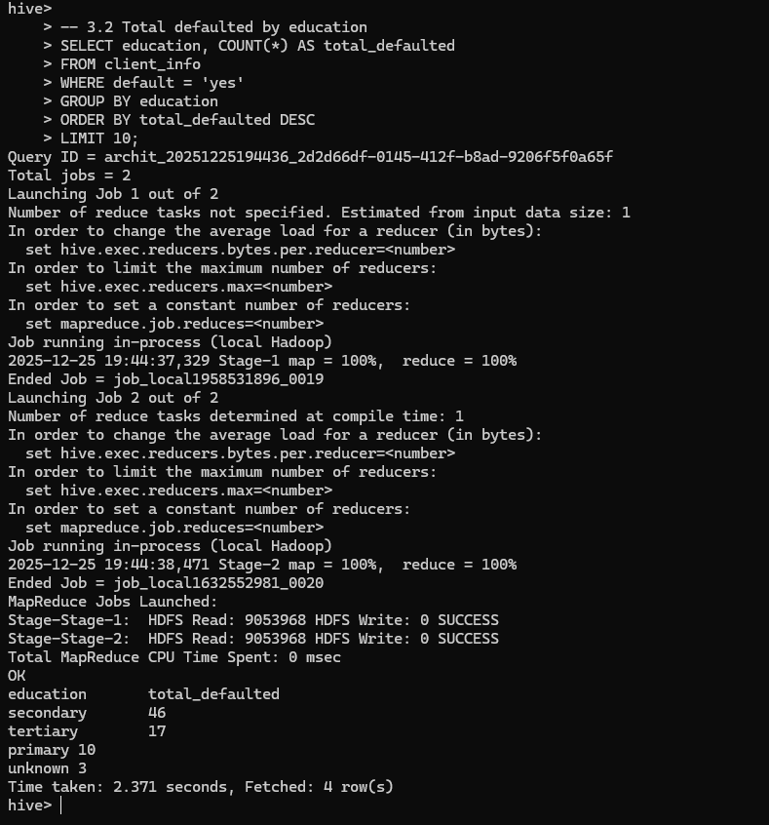
- Top jobs by average balance and subscription rate.
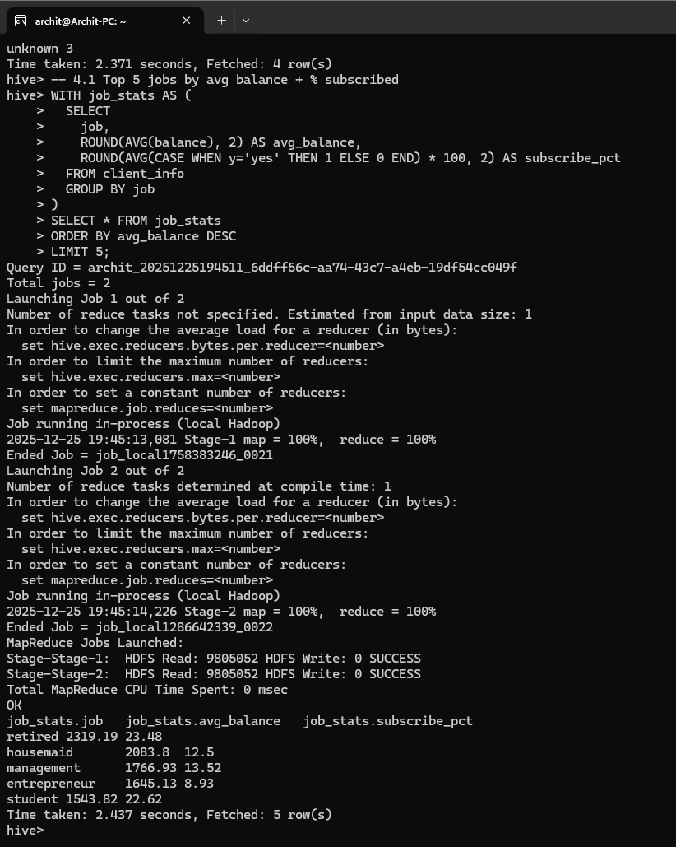
- Highest contact month and success rate.
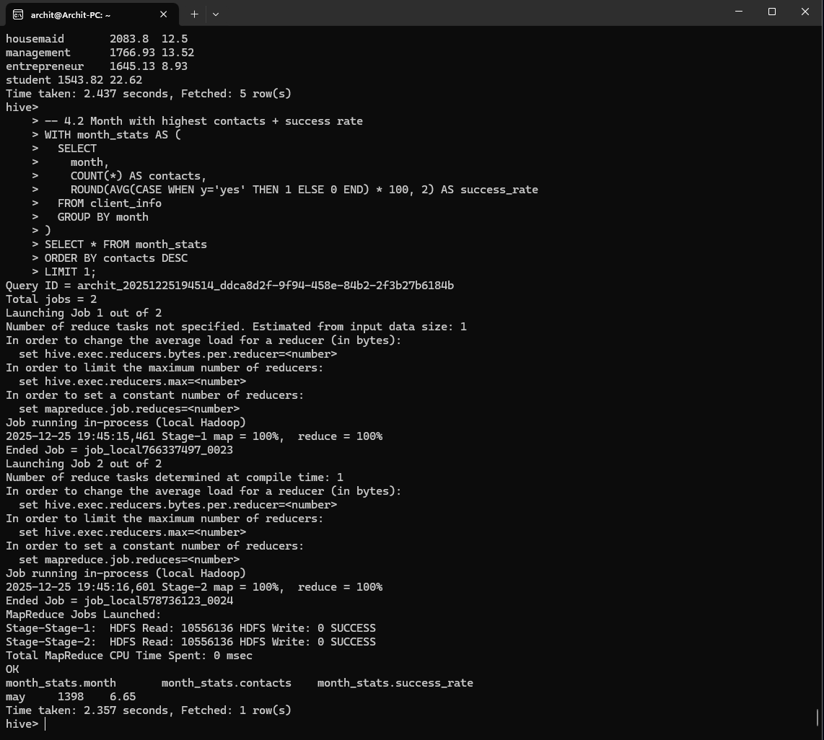

- Correlation between age and balance.
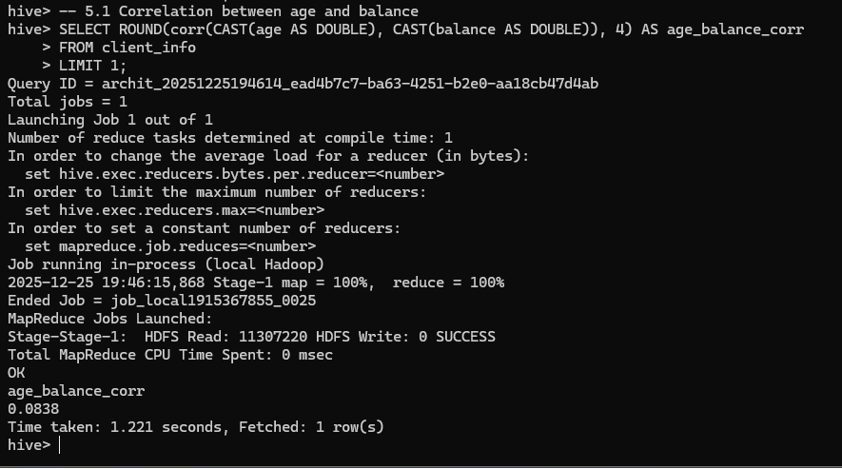
- Trend analysis of contacts.
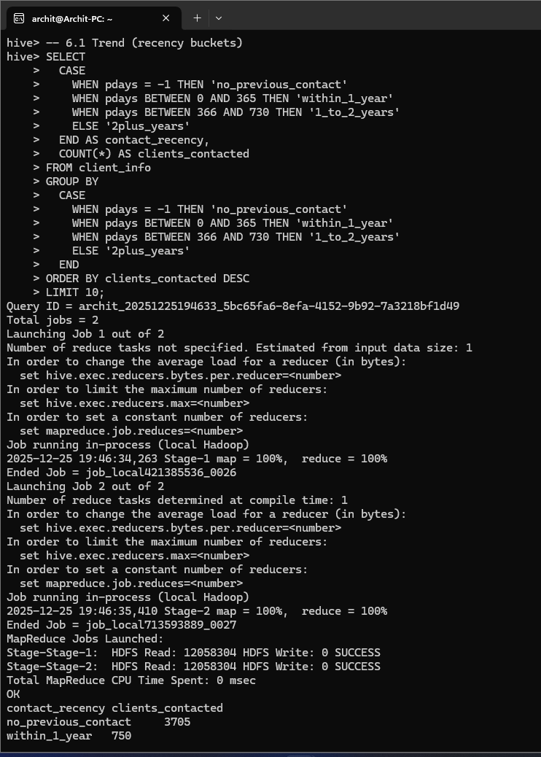
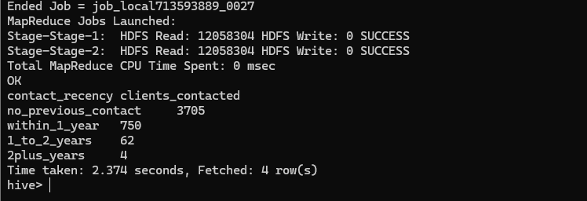

- Anomaly detection on average balance by education.
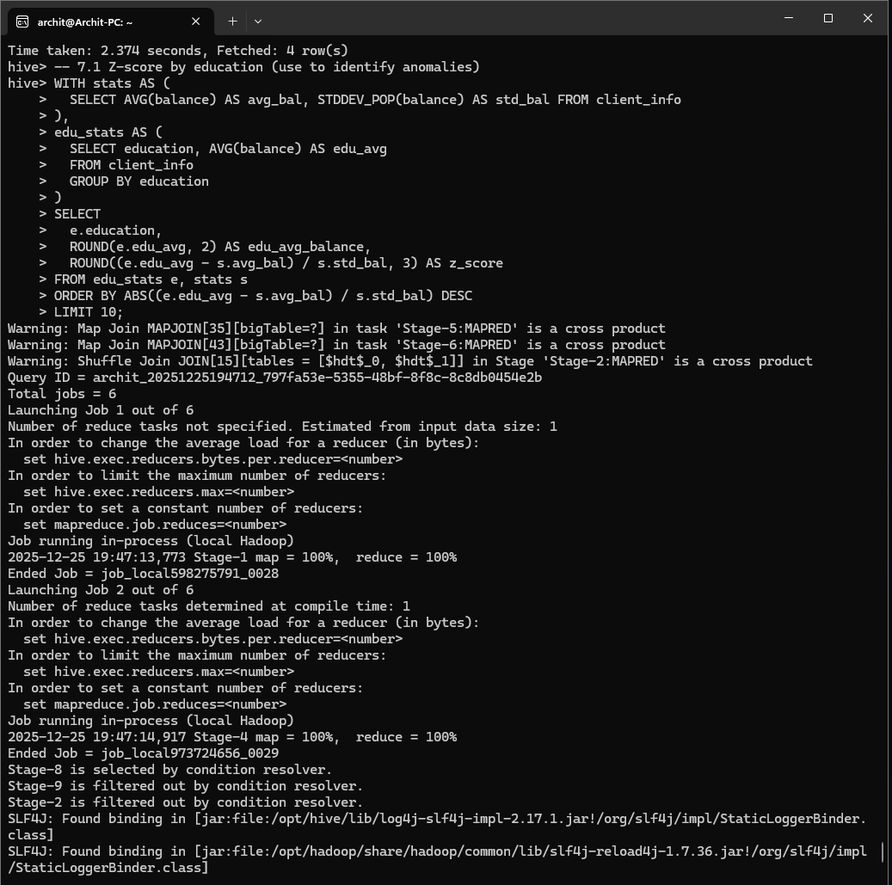
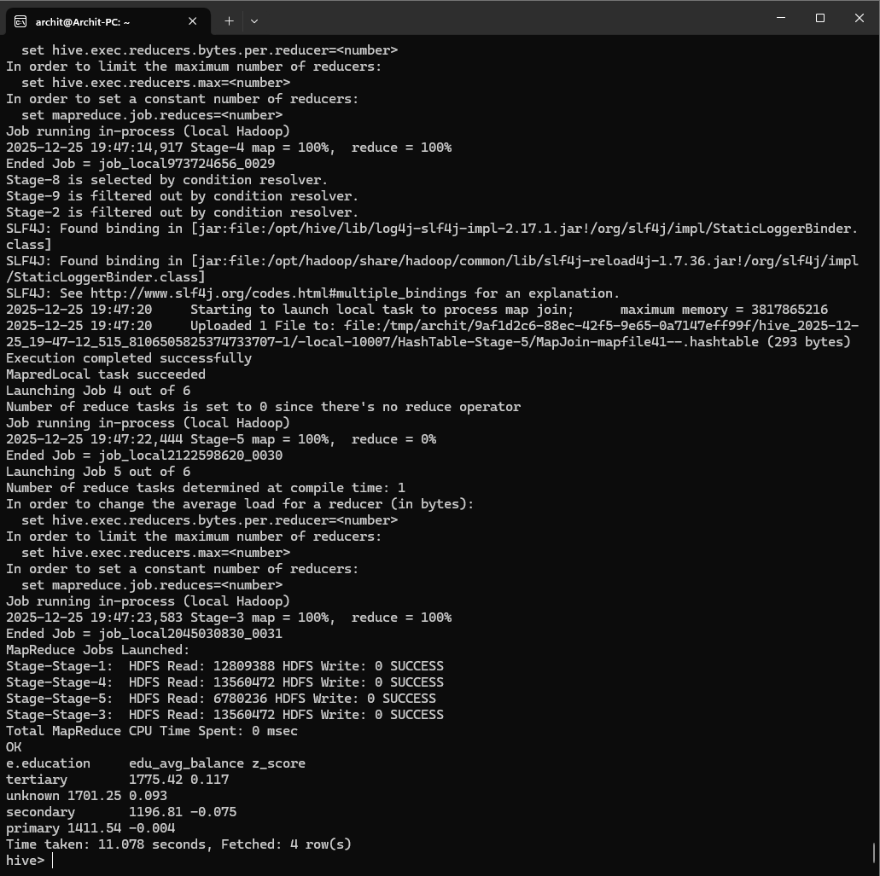
- Poutcome impact on subscription rate.
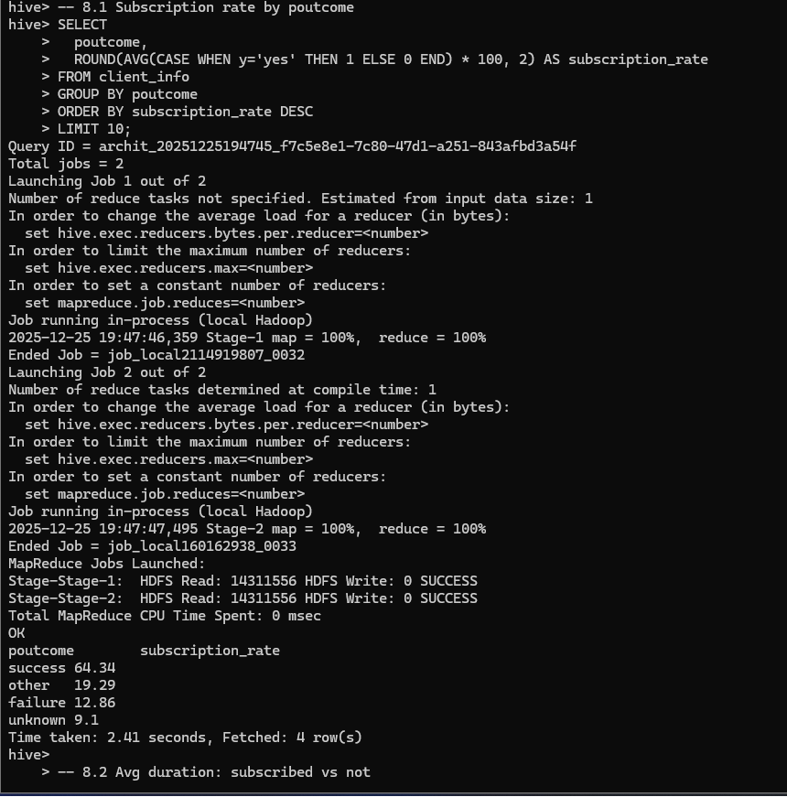
- Average duration for subscribed vs not subscribed.
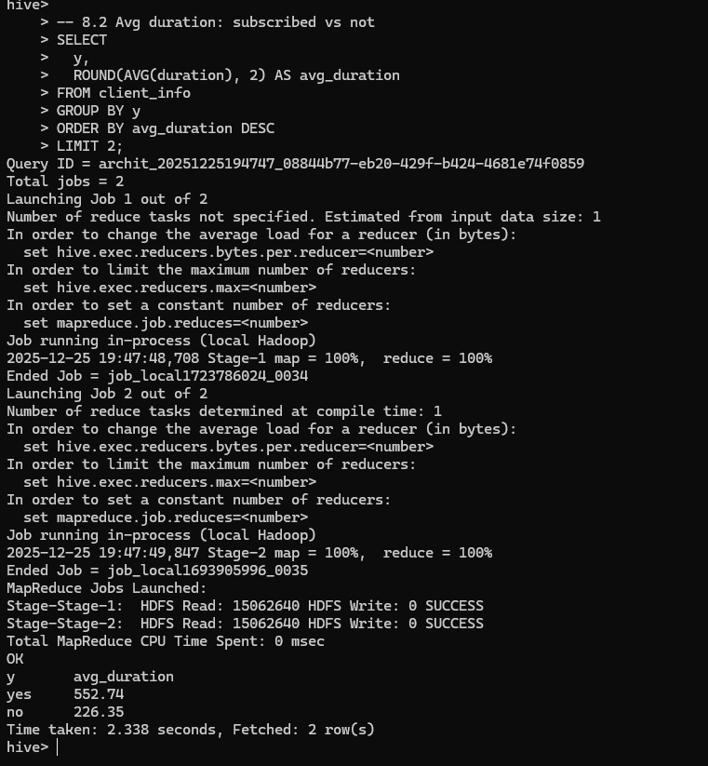

Operational Recommendations
- Use WSL for Hadoop and Hive to avoid Windows filesystem issues.
- Keep Java 17 for Spark and Java 8 for Hadoop/Hive to avoid gateway errors.
- Ensure HDFS is out of safe mode before loading data.
- Increase Hadoop client heap when running Hive locally to prevent OOM.
- Stop streaming queries before restarting to avoid name conflicts.

Appendices
- File Inventory:
- `start.ipynb`: Spark batch + streaming notebook.
- `bank.csv`: Dataset.
- `models/`: Saved streaming ML pipeline.
- `streaming_data/`: Streaming input and checkpoints.

