PROJECT REPORT

Aircraft Engine Remaining Useful Life Prediction

Using Deep Learning



Submitted by

Mehul Mishra(1025150370)
Ananya Nagpal(1025150373)
Sumedha Sharma(1025150316)
Ansh Sharma(1025150366)
Archit Goel(1025150399)

Under the Guidance of

Dr. Jyoti

Thapar Institute of Engineering and Technology

Academic Year: 2026–2027

Abstract

Aircraft engines operate under demanding conditions and experience gradual degradation during operation. Predicting the Remaining Useful Life (RUL) of an engine can help plan maintenance and reduce unexpected failures.
This project focuses on predicting the Remaining Useful Life of aircraft engines using the NASA C-MAPSS FD001 dataset. The dataset contains operational settings and sensor measurements recorded over successive engine cycles.
The data is processed using Python in Google Colab. The proposed workflow includes data inspection, preprocessing, feature scaling, RUL label generation, and preparation of sequential input data. An LSTM (Long Short-Term Memory) neural network is proposed for estimating the remaining operating cycles of an engine.
The model will be evaluated using Mean Absolute Error (MAE) and Root Mean Squared Error (RMSE). The actual performance and conclusions will be reported after training and testing the model.

Contents

- Introduction 4
  - Background . . . . . . . . . . . . . . . . . . . . . . . . . . . . . . . . . . 4
  - Problem Statement . . . . . . . . . . . . . . . . . . . . . . . . . . . . . . 4
  - Objectives . . . . . . . . . . . . . . . . . . . . . . . . . . . . . . . . . . . 4
- Literature Review 5
  - Existing Approaches to RUL Prediction . . . . . . . . . . . . . . . . . . . 5
  - Deep Learning for RUL Prediction . . . . . . . . . . . . . . . . . . . . . 5
  - Research Gap . . . . . . . . . . . . . . . . . . . . . . . . . . . . . . . . . 5
  - Motivation and Objectives . . . . . . . . . . . . . . . . . . . . . . . . . . 6
- Dataset Description and Methodology 7
  - Dataset Description . . . . . . . . . . . . . . . . . . . . . . . . . . . . . . 7
  - Data Inspection . . . . . . . . . . . . . . . . . . . . . . . . . . . . . . . . 7
  - RUL Label Generation . . . . . . . . . . . . . . . . . . . . . . . . . . . . 7
  - Feature Selection and Scaling . . . . . . . . . . . . . . . . . . . . . . . . 8
  - Sequence Preparation . . . . . . . . . . . . . . . . . . . . . . . . . . . . . 8
  - LSTM Model Architecture . . . . . . . . . . . . . . . . . . . . . . . . . . 8
  - Random Forest Baseline . . . . . . . . . . . . . . . . . . . . . . . . . . . 9
- Experimental Setup 10
  - Development Environment 10
  - Software and Tools 10
  - Model Configuration 10
  - Training and Testing Procedure 11
- Results and Discussion 12
- Results and Discussion 13
  - Evaluation Metrics 13
  - Validation Results 13
  - Test Results 14
  - Discussion 14
- Conclusion and Future Work 15
  - Conclusion 15
  - Future Work 15

Chapter 1 Introduction

Background
Aircraft engines are complex systems that operate under high temperatures, pressure, and mechanical stress. During operation, engine components gradually degrade, which may affect their performance and reliability.
Remaining Useful Life (RUL) is the estimated number of operating cycles remaining before an engine reaches its defined end-of-life condition. RUL prediction can help maintenance teams plan inspections and repairs more effectively.
Machine learning techniques can analyze historical sensor measurements to identify patterns associated with engine degradation. This project explores the use of an LSTM neural network to predict aircraft engine RUL using the NASA C-MAPSS FD001 dataset.

Problem Statement
The main problem addressed in this project is to estimate the remaining operating cycles of an aircraft engine using its operational history and sensor measurements.

Objectives
    - Study the NASA C-MAPSS FD001 dataset.
    - Preprocess engine sensor measurements.
    - Generate RUL target values.
    - Develop an LSTM based prediction model.
    - Evaluate model performance using MAE and RMSE.

Chapter 2 Literature Review

Existing Approaches to RUL Prediction
Remaining Useful Life (RUL) prediction is an important task in predictive maintenance. Different approaches have been explored, including physics-based models, statistical methods, and machine learning techniques.
Physics-based methods use knowledge of the physical behavior of equipment. Statistical methods use historical data to estimate degradation patterns. Machine learning methods learn relationships between sensor measurements and the remaining life of equipment.

Deep Learning for RUL Prediction
Deep learning methods can learn complex patterns from large amounts of data. Recurrent Neural Networks (RNNs) are useful for sequential data, while Long Short Term Memory (LSTM) networks are designed to learn dependencies across time steps.
In this project, an LSTM network is proposed to learn degradation patterns from aircraft engine sensor data.

Research Gap
Predicting RUL is challenging because engine sensor measurements change over time and degradation patterns may be complex. Data preprocessing, feature selection, sequence length, and model configuration can influence prediction performance.
This project focuses on developing a complete RUL prediction workflow using the NASA C-MAPSS FD001 dataset, including preprocessing, LSTM model development, and performance evaluation.

Objectives
The motivation is to investigate whether sequential sensor measurements can provide useful information for estimating the remaining operating cycles of an aircraft engine. The objectives are to prepare the data, train a prediction model, evaluate its performance, and analyze the results.

Chapter 3
Dataset Description and Methodology

Dataset Description
The project uses the NASA C-MAPSS FD001 dataset, which contains simulated aircraft engine operating histories and sensor measurements. The dataset was loaded from TXT files using Python and pandas in Google Colab by zip file and also created the excel to analyse it.
The training dataset contains 20,631 records from 100 engines, while the test dataset contains 13,096 records from 100 engines. A separate file provides the reference Remaining Useful Life (RUL) values for the test engines.
Each record contains an engine identifier, operating cycle, three operational settings, and 21 sensor measurements.
Features | Min | Max | Average
operational_setting_1 | -0.0087 | 0.0087 | -0.000009
operational_setting_2 | -0.0006 | 0.0006 | 0.000002
operational_setting_3 | 100 | 100 | 100.000000
sensor_measurement_1 | 518.67 | 518.67 | 518.670000
sensor_measurement_2 | 641.21 | 644.53 | 642.680934
sensor_measurement_3 | 1571.04 | 1616.91 | 1590.523119
sensor_measurement_4 | 1382.25 | 1441.49 | 1408.933782
sensor_measurement_5 | 14.62 | 14.62 | 14.620000
sensor_measurement_6 | 21.60 | 21.61 | 21.609803
sensor_measurement_7 | 549.85 | 556.06 | 553.367711
sensor_measurement_8 | 2387.90 | 2388.56 | 2388.096652
sensor_measurement_9 | 9021.73 | 9244.59 | 9065.242941
sensor_measurement_10 | 1.30 | 1.30 | 1.300000
sensor_measurement_11 | 46.85 | 48.53 | 47.541168
sensor_measurement_12 | 518.69 | 523.38 | 521.413470
sensor_measurement_13 | 2387.88 | 2388.56 | 2388.096152
sensor_measurement_14 | 8099.94 | 8293.72 | 8143.752722
sensor_measurement_15 | 8.3249 | 8.5848 | 8.442146
sensor_measurement_16 | 0.03 | 0.03 | 0.030000
sensor_measurement_17 | 388 | 400 | 393.210654
sensor_measurement_18 | 2388 | 2388 | 2388.000000
sensor_measurement_19 | 100 | 100 | 100.000000
sensor_measurement_20 | 38.14 | 39.43 | 38.816271
sensor_measurement_21 | 22.8942 | 23.6184 | 23.289705

Data Inspection
The training dataset was examined for missing values, duplicate rows, and basic statistical properties. The notebook reported zero missing values and zero duplicate rows in the training dataset with the 7 contant features with constant values .
Column | Constant value
operational_setting_3 | 100
sensor_measurement_1 | 518.67
sensor_measurement_5 | 14.62
sensor_measurement_10 | 1.30
sensor_measurement_16 | 0.03
sensor_measurement_18 | 2388
sensor_measurement_19 | 100
So we have to remove them .
The engine identifier and cycle number were retained for organizing the time-series records.
Item | Before | After
Input features | 24 | 17
Total columns, including engine ID, cycle and RUL | 27 | 20
Number of records | 20,631 | 20,631

RUL Label Generation
The RUL label for each training record was calculated by subtracting the current operating cycle from the maximum recorded cycle for the corresponding engine.

RUL_{i,t} = T_{i} − t

where T_{i} represents the last recorded cycle for engine i, and t represents the current cycle.
To limit the influence of large early Slife RUL values, the revised model uses a capped RUL target:

RUL _{capped} = min (RUL, 125)
The purpose is to prevent the model from being overly influenced by large RUL values early in an engine's life.
For example, an engine with 250 cycles remaining and one with 150 cycles remaining both receive a target of 125. The model can focus more on learning changes as engines approach failure.

Feature Selection and Scaling
The input features consist of two operational settings and 15 sensor measurements, giving 17 features in total. The engine identifier, cycle number, and RUL target are not included among the 17 input features.
Sensor features have different numerical ranges. For example, one sensor may have values near 0.03 while another has values around 9,000.
Scaling brings the features onto a comparable numerical scale, helping neural-network training.
MinMaxScaler : The scaler must be fitted on training data only, then applied to validation and test data. We scaled it from range (0-1)

The 100 training engines were divided into 80 training engines and 20 validation engines using a fixed random seed. A Min Max Scaler was fitted using the training-engine subset and applied to the training, validation, and test features.
Training sequence shape: (14241, 30, 17)
Training target shape: (14241,)
Validation sequence shape: (3490, 30, 17)
Validation target shape: (3490,)

Sequence Preparation
The sensor measurements were organized by engine and sorted by operating cycle. A sliding window of 30 consecutive cycles was used to construct each input sequence.
Each sequence contains 30 time steps and 24 features. The target value corresponds to the RUL at the last cycle of that sequence.
The resulting training sequences have the shape (14241, 30, 24), while the validation sequences have the shape (3490, 30, 24) which is then converted to shape (14241, 30, 17) because the columns have the constant values.

LSTM Model Architecture
The final LSTM model contains one LSTM layer with 64 units, followed by a dropout layer with a rate of 0.1. A fully connected layer with 32 neurons and ReLU activation is used before the final single-neuron output layer.
The model is trained using the Adam optimizer with a learning rate of 0.0005. Mean Squared Error (MSE) is used as the loss function, and Mean Absolute Error (MAE) is monitored as an additional metric.
Training is configured for up to 60 epochs with a batch size of 64. Early stopping and learning-rate reduction callbacks are used to support training and limit unnecessary epochs.

Random Forest Baseline
A Random Forest regressor is implemented as a baseline for comparison. It uses 200 trees and a minimum leaf size of two. For this model, the last time step of each 30-cycle sequence is used as the input feature vector.
Both models are evaluated against the same validation targets using MAE and RMSE.

Chapter 4 Experimental Setup

Development Environment
The project is implemented in Python using Google Colab . The environment is used for data preprocessing, model development, training, and evaluation.

Software and Tools
    - Programming language: Python
    - Development environment: Google Colab
    - Dataset: NASA C-MAPSS FD001
    - Data format: TXT
    - Data processing: pandas and NumPy
    - Prediction model: LSTM neural network

Model Configuration
The LSTM model receives sequential engine sensor measurements and predicts the Remaining Useful Life (RUL) of an aircraft engine. The model configuration used in this project is summarized below.
- Input sequence length: 30 operating cycles
- Number of LSTM layers and units: Two LSTM layers, with 64 units in the first layer and 32 units in the second layer
- Dropout rate: 0.2 after each LSTM layer to help reduce overfitting
- Optimizer and learning rate: Adam optimizer with an initial learning rate of 0.001
- Loss function: Mean Squared Error (MSE)
- Batch size and number of epochs: Batch size of 64 and a maximum of 100 epochs
- Training and validation procedure: The dataset is split by engine ID, using 80 engines for training and 20 engines for validation
- Early stopping: Training stops if validation loss does not improve for 10 consecutive epochs, restoring the best model weights
- Output layer: One neuron with a linear activation function to predict a continuous RUL value
- Evaluation metrics: Mean Absolute Error (MAE) and Root Mean Squared Error (RMSE)

Training and Testing Procedure

The training and testing procedure is designed to develop and evaluate an LSTM-based model for predicting the Remaining Useful Life (RUL) of aircraft engines using historical sensor measurements.
1. Preparation of Training Data
After data cleaning, constant-feature removal, and feature scaling, the sensor measurements are organized into sequences of 30 consecutive operating cycles. Each sequence contains the selected sensor features and operating settings. The corresponding RUL value is used as the target label for supervised learning. In the revised model, RUL values may be capped at 125 cycles to reduce the influence of large early-life RUL values.
2. Training and Validation Split
The training dataset is divided into training and validation subsets based on engine IDs. The current procedure uses 80 engines for training and 20 engines for validation. This approach helps prevent data leakage between the training and validation sets because observations from the same engine are not shared between them.
3. Model Training
The LSTM model learns temporal patterns in the sensor measurements to estimate the remaining operating cycles of an engine. During training, the model's weights are updated to minimize the Mean Squared Error (MSE) loss function. The Adam optimizer is used with an initial learning rate of 0.001, a batch size of 64, and a maximum of 100 epochs.
4. Validation and Training Control
After each epoch, the model's performance is evaluated on the validation dataset. Validation loss is monitored to determine whether the model is improving on unseen engines. Early stopping is configured with a patience of 10 epochs and restores the best-performing model weights. Additionally, the learning rate is reduced by a factor of 0.5 if validation loss does not improve for four consecutive epochs. These techniques help control overfitting and improve training stability.
5. Testing on Unseen Data
After model training and selection, the final model is evaluated using the separate test dataset, which contains sensor histories from engines not used to fit the model parameters. The same feature selection, fitted scaler, and sequence-generation procedure are applied to the test data. Predictions are generated for the required test-engine observations and compared with the provided true RUL labels.
6. Performance Evaluation
The model's predictive performance is assessed using Mean Absolute Error (MAE) and Root Mean Squared Error (RMSE). MAE measures the average absolute difference between actual and predicted RUL, while RMSE gives greater weight to larger prediction errors. Lower values of both metrics indicate better predictive performance.
The project also uses actual-versus-predicted RUL plots and prediction-error distributions to understand the model's behavior. A Random Forest model is included as a baseline for comparison with the LSTM model.
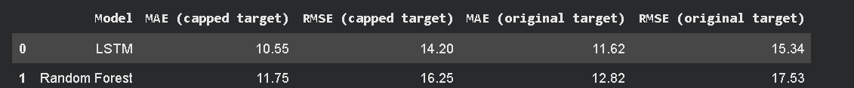
7. Final Model Assessment
The final assessment considers prediction error, consistency across validation observations, and performance on unseen test engines. Capped-target and original-target results are reported separately when both are evaluated, ensuring that the results are interpreted according to the target definition used. The test dataset is reserved for final evaluation rather than repeated model tuning.
Chapter 5
Results and Discussion

Evaluation Metrics
Mean Absolute Error (MAE) and Root Mean Squared Error (RMSE) are used to evaluate the RUL prediction models.

. Mean Absolute Error (MAE)
$$\left\{MAE\right\}=1/n\sum_{\left\{i=1\right\}}^{n}{\left|y_{i}-y^\right|}$$

2. Root Mean Squared Error (RMSE)
$$\left\{RMSE\right\}=\sqrt{\left\{1/n\sum_{\left\{i=1\right\}}^{n}{{\left(y_{i}-{\left\{y^\right\}}_{i}\right)}^{2}}\right\}}$$

Definitions
- n = Number of evaluated samples
- y _{i} = Actual Remaining Useful Life (RUL)
- y^i = Predicted Remaining Useful Life (RUL)

5.2 Validation Results
The LSTM model was compared with a Random Forest baseline using the same validation targets. The RUL targets were capped at 125 cycles.

Model | MAE | RMSE
LSTM | 8.55 | 11.91
Random Forest | 13.08 | 17.56

The LSTM model achieved a validation MAE of 8.55 cycles and an RMSE of 11.91 cycles. The Random Forest model produced a higher MAE of 13.08 cycles and an RMSE of 17.56 cycles.

These results indicate that the LSTM model performed better than the selected Random Forest baseline on the validation dataset. The comparison suggests that the sequential modeling approach was useful for this implementation.

5.3 Test Results
The final LSTM model was evaluated on the 100 test engines using the reference RUL values supplied with the dataset. Since the model was trained on RUL values capped at 125 cycles, predictions were restricted to the range from 0 to 125 cycles for the comparison below.
Target definition | MAE | RMSE
Capped RUL | 9.70 | 13.03
Original RUL | 10.77 | 14.39

The model achieved an MAE of 10.77 cycles and an RMSE of 14.39 cycles when evaluated against the original test RUL values. Against the capped test targets, the corresponding errors were 9.70 and 13.03 cycles.
The two results differ because the original RUL targets may exceed 125 cycles, whereas the capped targets are limited to a maximum of 125 cycles.
Sample predictions:
 | Actual RUL | Predicted RUL
0 | 125.0 | 121.779999
1 | 125.0 | 121.610001
2 | 125.0 | 121.489998
3 | 125.0 | 121.260002
4 | 125.0 | 121.510002
5 | 125.0 | 120.150002
6 | 125.0 | 121.860001
7 | 125.0 | 124.120003
8 | 125.0 | 126.980003
9 | 125.0 | 129.589996
10 | 125.0 | 131.089996
11 | 125.0 | 132.089996
12 | 125.0 | 132.720001
13 | 125.0 | 130.589996
14 | 125.0 | 131.080002

LSTM Model Evaluation
------------------------------
MAE: 9.70cycles
RMSE: 13.03 cycles
R² Score: 0.8342
R² Score (%): 83.42%

Discussion
The experimental results show that the revised LSTM model produced lower validation errors than the Random Forest baseline. The test results also show that the model can generate RUL estimates for unseen engine trajectories.
However, prediction errors remain, and the results should not be interpreted as proof of suitability for actual aircraft maintenance without further validation. Performance may depend on feature selection, sequence length, target capping, and model configuration.
The experiments provide a basis for further improvements, including additional feature analysis, hyperparameter tuning, and evaluation on other C-MAPSS subsets.

Chapter 7
Conclusion and Future Work

Conclusion
This project developed an LSTM-based approach for predicting the Remaining Useful Life of aircraft engines using the NASA C-MAPSS FD001 dataset.
The implementation included data loading, data inspection, RUL label generation, feature scaling, sequence preparation, LSTM model training, and evaluation. The input sequences contained 30 operating cycles and 24 features.
On the validation dataset, the LSTM model achieved an MAE of 8.55 cycles and an RMSE of 11.91 cycles, outperforming the Random Forest baseline, which achieved an MAE of 13.08 cycles and an RMSE of 17.56 cycles.
On the original test RUL targets, the final LSTM model achieved an MAE of 10.77 cycles and an RMSE of 14.39 cycles when predictions were restricted to the range from 0 to 125 cycles.
The results demonstrate the potential of sequential deep learning for aircraft engine RUL estimation on this dataset. Further experimentation and validation would be necessary before considering practical use in real aircraft maintenance.

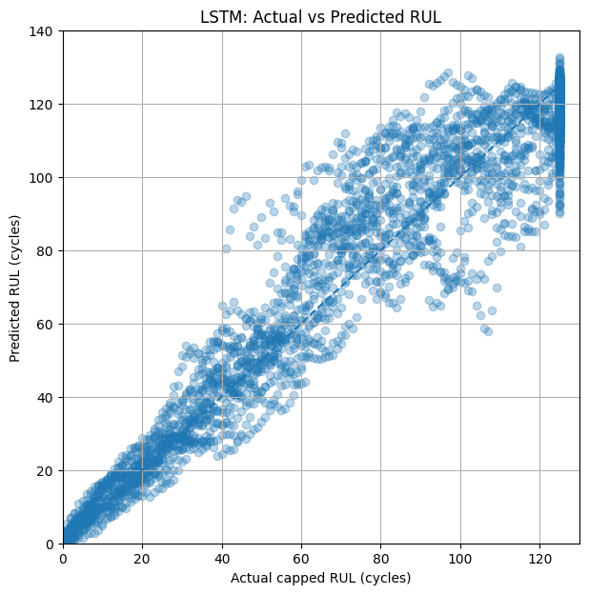
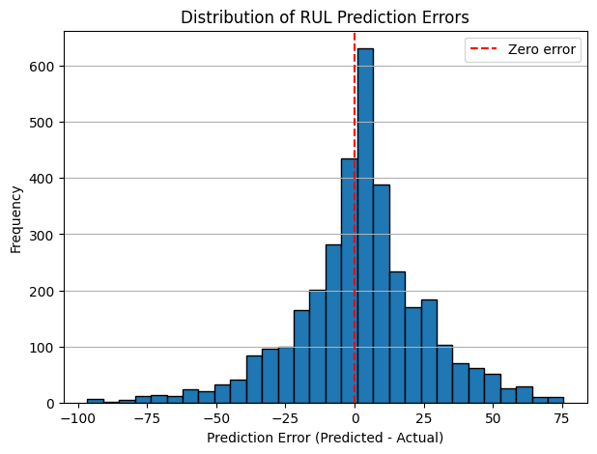

Future Work
Future work may include:
    - Testing different sequence lengths.
    - Investigating the contribution of individual sensor measurements.
    - Tuning LSTM architecture and training settings.
    - Evaluating additional C-MAPSS subsets.
    - Comparing additional machine learning models.

    - Studying prediction uncertainty and practical maintenance requirements.

