

Foundations of Programming
Assignment No. : 13

PROBLEM STATEMENT:
Write a program in C to accept a number from the user and print the digits of the number in reverse order.

OBJECTIVE:
• To understand number manipulation using loops
. • To learn the use of modulo (%) and division (/) operators.
• To implement logic for reversing digits of a number.
• To improve problem-solving skills using iterative structures.

THEORY:
• To understand number manipulation using loops. • To learn the use of modulo (%) and division (/) operators. • To implement logic for reversing digits of a number. • To improve problem-solving skills using iterative structures.

PLATFORM:
Linux

ALGORITHM:
• Start
• Declare variables num, digit, rev = 0
• Read number from user
• Repeat while num > 0
- Find last digit → digit = num % 10
- Build reverse → rev = rev * 10 + digit
- Remove last digit → num = num / 10
• Print rev
• stop

C PROGRAM:
#include <stdio.h>

int main()
{
int num;
int rem = 0;
int digit;

printf("Enter number: ");
scanf("%d", &num);

while(num > 0)
{
digit = num % 10;
rem = rem * 10 + digit;
num = num / 10;
}

printf("Reverse = %d", rem);

return 0;
}

INPUT:
INPUT:
The user enters an integer number.
Example Input: Number: 4567

Paste Screen Shot of Input

OUTPUT:
The program prints the digits of the number in reverse order.
Example Output: Digits in reverse order: 7 6 5 4
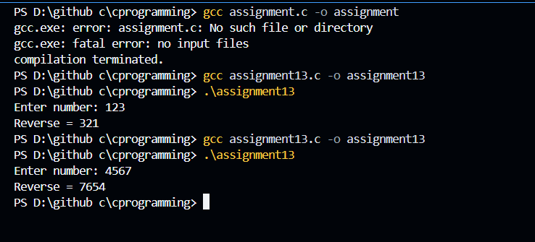

Paste Screen Shot of Output

CONCLUSION:
Thus, the program to print the digits of a number in reverse order was successfully implemented using C programming. The program demonstrates the effective use of loops, modulo operator, and division operator.

FAQs:
- Why is the modulo operator (%) used in this program?
- Why is division by 10 used after extracting each digit?
- What happens if the input number is zero?
- How will the program behave for negative numbers?
- Why is a while loop preferred for this operation?

