Q.1 > Draw a DFA for the language accepting strings ending with ’01’ over input alphabets ∑ = {0, 1}

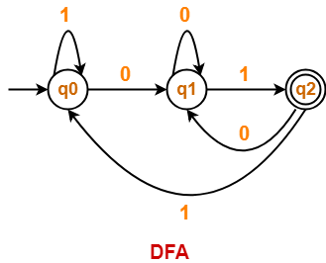

Q.2 > Draw a DFA for the language accepting strings ending with ‘abb’ over input alphabets ∑ = {a, b}

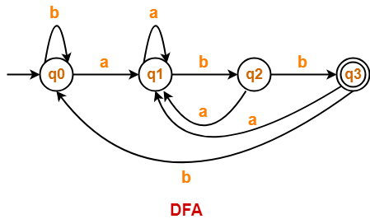

Q.3 > Draw a DFA for the language accepting strings ending with ‘abba’ over input alphabets ∑ = {a, b}

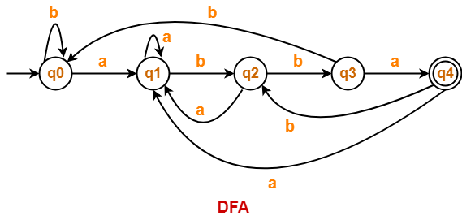

Q.4 > Draw a DFA for the language accepting strings ending with ‘0011’ over input alphabets ∑ = {0, 1}

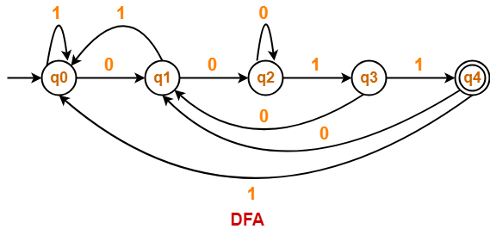

Q.5 > Draw a DFA for the language accepting strings starting with ‘ab’ over input alphabets ∑ = {a, b}

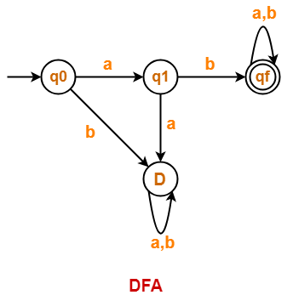

Q.6 > Draw a DFA for the language accepting strings starting with ‘a’ over input alphabets ∑ = {a, b}

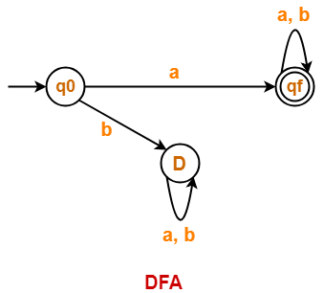

Q.7 > Draw a DFA for the language accepting strings starting with ‘101’ over input alphabets ∑ = {0, 1}

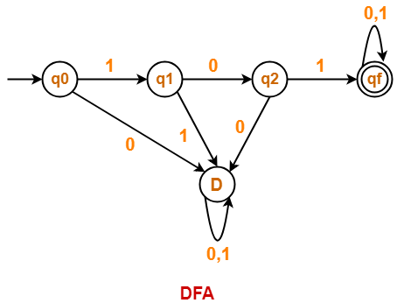

Q.8 > Draw a DFA that accepts a language L over input alphabets ∑ = {0, 1} such that L is the set of all strings starting with ’00’.

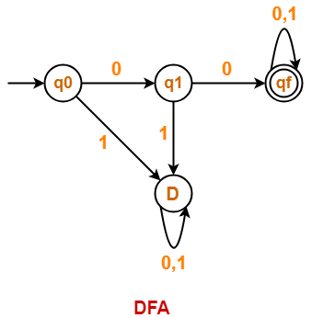

Q.9 > Construct a DFA that accepts a language L over input alphabets ∑ = {a, b} such that L is the set of all strings starting with ‘aa’ or ‘bb’.

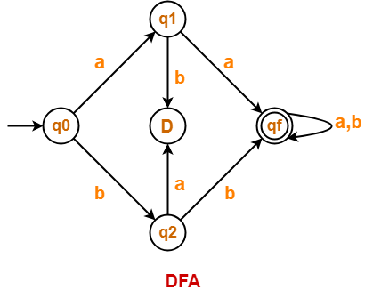

Q.10 > Construct a DFA that accepts a language L over input alphabets ∑ = {a, b} such that L is the set of all strings starting with ‘aba’.

