**INTRODUCTION TO DATA MANAGEMENT**

**PROJECT REPORT**

(Project Semester January-April 2025)

***DISTRICT-WISE MGNREGA ANALYSIS FOR GUJARAT***

Submitted by

**Archita Dubey**

Registration No. 12324628

Programme and Section- B. Tech & KM007

Course Code INT217

Under the Guidance of

**Maneet Kaur (UID: 15709)**

**(Name of faculty coordinator with U.Id and designation)**

**Discipline of CSE/IT**

**Lovely School of Computer Science and Engineering**

**Lovely Professional University, Phagwara**

**DECLARATION**

**I, Archita Dubey, student of B. Tech (Program name) under CSE/IT Discipline at, Lovely Professional University, Punjab, hereby declare that all the information furnished in this project report is based on my own intensive work and is genuine.**

**Date: 12-04-2025 Signature**

**Registration No. 12324628 Name of the student- Archita Dubey**

**CERTIFICATE**

This is to certify that Archita Dubey bearing Registration no. 12324628 has completed INT217 project titled, **“*DISTRICT-WISE MGNREGA ANALYSIS FOR GUJARAT*”** under my guidance and supervision. To the best of my knowledge, the present work is the result of his/her original development, effort and study.

**Signature and Name of the Supervisor**

**Designation of the Supervisor**

**School of Computer Science and Engineering**

Lovely Professional University

Phagwara, Punjab.

Date:

**ACKNOWLEDGEMENT**

**I would like to express my heartfelt gratitude to everyone who supported me in the successful completion of this Excel project titled " *DISTRICT-WISE MGNREGA ANALYSIS FOR GUJARAT*."**

**First and foremost, I would like to sincerely thank my respected teacher, Ms. Maneet Kaur, for her valuable guidance, constant encouragement, and insightful feedback throughout the course of this project. Her support played a crucial role in helping me explore and analyse the dataset effectively.**

**I would also like to extend my appreciation to Lovely Professional University for providing the academic resources and platform that made this project possible.**

**This project has not only enhanced my Excel skills—such as working with formulas, charts, pivot tables, and data visualization—but also deepened my interest in data analysis using real-world topics like the Olympic Games.**

**Lastly, I thank my friends and family for their continued support and motivation during this project journey.**

**TABLE OF CONTENT**

|  |  |  |
| --- | --- | --- |
| Sr. No. | Title | Pg No. |
| 1 | Introduction | 6 |
| 2 | Source of dataset | 7 |
| 3 | Dataset Preprocessing | 8 |
| 4 | Analysis on dataset   1. General Description 2. Specific Requirements 3. Analysis results 4. Visualization | 9-17 |
| 5 | Conclusion | 17 |
| 6 | Future scope | 18 |
| 7 | References | 18 |

**INTRODUCTION**

This Excel project titled **"MGNREGA Data Analysis"** focuses on analyzing employment and financial data related to the Mahatma Gandhi National Rural Employment Guarantee Act (MGNREGA). The dataset comprises vital information such as financial year, district names, job card counts, person-days generated, total expenditure, and other employment-related metrics across different regions.

Using Microsoft Excel, the project delves into key analytical aspects including employment trends over the years, district-wise performance, fund utilization, and gender participation in rural employment schemes. Through the use of pivot tables, charts, and summary statistics, the project presents meaningful insights into the impact and reach of MGNREGA at both state and district levels.

The aim of this project is to enhance understanding of government employment initiatives using a data-driven approach, while also improving proficiency in Excel-based data analysis and visualization techniques.

**SOURCE OF DATASET**

DISTRICT-WISE MGNREGA ANALYSIS FOR GUJARAT DATA SOURCE LINK:

https://www.data.gov.in/resource/district-wise-mgnrega-data-glance

**DATASET PREPROCESSING**

To ensure the accuracy and reliability of analysis, several preprocessing steps were carried out on the original MGNREGA dataset before proceeding with visualization and interpretation in Excel. These steps helped enhance data quality, remove inconsistencies, and make the dataset more suitable for meaningful insights.

The preprocessing steps included:

1. **Data Extraction and Sample Refinement:**
   * The dataset included records from various districts and years.
   * A focused subset of data was selected to keep the analysis manageable and relevant, highlighting key parameters such as job cards issued, person-days generated, and total expenditure.
2. **Removing Duplicates:**
   * Duplicate entries, particularly those arising from repeated district-level entries across different rows or financial years, were identified and removed to avoid inflated figures and maintain data integrity.
3. **Standardizing Location Names and Codes:**
   * Inconsistent naming of districts or states (e.g., spelling variations, use of abbreviations) was corrected.
   * This standardization ensured better grouping and clearer insights when summarizing or comparing data.
4. **Data Type Conversion and Formatting:**
   * Columns such as financial year and expenditure were verified to be in the appropriate formats (date, numeric).
   * Uniform formatting was applied to ensure consistency in visualizations, with appropriate use of currency symbols, comma separators, and date formats.
5. **Sorting, Filtering, and Structuring:**
   * Data was sorted based on parameters like financial year, state, or total expenditure depending on the analysis objective.
   * Filters were applied for focused examination of high-performing or underperforming districts.
   * Pivot tables were created to dynamically explore patterns in employment generation and fund utilization.

**ANALYSIS ON DATASET**

**Objective 1**

**Examine the month-wise distribution of total expenditure under the MGNREGA scheme across various districts in Gujarat**

**General Description:**  
• Identify months with highest and lowest expenditure.  
• Analyze overall spending trends and patterns throughout the year.

**Specific Requirements:**  
**Excel Features Used:**  
• PivotTables to summarize monthly expenditure.  
• Column Charts for visual representation.  
• Conditional Formatting to highlight highs/lows.  
• Sorting to rank months by total expenditure.

**Analysis Results:**  
• Highest expenditure occurred in **March**, followed by **May** and **June**.  
• **April** and **January** had the lowest expenditures.  
• Spending tends to peak during agricultural off-seasons, showing effective implementation.  
• Such trends are critical for seasonal planning and fund allocation.

**Visualization –**

### **Objective 2**

**Visualize the distribution of Scheduled Caste (SC) and Scheduled Tribe (ST) workers actively employed under the MGNREGA scheme across various districts.**

**General Description:**  
• Highlight the inclusion of SC/ST communities in employment opportunities.  
• Assess regional representation of these communities in scheme implementation.

**Specific Requirements:**  
**Excel Features Used:**• PivotTables to organize SC/ST worker data by district.  
• Bar Charts for side-by-side SC/ST comparisons.  
• Conditional Formatting to identify high/low representation.  
• Filtering to focus on specific categories.

**Analysis Results:**  
• Districts with significant ST populations like **Dahod**, **Narmada**, and **Panchmahal** showed higher ST worker participation.  
• SC participation was relatively consistent but higher in **Ahmedabad** and **Surat**.  
• This reflects targeted outreach to marginalized communities in rural employment

**Visualization –**

**OBJECTIVE 3- Evaluate district-wise participation in the MGNREGA scheme across Gujarat by analyzing the total number of individuals worked.**

**General Description:**  
• Understand workforce distribution under MGNREGA.  
• Identify high and low participation districts for focused policymaking.

**Specific Requirements:**  
**Excel Features Used:**  
• PivotTables for district-wise worker count.  
• Charts to display comparison.  
• Sorting to identify top and bottom districts.  
• Conditional Formatting to highlight participation patterns.

**Analysis Results:**  
• **Dahod**, **Banaskantha**, and **Surendranagar** recorded the highest participation.  
• Urban districts like **Valsad** and **Gandhinagar** had lower figures.  
• Indicates strong engagement in rural and tribal regions where employment need is high.  
• Data can guide allocation of additional resources to low-participation areas.

**Visualization –**

**OBJECTIVE 4- Identify months with higher or lower employment distribution**

**General Description:**  
• Compare month-wise employment numbers.  
• Examine seasonal patterns in rural employment needs.

**Specific Requirements:**  
**Excel Features Used:**  
• PivotTables to count employment days by month.  
• Line or Column Charts for trend visualization.  
• Sorting to rank months.  
• Conditional Formatting for quick visual analysis.

**Analysis Results:**  
• **May**, **June**, and **March** saw peak employment levels.  
• Employment dipped in **January** and **April**.  
• Employment patterns suggest alignment with agricultural cycles and monsoon-based demand shifts.  
• Results can be used to optimize planning and pre-scheduling of work

**Visualization –**

**OBJECTIVE 5- Provide a transparent and detailed breakdown of total expenditure incurred under the MGNREGA scheme.**

**General Description:**  
• Break down spending into components: wages, materials, administration, etc.  
• Assess fund utilization and transparency.

**Specific Requirements:**  
**Excel Features Used:**  
• Formulas for total calculation.  
• Pie Charts to show share of components.  
• PivotTables for detailed component analysis.  
• Color Formatting for clarity.

**Analysis Results:**  
• **Wage Payments** made up the largest share of expenditure (~₹2.13 crore).  
• The data suggests funds are primarily directed toward direct employment — achieving the intended purpose.  
• Breakdown increases accountability and ensures transparency in rural employment funding.

**Visualization –**

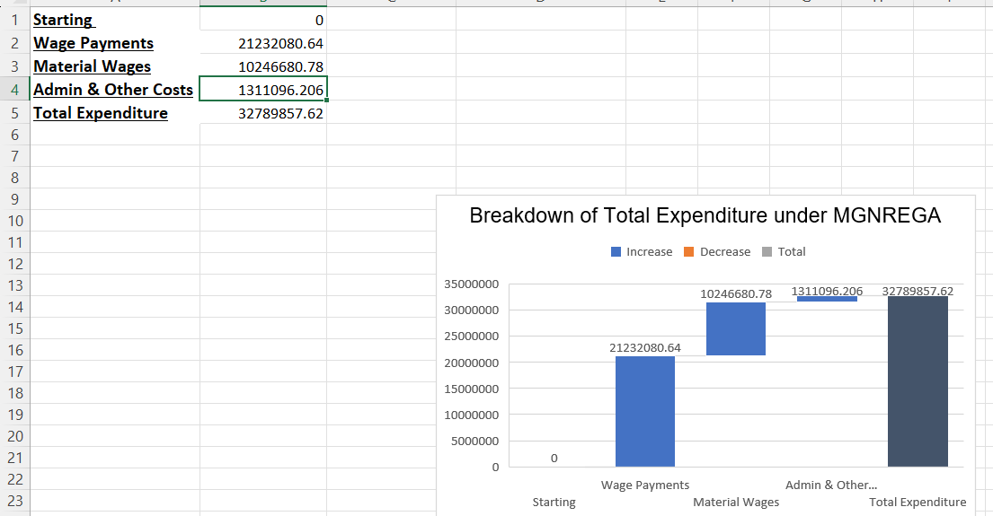

**Objective 7 – DASHBOARD**

**General Description –**  
The dashboard is designed as an interactive tool for analyzing district-level data related to **MGNREGA (Mahatma Gandhi National Rural Employment Guarantee Act)** in **Gujarat**. It provides a user-friendly visual summary of key performance indicators, allowing exploration of:

* Total active workers per district
* Category-wise expenditure (Wages, Material, Admin costs)
* Trends in fund utilization
* District comparisons based on workforce and financial metrics

### **Specific Requirements –**

**• PivotTables & Charts:**

* **District-Wise Worker Participation** – Total number of active workers in each district
* **Expenditure Breakdown** – Segregated views of wages, material & skilled wages, and admin costs
* **Fund Utilization Overview** – Waterfall chart visualizing total expenditure and category contributions
* **Comparative Views** – District-wise bar charts comparing worker count and wage disbursement

**• Slicers (Interactive Filters):**

* **District Name**
* **Financial Year (if available)**
* **Expenditure Category**
* **Worker Category (if differentiated)**

**• Excel Features Used:**

* Pivot Tables and Pivot Charts
* Dynamic named ranges
* Slicers for easy filtering and comparisons
* Waterfall charts for expenditure breakdown
* Clean, user-friendly dashboard layout on a dedicated sheet

### **Analysis Results –**

The dashboard reveals important patterns in MGNREGA implementation across Gujarat:

* **Banaskantha, Dahod, and Narmada** districts show higher worker participation
* **Wage payments form the largest portion** of total expenditure, with material costs next
* Some districts exhibit **imbalances in fund utilization**, indicating scope for resource optimization
* The dashboard supports **targeted decision-making** by visually highlighting high and low-performing districts

Users can drill down into specific categories or compare districts directly, aiding transparency and informed policy evaluation.

**Visualization –**

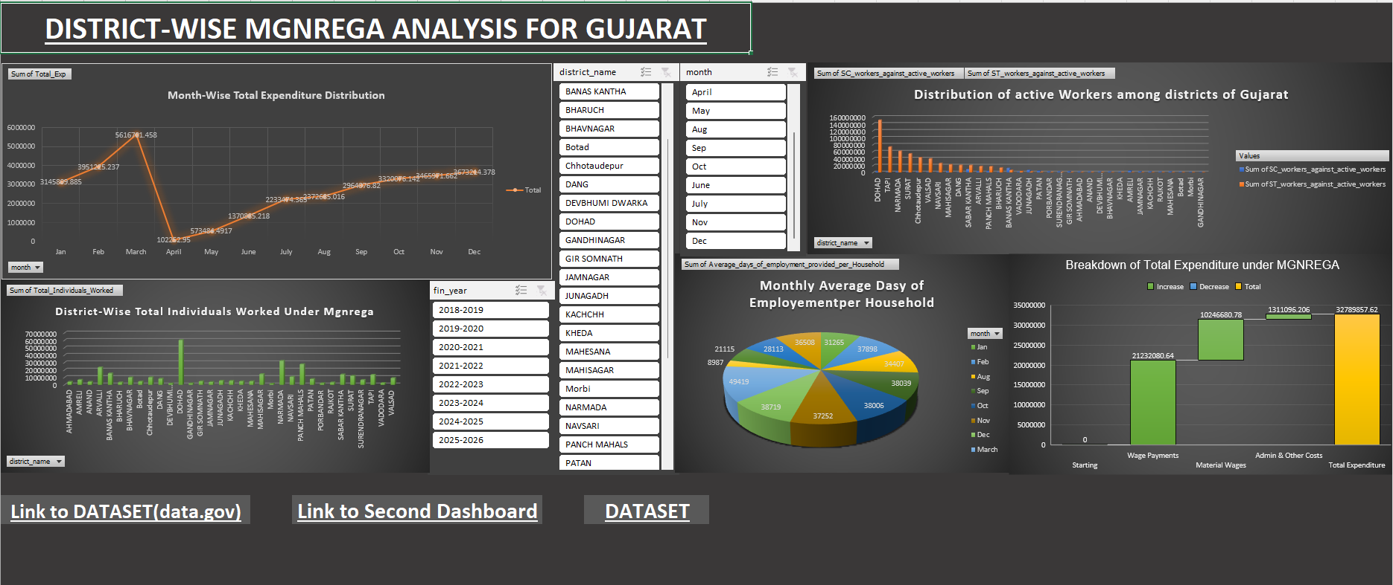

### **CONCLUSION**

This project delivered critical insights into MGNREGA implementation at the district level in Gujarat through comprehensive data cleaning, analysis, and visualization. Leveraging Excel functionalities such as PivotTables, dynamic charts, slicers, and waterfall visualizations, an interactive and intuitive dashboard was built. It highlights district-wise worker participation, expenditure patterns, and fund utilization efficiency. The project not only strengthened analytical and data visualization skills but also demonstrated how Excel can be used effectively to process government datasets and extract meaningful policy-level insights in a structured and visually compelling format.

**LinkedIn:**  https://www.linkedin.com/in/archita9/

### **FUTURE SCOPE**

While this project effectively visualized and analyzed critical components of MGNREGA implementation in Gujarat, several opportunities exist to expand and deepen the analysis in future phases:

1. **Addition of Multi-Year Data**:  
   Expanding the dashboard to include multiple financial years will enable longitudinal analysis and reveal long-term trends in employment, expenditure, and fund utilization.
2. **Granular Demographic Insights**:  
   Incorporating more granular data such as age groups, education levels, and job card issuance per capita could offer deeper demographic insights into the beneficiaries of MGNREGA.
3. **Predictive Modelling and Forecasting**:  
   Using tools like Python or Power BI, future iterations could implement predictive analytics to forecast labor demand, expenditure patterns, or potential fund mismanagement.
4. **Geo-Spatial Visualizations**:  
   Integration with Power Map or Tableau can help generate interactive maps, allowing users to visualize district-wise performance spatially for faster policy assessment.
5. **Real-Time Data Integration**:  
   Future versions can connect with government APIs or live dashboards for up-to-date reporting and monitoring of scheme implementation.
6. **Scalability Across States**:  
   The current framework can be extended to perform similar analysis across other states to compare regional performance and identify best practices in MGNREGA operations.

This future roadmap sets a foundation for a scalable and impactful data analytics solution that can assist in policy formulation, impact tracking, and public accountability.

### **REFERENCES**

• MGNREGA Data – District-wise MGNREGA data from official records and government portals  
• Microsoft Excel Documentation – Advanced features including PivotTables, slicers, and charting tools  
• Lovely Professional University (LPU) – Curriculum and project supervision support  
• Government of India – Ministry of Rural Development MGNREGA Dashboard and Reports  
• Towards Data Science – Excel-based data visualization and dashboard techniques