ARCHITA AGRAHARI

22CS3015

**WEB TECHNOLOGY**

**LAB-10**

**Connect to a MongoDB server using MongoDB Compass.**

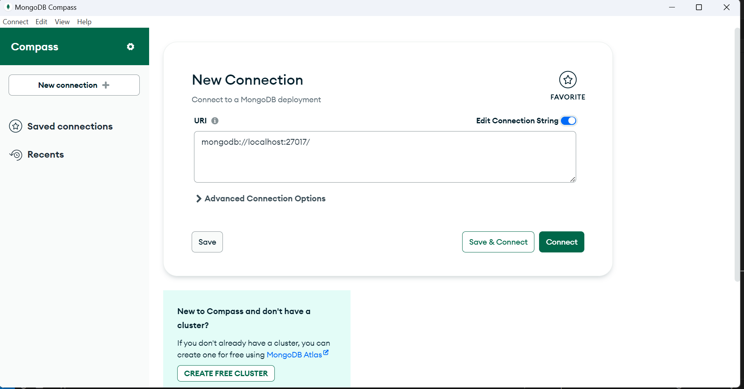

**Create a new database named "testdb" in MongoDB Compass.**

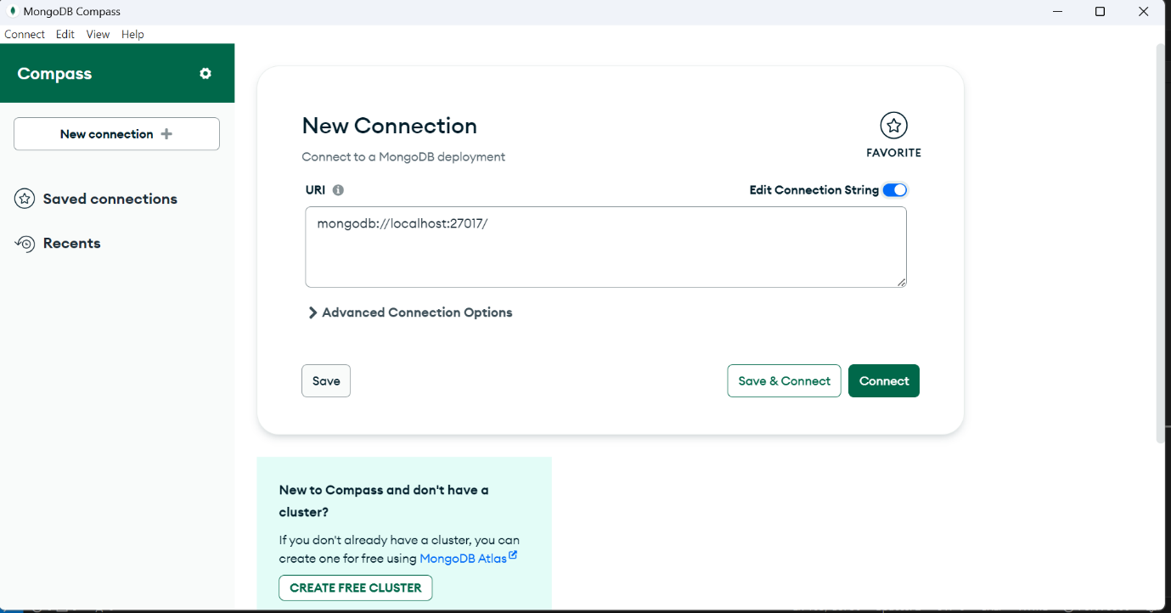

**Create a new collection named "students" in the "testdb" database.**

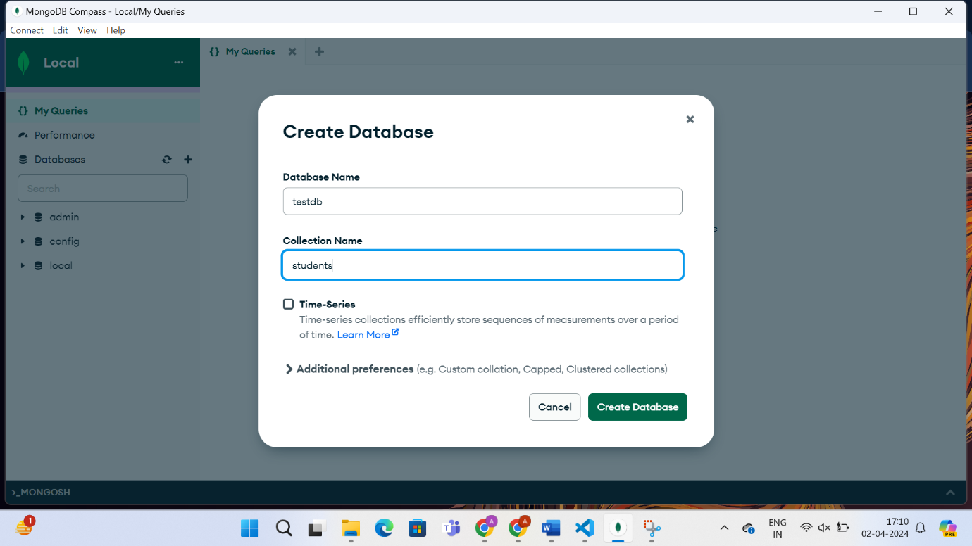

**Insert ten documents into the "students" collection with the following fields:**

**name, age, and email.**

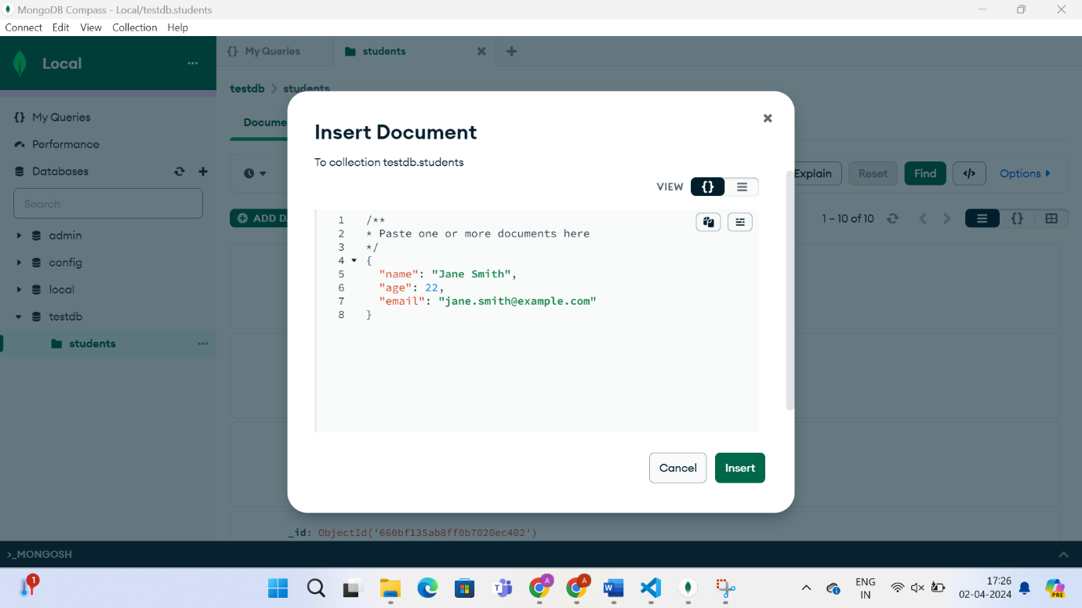

**View the contents of the "students" collection.**

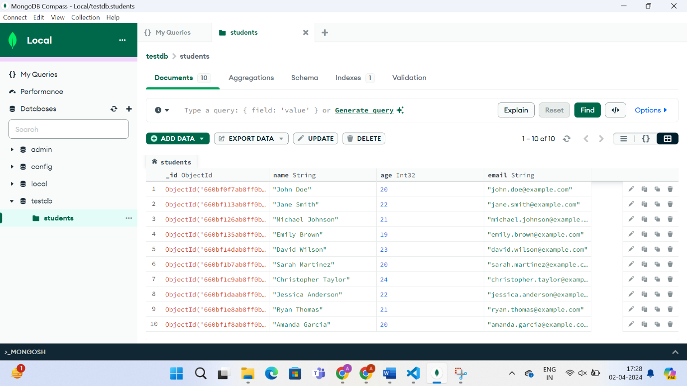

**Update the age of a specific student in the "students" collection.**

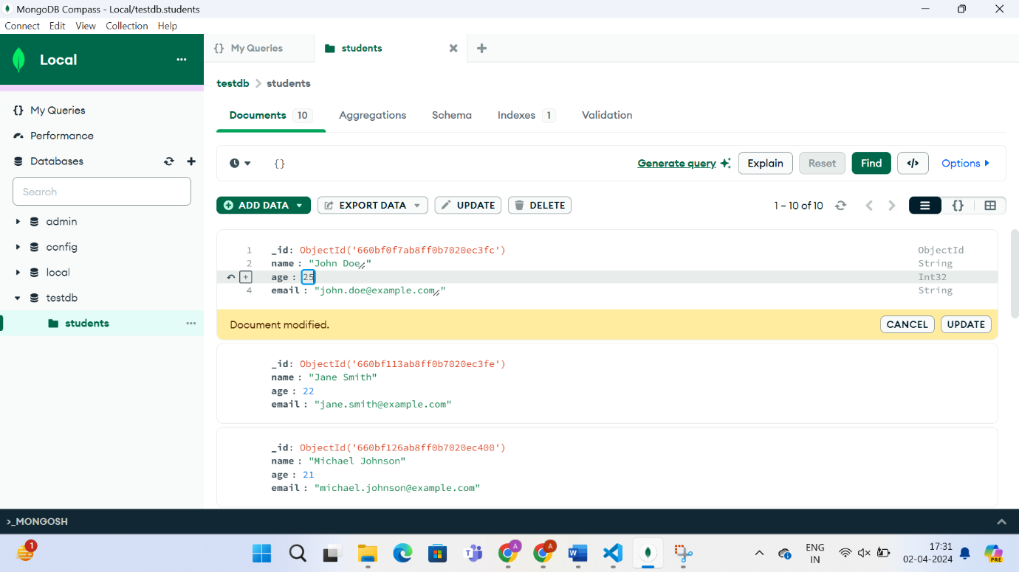

**Delete a document from the "students" collection based on a specific**

**condition.**

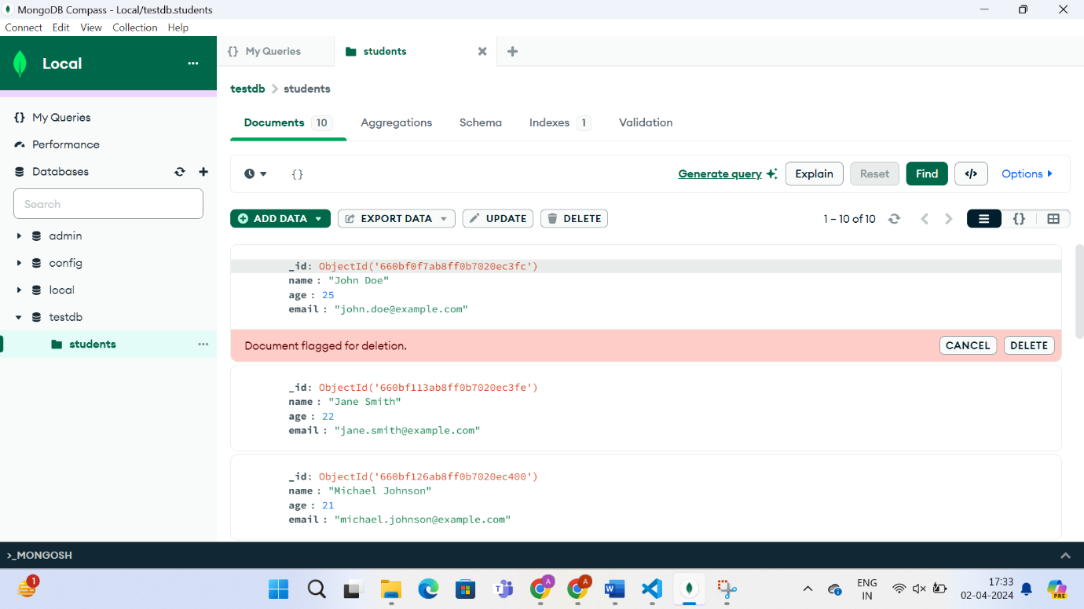

**Use the aggregation pipeline to calculate the average age of all students in the"students" collection.**

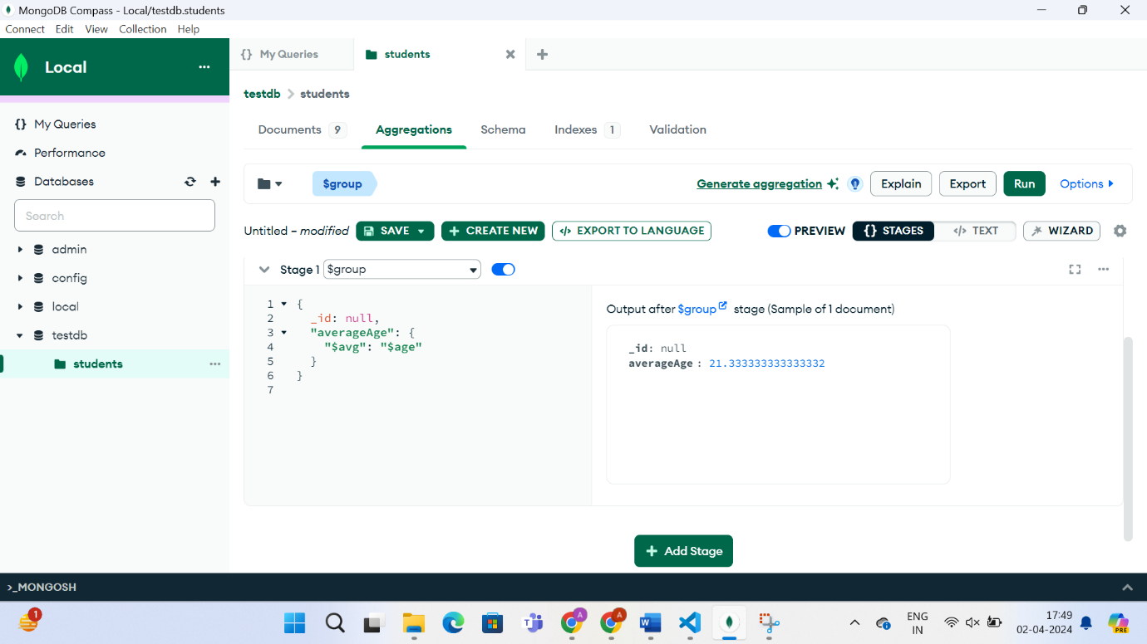

**Create an index on the "name" field in the "students" collection.**

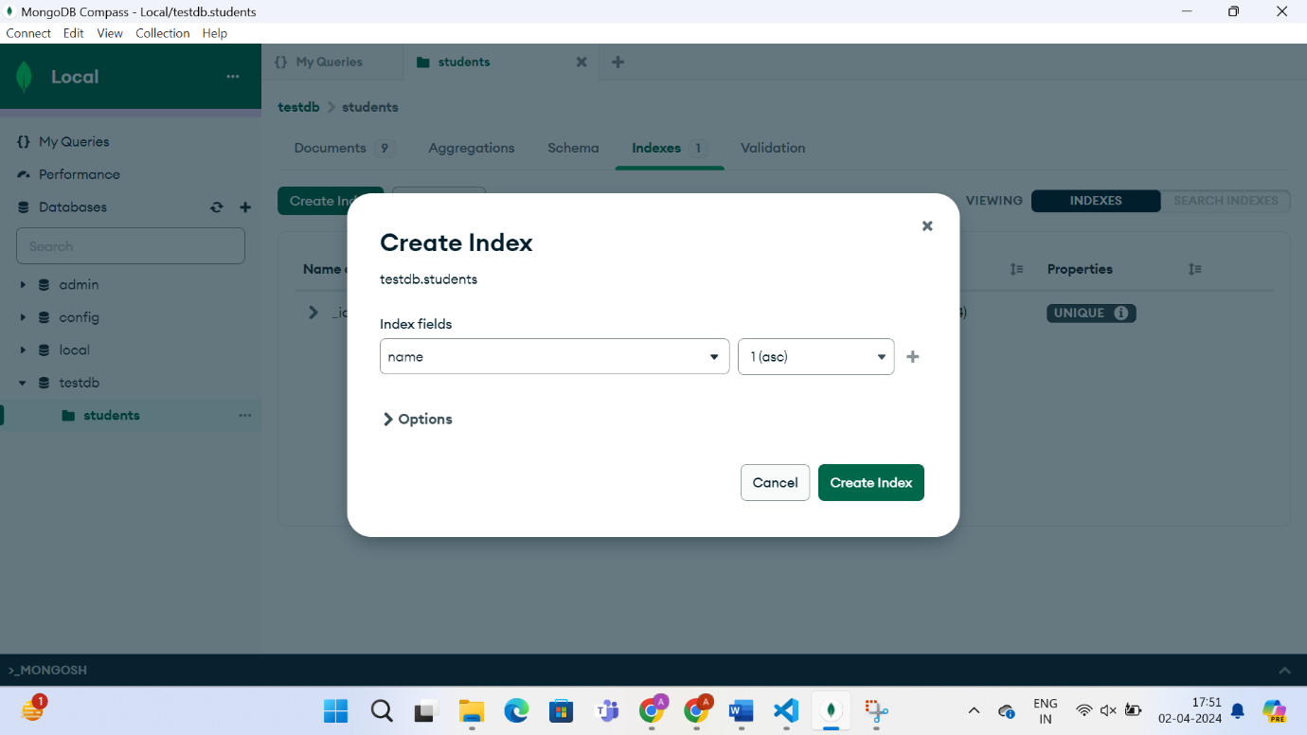

**Export the contents of the "students" collection to a JSON file.**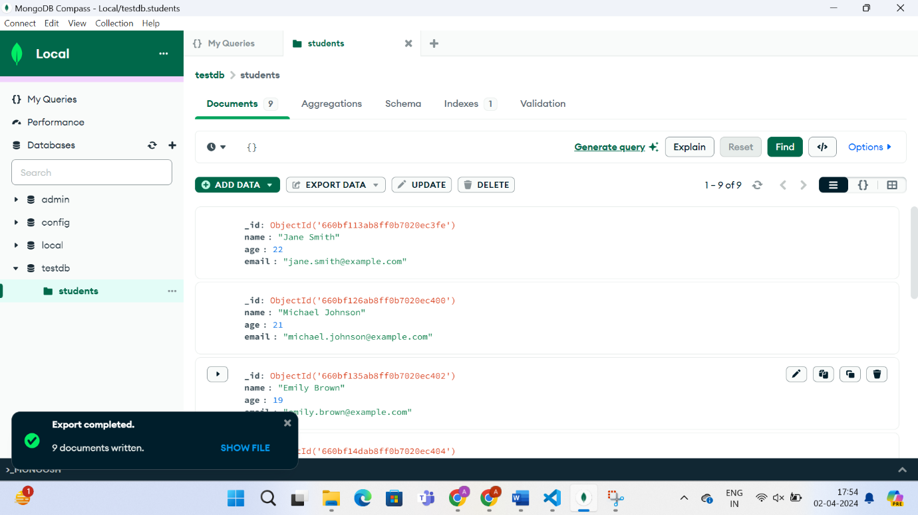

**Perform a complex aggregation operation to find the top 5 oldest students in**

**the "students" collection.**

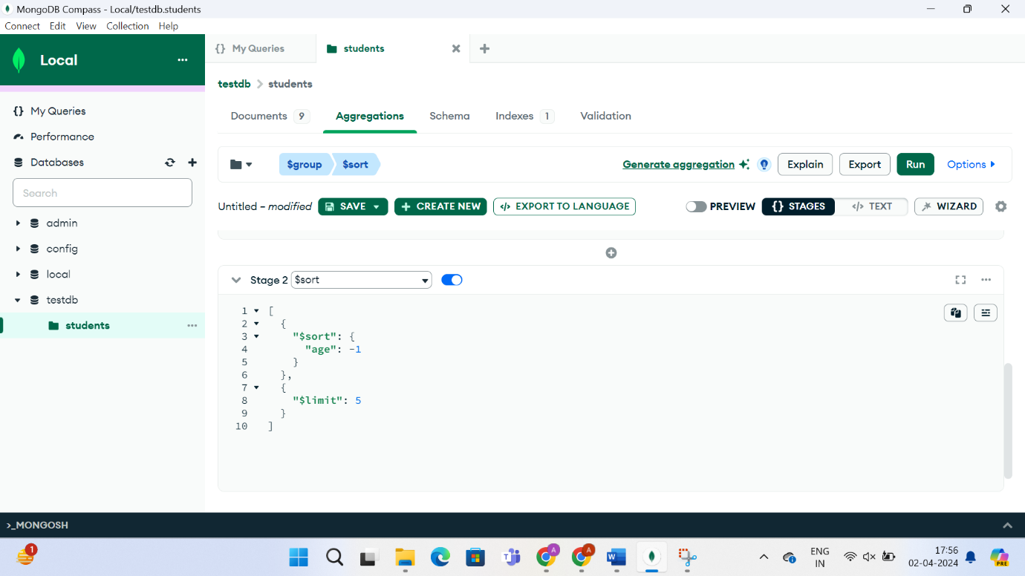

**Create a geospatial index on a field representing the location of students.**

