**WEB TECH**

**LAB 4**

Name: Archita Agrahari

Roll No.: 22CS3015

**Q1. Create a webpage that has a heading and a button. Write a script to change the background color and text when the button is clicked.**

<!DOCTYPE html>

<html lang="en">

<head>

<meta charset="UTF-8">

<meta name="viewport" content="width=device-width, initial-scale=1.0">

<title>Change Background Color and Text</title>

<style>

  body {

    font-family: Arial, sans-serif;

    text-align: center;

    background-color: #f0f0f0;

    transition: background-color 0.5s ease;

  }

  h1 {

    color: #333;

  }

  button {

    padding: 10px 20px;

    font-size: 16px;

    background-color: #007bff;

    color: #fff;

    border: none;

    cursor: pointer;

    transition: background-color 0.3s ease;

  }

  button:hover {

    background-color: #0056b3;

  }

</style>

</head>

<body>

<h1 id="heading">Original Heading</h1>

<button id="changeButton">Change Background color and Text</button>

<script>

  document.getElementById('changeButton').addEventListener('click', function() {

    var randomColor = '#' + Math.floor(Math.random()*16777215).toString(16);

    document.body.style.backgroundColor = randomColor;

    document.getElementById('heading').textContent = 'New Heading';

  });

</script>

</body>

</html>

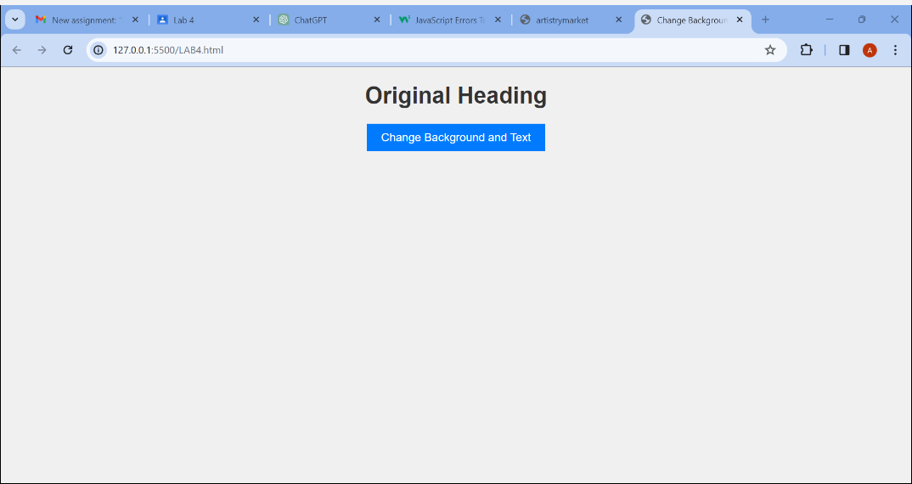

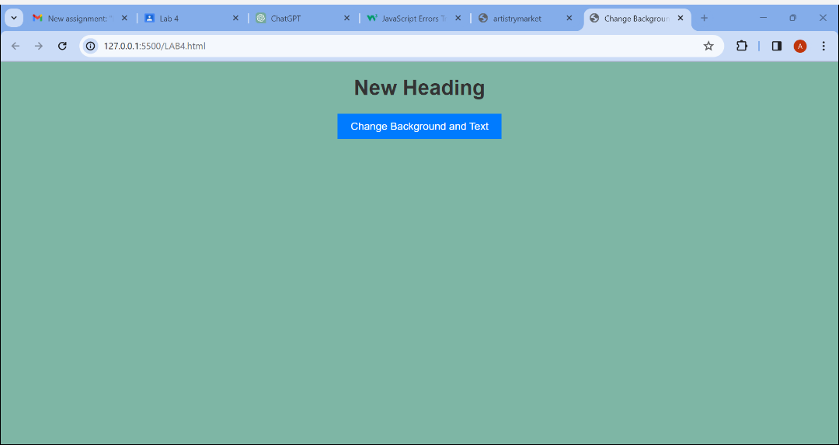

**T2. For T1, experiment with the Javascript code by trying the following things:**

**a. Make the background light green.**

**b. Add a line that makes the text red.**

**c. Change the fontSize to 48pt.**

**d. Change the wording inside the <h1> tag in the Javascript.**

**e. Add <button>Click Me</button> after the closing </h1>.**

<!DOCTYPE html>

<html lang="en">

<head>

<meta charset="UTF-8">

<meta name="viewport" content="width=device-width, initial-scale=1.0">

<title>Change Background Color and Text</title>

<style>

  body {

    font-family: Arial, sans-serif;

    text-align: center;

    background-color: #f0f0f0; /* Default background color */

    transition: background-color 0.5s ease;

  }

  h1 {

    color: #333; /* Default text color */

  }

  button {

    padding: 10px 20px;

    font-size: 16px;

    background-color: #007bff;

    color: #fff;

    border: none;

    cursor: pointer;

    transition: background-color 0.3s ease;

  }

  button:hover {

    background-color: #0056b3;

  }

</style>

</head>

<body>

<h1 id="heading">Original Heading <button id="clickMe">Click Me</button></h1>

<button id="changeButton">Change Background and Text</button>

<script>

  // JavaScript to change background color and text when button is clicked

  document.getElementById('changeButton').addEventListener('click', function() {

    // Make the background light green

    document.body.style.backgroundColor = 'lightgreen';

    // Make the text red

    document.getElementById('heading').style.color = 'red';

    // Change fontSize to 48pt

    document.getElementById('heading').style.fontSize = '48pt';

    // Change the wording inside the <h1> tag

    document.getElementById('heading').textContent = 'Modified Heading';

  });

</script>

</body>

</html>

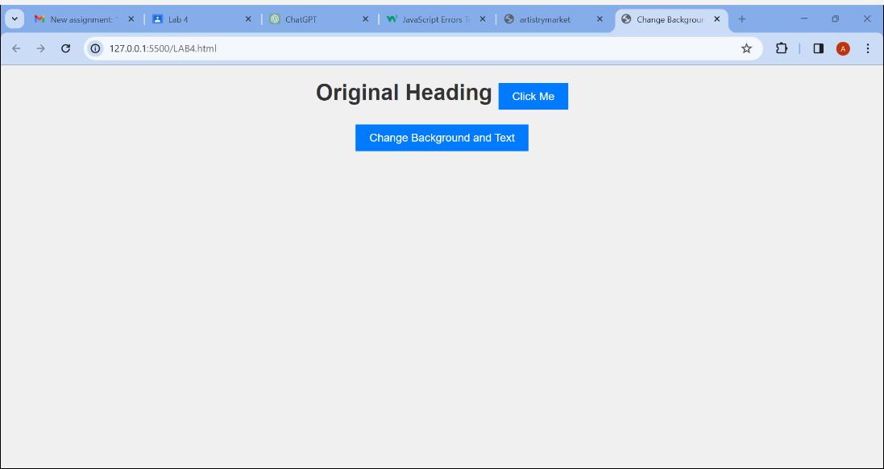

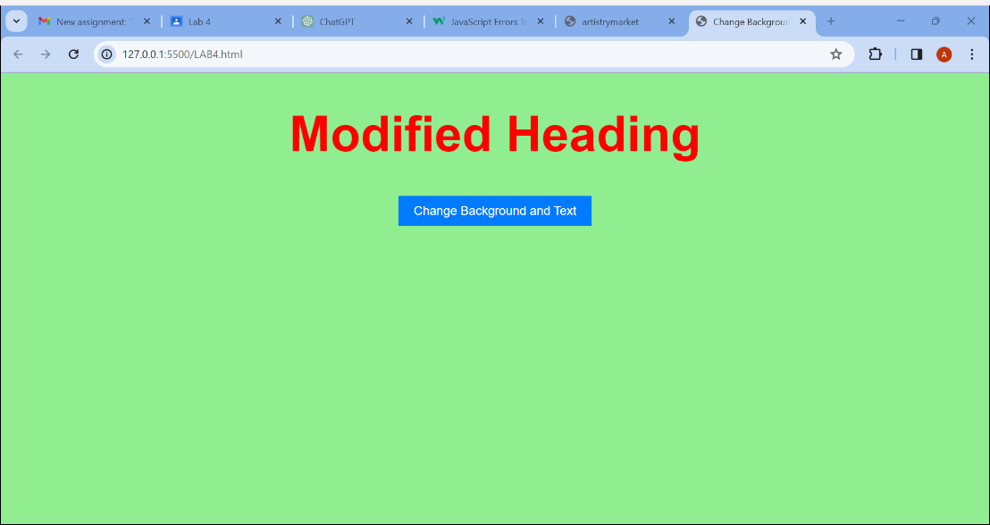

**Q3.** **T3. For T1, set the color of the background directly with the class attribute. Generate alerts before and after assigning the class attribute to document object.**

<!DOCTYPE html>

<html lang="en">

<head>

<meta charset="UTF-8">

<meta name="viewport" content="width=device-width, initial-scale=1.0">

<title>Change Background Color and Text</title>

<style>

  body {

    font-family: Arial, sans-serif;

    text-align: center;

    background-color: #f0f0f0; /* Default background color */

    transition: background-color 0.5s ease;

  }

  .light-green-background {

    background-color: lightgreen;

  }

</style>

</head>

<body>

<h1 id="heading">Original Heading</h1>

<button id="changeButton">Change Background and Text</button>

<script>

  // Alert before assigning class attribute

  alert("Before assigning class attribute");

  // JavaScript to change background color and text when button is clicked

  document.getElementById('changeButton').addEventListener('click', function() {

    // Alert after assigning class attribute

    alert("After assigning class attribute");

    // Assigning the class attribute to change the background color

    document.body.classList.add('light-green-background');

    // Change the text of the heading

    document.getElementById('heading').textContent = 'New Heading';

  });

</script>

</body>

</html>

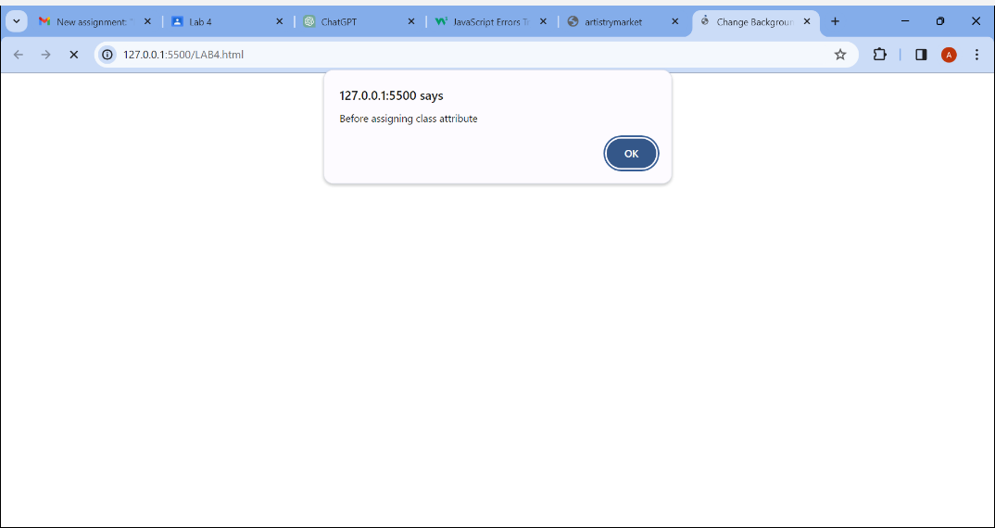

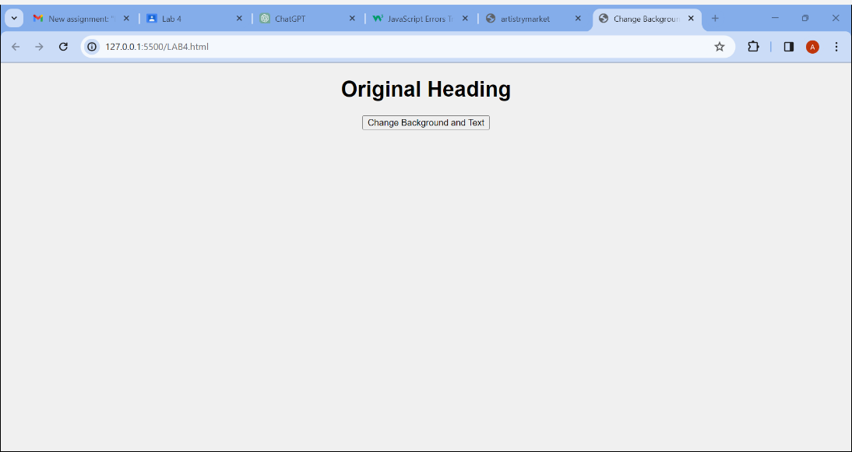

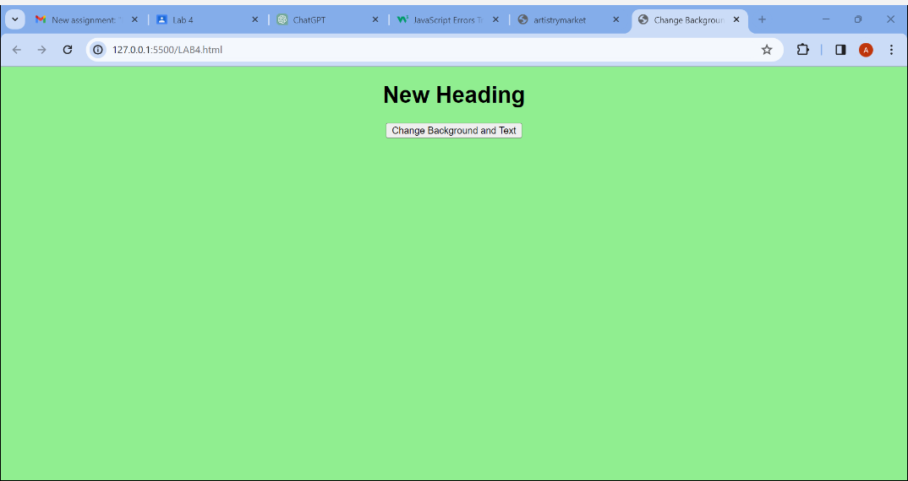

**T4. Design a page having contents within and outside the main section. The page must contain a button that when clicked replaces the content of the main section with another content having different style.**

<!DOCTYPE html>

<html lang="en">

<head>

<meta charset="UTF-8">

<meta name="viewport" content="width=device-width, initial-scale=1.0">

<title>Dynamic Content Change</title>

<style>

  body {

    font-family: Arial, sans-serif;

    margin: 0;

    padding: 0;

  }

  header {

    background-color: #333;

    color: white;

    padding: 10px;

    text-align: center;

  }

  nav {

    background-color: #f0f0f0;

    padding: 10px;

  }

  nav ul {

    list-style-type: none;

    margin: 0;

    padding: 0;

    text-align: center;

  }

  nav ul li {

    display: inline;

    margin-right: 10px;

  }

  main {

    padding: 20px;

  }

  .default-content {

    background-color: #f9f9f9;

    padding: 20px;

    border: 1px solid #ddd;

  }

  .new-content {

    background-color: #007bff;

    color: white;

    padding: 20px;

    border: 1px solid #0056b3;

  }

</style>

</head>

<body>

<header>

  <h1>Website Title</h1>

</header>

<nav>

  <ul>

    <li><a href="#">Home</a></li>

    <li><a href="#">About</a></li>

    <li><a href="#">Contact</a></li>

  </ul>

</nav>

<main>

  <section class="default-content" id="mainSection">

    <h2>Main Section Content</h2>

    <p>This is the default content of the main section.</p>

  </section>

</main>

<button id="changeContentButton">Change Main Content</button>

<script>

  document.getElementById('changeContentButton').addEventListener('click', function() {

    var mainSection = document.getElementById('mainSection');

    mainSection.innerHTML = `

      <section class="new-content">

        <h2>New Main Section Content</h2>

        <p>This is the new content of the main section with different style.</p>

      </section>

    `;

  });

</script>

</body>

</html>

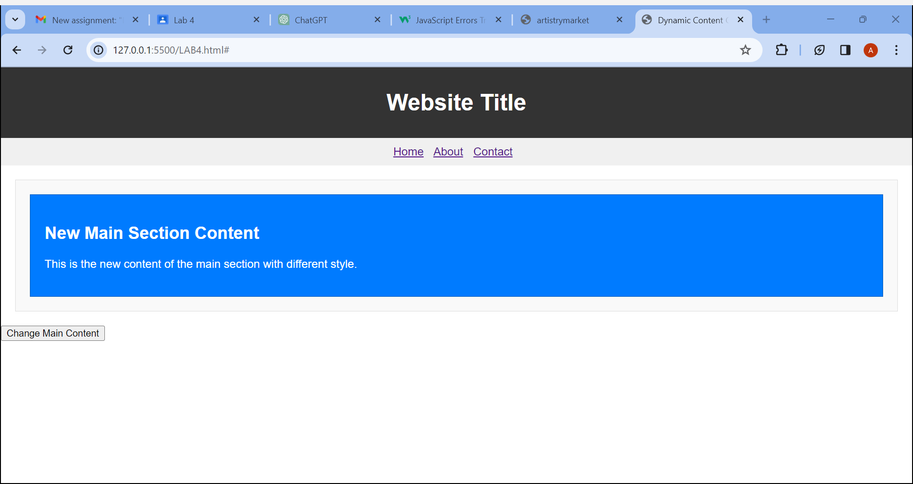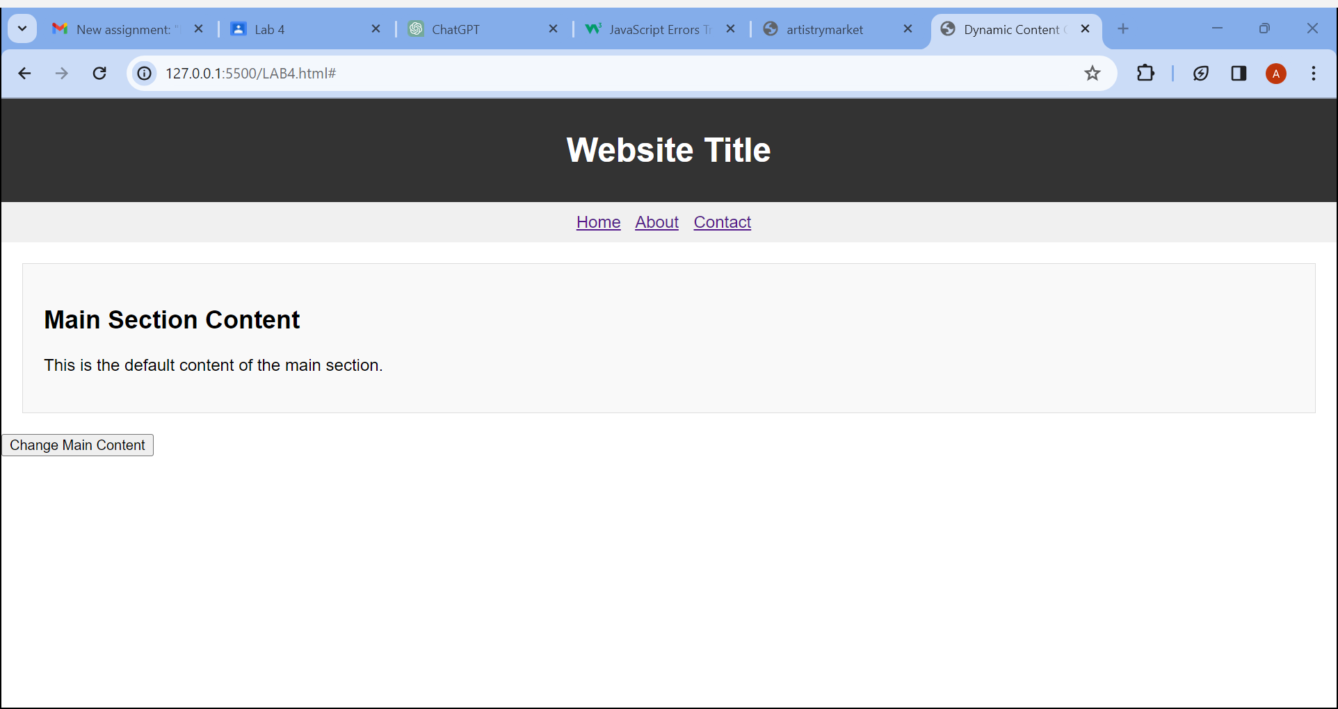

**T5. Consider a h1 heading lying outside the main section in the page. Try changing the color of h1 in at least 3 different ways.**

**1.** **<!-- By getElementById -->**

<!DOCTYPE html>

<html lang="en">

<head>

    <meta charset="UTF-8">

    <meta name="viewport" content="width=device-width, initial-scale=1.0">

    <title>Change h1 Color</title>

</head>

<body>

    <h1 id="myHeading">Your Heading</h1>

    <script>

        var headingElement = document.getElementById("myHeading");

        headingElement.style.color = "red";

    </script>

</body>

</html>

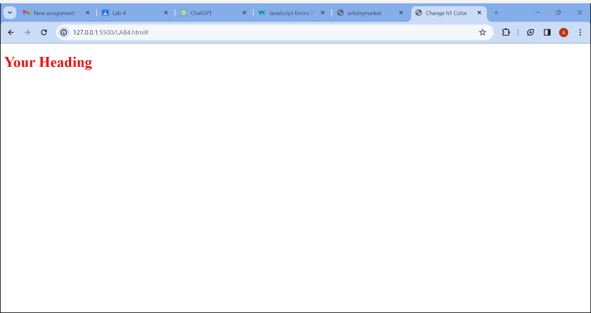**2.** **<!-- By document.querySelector -->**

<!DOCTYPE html>

<html lang="en">

<head>

    <meta charset="UTF-8">

    <meta name="viewport" content="width=device-width, initial-scale=1.0">

    <title>Change h1 Color</title>

</head>

<body>

    <h1 class="myClass">Your Heading</h1>

    <script>

        var headingElement = document.querySelector(".myClass");

        headingElement.style.color = "green";

    </script>

</body>

</html>

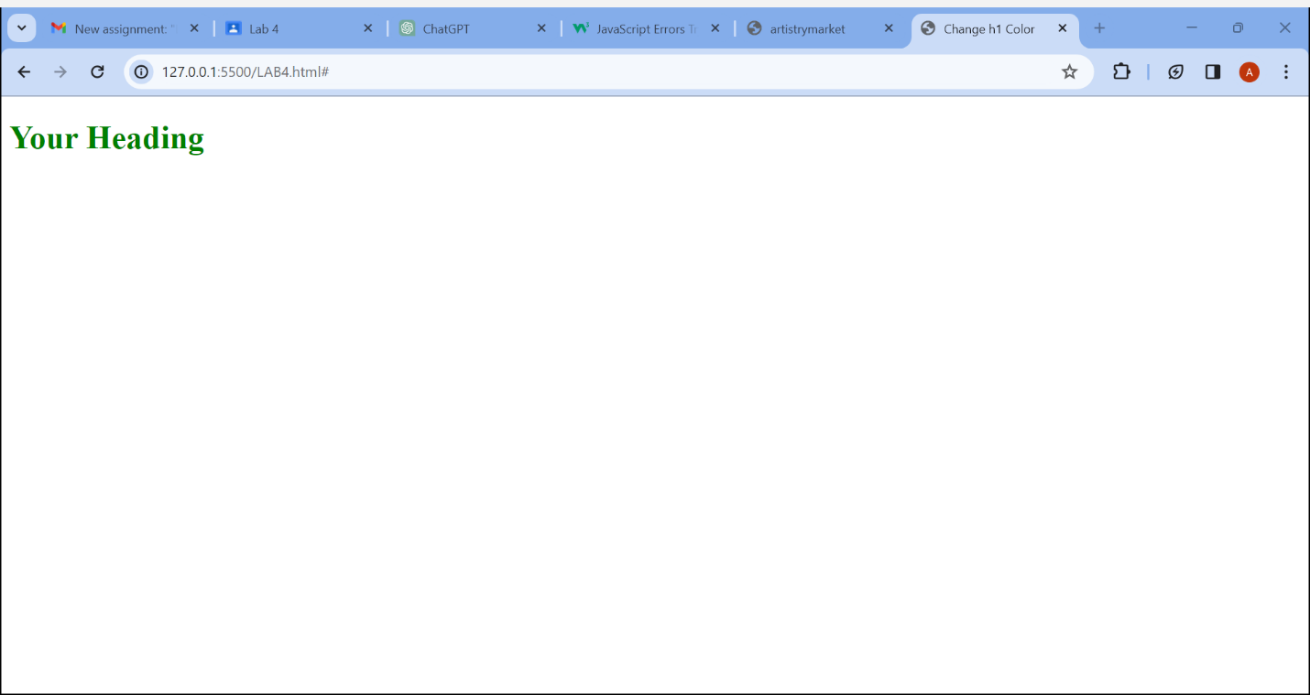

**3.** **<!-- By getElementsByTagName -->**

<!DOCTYPE html>

<html lang="en">

<head>

    <meta charset="UTF-8">

    <meta name="viewport" content="width=device-width, initial-scale=1.0">

    <title>Change h1 Color</title>

</head>

<body>

    <h1>Your Heading</h1>

    <script>

        var headingElement = document.getElementsByTagName("h1")[0];

        headingElement.style.color = "blue";

    </script>

</body>

</html>

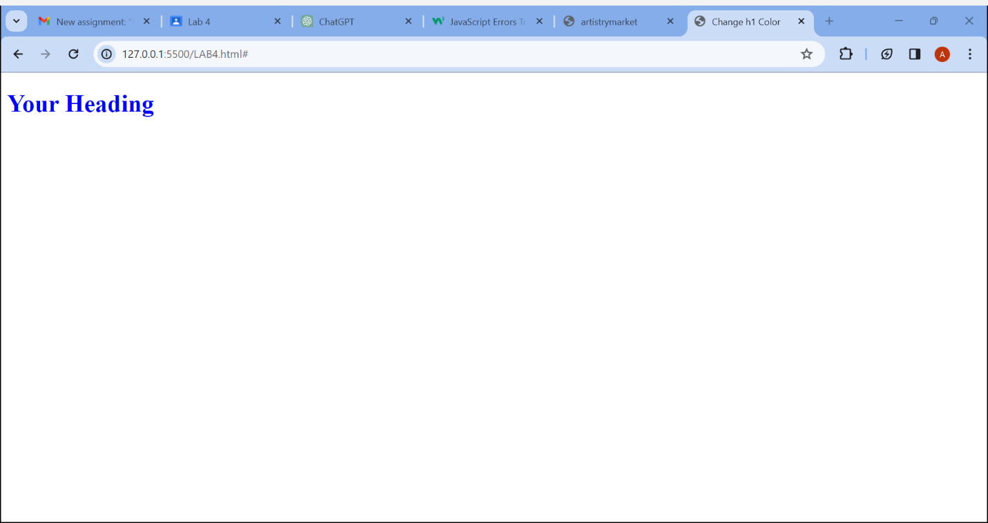**Q6. Design a webpage using grid layout that displays the following:**

**The first row shows icons of various web browsers and the second row shows the latest version number.**

<!DOCTYPE html>

<html lang="en">

<head>

    <meta charset="UTF-8">

    <meta name="viewport" content="width=device-width, initial-scale=1.0">

    <title>Browser Versions</title>

    <style>

        body {

            font-family: Arial, sans-serif;

            margin: 0;

            padding: 0;

        }

        table {

            width: 100%;

            border-collapse: collapse;

        }

        th,

        td {

            padding: 10px;

            text-align: center;

            border: 1px solid #ddd;

        }

        img {

            width: 50px;

            height: 50px;

        }

        tr:nth-child(2) {

            background-color: #f2f2f2;

        }

    </style>

</head>

<body>

    <table>

        <tr>

            <th><img src="c.png" alt="Chrome"></th>

            <th><img src="c2.jpeg" alt="Edge"></th>

            <th><img src="c3.jpeg" alt="Firefox"></th>

            <th><img src="c4.webp" alt="Safari"></th>

            <th><img src="c5.jpeg" alt="Opera"></th>

        </tr>

        <tr>

            <td>57.0</td>

            <td>16.0</td>

            <td>52.0</td>

            <td>10</td>

            <td>44</td>

        </tr>

    </table>

</body>

</html>

