**LAB – 9**

**WEB - TECHNOLOGY**

**Name: Archita Agrahari**

**Branch: CSE Roll no.: 22CS3015**

**Ques 1] Using vue.js Develop a currency converter application that allows users to input an amount in one currency and convert it to another. For the sake of this challenge, you can use a hard-coded exchange rate. Take advantage of React state and event handlers to manage the input and conversion calculations.**

<template>

<div id="app">

<h1>Currency Converter</h1>

<input type="number" v-model="amount" placeholder="Enter amount" />

<select v-model="fromCurrency">

<option value="USD">USD</option>

<option value="EUR">EUR</option>

</select>

<select v-model="toCurrency">

<option value="USD">USD</option>

<option value="EUR">EUR</option>

</select>

<button @click="convertCurrency">Convert</button>

<p>{{ convertedAmount }}</p>

</div>

</template>

<script>

export default { data() {

return { amount: null,

fromCurrency: 'USD',

toCurrency: 'EUR',

exchangeRate: {

USD: { EUR: 0.85 },

EUR: { USD: 1.18 },

},

convertedAmount: null,

};

},

methods: { convertCurrency() {

this.convertedAmount = this.amount * this.exchangeRate[this.fromCurrency][this.toCurrency];

},

},

};

</script>

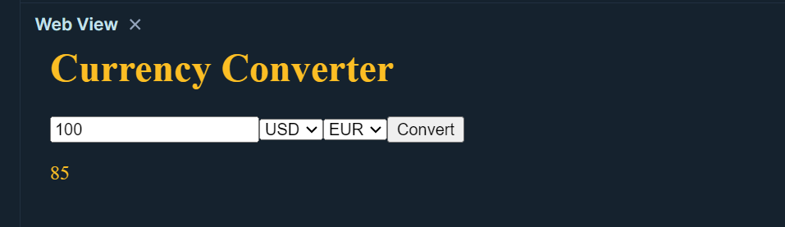

**Ques 2] Using vue.js Create a stopwatch application through which users can start, pause and reset the timer. Use React state, event handlers and the setTimeout or setInterval functions to manage the timer’s state and actions.**

<template>

<div id="app">

<h1>Stopwatch</h1>

<button @click="startStopwatch">Start</button>

<button @click="pauseStopwatch">Pause</button>

<button @click="resetStopwatch">Reset</button>

<p>{{ time }}</p>

</div>

</template>

<script>

export default { data() {

return { time: 0,

intervalId: null,

};

},

methods: { startStopwatch() {

this.intervalId = setInterval(() => { this.time++;

}, 1000);

},

pauseStopwatch() { clearInterval(this.intervalId);

},

resetStopwatch() { this.time = 0;

clearInterval(this.intervalId);

},

},

};

</script>

**Output]**

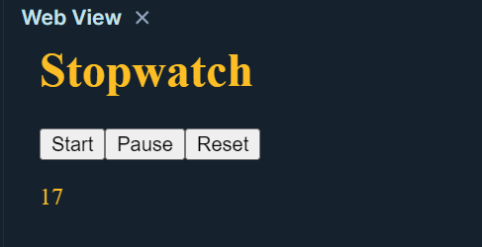

**Ques 3] Using vue.js Develop a messaging application that allows users to send and receive messages in real time. The application should display a list of conversations and allow the user to select a specific conversation to view its messages. The messages should be displayed in a chat interface with the most recent message at the top. Users should be able to send new messages and receive push notifications.**

<template>

<div id="app">

<h1>Messaging App</h1>

<div v-for="conversation in conversations" :key="conversation.id">

<h2 @click="selectConversation(conversation.id)">{{ conversation.name

}}</h2>

</div>

<div v-if="selectedConversation">

<div v-for="message in selectedConversation.messages" :key="message.id">

<p>{{ message.text }}</p>

</div>

<input type="text" v-model="newMessage" placeholder="Type a message" />

<button @click="sendMessage">Send</button>

</div>

</div>

</template>

<script>

export default { data() {

return { conversations: [

{ id: 1, name: 'Conversation 1', messages: [] },

{ id: 2, name: 'Conversation 2', messages: [] },

],

selectedConversation: null, newMessage: '',

};

},

methods: { selectConversation(*id*) {

this.selectedConversation = this.conversations.find(*c* => c.id === id);

},

sendMessage() {

if (this.newMessage.trim() !== '') { this.selectedConversation.messages.push({ id: Date.now(), text:

this.newMessage });

this.newMessage = '';

}

},

},

};

</script>

**Output**

